Module Design Document
For
McuDiagc

Sep 28, 2016
Prepared For:
Software Engineering
Nexteer Automotive,
Saginaw, MI, USA
Prepared By:
Software Group,
Nexteer Automotive,
Saginaw, MI, USAChange History
Description | Author | Version | Date
Initial Version | Selva Sengottaiyan | 1.0 | 29-Mar-2016
Updated for the 2Millisecond to MotorControl Diagnostic and changed NTC logic | Avinash James | 2.0 | 22-Jun-2016
Optimized the diagniostics and removed periodic 3 | Avinash James | 3.0 | 28-Sep-2016

Table of Contents

1 Introduction 5

1.1 Purpose 5

2 McuDiagc & High-Level Description 6

3 Design details of software module 7

3.1 Graphical representation of McuDiagc 7

3.2 Data Flow Diagram 7

3.2.1 Component level DFD 7

3.2.2 Function level DFD 7

4 Constant Data Dictionary 8

4.1 Program (fixed) Constants 8

4.1.1 Embedded Constants 8

5 Software Component Implementation 9

5.1 Sub-Module Functions 9

5.1.1 Init: McuDiagcInit1 9

5.1.1.1 Design Rationale 9

5.1.1.2 Module Outputs 9

5.1.2 Per: McuDiagcPer1 9

5.1.2.1 Design Rationale 9

5.1.2.2 Store Module Inputs to Local copies 9

5.1.2.3 (Processing of function)……… 9

5.1.2.4 Store Local copy of outputs into Module Outputs 9

5.1.3 Per: McuDiagcPer2 9

5.1.3.1 Design Rationale 9

5.1.3.2 Store Module Inputs to Local copies 9

5.1.3.3 (Processing of function)……… 9

5.1.3.4 Store Local copy of outputs into Module Outputs 10

5.2 Server Runnable 10

5.3 Interrupt Functions 10

5.4 Module Internal (Local) Functions 10

5.5 GLOBAL Function/Macro Definitions 10

6 Known Limitations with Design 11

7 Outputs are not range limited as it is intentional and it is expected to go full range as it is a rolling counterUNIT TEST CONSIDERATION 12

Appendix A Abbreviations and Acronyms 13

Appendix B Glossary 14

Appendix C References 16

Introduction

Purpose
Module design document for Micro Controller Diagnostics

McuDiagc & High-Level Description
Refer the Design.

Design details of software module

Graphical representation of McuDiagc

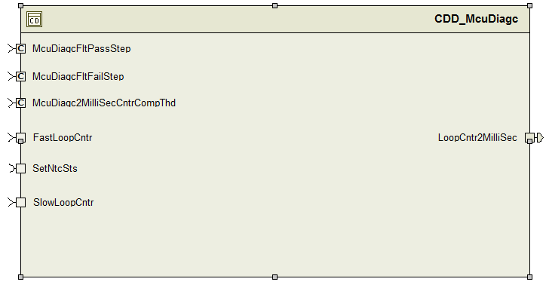

Data Flow Diagram

Component level DFD
N/A

Function level DFD
N/A

Constant Data Dictionary

Program (fixed) Constants

Embedded Constants

Local Constants
Constant Name | Resolution | Units | Value
FASTLOOPCNTRENGMAX_CNT_U16 | 1 | Cnt | 65535
FASTLOOPCNTRENGMIN_CNT_U16 | 1 | Cnt | 0
ROLLOVROFFS_CNT_U16 | 1 | Cnt | 65535U
ROLLOVRCHK_CNT_U16 | 1 | Cnt | 32767U
LOOPCNTR2MILLISECMOTCTRLDIFFMIN_CNT_U16 | 1 | Cnt | 0U
Refer .m file

Software Component Implementation

Sub-Module Functions
The sub-module functions are grouped based on similar functionality that needs to be executed in a given “State” of the system (refer States and Modes). For a given module, the MDD will identify the type and number of sub-modules required. The sub-module types are described below.

Init: McuDiagcInit1

Design Rationale
Refer to FDD

Module Outputs
Refer to FDD

Per: McuDiagcPer1

Design Rationale
None

Store Module Inputs to Local copies
Refer to FDD

(Processing of function)………
Refer to FDD0

Store Local copy of outputs into Module Outputs
Refer to FDD

Per: McuDiagcPer2

Design Rationale
None

Store Module Inputs to Local copies
Refer to FDD

(Processing of function)………
Refer to FDD0

Store Local copy of outputs into Module Outputs
Refer to FDD

Server Runnable
None

Interrupt Functions
None

Module Internal (Local) Functions
None

GLOBAL Function/Macro Definitions
None

Known Limitations with Design
Outputs are not range limited as it is intentional and it is expected to go full range as it is a rolling counter

UNIT TEST CONSIDERATION
Overflow for the variable Rte_Pim_FastLoopCntrPrev, Rte_Pim_LoopCntr2MilliSecStore is intentional as this is used as a rolling counter.

Abbreviations and Acronyms
Abbreviation or Acronym | Description
DFD | Design functional diagram
MDD | Module design Document

Glossary
Note: Terms and definitions from the source “Nexteer Automotive” take precedence over all other definitions of the same term. Terms and definitions from the source “Nexteer Automotive” are formulated from multiple sources, including the following:
- ISO 9000
- ISO/IEC 12207
- ISO/IEC 15504
- Automotive SPICE® Process Reference Model (PRM)
- Automotive SPICE® Process Assessment Model (PAM)
- ISO/IEC 15288
- ISO 26262
- IEEE Standards
- SWEBOK
- PMBOK
- Existing Nexteer Automotive documentation
Term | Definition | Source
MDD | Module Design Document
DFD | Data Flow Diagram

References
Ref. # | Title | Version
1 | AUTOSAR Specification of Memory Mapping (Link:AUTOSAR_SWS_MemoryMapping.pdf) | v1.3.0 R4.0 Rev 2
2 | MDD Guideline | EA4 01.00.01
3 | Software Naming Conventions.doc | 1.0
4 | Software Design and Coding Standards.doc | 2.1
5 | FDD – ES002A McuDiagc | See Synergy subproject version

