Module Design Document
For
BattVltgCorrln

May 24, 2016Mar 21, 2016
Prepared For:
Software Engineering
Nexteer Automotive,
Saginaw, MI, USA
Prepared By:
Nick Saxton,
Nexteer Automotive,
Saginaw, MI, USAChange History
Description | Author | Version | Date
Initial Version | N. Saxton | 1.00.00 | 08-Jul-2015
Updated for FDD 1.2.2 | N. Saxton | 2.00.00 | 06-Aug-2015
Updated for FDD 1.4.0 | Sankardu Varadapureddi | 3 | 21-Mar-2016
Updated for FDD 2.0.0 | N. Saxton | 4 | 24-May-2016

Table of Contents

1 BattVltgCorrln & High-Level Description 4

2 Design details of software module 5

2.1 Graphical representation of BattVltgCorrln 5

2.2 Data Flow Diagram 5

2.2.1 Component level DFD 5

2.2.2 Function level DFD 5

3 Constant Data Dictionary 6

3.1 Program (fixed) Constants 6

3.1.1 Embedded Constants 6

4 Software Component Implementation 7

4.1.1 Sub-Module Functions 7

4.1.2 Interrupt Service Routines 7

4.1.3 Server Runnable Functions 7

4.1.4 Module Internal (Local) Functions 7

4.1.5 Transition Functions 9

5 Known Limitations with Design 10

6 UNIT TEST CONSIDERATION 11

Appendix A Abbreviations and Acronyms 12

Appendix B Glossary 13

Appendix C References 15

BattVltgCorrln & High-Level Description
This function determines the correlation between three input signals (battery voltage, switched battery voltage 1, and switched battery voltage 2) to conclude their validities.

Design details of software module

Graphical representation of BattVltgCorrln
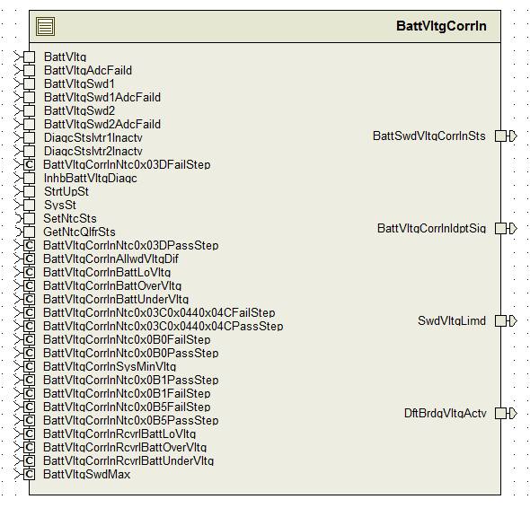

Data Flow Diagram

Component level DFD
N/A

Function level DFD
N/A

Constant Data Dictionary

Program (fixed) Constants

Embedded Constants

Local Constants
Constant Name | Resolution | Units | Value
BATTVLTGIDPTSIGLOLIMIT_CNT_U08 | None | NA | 0
BATTVLTGIDPTSIGHILIMIT _CNT_U08 | None | NA | 3

* Refer FDD for other constant definition

Software Component Implementation

Sub-Module Functions

Initialization sub-module {_Init()}
None

Periodic sub-module {_Per()}

BattVltgCorrlnPer1

Design Rationale
Refer to FDD

Store module inputs to local copies
Refer to FDD

(Processing of function)……
Refer to FDD

Store local copy of outputs into module outputs
Refer FDD

Interrupt Service Routines
None

Server Runnable Functions
None

Module Internal (Local) Functions

Local Function #1
Function Name | InstCorrln | Type | Min | Max
Arguments Passed | Vltg_Volt_T_f32 | float32 | 0 | 40
 | VltgSwd1_Volt_T_f32 | float32 | 0 | 40
 | VltgSwd2_Volt_T_f32 | float32 | 0 | 40
 | BattVltgAdcFaild_Cnt_T_logl | boolean | FALSE | TRUE
 | BattVltgSwd1AdcFaild_Cnt_T_logl | boolean | FALSE | TRUE
 | BattVltgSwd2AdcFaild_Cnt_T_logl | boolean | FALSE | TRUE
 | *VltgOk_Cnt_T_u08 | uint8 | 0 | 1
 | *Swd1Ok_Cnt_T_u08 | uint8 | 0 | 1
 | *Swd2Ok_Cnt_T_u08 | uint8 | 0 | 1
Return Value | BattSwdVltgLimd_Cnt_T_logl | boolean | FALSE | TRUE

Description
Refer FDD

Local Function #2
Function Name | DetIdptSig | Type | Min | Max
Arguments Passed | Ntc0x3CQlfrSts_Cnt_T_enum | enum | SIGQLFR_NORES | SIGQLFR_FAILD
 | Ntc044QlfrSts_Cnt_T_enum | enum | SIGQLFR_NORES | SIGQLFR_FAILD
 | Ntc0x4CQlfrSts_Cnt_T_enum | enum | SIGQLFR_NORES | SIGQLFR_FAILD
 | *VltgNotFailed_Cnt_T_u08 | uint8 | 0 | 1
 | *VltgSwd1NotFailed_Cnt_T_u08 | uint8 | 0 | 1
 | *VltgSwd2NotFailed_Cnt_T_u08 | uint8 | 0 | 1
Return Value | VltgCorrlnIdptSig_Cnt_T_u08 | uint8 | 0 | 3

Description
This function implements the Determine Independent Signals block in the FDD but with a few differences. Instead of implementing the truth table as shown in the FDD, each signal “not failed” variable is set based on the signal’s OK status. Once a signal is considered “not failed”, the variable representing the number of independent signals is incremented. However, while possible in the code, it is not possible for a situation to arise in which there is only one independent signal, therefore a check is performed at the end of this function to set the number of independent signals to 0 and each “not failed” variable to FALSE if this situation occurs.

Local Function #3
Function Name | GetCorrlnSts | Type | Min | Max
Arguments Passed | VltgNotFailed_Cnt_T_u08 | uint8 | 0 | 1
 | VltgSwd1NotFailed_Cnt_T_u08 | uint8 | 0 | 1
 | VltgSwd2NotFailed_Cnt_T_u08 | uint8 | 0 | 1
 | VltgOk_Cnt_T_u08 | uint8 | 0 | 1
 | Swd1Ok_Cnt_T_u08 | uint8 | 0 | 1
 | Swd2Ok_Cnt_T_u08 | uint8 | 0 | 1
 | * DftBrdgVltgActv_Cnt_T_logl | boolean | FALSE | TRUE
Return Value | CorrlnSts_Cnt_T_u08 | uint8 | 0 | 7
* DftBrdgVltgActv_Cnt_T_logl is an output of this function.

Description
Refer FDD

Local Function #4
Function Name | DetSwdSat | Type | Min | Max
Arguments Passed | VltgSwd1_Volt_T_f32 | float32 | 0 | 40
 | VltgSwd2_Volt_T_f32 | float32 | 0 | 40
 | VltgSwd1Ok_Cnt_T_u08 | uint8 | 0 | 1
 | VltgSwd2Ok_Cnt_T_u08 | uint8 | 0 | 1
Return Value | SwdSat_Cnt_T_lgc | boolean | FALSE | TRUE

Description
This function determines if switched battery voltages have reached saturation voltage and was created to reduce cyclomatic complexity and static path count of the Instantaneous Correlation subfunction.

Local Function #5
Function Name | DetNtcQlfrSts | Type | Min | Max
Arguments Passed | Invtr1Inctv_Cnt_T_logl | boolean | FALSE | TRUE
 | Invtr2Inctv_Cnt_T_logl | boolean | FALSE | TRUE
 | VltgOk_Cnt_T_u08 | uint8 | 0 | 1
 | Swd1Ok_Cnt_T_u08 | uint8 | 0 | 1
 | Swd2Ok_Cnt_T_u08 | uint8 | 0 | 1
 | *Ntc3CQlfrSts_Cnt_T_enum | enum | SIGQLFR_NORES | SIGQLFR_FAILD
 | *Ntc3CQlfrSts_Cnt_T_enum | enum | SIGQLFR_NORES | SIGQLFR_FAILD
 | *Ntc3CQlfrSts_Cnt_T_enum | enum | SIGQLFR_NORES | SIGQLFR_FAILD

Description
This function implements the NTC <xx> blocks in the Determine Independent Signals subfunction. It sets each NTC status based on the OK status of each voltage signal. Then, the NTC qualifier status for each signal is retrieved and saved in the corresponding enum parameter. This function was created to reduce complexity and static path count of the Determine Independent Signals subfunction.

Local Function #6
Function Name | FlgChk | Type | Min | Max
Arguments Passed | FlgIn_Cnt_T_logl | boolean | FALSE | TRUE
 | *FlgOut_Cnt_T_u08 | uint8 | 0 | 1
*FlgOut_Cnt_T_u08 is an output of this function.

Description
If Input flag is 'TRUE', then set output flag to 'FASLE'. Otherwise don't do anything. This function is added to reduce cyclomatic complexity of 'InstCorrln' function.

Local Function #7
Function Name | RngChk | Type | Min | Max
Arguments Passed | Vltg_Volt_T_f32 | float32 | 0 | 40
 | VltgSwd1_Volt_T_f32 | float32 | 0 | 40
 | VltgSwd2_Volt_T_f32 | float32 | 0 | 40
 | *VltgRngOk_Cnt_T_u08 | uint8 | 0 | 1
 | *Swd1RngOk_Cnt_T_u08 | uint8 | 0 | 1
 | *Swd2RngOk_Cnt_T_u08 | uint8 | 0 | 1
*VltgRngOk_Cnt_T_u08, *Swd1RngOk_Cnt_T_u08 and *Swd2RngOk_Cnt_T_u08 are outputs of this function.

Description
Implements “Range Check” block in the model. Created to reduce cyclomatic complexity and static path count.

Transition Functions
None

Known Limitations with Design
None

UNIT TEST CONSIDERATION
None

Abbreviations and Acronyms
None

Glossary
Note: Terms and definitions from the source “Nexteer Automotive” take precedence over all other definitions of the same term. Terms and definitions from the source “Nexteer Automotive” are formulated from multiple sources, including the following:
- ISO 9000
- ISO/IEC 12207
- ISO/IEC 15504
- Automotive SPICE® Process Reference Model (PRM)
- Automotive SPICE® Process Assessment Model (PAM)
- ISO/IEC 15288
- ISO 26262
- IEEE Standards
- SWEBOK
- PMBOK
- Existing Nexteer Automotive documentation
Term | Definition | Source
MDD | Module Design Document
DFD | Data Flow Diagram

References
Ref. # | Title | Version
1 | AUTOSAR Specification of Memory Mapping (Link:AUTOSAR_SWS_MemoryMapping.pdf) | v1.3.0 R4.0 Rev 2
2 | MDD Guideline | EA4 01.00.00
3 | Software Naming Conventions.doc | 2.0
4 | Software Design and Coding Standards.doc | 2.1
5 | FDD – ES259A Battery or Switched Voltage Correlation | See Synergy subproject version

