Module Design Document
For
DampgPahFwl

February 9, 2016
Prepared For:
Software Engineering
Nexteer Automotive,
Saginaw, MI, USA
Prepared By:
Akhil Krishna N D (Tata Elxsi),
Trivandrum, INDIA
Change History
Description | Author | Version | Date
Initial Version | Akhil Krishna N D | 1.0 | 09-Feb-2016

Table of Contents

1 Introduction 5

1.1 Purpose 5

2 DampgPahFwl & High-Level Description 6

3 Design details of software module 7

3.1 Graphical representation of DampgPahFwl 7

3.2 Data Flow Diagram 7

3.2.1 Component level DFD 7

3.2.2 Function level DFD 7

4 Constant Data Dictionary 8

4.1 Program (fixed) Constants 8

4.1.1 Embedded Constants 8

5 Software Component Implementation 9

5.1 Sub-Module Functions 9

5.1.1 Init: DampgPahFwlInit1 9

5.1.1.1 Design Rationale 9

5.1.1.2 Module Outputs 9

5.2 Per: DampgPahFwlPer1 9

5.2.1.1 Design Rationale 9

5.2.1.2 Store Module Inputs to Local copies 9

5.2.1.3 (Processing of function)……… 9

5.2.1.4 Store Local copy of outputs into Module Outputs 9

5.3 Server Runables 9

5.4 Interrupt Functions 9

5.5 Module Internal (Local) Functions 9

5.5.1 Local Function #1 9

5.5.1.1 Design Rationale 9

5.5.1.2 Processing 10

5.5.2 Local Function #2 10

5.5.2.1 Design Rationale 10

5.5.2.2 Processing 10

5.5.3 Local Function #3 10

5.5.3.1 Design Rationale 10

5.5.3.2 Processing 10

6 Known Limitations with Design 11

7 UNIT TEST CONSIDERATION 12

Appendix A Abbreviations and Acronyms 13

Appendix B Glossary 14

Appendix C References 15

Introduction

Purpose

DampgPahFwl & High-Level Description
Please refer FDD.

Design details of software module

Graphical representation of DampgPahFwl
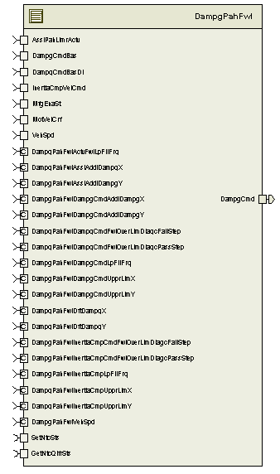

Data Flow Diagram
Please refer FDD

Component level DFD
Please refer FDD

Function level DFD
Please refer FDD

Constant Data Dictionary

Program (fixed) Constants

Embedded Constants

Local Constants
Constant Name | Resolution | Units | Value
NODEBSTEP_CNT_U16 | 1 | Cnt | 65535
Please refer .m file for the rest

Software Component Implementation

Sub-Module Functions

Init: DampgPahFwlInit1

Design Rationale
None

Module Outputs
None

Per: DampgPahFwlPer1

Design Rationale
None

Store Module Inputs to Local copies
None

(Processing of function)………
Please refer FDD

Store Local copy of outputs into Module Outputs
Please refer FDD

Server Runables
None

Interrupt Functions
None

Module Internal (Local) Functions

Local Function #1
Function Name | DebncDmpCmdOverBound | Type | Min | Max
Arguments Passed | DampgCmdFWOverBound_Cnt_T_logl | boolean | FALSE | TRUE
Return Value | DampgCmdFailSts_Cnt_T_logl | boolean | FALSE | TRUE

Design Rationale
None

Processing
Please refer Debounce Damp Cmd Overboundary block in FDD

Local Function #2
Function Name | DebncVBICOverBound | Type | Min | Max
Arguments Passed | InertiaCmpFwlOverBnd_Cnt_T_logl | boolean | FALSE | TRUE
Return Value | VBICCmdFailSts_Cnt_T_logl | boolean | FALSE | TRUE

Design Rationale
None

Processing
Please refer ‘Debounce VBIC Overboundary’ block in FDD

Local Function #3
Function Name | SetFaults | Type | Min | Max
Arguments Passed | DampgFwlReached_Cnt_T_logl | boolean | FALSE | TRUE
 | VBICFwlReached_Cnt_T_logl | boolean | FALSE | TRUE
Return Value | None | NA | NA | NA

Design Rationale
None

Processing
Please refer ‘Set_Faults’ block in FDD

Known Limitations with Design
None.

UNIT TEST CONSIDERATION
None.

Abbreviations and Acronyms
Abbreviation or Acronym | Description

Glossary
Note: Terms and definitions from the source “Nexteer Automotive” take precedence over all other definitions of the same term. Terms and definitions from the source “Nexteer Automotive” are formulated from multiple sources, including the following:
- ISO 9000
- ISO/IEC 12207
- ISO/IEC 15504
- Automotive SPICE® Process Reference Model (PRM)
- Automotive SPICE® Process Assessment Model (PAM)
- ISO/IEC 15288
- ISO 26262
- IEEE Standards
- SWEBOK
- PMBOK
- Existing Nexteer Automotive documentation
Term | Definition | Source
MDD | Module Design Document
DFD | Data Flow Diagram

References
Ref. # | Title | Version
1 | AUTOSAR Specification of Memory Mapping (Link:AUTOSAR_SWS_MemoryMapping.pdf) | v1.3.0 R4.0 Rev 2
2 | MDD Guideline | EA4 01.00.01
3 | Software Naming Conventions.doc | 1.0
4 | Software Design and Coding Standards.doc | 2.0
5 | FDD: SF035A_DampgPahFwl_Design | See Synergy sub project version

