Module Design Document
For
MotCurrRegCfg

VERSION: 4.0
DATE: 11-Nov-2016

Prepared By:
Software Group
Location: The official version of this document is stored in the Nexteer Configuration Management System.

Revision History

Sl. No. | Description | Author | Version | Date
1 | Initial Version | Selva | 1.0 | 02-JUN-2015
2 | Updated per design rev. 1.3.0 | Rijvi | 2.0 | 12-Mar-2016
3 | Updated per design rev. 1.4.0 | Krishna | 3.0 | 29-Apr-2016
4 | Updated per design rev. 2.1.0 | JK | 4.0 | 11-Nov-2016
Table of Contents
1 Abbrevations And Acronyms 5
2 References 6
3 MotCurrRegCfg & High-Level Description 7
4 Design details of software module 8
4.1 Graphical representation of MotCurrRegCfg 8
4.2 Data Flow Diagram 8
4.2.1 Module level DFD 8
4.2.2 Sub-Module level DFD 8
4.3 COMPONENT FLOW DIAGRAM 8
5 Variable Data Dictionary 9
5.1 User defined typedef definition/declaration 9
5.2 Variable definition for enumerated types 9
6 Constant Data Dictionary 10
6.1 Program(fixed) Constants 10
6.1.1 Embedded Constants 10
6.1.1.1 Local 10
6.1.1.2 Global 10
6.1.2 Module specific Lookup Tables Constants 10
7 Software Module Implementation 11
7.1 Sub-Module Functions 11
7.2 Initialization Functions 11
7.2.1 Per: MotCurrRegCfgINIT1 11
7.2.1.1 Design Rationale 11
7.2.1.2 Store Module Inputs to Local copies 11
7.2.1.3 (Processing of function)……… 11
7.2.1.4 Store Local copy of outputs into Module Outputs 11
7.3 PERIODIC FUNCTIONS 11
7.3.1 Per: MotCurrRegCfgper1 11
7.3.1.1 Design Rationale 11
7.3.1.2 Store Module Inputs to Local copies 11
7.3.1.3 (Processing of function)……… 11
7.3.1.4 Store Local copy of outputs into Module Outputs 11
7.4 Non PERIODIC FUNCTIONS 11
7.5 Interrupt Functions 11
7.6 Serial Communication Functions 12
7.7 Local Function/Macro Definitions 12
7.8 GLObAL Function/Macro Definitions 12
7.9 TRANSIENT FUNCTIONS 12
8 Unit Test Considerations 13
9 Known Limitations With Design 14
10 UNIT TEST CONSIDERATION 15
11 Appendix 16

Abbrevations And Acronyms
Abbreviation | Description
DFD | Design functional diagram
MDD | Module design Document
 | <ADD more to the table if applicable>

References
This section lists the title & version of all the documents that are referred for development of this document
Sr. No. | Title | Version
<1> | <MDD Guidelines> | Process 04.02.01
<2> | <Software Naming Conventions> | Process 04.02.01
<3> | <Coding standards> | Process 04.02.01
<4> | FDD - SF104A_MotCurrRegCfg_Design | See Synergy Subproject version
 | <Add if more available>

MotCurrRegCfg & High-Level Description

Design details of software module

Graphical representation of MotCurrRegCfg

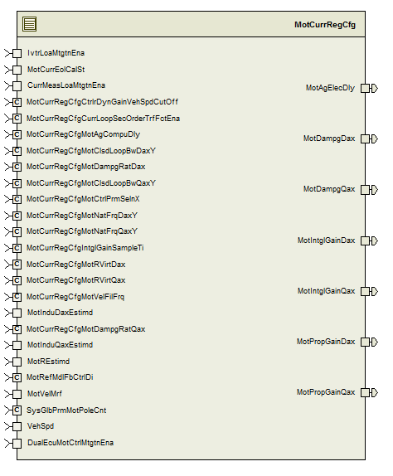

Data Flow Diagram

Module level DFD

Sub-Module level DFD

COMPONENT FLOW DIAGRAM

Variable Data Dictionary

User defined typedef definition/declaration

Typedef Name | Element Name | User Defined Type | Legal Range  (min) | Legal Range  (max)
N/A

Variable definition for enumerated types
Enum Name | Element Name | Value
N/A | <(Variable name qualified Refer[2])> | <Define the value >

Constant Data Dictionary

Program(fixed) Constants

Embedded Constants
< All program specific constants will be defined in detail >

Local
Constant Name | Resolution | Units | Value
Refer constants from .m file

Global
<This section lists the global constants used by the module. For details on global constants, refer to the Data Dictionary for the application>
Constant Name
Refer constants from .m file

Module specific Lookup Tables Constants
<(This is for lookup tables (arrays) with fixed values, same name as other tables)>
Constant Name | Resolution | Value | Software Segment
Refer .m file

Software Module Implementation

Sub-Module Functions
NONE

Initialization Functions

Per: MotCurrRegCfgINIT1

Design Rationale
Refer to FDD

Store Module Inputs to Local copies
Refer to FDD

(Processing of function)………
Refer to FDD

Store Local copy of outputs into Module Outputs
Refer to FDD

PERIODIC FUNCTIONS

Per: MotCurrRegCfgper1

Design Rationale

Store Module Inputs to Local copies
Refer to FDD

(Processing of function)………
Refer to FDD

Store Local copy of outputs into Module Outputs
Refer to FDD

Non PERIODIC FUNCTIONS
None

Interrupt Functions
None

Serial Communication Functions
None

Local Function/Macro Definitions
None

GLObAL Function/Macro Definitions
None

TRANSIENT FUNCTIONS
None

Unit Test Considerations
None

Known Limitations With Design

UNIT TEST CONSIDERATION
The range of the application data type used for the calibration MotCurrRegCfgMotClsdLoopBwDaxY and MotCurrRegCfgMotNatFrqQaxY are not updated per the DataDict.m file changes. We moved away using the application data type, hence it has no impact.

Appendix
None

