Module -- Battery Voltage66

High-Level Description
This module is responsible for applying voltage and time based hysteresis to the battery voltage to determine over voltage(B5) and low voltage faults(B0). Requirements for all these faults are detailed in SER. Also customer specific B1diagnostic is implemented.

Figures

Diagram – Function Data Sharing
This diagram shows all data that is shared between functions within the module.

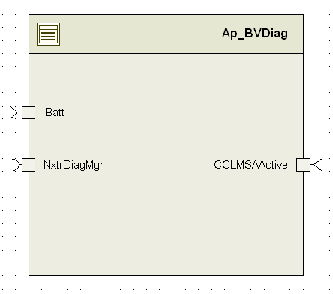

Variable Data Dictionary
For details on module input / output variable, refer to the Data Dictionary for the application. Input / output variable names are listed here for reference.
(Note: Full variable names required in table.)
(Note: All global variables including End Of Line data used should be shown here)
Module Inputs (Global Variable Name) | Module Outputs (Global Variable Name)
Batt_Volt_f32
CCLMSAActive_Cnt_lgc

Module Internal Variables
This section identifies the name, range and resolutions for module specific data created by this module. If there are no range restrictions on the variable, the term “FULL” is placed into the table for legal range.
Variable Name | User Defined Type | Resolution | Legal Range  (min) | Legal Range  (max) | Software Segment
BVDiag_LowSetInitBD_ms_M_u32p0 | N/A | 1ms/Cnt | FULL | FULL
BVDiag_LowClrInitBD_ms_M_u32p0 | N/A | 1ms/Cnt | FULL | FULL
BVDiag_OvSetInitBD_ms_M_u32p0 | N/A | 1ms/Cnt | FULL | FULL
BVDiag_OvClrInitBD_ms_M_u32p0 | N/A | 1ms/Cnt | FULL | FULL
BVDiag_UvSetInitBD_ms_M_u32p0 | N/A | 1ms/Cnt | FULL | FULL
BVDiag_UvClrInitBD_ms_M_u32p0 | N/A | 1ms/Cnt | FULL | FULL

User defined typedef definition/declaration
This section documents any user types uniquely used for the module.
Typedef Name | Element Name | User Defined Type | Legal Range  (min) | Legal Range  (max)
None

Constant Data Dictionary

Calibration Constants
This section lists the calibrations used by the module. For details on calibration constants, refer to the Data Dictionary for the application.
Constant Name
k_OvDetect_Volts_u10p6
k_OvNotDetect_Volts_u10p6
k_OvDetect_ms_u16p0
k_OvNotDetect_ms_u16p0
k_LowNotDetect_Volts_u10p6
k_LowDetect_Volts_u10p6
k_LowDetect_ms_u16p0
k_LowNotDetect_ms_u16p0
k_MSALowNotDetect_Volts_u10p6
k_MSALowDetect_Volts_u10p6
k_MSALowDetect_ms_u16p0
k_MSALowNotDetect_ms_u16p0
k_BattDiagUvMax_Volt_u10p6
k_BattDiagUvMin_Volt_u10p6
k_UvNotDetect_ms_u16p0
k_UvDetect_ms_u16p0
k_BattUvRecMax_Volt_u10p6

Program(fixed) Constants

Embedded Constants
All embedded constants whose values are provided in Eng units will be evaluated to the equivalent counts by using the FPM_InitFixedPoint_m() macro within the #define statement.

Local
Constant Name | Resolution | Value
D_ABOVEMAX_CNT_U16 | 1 | 0x11
D_BELOWMIN_CNT_U16 | 1 | 0x22
D_INDEADBAND_CNT_U16 | 1 | 0x33
D_DIAGOV_CNT_U16 | 1 | 1
D_DIAGLOW_CNT_U16 | 1 | 2

Global
This section lists the global constants used by the module. For details on global constants, refer to the Data Dictionary for the application.
Constant Name
NTC_Num_OpVoltage
NTC_Num_OpVoltageOvrMax

Module specific Lookup Tables Constants
(This is for lookup tables (arrays) with fixed values, same name as other tables)
Constant Name | Resolution | Value | Software Segment
None

Functions/Macros used by the Sub-Modules

Library Functions / Macros
The library functions / Macros that are called by the various sub modules are identified below,
- FPM_FloatToFixed_m()

Data Hiding Functions
The data hiding functions / macros used in this module are identified below,
- Rte_Call_NxtrDiagMgr_SetNTCStatus()
- Rte_Call_BVDiag_Per1_CP0_CheckpointReached()
- Rte_Call_BVDiag_Per1_CP1_CheckpointReached()
- Rte_IRead_BVDiag_Per1_CCLMSAActive_Cnt_lgc()
- Rte_Call_SystemTime_GetSystemTime_mS_u32()
- Rte_Call_SystemTime_DtrmnElapsedTime_mS_u16()
- Rte_Call_SystemTime_GetSystemTime_mS_u32()
- Rte_Call_SystemTime_DtrmnElapsedTime_mS_u16()

Local Functions/Macros Used by this MDD only
(Note if they are defined in another source file, then reference the appropriate header file)
The local functions/macros in this module are identified below,
- ApplyHysteresis()
- ControlTimers()

Software Module Implementation

Initialization Functions
Module state variables are initialized to 0 at start-up by RAM init.

Periodic Functions

Per: BVDiag_Per1

Design Rationale
All customer SER’s describes same functionality for B0,B5.
B1 NTC is only for Chrysler.

Program Flow Start
Rte_Call_BVDiag_Per1_CP0_CheckpointReached()

Store Module Inputs to Local copies
BattVoltage_Volts_T_f32 = Rte_IRead_BVDiag_Per1_Batt_Volt_f32()
MSAActive_T_lgc = Rte_IRead_BVDiag_Per1_CCLMSAActive_Cnt_lgc();

Perform Over and Low Voltage Diagnostics

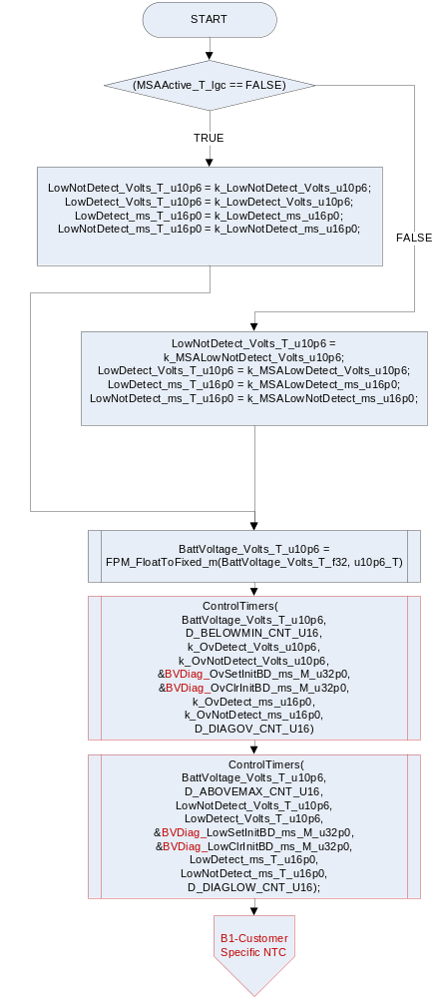
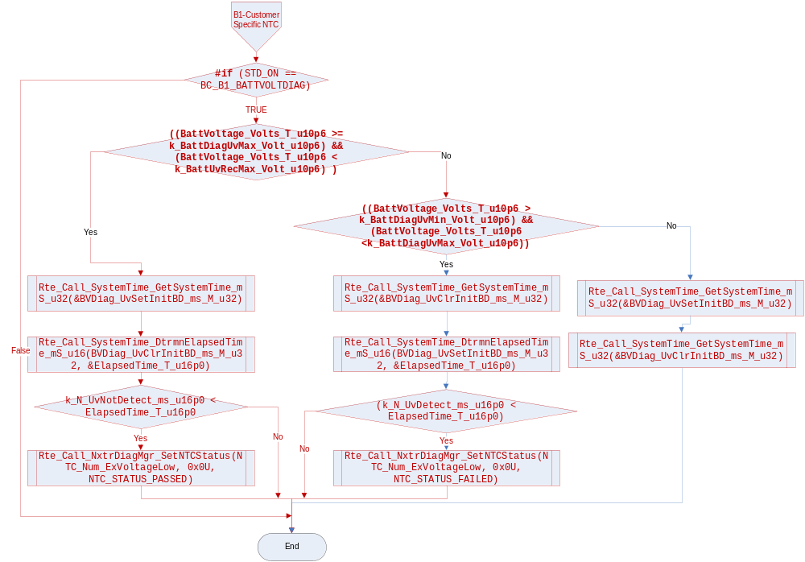

Store Local copy of outputs into Module Outputs
None.

Program Flow End
Rte_Call_BVDiag_Per1_CP1_CheckpointReached()

Fault Recovery Functions
None

Shutdown Functions
None

Interrupt Functions
None

Serial Communication Functions
None

Local Function/Macro Definitions
If these are numerous and defined in a separate source file then reference the source file only.

Control Timers
Function Name | ControlTimers | Type | Min | Max
Arguments Passed | BattVoltage_Volts_T_u10p6 | u10p6_T | See DD¹ | See DD¹
 | CompareType_T_u16 | UINT16 | 0x0011 | 0x0022
 | UpperCal_T_u10p6 | u10p6_T | See DD¹ | See DD¹
 | LowerCal_T_u10p6 | u10p6_T | See DD¹ | See DD¹
 | SetTimer_T_ptr | u32p0_T* | FULL | FULL
 | ClrTimer_T_ptr | u32p0_T* | FULL | FULL
 | SetTimer_ms_T_u16p0 | u16p0_T | FULL | FULL
 | ClrTimer_ms_T_u16p0 | u16p0_T | FULL | FULL
 | Option_T_u16 | UINT16 | 0x0001 | 0x0002
Return Value | N/A

Note 1 – See data dictionary for input which corresponds to a calibration or global variable

Description
This generic local function is used to control set and clear timers for the diagnostic functions as well as control flags used to indicate battery voltage is “Ok” for the application. Data is passed to indicate the following:
CompareType_T_u16: Passed data to indicate the type of comparison to be made internally to the function (Above Max or Below Min). Used in a decision block within the function. Essentially, reverses the logic between an over voltage test (where below min is a normal operating point) and low voltage test (where above max is a normal operating point)
UpperCal_T_u10p6: Voltage level calibration of the hysteresis (upper threshold).
LowerCal_T_u10p6: Voltage level calibration of the hysteresis (lower threshold). Note: Lower cal must be <= Upper Cal.
SetTimer_T_ptr: Pointer to the appropriate module specific 32-bit set timer under test (examples are set timer for over voltage, low voltage, battery Ok, etc.)
ClrTimer_T_ptr: Pointer to the appropriate module specific 32-bit clear timer under test (examples are set timer for over voltage, low voltage, battery Ok, etc.)
SetTimer_ms_T_u16p0: Calibration used for the time based hysteresis to set the condition. Note that the calibrations will differ for set timers for over voltage, low voltage, etc.
ClrTimer_ms_T_u16p0: Calibration used for the time based hysteresis to clear the condition. Note that the calibrations will differ for set timers for over voltage, low voltage, etc.
Option_T_u16: Identifies which function is being used to identify which set fault, clear fault functions to call, which battery voltage OK state is being checked, etc.
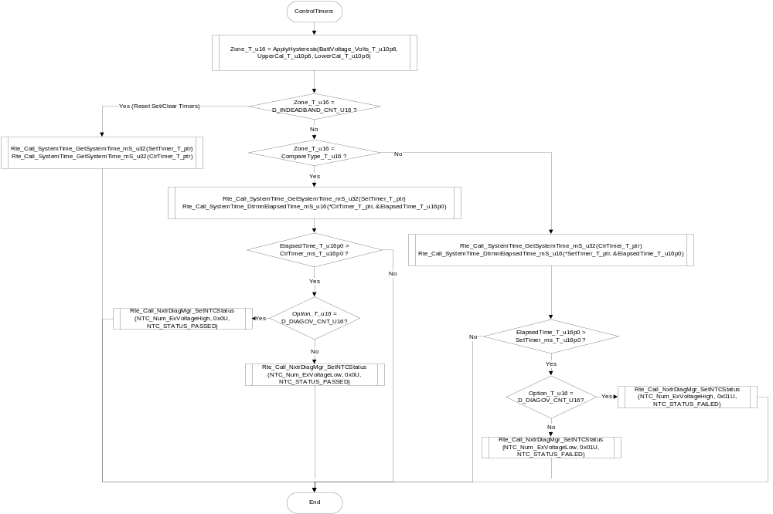

Apply Hysteresis
Function Name | ApplyHysteresis | Type | Min | Max
Arguments Passed | BattIn_T_u10p6 | u10p6_T | See DD¹ | See DD¹
 | HighCal_T_u10p6 | u10p6_T | See DD¹ | See DD¹
 | LowCal_T_u10p6 | u10p6_T | See DD¹ | See DD¹
Return Value | OutputZone_T_u16 | UINT16 | 0x0011 | 0x0033

Note 1 – See data dictionary for input which corresponds to a calibration or global variable

Description
This local function is used to determine the next state for a voltage based hysteresis as applied to the battery voltage level. Data is passed to include the battery voltage, upper calibration and a lower calibration. The function returns the state of the battery voltage relative to the cals (either “Above Max”, “Below Min” or “In Deadband”). Note that the design requires the upper cal to be larger than the lower cal for proper operation.
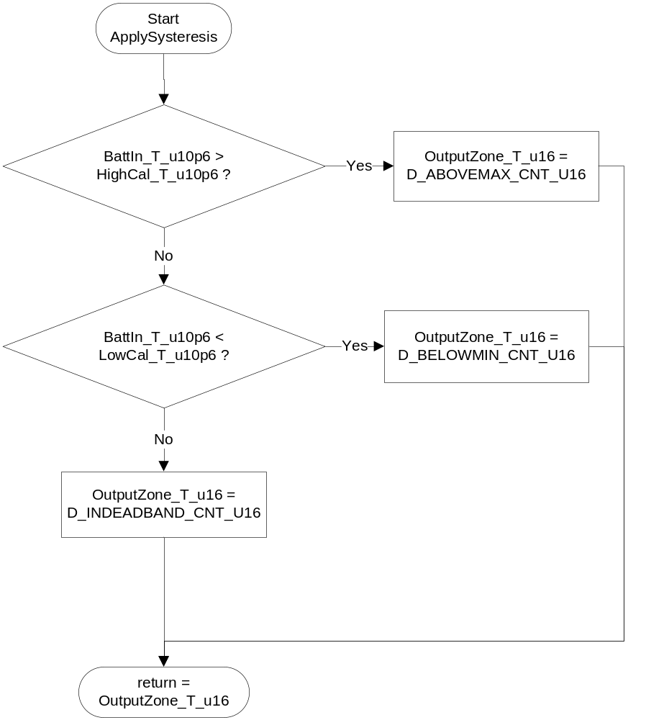

Execution Requirements

Execution Sequence of the Module
(Describe in words relevant details about the execution sequence of the different sub modules.)

Execution Rates for sub-modules called by the Scheduler
This table serves as reference for the Scheduler design
Function Name | Task List | Calling Frequency | System State(s) in which the function is called
BVDiag_Per1 |  | 10ms | ALL

Execution Requirements for Serial Communication Functions
Function Name | Sub-Module called by (Serial Comm Function Name)
None

Memory Map Definition Requirements

Sub Modules (Functions)
This table identifies the software segments for functions identified in this module.
Name of Sub Module | Software Segment
BVDiag_Per1() | RTE_AP_BVDIAG_APPL_CODE

Local Functions
This table identifies the software segments for local functions identified in this module.
Name of Sub Module | Software Segment
ControlTimers() | AP_BVDIAG_CODE
ApplyHysteresis() | AP_BVDIAG_CODE

Known Issues / Limitations With Design
- B1,B4 faults are removed from BMW,K2XX SER.
Revision Control Log
Item # | Rev # | Change Description | Date | Author Initials
1 | 1.0 | Initial AutoSAR release. | 19-Oct-12 | NRAR
2 | 2.0 | Updated to SER Rev BMW SER EPS24102912 Rev 011C (CUSTOMER VERSION).docx | 18-Mar-2013 | SP
4 | 4.0 | Updated to Implement B1 as per Chrysler LWR SER Ver 5G | 11-Sep-13 | NRAR

