Module – Serial Communications Output

High-Level Description
The Serial Communications Output module provides a signal level interface between the EPS application layer and the serial communications software. Provide for the network management functionality for the serial communications interface. This module will be customized for each distinct vehicle platform. This module will be responsible for converting the range and resolution of the Application Layer variables to the range and resolution of the associated serial communications signals.
This module processes the data for transmit signals that are sent from the EPS controller to other ECUs on the communication bus. Global application input data is scaled appropriately and then transferred to the serial communications Interaction Layer using function calls or macros provided. Similarly, the Serial Communications Input module, takes the signal data that is received from the Interaction Layer, scales the data as required by the EPS controller and transfers the updated global data to the EPS application software.

Figures

Component Diagram
This diagram shows all data that is shared between functions within the module.
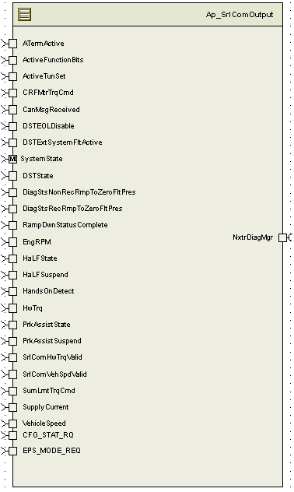

Variable Data Dictionary
For details on module input / output variable, refer to the Data Dictionary for the application. Input / output variable names are listed here for reference.
(Note: Full variable names required in table.)
Module Inputs (Global Variable Name) | Module Outputs (Global Variable Name)
ATermActive_Cnt_lgc
ActiveFunctionBits_Cnt_u08
ActiveTunSet_Cnt_u16
CanMsgReceived_Cnt_lgc
DSTEOLDisable_Cnt_lgc
DSTExtSystemFltActive_Cnt_lgc
SystemState_Mode
DSTState_Cnt_u08
DiagStsRecRmpToZeroFltPres_Cnt_lgc(
DiagStsNonRecRmpToZeroFltPres_Cnt_lgc
RampDwnStatusComplete_Cnt_lgc
EngRPM_Cnt_u16
HaLFState_Cnt_u08
HaLFSuspend_Cnt_lgc
HandsOnDetect_Cnt_lgc
HwTrq_HwNm_f32
PrkAssistState_Cnt_u08
PrkAssistSuspend_Cnt_lgc
SrlComHwTrqValid_Cnt_lgc
SrlComVehSpdValid_Cnt_lgc
SumLmtTrqCmd_MtrNm_f32
SupplyCurrent_Amp_f32
VehicleSpeed_Kph_f32
CFG_STAT_RQ_Cnt_u16
EPS_MODE_REQ_Cnt_u16
CTermActive_Cnt_lgc
SpStPrsnt_Cnt_lgc
OutputRampMult_Uls_f32;

Module Internal Variables
This section identifies the name, range and resolutions for module specific data created by this module. If there are no range restrictions on the variable, the term “FULL” is placed into the table for legal range.
Variable Name | Resolution | Legal Range  (min) | Legal Range  (max) | Software Segment
NMBusWaitSleepCancel_Cnt_M_lgc | 1 | FALSE | TRUE | SRLCOMOUTPUT_START_SEC_VAR_CLEARED_BOOLEAN
CanMsgReceived_Cnt_M_lgc | 1 | FALSE | TRUE | SRLCOMOUTPUT_START_SEC_VAR_CLEARED_BOOLEAN
MtrTrqValid_Cnt_M_lgc | 1 | FALSE | TRUE | SRLCOMOUTPUT_START_SEC_VAR_CLEARED_BOOLEAN
MCEPS1_Cnt_M_u08 | 1 | 0 | FULL | SRLCOMOUTPUT_START_SEC_VAR_CLEARED_8
NMFirstMsg_mS_M_u32 | 1 | 0 | FULL | SRLCOMOUTPUT_START_SEC_VAR_CLEARED_32
NMBusWaitSleepCancel_mS_M_u32 | 1 | 0 | FULL | SRLCOMOUTPUT_START_SEC_VAR_CLEARED_32
EPS1_M_str | 1 | 0 | FULL | SRLCOMOUTPUT_START_SEC_VAR_CLEARED_32

User defined typedef definition/declaration
This section documents any user types uniquely used for the module.
Typedef Name | Element Name | User Defined Type | Legal Range  (min) | Legal Range  (max)

Constant Data Dictionary

Calibration Constants
This section lists the calibrations used by the module. For details on calibration constants, refer to the Data Dictionary for the application.
Constant Name
k_VehSpdAstLmt_Kph_f32
k_StrClmTrqPolarity_Cnt_s08
k_InvGearRatio_Uls_f32
k_StrClmTrqPolarity_Cnt_s08

Program(fixed) Constants

Embedded Constants
All embedded constants whose values are provided in Eng units will be evaluated to the equivalent counts by using the FPM_InitFixedPoint_m() macro within the #define statement.

Local
Constant Name | Value
D_SUPPLYCURROFFSET_ULS_F32 | 50.0
D_EPSCURR_HILMT_AMP_F32 | 203.0
D_EPSCURR_LOLMT_AMP_F32 | -50.0
D_CRCINIT_CNT_U8 | 0xFF
D_CRCXORVALUE_CNT_U8 | 0xFF
D_COUNTERCYCLE16_CNT_U16 | 0x10
D_UNUSED0MSG221_CNT_U8 | 0xFF
D_STRCLMTRQLOLIMIT_HWNM_F32 | -8.0
D_STRCLMTRQHILIMIT_HWNM_F32 | 7. 9765625
D_STRCLMTRQOFFSET_HWNM_F32 | 8.0
D_STRCLMTRQ_SIGNOTAVAL_CNTS_U16 | 0x07FF
D_ASSTTRQ_HILMT_HWNM_F32 | 104.65
D_ASSTTRQ_LOLMT_HWNM_F32 | -100.0
D_ASSTTRQ_OFFSET_HWNM_F32 | 100.0
D_ASSTTRQ_ENGTOCNTS_SCALE_HWNM_F32 | 20.0
D_HALFSTATEINACTIVE_CNT_U08 | 0
D_HALFSTATEACTIVE_CNT_U08 | 1
D_HALFSTATEINHIBITED_CNT_U08 | 2
D_HALFSTATERECOVERABLE_CNT_U08 | 3
D_PPPAFUNCBIT_CNT_U08 | 1
D_DSTFUNCBIT_CNT_U08 | 2
D_HALFFUNCBIT_CNT_U08 | 4
D_PASTATEINACTIVE_CNT_U08 | 0
D_PASTATEACTIVE_CNT_U08 | 1
D_PASTATEINHIBITED_CNT_U08 | 2
D_PASTATERECOVERABLE_CNT_U08 | 3
D_EPSMTRTRQ_HILMT_MTRNM_F32 | 1.998046875
D_EPSMTRTRQ_LOLMT_MTRNM_F32 | -2.0
D_EPSMTRTRQ_OFFSET_ULS_F32 | 2.0
D_EPSMTRTRQ_SIGNOTAVAL_CNT_U16 | 0xFFFF
D_NMAWAKENWST_CNT_U08 | 0x01U
D_NMAWAKEDIAGACTV_CNT_U08 | 0x02
D_NMAWAKERAMPOUT_CNT_U08 | 0x04
D_NMAWAKEVSSHIGH_CNT_U08 | 0x08
D_NMAWAKEENGRPMHIGH_CNT_U08 | 0x10
D_NMAWAKEIGNHIGH_CNT_U08 | 0x20
D_NMSTARTUPSLEEPDELAY_MS_U32 | 0x50000
D_NMWAKEUPREASONIGN_CNT_U08 | 0x01
D_ENGONRPM_CNT_U16 | 0x12
D_ENGRPMINVLD_CNT_U16 | 0xFFFF
EPSA1_AsstStat
EPSA1_AsstStat_Active | 0x00
EPSA1_AsstStat_Off | 0x01
EPSA1_AsstStat_ThrmRed | 0x02
EPSA1_AsstStat_SigNotAval | 0x07
EPSA1_WarnDisp
EPSA1_WarnDisp_FuncActive | 0x00
EPSA1_WarnDisp_ServPwrSteer | 0x01
EPSA1_WarnDisp_PwrSteerOvTmp | 0x02
EPSA1_WarnDisp_ServReqdHighPri | 0x03
EPSA1_WarnDisp_SigNotAval | 0x07
kDescStateSessionDefault | 0x01
D_TXAWAKE_NWST_CNT_U08 | 0x01
D_TXAWAKE_DIAGACTIVE_CNT_U08 | 0x02
D_TXAWAKE_RAMPOUT_CNT_U08 | 0x04
D_TXAWAKE_VSSHIGH_CNT_U08 | 0x08
D_TXAWAKE_ENGRPM_CNT_U08 | 0x10
D_TXAWAKE_IGNHIGH_CNT_U08 | 0x20
D_SLEEPINDICATORCLEAR_U08 | 0x40
D_SLEEPSTATE_U08 | 0x00U
D_ENGONRPM_CNT_U16 | 0x12C
D_ENGRPMINVLD_CNT_U16 | 0xFFFF
TOCSTATE_PNA | 2

Global
This section lists the global constants used by the module. For details on global constants, refer to the Data Dictionary for the application.
Constant Name

Module specific Lookup Tables Constants
(This is for lookup tables (arrays) with fixed values, same name as other tables)
Constant Name | Resolution | Value | Software Segment
none

Functions/Macros used by the Sub-Modules

Library Functions / Macros
The library functions / Macros that are called by the various sub modules are identified below,
- None

Data Hiding Functions
The data hiding functions / macros used in this module are identified below,

Local Functions/Macros Used by this MDD only
(Note if they are defined in another source file, then reference the appropriate header file)
The local functions/macros in this module are identified below,

- CalcCRC_EPS_1( void)
- DetermineWarnDisp(void)
- ScaleSignal_u16( float32 Signal_Uls_T_f32, float32 LoLmt_Uls_T_f32, float32 HiLmt_Uls_T_f32, float32 Scale_Uls_T_f32, Offset_Uls_T_f32)
- SrlComOutput_WriteBits(uint32 Data_T_Cnt_u32, uint8* Buffer_T_Cnt_u08, uint16 StartBit_Cnt_T_u16, uint16 EndBit_Cnt_T_u16)

Software Module Implementation

Initialization Functions

Init: SrlComOutput_Init1

Design Rationale

Module Outputs

Module Internal

Set Default Messages
EPSA1_T_str.s.unused0 = 0x00
SetValueTxEPS_AsstStat(EPSA1_T_str, 0x01)
SetValueTxEPS_Warn_Disp_Rq(EPSA1_T_str, 0x00)
EPSA1_T_str.s.unused1 = 0x00
EPSA1_T_str.s.unused2 = 0x00
SetValueTxEPS_Curr(EPSA1_T_str, 0xFF)
EPSA1_T_str.s.unused3 = 0x00
EPSA1_T_str.s.unused4 = 0x00
EPSA1_T_str.s.unused5 = 0x00
EPSA1_T_str.s.unused6 = 0x00
dbkPutTxEPS_A1_PKT(EPSA1_T_str)

CclEnableCommunication()
DpmExternalRequest(DPM_EPS)

SetValueTxWakeupRsn_EPS(WakeupEPS_T_str, D_NMWAKEUPREASONIGN_CNT_U08)
SetValueTxWakeupCnt(WakeupEPS_T_str, 0x00)
WakeupEPS_T_str.s.unused0 = 0x00
nmpduPutWakeup_EPS(WakeupEPS_T_str)

SetValueTxTOI_Act_Sts(EPS1_M_str, 0x00)
SetValueTxStrClmTrqVD(EPS1_M_str, 0x00)
SetValueTxStrClmTrq(EPS1_M_str, 0x07FF)
SetValueTxAssistanceTorque(EPS1_M_str, 0x00)
SetValueTxPTSDriveStyleSts(EPS1_M_str, 0x00)
SetValueTxDSTTorqueOverlayFault(EPS1_M_str, 0x00)
SetValueTxHALFTorqueOverlayFault(EPS1_M_str, 0x00)
SetValueTxHALFTorqueOverlayIntActivated(EPS1_M_str, 0x00)
SetValueTxEPSMotorTorque(EPS1_M_str, 0x00)
SetValueTxEPSMotorTorqueValidData(EPS1_M_str, 0x00)
SetValueTxEPSHandsOnRecognition(EPS1_M_str, 0x00)
SetValueTxEPSTemporaryDeactivationLDW(EPS1_M_str, 0x00)
SetValueTxPTSTorqueOverlayFault(EPS1_M_str, 0x00)
SetValueTxPTSTorqueOverlayIntActivated(EPS1_M_str, 0x00)

SetValueTxMC_EPS_1(EPS1_M_str, MCEPS1_Cnt_M_u08)
CalcCRC_EPS_1()
dbkPutTxEPS_1_PKT(EPS1_M_str)

Rte_Call_SystemTime_GetSystemTime_mS_u32(&NMFirstMsg_mS_M_u32)

Periodic Functions

Per: SrlComOutput_Per1

Design Rationale
Process and update Transmit signal data.

Program Flow Start
N/A

Store Module Inputs to Local copies
Rte_Read_ATermActive_Cnt_lgc(&ATermActive_Cnt_T_lgc)
Rte_Read_EngRPM_Cnt_u16(&EngRPM_Cnt_T_u16)
Rte_Read_VehicleSpeed_Kph_f32(&VehSpd_Kph_T_f32)
Rte_Read_SrlComVehSpdValid_Cnt_lgc(&VehSpdValid_Cnt_T_lgc)
Rte_Read_RampDwnStatusComplete_Cnt_lgc(&RampStatusComplete_T_Cnt_lgc)
Rte_Read_Ap_SrlComOutput_CanMsgReceived_Cnt_lgc(&CanMsgReceived_Cnt_T_lgc)
Rte_Read_Ap_SrlComOutput_OutputRampMult_Uls_f32(&OutputRampMult_Uls_T_f32)

Description

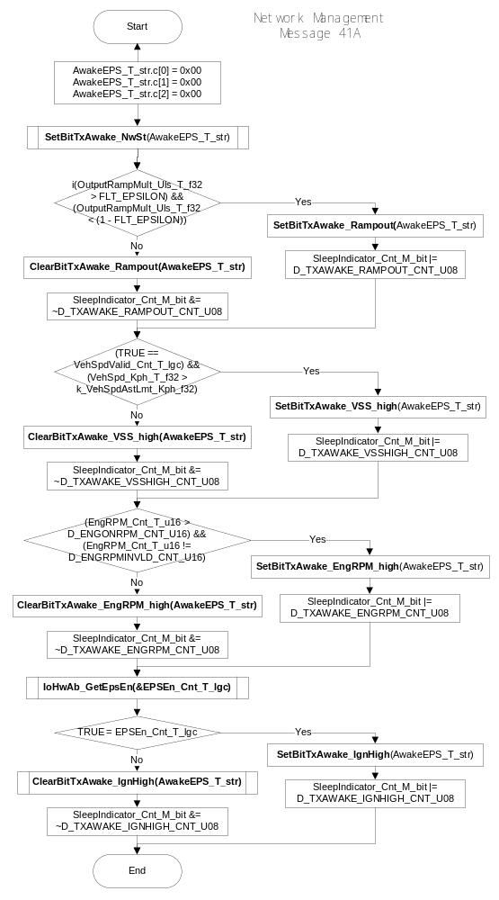
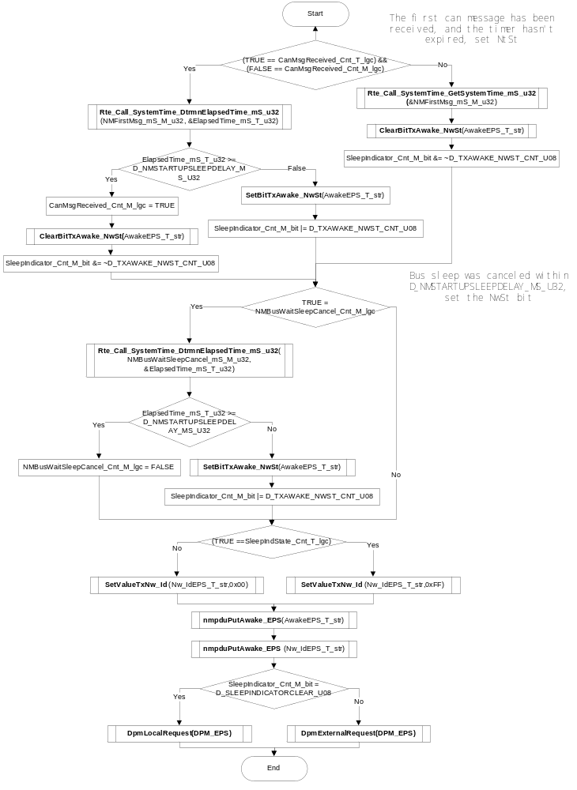

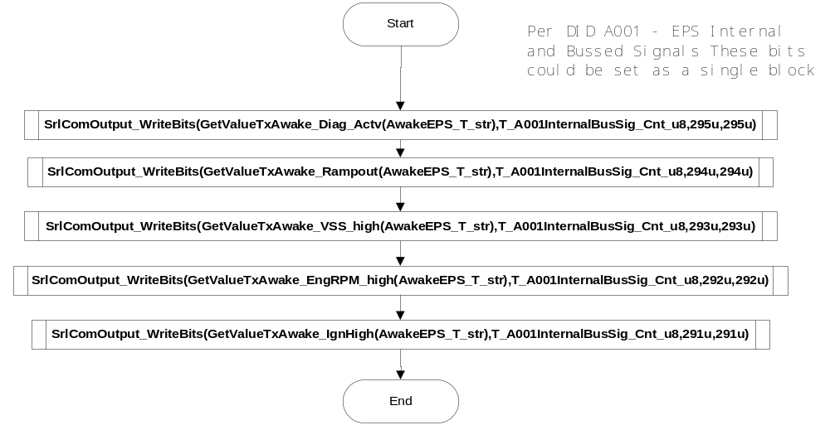

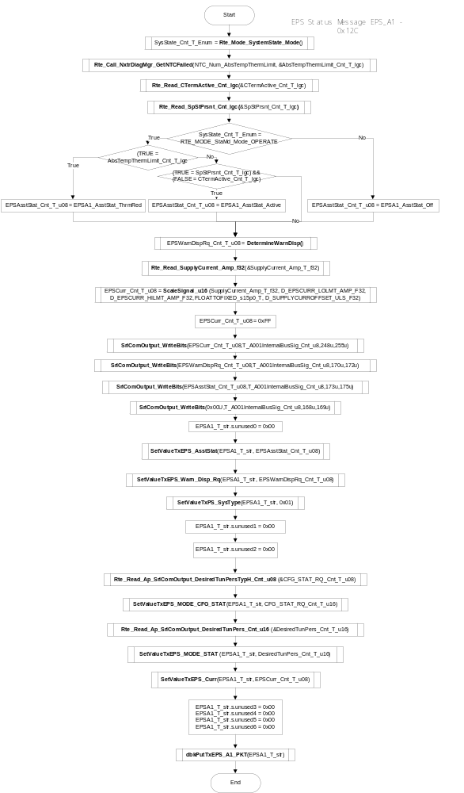
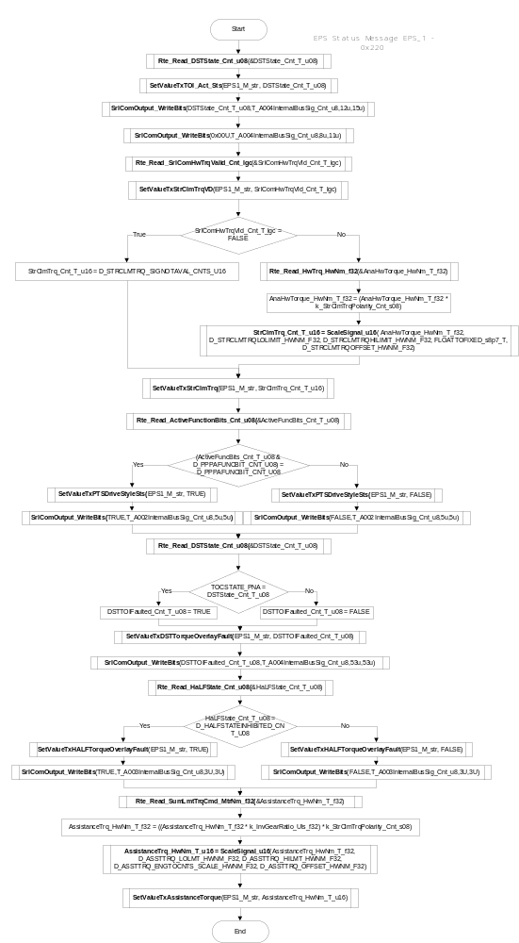
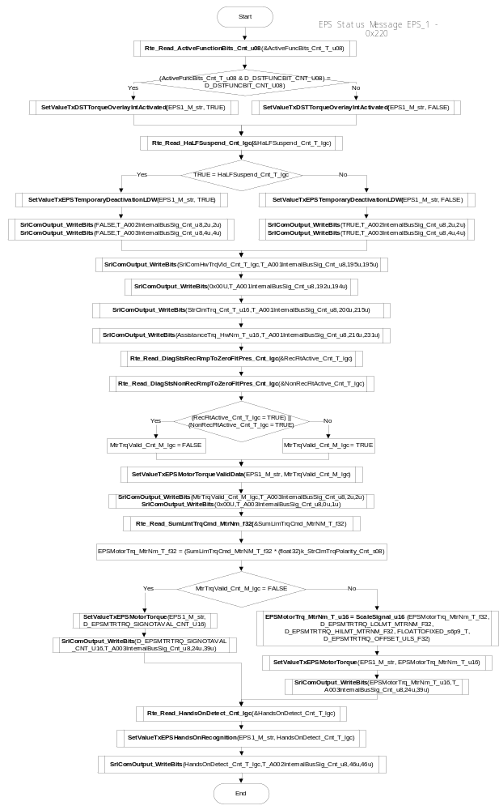

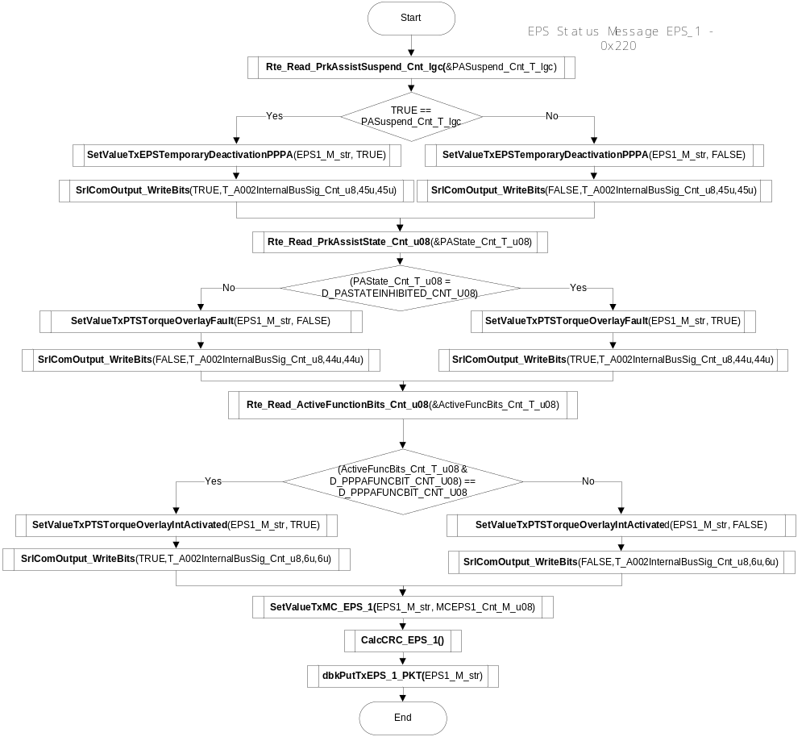

Store Local copy of outputs into Module Outputs
See section above.

Program Flow End
N/A

Fault Recovery Functions
None

Shutdown Functions
None

Interrupt Functions
None

Serial Communication Functions
None

Transition Functions

SrlComOutput_

Design Rationale

Program Flow Start
N/A

Store Module Inputs to Local copies
*See below

Description

Store Local copy of outputs into Module Outputs
See section above.

Program Flow End
N/A

Local Function/Macro Definitions
If these are numerous and defined in a separate source file then reference the source file only.

CalcCRC_EPS_1
Function Name | CalcCRC_EPS_1 | Type | Min | Max
Arguments Passed
Return Value

Description
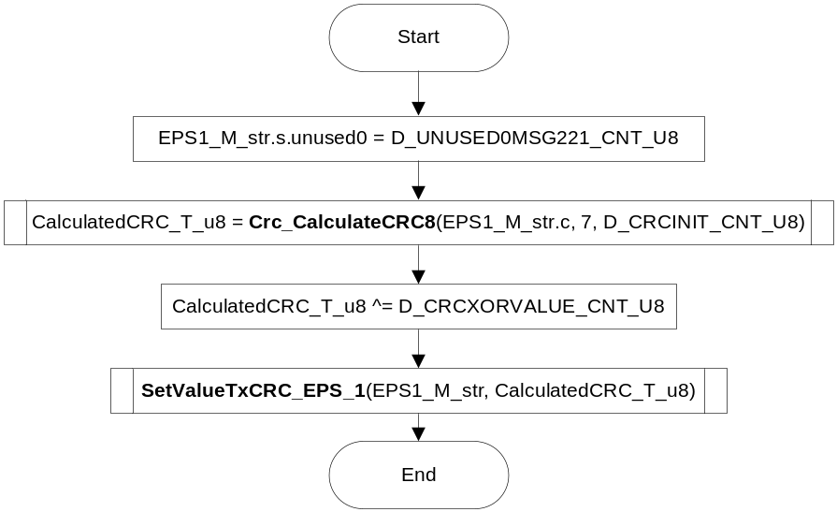

DetermineWarnDisp
Function Name | DetermineWarnDisp | Type | Min | Max
Arguments Passed
Return Value | FinalOutput_Cnt_T_u08 | uint8 | 0 | 7

Description

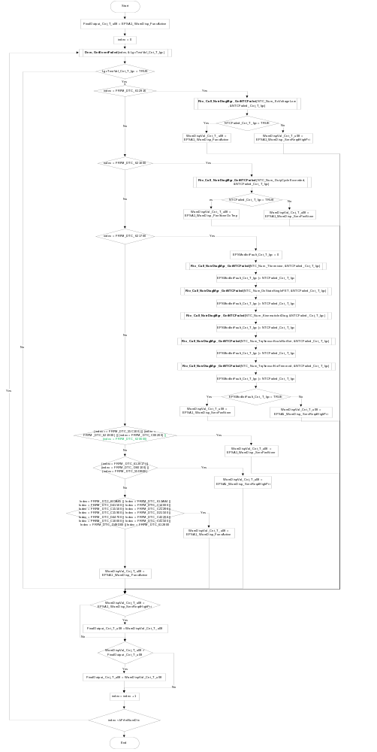

ScaleSignal_u16
Function Name | ScaleSignal_u16 | Type | Min | Max
Arguments Passed | Signal_Uls_T_f32 | float32 | Full | Full
 | LoLmt_Uls_T_f32 | float32 | Full | Full
 | HiLmt_Uls_T_f32 | float32 | Full | Full
 | Scale_Uls_T_f32 | float32 | Full | Full
 | Offset_Uls_T_f32 | float32 | Full | Full
Return Value | Signal_Cnt_T_u16 | Uint16 | 0 | Full

Description

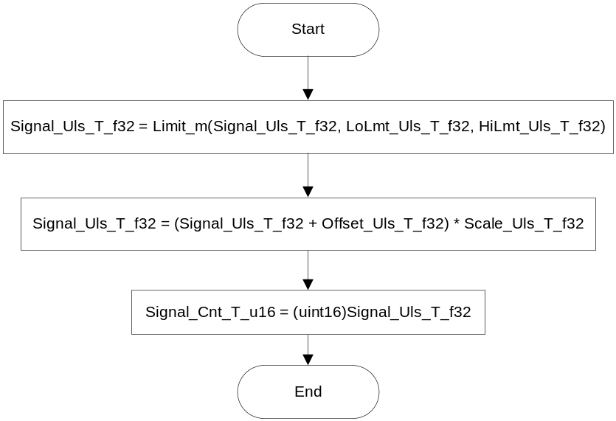

EPS1_PKTConfirmation
Function Name | EPS1_PKTConfirmation | Type | Min | Max
Arguments Passed
Return Value

Description

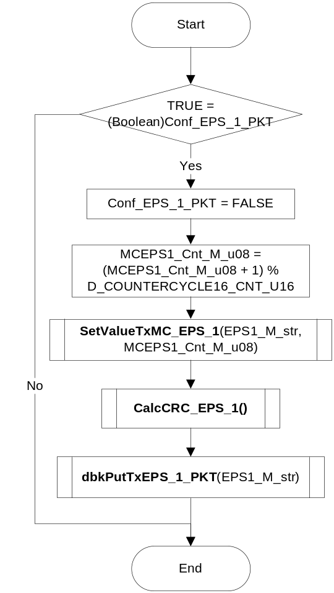

ApplCclComStart
Function Name | ApplCclComStart | Type | Min | Max
Arguments Passed
Return Value

Description

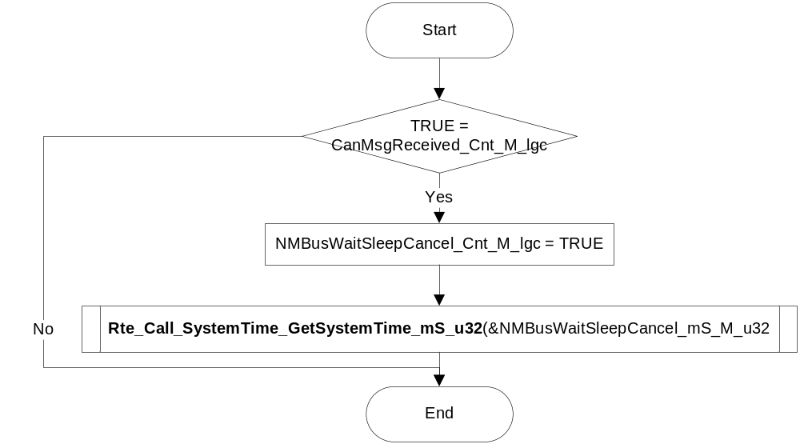

SrlComOutput_WriteBits
Function Name | SrlComOutput_WriteBits | Type | Min | Max
Arguments Passed | Data_T_Cnt_u32 | uint32 | Full | Full
 | Buffer_T_Cnt_u08 | uint8 | Full | Full
 | StartBit_Cnt_T_u16 | uint16 | Full | Full
 | EndBit_Cnt_T_u16 | uint16 | Full | Full
Return Value

Description

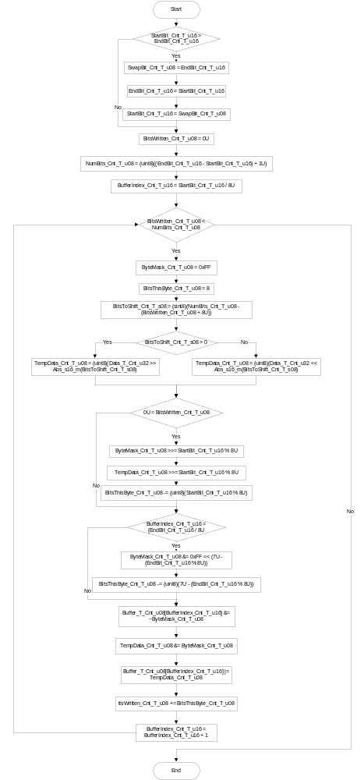

Execution Requirements

Execution Sequence of the Module
(Describe in words relevant details about the execution sequence of the different sub modules.)

Execution Rates for sub-modules called by the Scheduler
This table serves as reference for the Scheduler design
Function Name | Calling Frequency | System State(s) in which the function is called
SrlComOutput_Init1() | Once | START UP
SrlComOutput_Per1() | 10ms | WARM INIT, OPERATE, DISABLE

Execution Requirements for Serial Communication Functions
Function Name | Sub-Module called by (Serial Comm Function Name)
N/A

Memory Map Definition Requirements

Sub Modules (Functions)
This table identifies the software segments for functions identified in this module.
Name of Sub Module | Software Segment
SrlComOutput_Init1() | RTE_AP_SRLCOMOUTPUT_APPL_CODE
SrlComOutput_Per1() | RTE_AP_SRLCOMOUTPUT_APPL_CODE
SrlComOutput_Trns1() | RTE_AP_SRLCOMOUTPUT_APPL_CODE

Local Functions
This table identifies the software segments for local functions identified in this module.
Name of Sub Module | Software Segment
CalcCRC_EPS_1 () | AP_SRLCOMOUTPUT_CODE
DetermineWarnDisp | AP_SRLCOMOUTPUT_CODE
ScaleSignal_u16 | AP_SRLCOMOUTPUT_CODE
EPS1_PKTConfirmation | AP_SRLCOMOUTPUT_CODE
ApplCclComStart | AP_SRLCOMOUTPUT_CODE
SrlComOutput_WriteBits | RTE_AP_SRLCOMINPUT_APPL_CODE

Known Issues / Limitations With Design
- INLINE functions defined in “GlobalMacro.h” are not unit tested

Revision Control Log
Item # | Rev # | Change Description | Date | Author Initials
1 | 1.0 | Initial Version | 29May13 | M. Story
2 | 2.0 | Anomaly 5014 DetermineWarnDisp | 16JUN13 | M. Story
3 | 3.0 | Anomaly 5416 | 12AUG13 | M. Story
4 | 4.0 | Fully implemented A001 A002 A003 A004 | 13SEP13 | M. Story
5 | 5.0 | Changes for 01.00.01 version of CL | 30SEP13 | M. Story
6 | 6.0 | Changes for 01.00.03 version of CL | 25OCT13 | M. Story
7 | 7.0 | Changes for NM anomaly 5911 | 31OCT13 | M. Story
8 | 8.0 | Import prior changes to L path | 20NOV13 | M. Story
9 | 9.0 | Anomaly 6408 | 10APR14 | M. Story

