Module -- Hand Wheel Torque2626

High-Level Description
This function calculates the Hand Wheel Torque and performs the diagnostics on the Torque input signals T1 and T2.

Figures

Component Diagram

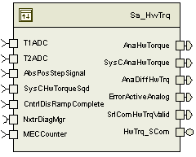

Variable Data Dictionary
For details on module input / output variable, refer to the Data Dictionary for the application. Input / output variable names are listed here for reference.
Module Inputs (Global Variable Name) | Module Outputs (Global Variable Name)
T1ADC_Volt_f32 | AnaHwTorque_HwNm_f32
T2ADC_Volt_f32 | SysCAnaHwTorque_HwNm_f32
SysCHwTorqueSqd_HwNmSq_f32 | AnaDiffHwTrq_HwNm_f32
AbsPosStepSignal_Cnt_u08 | SrlComHwTrqValid_Cnt_lgc
CntrlDisRampComplete_Cnt_lgc | ErrorActiveAnalog_Cnt_enum
MECCounter_Cnt_enum

Module Internal Variables
This section identifies the name, range and resolutions for module specific data created by this module. If there are no range restrictions on the variable, the term “FULL” is placed into the table for legal range.
Variable Name | Resolution | Legal Range  (min) | Legal Range  (max) | Software Segment
CorrDiagFiltOut_Volt_M_s4p11 | 2⁻¹¹ | -5.0 | 5.0 | HWTRQ_START_SEC_VAR_CLEARED_16
CorrDiagFiltSV_Volt_M_s4p27 | 2⁻¹¹ | -5.0 | 5.0 | HWTRQ_START_SEC_ VAR_SAVED_ZONEH_32
SSDiagFiltOut_Volt_M_s4p11 | 2⁻¹¹ | -5.0 | 5.0 | HWTRQ_START_SEC_VAR_CLEARED_16
SSDiagFiltSV_Volt_M_s4p27 | 2⁻²⁷ | -5.0 | 5.0 | HWTRQ_START_SEC_VAR_CLEARED_32
TDiagFiltOut_Volt_M_s4p11 | 2⁻¹¹ | -5.0 | 5.0 | HWTRQ_START_SEC_VAR_CLEARED_16
TDiagFiltSV_Volt_M_s4p27 | 2⁻²⁷ | -5.0 | 5.0 | HWTRQ_START_SEC_VAR_CLEARED_32
SumFltOut_Volt_M_u5p11 | 2⁻¹¹ | 0 | 5.0 | HWTRQ_START_SEC_VAR_CLEARED_16
T1RngErrAcc_Cnt_M_u16 | 1 | 0 | FULL | HWTRQ_START_SEC_VAR_CLEARED_16
T2RngErrAcc_Cnt_M_u16 | 1 | 0 | FULL | HWTRQ_START_SEC_VAR_CLEARED_16
AnaDiffHwTrq_Volt_M_f32 | Single Precision Floating Point | -5 | 5 | HWTRQ_START_SEC_VAR_CLEARED_32
AnaHwTorque_HwNm_M_f32 | Single Precision Float | -10 | 10 | HWTRQ_START_SEC_VAR_CLEARED_32
TrqSum_Volts_M_s4p11 | 2⁻¹¹ | -5.0 | 5.0 | HWTRQ_START_SEC_VAR_CLEARED_16
TrqSensorRecDiagAcc_Cnt_M_u16 | 1 | 0 | FULL | HWTRQ_START_SEC_VAR_CLEARED_16
NvMBlkStatus_Cnt_M_u8 | NvM_RequestResultType | N/A | N/A | HWTRQ_START_SEC_VAR_CLEARED_8
AnaHwTorqueSqd_HwNmSq_D_f32 | Single Precision Float | 0 | 100 | HWTRQ_START_SEC_VAR_CLEARED_32
HWTorqCorrLimDiff_HwNmSq_D_f32 | Single Precision Float | 0 | 100 | HWTRQ_START_SEC_VAR_CLEARED_32
HwTorqCh1vsCh2CorrLim_HwNmSq_D_f32 | Single Precision Float | 0 | 100 | HWTRQ_START_SEC_VAR_CLEARED_32

User defined typedef definition/declaration
This section documents any user types uniquely used for the module.
Typedef Name | Element Name | User Defined Type | Legal Range  (min) | Legal Range  (max)
HwTrqStatusType | HWTRQSTATUS_NONE = 0  HWTRQSTATUS_ACTIVE = 1  HWTRQSTATUS_FAULT = 2 | uint8 | 0 | 2
ManufModeType | ProductionMode = 0  ManufacturingMode = 1  EngineeringMode = 2 | Uint8 | 0 | 2

Constant Data Dictionary

Calibration Constants
This section lists the calibrations used by the module. For details on calibration constants, refer to the Data Dictionary for the application.
Constant Name
k_TbarStiff_NmpDeg_f32
k_HwTrqSclNom_VoltspDeg_f32
k_AnaRngDiag_Cnt_str
k_T1LowRange_Volts_f32
k_T1HghRange_Volts_f32
k_T2LowRange_Volts_f32
k_T2HghRange_Volts_f32
k_MaxTrqSumLmt_Volts_f32
t_TdiagFiltKnTbl_Cnt_u16[17]
t_TdiagIndptTbl_Volts_u5p11[17]
k_TdiagLim_Volts_u5p11
k_SSDiagKn_Cnts_u16
k_CorrDiagKn_Cnts_u16
k_TdiagCorrLim_Volts_u5p11
k_SSDiagLim_Volts_u5p11
k_CorrDiagFiltActiv_Volts_u5p11
k_MaxHwTrqTrim_Volts_f32
k_SumFiltRecLim_Volt_u5p11
k_SSFiltRecLim_Volt_u5p11
k_TrqFltRecLim_Cnt_u16
k_T1AccRecLim_Cnt_u16
k_T2AccRecLim_Cnt_u16
k_AnaT1T2ErrThreshold_Volts_u5p11
t_HwTorqCorrLimXAxis_HwNm_u4p12[]
t_HwTorqCorrLimYAxis_HwNmSq_u7p9[]
k_HwTorqCorrLimDiag_Cnt_str
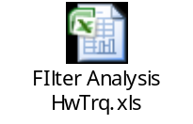

Program(fixed) Constants

Embedded Constants
All embedded constants whose values are provided in Eng units will be evaluated to the equivalent counts by using the FPM_InitFixedPoint_m() macro within the #define statement.

Local
Constant Name | Resolution | Value
D_HWTRQLOLMT_HWNM_F32 | Single Precision Floating Point | -10.0
D_HWTRQHILMT_HWNM_F32 | Single Precision Floating Point | 10.0
D_DFLTRTRQTRIM_VOLT_F32 | Single Precision Floating Point | 2.5
D_TRQSCALEWNDW_ULS_F32 | Single Precision Floating Point | 0.20
D_NTCFAILED_CNT_U08 | 1 | 0x01U
D_SSDIAGNFILTSVLMT_VOLT_S4P27 | 2⁻²⁷ | FPM_Fix_m((k_SSDiagLim_Volts_u5p11 + 1), u5p11_T, s4p27_T)
D_FAILEDANDFAILEDTHISOPCYCLE_CNT_U08 | 1 | 0x03
D_TESTNOTCOMPLETEDTHISOPCYCLE_CNT_U08 | 1 | 0x40
D_NUMTRQSTEP_CNT_U08 | 1 | 10

Global
This section lists the global constants used by the module. For details on global constants, refer to the Data Dictionary for the application.
Constant Name
D_FALSE_CNT_LGC
D_ZERO_ULS_F32
D_ZERO_CNT_U16
D_ZERO_CNT_U8

Module specific Lookup Tables Constants
Constant Name | Resolution | Value | Software Segment
None

Functions/Macros used by the Sub-Modules

Library Functions / Macros
The library functions / Macros that are called by the various sub modules are identified below,
- FPM_FixedToFloat_m()
- FPM_FloatToFixed_m()
- Limit_m()
- Abs_f32_m ()
- IntplVarXY_u16_u16Xu16Y_Cnt()
- LPF_SvUpdate_s16InFixKTrunc_m()
- LPF_OpUpdate_s16InFixKTrunc_m()
- DiagPStep_m()
- DiagNStep_m()
- DiagFailed_m()

Data Hiding Functions
The data hiding functions / macros used in this module are identified below,
- Rte_Pim_HwTrqTrimData()
- Rte_Pim_HwTrqScaleData()
- Rte_Pim_EOLTrqStepData()
- Rte_Call_NxtrDiagMgr_SetNTCStatus()
- Rte_Call_HwTrqTrim_WriteBlock()
- Rte_Call_HwTrqScale_WriteBlock()
- Rte_Call_NxtrDiagMgr_GetNTCFailed()
- Rte_Call_NxtrDiagMgr_ResetEventStatus()
- Rte_Call_HwTrqTrim_GetErrorStatus()

Local Functions/Macros Used by this MDD only
The local functions/macros in this module are identified below,
- IsTrqScaleInRng_lgc()
- TrqTrimPerfDiag()

Software Module Implementation

Initialization Functions

Init: HwTrq_Init

Design Rationale
None

Check Faults and Initialize Filters
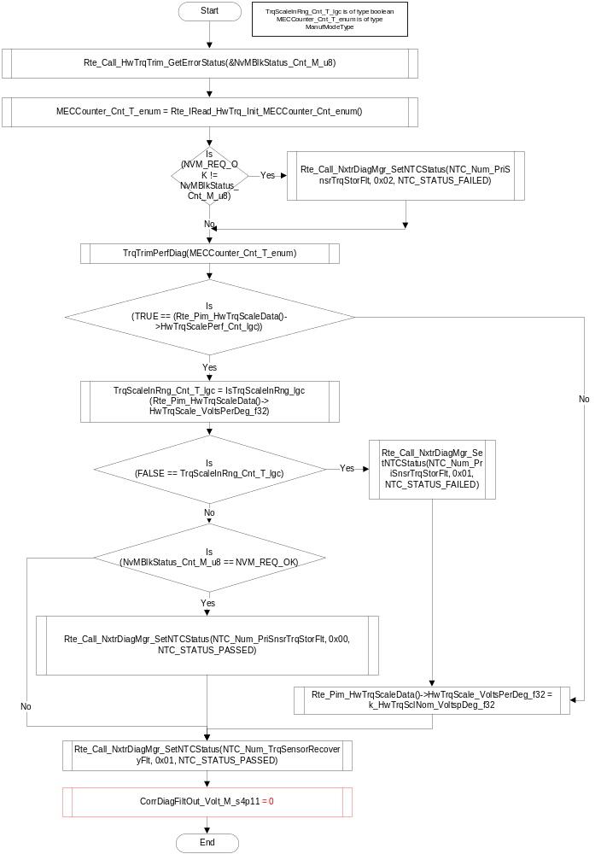

Periodic Functions

Per: HwTrq_Per1

Design Rationale
None

Program Flow Start
Rte_Call_HwTrq_Per1_CP0_CheckpointReached()

Store Module Inputs to Local copies
AbsPosStepSignal_Cnt_T_u08 = Rte_IRead_HwTrq_Per1_AbsPosStepSignal_Cnt_u08()
Torque1_Volt_T_f32 = Rte_Iread_HwTrq_Per1_T1ADC_Volt_f32()
Torque2_Volt_T_f32 = Rte_Iread_HwTrq_Per1_T2ADC_Volt_f32()

Rte_Call_NxtrDiagMgr_GetNTCStatus(NTC_Num_TrqSensorRecoveryFlt, &DiagTrqRecvStatus_Cnt_T_u08)
Rte_Call_NxtrDiagMgr_GetNTCStatus(NTC_Num_T1OutofRange, &DiagT1OutofRangeStatus_Cnt_T_u08)
Rte_Call_NxtrDiagMgr_GetNTCStatus(NTC_Num_T2OutofRange, &DiagT2OutofRangeStatus_Cnt_T_u08)
Rte_Call_NxtrDiagMgr_GetNTCStatus(NTC_Num_T1vsT2, &DiagT1vsT2Status_Cnt_T_u08)
Rte_Call_NxtrDiagMgr_GetNTCStatus(NTC_Num_TrqSensorNotTrimmed, &DiagTrqTrimNotPerfStatus_Cnt_T_u08)
Rte_Call_NxtrDiagMgr_GetNTCStatus(NTC_Num_PriSnsrTrqStorFlt, &DiagTrqTrimInvalidStatus_Cnt_T_u08)
AbsPosStepSignal_Cnt_T_u08 = Limit_m(AbsPosStepSignal_Cnt_T_u08, D_ZERO_CNT_U8, D_NUMTRQSTEP_CNT_U08 - 1U)

Calculate Handwheel Torque and SCom Validity
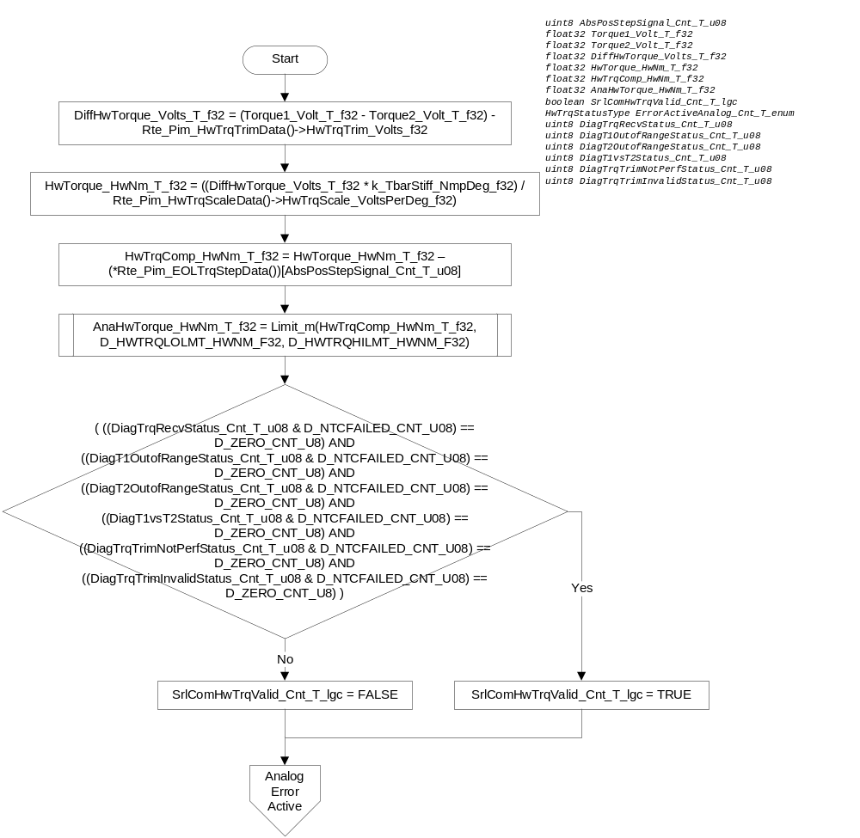

Analog Error Active
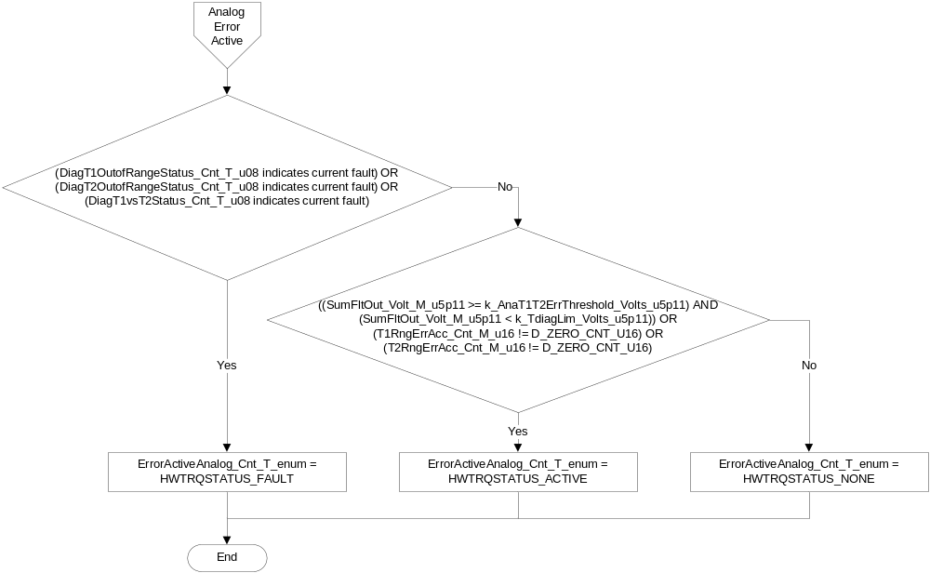

Store Local copy of outputs into Module Outputs
AnaDiffHwTrq_Volt_M_f32 = DiffHwTorque_Volts_T_f32
AnaHwTorque_HwNm_M_f32 = AnaHwTorque_HwNm_T_f32
Rte_IWrite_HwTrq_Per1_AnaDiffHwTrq_Volt_f32(DiffHwTorque_Volts_T_f32)
Rte_Iwrite_HwTrq_Per1_AnaHwTorque_HwNm_f32(AnaHwTorque_HwNm_T_f32)
Rte_IWrite_HwTrq_Per1_SysCAnaHwTorque_HwNm_f32(AnaHwTorque_HwNm_T_f32)
Rte_IWrite_HwTrq_Per1_ErrorActiveAnalog_Cnt_enum(ErrorActiveAnalog_Cnt_T_enum)
Rte_Iwrite_HwTrq_Per1_SrlComHwTrqValid_Cnt_lgc(SrlComHwTrqValid_Cnt_T_lgc)

Program Flow End
Rte_Call_HwTrq_Per1_CP1_CheckpointReached()

Per: HwTrq_Per2

Design Rationale
None

Program Flow Start
Rte_Call_HwTrq_Per2_CP0_CheckpointReached()

Store Module Inputs to Local copies
CntrlDisRampComplete_Cnt_T_lgc = Rte_IRead_HwTrq_Per2_CntrlDisRampComplete_Cnt_lgc()
SysCHwTorqueSqd_HwNmSq_T_f32 = Rte_IRead_HwTrq_Per2_SysCHwTorqueSqd_HwNmSq_f32()
Torque1_Volt_T_f32 = Rte_Iread_HwTrq_Per2_T1ADC_Volt_f32()
Torque2_Volt_T_f32 = Rte_Iread_HwTrq_Per2_T2ADC_Volt_f32()
T1Trim_Volt_T_f32 = Rte_Pim_HwTrqTrimData()->T1Trim_Volts_f32
T2Trim_Volt_T_f32 = Rte_Pim_HwTrqTrimData()->T2Trim_Volts_f32

T1 & T2 Out of Range
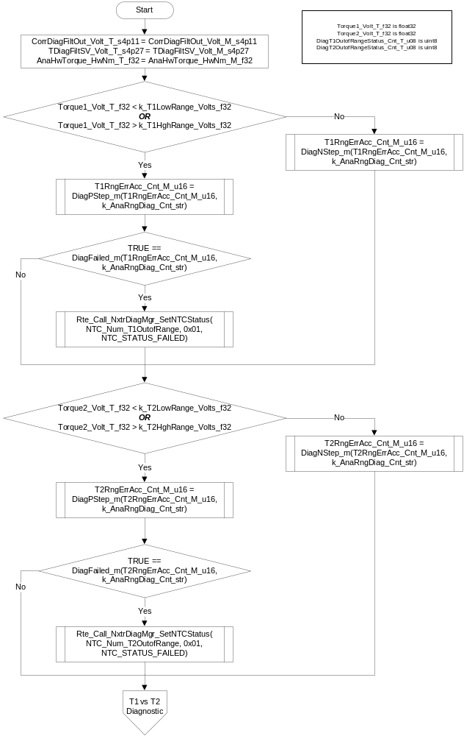

T1 vs T2 Diagnostic
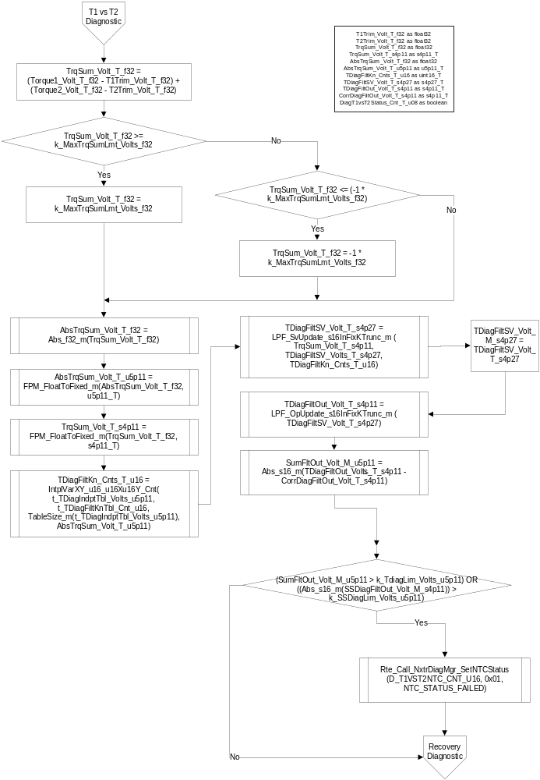

Torque Recovery Diagnostic
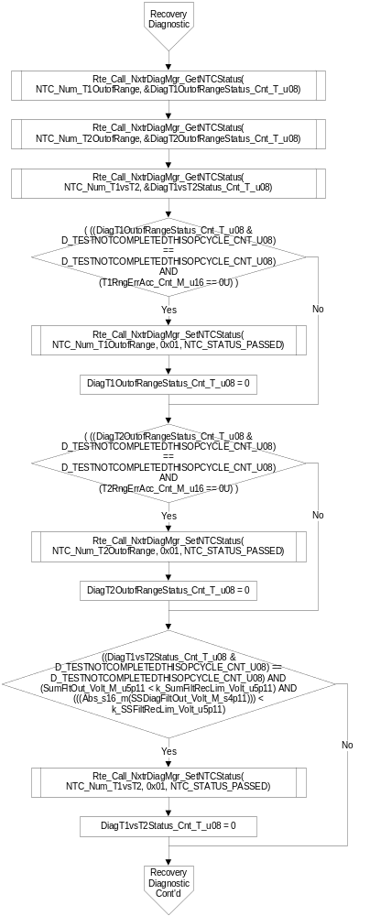
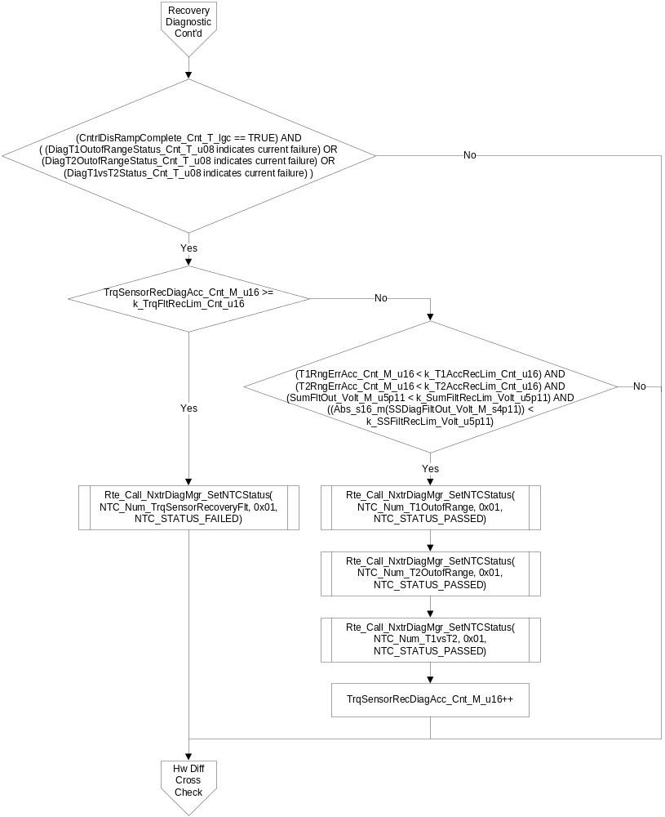

Handwheel Diff Torque Cross Check
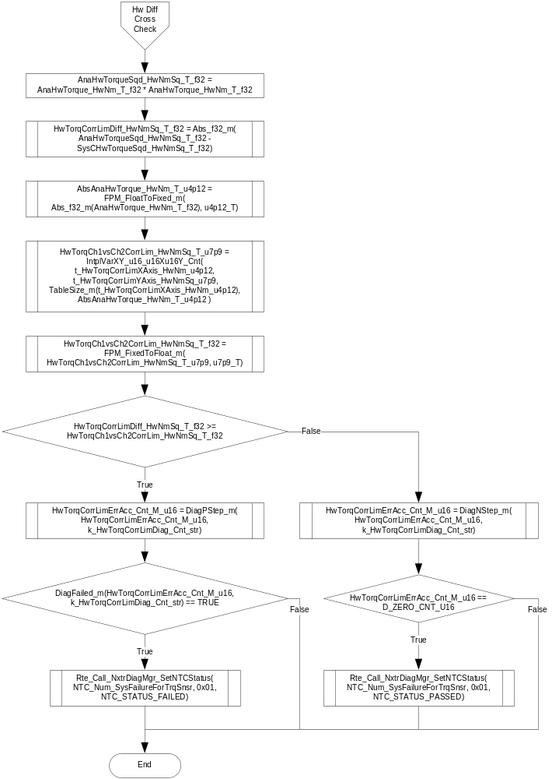

Store Local copy of outputs into Module Outputs
TrqSum_Volt_M_s4p11 = TrqSum_Volt_T_s4p11
TDiagFiltOut_Volt_M_s4p11 = TDiagFiltOut_Volt_T_s4p11
AnaHwTorqueSqd_HwNmSq_D_f32 = AnaHwTorqueSqd_HwNmSq_T_f32
HWTorqCorrLimDiff_HwNmSq_D_f32 = HwTorqCorrLimDiff_HwNmSq_T_f32
HwTorqCh1vsCh2CorrLim_HwNmSq_D_f32 = HwTorqCh1vsCh2CorrLim_HwNmSq_T_f32

Program Flow End
Rte_Call_HwTrq_Per2_CP1_CheckpointReached()

Per: HwTrq_Per3

Design Rationale
None

Program Flow Start
Rte_Call_HwTrq_Per3_CP0_CheckpointReached()

Store Module Inputs to Local copies
None

T1 Vs T2 Diagnostic
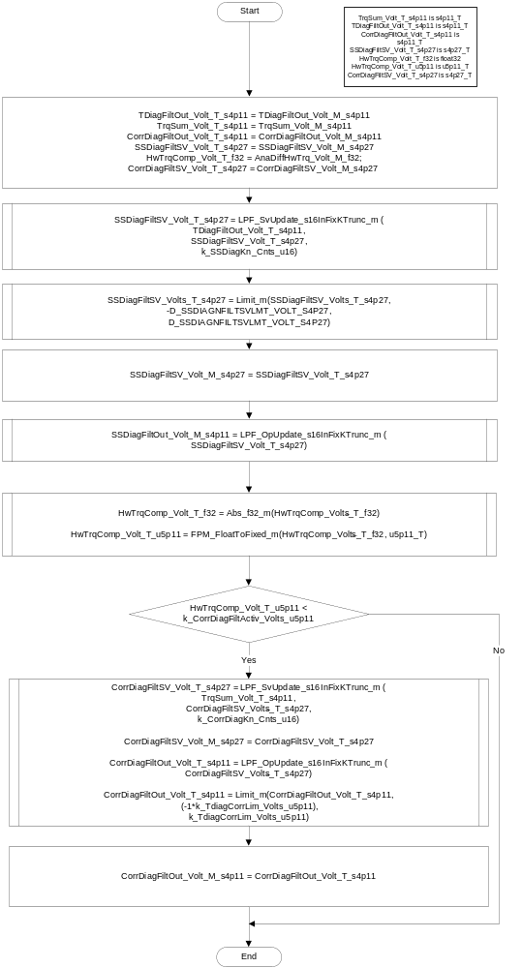

Store Local copy of outputs into Module Outputs

Program Flow End
Rte_Call_HwTrq_Per3_CP1_CheckpointReached()

Serial Communication Functions

Scomm: HwTrq_Scom_ClrHwTrqScale

Design Rationale
None

Program Flow Start
N/A

Store Module Inputs to Local copies

Clear Handwheel Torque Scale Service
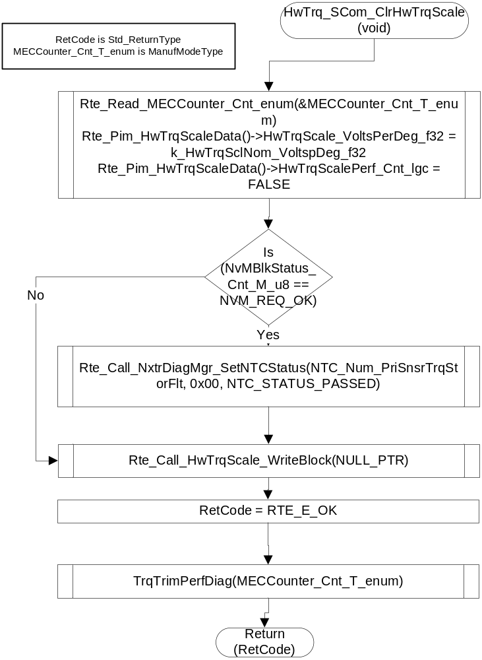

Store Local copy of outputs into Module Outputs
None

Program Flow End
N/A

Scomm: HwTrq_Scom_ClrHwTrqTrim

Design Rationale
None

Program Flow Start
N/A

Store Module Inputs to Local copies

Clear Handwheel Torque Trim Service

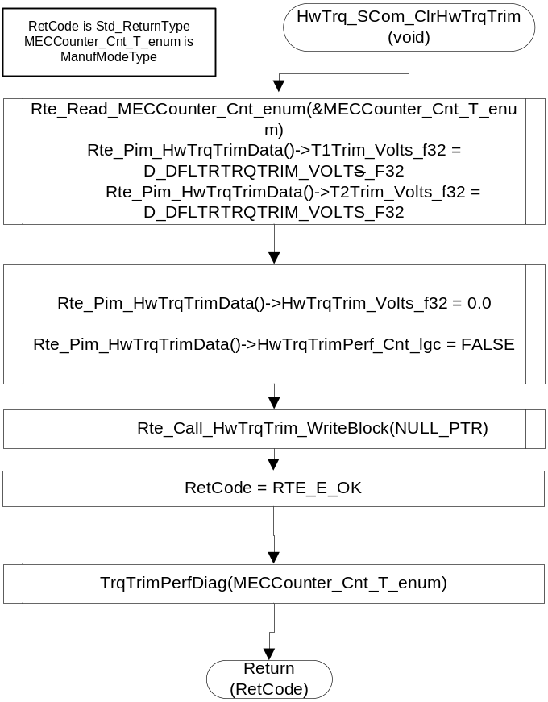

Store Local copy of outputs into Module Outputs
None

Program Flow End
N/A

Scomm: HwTrq_Scom_ReadHwTrqScale

Design Rationale
None

Program Flow Start
N/A

Store Module Inputs to Local copies
None

Read Handwheel Torque Scale Service
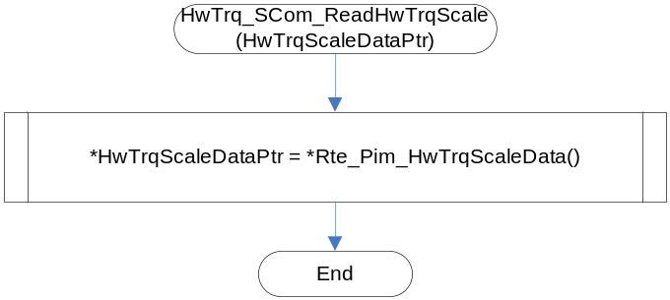

Store Local copy of outputs into Module Outputs
None

Program Flow End
N/A

Scomm: HwTrq_Scom_ReadHwTrqTrim

Design Rationale
None

Program Flow Start
N/A

Store Module Inputs to Local copies
None

Read Handwheel Torque Trim Service
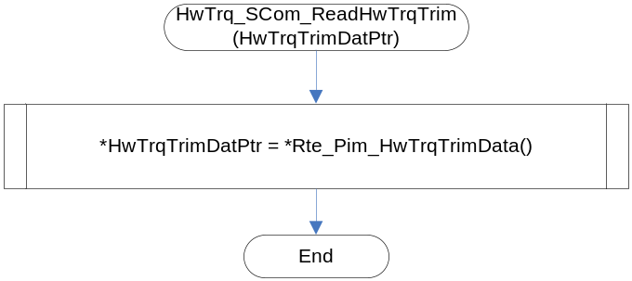

Store Local copy of outputs into Module Outputs
None

Program Flow End
N/A

Scomm: HwTrq_Scom_SetHwTrqScale

Design Rationale
None

Program Flow Start
N/A

Store Module Inputs to Local copies
None

Set Handwheel Torque Scale Service
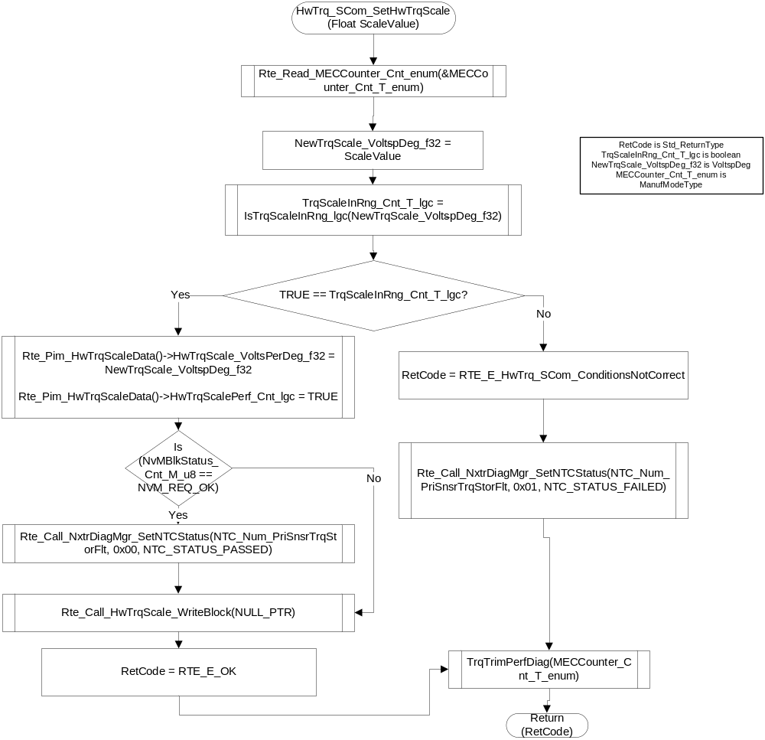

Store Local copy of outputs into Module Outputs
None

Program Flow End
N/A

Scomm: HwTrq_Scom_SetHwTrqTrim

Design Rationale
None

Program Flow Start
N/A

Store Module Inputs to Local copies
Rte_Read_T1ADC_Volt_f32(&Torque1_Volt_T_f32)
Rte_Read_T2ADC_Volt_f32(&Torque2_Volt_T_f32)
Rte_Read_MECCounter_Cnt_enum(&MECCounter_Cnt_T_enum)

Set Handwheel Torque Trim Service
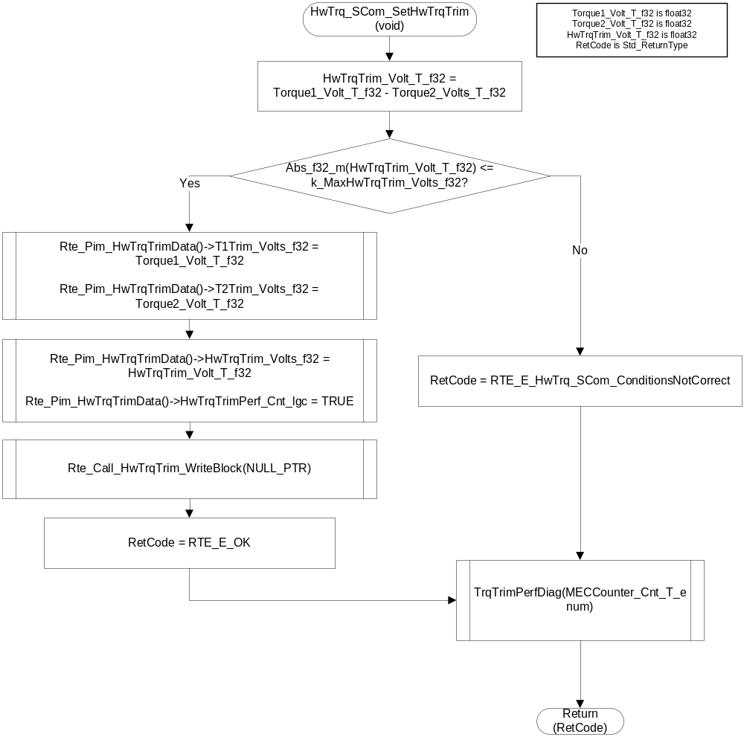

Store Local copy of outputs into Module Outputs
None

Program Flow End
N/A

Manual Set Hand wheel Torque Trim

Description

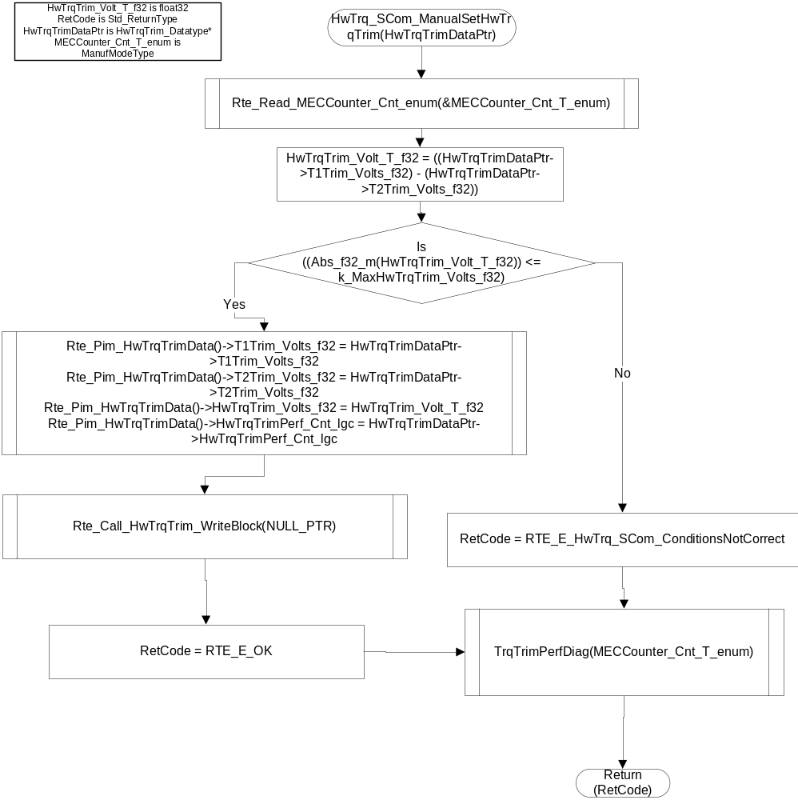

Scomm: HwTrq_SCom_ReadEOLTrqStep
 |  | Type | Min | Max | UTP Tol.
Arguments Passed | TrqStep_HwNm_T_f32 | float * (array of 10 float values) | -10 | 10
Return Value | None

Description
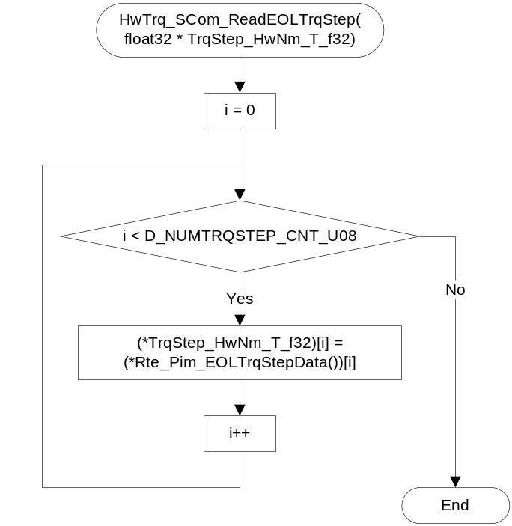

Scomm: HwTrq_SCom_SetEOLTrqStep
 |  | Type | Min | Max | UTP Tol.
Arguments Passed | TrqStep_HwNm_T_f32 | float * (array of 10 float values) | -10 | 10
Return Value | None

Description
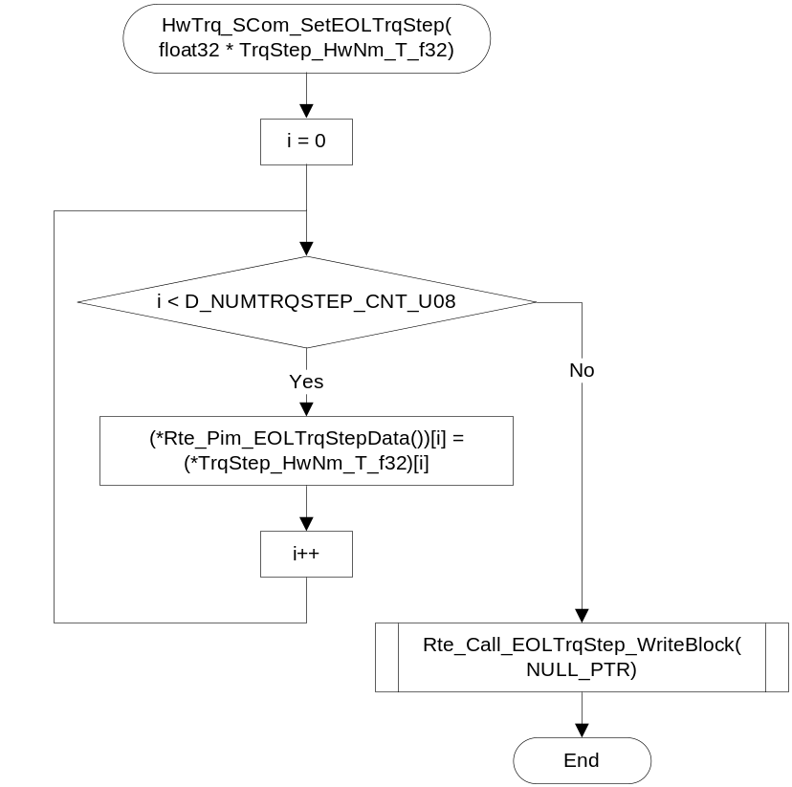

Local Function/Macro Definitions
If these are numerous and defined in a separate source file then reference the source file only.

Is Torque Scale In Range Check
Function Name | IsTrqScaleInRng_lgc | Type | Min | Max | UTP Tol.
Arguments Passed | TrqScale_VoltspDeg_T_f32 | Single Precision Floating Point | 0 | FULL
Return Value | TrqSclInRng_Cnt_T_lgc | BOOLEAN | N/A | N/A

Description
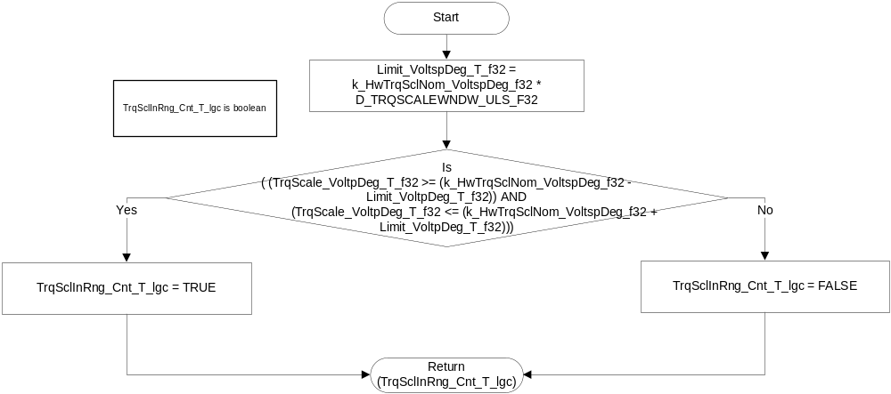

Torque Trim Performance Diagnostic
Function Name | TrqTrimPerfDiag | Type | Min | Max | UTP Tol.
Arguments Passed | MECCounter_Cnt_T_enum | ManufModeType | N/A | N/A
Return Value | None

Description
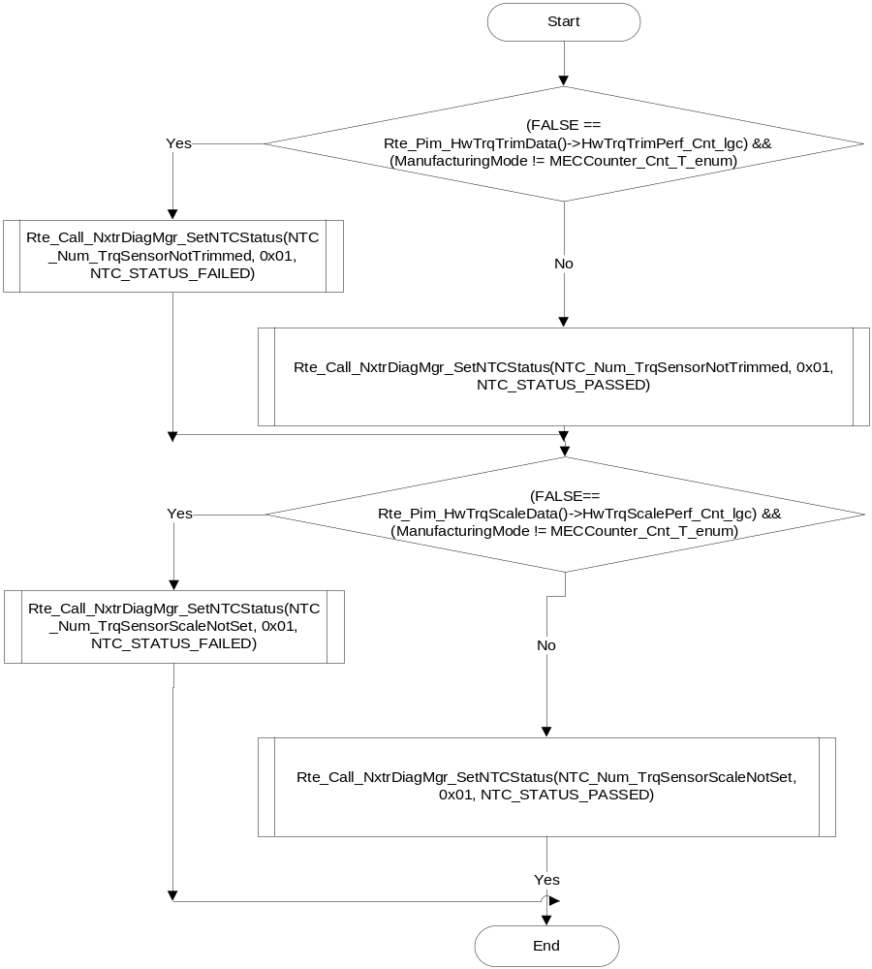

Execution Requirements

Execution Rates for sub-modules called by the Scheduler
This table serves as reference for the Scheduler design
Function Name | Calling Frequency | System State(s)
HwTrq_Init | Once at Initialization | STARTUP
HwTrq_Per1 | 2ms | WARM INIT, OPERATE, DISABLE
HwTrq_Per2 | 4ms | WARM INIT, OPERATE, DISABLE
HwTrq_Per3 | 100ms | WARM INIT, OPERATE, DISABLE

Execution Requirements for Serial Communication Functions
Function Name | Sub-Module called by (Serial Comm Function Name)
HwTrq_Scom_ClrHwTrqScale() | EPSInternalPIDWrite(),EPSInternalRoutineControl()
HwTrq_Scom_ClrHwTrqTrim() | EPSInternalRoutineControl()
HwTrq_Scom_ReadHwTrqScale() | EPSInternalPIDRead()
HwTrq_Scom_ReadHwTrqTrim() | EPSInternalPIDRead()
HwTrq_Scom_SetHwTrqScale() | EPSInternalPIDWrite()
HwTrq_Scom_SetHwTrqTrim() | EPSInternalRoutineControl()
HwTrq_SCom_ManualSetHwTrqTrim
HwTrq_SCom_ReadEOLTrqStep
HwTrq_SCom_SetEOLTrqStep

Memory Map Definition Requirements

Sub Modules (Functions)
This table identifies the software segments for functions identified in this module.
Name of Sub Module | Software Segment
HwTrq_Init() | RTE_SA_HWTRQ_APPL_CODE
HwTrq_Per1() | RTE_SA_HWTRQ_APPL_CODE
HwTrq_Per2() | RTE_SA_HWTRQ_APPL_CODE
HwTrq_Per3() | RTE_SA_HWTRQ_APPL_CODE
HwTrq_Scom_ClrHwTrqScale() | RTE_SA_HWTRQ_APPL_CODE
HwTrq_Scom_ClrHwTrqTrim() | RTE_SA_HWTRQ_APPL_CODE
HwTrq_Scom_ReadHwTrqScale() | RTE_SA_HWTRQ_APPL_CODE
HwTrq_Scom_ReadHwTrqTrim() | RTE_SA_HWTRQ_APPL_CODE
HwTrq_Scom_SetHwTrqScale() | RTE_SA_HWTRQ_APPL_CODE
HwTrq_Scom_SetHwTrqTrim() | RTE_SA_HWTRQ_APPL_CODE
HwTrq_Scom_ManualSetHwTrqTrim | RTE_SA_HWTRQ_APPL_CODE
HwTrq_SCom_ReadEOLTrqStep | RTE_SA_HWTRQ_APPL_CODE
HwTrq_SCom_SetEOLTrqStep | RTE_SA_HWTRQ_APPL_CODE

Local Functions
This table identifies the software segments for local functions identified in this module.
Name of Sub Module | Software Segment
IsTrqScaleInRng_lgc() | RTE_SA_HWTRQ_APPL_CODE
TrqTrimPerfDiag() | RTE_SA_HWTRQ_APPL_CODE

Known Issues / Limitations With Design

INLINE functions defined in globalmacro.h are not unit tested

Revision Control Log
Rev # | Change Description | Date | Author Initials
1.0 | Initial AutoSAR Release. | 04FEB11 | L.N.
2.0 | Rte_Call_CorrDiagFiltSV_SetRamBlockStatus() added in Init() and Cross Check Diag Support Added | 03May11 | N.R.A.R
3.0 | Updated for anomaly 3258 | 17JUN11 | LWW
4.0 | Removed Cross Check Diag Support | 20JUL11 | LWW
5.0 | Changes as per FDD #04 rev008 | 22Nov11 | VK
5.1 | Changes to Scom functions passing a null pointer instead of Boolean flag for the writeblock Rte call. Changed SumFltOut_Volt_M_u5p11 and SSDiagFiltOut_Volt_M_s4p11 to display variables | 2Dec11 | VK
6 | Per3 trigger rate moved to 100ms from 128ms  Removed residual periodic specifiations | 5Dec11 | JJW
7 | Corrected GetNTCFailed RTE call arguments in Per1 | 5Dec11 | VK
8 | Changed HwTrqScaleStatus, HwTrqTrimStatus to boolean | 13Dec11 | VK
9 | Matched the names of the elements in HwTrqScale_Datatype and HwTrqTrim_Datatype as in digital hw torque | 14Dec11 | VK
10 | Corrected Rte read for MEC | 14Dec11 | VK
11 | Updated Argument to Set Scale function to match DigHwTrq | 15Dec11 | OT
12 | Fixed scale validity check logic | 16Dec11 | OT
13 | Fixed NTC_STATUS_PASSED path anomaly, added error accumulator macros | 1Feb12 | OT
14 | Fixed previous NTC_STATUS_PASSED anomaly fix, changed diff torque limit | 5Mar12 | OT
15 | Added manual write scom function for torque trim block, removed MEC | 20 Apr 12 | VK
16 | Updated NTC's NTC_Num_TrqSensorScaleInvalid and NTC_Num_EEPROMDiagTrqSnrStr with NTC_Num_PriSnsrTrqStorFlt and logic to clear the fault | 21-Apr-12 | VK
17 | Changes to HwTrq_SCom_ManualSetHwTrqTrim to match the name of the argument being passed. Changes to Per1 updating DiagTrqTrimInvalid_Cnt_T_lgc | 23-Apr-12 | VK
18 | Removal of polarity input (not called out in FDD) | 27-Apr-12 | LWW
19 | Updated to FDD 04A v005 | 06-Jun-12 | OT
20 | Updated to FDD 04A v006 | 14-Jun-12 | JWJ
21 | Removed double de-reference from EOLTrqStepData pointers in Per1 and Scom functions. | 17-Jun-12 | KJS
22 | Brought in Nexteer MEC Counter | 23-Aug-12 | VK
23 | Added double de-reference to EOLTrqStepData pointers in Per1 and Scom functions. | 04-Sep-12 | VK
24 | MDD, Src mismatch corrections | 10-Sep-12 | VK
25 | Added checkpoints and memmap software segment is updated for static variables | 27-Sep-12 | Selva
26 | Implemented FDD 04A v007 | 12-Oct-12 | OT
27 | Anomaly 2824 – T1 vs T2 comparison cal usage | 24-Oct-12 | OT
27.1.1 | Anomaly 4683 Correction | 25-Mar-13 | LWW

