Module – Limiter Conditioning

High-Level Description
This MDD describes the summation of all assist and limit terms used in an Electric Power Steering application.

Figures

Diagram – Component Diagram

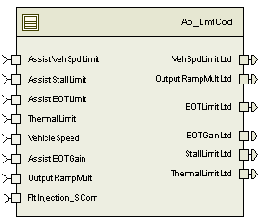

Variable Data Dictionary
For details on module input / output variable, refer to the Data Dictionary for the application. Input / output variable names are listed here for reference.
Module Inputs | Module Outputs
AssistEOTGain_Uls_f32 |  | EOTGainLtd_Uls_f32
AssistEOTLimit_MtrNm_f32 |  | EOTLimitLtd_MtrNm_f32
AssistStallLimit_MtrNm_f32 |  | OutputRampMultLtd_Uls_f32
AssistVehSpdLimit_MtrNm_f32 |  | StallLimitLtd_MtrNm_f32
OutputRampMult_Uls_f32 |  | ThermalLimitLtd_MtrNm_f32
ThermalLimit_MtrNm_f32 |  | VehSpdLimitLtd_MtrNm_f32
VehicleSpeed_Kph_f32

Module Internal Variables
This section identifies the name, range and resolutions for module specific data created by this module. If there are no range restrictions on the variable, the term “FULL” is placed into the table for legal range.
Variable Name | Resolution | Legal Range  (min) | Legal Range  (max) | Software Segment
CurrAssistEOTGain_Uls_M_f32 | Single Precision Float | 0 | 1 | LMTCOD_START_SEC_VAR_CLEARED_32
CurrOutputRampMult_Uls_M_f32 | Single Precision Float | 0 | 1 | LMTCOD_START_SEC_VAR_CLEARED_32
CurrAssistEOTLimit_MtrNm_M_f32 | Single Precision Float | 0 | 8.8 | LMTCOD_START_SEC_VAR_CLEARED_32
CurrAssistStallLimit_MtrNm_M_f32 | Single Precision Floating Point | 0 | 8.8 | LMTCOD_START_SEC_VAR_CLEARED_32
CurrAssistVehSpdLimit_MtrNm_M_f32 | Single Precision Floating Point | 0 | 8.8 | LMTCOD_START_SEC_VAR_CLEARED_32
CurrThermalLimit_MtrNm_M_f32 | Single Precision Floating Point | 0 | 8.8 | LMTCOD_START_SEC_VAR_CLEARED_32

User defined typedef definition/declaration
This section documents any user types uniquely used for the module.
Typedef Name | Element Name | User Defined Type | Legal Range  (min) | Legal Range  (max)
None

Constant Data Dictionary

Calibration Constants
This section lists the calibrations used by the module. For details on calibration constants, refer to the Data Dictionary for the application.
Constant Name
k_GainDecSlew_UlspS_f32
k_TorqueDecSlew_MtrNmpS_f32
t_GainIncSlewTblX_Kph_u9p7[2]
t_GainIncSlewTblY_UlspS_u9p7[2]
t_TorqueIncSlewTblX_Kph_u9p7[2]
t_TorqueIncSlewTblY_MtrNmpS_u13p3[2]

Program(fixed) Constants

Embedded Constants
All embedded constants whose values are provided in Eng units will be evaluated to the equivalent counts by using the FPM_InitFixedPoint_m() macro within the #define statement.

Local
Constant Name | Resolution | Units | Value

Global
This section lists the global constants used by the module. For details on global constants, refer to the Data Dictionary for the application.
Constant Name
D_2MS_SEC_F32
FLTINJ_ASSTEOTGAIN_LMTCOD
FLTINJ_OUTPUTRAMPMULT_LMTCOD
FLTINJ_ASSTEOTLIMIT_LMTCOD
BC_LMTRCONDN_FAULTINJECTIONPOINT

Module specific Lookup Tables Constants
(This is for lookup tables (arrays) with fixed values, same name as other tables)
Constant Name | Resolution | Value | Software Segment
None

Functions/Macros used by the Sub-Modules

Library Functions / Macros
The library and functions / Macros that are called by the various sub modules are identified below,
- Limit_m()
- Sign_f32_m()
- Min_m()
- Max_m()
- Abs_f32_m()
- IntplVarXY_u16_u16Xu16Y_Cnt()
- FPM_FloatToFixed_m()
- FPM_FixedToFloat_m()

Data Hiding Functions
- N/A

Global Functions/Macros Defined by this Module
N/A

Local Functions/Macros Used by this MDD only
N/A

Software Module Implementation

Runtime Environment (RTE) Initial Values
This section lists the initial values of data written by this module but controlled by the RTE. After RTE initialization, the data in this table will contain these values.
Data | Value
Rte_InitValue_AssistEOTGain_Uls_f32 | 1
Rte_InitValue_AssistEOTLimit_MtrNm_f32 | 8.8
Rte_InitValue_AssistStallLimit_MtrNm_f32 | 8.8
Rte_InitValue_AssistVehSpdLimit_MtrNm_f32 | 8.8
Rte_InitValue_OutputRampMult_Uls_f32 | 0
Rte_InitValue_ThermalLimit_MtrNm_f32 | 8.8
Rte_InitValue_EOTGainLtd_Uls_f32 | 1
Rte_InitValue_EOTLimitLtd_MtrNm_f32 | 8.8
Rte_InitValue_OutputRampMultLtd_Uls_f32 | 0
Rte_InitValue_StallLimitLtd_MtrNm_f32 | 8.8
Rte_InitValue_ThermalLimitLtd_MtrNm_f32 | 8.8
Rte_InitValue_VehSpdLimitLtd_MtrNm_f32 | 8.8
Rte_InitValue_VehicleSpeed_Kph_f32 | 0.0

Initialization Functions
N/A

Periodic Functions

Per: LmtCod_Per1

Design Rationale
This function provides a layer of protection from erroneous signals feeding into SF-04 Sum & Limit. It is applied primarily to “Limiting” signals that serve to reduce motor torque command under certain operating conditions. This function can prevent step response or “toggling” behavior that might cause undesirable vehicle feel. It includes capability of fault injection at some inputs to facilate tuning. See FDD SF-38 for more details.

Program Flow Start
Rte_Call_LmtCod_Per1_CP0_CheckpointReached()

Store Module Inputs to Local copies
Local Copy | Module Input Name
AssistEOTGain_Uls_T_f32 | Rte_IRead_LmtCod_Per1_AssistEOTGain_Uls_f32
AssistEOTLimit_MtrNm_T_f32 | Rte_IRead_LmtCod_Per1_AssistEOTLimit_MtrNm_f32
AssistStallLimit_MtrNm_T_f32 | Rte_IRead_LmtCod_Per1_AssistStallLimit_MtrNm_f32
AssistVehSpdLimit_MtrNm_T_f32 | Rte_IRead_LmtCod_Per1_AssistVehSpdLimit_MtrNm_f32
OutputRampMult_Uls_T_f32 | Rte_IRead_LmtCod_Per1_OutputRampMult_Uls_f32
ThermalLimit_MtrNm_T_f32 | Rte_IRead_LmtCod_Per1_ThermalLimit_MtrNm_f32
VehicleSpeed_Kph_T_f32 | Rte_IRead_LmtCod_Per1_VehicleSpeed_Kph_f32

(Processing of function)………

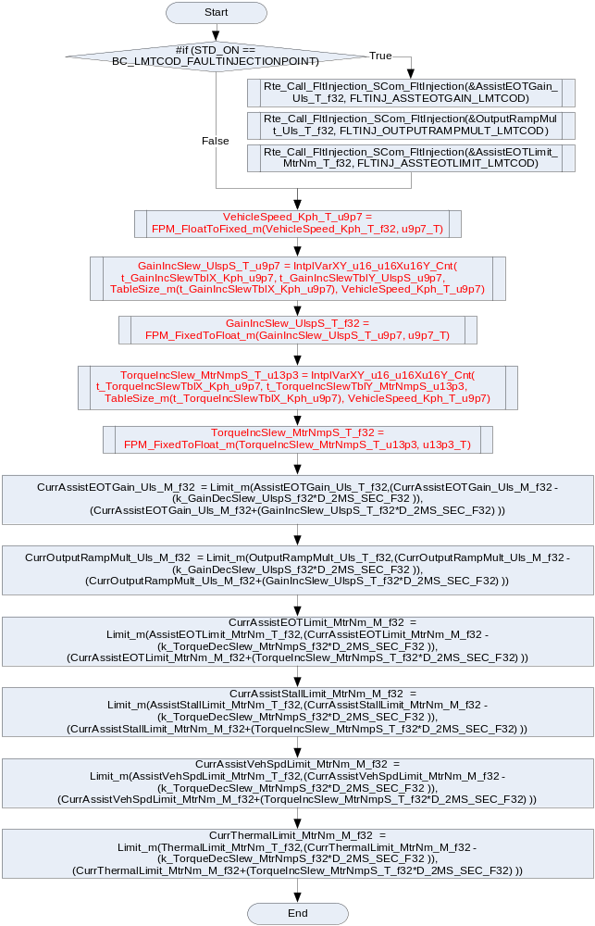

Store Local copy of outputs into Module Outputs
Local Copy | Module Output Name
CurrAssistEOTGain_Uls_M_f32 | Rte_IWrite_LmtCod_Per1_EOTGainLtd_Uls_f32
CurrAssistEOTLimit_MtrNm_M_f32 | Rte_IWrite_LmtCod_Per1_EOTLimitLtd_MtrNm_f32
CurrOutputRampMult_Uls_M_f32 | Rte_IWrite_LmtCod_Per1_OutputRampMultLtd_Uls_f32
CurrAssistStallLimit_MtrNm_M_f32 | Rte_IWrite_LmtCod_Per1_StallLimitLtd_MtrNm_f32
CurrThermalLimit_MtrNm_M_f32 | Rte_IWrite_LmtCod_Per1_ThermalLimitLtd_MtrNm_f32
CurrAssistVehSpdLimit_MtrNm_M_f32 | Rte_IWrite_LmtCod_Per1_VehSpdLimitLtd_MtrNm_f32

Program Flow End
Rte_Call_LmtCod_Per1_CP1_CheckpointReached()

Fault Recovery Functions
N/A

Shutdown Functions
N/A

Interrupt Functions
N/A

Serial Communication Functions
N/A

Execution Requirements

Execution Sequence of the Module

Execution Rates for sub-modules called by the Scheduler
This table serves as reference for the Scheduler design
Function Name | Calling Frequency | System State(s) in which the function is called
LmtCod_Per1 | 2ms | All

Execution Requirements for Serial Communication Functions
Function Name | Sub-Module called by (Serial Comm Function Name)
None

Memory Map Definition Requirements

Sub Modules (Functions)
This table identifies the software segments for functions identified in this module.
Name of Sub Module | Software Segment
LmtCod_Per1() | RTE_START_SEC_AP_LMTCOD_APPL_CODE

Local Functions
This table identifies the software segments for local functions identified in this module.
Name of Sub Module | Software Segment
None

Known Issues / Limitations With Design
- INLINE functions defined in globalmacro.h are not unittested.

Revision Control Log
Item # | Rev # | Change Description | Date | Author Initials
1 | 1.0 | Document creation for component based design process | 28-Aug-12 | NRAR
2 | 2.0 | Check points corrected | 23-Sep-12 | Selva
3 | 3.0 | Update to FDD SF38 v002 – CR8292 | 17-May-13 | BDO

