Module -- Motor Velocity

High-Level Description
This function calculates motor velocity using a diverse method and a converts this to HwVel.
Based on HighLevelDesignDocument (State Dependant Runnables_BMW_Future.xlsx), Runnables shown in different application segments are placed in different source files. For MtrVel, FDD Ver 007, HLDD has 4 runnables, two of which are in ASILD listed as MtrVel_Per1() and MtrVel_Per2(). And two of them are in ASILB’(D) listed as MtrVel2_Per1() and MtrVel2_Per2(). This document is responsible for ASILB’(D) runnables.

Figures

Diagram – Function Data Sharing
This diagram shows all data that is shared between functions within the module.
No Shared Data

Diagram – MtrVel
This diagram describes the functional characteristics and data flow of a given function.

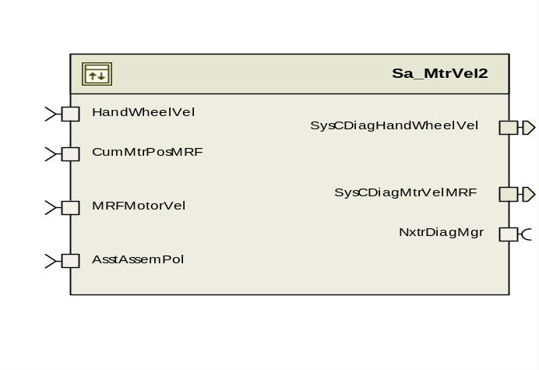

Variable Data Dictionary
For details on module input / output variable, refer to the Data Dictionary for the application. Input / output variable names are listed here for reference.
(Note: Full variable names required in table.)
(Note: All global variables including End Of Line data used should be shown here)
Module Inputs (Global Variable Name) | Module Outputs (Global Variable Name)
CumMtrPosMRF_Deg_f32 | SysCDiagHandWheelVel_HwRadpS_f32
AsstAssemPol_Cnt_s8 | SysCDiagMtrVelMRF_MtrRadpS_f32
HandwheelVel_HwRadpS_f32
MRFMotorVel_MtrRadpS_f32

Module Internal Variables
This section identifies the name, range and resolutions for module specific data created by this module. If there are no range restrictions on the variable, the term “FULL” is placed into the table for legal range.
Variable Name | Resolution | Legal Range  (min) | Legal Range  (max) | Software Segment
PrevSysCDiagCumMtrPos_Rad_M_f32 | Single Precision Floating Point | -1745.33 | 1745.33 | MTRVEL2_START_SEC_VAR_CLEARED_32
SysCMtrVelMRF_MtrRadpS_M_f32 | Single Precision Floating Point | -1350 | 1350 | MTRVEL2_START_SEC_VAR_CLEARED_32
SysCHwVelCRF_HwRadpS_M_f32 | Single Precision Floating Point | -42 | 42 | MTRVEL2_START_SEC_VAR_CLEARED_32
SysCMtrVelDiffAcc_Cnt_M_u16 | 1 | 0 | 255 | MTRVEL2_START_SEC_VAR_CLEARED_16
SysCHwVelDiffAcc_Cnt_M_u16 | 1 | 0 | 255 | MTRVEL2_START_SEC_VAR_CLEARED_16
SysCMtrVelCorrLimDiff_MtrRadpS_D_f32 | Single Precision Floating Point | 0 | 2700 | MTRVEL2_START_SEC_VAR_CLEARED_32
SysCHwVelCorrLimDiff_HwRadpS_D_f32 | Single Precision Floating Point | 0 | 2700 | MTRVEL2_START_SEC_VAR_CLEARED_32
SysCDiagCumMtrPosDelta_Rad_D_f32 | Single Precision Floating Point | -6.283185 | 6.283185 | MTRVEL2_START_SEC_VAR_CLEARED_32
SysCDiagMtrVelRawMRF_MtrRadpS_D_f32 | Single Precision Floating Point | -6283.08943 | 6283.08943 | MTRVEL2_START_SEC_VAR_CLEARED_32
SysCDiagMtrVelRawMRFSv_M_str | N/A | N/A | N/A | MTRVEL2_START_SEC_VAR_CLEARED_UNSPECIFIED
SysCDiagMtrVelRawMRFSv_M_str.K_Uls_f32 | Single Precision Floating Point | 0.222232321 | 0.529510782 | MTRVEL2_START_SEC_VAR_CLEARED_UNSPECIFIED
SysCDiagMtrVelRawMRFSv_M_str.SV_Uls_f32 | Single Precision Floating Point | -6283.08943 | 6283.08943 | MTRVEL2_START_SEC_VAR_CLEARED_UNSPECIFIED
* Note: These ranges are based on the range of the normalized sine and cosine global inputs, which in turn are based on the maximum amount of signal variation that can be caused by temperature changes on the MSB signals.

User defined typedef definition/declaration
This section documents any user types uniquely used for the module.
Typedef Name | Element Name | User Defined Type | Legal Range  (min) | Legal Range  (max)
(Name given for the user defined typdef of type struct/union)  (Variable name qualified similar to all other variables) | (Variable name qualified similar to all other variables) | as other variables

Constant Data Dictionary

Calibration Constants
This section lists the calibrations used by the module. For details on calibration constants, refer to the Data Dictionary for the application.
Constant Name
k_HwVelSampleTime_ms_f32
k_DiagMtrVelFiltKn_Hz_f32
k_GearRatio_Uls_f32
k_MtrVelCorrLim_Cnt_Str
k_HwVelCorrLim_Cnt_Str
k_MtrVelCorrLim_MtrRadpS_f32
k_HwVelCorrLim_HwRadpS_f32

Program(fixed) Constants

Embedded Constants
All embedded constants whose values are provided in Eng units will be evaluated to the equivalent counts by using the FPM_InitFixedPoint_m() macro within the #define statement.

Local
Constant Name | Resolution | Value
D_MTRVELLOLMT_MTRRADPS_F32 | Single Precision Floating Point | -1350
D_MTRVELLOLMT_MTRRADPS_F32 | Single Precision Floating Point | 1350
D_HWVELLOLMT_HWRADPS_F32 | Single Precision Floating Point | -42
D_HWVELHILMT_HWRADPS_F32 | Single Precision Floating Point | 42

Global
This section lists the global constants used by the module. For details on global constants, refer to the Data Dictionary for the application.
Constant Name
D_MSECPERSEC_ULS_F32
D_PIOVR180_ULS_F32

Module specific Lookup Tables Constants
(This is for lookup tables (arrays) with fixed values, same name as other tables)
Constant Name | Resolution | Value | Software Segment
None

Functions/Macros used by the Sub-Modules

Library Functions / Macros
The library functions / Macros that are called by the various sub modules are identified below,
- Abs_f32_m()
- LPF_OpUpdate_f32_m ()
- LPF_KUpdate_f32_m

Data Hiding Functions
The data hiding functions / macros used in this module are identified below,

Local Functions/Macros Used by this MDD only
(Note if they are defined in another source file, then reference the appropriate header file)
The local functions/macros in this module are identified below,

Software Module Implementation

Initialization Functions

Init: MtrVel2_Init1

Design Rationale
None

Module Outputs
SysCDiagCumMtrPos_Rad_T_f32 as float

SysCDiagCumMtrPos_Rad_T_f32= Rte_IRead_MtrVel2_Init_ CumMtrPosMRF_Rev_f32 ()
PrevSysCDiagCumMtrPos_Rad_M_f32 = SysCDiagCumMtrPos_Rad_T_f32
LPF_KUpdate_f32_m(k_DiagMtrVelFiltKn_Hz_f32, D_2MS_SEC_F32, &SysCDiagMtrVelRawMRFSv_M_str)

Module Internal
None

Periodic Functions

Per: MtrVel2_Per1

Design Rationale

Program Flow Start
N/A

Store Module Inputs to Local copies

Rte_Call_MtrVel2_Per1_CP0_CheckpointReached()
AsstAssemPol_Cnt_T_s8 = Rte Rte_IRead_MtrVel2_Per1_AsstAssemPol_Cnt_s8 ()
SysCMechMtrPos_Rev_T_f32 = Rte_IRead_MtrVel2_Per1_SysCMechMtrPos_Rev_f32 ()

Calculate SysC Motor Velocity
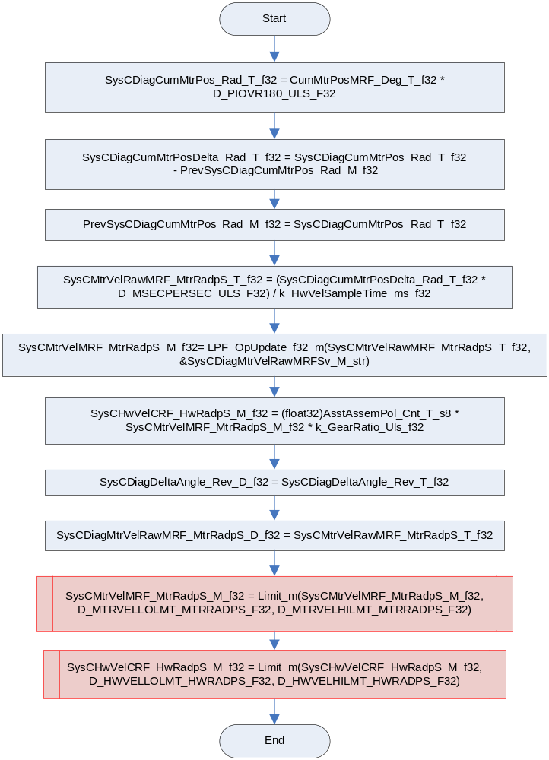

Store Local copy of outputs into Module Outputs
Rte_IWrite_MtrVel2_Per1_SysCDiagHandWheelVel_HwRadpS_f32 (SysCHwVelCRF_HwRadpS_M_f32)
Rte_IWrite_MtrVel2_Per1_SysCDiagMtrVelMRF_MtrRadpS_f32 (SysCMtrVelMRF_MtrRadpS_M_f32)

Rte_Call_MtrVel2_Per1_CP1_CheckpointReached()

Program Flow End
N/A

Periodic Functions

Per: MtrVel2_Per2

Design Rationale

Program Flow Start
N/A

Store Module Inputs to Local copies
Rte_Call_MtrVel2_Per2_CP0_CheckpointReached()
HandwheelVel_HwRadpS_T_f32 = Rte_IRead_MtrVel2_Per2_HandWheelVel_HwRadpS_f32 ()
MRFMotorVel_MtrRadpS_T_f32 = Rte_IRead_MtrVel2_Per2_MRFMotorVel_MtrRadpS_f32 ()

Calculate Raw Motor Velocity

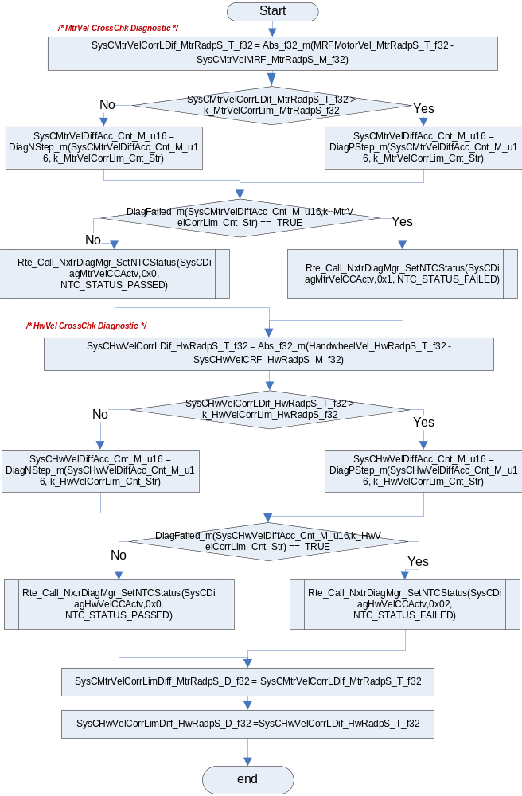

Rte_Call_MtrVel2_Per2_CP1_CheckpointReached()

Fault Recovery Functions
None

Shutdown Functions
None

Interrupt Functions
None

Serial Communication Functions
None

Local Function/Macro Definitions
None

Execution Requirements

Execution Sequence of the Module
(Describe in words relevant details about the execution sequence of the different sub modules.)

Execution Rates for sub-modules called by the Scheduler
This table serves as reference for the Scheduler design
Function Name | Calling Frequency | System State(s) in which the function is called
MtrVel2_Init1 | Once | ALL STATES
MtrVel2_Per1 | 2ms | ALL STATES
MtrVel2_Per2 | 4ms | ALL STATES

Execution Requirements for Serial Communication Functions
Function Name | Sub-Module called by (Serial Comm Function Name)
N/A

Memory Map Definition Requirements

Sub Modules (Functions)
This table identifies the software segments for functions identified in this module.
Name of Sub Module | Software Segment
MtrVel2_Per1
MtrVel2_Per2

Local Functions
none

Known Issues / Limitations With Design

Revision Control Log
Item # | Rev # | Change Description | Date | Author Initials
1 | 1.0 | Initial AutoSAR release. | 5OCT12 | NRAR
2 | 2.0 | Input range changes on MtrVel and HwVel signals to match FDD | 08APR13 | JJW
3 | 3.0 | Changes corresponding to FDD 02B r11. Updates to diverse computation of motor velocity. | 25APR13 | JJW
4 | 4.0 | Added limits per anomaly 5139 | 12JUN13 | KJS

