Module -- Motor Velocity

High-Level Description
This function is responsible for calculating motor velocity from the sine and cosine motor position sensor signals. This portion of the motor velocity component actually runs in the motor control ISR to capture motor position values for use in calculating the motor velocity in MtrVel(1).

Figures

Diagram – Function Data Sharing
This diagram shows all data that is shared between functions within the module.
No Shared Data
Variable Data Dictionary
For details on module input / output variable, refer to the Data Dictionary for the application. Input / output variable names are listed here for reference.
(Note: Full variable names required in table.)
(Note: All global variables including End Of Line data used should be shown here)
Module Inputs (Global Variable Name) | Module Outputs (Global Variable Name)
MtrPos_SinTheta1_Volts_G_s2p13 | N/A
MtrPos_CosTheta1_Volts_G_s2p13
MtrPos_MechMtrPos_Rev_G_u0p16
MtrPos_SampleTime_uS_G_u32

Module Internal Variables
This section identifies the name, range and resolutions for module specific data created by this module. If there are no range restrictions on the variable, the term “FULL” is placed into the table for legal range.
Variable Name | Resolution | Legal Range  (min) | Legal Range  (max) | Software Segment
MtrVel3_SinBuffer_Uls_M_s2p13[4][8] | 2^-13 | -2 | 2 | MTRVEL3_START_SEC_VAR_CLEARED_16
MtrVel3_CosBuffer_Uls_M_s2p13[4][8] | 2^-13 | -2 | 2 | MTRVEL3_START_SEC_VAR_CLEARED_16
MtrVel3_PosBuffer_Rev_M_u0p16[4][8] | 2^-16 | FULL | FULL | MTRVEL3_START_SEC_VAR_CLEARED_16
MtrVel3_TimeBuffer_uS_M_u16p0[4][8] | 1 | FULL | FULL | MTRVEL3_START_SEC_VAR_CLEARED_16
MtrVel3_OsBufPos_Cnt_M_u08[4] | 1 | 0 | 7 | MTRVEL3_START_SEC_VAR_CLEARED_8
* Note: These ranges are based on the range of the normalized sine and cosine global inputs, which in turn are based on the maximum amount of signal variation that can be caused by temperature changes on the MSB signals.

User defined typedef definition/declaration
This section documents any user types uniquely used for the module.
Typedef Name | Element Name | User Defined Type | Legal Range  (min) | Legal Range  (max)
N/A

Constant Data Dictionary

Calibration Constants
This section lists the calibrations used by the module. For details on calibration constants, refer to the Data Dictionary for the application.
Constant Name
N/A

Program(fixed) Constants

Embedded Constants
All embedded constants whose values are provided in Eng units will be evaluated to the equivalent counts by using the FPM_InitFixedPoint_m() macro within the #define statement.

Local
Constant Name | Resolution | Value
D_BUFFERMASK_CNT_U08 | 1 | D_MTRVELOSBUFSZ_CNT_U08 – 1
D_MTRVELOSBUFNUM_CNT_U08 | 1 | 4
D_MTRVELOSBUFSZ_CNT_U08 | 1 | 8
D_MTRVELNUMBUFINIT_CNT_U08 | 1 | 2
D_SAMPLETNOM_US_U16 | 1 | 62
D_MTRVELTNOM_US_U16 | 1 | 1000

Global
This section lists the global constants used by the module. For details on global constants, refer to the Data Dictionary for the application.
Constant Name
N/A

Module specific Lookup Tables Constants
(This is for lookup tables (arrays) with fixed values, same name as other tables)
Constant Name | Resolution | Value | Software Segment
None

Functions/Macros used by the Sub-Modules

Library Functions / Macros
The library functions / Macros that are called by the various sub modules are identified below,
- N/A

Data Hiding Functions
The data hiding functions / macros used in this module are identified below,

Local Functions/Macros Used by this MDD only
(Note if they are defined in another source file, then reference the appropriate header file)
The local functions/macros in this module are identified below,
- N/A
Software Module Implementation

Initialization Functions

Init: MtrVel3_Init1

Design Rationale
None

Module Outputs
N/A

Module Internal
None

Description

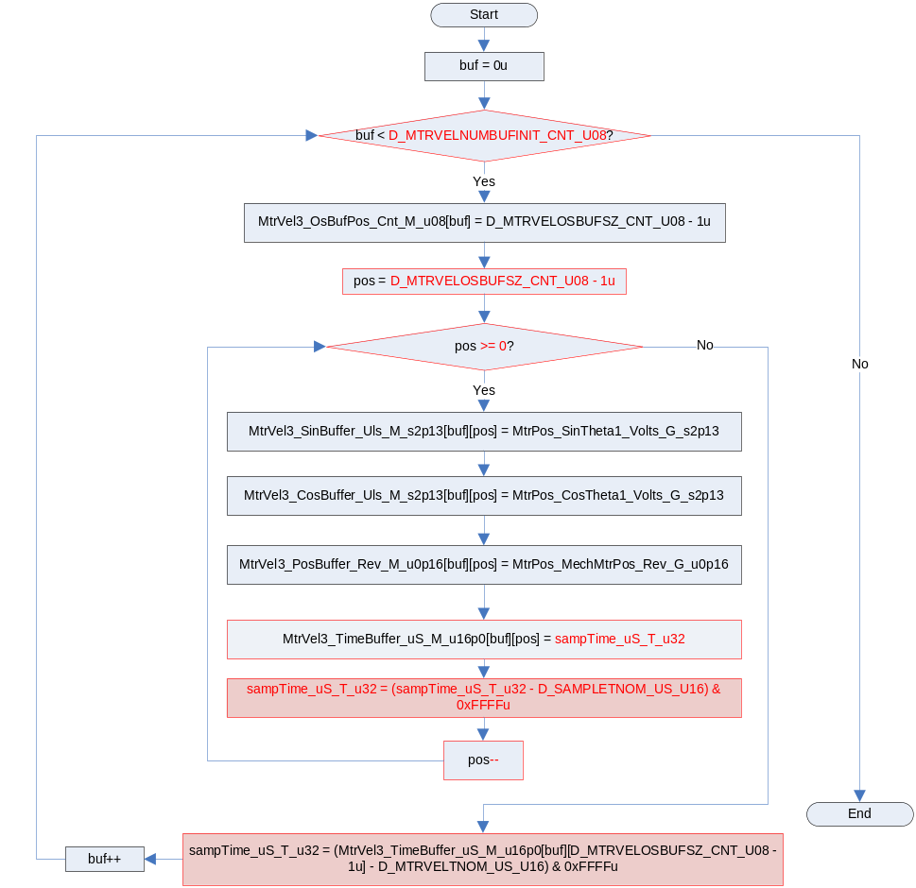

Periodic Functions

Per: MtrVel3_Per1

Design Rationale
N/A

Program Flow Start
N/A

Store Module Inputs to Local copies
N/A

Populate Sample Buffers
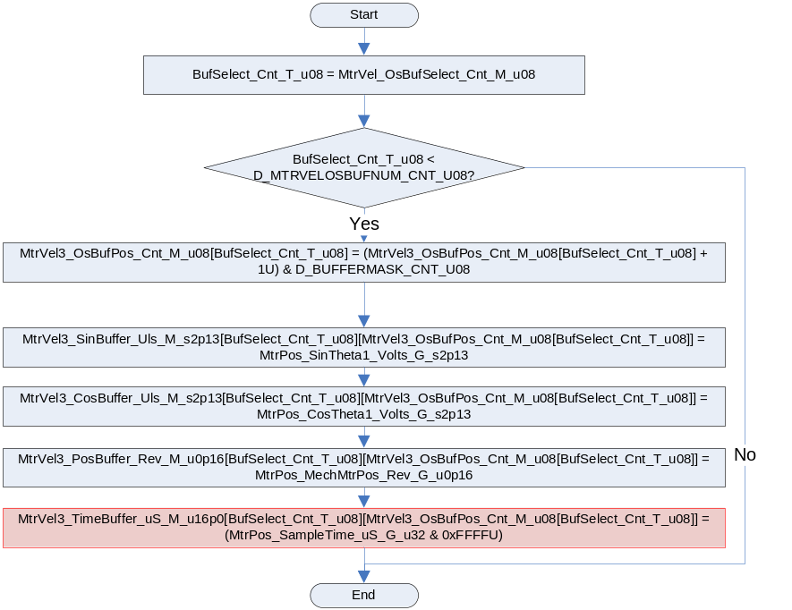

Store Local copy of outputs into Module Outputs
N/A

Program Flow End
N/A

Fault Recovery Functions
None

Shutdown Functions
None

Interrupt Functions
None

Serial Communication Functions
None

Local Function/Macro Definitions
If these are numerous and defined in a separate source file then reference the source file only.

Execution Requirements

Execution Sequence of the Module
(Describe in words relevant details about the execution sequence of the different sub modules.)

Execution Rates for sub-modules called by the Scheduler
This table serves as reference for the Scheduler design
Function Name | Calling Frequency | System State(s) in which the function is called
MtrVel3_Init1 | Once | ALL STATES
MtrVel3_Per1 | Motor Control ISR | ALL STATES

Execution Requirements for Serial Communication Functions
Function Name | Sub-Module called by (Serial Comm Function Name)
N/A

Memory Map Definition Requirements

Sub Modules (Functions)
This table identifies the software segments for functions identified in this module.
Name of Sub Module | Software Segment
MtrVel3_Init1 | RTE_SA_MTRVEL_APPL_CODE
MtrVel3_Per1 | RTE_SA_MTRVEL_APPL_CODE

Local Functions
This table identifies the software segments for local functions identified in this module.
Name of Sub Module | Software Segment
None

Known Issues / Limitations With Design
- N/A

Revision Control Log
Item # | Rev # | Change Description | Date | Author Initials
1 | 1.0 | Initial release for FDD v010 | 6-FEB-13 | JWJ
2 | 2.0 | Corrections per UTP feedback | 04-APR-13 | JJW
3 | 3.0 | Corrected typo in MtrVel3_Init per UTP feedback | 04-APR-13 | JJW
5 | 5 | Corrected value of D_MTRVELOSBUFNUM_CNT_U08 | 08-APR-13 | JJW
6 | 6 | Added mask to convert 32 bit value and store in 16-bit buffer | 13-JUN-13 | KJS

