Module -- Motor Velocity

High-Level Description
This function is responsible for calculating motor velocity from the sine and cosine motor position sensor signals.
Based on HighLevelDesignDocument (State Dependant Runnables_BMW_Future.xlsx), Runnables shown in different application segments are placed in different source files. For MtrVel, FDD Ver 007, HLDD has 4 runnables, two of which are in ASILD listed as MtrVel_Per1() and MtrVel_Per2(). And two of them are in ASILB’(D) listed as MtrVel2_Per1() and MtrVel2_Per2(). This document is responsible for ASILD runnables.

Figures

Diagram – Function Data Sharing
This diagram shows all data that is shared between functions within the module.
No Shared Data

Diagram – MtrVel_Per1
This diagram describes the functional characteristics and data flow of a given function.

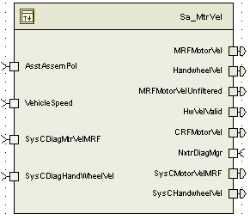

Variable Data Dictionary
For details on module input / output variable, refer to the Data Dictionary for the application. Input / output variable names are listed here for reference.
(Note: Full variable names required in table.)
(Note: All global variables including End Of Line data used should be shown here)
Module Inputs (Global Variable Name) | Module Outputs (Global Variable Name)
VehicleSpeed_Kph_f32 | CRFMotorVel_MtrRadpS_f32
AsstAssemPol_Cnt_s08 | MRFMotorVel_MtrRadpS_f32
MtrVel3_SinBuffer_Uls_M_s2p13[4][8] | HandwheelVel_HwRadpS_f32
MtrVel3_CosBuffer_Uls_M_s2p13[4][8] | HwVelValid_Cnt_lgc
MtrVel3_PosBuffer_Rev_M_u0p16 [4][8] | MRFMotorVelUnfiltered_MtrRadpS_f32
MtrVel3_TimeBuffer_uS_M_u16p0[4][8] | SysCHandwheelVel_HwRadpS_f32
MtrVel3_OsBufPos_Cnt_M_u08[4] | SysCMotorVelMRF_MtrRadpS_f32
SysCDiagHandWheelVel_HwRadpS_f32
SysCDiagMtrVelMRF_MtrRadpS_f32

Module Internal Variables
This section identifies the name, range and resolutions for module specific data created by this module. If there are no range restrictions on the variable, the term “FULL” is placed into the table for legal range.
Variable Name | Resolution | Legal Range  (min) | Legal Range  (max) | Software Segment
CrsMtrVel_MtrRadpS_D_f32[2] | Single Precision Floating Point | -1350 | 1350 | MTRVEL_START_SEC_VAR_CLEARED_32
DeltaTheta_Uls_D_s18p13[2][8] | 2^-13 | FULL | FULL | MTRVEL_START_SEC_VAR_CLEARED_32
HwVel_HwRadpS_M_f32 | Single Precision Floating Point | -42 | 42 | MTRVEL_START_SEC_VAR_CLEARED_32
HwVelCorrLimDiff_HwRadpS_D_f32 | Single Precision Floating Point | 0 | 84 | MTRVEL_START_SEC_VAR_CLEARED_32
HwVelDiffAcc_Cnt_M_u16 | 1 | 0 | 255 | MTRVEL_START_SEC_VAR_CLEARED_16
MtrVel_ActiveBufSet_Cnt_M_u08 | 1 | 0 | 1 | MTRVEL_START_SEC_VAR_CLEARED_8
MtrVel_AvgDeltaT_uS_D_u16p0[2] | 1 | FULL | FULL | MTRVEL_START_SEC_VAR_CLEARED_16
MtrVel_DeltaThetaIntercept_Uls_D_s7p24[2] | 2^-24 | FULL | FULL | MTRVEL_START_SEC_VAR_CLEARED_32
MtrVel_MtrRadpS_M_f32 | Single Precision Floating Point | -1350 | 1350 | MTRVEL_START_SEC_VAR_CLEARED_32
MtrVel_OldPosBuf_Cnt_M_u08 | 1 | 0 | 3 | MTRVEL_START_SEC_VAR_CLEARED_8
MtrVel_OsBufSelect_Cnt_M_u08 | 1 | 0 | 4 | MTRVEL_START_SEC_VAR_CLEARED_8
MtrVel_Slope_puS_D_sm11p42[2] | 2^-42 | FULL | FULL | MTRVEL_START_SEC_VAR_CLEARED_32
MtrVel_SnapShotSet_Cnt_G_u08 | 1 | 0 | 1 | MTRVEL_START_SEC_VAR_CLEARED_8_GLOBALSHARED
MtrVelCorrLimDiff_MtrRadpS_D_f32 | Single Precision Floating Point | 0 | 2700 | MTRVEL_START_SEC_VAR_CLEARED_32
MtrVelDelta_MtrRadpS_M_u12p4 | 2⁻⁴ | 0 | 1350 | MTRVEL_START_SEC_VAR_CLEARED_16
MtrVelDiffAcc_Cnt_M_u16 | 1 | 0 | 255 | MTRVEL_START_SEC_VAR_CLEARED_16
MtrVelFiltSV_MtrRadpS_M_s11p20 | 2^-20 | FULL | FULL | MTRVEL_START_SEC_VAR_CLEARED_32
OldMtrVel_MtrRadpS_M_s11p4 | 2⁻⁴ | -1350 | 1350 | MTRVEL_START_SEC_VAR_CLEARED_16
PosAvg_Rev_M_u0p16 | 2⁻¹⁶ | FULL | FULL | MTRVEL_START_SEC_VAR_CLEARED_16
PredDeltaTheta_Uls_D_f32[2] | Single Precision Floating Point | FULL | FULL | MTRVEL_START_SEC_VAR_CLEARED_32
PredDeltaThetaCor_Uls_D_f32[2] | Single Precision Floating Point | FULL | FULL | MTRVEL_START_SEC_VAR_CLEARED_32
WestBlendedMtrVel_MtrRadpS_D_f32[2] | Single Precision Floating Point | FULL | FULL | MTRVEL_START_SEC_VAR_CLEARED_32
WestVelocity_MtrRadpS_D_f32[2] | Single Precision Floating Point | FULL | FULL | MTRVEL_START_SEC_VAR_CLEARED_32
* Note: These ranges are based on the range of the normalized sine and cosine global inputs, which in turn are based on the maximum amount of signal variation that can be caused by temperature changes on the MSB signals.

User defined typedef definition/declaration
This section documents any user types uniquely used for the module.
Typedef Name | Element Name | User Defined Type | Legal Range  (min) | Legal Range  (max)
(Name given for the user defined typdef of type struct/union)  (Variable name qualified similar to all other variables) | (Variable name qualified similar to all other variables) | as other variables

Constant Data Dictionary

Calibration Constants
This section lists the calibrations used by the module. For details on calibration constants, refer to the Data Dictionary for the application.
Constant Name
t_MtrVelDeltaKpTblX_MtrRadpS_u12p4
t_MtrVelDeltaKpTblY_Cnt_u16
t_MtrVelFiltKpTblX_Kph_u9p7
t_MtrVelFiltKpYTbl_Cnt_u16
t_MtrVelBlendTblX_MtrRadpS_u12p4
k_MtrVelFiltEn_Cnt_lgc
k_GearRatio_Uls_f32
k_MtrVelCorrLim_Cnt_Str
k_HwVelCorrLim_Cnt_Str
k_MtrVelCorrLim_MtrRadpS_f32
k_HwVelCorrLim_HwRadpS_f32
t_MtrVelTimeOffsetTblX_Kph_u9p7
t_MtrVelTimeOffsetYTbl_uS_u16

Program(fixed) Constants

Embedded Constants
All embedded constants whose values are provided in Eng units will be evaluated to the equivalent counts by using the FPM_InitFixedPoint_m() macro within the #define statement.

Local
Constant Name | Resolution | Value
D_CORRTERMA0_ULS_F32 | Single Precision Floating Point | 0.5240920730306
D_CORRTERMN1P_ULS_F32 | Single Precision Floating Point | 0.09361941664774
D_CORRTERMN2P_ULS_F32 | Single Precision Floating Point | 1.488737214789
D_CORRTERME1P_ULS_F32 | Single Precision Floating Point | 1.27106431778
D_CORRTERME2P_ULS_F32 | Single Precision Floating Point | 3.700991517299
D_USECPERSEC_ULS_F32 | Single Precision Floating Point | 1000000.0
D_MTRVELOSBUFNUM_CNT_U08 | 1 | 4
D_MTRVELOSBUFSZ_CNT_U08 | 1 | 8
D_SNAPSHOTBUF_CNT_U08 | 1 | 2
D_MTRVELLOLMT_MTRRADPS_F32 | Single Precision Floating Point | -1350
D_MTRVELLOLMT_MTRRADPS_F32 | Single Precision Floating Point | 1350
D_B1NUMLIMIT_US_S7P24 | 2⁻²⁴ | 0.0625 – 1count
D_HWVELLOLMT_HWRADPS_F32 | Single Precision Floating Point | -42
D_HWVELHILMT_HWRADPS_F32 | Single Precision Floating Point | 42
D_FIXPTMTRVELHILMT_MTRRADPS_F32 | Single Precision Floating Point | 2047.9375
D_FIXPTMTRVELLOLMT_MTRRADPS_F32 | Single Precision Floating Point | -2048.0

Global
This section lists the global constants used by the module. For details on global constants, refer to the Data Dictionary for the application.
Constant Name
D_RADPERREV_ULS_F32

Module specific Lookup Tables Constants
(This is for lookup tables (arrays) with fixed values, same name as other tables)
Constant Name | Resolution | Value | Software Segment
T_MtrVelBlendTblY_Uls_u2p14 | 2^-14 | {0, 1}

Functions/Macros used by the Sub-Modules

Library Functions / Macros
The library functions / Macros that are called by the various sub modules are identified below,
- FPM_FixedToFloat_m()
- FPM_FloatToFixed_m()
- FMP_Fix_m()
- Max_m()
- Abs_s16_m()
- Abs_f32_m()
- IntplVarXY_u16_u16Xu16Y_Cnt()
- LPF_SvUpdate_s16InFixKTrunc_m()
- LPF_OpUpdate_s16InFixKTrunc_m()
- Rte_Call_NxtrDiagMgr_GetNTCFailed
- Rte_Call_NxtrDiagMgr_SetNTCStatus
- TableSize_m()

Data Hiding Functions
The data hiding functions / macros used in this module are identified below,

Local Functions/Macros Used by this MDD only
(Note if they are defined in another source file, then reference the appropriate header file)
The local functions/macros in this module are identified below,
- Square_m(x) ((x)*(x))
- CalcCoarseVel()
- CorrectVel()
- MtrVelBlend()
- RegressionFit()

Software Module Implementation

Initialization Functions

Init: MtrVel_Init1

Design Rationale
None

Module Outputs
None

Module Internal
None

Description
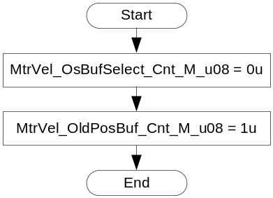

Periodic Functions

Per: MtrVel_Per1

Design Rationale

Coarse and Fine Velocity Calculations
A “coarse” motor velocity signal is calculated which is simply calculated from (change in averaged motor position) / (change in averaged time).
The “fine” motor velocity signal has inherent error at high speeds due to the nature of the algorithm. Because of the way the calculation is done and the fact that the samples are done every 1mS, the maximum velocity that this algorithm can calculate is +/-pi rad/ms ~ +/- 3142 rad/sec. Additionally, there is significant error in the calculation as velocity increases to this limit. For this reason, a correction is calculated and applied to the fine velocity to increase the accuracy up to a certain speed, and a blending is done so that “fine” velocity is used at lower speeds when it is accurate, and “coarse” velocity is used at high speeds.

Unit Testing Considerations
The design of this module was done with physical motor velocity considerations taken into account. For example, the limits on the inputs to some of the local functions are based on the physical system. Assuming the motor can rotate at a maximum of +/- 1350 Rads/Sec, the design only needs to accommodate a certain “change in position” from the last loop. Similarly, a “change in time” from the last loop will always correspond to the calculation loop rate within a tolerance. This was where the limits for the Coarse and Fine velocity functions were derived. All unit-testing test vectors should be designed in such a way as to conform to these physical limitations. Additionally, for any use of combinations of the sin and cos signals, the standard sin vs cos relationship may need to be followed (e.g. sin and cos are never both “0” at the same point in time).

Program Flow Start

Rte_Call_MtrVel_Per1_CP0_CheckpointReached()Store Module Inputs to Local copies
SinAvg_Uls_T_s2p13 as sint16
CosAvg_Uls_T_s2p13 as sint16
PosAvg_Rev_T_u0p16 as uint16
TimeAvg_uS_T_u16p0 as uint16

MtrVel_ActiveBufSet_Cnt_M_u08 = (MtrVel_SnapShotSet_Cnt_G_u08 ^ 1u) & 1u
AsstAssemPol_Cnt_T_s08 = Rte_IRead_MtrVel_Per1_AsstAssemPol_Cnt_s08()
VehSpd_Kph_T_f32 = Rte_IRead_MtrVel_Per1_VehSpd_Kph_f32()
VehSpd_Kph_T_u9p7 = FPM_FloatToFixed_m(VehSpd_Kph_T_f32, u9p7_T);
Rte_Call_NxtrDiagMgr_GetNTCFailed(NTC_Num_PriMSB_SinCosCorr,&MtrPosFault1_Cnt_T_lgc)
Rte_Call_NxtrDiagMgr_GetNTCFailed(NTC_Num_PriVsSec_SinCosCorr, &MtrPosFault2_Cnt_T_lgc)

Calculate Raw Motor Velocity
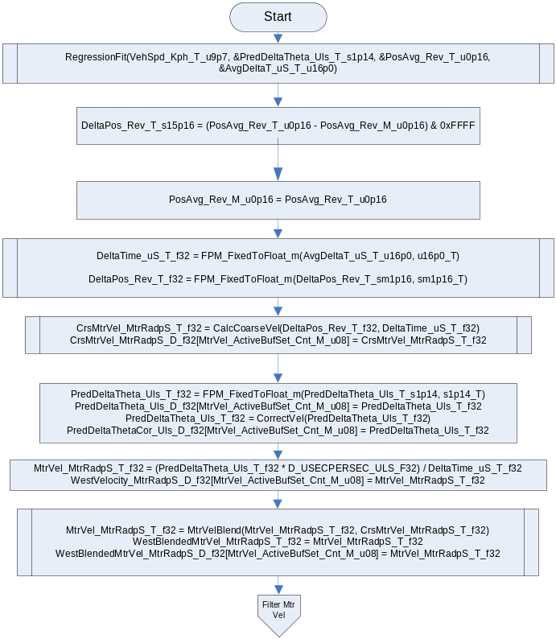
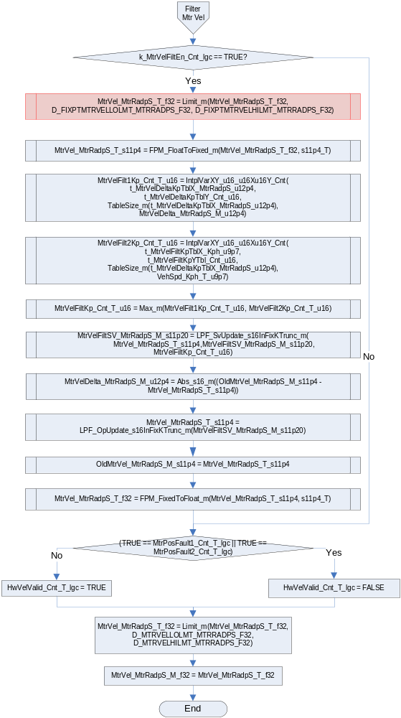

Store Local copy of outputs into Module Outputs
Rte_IWrite_MtrVel_Per1_MRFMtrVel_MtrRadpS_f32(MtrVel_MtrRadpS_T_f32)
MtrVel_MtrRadpS_T_f32 = AsstAssemPol_Cnt_T_s08 * MtrVel_MtrRadpS_T_f32
Rte_IWrite_MtrVel_Per1_CRFMtrVel_MtrRadpS_f32(MtrVel_MtrRadpS_T_f32)
HwVel_HwRadpS_T_f32 = MtrVel_MtrRadpS_T_f32 * k_GearRatio_Uls_f32
HwVel_HwRadpS_M_f32 = Limit_m(HwVel_HwRadpS_T_f32, D_HWVELLOLMT_HWRADPS_F32, D_HWVELHILMT_HWRADPS_F32)

Rte_IWrite_MtrVel_Per1_HandwheelVel_HwRadpS_f32 (MtrVel_MtrRadpS_T_f32)
Rte_IWrite_MtrVel_Per1_HwVelValid_Cnt_lgc(HwVelValid_Cnt_T_lgc)
Rte_IWrite_MtrVel_Per1_MRFMotorVelUnfiltered_MtrRadpS_f32(WestBlendedMtrVel_MtrRadpS_D_f32)

Rte_IWrite_MtrVel_Per1_SysCMotorVelMRF_MtrRadpS_f32(MtrVel_MtrRadpS_M_f32)
Rte_IWrite_MtrVel_Per1_SysCHandwheelVel_HwRadpS_f32(HwVel_HwRadpS_M_f32)

Program Flow End
Rte_Call_MtrVel_Per1_CP1_CheckpointReached()

Periodic Functions

Per: MtrVel_Per2

Design Rationale

Program Flow Start

Rte_Call_MtrVel_Per2_CP0_CheckpointReached()Store Module Inputs to Local copies
SysC_DiagMtrVelMRF_MtrRadpS_T_f32 = Rte_IRead_MtrVel_Per2_SysCDiagMtrVelMRF_MtrRadpS_f32()
SysC_DiagHandWheelVel_HwRadpS_T_f32 = Rte_IRead_MtrVel_Per2_SysCDiagHandWheelVel_HwRadpS_f32()

Calculate Raw Motor Velocity
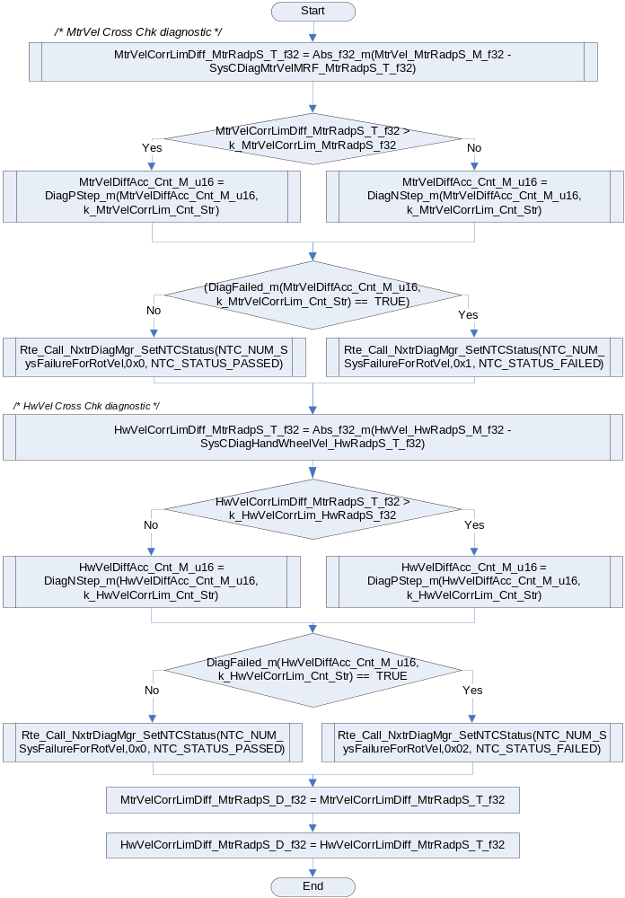

Program Flow End
Rte_Call_MtrVel_Per2_CP1_CheckpointReached()

Fault Recovery Functions
None

Shutdown Functions
None

Interrupt Functions
None

Serial Communication Functions
None

Local Function/Macro Definitions
If these are numerous and defined in a separate source file then reference the source file only.

Calculation Coarse Velocity
Function Name | CalcCoarseVel | Type | Dir. | Min | Max | UTP Tol.
Arguments Passed | DeltaPos_Rev_T_f32 | Single Precision Floating Point | I | -0.2 | 0.2
 | DeltaTime_uS_T_f32 | Single Precision Floating Point | I | 900 | 1100
Return Value | MtrVel_MtrRadpS_T_f32 | Single Precision Floating Point | O | -1350 | 1350 | 6.25E-2

Description
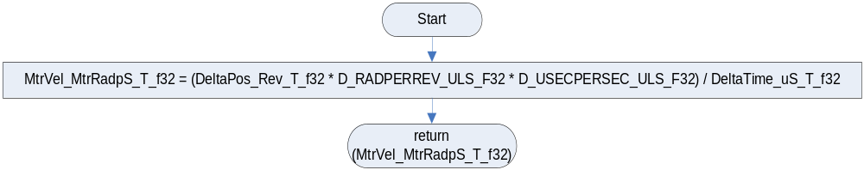

Correct Velocity
Function Name | CorrectVel | Type | Dir. | Min | Max | UTP Tol.
Arguments Passed | MtrVel_MtrRadpS_T_f32 | Single Precision Floating Point | I | -1350 | 1350
Return Value | MtrVel_MtrRadpS_T_f32 | Single Precision Floating Point | O | -1350 | 1350 | 6.25E-2

Design Rationale
This function will calculate and apply a correction factor to the fine motor velocity. This will increase the range of speeds over which the fine motor velocity is accurate. The calculation of the correction term is shown below:
Correction Term = A0 + N_1P/(E_1P - w^2) + N_2P/(E_2P - w^2)
A0 = 0.5249978317
N_1P = 0.09425018578 / SampleTime^2 = 94250.18578
E_1P = 3 1.270451499 / SampleTime^2 = 1270451.499
N_2P = 1.484093006 / SampleTime^2 = 1484093.006
E_2P = 3.702672882 / SampleTime^2 = 3702672.882
w = Calculated Fine Motor Velocity

Description
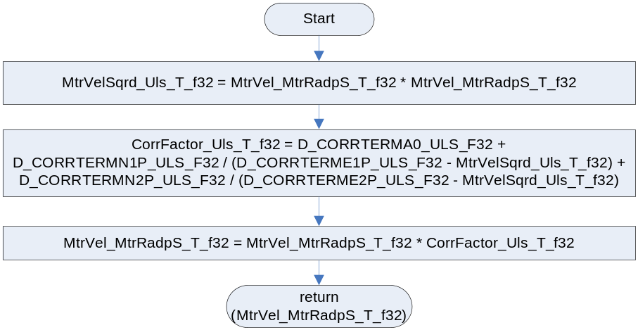

Motor Velocity Blend
Function Name | MtrVelBlend | Type | Dir. | Min | Max | UTP Tol.
Arguments Passed | FinMtrVel_MtrRadpS_T_f32 | Single Precision Floating Point | I | -1350 | 1350
 | CrsMtrVel_MtrRadpS_T_f32 | Single Precision Floating Point | I | -1350 | 1350
Return Value | MtrVel_MtrRadpS_T_f32 | Single Precision Floating Point | O | -1350 | 1350 | 6.25E-2

Description
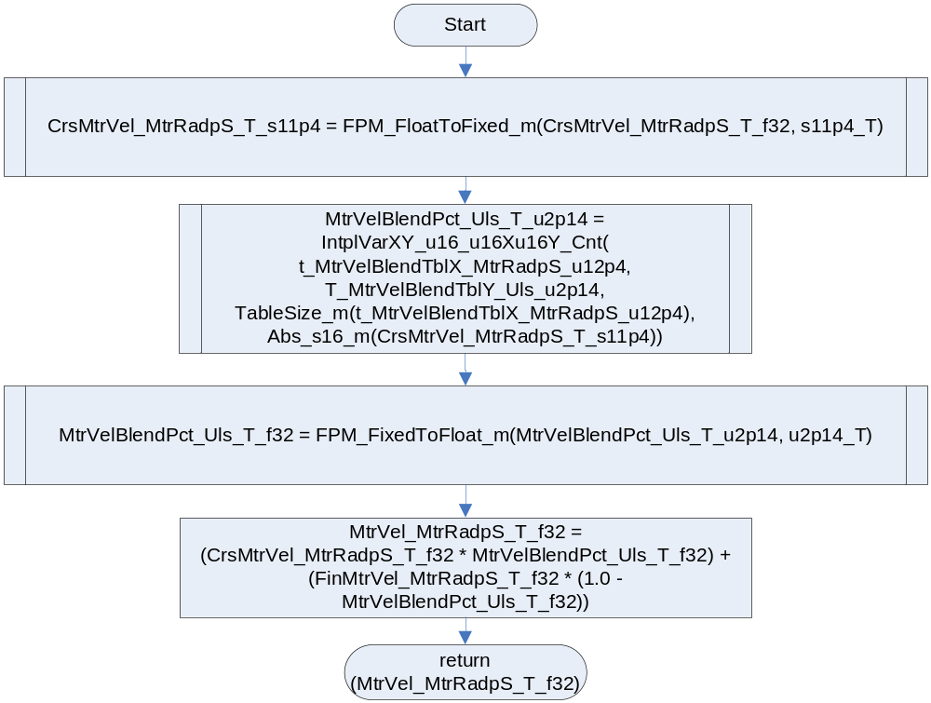

Regression Fit
Function Name | Regression Fit | Type | Dir. | Min | Max | UTP Tol.
Arguments Passed | VehSpd_Kph_T_u9p7 | uint16 | I | 0 | 512
 | PredDeltaThetaPtr_Uls_T_s1p14 | P2VAR, sint16 | O | FULL | FULL | 6.11E-05
 | PosAvgPtr_Rev_T_u0p16 | P2VAR, uint16 | O | FULL | FULL | 1.53E-05
 | AvgDeltaTPtr_uS_T_u16p0 | P2VAR, uint16 | O | 250 | 2000 | 1
Return | None

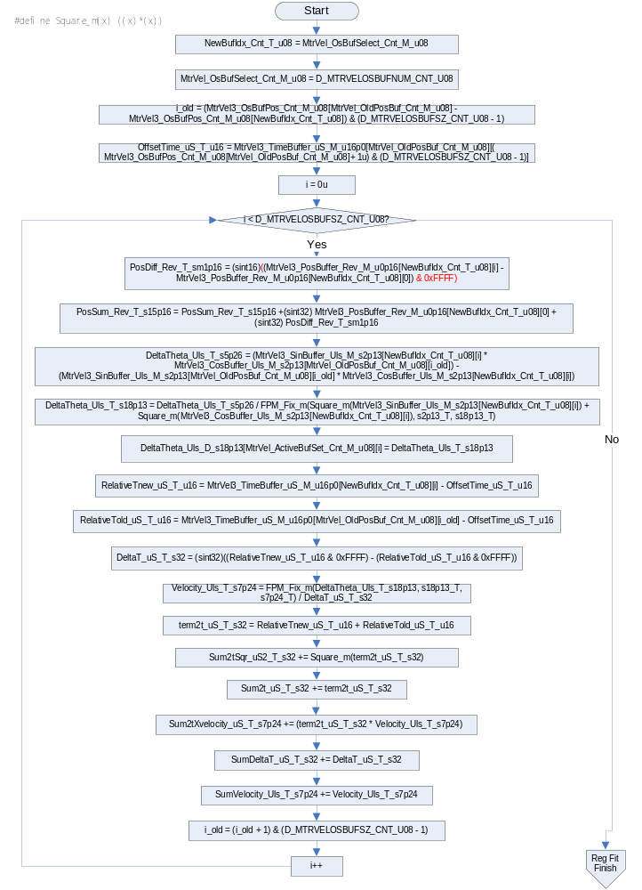
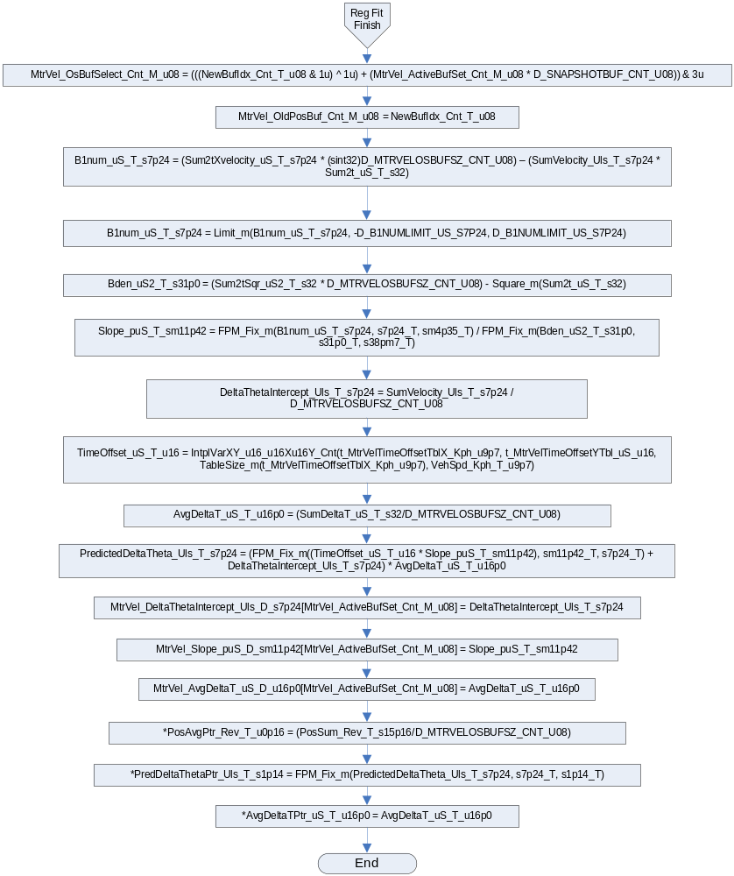

Execution Requirements

Execution Sequence of the Module
(Describe in words relevant details about the execution sequence of the different sub modules.)

Execution Rates for sub-modules called by the Scheduler
This table serves as reference for the Scheduler design
Function Name | Calling Frequency | System State(s) in which the function is called
MtrVel_Init1 | Once | ALL STATES
MtrVel_Per1 | 1ms | ALL STATES
MtrVel_Per2 | 4ms | ALL STATES

Execution Requirements for Serial Communication Functions
Function Name | Sub-Module called by (Serial Comm Function Name)
N/A

Memory Map Definition Requirements

Sub Modules (Functions)
This table identifies the software segments for functions identified in this module.
Name of Sub Module | Software Segment
MtrVel_Per1 | RTE_SA_MTRVEL_APPL_CODE
MtrVel_Per2 | RTE_SA_MTRVEL_APPL_CODE

Local Functions
This table identifies the software segments for local functions identified in this module.
Name of Sub Module | Software Segment
CalcCoarseVel | AP_MTRVEL_CODE
CalcVel | AP_MTRVEL_CODE
CorrectVel | AP_MTRVEL_CODE
MtrVelBlend | AP_MTRVEL_CODE
CalcAvgMtrVelSignals | AP_MTRVEL_CODE

Known Issues / Limitations With Design
- In this design, MtrVel3_TimeBuffer_uS_M_u16p0[][] represents a set of independent circular buffers. Each buffer contains a set of continuous timestamps with the most recent timestamp index of each sample set stored in the associated index of MtrVel3_OsBufPos_Cnt_M_u08[] . The design requires monotonically increasing timestamps relative to the starting index value in MtrVel3_OsBufPos_Cnt_M_u08[]. Due to the modulo 65536 behavior of the timestamp, a single timestamp rollover within the active sample set pair is correctly handled by the design. Simultaneous sample points (e.g. ∆t = 0 for consecutive timestamps) are invalid and will result in a divide by zero in the current design. Unit Test vectors for functions which have MtrVel3_TimeBuffer_uS_M_u16p0[4][8] as an input (MtrVel_Per1 and RegressionFit) must provide an input vector value set which conforms to the set of rules in the following table:
Parameter | Min | Max | Notes
Buffer consecutive timestamp value ∆  i.e. MtrVel3_TimeBuffer_uS_M_u16p0 [i][k] - MtrVel3_TimeBuffer_uS_M_u16p0 [i][k+1] | 10 uS | 125 uS | Monotonically increasing in a modulo 65536 fashion (e.g. testing of the 16 bit rollover point allows for a single rollover point within the data buffer that is not monotonically increasing).  The UTP MUST provide at least 1 test vector that provides a data set with a time stamp rollover (See Table 2).  10 uS is the worst case minimum sampling period based on the MtrCtrl ISR runtime.  125uS is twice the nominal execution rate for MtrCtrl ISR. This is to account for a worst case delay scenario.
Cross buffer set timestamp pair ∆  (e.g the ∆ between the oldest samples in each buffer, the ∆ between the second oldest oldest samples in each buffer, etc)  i.e. MtrVel3_TimeBuffer_uS_M_u16p0 [MtrVel_OsBufSelect_M_u08][i] - MtrVel3_TimeBuffer_uS_M_u16p0 [MtrVel_OldPosBuf_M_u08][k]  where k = i + (MtrVel3_OsBufPos_Cnt_M_u08[MtrVel_OldPosBuf_M_u08] - MtrVel3_OsBufPos_Cnt_M_u08[MtrVel_OsBufSelect_M_u08]) modulo 8 | 250 uS | 2000 uS | 250 uS is the minimum required time to guarantee 8 samples at a nominal 62.5 uS sample rate have been completed.  2000 uS is twice the execution rate for MtrVel_Per1. This is to account for a worst case delay scenario.  When computing the delta it is necessary to perform modulo 65536 math compensation to account for rollover situations (e.g. Table 2 [z-7] samples depict a rollover case where the natural delta is 1764 – 65300 = -63536, however this is not the correct delta result for the strictly increasing modulo 65536 accumulator. Since the natural result is negative, 65536 must be added to obtain the actual delta, -63536 + 65536 = 2000.  See Table 2 for a complete example conforming to this rule.
Table 1: Time Buffer UTP Constraints
The following *.bas is a VBA function to validate the timestamp data sets.
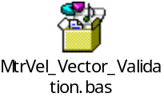
EXAMPLE TimeStamp Buffer Data Set:
The following buffer timestamp data set provides an example when buffers 0 and 1 are active. Values for buffers 2 and 3 are don’t care values for this example and shown as “X” or “Don’t Care”. The samples within the buffers have subscripts which describe the samples order relative to the newest sample in the buffer (e.g. z-1 indicates that the sample is 1 sample period old, z-2 indicates the sample is 2 sample periods old, etc). Samples of the same relative order within each buffer have the same cell shading applied to aid the reader in locating cross buffer sample pairs.
MtrVel_OldPosBuf_M_u08 = 0
MtrVel_OsBufSelect_M_u08 = 1
MtrVel3_OsBufPos_Cnt_M_u08[0] = 0
MtrVel3_OsBufPos_Cnt_M_u08[1] = 2
MtrVel3_OsBufPos_Cnt_M_u08[2] = Don’t Care
MtrVel3_OsBufPos_Cnt_M_u08[3] = Don’t Care

Index | 0 | 1 | 2 | 3 | 4 | 5 | 6 | 7
0 | 198 | 65300_{z-7} | 65362_{z-6} | 65424_{z-5} | 65486_{z-4} | 12_{z-3} | 74_{z-2} | 136_{z-1}
1 | 2074_{z-2} | 2136_{z-1} | 2198 | 1764_{z-7} | 1826_{z-6} | 1888_{z-5} | 1950_{z-4} | 2012_{z-3}
2 | X | X | X | X | X | X | X | X
3 | X | X | X | X | X | X | X | X
Table 2: Example UTP TimeBuffer Roll-Over Sample Set

- The state variables MtrVel_OldPosBuf_M_u08 and MtrVel_OsBufSelect_Cnt_M_u08 have a relationship that is maintained by logic that is executed after their use in RegressionFit(). The RegressionFit() function design requires a valid set of state variables to function properly. Therefore, it is possible to provide an illegal value set for the related state variables in a unit testing environment that will cause an illegal execution of RegressionFit(). All unit test vectors must ensure that MtrVel_OldPosBuf_M_u08 ≠ MtrVel_OsBufSelect_Cnt_M_u08. Failure to do so will result in a divide by 0 exception.

Revision Control Log
Item # | Rev # | Change Description | Date | Author Initials
1 | 1.0 | Initial AutoSAR release. | 31JAN11 | L.N.
2 | 2 | Created new handwheel velocity output. | 01-Jun-11 | YY
3 | 3 | Fixed filter time constant anomaly. Update rationale and ranges for current implementation. | 16-Jun-11 | LWW
4 | 4 | Component created | 11-July-12 | NRAR
5 | 5 | Updated to ver 007 – Safety stuff added | 5-OCT-12 | NRAR
6 | 6 | Updated to v010 | 6-FEB-13 | JWJ
7 | 7 | Corrected RegressionFit truncation and calculation errors | 8-FEB-13 | JJW
8 | 8 | Corrected FPM resolution of Slope in RegressionFit function | 14-FEB-13 | JJW
9 | 9 | Added missing module level variables per UTP feedback | 04-APR-13 | JJW
10 | 10 | Corrected MtrVel_Init1 variable name typo  Added “UTP Tol.” Field to all local functions  Updated range of MtrVel Rad/S signals to FDD specified +/-1350  Added “Dir.” Field to all local functions to specify the direction of the data in the case of values passed by reference.  Added missing limit on HwVel output | 08-APR-13 | JJW
11 | 11 | Corrected range of MtrVel_OldPosBuf_Cnt_M_u08 and MtrVel_OsBufSelect_Cnt_M_u08 | 10-APR-13 | JJW
12 | 12 | Corrected range of MtrVel_OsBufSelect_Cnt_M_u08 | 17-APR-13 | JJW
13 | 13 | Updated “Known Issues/Limitations with Design” section to provide direction for UTP development with regard to selecting vectors for the TimeStamp buffer and buffer selection variables.  Added explicit 0xFFFF masking to result of PosBuffer_Rev_M_u0p16 delta and PosAvg_Rev_T_u0p16 delta.  Added description of design limitations due to anomaly 5048 | 07-MAY-13 | JJW
14 | 14 | Added limit macro support for Per1 if the filter is enabled to correct anomaly 5048, removed comment in design limitations pertaining to this anomaly. | 13-Jun-13 | KJS

