Module -- Stability Control Torque Overlay66

High-Level Description
This function describes the algorithms used to implement the activation logic for torque overlay functionality related to dynamic stability.

Figures

Diagram – Function Data Sharing
This diagram shows all data that is shared between functions within the module.

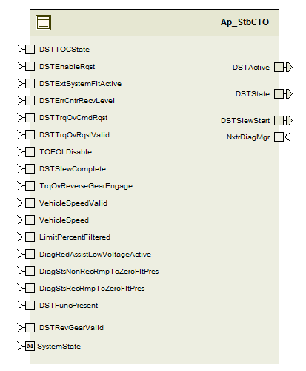

Variable Data Dictionary
For details on module input / output variable, refer to the Data Dictionary for the application. Input / output variable names are listed here for reference.
(Note: Full variable names required in table.)
(Note: All global variables including End Of Line data used should be shown here)
Module Inputs (Global Variable Name) | Module Outputs (Global Variable Name)
DSTTOCState_Cnt_u08 | DSTActive_Cnt_lgc
DSTEnableRqst_Cnt_lgc | DSTState_Cnt_u08
DSTExtSystemFltActive_Cnt_lgc | DSTSlewStart_Cnt_lgc
DSTErrCntrRecvLevel_Cnt_u08
DSTTrqOvCmdRqst_HwNm_f32
DSTTrqOvRqstValid_Cnt_lgc
NTCDSTMaxValue_Cnt_T_lgc
NTCDSTMaxRate_Cnt_lgc
NTCDSTMaxTime_Cnt_lgc
NTCDSTXOR_Cnt_lgc
NTCDSTStuckValue_Cnt_lgc
TOEOLDisable_Cnt_lgc
DSTSlewComplete_Cnt_lgc
TrqOvReverseGearEngage_Cnt_lgc
VehicleSpeed_Kph_f32
VehicleSpeedValid_ Cnt_lgc
LimitPercentFiltered_Uls_f32
NTCLowBattVtg_Cnt_T_lgc
DiagStsNonRecRmpToZeroFltPres_Cnt_lgc
DiagStsRecRmpToZeroFltPres_Cnt_lgc
DSTFuncPresent_Cnt_lgc
SystemState_Mode
DSTRevGearValid_Cnt_lgc

Module Internal Variables
This section identifies the name, range and resolutions for module specific data created by this module. If there are no range restrictions on the variable, the term “FULL” is placed into the table for legal range.
Variable Name | User Defined Type | Resolution | Legal Range  (min) | Legal Range  (max) | Software Segment
DSTRDTimer_M_mS_u32 | UINT32 | N/A | FULL | FULL | STBCTO_START_SEC_VAR_CLEARED_32
DSTTNATimer_M_mS_u32 | UINT32 | N/A | FULL | FULL | STBCTO_START_SEC_VAR_CLEARED_32
RDStateCounter_Cnt_M_u08 | UINT8 | N/A | 0 | 255 | STBCTO_START_SEC_VAR_CLEARED_8
DSTVspdActive_Cnt_M_lgc | BOOLEAN | N/A | FALSE | TRUE | STBCTO_START_SEC_VAR_CLEARED_BOOLEAN
DSTBkwdMotionAbsent_Cnt_M_lgc | BOOLEAN | N/A | FALSE | TRUE | STBCTO_START_SEC_VAR_CLEARED_BOOLEAN
VehExtCondDSTActive_Cnt_M_lgc | BOOLEAN | N/A | FALSE | TRUE | STBCTO_START_SEC_VAR_CLEARED_BOOLEAN
IntCondDSTEnable_Cnt_M_lgc | BOOLEAN | N/A | FALSE | TRUE | STBCTO_START_SEC_VAR_CLEARED_BOOLEAN
LoSpdInactive_Cnt_M_lgc | BOOLEAN | N/A | FALSE | TRUE | STBCTO_START_SEC_VAR_CLEARED_BOOLEAN
HiSpdInactive_Cnt_M_lgc | BOOLEAN | N/A | FALSE | TRUE | STBCTO_START_SEC_VAR_CLEARED_BOOLEAN
DiagStsNonRecRmpToZeroFltPres_Cnt_M_lgc | BOOLEAN | N/A | FALSE | TRUE | STBCTO_START_SEC_VAR_CLEARED_BOOLEAN
DiagStsRecRmpToZeroFltPres_Cnt_M_lgc | BOOLEAN | N/A | FALSE | TRUE | STBCTO_START_SEC_VAR_CLEARED_BOOLEAN
DSTInternalCondTimer_mS_M_u32 | UINT32 | N/A | FULL | FULL | STBCTO_START_SEC_VAR_NOINIT_32
DSTBkwdMotionTime_mS_M_u32 | UINT32 | N/A | FULL | FULL | STBCTO_START_SEC_VAR_NOINIT_32
activeTimer_mS_M_u32 | UINT32 | N/A | FULL | FULL | STBCTO_START_SEC_VAR_CLEARED_32
InactiveTimer_mS_M_u32 | UINT32 | N/A | FULL | FULL | STBCTO_START_SEC_VAR_CLEARED_32
DSTState_Cnt_M_enum | TOC_STATE | N/A | 0 | 8 | STBCTO_START_SEC_VAR_CLEARED_UNSPECIFIED
StartTNATimer_Cnt_M_lgc | BOOLEAN | N/A | FALSE | TRUE | STBCTO_START_SEC_VAR_CLEARED_BOOLEAN
StartRDTimer_Cnt_M_lgc | BOOLEAN | N/A | FALSE | TRUE | STBCTO_START_SEC_VAR_CLEARED_BOOLEAN

User defined typedef definition/declaration
This section documents any user types uniquely used for the module.
Typedef Name | Element Name | User Defined Type | Legal Range  (min) | Legal Range  (max)
typedef void(*DSTHandler_T)(boolean*DSTActive_T_lgc,boolean*DSTSlewStart_T_lgc)
TOC_STATE | TOCSTATE_OFF | Uint8 | 0
 | TOCSTATE_TNA | Uint8 | 1
 | TOCSTATE_PNA | Uint8 | 2
 | TOCSTATE_READY | Uint8 | 3
 | TOCSTATE_REQUESTDENIED | Uint8 | 4
 | TOCSTATE_ACTIVEMODE05 | Uint8 | 5
 | TOCSTATE_ACTIVEMODE06 | Uint8 | 6
 | TOCSTATE_ACTIVEMODE07 | Uint8 | 7
 | TOCSTATE_NOTAVAILABLE | Uint8 | 8

Constant Data Dictionary

Calibration Constants
This section lists the calibrations used by the module. For details on calibration constants, refer to the Data Dictionary for the application.
Constant Name
k_DSTVSpdVLH_Kph_f32
k_DSTVSpdVHH_Kph_f32
k_DSTVSpdVLL_Kph_f32
k_DSTVSpdVHL_Kph_f32
k_DSTVehSpdActvTime_mS_u16
k_DSTVehSpdInActvTime_mS_u16
k_DSTBkwdMotionTime_mS_u16
k_TrqOverlayLimitPerc_Uls_f32
k_TrqOverlaySuspendTime_mS_u16
k_DSTTrqOvActiveMaxLimit_MtrNm_f32
k_DSTTNAMaxTime_mS_u16
k_DSTRDMaxTime_mS_u16
k_DSTRDStateMaxCount_Cnt_u08

Program (fixed) Constants

Embedded Constants
All embedded constants whose values are provided in Eng units will be evaluated to the equivalent counts by using the FPM_InitFixedPoint_m() macro within the #define statement.

Local
Constant Name | Resolution | Value

Global
This section lists the global constants used by the module. For details on global constants, refer to the Data Dictionary for the application.
Constant Name
D_ONE_CNT_U8

Module specific Lookup Tables Constants
(This is for lookup tables (arrays) with fixed values, same name as other tables)
Constant Name | Resolution | Value | Software Segment
t_DSTStates_Cnt_Fn | n/a | &StbCTO_DSTSt_Off  &StbCTO_DSTSt_TNA  &StbCTO_DSTSt_PNA  &StbCTO_DSTSt_Ready  &StbCTO_DSTSt_RequestDenied  &StbCTO_DSTSt_Active  &StbCTO_DSTSt_Active  &StbCTO_DSTSt_Active  &StbCTO_DSTSt_NotApplicable | AP_STBCTO_CODE

Functions/Macros used by the Sub-Modules

Library Functions / Macros
The library functions / Macros that are called by the various sub modules are identified below,

Data Hiding Functions
The data hiding functions / macros used in this module are identified below,
- Rte_Call_NxtrDiagMgr_SetNTCStatus()

Local Functions/Macros Used by this MDD only
(Note if they are defined in another source file, then reference the appropriate header file)
The local functions/macros in this module are identified below,
- StbCTO_DSTSt_Notvailable ()
- StbCTO_DSTSt_Off()
- StbCTO_DSTSt_TNA()
- StbCTO_DSTSt_PNA()
- StbCTO_DSTSt_Ready()
- StbCTO_DSTSt_Active()
- StbCTO_DSTSt_RequestDenied()

Software Module Implementation

Initialization Functions
Module state variables are initialized to 0 at start-up by RAM init.
LoSpdInactive_Cnt_M_lgc = TRUE

Periodic Functions

Per: StbCTO_Per1

Design Rationale
- StartTNATimer_Cnt_M_lgc, This var is set to TRUE whenever transitioning to TNA state to initialize TNA Timer and set to FALSE when TNA timer is expired. Timer expired is checked in StartandStopTimer()
- StartRDTimer_Cnt_M_lgc, This var is set to TRUE whenever transitioning to RD state to initialize RD Timer and set to FALSE when RD timer is expired. Timer expired is checked in StartandStopTimer()

Program Flow Start
Rte_Call_StbCTO_Per1_CP0_CheckpointReached()

Store Module Inputs to Local copies
SysState_Cnt_T_Enum = Rte_Mode_SystemState_Mode()
DSTFuncPresent_Cnt_T_lgc = Rte_IRead_StbCTO_Per1_DSTFuncPresent_Cnt_lgc()
Rte_Call_NxtrDiagMgr_GetNTCFailed(NTC_Num_ExVoltageLow, &NTCLowBattVtg_Cnt_T_lgc)
HalfActive_Cnt_T_lgc = Rte_IRead_StbCTO_Per1_HalfActive_Cnt_lgc()
LimitPercentFiltered_Uls_T_f32 = Rte_IRead_StbCTO_Per1_LimitPercentFiltered_Uls_f32()
PrkAssistActive_Cnt_T_lgc = Rte_IRead_StbCTO_Per1_PrkAssistActive_Cnt_lgc()
TrqOvReverseGearEngage_Cnt_lgc = Rte_IRead_StbCTO_Per1_TrqOvReverseGearEngage_Cnt_lgc()
VehicleSpeed_Kph_T_f32 = Rte_IRead_StbCTO_Per1_VehicleSpeed_Kph_f32()
DiagStsNonRecRmpToZeroFltPres_Cnt_M_lgc = Rte_IRead_StbCTO_Per1_DiagStsNonRecRmpToZeroFltPres_Cnt_lgc()
DiagStsRecRmpToZeroFltPres_Cnt_M_lgc = Rte_IRead_StbCTO_Per1_DiagStsRecRmpToZeroFltPres_Cnt_lgc()
VehicleSpeedValid_Cnt_T_lgc = Rte_IRead_StbCTO_Per1_VehicleSpeedValid_Cnt_lgc()
DSTRevGearValid_Cnt_T_lgc = Rte_IRead_StbCTO_Per1_DSTRevGearValid_Cnt_lgc()

PrevDSTState_Cnt_T_enum = DSTState_Cnt_M_enum;
Rte_Call_NxtrDiagMgr_GetNTCFailed(NTC_Num_VLF_10, &NTCDSTNotPresentCmdNotZero_Cnt_T_lgc);
Rte_Call_NxtrDiagMgr_GetNTCFailed(NTC_Num_VLF_11, &NTCDSTEnableTrqRqstNotZero_Cnt_T_lgc);
Rte_Call_NxtrDiagMgr_GetNTCFailed(NTC_Num_VLF_12, &NTCDSTStateRqstDenied_Cnt_T_lgc);
Rte_Call_NxtrDiagMgr_GetNTCFailed(NTC_Num_VLF_13, &NTCDSTPresentTNARDTimerExpired_Cnt_T_lgc)

Perform Over and Low Voltage Diagnostics

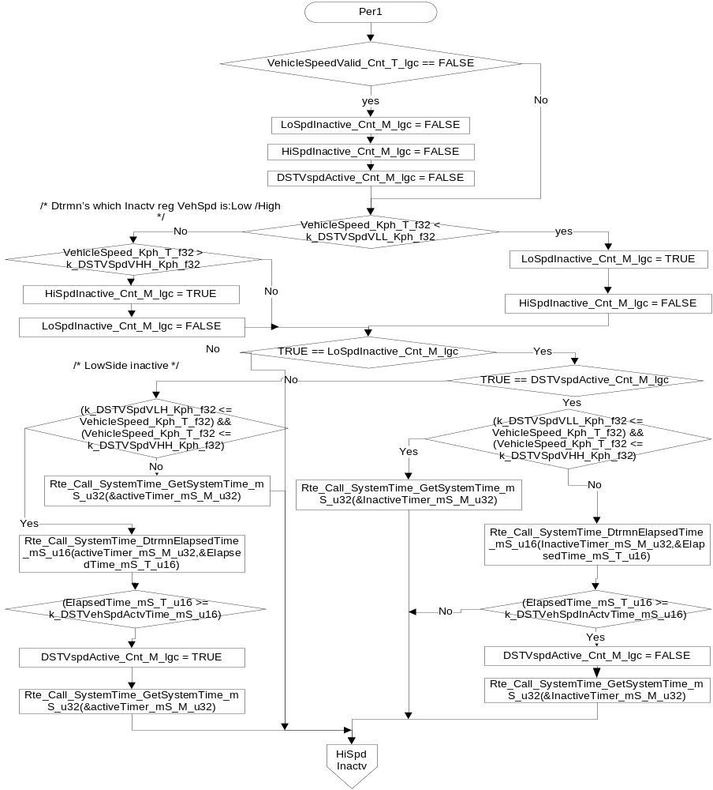
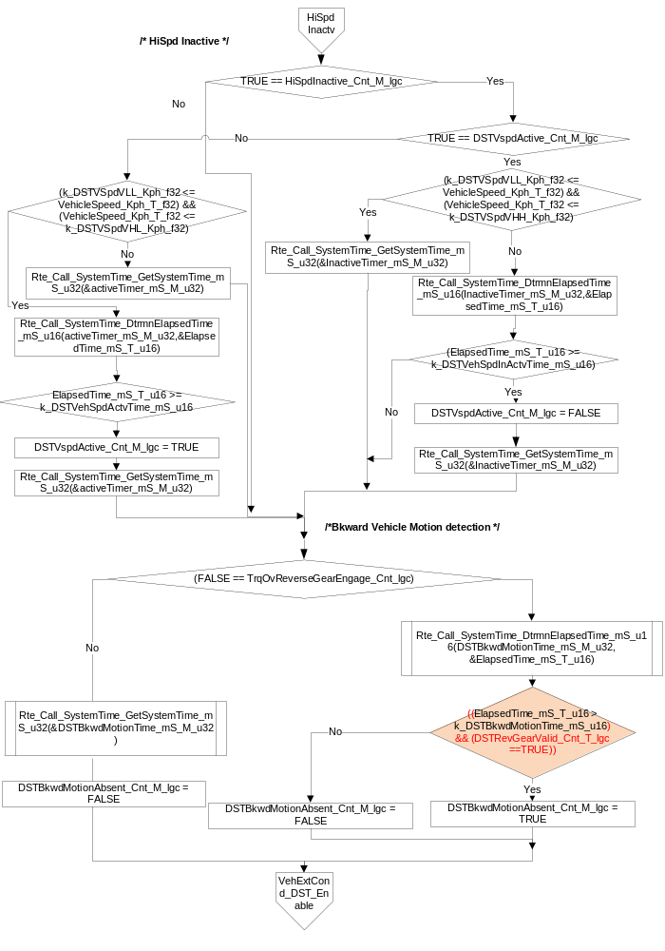

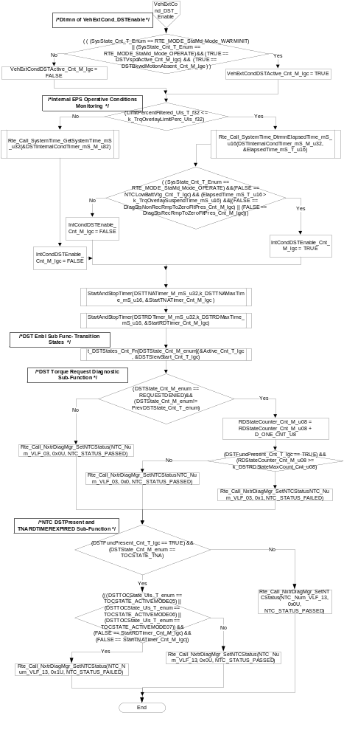

Store Local copy of outputs into Module Outputs
Rte_IWrite_StbCTO_Per1_DSTSlewStart_Cnt_lgc(DSTSlewStart_Cnt_T_lgc)
Rte_IWrite_StbCTO_Per1_DSTActive_Cnt_lgc(DSTActive_Cnt_M_lgc)
Rte_IWrite_StbCTO_Per1_DSTState_Cnt_u08 (DSTState_Cnt_M_enum)

Program Flow End
Rte_Call_StbCTO_Per1_CP1_CheckpointReached()

Fault Recovery Functions
None

Shutdown Functions
None

Interrupt Functions
None

Serial Communication Functions
None

Local Function/Macro Definitions

NotAVailable
Function Name | StbCTO_DSTSt_NotAvailable | Type | Min | Max
Arguments Passed | DSTActive_T_lgc | boolean pointer | FALSE | TRUE
 | DSTSlewStart_T_lgc | boolean pointer | FALSE | TRUE
Return Value | N/A

Description
/* This function does nothing. */
DSTActive_T_lgc = DSTActive_T_lgc
DSTSlewStart_T_lgc = DSTSlewStart_T_lgc

OFF state
Function Name | StbCTO_DSTSt_Off | Type | Min | Max
Arguments Passed | DSTActive_T_lgc | boolean pointer | FULL | FULL
 | DSTSlewStart_T_lgc | boolean pointer | FALSE | TRUE
Return Value | N/A

Description
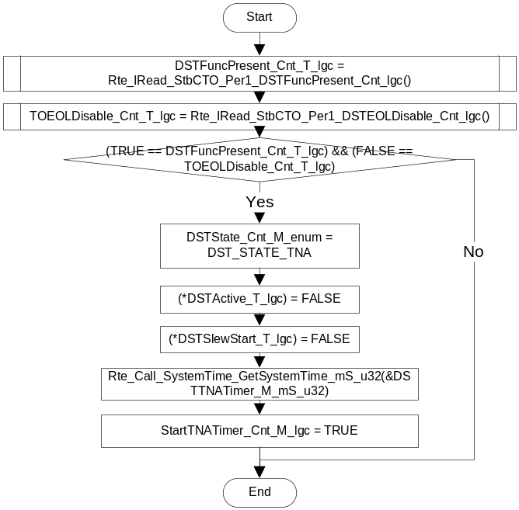

TNA
Function Name | StbCTO_DSTSt_TNA | Type | Min | Max
Arguments Passed | DSTActive_T_lgc | boolean pointer | FALSE | TRUE
 | DSTSlewStart_T_lgc | boolean pointer | FALSE | TRUE
Return Value | N/A

Description
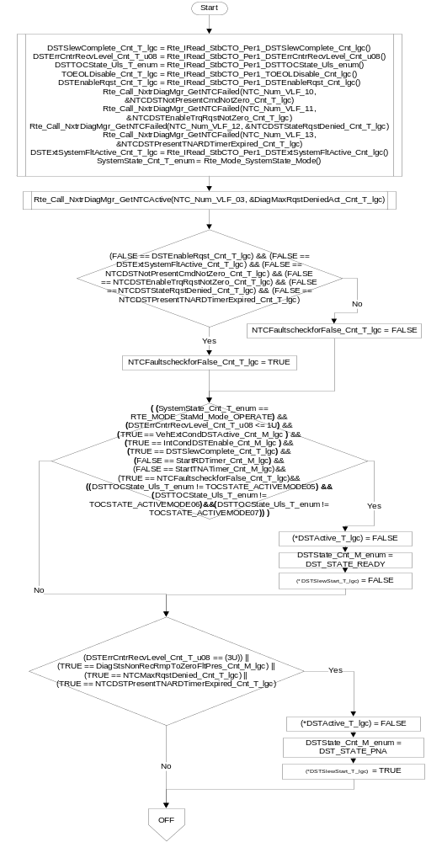
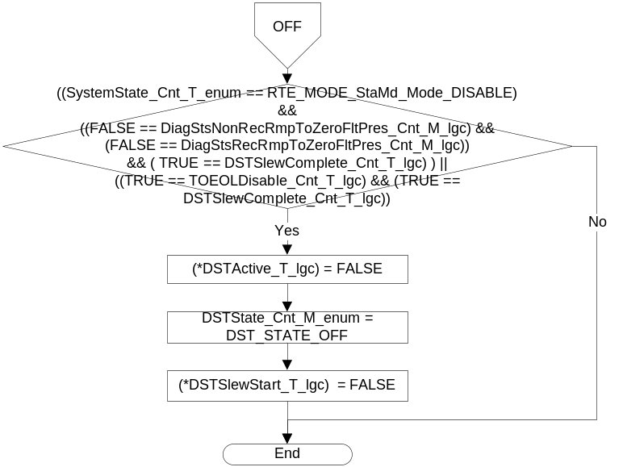

PNA
Function Name | StbCTO_DSTSt_PNA | Type | Min | Max
Arguments Passed | DSTActive_T_lgc | boolean pointer | FULL | FULL
 | DSTSlewStart_T_lgc | boolean pointer | FALSE | TRUE
Return Value | N/A

Description
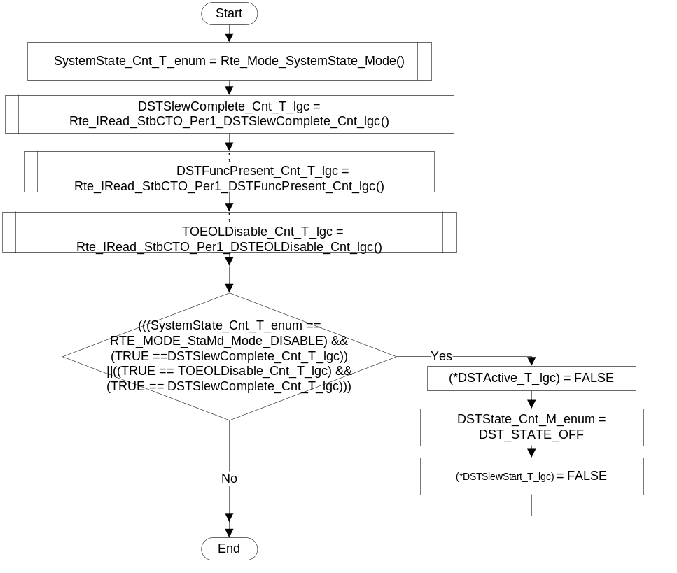

READY
Function Name | StbCTO_DSTSt_Ready | Type | Min | Max
Arguments Passed | DSTActive_T_lgc | boolean pointer | FULL | FULL
 | DSTSlewStart_T_lgc | boolean pointer | FALSE | TRUE
Return Value | N/A

Description
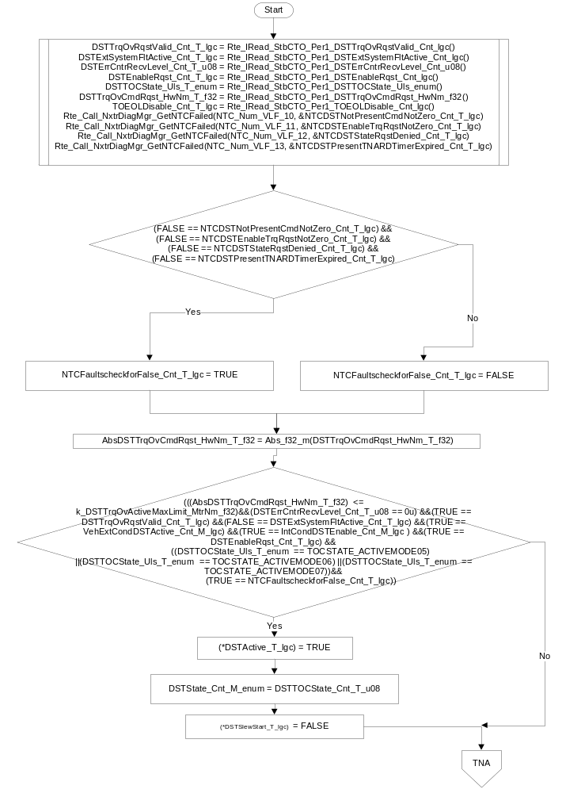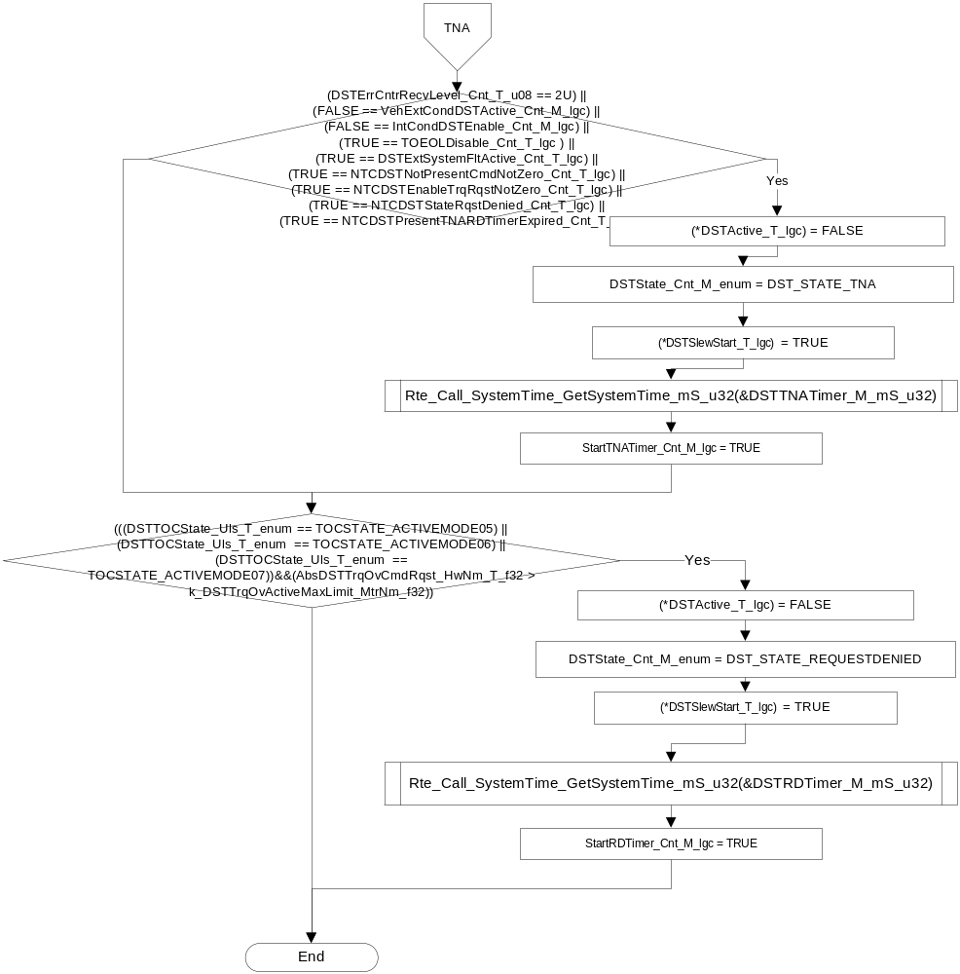

ACTIVE
Function Name | StbCTO_DSTSt_Active | Type | Min | Max
Arguments Passed | DSTActive_T_lgc | boolean pointer | FULL | FULL
 | DSTSlewStart_T_lgc | boolean pointer | FALSE | TRUE
Return Value | N/A

Description
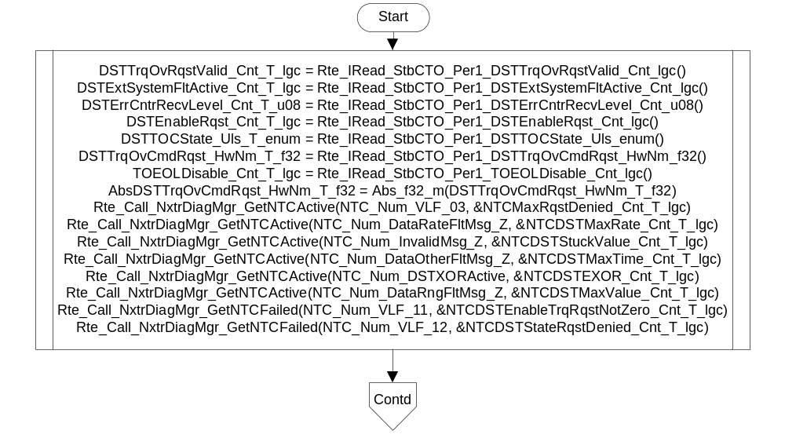
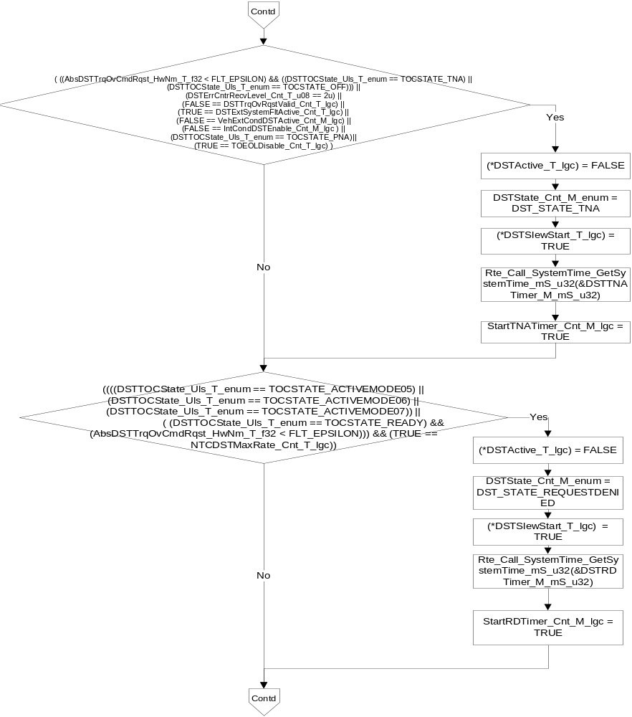

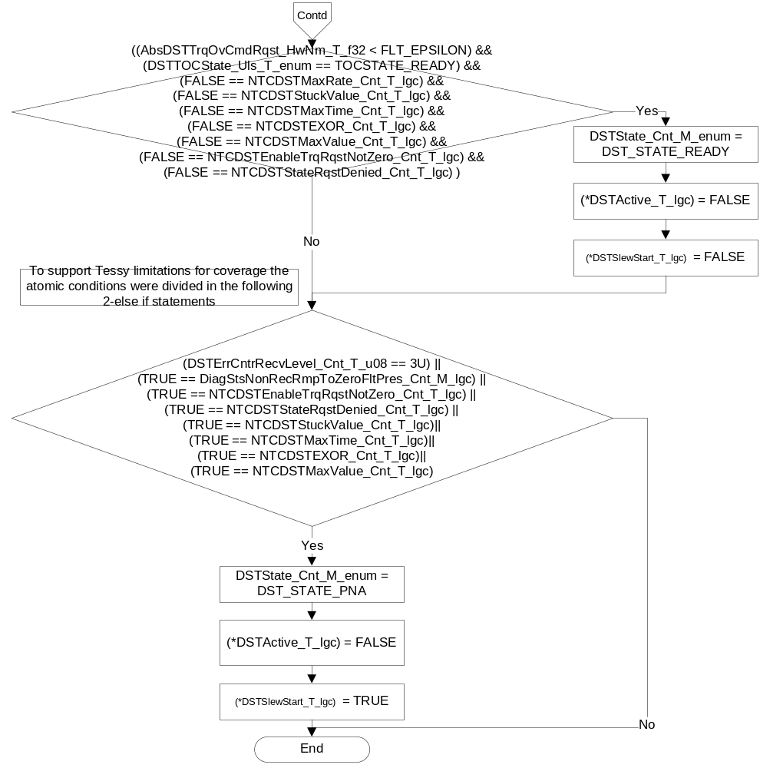

REQUEST DENIED
Function Name | StbCTO_DSTSt_RequestDenied | Type | Min | Max
Arguments Passed | DSTActive_T_lgc | boolean pointer | FULL | FULL
 | DSTSlewStart_T_lgc | boolean pointer | FALSE | TRUE
Return Value | DSTActive_T_lgc | boolean pointer | FULL | FULL

Description

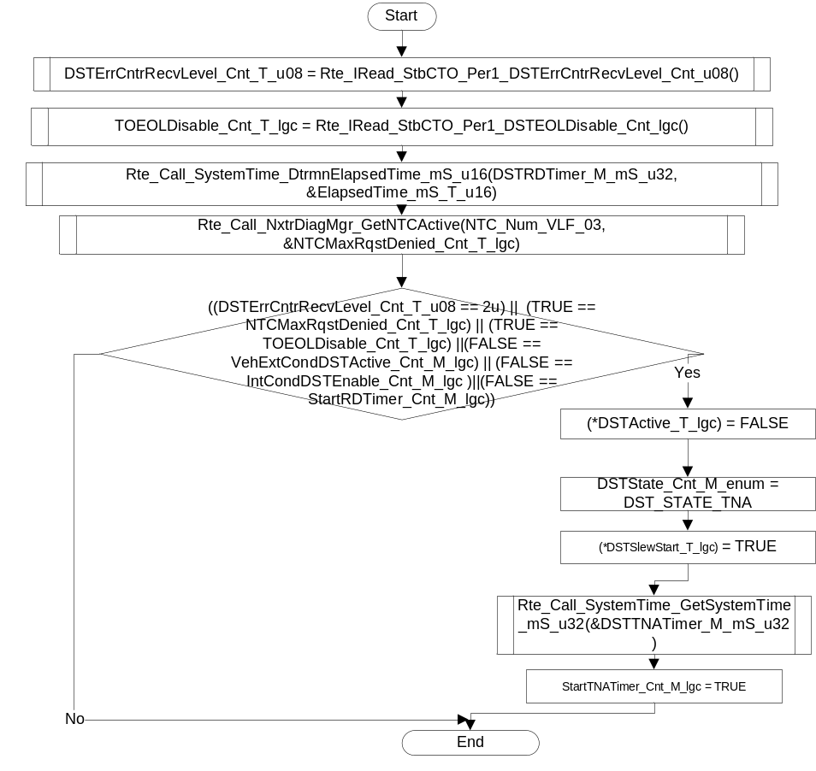

StartAndStopTimer
Function Name | StartAndStopTimer | Type | Min | Max
Arguments Passed | StartTime_mS_T_u32 | Uint32 | FULL | FULL
 | TimeOut_mS_T_u16 | Uint16 | 0 | 5000
 | StartTimer_Cnt_T_lgc | Boolean pointer | FALSE | TRUE
Return Value | N/A

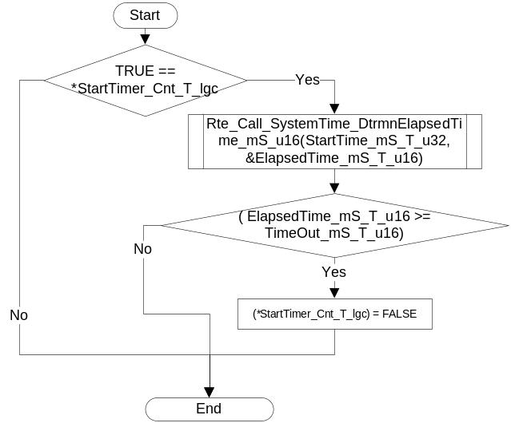

Execution Requirements

Execution Sequence of the Module
(Describe in words relevant details about the execution sequence of the different sub modules.)

Execution Rates for sub-modules called by the Scheduler
This table serves as reference for the Scheduler design
Function Name | Task List | Calling Frequency | System State(s) in which the function is called
StbCTO_Init1 |  | Executed once after the RTE is started | ALL
StbCTO_per1 |  | 2ms | WARMINIT, OPERATE,DISABLE

Execution Requirements for Serial Communication Functions
Function Name | Sub-Module called by (Serial Comm Function Name)

Memory Map Definition Requirements

Sub Modules (Functions)
This table identifies the software segments for functions identified in this module.
Name of Sub Module | Software Segment
StbCTO _Per1() | RTE_AP_STBCTO_APPL_CODE

Local Functions
This table identifies the software segments for local functions identified in this module.
Name of Sub Module | Software Segment
StbCTO_DSTSt_NotApplicable | AP_STBCTO_CODE
StbCTO_DSTSt_Off | AP_STBCTO_CODE
StbCTO_DSTSt_TNA | AP_STBCTO_CODE
StbCTO_DSTSt_PNA | AP_STBCTO_CODE
StbCTO_DSTSt_Ready | AP_STBCTO_CODE
StbCTO_DSTSt_Active | AP_STBCTO_CODE
StbCTO_DSTSt_RequestDenied | AP_STBCTO_CODE
StartAndStopTimer | AP_STBCTO_CODE

Known Issues / Limitations With Design
This module is not meeting FDD for below points:
1) System_State is not shown as input in FDD sec 3 and sec 3.1
2) HalF_Active and PrkAssist_Active is not used in this module, But these are shown in FDD Sec 3, 3.1, 3.3
This is informed to FDD owner and FDD will be updated for next release.

Revision Control Log
Item # | Rev # | Change Description | Date | Author Initials
1 | 1.0 | Initial AutoSAR release. | 19-Oct-12 | NRAR
2 | 2.0 | Updated design rationale in Per1 and Sec 9 | 27-Nov-12 | NRAR
3 | 3.0 | Updated some of the port names | 27-Nov-12 | NRAR
4 | 4.0 | Corrected anomaly 4476 and 4477 SCR 7438 | 21-Fev-13 | DD
5 | 5.0 | Set DSTActive as a global variable | 23-Fev-13 | DD
6 | 6.0 | Correct transition from ACTIVE to Request Denied | 23-Fev-13 | DD
7 | 7.0 | Update to FDD 40C v004, v005 | 09-May-13 | BDO
8 | 8.0 | Updated StbCTO_DSTSt_Active() to support for Tessy coverage limitations, update StartAndStopTimer() | 28-May-13 | BDO
9 | 9.0 | Updated to CF08B Ver 001 | 15-Jul-13 | SP
10 | 10.0 | Added logic to pass the NTCs if the enable criteria is FALSE, And added AbsDSTTrqOvCmdRqst_HwNm_T_f32 in StbCTO_DSTSt_Ready to fix the QAC Warning | 08-Oct-13 | MR
11 | 11.0 | Added logic to pass the NTC as per FDD version CF08B Ver4. | 22-Oct-13 | MR
12 | 12.0 | Updated to CF-08B v005 | 23-Jan-14 | VT

