Module -- CurrCmd

High-Level Description
This Module generates the current command and the voltage reference for the current control.

Diagram – Function Data Sharing
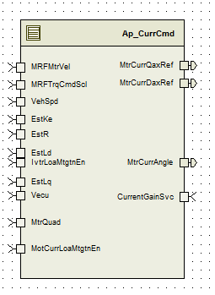

Diagram – Function (Name)

Variable Data Dictionary
For details on module input / output variable, refer to the Data Dictionary for the application. Input / output variable names are listed here for reference.
Module Inputs | Module Outputs
Refer Data Dictionary |  | Refer Data Dictionary

Module Internal Variables
This section identifies the name, range and resolutions for module specific data created by this module. If there are no range restrictions on the variable, the term “FULL” is placed into the table for legal range.
Variable Name | Resolution | Legal Range  (min) | Legal Range  (max) | Software Segment
For all information regarding Module level/Display variable refer Data Dictionary | For all information regarding Module level/Display variable refer Data Dictionary | For all information regarding Module level/Display variable refer Data Dictionary | For all information regarding Module level/Display variable refer Data Dictionary | For all information regarding Module level/Display variable refer Data Dictionary

User defined typedef definition/declaration
This section documents any user types uniquely used for the module.
Typedef Name | Element Name | User Defined Type | Legal Range  (min) | Legal Range  (max)
LowPassFiltBilinear_Str | PrevInput_Uls_f32 | Single precision float | FULL RANGE | FULL RANGE
 | PrevOutput_Uls_f32 | Single precision float | FULL RANGE | FULL RANGE
 | TermN_Uls_f32 | Single precision float | FULL RANGE | FULL RANGE
 | TermD_Uls_f32 | Single precision float | FULL RANGE | FULL RANGE

Constant Data Dictionary

Calibration Constants
This section lists the calibrations used by the module. For details on calibration constants, refer to the Data Dictionary for the application.

Program(fixed) Constants
Constant Name
Refer Data Dictionary

Embedded Constants
All embedded constants whose values are provided in Eng units will be evaluated to the equivalent counts by using the FPM_InitFixedPoint_m() macro within the #define statement.

Local
Constant Name | Resolution | Units | Value
D_SQRT3OVR2_ULS_F32 | Single Precision Float | Uls | 0.866025403784
D_MTRPOLESDIV2_CNT_F32 | Single Precision Float | Cnt | 3.0
D_2OVRSQRT3_ULS_F32 | Single Precision Float | Uls | 1.15470053837925
D_NEG2OVRSQRT3_ULS_F32 | Single Precision Float | Uls | -1.15470053837925F
D_ROUND_ULS_F32 | Single Precision Float | Uls | 0.5
D_NEGROUND_ULS_F32 | Single Precision Float | Uls | -0.5
D_NEG_ULS_F32 | Single Precision Float | Uls | - 1
D_MAXCURRENT_AMP_F32 | Single Precision Float | Amp | 220
D_SIZERDLTAPOINTS_CNT_U16 | 1 | Cnt | TableSize_m(t_RefDeltaPoints_Rad_f32)
D_MAXDELTAPOINTSSIZE_CNT_U16 | 1 | Cnt | D_SIZERDLTAPOINTS_CNT_U16 – 1U)
D_PIPLUSPIOVER4_ULS_F32 | Single Precision Float | ULS | D_PI_ULS_F32+( D_2PI_ULS_F32/4)
D_VECUMAX_VOLTS_F32 | Single Precision Float | Volts | 31.0F
D_2PISQRT3OVR2_ULS_F32 | Single Precision Float | ULS | (D_2PI_ULS_F32*D_SQRT3OVR2_ULS_F32)
D_FOUROVRSQRT3_ULS_F32 | Single Precision Float | ULS | ( D_2OVRSQRT3_ULS_F32* 2.0F)
D_BANDWIDTHLOLIM_HZ_F32 | Single Precision Float | Hz | 0.0
D_BANDWIDTHHILIM_HZ_F32 | Single Precision Float | Hz | (1000.0F)
D_NATFREQLOLIM_HZ_F32 | Single Precision Float | Hz | 0.0f
D_NATFREQHILIM_HZ_F32 | Single Precision Float | Hz | 500.0f
D_VECUDEFAULT_VOLT_F32 | Single Precision Float | Volt | 12.5

Global
This section lists the global constants used by the module. For details on global constants, refer to the Data Dictionary for the application.
Constant Name
D_ZERO_ULS_F32
D_180OVRPI_ULS_F32
D_ONE_ULS_F32
D_QUADRANT3_CNT_U8
D_QUADRANT1_CNT_U8
D_2PI_ULS_F32
D_ZERO_CNT_U16
D_VECUMIN_VOLTS_F32

Module specific Lookup Tables Constants
(This is for lookup tables (arrays) with fixed values, same name as other tables)
Constant Name | Resolution | Value | Software Segment
None

Functions/Macros used by the Sub-Modules

Library Functions / Macros
The library and functions / Macros that are called by the various sub modules are identified below,
- FPM_FloatToFixed_m
- LPF_SvUpdate_s16InFixKTrunc_m
- LPF_OpUpdate_s16InFixKTrunc_m
- FPM_FixedToFloat_m
- Sqrtf
- Abs_f32_m
- atan2f
- IntplVarXY_u16_u16Xu16Y_Cnt
- Sinf
- Cosf

Data Hiding Functions

Global Functions/Macros Defined by this Module

None

Local Functions/Macros Used by this MDD only

Local Function #1
Function Name | ParabolicInterpolation | Type | Min | Max | UTP Tol.
Arguments Passed | IntpolPoints_Uls_T_f32[6] | Float32 | - | -
Return Value | ParaIntpol_Uls_T_f32 | Float32 | N/A | N/A

Description

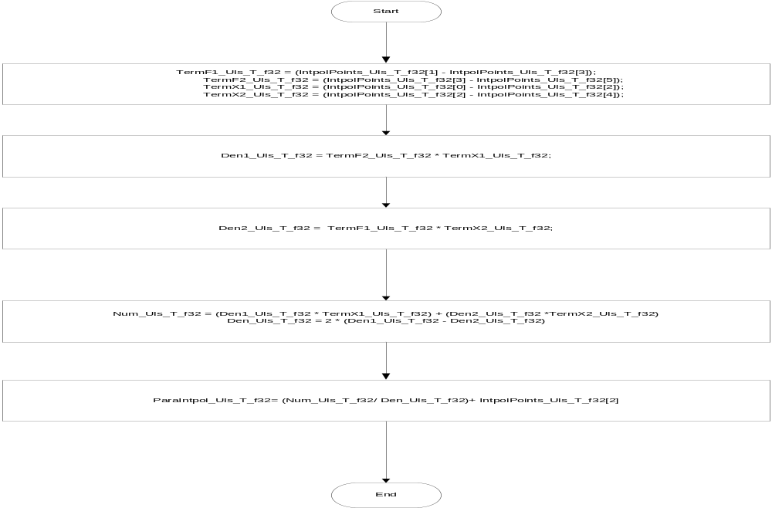

Local Function #2
Function Name | CalculateImVSIdq | Type | Min | Max | UTP Tol.
Arguments Passed | IdRef_Amp_T_f32 | Float32 | -220 | +220
 | IqRef_Amp_T_f32 | Float32 | -220 | +220
Return Value | ImVSIdq_AmpSq_T_f32 | Float32 | 0 | 96800

Description

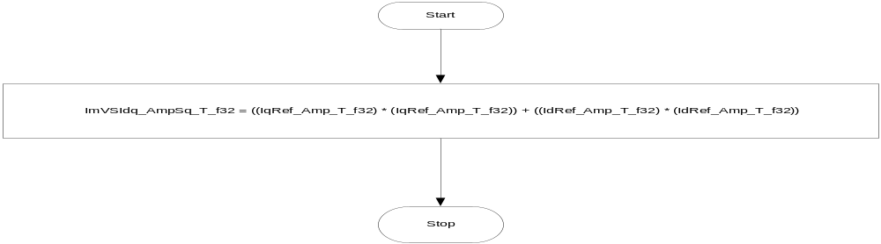

Local Function #3
Function Name | CalculateIq | Type | Min | Max | UTP Tol.
Arguments Passed | Torquecmd_MtrNm_T_f32 | Float32 | -8.8 | 8.8
 | IdRef_Amp_T_f32 | Float32 | -220 | 220
Return Value | IqRefTmp_Amp_T_f32 | Float32 | -220 | 220

Description

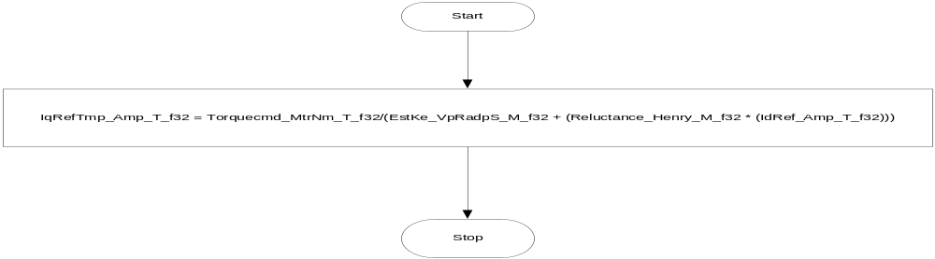

Local Function #4
Function Name | CurrtoVoltTest | Type | Min | Max | UTP Tol.
Arguments Passed | IqRef_Amp_T_f32 | Float32 | -220 | 220
 | IdRef_Amp_T_f32 | Float32 | -220 | 220
 | *VqR_Amp_T_f32 | Float32 | -220 | 220
 | *VdR_Amp_T_f32 | Float32 | -220 | 220
Return Value | VoltTest_Uls_T_lgc | Boolean | False | True

Description
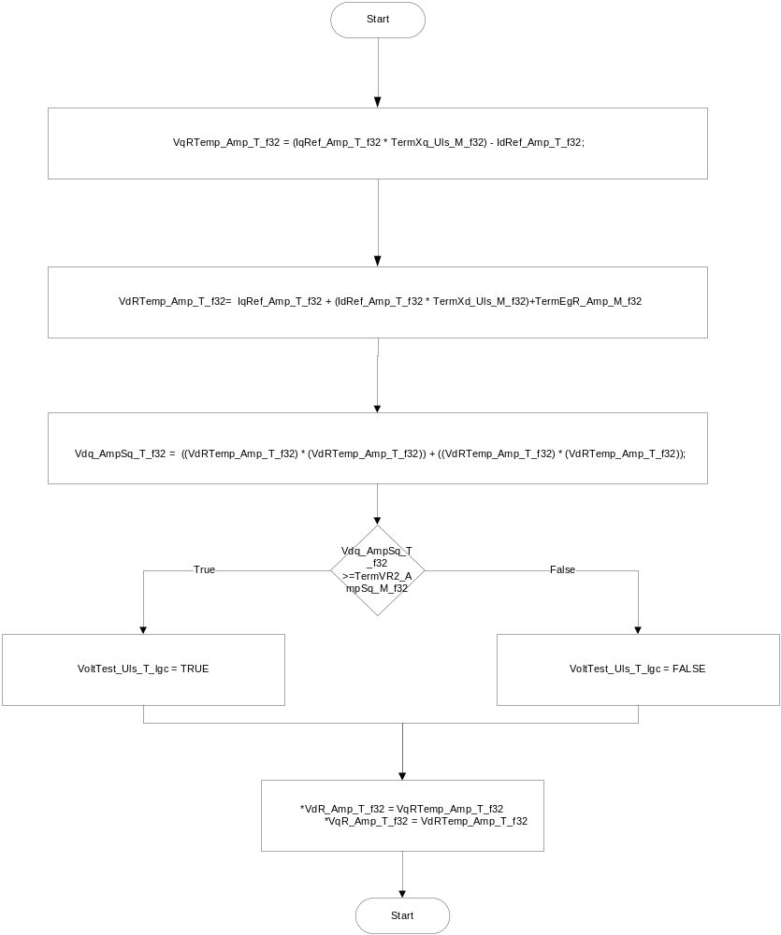

Local Function #5
Function Name | CalcTorque | Type | Min | Max | UTP Tol.
Arguments Passed | CosDelta_Cnt_T_f32 | Float32 | 0 | 1
 | SinDelta_Cnt_T_f32 | Float32 | 0 | 1
 | *IdMax_Amp_T_f32 | Float32 | -220 | 220
Return Value | TorqueCalc_MtrNm_T_f32 | Float32 | -8.8 | 8.8

Description
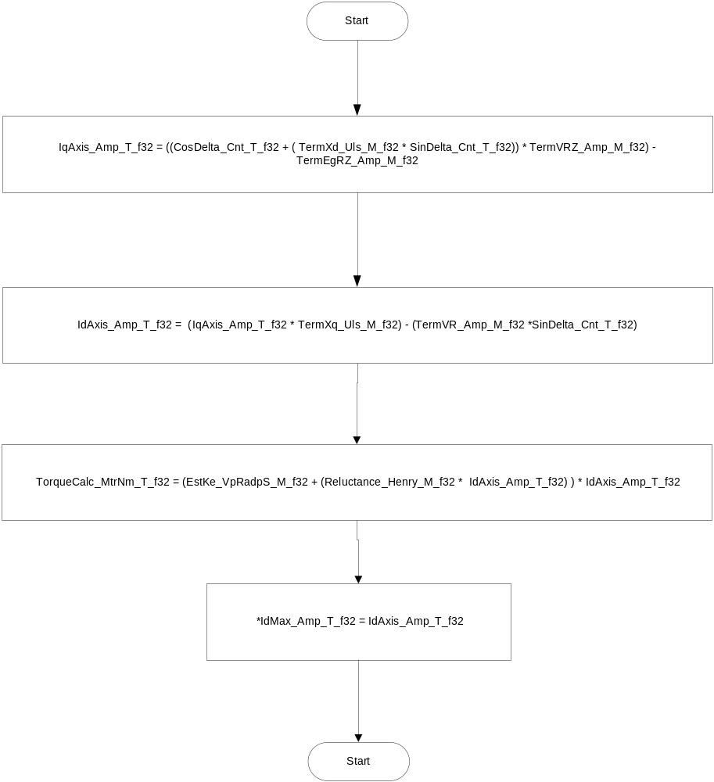

Local Function #6
Function Name | LocateTrqExtremese | Type | Min | Max | UTP Tol.
Arguments Passed | MtrTrqCmd_MtrNm_T_f32 | Float32 | -8.8 | 8.8
 | *IdMax_Amp_T_f32 | Float32 | -220 | 220
 | *PhsAdvPeak_Rad_T_f32 | Float32 | -2*pi | +2*pi
Return Value | LimitedMRFMtrTrqCmd_MtrNm_T_f32 | Float32 | -8.8 | 8.8

Description

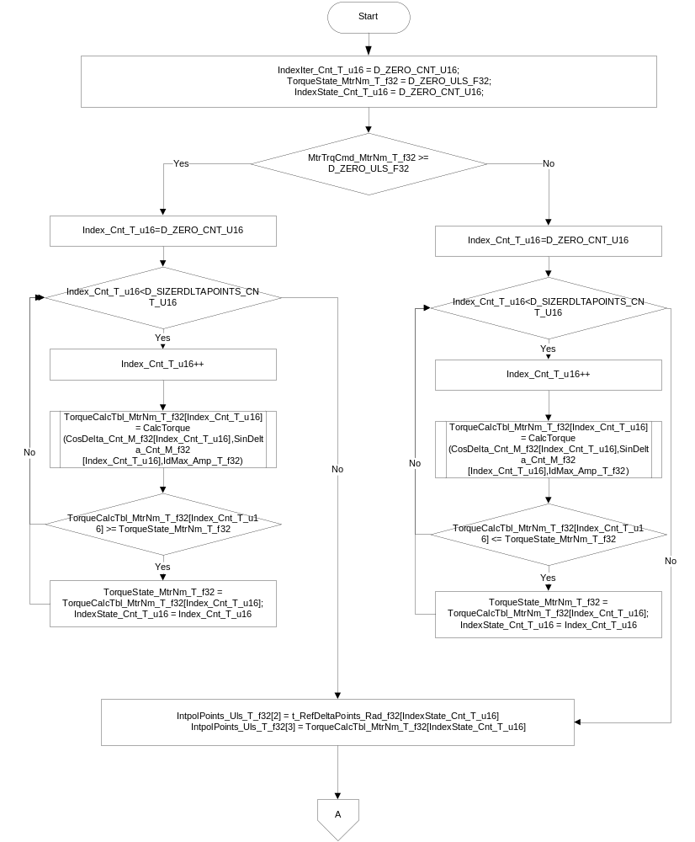

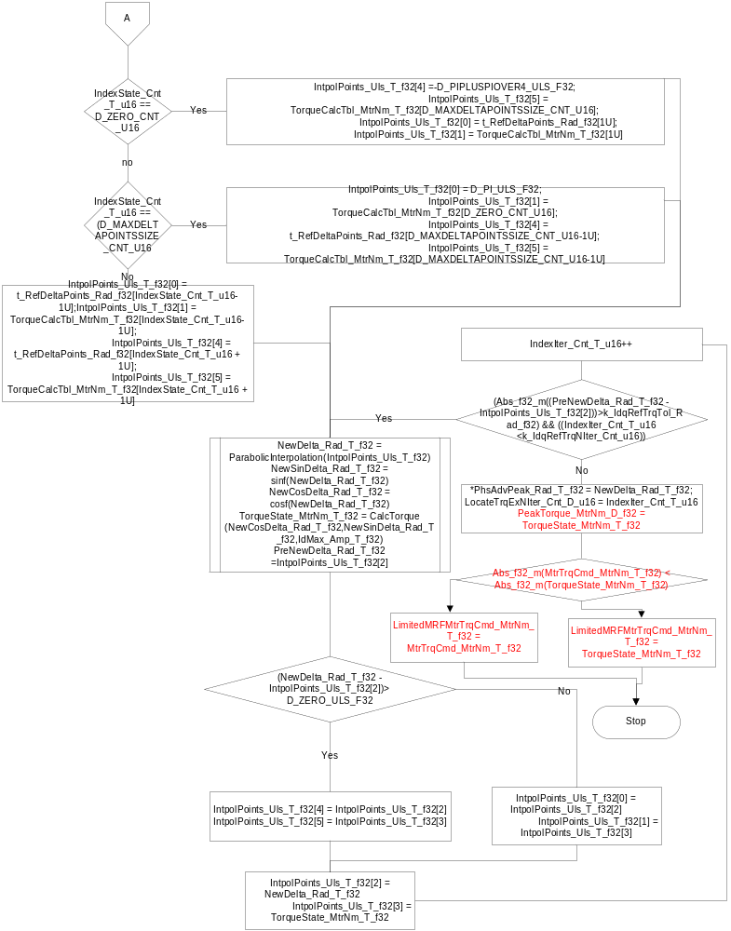

Local Function #7
Function Name | LocateMinimumIm | Type | Min | Max | UTP Tol.
Arguments Passed | MtrTrqCmd_MtrNm_T_f32 | Float32 | -8.8 | 8.8
 | * IdMin_Amp_T_f32 | Float32 | -220 | 220
 | * IqMin_Amp_T_f32 | Float32 | -220 | 220
Return Value | ImSqrMin_AmpSq_T_f32 | Float32 | 0 | 96800

Description

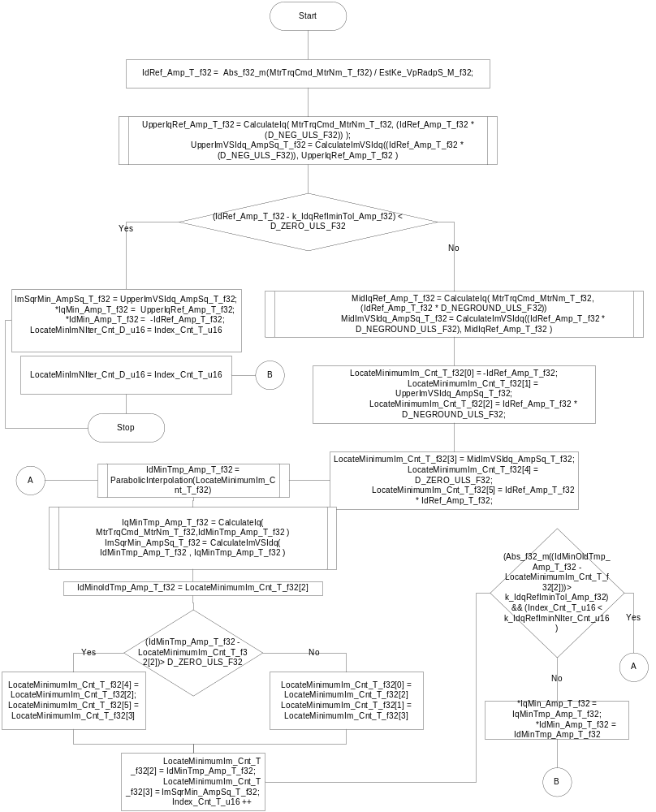

Local Function #8
Function Name | CalLowPassFiltBilinearOut | Type | Min | Max | UTP Tol.
Arguments Passed | Input_Uls_T_f32 | Float32 | FULL RANGE | FULL RANGE
 | *LowPassFiltBilinear_T_Str | LowPassFiltBilinear_Str | FULL RANGE | FULL RANGE
Return Value | Output_Uls_T_f32 | Float32 | FULL RANGE | FULL RANGE

Description
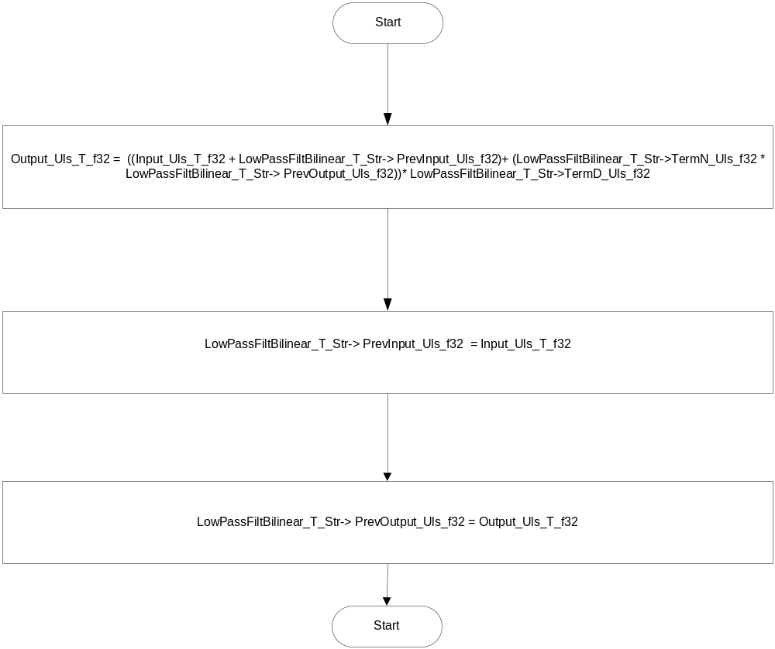

Local Function #9 CalLowPassFiltBilinearTerm
Function Name | CalLowPassFiltBilinearTerm | Type | Min | Max | UTP Tol.
Arguments Passed | Freq_Hz_T_f32 | Float32 | FULL RANGE | FULL RANGE
 | TimeCons_Sec_T_f32 | Float32 | FULL RANGE | FULL RANGE
Return Value | LowPassFiltBilinear_T_Str | LowPassFiltBilinear_Str | FULL RANGE | FULL RANGE

Description
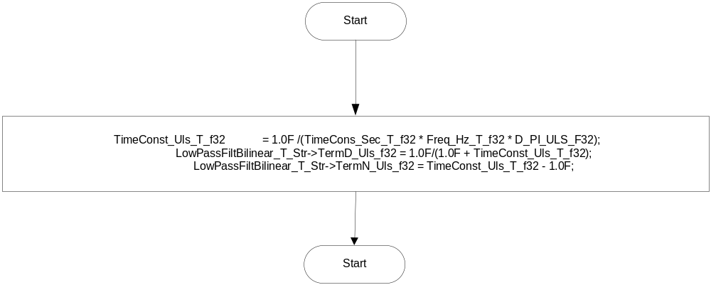

Local Function #10
Function Name | AngleWrap | Type | Min | Max | UTP Tol.
Arguments Passed | MtrCurrAngle_Rev_T_f32 | Float32 | -1 | 1
Return Value | MtrCurrAngle_Rev_T_f32 | Float32 | 0 | 1

Description
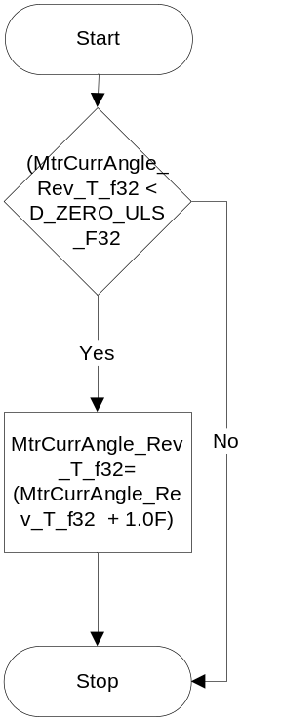

Local Function #11
Function Name | CalculateIdBoost | Type | Min | Max | UTP Tol.
Arguments Passed | *IqMin_Amp_T_f32 | Float32 | -220 | 220
 | *IdMin_Amp_T_f32 | Float32 | -220 | 220
 | LimitedMRFMtrTrqCmd_MtrNm_T_f32 | Float32 | -8.8 | 8.8
 | IdMax_Amp_T_f32 | Float32 | -220 | 220
Return Value | None

Description
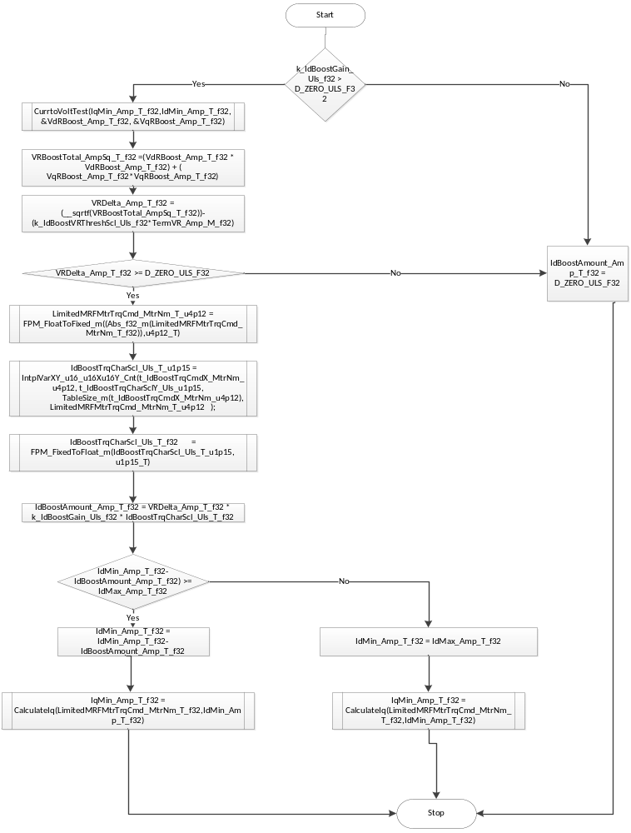

Software Module Implementation

Runtime Environment (RTE) Initial Values
This section lists the initial values of data written by this module but controlled by the RTE. After RTE initialization, the data in this table will contain these values.
Data | Value
Rte_InitValue_DaxIntegralGain_Uls_f32 | 0
Rte_InitValue_DaxPropotionalGain_Uls_f32 | 0
Rte_InitValue_EstKe_VpRadpS_f32 | 0
Rte_InitValue_EstLd_Henry_f32 | 0
Rte_InitValue_EstLq_Henry_f32 | 0
Rte_InitValue_EstR_Ohm_f32 | 0
Rte_InitValue_MRFMtrVel_MtrRadpS_f32 | 0
Rte_InitValue_MRFTrqCmdScl_MtrNm_f32 | 0
Rte_InitValue_MtrCurrAngle_Rev_f32 | 0
Rte_InitValue_MtrCurrDaxRef_Amp_f32 | 0
Rte_InitValue_MtrCurrQaxRef_Amp_f32 | 0
Rte_InitValue_MtrPosComputationDelay_Deg_f32 | 0
Rte_InitValue_MtrTrqCmdSign_Cnt_s16 | 0
Rte_InitValue_MtrVoltDaxFF_Volt_f32 | 0
Rte_InitValue_MtrVoltQaxFF_Volt_f32 | 0
Rte_InitValue_QaxIntegralGain_Uls_f32 | 0
Rte_InitValue_QaxPropotionalGain_Uls_f32 | 0
Rte_InitValue_VehSpd_Kph_f32 | 0
FastDataAccessBufIndex | 0

Initialization Functions

CurrCmd_Init

Program Flow Start
Rte_Call_CurrCmd_Per1_CP0_CheckpointReached()

Processing

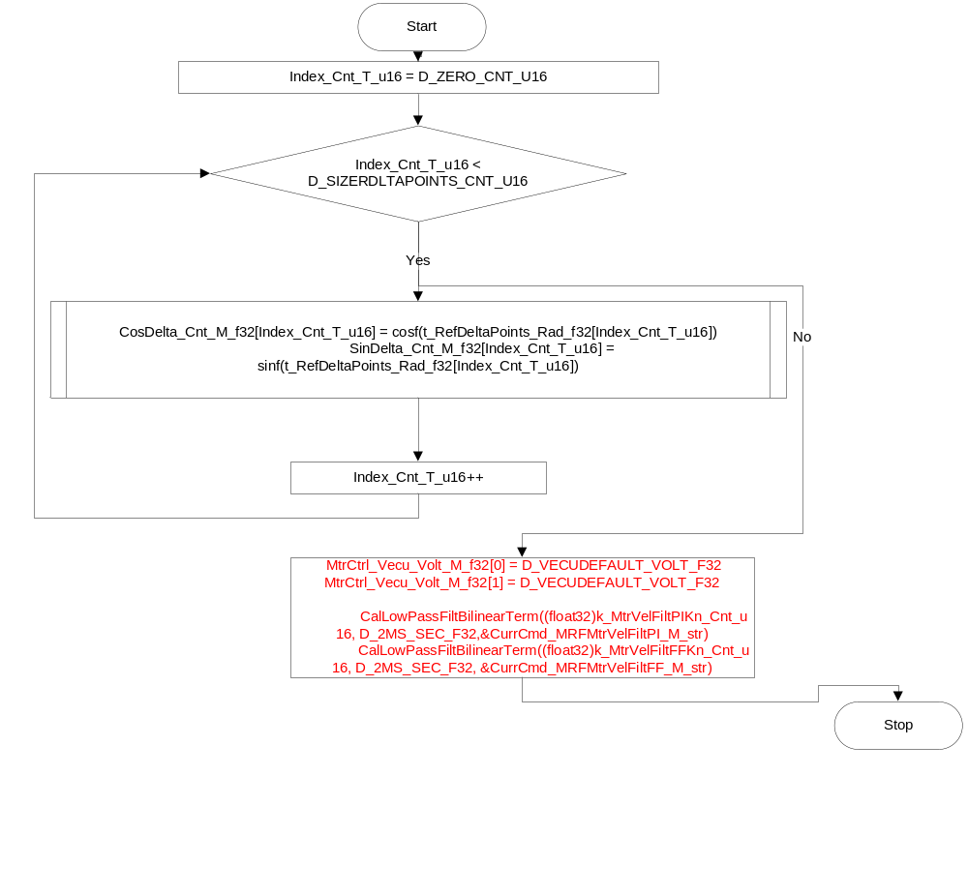

Periodic Functions

Per: CurrCmd_Per1

Design Rationale
None

Program Flow Start
Rte_Call_CurrCmd_Per1_CP0_CheckpointReached()

Store Module Inputs to Local copies
WriteAccessBufIndex_Cnt_T_u16= (FastDataAccessBufIndex_Cnt_M_u16&1)^1;
MRFMtrTrqCmd_MtrNm_T_f32=Rte_Iread_CurrCmd_Per1_MRFTrqCmdScl_MtrNm_f32
MRFMtrVel_MtrRadpS_T_f32=Rte_Iread_CurrCmd_Per1_MRFMtrVel_MtrRadpS_f32
EstKe_VpRadpS_T_f32=Rte_Iread_CurrCmd_Per1_EstKe_VpRadpS_f32
EstR_Ohm_T_f32=Rte_Iread_CurrCmd_Per1_EstR_Ohm_f32
EstLd_Henry_T_f32=Rte_Iread_CurrCmd_Per1_EstLd_Henry_f32
EstLq_Henry_T_f32=Rte_Iread_CurrCmd_Per1_EstLq_Henry_f32
VehSpd_Kph_T_f32=Rte_Iread_CurrCmd_Per1_VehSpd_Kph_f32
MtrQuad_Cnt_T_u8 = Rte_Iread_CurrCmd_Per1_MtrQuad_Cnt_u08
CurrentGainSvc_Cnt_T_lgc = Rte_IRead_CurrCmd_Per1_CurrentGainSvc_Cnt_lgc()
Vecu_Volt_T_f32 = Limit_m(Vecu_Volt_T_f32, D_VECUMIN_VOLTS_F32, D_VECUMAX_VOLTS_F32)
IvtrLoaMtgtnEn_Cnt_T_lgc = Rte_IRead_CurrCmd_Per1_IvtrLoaMtgtnEn_Cnt_lgc()
MotCurrLoaMtgtnEn_Cnt_T_lgc= Rte_IRead_CurrCmd_Per1_MotCurrLoaMtgtnEn_Cnt_lgc()
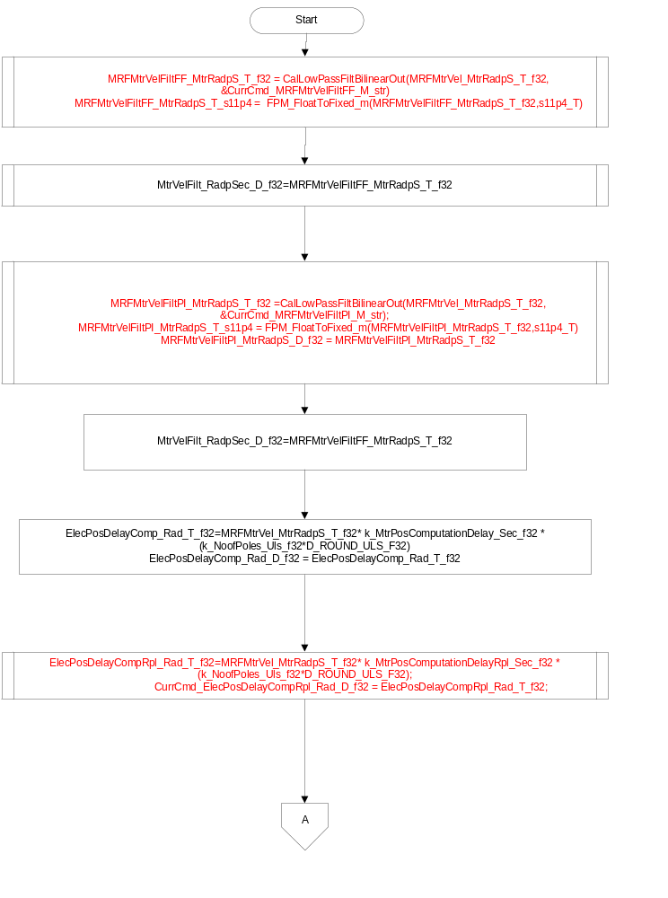
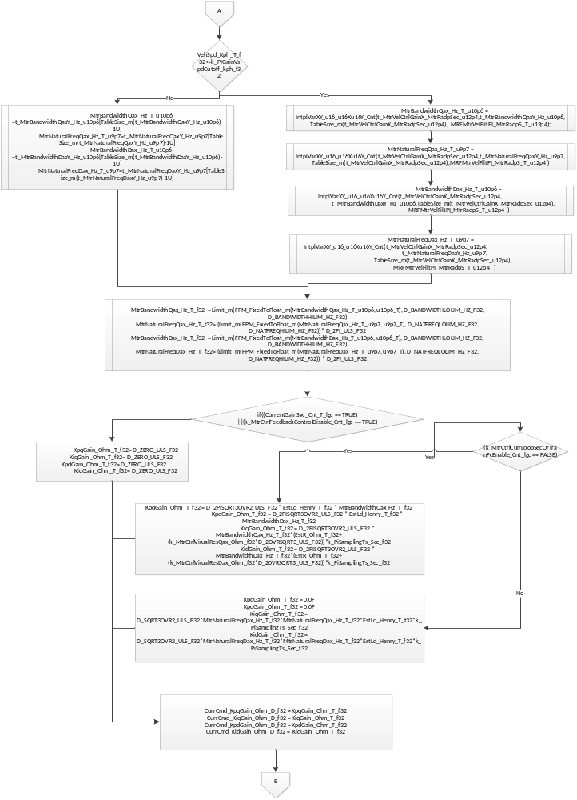
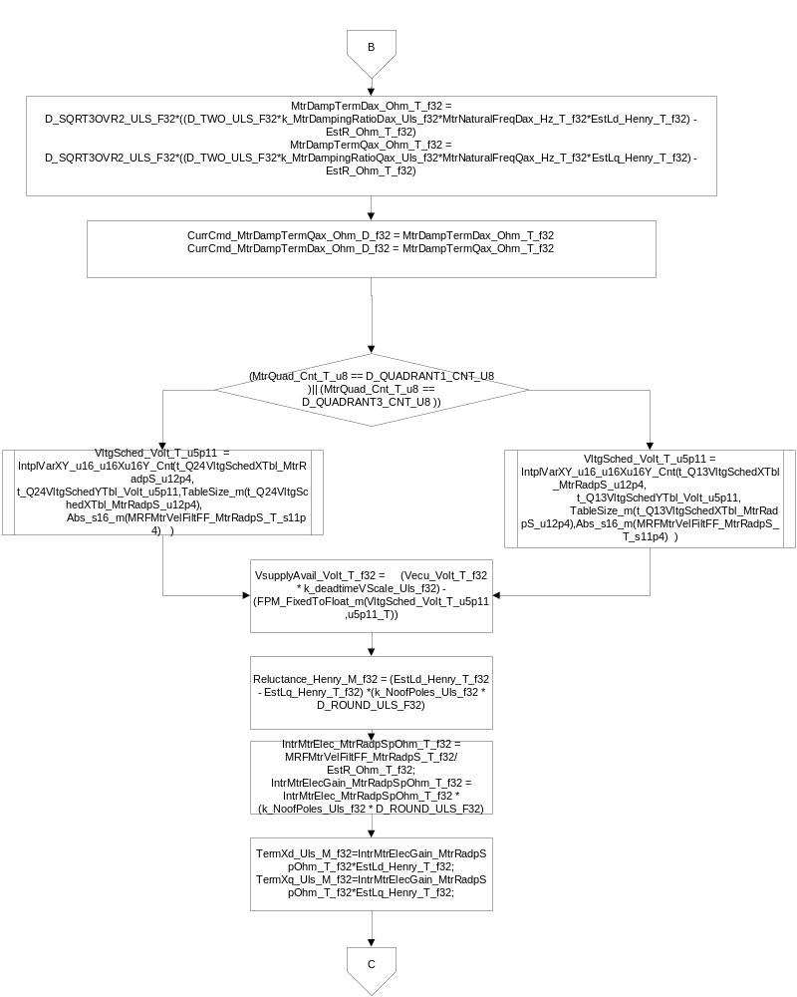
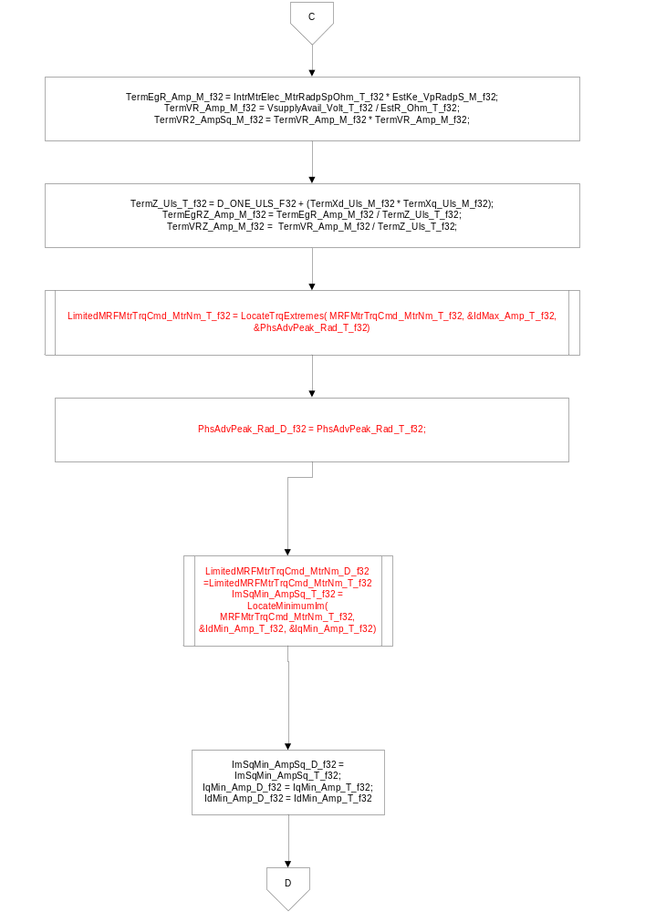

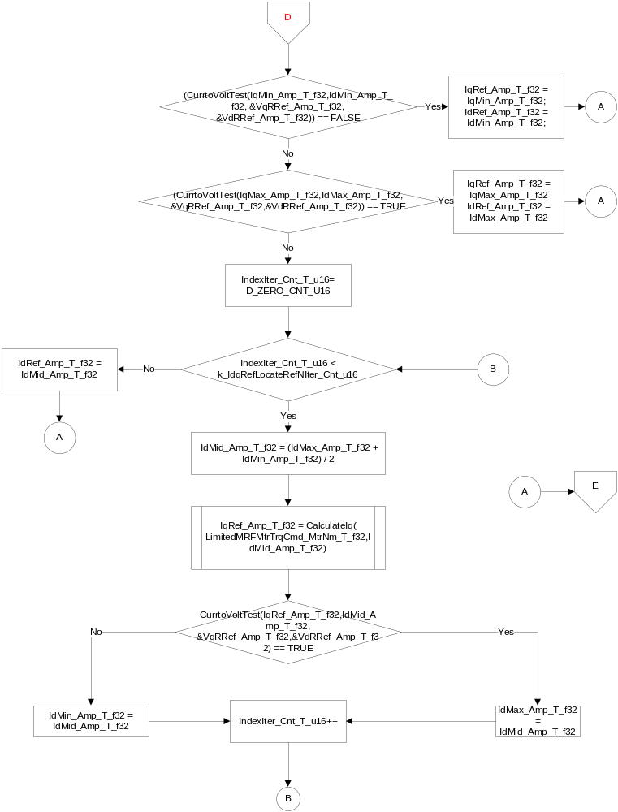
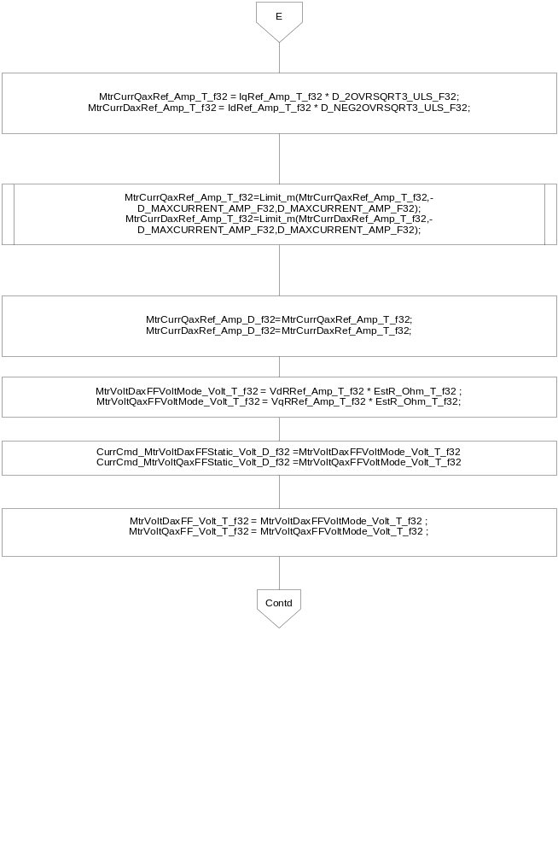

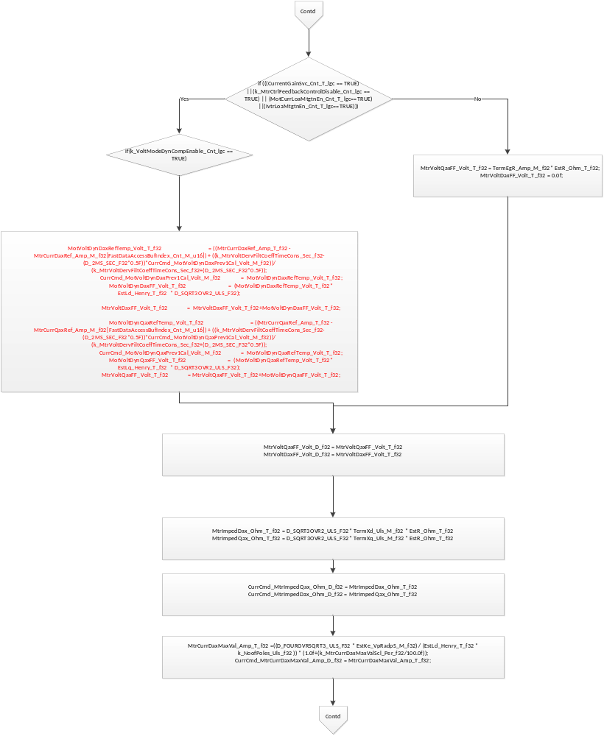

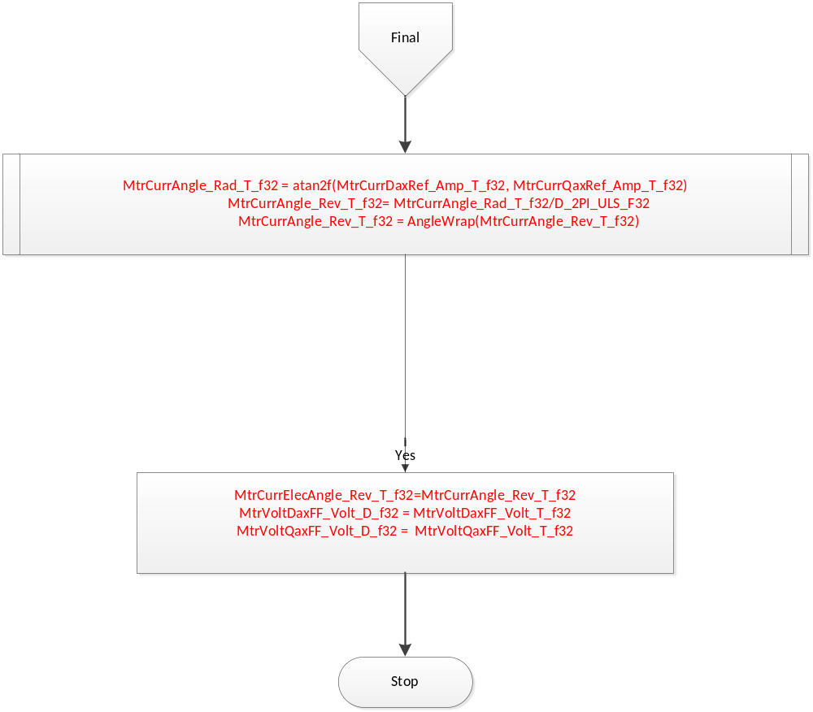

Store Local copy of outputs into Module Outputs

MtrCurrQaxRef_Amp_M_f32[WriteAccessBufIndex_Cnt_T_u16] = MtrCurrQaxRef_Amp_T_f32;
MtrCurrDaxRef_Amp_M_f32[WriteAccessBufIndex_Cnt_T_u16] = MtrCurrDaxRef_Amp_T_f32;
MtrCtrl_MtrDaxIntegralGain_Ohm_M_f32[WriteAccessBufIndex_Cnt_T_u16] = KidGain_Ohm_T_f32
MtrCtrl_MtrDaxPropotionalGain_Ohm_M_f32[WriteAccessBufIndex_Cnt_T_u16] = KpdGain_Ohm_T_f32
MtrCtrl_MtrQaxIntegralGain_Ohm_M_f32[WriteAccessBufIndex_Cnt_T_u16] = KiqGain_Ohm_T_f32
MtrCtrl_MtrQaxPropotionalGain_Ohm_M_f32[WriteAccessBufIndex_Cnt_T_u16] = KpqGain_Ohm_T_f32
Rte_IWrite_CurrCmd_Per1_MtrCurrDaxRef_Amp_f32(MtrCurrDaxRef_Amp_T_f32)
Rte_IWrite_CurrCmd_Per1_MtrCurrQaxRef_Amp_f32(MtrCurrQaxRef_Amp_T_f32)
Rte_IWrite_CurrCmd_Per1_MtrCurrAngle_Rev_f32(MtrCurrAngle_Rev_T_f32)

MtrCtrl_MtrVoltDaxFF_Volt_M_f32[WriteAccessBufIndex_Cnt_T_u16] = MtrVoltDaxFF_Volt_T_f32
MtrCtrl_MtrVoltQaxFF_Volt_M_f32[WriteAccessBufIndex_Cnt_T_u16] = MtrVoltQaxFF_Volt_T_f32
MtrPosComputationDelay_Rad_M_f32[WriteAccessBufIndex_Cnt_T_u16] = ElecPosDelayComp_Rad_T_f32
MtrCtrl_MtrDampTermDax_Ohm_M_f32[WriteAccessBufIndex_Cnt_T_u16] = MtrDampTermDax_Ohm_T_f32
MtrCtrl_MtrDampTermQax_Ohm_M_f32[WriteAccessBufIndex_Cnt_T_u16] = MtrDampTermQax_Ohm_T_f32
MtrCtrl_MtrImpedDax_Ohm_M_f32[WriteAccessBufIndex_Cnt_T_u16] = MtrImpedDax_Ohm_T_f32
MtrCtrl_MtrImpedQax_Ohm_M_f32[WriteAccessBufIndex_Cnt_T_u16] = MtrImpedQax_Ohm_T_f32
MtrCtrl_MtrCurrDaxMaxVal_Amp_M_f32[WriteAccessBufIndex_Cnt_T_u16]=MtrCurrDaxMaxVal_Amp_T_f32
MtrCtrl_MtrPosComputationDelayRpl_Rad_M_f32[WriteAccessBufIndex_Cnt_T_u16] = ElecPosDelayCompRpl_Rad_T_f32
MtrCtrl_Vecu_Volt_M_f32[WriteAccessBufIndex_Cnt_T_u16] = Vecu_Volt_T_f32

Program Flow End
Rte_Call_CurrCmd_Per1_CP1_CheckpointReached()

Fault Recovery Functions

None

Shutdown Functions

None

Interrupt Functions

None

Serial Communication Functions

None

Execution Requirements

Execution Sequence of the Module
(Describe in words relevant details about the execution sequence of the different sub modules.)

Execution Rates for sub-modules called by the Scheduler
This table serves as reference for the Scheduler design
Function Name | Calling Frequency | System State(s) in which the function is called
CurrCmd_Per1 | 2ms | ALL
CurrCmd_Init | At init | ALL

Execution Requirements for Serial Communication Functions
Function Name | Sub-Module called by (Serial Comm Function Name)
None

Memory Map Definition Requirements

Sub Modules (Functions)
This table identifies the software segments for functions identified in this module.
Name of Sub Module | Software Segment
CurrCmd_Per1 | RTE_START_SEC_AP_CURRCMD_APPL_CODE
CurrCmd_Init | RTE_START_SEC_AP_CURRCMD_APPL_CODE

Local Functions
This table identifies the software segments for local functions identified in this module.
Name of Sub Module | Software Segment
ParabolicInterpolation | RTE_START_SEC_AP_CURRCMD_APPL_CODE
CalculateIq | RTE_START_SEC_AP_CURRCMD_APPL_CODE
CalculateImVSIdq | RTE_START_SEC_AP_CURRCMD_APPL_CODE
CurrtoVoltTest | RTE_START_SEC_AP_CURRCMD_APPL_CODE
CalcTorque | RTE_START_SEC_AP_CURRCMD_APPL_CODE
LocateTrqExtremes | RTE_START_SEC_AP_CURRCMD_APPL_CODE
LocateMinimumIm | RTE_START_SEC_AP_CURRCMD_APPL_CODE
CalLowPassFiltBilinearTerm | RTE_START_SEC_AP_CURRCMD_APPL_CODE
CalLowPassFiltBilinearOut | RTE_START_SEC_AP_CURRCMD_APPL_CODE
AngleWrap | RTE_START_SEC_AP_CURRCMD_APPL_CODE
CalculateIdBoost | RTE_START_SEC_AP_CURRCMD_APPL_CODE

Known Issues / Limitations With Design
- Global Macro’s are not unit tested.

Revision Control Log
Item # | Rev # | Change Description | Date | Author Initials
1 | 1.0 | Initial version | 15th-May-12 | KPIT-RT
2 | 2.0 | Partial implementation of SF-99B v004 | 20-Sep-12 | OT
3 | 3.0 | Checkpoints and memmap statements added | 20-Nov-12 | Selva
4 | 4.0,5.0 | Implementation of SF99 v8 | 23-Mar-13  19-Apr-13 | Selva
6 | 6.0 | Corrected for A5883. Corrected LocateMinimumIm | 21-Oct-13 | Selva
7 | 7.0 | Updated for v11 FDD99B | 6-Nov-13 | Selva
8 | 8,0 | Corrected for NewDelta calculation / Updated for v11 FDD99B UTP fixes | 8-Nov-13 | Selva
9 | 9.0 | Updated for V12 of FDD SF99 | 26-Nov-13 | Selva
10 | 10.0 | Updated for v15 of FDD SF99B | 20-Mar-15 | Selva
11 | 11.0 | Updated for V17 of FDD SF99 EA3#A283,EA3#1777 fixed | 21-Aug-15 | Selva

