Module – Serial Communications Output

High-Level Description
The Serial Communications Output module provides a signal level interface between the EPS application layer and the serial communications software. Provide for the network management functionality for the serial communications interface. This module will be customized for each distinct vehicle platform. This module will be responsible for converting the range and resolution of the Application Layer variables to the range and resolution of the associated serial communications signals.
This module processes the data for transmit signals that are sent from the EPS controller to other ECUs on the communication bus. Global application input data is scaled appropriately and then transferred to the serial communications Interaction Layer using function calls or macros provided. Similarly, the Serial Communications Input module, takes the signal data that is received from the Interaction Layer, scales the data as required by the EPS controller and transfers the updated global data to the EPS application software.

Figures

Component Diagram
This diagram shows all data that is shared between functions within the module.

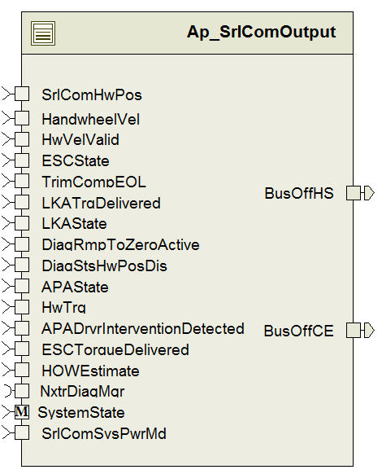

Variable Data Dictionary
For details on module input / output variable, refer to the Data Dictionary for the application. Input / output variable names are listed here for reference.
(Note: Full variable names required in table.)
Module Inputs (Global Variable Name) | Module Outputs (Global Variable Name)
LKATrqDelivered_HwNm_f32 | BusOffCE_Cnt_lgc
HwTrq_HwNm_f32 | BusOffHS_Cnt_lgc
LKAState_State_enum
HOWEstimate_Uls_f32
SrlComHwPosStatus_Cnt_u16
SrlComHwPos_HwDeg_f32
HwVelValid_Cnt_lgc
APADrvrInterventionDetected_Cnt_lgc
APAState_State_enum
Rte_TrqOvlSta_TrqOvlStaMfgEnable_Cnt_b08
TrimCompEOL_Cnt_lgc
HandwheelVel_HwRadpS_f32
ESCState_State_enum
ESCTorqueDelivered_HwNm_f32
DiagRmpToZeroActive_Cnt_lgc
DiagStsHwPosDis_Cnt_lgc
SrlComSysPwrMd_Cnt_enum

Module Internal Variables
This section identifies the name, range and resolutions for module specific data created by this module. If there are no range restrictions on the variable, the term “FULL” is placed into the table for legal range.
Variable Name | Resolution | Legal Range  (min) | Legal Range  (max) | Software Segment
DTCTriggeredFlag_Cnt_M_lgc[DEM_MAX_NUMBER_EVENT_ENTRY + 1] | See Data Dictionary | See Data Dictionary | See Data Dictionary | SRLCOMOUTPUT_START_SEC_VAR_CLEARED_UNSPECIFIED
DTCFailed_Cnt_M_lgc[DEM_MAX_NUMBER_EVENT_ENTRY + 1] | See Data Dictionary | See Data Dictionary | See Data Dictionary | SRLCOMOUTPUT_START_SEC_VAR_CLEARED_UNSPECIFIED
CurrentDTCSentThisIC_Cnt_M_lgc | See Data Dictionary | See Data Dictionary | See Data Dictionary | SRLCOMOUTPUT_START_SEC_VAR_CLEARED_UNSPECIFIED
DTCData | See Data Dictionary | See Data Dictionary | See Data Dictionary | SRLCOMOUTPUT_START_SEC_VAR_CLEARED_UNSPECIFIED
BusOffPresentChannel0_Cnt_M_lgc | See Data Dictionary | See Data Dictionary | See Data Dictionary | SRLCOMOUTPUT_START_SEC_VAR_CLEARED_UNSPECIFIED
BusOffPresentChannel1_Cnt_M_lgc | See Data Dictionary | See Data Dictionary | See Data Dictionary | SRLCOMOUTPUT_START_SEC_VAR_CLEARED_UNSPECIFIED
BusOffDiagActiveChannel0_Cnt_M_lgc | See Data Dictionary | See Data Dictionary | See Data Dictionary | SRLCOMOUTPUT_START_SEC_VAR_CLEARED_UNSPECIFIED
BusOffDiagActiveChannel1_Cnt_M_lgc | See Data Dictionary | See Data Dictionary | See Data Dictionary | SRLCOMOUTPUT_START_SEC_VAR_CLEARED_UNSPECIFIED
CTCEventId_Cnt_M_u8 | See Data Dictionary | See Data Dictionary | See Data Dictionary | SRLCOMOUTPUT_START_SEC_VAR_CLEARED_8
CTCEventIdSV_Cnt_M_u8 | See Data Dictionary | See Data Dictionary | See Data Dictionary | SRLCOMOUTPUT_START_SEC_VAR_CLEARED_8
GMStatus_Cnt_M_u8[D_NUMOFDEMEVENTS_CNT_U08 + 1] | See Data Dictionary | See Data Dictionary | See Data Dictionary | SRLCOMOUTPUT_START_SEC_VAR_CLEARED_8
LastReportedDTCEventID_Cnt_M_u8 | See Data Dictionary | See Data Dictionary | See Data Dictionary | SRLCOMOUTPUT_START_SEC_VAR_CLEARED_8
StartTimerToSetDTCFlag_mS_M_u32p0 | See Data Dictionary | See Data Dictionary | See Data Dictionary | SRLCOMOUTPUT_START_SEC_VAR_CLEARED_32
DemDTCNum_Cnt_M_u32[DEM_MAX_NUMBER_EVENT_ENTRY + 1] | See Data Dictionary | See Data Dictionary | See Data Dictionary | SRLCOMOUTPUT_START_SEC_VAR_CLEARED_32
LastReportedGMStatus_Cnt_M_u8 | See Data Dictionary | See Data Dictionary | See Data Dictionary | SRLCOMOUTPUT_START_SEC_VAR_CLEARED_8
LKATrqOvrlDlvdRC_Cnt_M_u8 | See Data Dictionary | See Data Dictionary | See Data Dictionary | SRLCOMOUTPUT_START_SEC_VAR_CLEARED_8
DrvStrIntfrDetARC_Cnt_M_u08 | See Data Dictionary | See Data Dictionary | See Data Dictionary | SRLCOMOUTPUT_START_SEC_VAR_CLEARED_8
ElcPwrStrAvalStatARC_Cnt_M_u08 | See Data Dictionary | See Data Dictionary | See Data Dictionary | SRLCOMOUTPUT_START_SEC_VAR_CLEARED_8
StWhlAngAliveRollCnt_Cnt_M_u08 | See Data Dictionary | See Data Dictionary | See Data Dictionary | SRLCOMOUTPUT_START_SEC_VAR_CLEARED_8
ESCRollCount_Cnt_T_u08 | See Data Dictionary | See Data Dictionary | See Data Dictionary | SRLCOMOUTPUT_START_SEC_VAR_CLEARED_8
StartTimerToSetDTCFlag_mS_M_u32p0 | See Data Dictionary | See Data Dictionary | See Data Dictionary | SRLCOMOUTPUT_START_SEC_VAR_CLEARED_8
DemDTCNum_Cnt_M_u32[D_NUMOFDEMEVENTS_CNT_U08 + 1U] | See Data Dictionary | See Data Dictionary | See Data Dictionary | SRLCOMOUTPUT_START_SEC_VAR_CLEARED_8
BusOffFltChannel0RecoverTimer_mS_M_u32 | See Data Dictionary | See Data Dictionary | See Data Dictionary | SRLCOMOUTPUT_START_SEC_VAR_CLEARED_8
BusOffFltChannel0DetectionTimer_mS_M_u32 | See Data Dictionary | See Data Dictionary | See Data Dictionary | SRLCOMOUTPUT_START_SEC_VAR_CLEARED_8
BusOffFltChannel1RecoverTimer_mS_M_u32 | See Data Dictionary | See Data Dictionary | See Data Dictionary | SRLCOMOUTPUT_START_SEC_VAR_CLEARED_8
BusOffFltChannel1DetectionTimer_mS_M_u32 | See Data Dictionary | See Data Dictionary | See Data Dictionary | SRLCOMOUTPUT_START_SEC_VAR_CLEARED_8
PrevWarningIndSignal_Cnt_M_u08[DEM_NUMBER_OF_INDICATORS] | See Data Dictionary | See Data Dictionary | See Data Dictionary | SRLCOMOUTPUT_START_SEC_VAR_CLEARED_8

3.1.1 User defined typedef definition/declaration
This section documents any user types uniquely used for the module.
Typedef Name | Element Name | User Defined Type | Legal Range  (min) | Legal Range  (max)
RT_DTC_Triggered_778 | DTCTriggered | DTCTriggered
RT_DTC_Triggered_778 | DTCSource | DTCSource
RT_DTC_Triggered_778 | DTCNumber | DTCNumber
RT_DTC_Triggered_778 | DTCFailType | DTCFailType
RT_DTC_Triggered_778 | DTCWrnIndRqdSt | DTCWrnIndRqdSt
RT_DTC_Triggered_778 | DTCTstFldPwrUpSt | DTCTstFldPwrUpSt
RT_DTC_Triggered_778 | DTCTstNPsdPwrupSt | DTCTstNPsdPwrUpSt
RT_DTC_Triggered_778 | DTCHistStat | DTCHistStat
RT_DTC_Triggered_778 | DTCTstFldCdClrdStat | DTCTstFldCdClrdStat
RT_DTC_Triggered_778 | DTCTstNPsdCdClrdSt | DTCTstNPsdCdClrdSt
RT_DTC_Triggered_778 | DTCCurrentStatus | DTCCurrentStatus
RT_DTC_Triggered_778 | DTCCodeSupported | DTCCodeSupported
RT_DTC_Triggered_778 | DTCFaulttype | DTCFaultType
DTCTriggered |  | boolean | FALSE | TRUE
DTCSource |  | Uint8 | 0 | 255
DTCNumber |  | Uint16 | 0 | 65535
DTCFailType |  | Uint8 | 0 | 255
DTCWrnIndRqdSt |  | Boolean | FALSE | TRUE
DTCTstFldPwrUpSt |  | Boolean | FALSE | TRUE
DTCTstNPsdPwrUpSt |  | Boolean | FALSE | TRUE
DTCHistStat |  | Boolean | FALSE | TRUE
DTCTstFldCdClrdStat |  | Boolean | FALSE | TRUE
DTCTstNPsdCdClrdSt |  | Boolean | FALSE | TRUE
DTCCurrentStatus |  | Boolean | FALSE | TRUE
DTCCodeSupported |  | Boolean | FALSE | TRUE
DTCFaultType |  | Uint8 | 0 | 255

Constant Data Dictionary

Calibration Constants
This section lists the calibrations used by the module. For details on calibration constants, refer to the Data Dictionary for the application.
Constant Name
k_MaxHOWEstimate_Uls_f32
k_SComTrqPosPol_Cnt_s08
k_LKAMfgEnable_Cnt_lgc
k_APAMfgEnable_Cnt_lgc
k_BusOffFaultTimeChannel0_mS_u16
k_BusOffRecoveryTimeChannel0_mS_u16
k_BusOffFaultTimeChannel1_mS_u16
k_BusOffRecoveryTimeChannel1_mS_u16

Program(fixed) Constants

Embedded Constants
All embedded constants whose values are provided in Eng units will be evaluated to the equivalent counts by using the FPM_InitFixedPoint_m() macro within the #define statement.

Local
Constant Name | Resolution | Value
D_TESTFAILED_CNT_U8 | 1 | 0x01
D_FAILEDTHISCYC_CNT_U8 | 1 | 0x02
D_CONFIRMED_CNT_U8 | 1 | 0x08
D_TESTNCTHISCYC_CNT_U8 | 1 | 0x40
D_WARNINGIND_CNT_U8 | 1 | 0x80
D_EPSSOURCEID_CNT_U16 | 1 | 0x31
Dem_Warning_Indicator * (defined in Dem.h) | 1 | 0
Dem_Steering_Reduced_Assist * (defined in Dem.h) | 1 | 1
D_NUMOFDEMEVENTS_CNT_U08 |  | 35
D_APAMFGENABLE_CNT_U08 |  | 0x02
D_INVALID_CNT_U08 |  | 0x01
D_VALID_CNT_U08 |  | 0x00
D_ENABLED_CNT_U08 |  | 1
D_FAILED_CNT_U08 |  | 2
D_LKAACTIVE_CNT_U08 |  | 1
D_HANDSON_CNT_U08 |  | 1
D_HANDSOFF_CNT_U08 |  | 0
D_DISABLED_CNT_U08 |  | 0
D_LKAMFGENABLE_CNT_U08 |  | 0x01
D_LKADRIVERAPPLIEDTORQUESF_NM_F32 |  | 0.01
D_LKADRIVERAPPLIEDTORQUEMAX_NM_F32 |  | 10.23
D_LKATRQDELIVEREDSF_NM_F32 |  | 0.01
D_LKATRQDELIVEREDMIN_NM_F32 |  | -10.24
D_LKATRQDELIVEREDMAX_NM_F32 |  | 10.23
D_TOTALTORQUESF_NM_F32 |  | 0.01
D_TOTALTORQUEMIN_NM_F32 |  | -10.24
D_TOTALTORQUEMAX_NM_F32 |  | 10.23
D_USEDATA_CNT_U08 |  | 1
D_DONTUSEDATA_CNT_U08 |  | 0
D_SENSORTYPE4_CNT_u08 |  | 3
D_CALSTATUNKNOWN_CNT_U08 |  | 0
D_CALSTATCALIBRATED_CNT_U08 |  | 2
D_STRWHANGSCALE_ULS_F32 |  | 0.0625
D_STRWHANGLOLMT_ULS_F32 |  | -2048
D_STRWHANGHILMT_ULS_F32 |  | 2047.9375
D_STRWHANGGRDLOLMT_ULS_F32 |  | -2048
D_STRWHANGGRDHILMT_ULS_F32 |  | 2047
D_WARNINGINDSTEERINGREDUCEDASSIST2_ENABLED |  | 0

Global
This section lists the global constants used by the module. For details on global constants, refer to the Data Dictionary for the application.
Constant Name
D_180OVRPI_ULS_F32

Module specific Lookup Tables Constants
(This is for lookup tables (arrays) with fixed values, same name as other tables)
Constant Name | Resolution | Value | Software Segment
none

Functions/Macros used by the Sub-Modules

Library Functions / Macros
The library functions / Macros that are called by the various sub modules are identified below,
- Limit_m

Data Hiding Functions
The data hiding functions / macros used in this module are identified below,
- Dem_GetIndicatorStatus
- IlPutTxPwrStrIO
- IlPutTxStrngAsstRdcdIO
- IlSetEvent
- IlPutTxStrAngSnsChksm_1
- IlPutTxStrAngSnsChksm_0
- IlPutTxStrWhAngGrdGroup_1
- IlPutTxStrWhAngGroup_1
- IlPutTxStrWhAngGrdGroup_0
- IlPutTxStrWhAngGroup_0
- IlPutTxStrWhAngGrd_1
- IlPutTxStrWhAngGrd_0
- IlPutTxStrWhAng_1
- IlPutTxStrWhAng_0
- IlPutTxStrWhlAngSenTyp_1
- IlPutTxStrWhlAngSenTyp_0
- IlPutTxStWhlAngAliveRollCnt_1
- IlPutTxStWhlAngAliveRollCnt_0
- IlPutTxStrWhlAngSenCalStat_1
- IlPutTxStrWhlAngSenCalStat_0
- IlPutTxStrWhAngGrdV_1
- IlPutTxStrWhAngGrdMsk_1
- IlPutTxStrWhAngGrdV_0
- IlPutTxStrWhAngGrdMsk_0
- IlPutTxStrWhAngV_1
- IlPutTxStrWhAngMsk_1
- IlPutTxStrWhAngV_0
- IlPutTxStrWhAngMsk_0
- IlPutTxDTCI_DTCFaultType_778
- IlPutTxLKADrvAppldTrqGroup
- IlPutTxHndsOffStrWhlDtStGroup
- Rte_Call_SystemTime_DtrmnElapsedTime_mS_u16
- Rte_Call_SystemTime_GetSystemTime_mS_u32
- Rte_Call_NxtrDiagMgr_GetNTCActive
- IlPutTxElecPwrStrAvalStat
- IlPutTxDrvStrIntfrDtcdV
- IlPutTxDrvStrIntfrDtcd
- IlPutTxDrvStrIntfrDetARC
- IlPutTxDrvStrIntfrDetPrtVal
- IlPutTxElcPwrStrAvalStatARC
- IlPutTxElcPwrStrAvalStatPVal
- IlPutTxDrvStrIntfrDtcdGroup
- CanPartOffline
- CanPartOnline
- IlPutTxElPwrStTtlTqDlrd
- IlPutTxTrqOvrlTrqDStat
- IlPutTxTrqOvrlDvrdARC
- IlPutTxTrqOvrlDltTrqDlrd
- IlPutTxTrqOvrlDChksm
- Rte_Call_NxtrDiagMgr_SetNTCStatus
Rte_Pim_DTCTrigSts[D_NUMOFDEMEVENTS_CNT_U08]

- IlPutTxStrAsstRdcdLvl2IO

Local Functions/Macros Used by this MDD only
(Note if they are defined in another source file, then reference the appropriate header file)
The local functions/macros in this module are identified below,

- ISOToGMStatus()
- SrlComOuput_BusOffHandlerInit()
- SrlComOutput_BusOffHandler(P2VAR(boolean, AUTOMATIC, AUTOMATIC) BusOffHS_Cnt_T_lgc, P2VAR(boolean, AUTOMATIC, AUTOMATIC) BusOffCE_Cnt_T_lgc)
- SrlComOutput_WarningIndicatorHandler(Dem_IndicatorIdType Dem_IndicatorId)

Note : Flow charts are not being updated as no value add observed.

Software Module Implementation

Initialization Functions

Init: SrlComOutput_Init1

Design Rationale
Request Full Communication mode.

Module Internal

Description
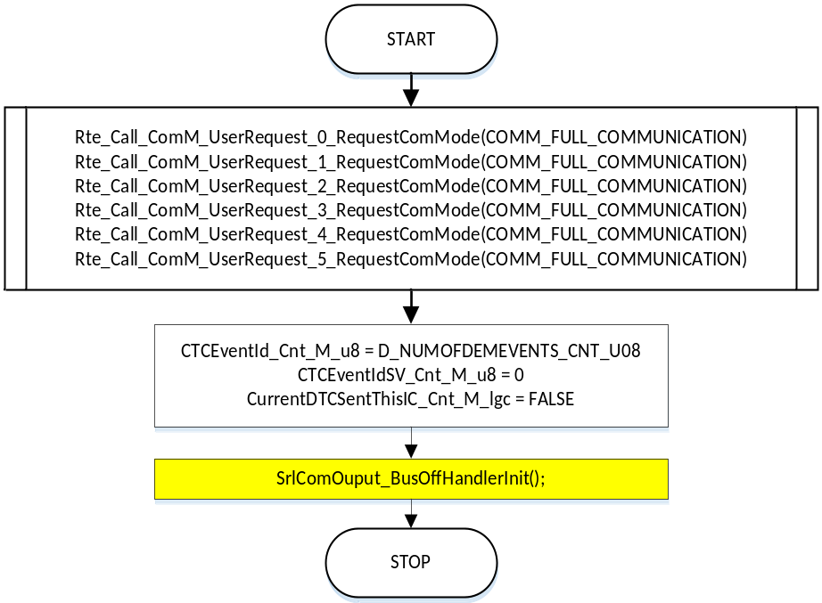

Module Outputs

Program Flow End
N/A

Periodic Functions

Per: SrlComOutput_Per1

Design Rationale
Process and update Transmit signal data.

Program Flow Start
N/A

Store Module Inputs to Local copies
See section below

Description
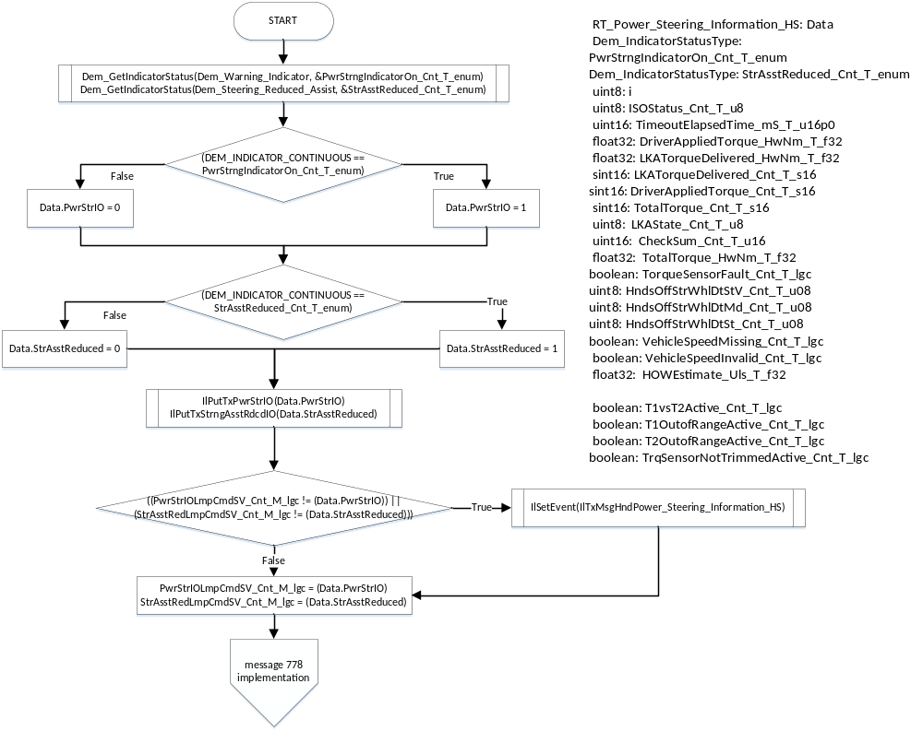

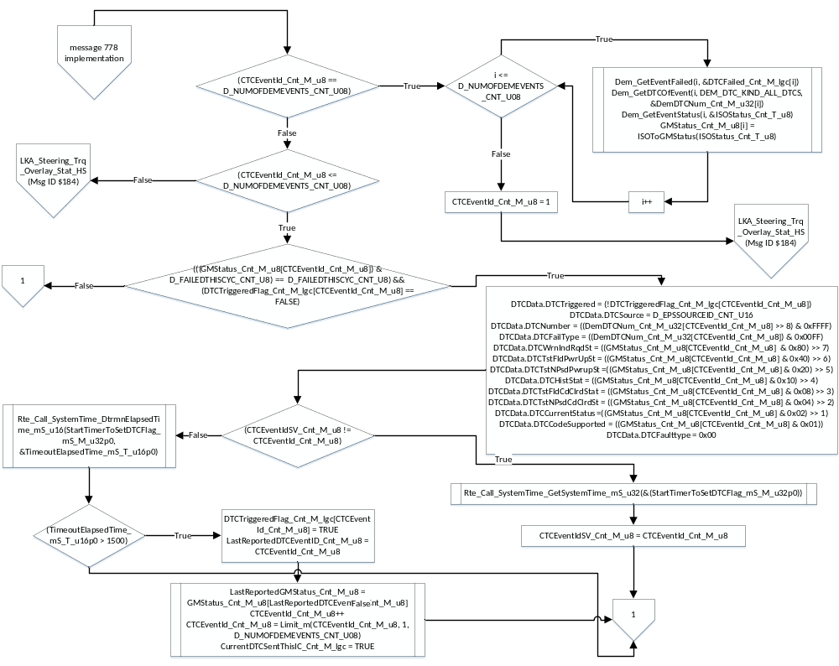

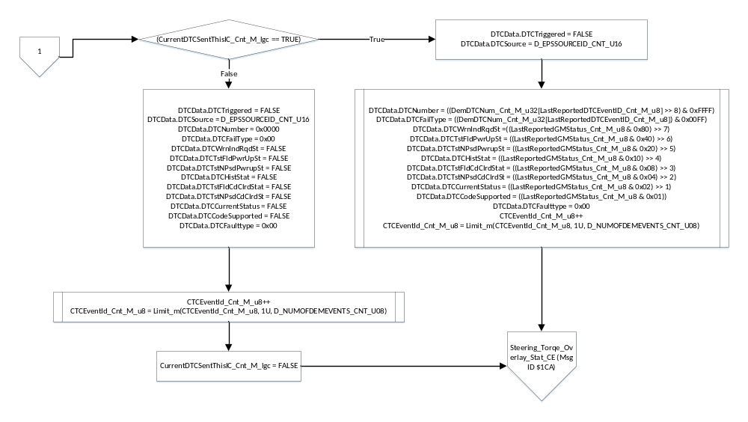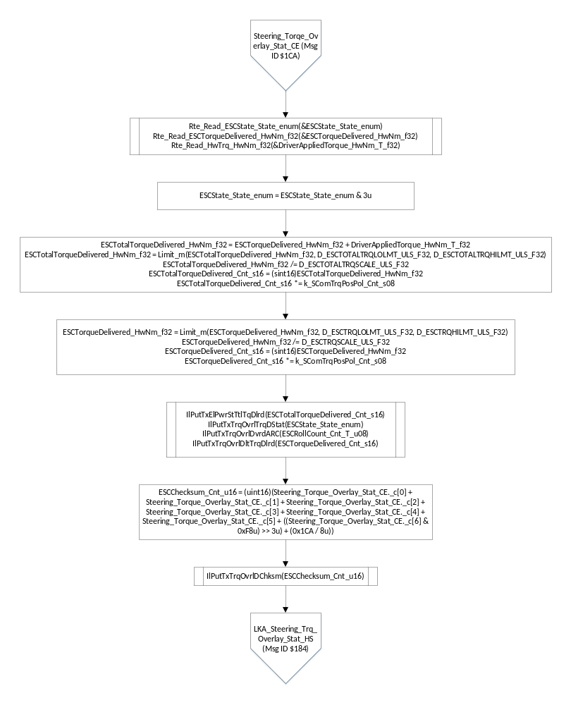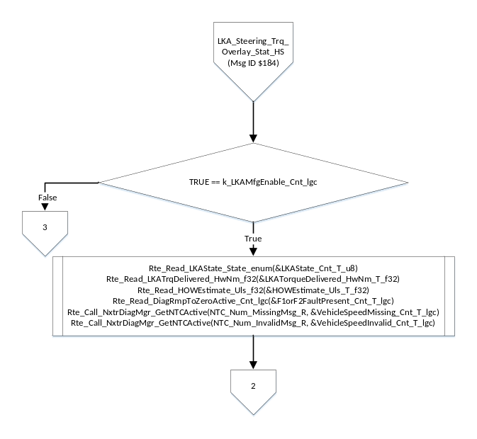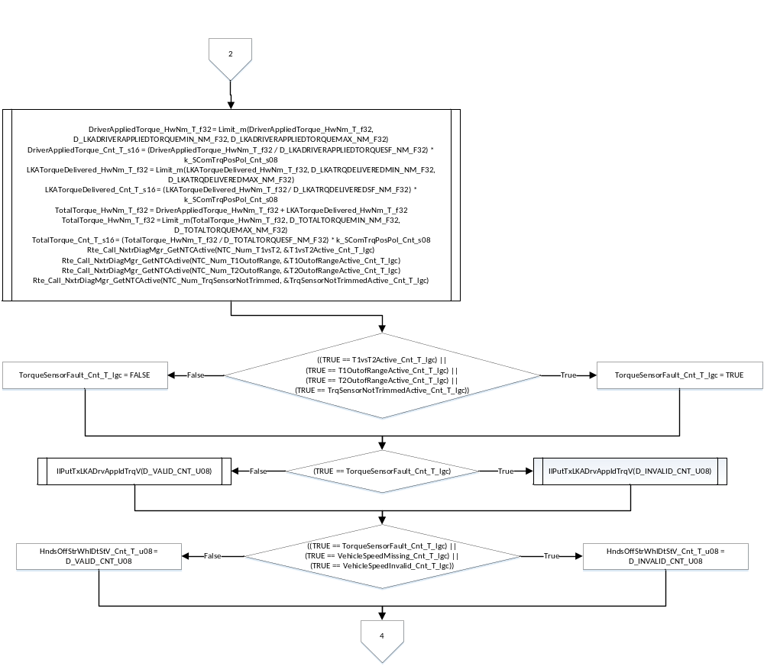
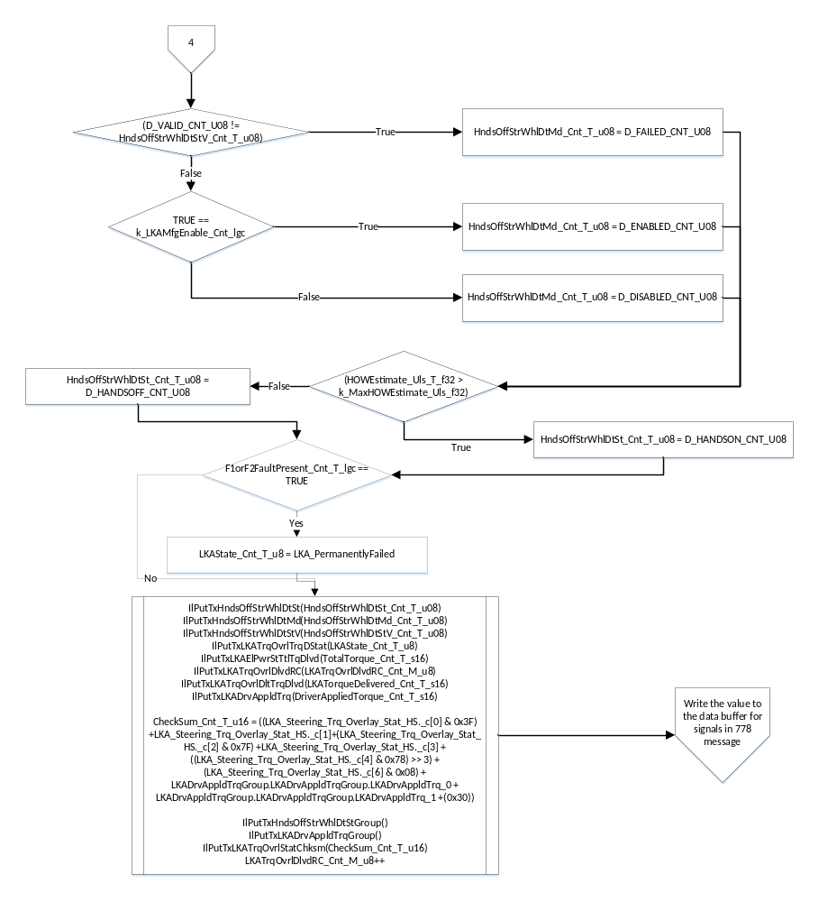

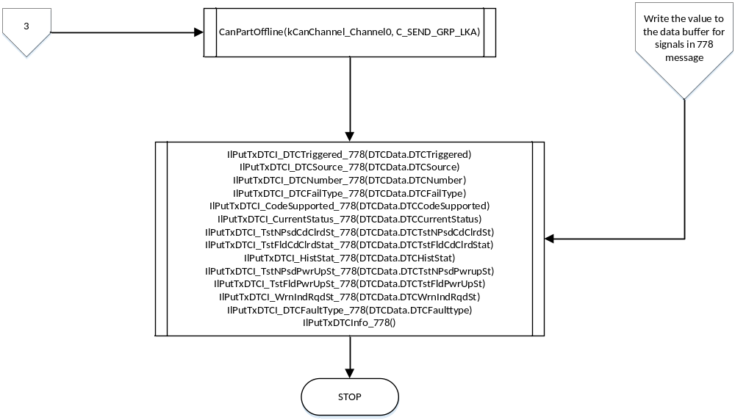

Store Local copy of outputs into Module Outputs
See section above.

Program Flow End
N/A

Per: SrlComOutput_Per2

Design Rationale
Process and update Transmit signal data.

Program Flow Start
N/A

Store Module Inputs to Local copies
See section below

Rte_Read_SrlComHwPos_HwDeg_f32(&SrlComHwPos_HwDeg_T_f32)
Rte_Read_SrlComHwPosStatus_Cnt_u16(&SrlComHwPosStatus_Cnt_T_u16)
Rte_Read_HandwheelVel_HwRadpS_f32(&HandwheelVel_HwRadpS_f32)
Rte_Read_HwVelValid_Cnt_lgc(&HandwheelVelValid_Cnt_lgc)
Rte_Read_TrimCompEOL_Cnt_lgc(&TrimCompEOL_Cnt_lgc)
Rte_Read_DiagStsHwPosDis_Cnt_lgc(&DiagStsHwPosDis_Cnt_T_lgc)
Rte_Read_APANonRecoverableFaults_Cnt_lgc(&APAFaultPresent_Cnt_T_lgc)
Rte_Read_SrlComSysPwrMd_Cnt_enum(&SysPwrMd_Cnt_T_enum)

6.2.2.4 Description

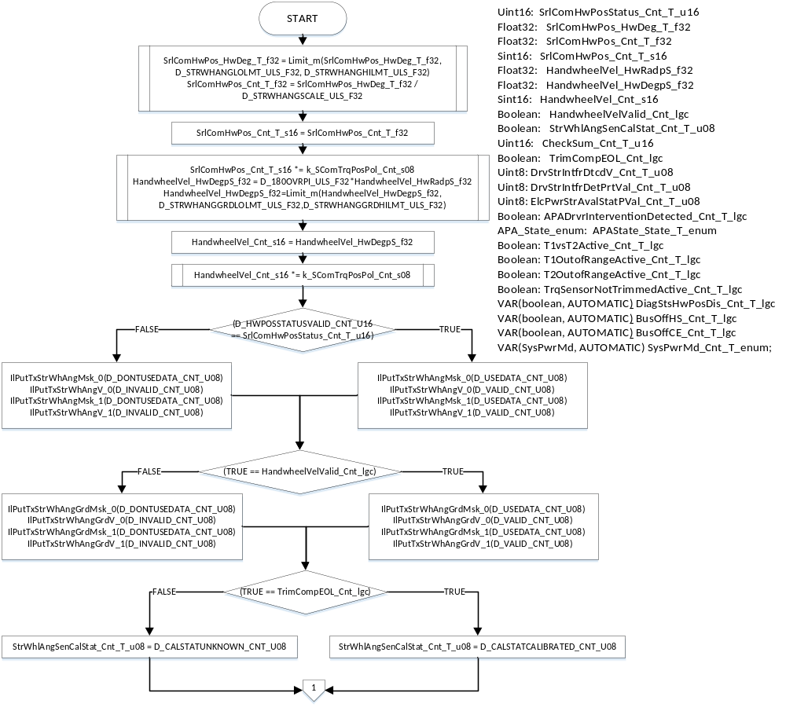
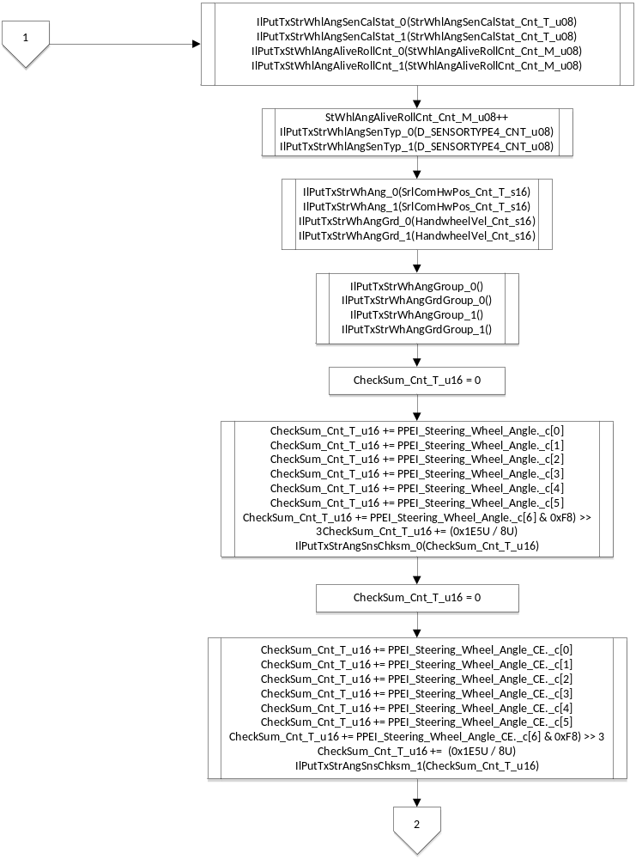

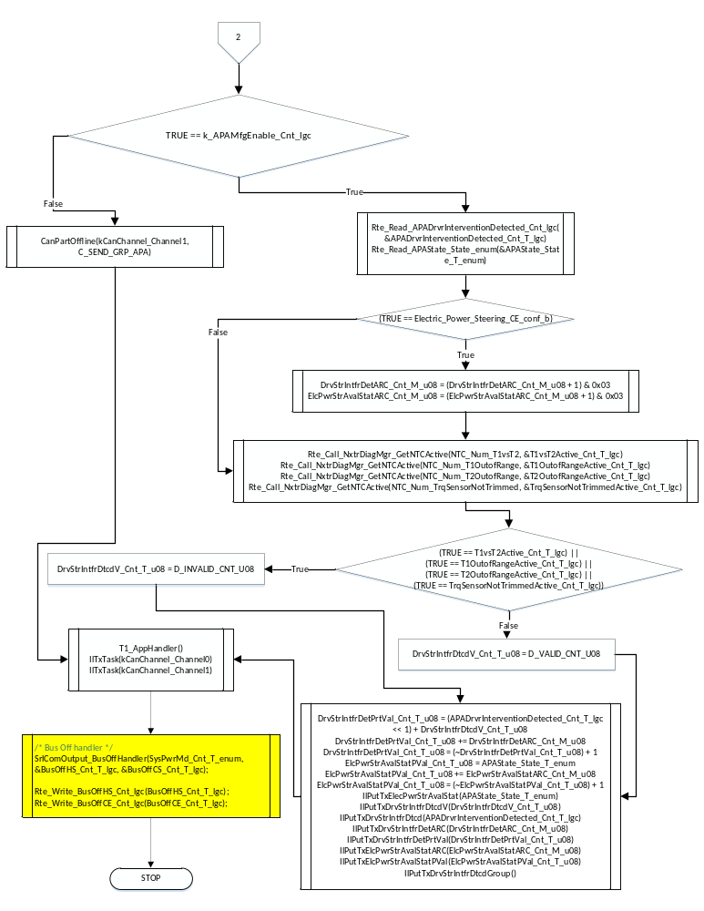

Store Local copy of outputs into Module Outputs
See section above.

Program Flow End
N/A

Fault Recovery Functions
None

Shutdown Functions
None

Interrupt Functions
None

Serial Communication Functions
None

Transition Functions

SrlComOutput_Trns1

Design Rationale

Program Flow Start
N/A

Store Module Inputs to Local copies
*See below

Description

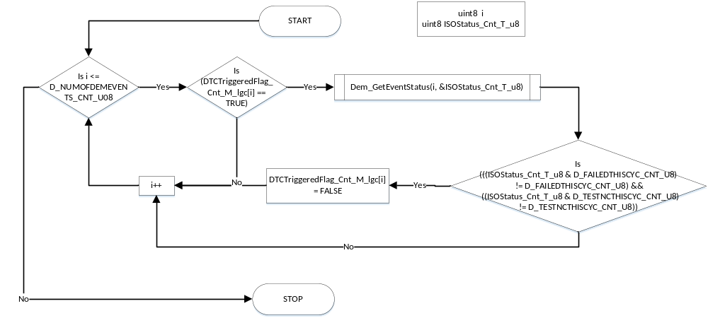

Store Local copy of outputs into Module Outputs
See section above.

Program Flow End
N/A

Local Function/Macro Definitions
If these are numerous and defined in a separate source file then reference the source file only.

ISOToGMStatus
Function Name | ISOToGMStatus | Type | Min | Max
Arguments Passed | statusMask | Uint8 | 0 | FULL
Return Value | BitMod | Uint8 | 0 | FULL

Description
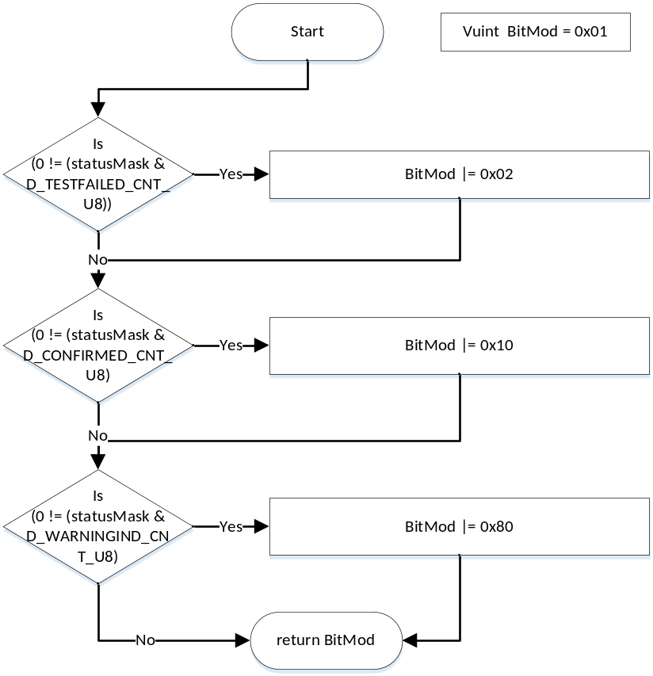

SrlComOutput_BusOffHandlerInit
Function Name | SrlComOutput_BusOffHandlerInit | Type | Min | Max
Arguments Passed
Return Value

Description
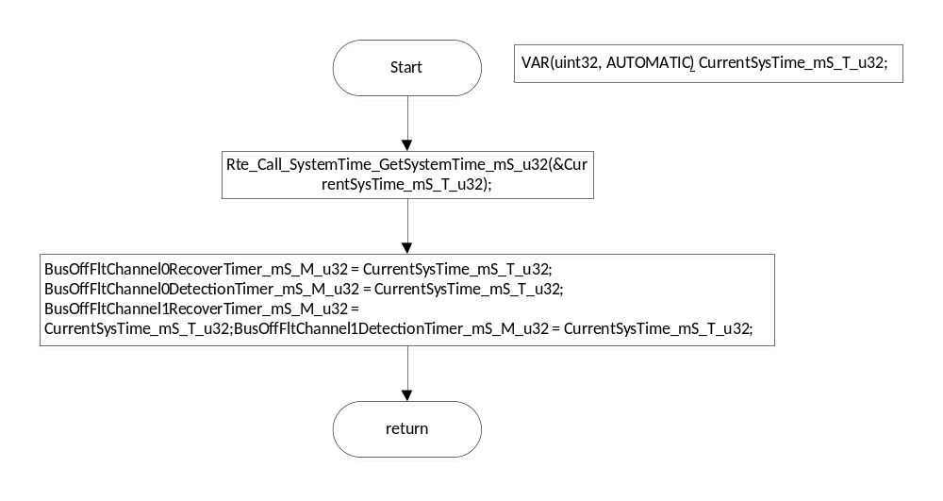

SrlComOutput_BusOffHandler
Function Name | SrlComOutput_BusOffHandler | Type | Min | Max
Arguments Passed | SysPwrMd_Cnt_T_enum | SysPwrMd | 0 | 3
Arguments Passed | BusOffHS_Cnt_T_lgc, | P2VAR(boolean, AUTOMATIC, AUTOMATIC) | 0 | 1
Arguments Passed | BusOffCE_Cnt_T_lgc, | P2VAR(boolean, AUTOMATIC, AUTOMATIC) | 0 | 1
Return Value

Description
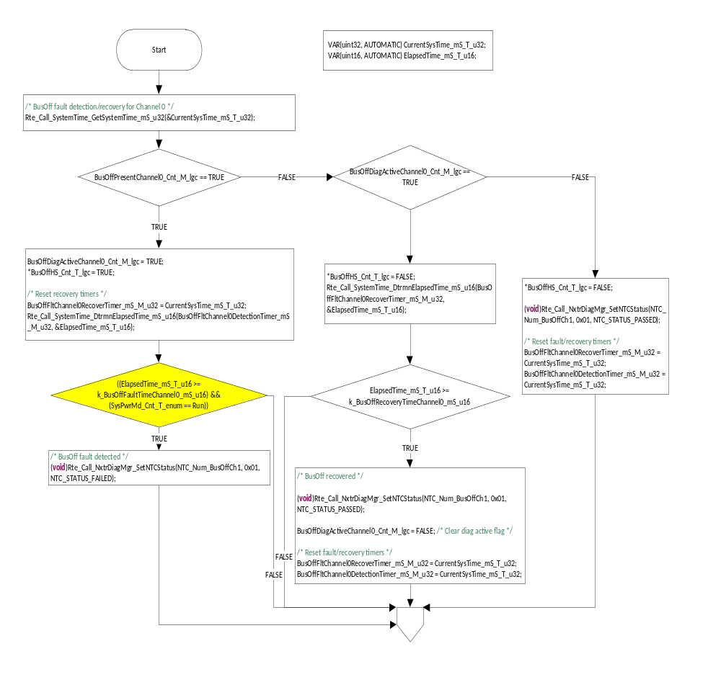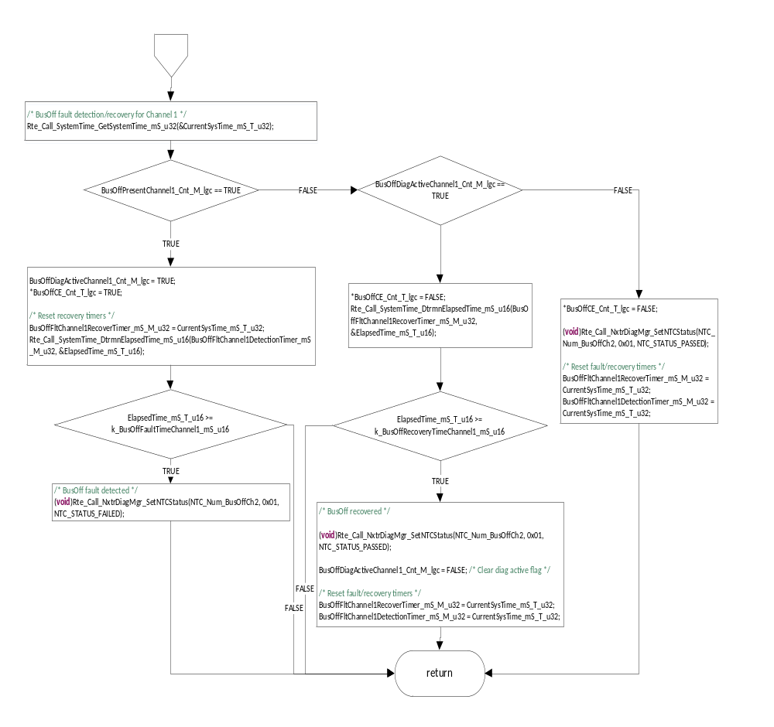

Appl_1E5MsgTxAck_HS
Function Name | Appl_1E5MsgTxAck_HS | Type | Min | Max
Arguments Passed | txObject, | CanTransmitHandle | NA | NA
Return Value

Description
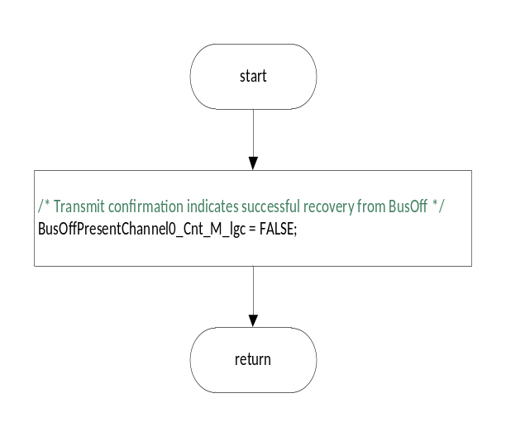

Appl_1E5MsgTxAck_CE
Function Name | Appl_1E5MsgTxAck_CE | Type | Min | Max
Arguments Passed | txObject, | CanTransmitHandle | NA | NA
Return Value

Description
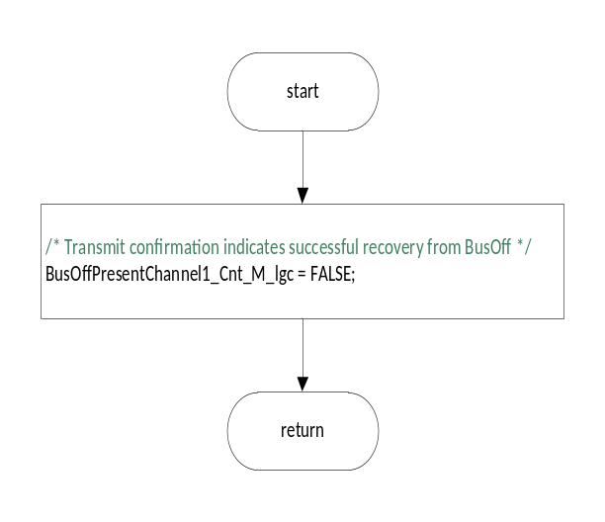

ApplNwmBusoff
Function Name | ApplNwmBusoff | Type | Min | Max
Arguments Passed | channel | CanChannelHandle | 0 | 1
Return Value

Description
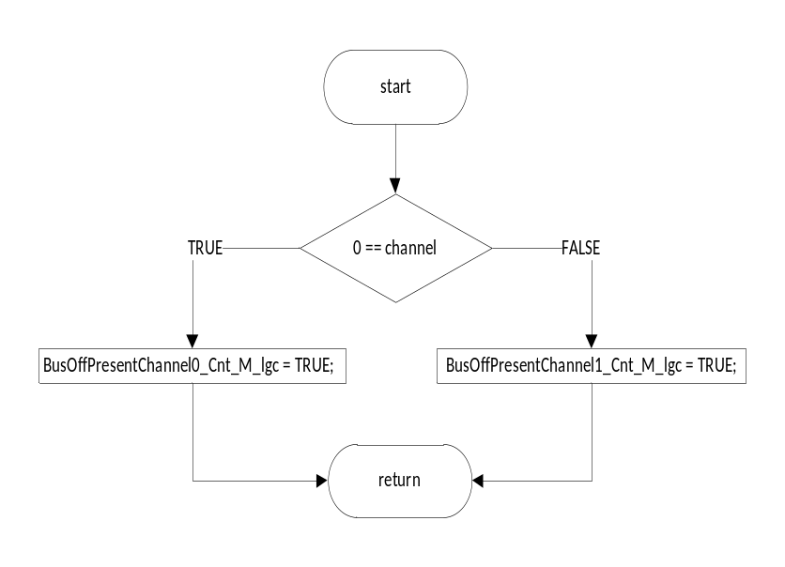

ApplNwmBusoffEnd
Function Name | ApplNwmBusoffEnd | Type | Min | Max
Arguments Passed | channel | CanChannelHandle | 0 | 1
Return Value

Description
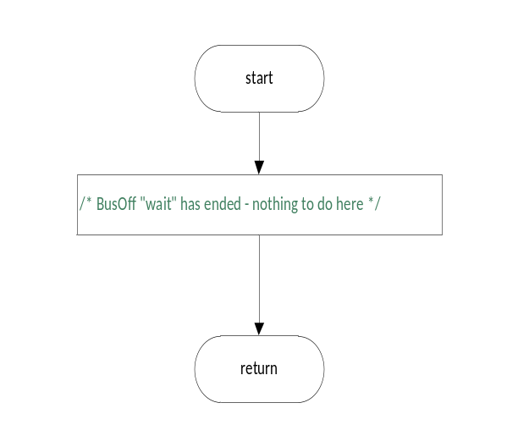

Execution Requirements

Execution Sequence of the Module
(Describe in words relevant details about the execution sequence of the different sub modules.)

Execution Rates for sub-modules called by the Scheduler
This table serves as reference for the Scheduler design
Function Name | Calling Frequency | System State(s) in which the function is called
SrlComOutput_Init1() | Once | START UP
SrlComOutput_Per1() | 100ms | Not in Mode(s) <OFF>
SrlComOutput_Per2() | 10ms | Not in Mode(s) <OFF>
SrlComOutput_Trns1() | On Event | On Entering OFF

Execution Requirements for Serial Communication Functions
Function Name | Sub-Module called by (Serial Comm Function Name)
N/A

Memory Map Definition Requirements

Sub Modules (Functions)
This table identifies the software segments for functions identified in this module.
Name of Sub Module | Software Segment
SrlComOutput_Init1() | RTE_AP_SRLCOMOUTPUT_APPL_CODE
SrlComOutput_Per1() | RTE_AP_SRLCOMOUTPUT_APPL_CODE
SrlComOutput_Per2() | RTE_AP_SRLCOMOUTPUT_APPL_CODE
SrlComOutput_Trns1() | RTE_AP_SRLCOMOUTPUT_APPL_CODE
Appl_1E5MsgTxAck_HS | AP_SRLCOMOUTPUT_CODE
Appl_1E5MsgTxAck_CE | AP_SRLCOMOUTPUT_CODE
ApplNwmBusoff | AP_SRLCOMOUTPUT_CODE
ApplNwmBusoffEnd | AP_SRLCOMOUTPUT_CODE

Local Functions
This table identifies the software segments for local functions identified in this module.
Name of Sub Module | Software Segment
ISOToGMStatus () | AP_SRLCOMOUTPUT_CODE
SrlComOuput_BusOffHandlerInit | AP_SRLCOMOUTPUT_CODE
SrlComOutput_BusOffHandler | AP_SRLCOMOUTPUT_CODE

Known Issues / Limitations With Design
- INLINE functions defined in “GlobalMacro.h” are not unit tested

Revision Control Log
Rev # | Change Description | Date | Author Initials
1.0 | Initial Version  Additional changes made after completion of unit test. | 16May14  8July14 | KPIT  BWL
2.0 | Updates for addition of ESC for SCIR 1G | 31July14 | BWL
3 | A7226: Updated checksum calculation as per new GM spec | 2-Sept-14 | JWJ
4 | A7322: Updated protection vlue calculation to use "binary add" (OR)  A7302: Correct HowDetect Mode to report enabled as long as LKA is enabled | 25-Sept-14 | JWJ
5 | A7487: Corrected protection value calculation (again) to match expectation rather than spec which was misleading. | 17-Oct-14 | JWJ
6 | A7522: Set LKA status to permanently failed when an F1 or F2 fault is present | 8-Dec-14 | JWJ
7 | Anomaly fix for ranf of APA state output | 6-Feb-15 | JWJ
8 | BusOff handler | 5-May-15 | GMN
10 | MDD Updated as per Unit Test findings. | 13-Jul-15 | KPIT
11 | MDD updated for anomaly fix done - Bus Off fault being set in Accessory and Off power modes (EA3#2426) | 12-Dec-15 | CP
12 | MDD updated to add Rte_Pim_DTCTrigSts. EA3#2060,EA32338 | 03-May-16 | CP
13 | Added new 0x148 message signal (warning indicator) | 09-May-16 | GMN

