Module – Customer Specific Periodic Services

High-Level Description
The Customer Specific Periodic Services module takes care of the processing that has to be achieved to meet customer diagnostic services requirements.

Figures

Component Diagram
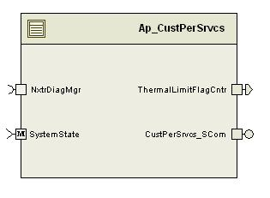

Variable Data Dictionary
For details on module input / output variable, refer to the Data Dictionary for the application. Input / output variable names are listed here for reference.
Module Inputs (Global Variable Name) | Module Outputs (Global Variable Name)
 | ThermalLimitFlagCntr_Cnt_u08
Note: Any input signals that are not listed in the ‘Module Inputs’ section above but shown in the component diagram as a receiver port are dummy signals which are used to determine loss of a certain message when data receive error event is triggered.

Module Internal Variables
This section identifies the name, range and resolutions for module specific data created by this module. If there are no range restrictions on the variable, the term “FULL” is placed into the table for legal range.
Variable Name | Resolution | Legal Range  (min) | Legal Range  (max) | Software Segment
ThermalLimitFlagCntr_Cnt_M_u08 | 1 | 0 | FULL | CUSTPERSRVCS_START_SEC_VAR_SAVED_ZONEH_8
ThermalLimitFlagClearCntr_Cnt_M_u08 | 1 | 0 | 50 | CUSTPERSRVCS_START_SEC_VAR_SAVED_ZONEH_8
PrevThermalLimitFlagStatus_Cnt_M_u08 | 1 | 0 | FULL | CUSTPERSRVCS_START_SEC_VAR_CLEARED_8
LTCompValBefReset_HwNm_M_f32 | Single Precision Float | -4 | 4 | CUSTPERSRVCS_START_SEC_VAR_CLEARED_32
CCWEOTPosBefReset_HwDeg_M_f32 | Single Precision Float | -1440.11 | 0 | CUSTPERSRVCS_START_SEC_VAR_CLEARED_32
CWEOTPosBefReset_HwDeg_M_f32 | Single Precision Float | 0 | 1440.11 | CUSTPERSRVCS_START_SEC_VAR_CLEARED_32
CCWEOTFndBefReset_Cnt_M_lgc | 1 | FALSE | TRUE | CUSTPERSRVCS_START_SEC_VAR_CLEARED_BOOLEAN
CWEOTFndBefReset_Cnt_M_lgc | 1 | FALSE | TRUE | CUSTPERSRVCS_START_SEC_VAR_CLEARED_BOOLEAN
WriteEOTValAftRst_Cnt_M_lgc | 1 | FALSE | TRUE | CUSTPERSRVCS_START_SEC_VAR_CLEARED_BOOLEAN
WriteLTCompValAftRst_Cnt_M_lgc | 1 | FALSE | TRUE | CUSTPERSRVCS_START_SEC_VAR_CLEARED_BOOLEAN

User defined typedef definition/declaration
This section documents any user types uniquely used for the module.
Typedef Name | Element Name | User Defined Type | Legal Range  (min) | Legal Range  (max)
None

Constant Data Dictionary

Calibration Constants
This section lists the calibrations used by the module. For details on calibration constants, refer to the Data Dictionary for the application.
Constant Name
None

Program(fixed) Constants

Embedded Constants
All embedded constants whose values are provided in Eng units will be evaluated to the equivalent counts by using the FPM_InitFixedPoint_m() macro within the #define statement.

Local
Constant Name | Resolution | Value
D_TESTFAILED_CNT_U08 | 1 | 0x01
D_TESTNOTCOMPTHISOPCYCLE_CNT_U08 | 1 | 0x40
D_MAXCLEARCOUNT_CNT_U08 | 1 | 50

Global
This section lists the global constants used by the module. For details on global constants, refer to the Data Dictionary for the application.
Constant Name
None

Module specific Lookup Tables Constants
(This is for lookup tables (arrays) with fixed values, same name as other tables)
Constant Name | Resolution | Value | Software Segment
none

Functions/Macros used by the Sub-Modules

Library Functions / Macros
The library functions / Macros that are called by the various sub modules are identified below,
- Rte_Call_NxtrDiagMgr_GetNTCStatus
- ActivePull_SCom_ReadParam
- ActivePull_SCom_SetLTComp

Data Hiding Functions
The data hiding functions / macros used in this module are identified below,
- None

Local Functions/Macros Used by this MDD only
(Note if they are defined in another source file, then reference the appropriate header file)
The local functions/macros in this module are identified below,

Software Module Implementation

Runtime Environment (RTE) Initial Values
This section lists the initial values of data written by this module but controlled by the RTE. After RTE initialization, the data in this table will contain these values.
Data | Value
Rte_InitValue_ ThermalLimitFlagCntr_Cnt_u08 | 0

Initialization Functions

Init: CustPerSrvcs_Init1

Design Rationale
Permit the fault counter to clear after a number of ignition cycles without a fault.

Program Flow Start
None

Description
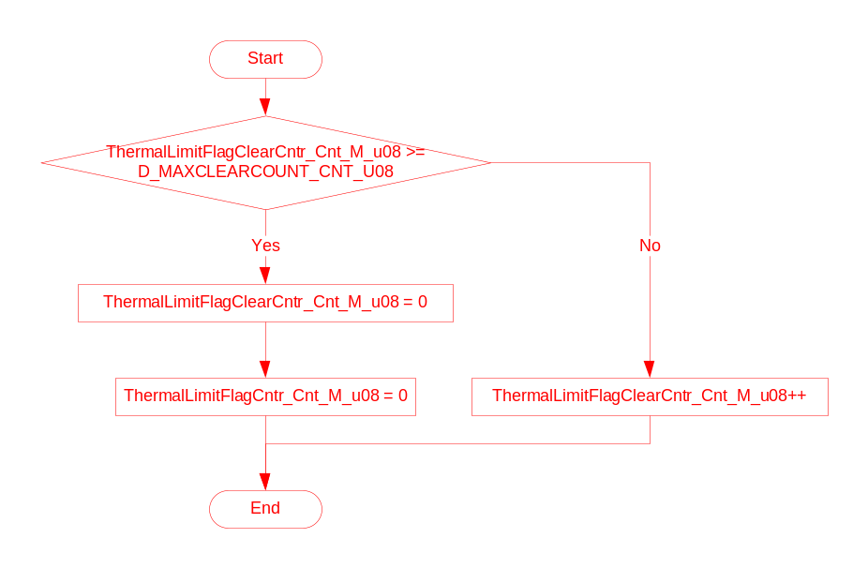

Program Flow End
None

Periodic Functions

Per: CustPerSrvcs_Per1

Design Rationale

Program Flow Start
Rte_Call_CustPerSrvcs_Per1_CP0_CheckpointReached()

Store Module Inputs to Local copies
See below section

Description

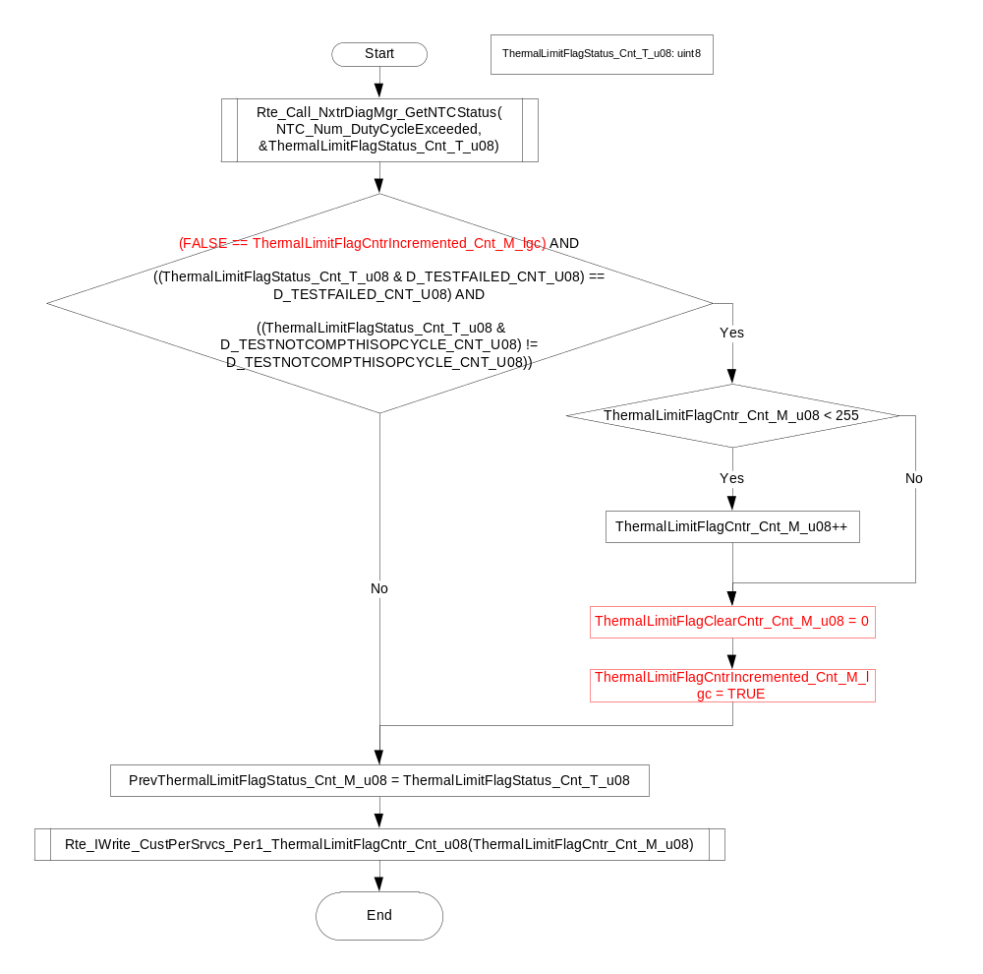

Store Local copy of outputs into Module Outputs
See above section

Program Flow End
Rte_Call_CustPerSrvcs_Per1_CP1_CheckpointReached();

Periodic Event Triggered Functions
None

Fault Recovery Functions
None

Shutdown Functions
None

Interrupt Functions
None

Serial Communication Functions

CustPerSrvcs_SCom_ResetThrmlCntr
 |  | Type | Min | Max | UTP Tol.
Arguments Passed | None
Return Value | None

Design Rationale

Program Flow Start
N/A

Store Module Inputs to Local copies
*See below

Description

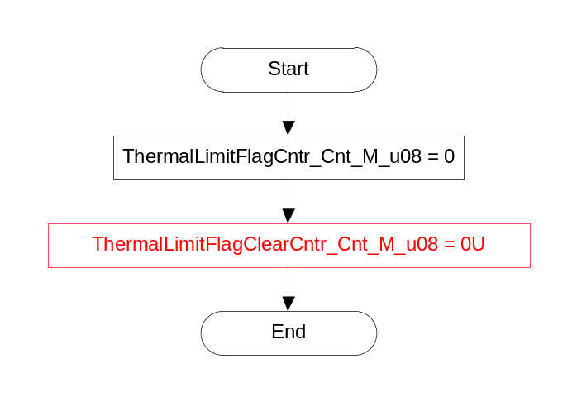

Store Local copy of outputs into Module Outputs
See section above.

Program Flow End
N/A

CustPerSrvcs_Scom_ReadActivePullParam
 |  | Type | Min | Max | UTP Tol.
Arguments Passed | None
Return Value | None

Design Rationale

Program Flow Start
N/A

Store Module Inputs to Local copies
*See below

Description

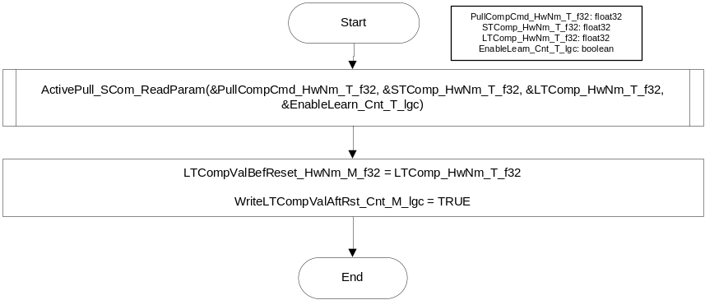

Store Local copy of outputs into Module Outputs
See section above.

Program Flow End
N/A

CustPerSrvcs_Scom_ReadLrnEOTParam
 |  | Type | Min | Max | UTP Tol.
Arguments Passed | None
Return Value | None

Design Rationale

Program Flow Start
N/A

Store Module Inputs to Local copies
*See below

Description

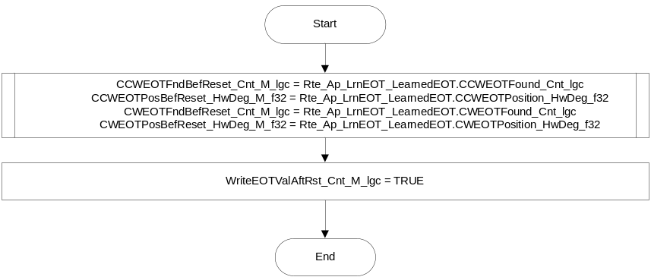

Store Local copy of outputs into Module Outputs
See section above.

Program Flow End
N/A

Transition Functions

CustPerSrvcs_Trns1

Design Rationale

Program Flow Start
N/A

Store Module Inputs to Local copies
*See below

Description

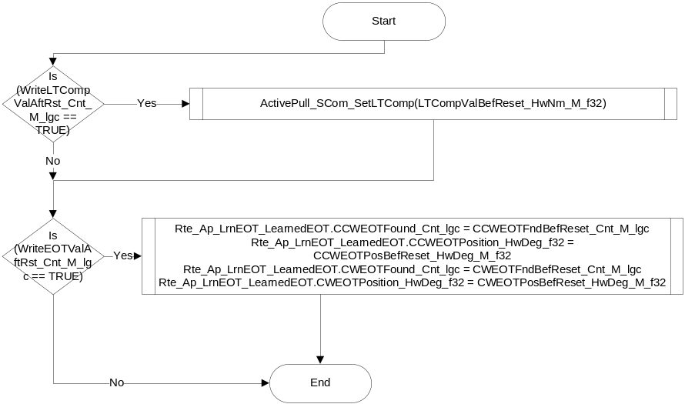

Store Local copy of outputs into Module Outputs
See section above.

Program Flow End
N/A

Execution Requirements

Execution Sequence of the Module
The calling frequency for Per1 is chosen as shown below because the fault for which the status being retrieved sets/ clears every 100ms. CustPerSrvcs_Trns1 must execute prior to states and modes OFF transition function execution.

Execution Rates for sub-modules called by the Scheduler
This table serves as reference for the Scheduler design
Function Name | Calling Frequency | System State(s) in which the function is called
CustPerSrvcs_Per1 | 100ms | ALL
CustPerSrvcs_Trns1 | On Event | On Entering OFF

Execution Requirements for Serial Communication Functions
Function Name | Sub-Module called by (Serial Comm Function Name)
CustPerSrvcs_Scom_ResetThrmlCntr | RTE_AP_CUSTPERSRVCS_APPL_CODE
CustPerSrvcs_Scom_ReadLrnEOTParam | RTE_AP_CUSTPERSRVCS_APPL_CODE
CustPerSrvcs_Scom_ReadActivePullParam | RTE_AP_CUSTPERSRVCS_APPL_CODE

Memory Map Definition Requirements

Sub Modules (Functions)
This table identifies the software segments for functions identified in this module.
Name of Sub Module | Software Segment
CustPerSrvcs_Per1 | RTE_AP_CUSTPERSRVCS_APPL_CODE
CustPerSrvcs_Scom_ResetThrmlCntr | RTE_AP_CUSTPERSRVCS_APPL_CODE
CustPerSrvcs_Scom_ReadLrnEOTParam | RTE_AP_CUSTPERSRVCS_APPL_CODE
CustPerSrvcs_Scom_ReadActivePullParam | RTE_AP_CUSTPERSRVCS_APPL_CODE

Local Functions
This table identifies the software segments for local functions identified in this module.
Name of Sub Module | Software Segment
None

Known Issues / Limitations With Design

Revision Control Log
Item # | Change Description | Date | Author Initials
1 | Initial Version | 29July13 | LWW
2 | Added ThermalLimitFlagClearCntr logic | 6Nov13 | BWL

