Module –Serial Communications Input

High-Level Description
The Serial Communications Input module provides a signal level interface between the EPS application layer and the serial communications software. Provide for the network management functionality for the serial communications interface. This module will be customized for each distinct vehicle platform. This module will be responsible for converting the range and resolution of the Application Layer variables to the range and resolution of the associated serial communications signals.
This module processes the data for signals that are received by the EPS controller from other ECUs on the communication bus. Serial Communications signal input data is scaled appropriately and then transferred to the global application data for use by the EPS application software. Similarly, the Serial Communications Output module, takes the global data to the EPS application software scales the data as required by the serial communication transmit signal and transfers the updated signal to the communication bus.

Figures

Component Diagram
This diagram shows all data that is shared between functions within the module.

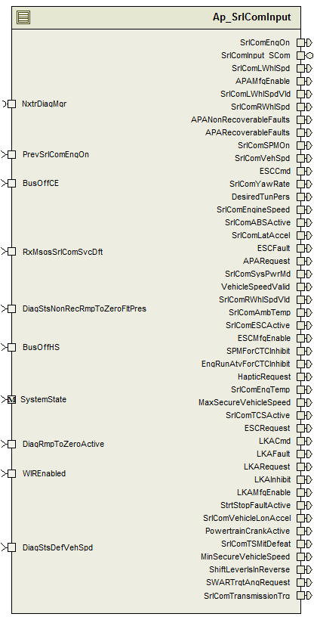

Variable Data Dictionary
For details on module input / output variable, refer to the Data Dictionary for the application. Input / output variable names are listed here for reference.

Module Inputs (Global Variable Name) | Module Outputs (Global Variable Name)
ECUResetPerformed_Cnt_G_lgc | SrlComAmbTemp_DegC_f32
Rte_TrqOvlSta_TrqOvlStaMfgEnable_Cnt_b08 | SrlComEngTemp_DegC_f32
RxMsgsSrlComSvcDft_Cnt_lgc | RespMsgBuffer[]
WIREnabled_Cnt_lgc | APARecoverableFaults_Cnt_lgc
IlNwmGetStatus[] | APANonRecoverableFaults_Cnt_lgc
IlNwmStateNormalCommHalted[] | APARequest_Cnt_lgc
IlNwmStateNoCommunication[] | SrlComLatAccel_g_f32
DiagStsDefVehSpd_Cnt_lgc | SrlComYawRate_DegpS_f32
SrlComWIRFltStatus_Cnt_u16 | EngRunAtvForCTCInhibit_Cnt_lgc
PrevSrlComEngOn_Cnt_lgc | SrlComLWhlSpd_Hz_f32
DiagRmpToZeroActive_Cnt_lgc | SrlComLWhlSpdVld_Cnt_lgc
BusOffCE_Cnt_lgc | SrlComRWhlSpd_Hz_f32
BusOffHS_Cnt_lgc | SrlComRWhlSpdVld_Cnt_lgc
 | SrlComSysPwrMd_Cnt_enum
 | SPMForCTCInhibit_Cnt_lgc
 | DesiredTunPers_Cnt_u16
 | SecureVehicleSpeed_Kph_f32
 | LKAInhibit_Cnt_lgc
 | LKAFault_Cnt_lgc
 | LKACmd_HwNm_f32
 | LKARequest_Cnt_lgc
 | SecureVehicleSpeed_Kph_f32
 | SrlComVehSpd_Kph_f32
 | VehicleSpeedValid_Cnt_lgc
 | StrtStopFaultActive_Cnt_lgc
 | SrlComEngineSpeed_Rpm_f32
 | SrlComEngOn_Cnt_lgc
 | SrlComSPMOn_Cnt_lgc
 | PosSrvoHwAngle_HwDeg_f32
 | PowertrainCrankActive_Cnt_lgc
 | ShiftLeverIsInReverse_Cnt_lgc
 | HapticRequest_Cnt_lgc
 | SrlComVehicleLonAccel_KphpS_f32

Module Internal Variables
This section identifies the name, range and resolutions for module specific data created by this module. If there are no range restrictions on the variable, the term “FULL” is placed into the table for legal range.

Variable Name | Resolution | Legal Range | Legal Range | Software Segment
Variable Name | Resolution | (min) | (max) | Software Segment
LastPlsChngTimeL_mS_M_u32 | 1 | Refer DD | Refer DD | AP_SRLCOMINPUT_VAR
LastPlsChngTimeR_mS_M_u32 | 1 | Refer DD | Refer DD | AP_SRLCOMINPUT_VAR
InvStartTimeL_mS_M_u32 | 1 | Refer DD | Refer DD | AP_SRLCOMINPUT_VAR
InvStartTimeR_mS_M_u32 | 1 | Refer DD | Refer DD | AP_SRLCOMINPUT_VAR
OldRawWhlFreqL_Hz_M_f32 | 1 | Refer DD | Refer DD | AP_SRLCOMINPUT_VAR
OldRawWhlFreqR_Hz_M_f32 | 1 | Refer DD | Refer DD | AP_SRLCOMINPUT_VAR
PulseScale_RevpCnt_M_f32 | 1 | Refer DD | Refer DD | AP_SRLCOMINPUT_VAR
WhlTstmpRes_SecpCnt_M_f32 | 1 | Refer DD | Refer DD | AP_SRLCOMINPUT_VAR
VehSpdAvgNDrvn_Kph_M_f32 | 1 | Refer DD | Refer DD | AP_SRLCOMINPUT_VAR
ManualVehSpd_Kph_M_f32 | 1 | Refer DD | Refer DD | AP_SRLCOMINPUT_VAR
AmbTempVldStartTime_mS_M_u32 | 1 | Refer DD | Refer DD | AP_SRLCOMINPUT_VAR
AmbTempVldAccum_Cnt_M_u16 | 1 | Refer DD | Refer DD | AP_SRLCOMINPUT_VAR
EngTempVldStartTime_mS_M_u32 | 1 | Refer DD | Refer DD | AP_SRLCOMINPUT_VAR
EngTempVldAccum_Cnt_M_u16 | 1 | Refer DD | Refer DD | AP_SRLCOMINPUT_VAR
LatAccVldStartTime_mS_M_u32 | 1 | Refer DD | Refer DD | AP_SRLCOMINPUT_VAR
LatAccVldAccum_Cnt_M_u16 | 1 | Refer DD | Refer DD | AP_SRLCOMINPUT_VAR
YawRateVldStartTime_mS_M_u32 | 1 | Refer DD | Refer DD | AP_SRLCOMINPUT_VAR
YawRateVldAccum_Cnt_M_u16 | 1 | Refer DD | Refer DD | AP_SRLCOMINPUT_VAR
VehSpdVldStartTime_mS_M_u32 | 1 | Refer DD | Refer DD | AP_SRLCOMINPUT_VAR
VehSpdVldAccum_Cnt_M_u16 | 1 | Refer DD | Refer DD | AP_SRLCOMINPUT_VAR
VehicleDynamicsESCHybCEVldStartTime_mS_M_u32 | 1 | Refer DD | Refer DD | AP_SRLCOMINPUT_VAR
VehicleDynamicsESCHybCEVldAccum_Cnt_M_u16 | 1 | Refer DD | Refer DD | AP_SRLCOMINPUT_VAR
ParkAssistParallelCEVldStartTime_mS_M_u32 | 1 | Refer DD | Refer DD | AP_SRLCOMINPUT_VAR
ParkAssistParallelCEVldAccum_Cnt_M_u16 | 1 | Refer DD | Refer DD | AP_SRLCOMINPUT_VAR
VSEActVldAccum_Cnt_M_u16 | 1 | Refer DD | Refer DD | AP_SRLCOMINPUT_VAR
TCSysEVldAccum_Cnt_M_u16 | 1 | Refer DD | Refer DD | AP_SRLCOMINPUT_VAR
TCSysAVldAccum_Cnt_M_u16 | 1 | Refer DD | Refer DD | AP_SRLCOMINPUT_VAR
TrnsShftLvrPosVldAccum_Cnt_M_u16 | 1 | Refer DD | Refer DD | AP_SRLCOMINPUT_VAR
ABSFldVldAccum_Cnt_M_u16 | 1 | Refer DD | Refer DD | AP_SRLCOMINPUT_VAR
WhlGrndVlctyRtDrvnHSVldAccum_Cnt_M_u16 | 1 | Refer DD | Refer DD | AP_SRLCOMINPUT_VAR
WhlGrndVlctyLftDrvnHSVldAccum_Cnt_M_u16 | 1 | Refer DD | Refer DD | AP_SRLCOMINPUT_VAR
WhlGrndVlctyRtNnDrvnHSVldAccum_Cnt_M_u16 | 1 | Refer DD | Refer DD | AP_SRLCOMINPUT_VAR
WhlGrndVlctyLftNnDrvnHSVldAccum_Cnt_M_u16 | 1 | Refer DD | Refer DD | AP_SRLCOMINPUT_VAR
WhlGrndVlctyRtDrvnCEVldAccum_Cnt_M_u16 | 1 | Refer DD | Refer DD | AP_SRLCOMINPUT_VAR
WhlGrndVlctyLftDrvnCEVldAccum_Cnt_M_u16 | 1 | Refer DD | Refer DD | AP_SRLCOMINPUT_VAR
WhlGrndVlctyRtNnDrvnCEVldAccum_Cnt_M_u16 | 1 | Refer DD | Refer DD | AP_SRLCOMINPUT_VAR
WhlGrndVlctyLftNnDrvnCEVldAccum_Cnt_M_u16 | 1 | Refer DD | Refer DD | AP_SRLCOMINPUT_VAR
AntilockTCbrakeVldStartTime_mS_M_u32p0 | 1 | Refer DD | Refer DD | AP_SRLCOMINPUT_VAR
RedntVSEActARCVldStartTime_mS_M_u32 | 1 | Refer DD | Refer DD | AP_SRLCOMINPUT_VAR
RedntVSEActARCVldAccum_Cnt_M_u16 | 1 | Refer DD | Refer DD | AP_SRLCOMINPUT_VAR
RedntVSEActVldStartTime_mS_M_u32 | 1 | Refer DD | Refer DD | AP_SRLCOMINPUT_VAR
RedntVSEActVldAccum_Cnt_M_u16 | 1 | Refer DD | Refer DD | AP_SRLCOMINPUT_VAR
ABSActvProtPValVldStartTime_mS_M_u32 | 1 | Refer DD | Refer DD | AP_SRLCOMINPUT_VAR
ABSActvProtPValVldAccum_Cnt_M_u16 | 1 | Refer DD | Refer DD | AP_SRLCOMINPUT_VAR
ABSActvProtARCVldStartTime_mS_M_u32 | 1 | Refer DD | Refer DD | AP_SRLCOMINPUT_VAR
ABSActvProtARCVldAccum_Cnt_M_u16 | 1 | Refer DD | Refer DD | AP_SRLCOMINPUT_VAR
ABSActvProtVldStartTime_mS_M_u32 | 1 | Refer DD | Refer DD | AP_SRLCOMINPUT_VAR
ABSActvProtVldAccum_Cnt_M_u16 | 1 | Refer DD | Refer DD | AP_SRLCOMINPUT_VAR
VSEActVldStartTime_mS_M_u32p0 | 1 | Refer DD | Refer DD | AP_SRLCOMINPUT_VAR
TCSysEVldStartTime_mS_M_u32p0 | 1 | Refer DD | Refer DD | AP_SRLCOMINPUT_VAR
TCSysAVldStartTime_mS_M_u32p0 | 1 | Refer DD | Refer DD | AP_SRLCOMINPUT_VAR
ABSFldVldStartTime_mS_M_u32p0 | 1 | Refer DD | Refer DD | AP_SRLCOMINPUT_VAR
VhDynCVldStartTime_mS_M_u32p0 | 1 | Refer DD | Refer DD | AP_SRLCOMINPUT_VAR
VhDynCVldAccum_Cnt_M_u16 | 1 | Refer DD | Refer DD | AP_SRLCOMINPUT_VAR
LKATqOvrDltCmdPrtVlVldStartTime_mS_M_u32 | 1 | Refer DD | Refer DD | AP_SRLCOMINPUT_VAR
LKATqOvrDltCmdPrtVlVldAccum_Cnt_M_u16 | 1 | Refer DD | Refer DD | AP_SRLCOMINPUT_VAR
LKATqOvrDltCmdRCVldStartTime_mS_M_u32 | 1 | Refer DD | Refer DD | AP_SRLCOMINPUT_VAR
LKATqOvrDltCmdRCVldAccum_Cnt_M_u16 | 1 | Refer DD | Refer DD | AP_SRLCOMINPUT_VAR
Msg1E9Loss_mS_M_u32 | 1 | Refer DD | Refer DD | AP_SRLCOMINPUT_VAR
Msg1E9LossAccum_Cnt_M_u16 | 1 | Refer DD | Refer DD | AP_SRLCOMINPUT_VAR
Msg214Loss_mS_M_u32 | 1 | Refer DD | Refer DD | AP_SRLCOMINPUT_VAR
Msg214LossAccum_Cnt_M_u16 | 1 | Refer DD | Refer DD | AP_SRLCOMINPUT_VAR
Msg232Loss_mS_M_u32 | 1 | Refer DD | Refer DD | AP_SRLCOMINPUT_VAR
Msg232LossAccum_Cnt_M_u16 | 1 | Refer DD | Refer DD | AP_SRLCOMINPUT_VAR
Msg0C9Loss_mS_M_u32 | 1 | Refer DD | Refer DD | AP_SRLCOMINPUT_VAR
Msg0C9LossAccum_Cnt_M_u16 | 1 | Refer DD | Refer DD | AP_SRLCOMINPUT_VAR
Msg0C1Loss_mS_M_u32 | 1 | Refer DD | Refer DD | AP_SRLCOMINPUT_VAR
Msg0C1LossAccum_Cnt_M_u16 | 1 | Refer DD | Refer DD | AP_SRLCOMINPUT_VAR
Msg1F1Loss_mS_M_u32 | 1 | Refer DD | Refer DD | AP_SRLCOMINPUT_VAR
Msg1F1LossAccum_Cnt_M_u16 | 1 | Refer DD | Refer DD | AP_SRLCOMINPUT_VAR
Msg1F5Loss_mS_M_u32 | 1 | Refer DD | Refer DD | AP_SRLCOMINPUT_VAR
Msg1F5LossAccum_Cnt_M_u16 | 1 | Refer DD | Refer DD | AP_SRLCOMINPUT_VAR
Msg3E9Loss_mS_M_u32 | 1 | Refer DD | Refer DD | AP_SRLCOMINPUT_VAR
Msg3E9LossAccum_Cnt_M_u16 | 1 | Refer DD | Refer DD | AP_SRLCOMINPUT_VAR
Msg500Loss_mS_M_u32 | 1 | Refer DD | Refer DD | AP_SRLCOMINPUT_VAR
Msg500LossAccum_Cnt_M_u16 | 1 | Refer DD | Refer DD | AP_SRLCOMINPUT_VAR
Msg348CELoss_mS_M_u32 | 1 | Refer DD | Refer DD | AP_SRLCOMINPUT_VAR
Msg348CELossAccum_Cnt_M_u16 | 1 | Refer DD | Refer DD | AP_SRLCOMINPUT_VAR
Msg348HSLoss_mS_M_u32 | 1 | Refer DD | Refer DD | AP_SRLCOMINPUT_VAR
Msg348HSLossAccum_Cnt_M_u16 | 1 | Refer DD | Refer DD | AP_SRLCOMINPUT_VAR
Msg180HSLoss_mS_M_u32 | 1 | Refer DD | Refer DD | AP_SRLCOMINPUT_VAR
Msg180HSLossAccum_Cnt_M_u16 | 1 | Refer DD | Refer DD | AP_SRLCOMINPUT_VAR
Msg34ACELoss_mS_M_u32 | 1 | Refer DD | Refer DD | AP_SRLCOMINPUT_VAR
Msg34ACELossAccum_Cnt_M_u16 | 1 | Refer DD | Refer DD | AP_SRLCOMINPUT_VAR
Msg34AHSLoss_mS_M_u32 | 1 | Refer DD | Refer DD | AP_SRLCOMINPUT_VAR
Msg34AHSLossAccum_Cnt_M_u16 | 1 | Refer DD | Refer DD | AP_SRLCOMINPUT_VAR
Msg337Loss_mS_M_u32 | 1 | Refer DD | Refer DD | AP_SRLCOMINPUT_VAR
Msg337LossAccum_Cnt_M_u16 | 1 | Refer DD | Refer DD | AP_SRLCOMINPUT_VAR
Msg17DLoss_mS_M_u32 |  |  |  | AP_SRLCOMINPUT_VAR
Msg17DLossAccum_Cnt_M_u16 |  |  |  | AP_SRLCOMINPUT_VAR
Msg182Loss_mS_M_u32 | 1 | Refer DD | Refer DD | AP_SRLCOMINPUT_VAR
Msg182LossAccum_Cnt_M_u16 | 1 | Refer DD | Refer DD | AP_SRLCOMINPUT_VAR
Msg3F1Loss_mS_M_u32 | 1 | Refer DD | Refer DD | AP_SRLCOMINPUT_VAR
Msg3F1LossAccum_Cnt_M_u16 | 1 | Refer DD | Refer DD | AP_SRLCOMINPUT_VAR
Msg4C1Loss_mS_M_u32 | 1 | Refer DD | Refer DD | AP_SRLCOMINPUT_VAR
Msg4C1LossAccum_Cnt_M_u16 | 1 | Refer DD | Refer DD | AP_SRLCOMINPUT_VAR
Msg180HSLKALoss_mS_M_u32 | 1 | Refer DD | Refer DD | AP_SRLCOMINPUT_VAR
Msg17DLKALoss_mS_M_u32 | 1 | Refer DD | Refer DD | AP_SRLCOMINPUT_VAR
Msg348HSLKALoss_mS_M_u32 | 1 | Refer DD | Refer DD | AP_SRLCOMINPUT_VAR
Msg348CELKALoss_mS_M_u32 | 1 | Refer DD | Refer DD | AP_SRLCOMINPUT_VAR
Msg34AHSLKALoss_mS_M_u32 | 1 | Refer DD | Refer DD | AP_SRLCOMINPUT_VAR
Msg34ACELKALoss_mS_M_u32 | 1 | Refer DD | Refer DD | AP_SRLCOMINPUT_VAR
Msg1E9LKALoss_mS_M_u32 | 1 | Refer DD | Refer DD | AP_SRLCOMINPUT_VAR
Msg214LKALoss_mS_M_u32 | 1 | Refer DD | Refer DD | AP_SRLCOMINPUT_VAR
WhlGrndVlctyRtDrvnCEStuck_mS_M_u32 | 1 | Refer DD | Refer DD | AP_SRLCOMINPUT_VAR
WhlGrndVlctyLftDrvnCEStuck_mS_M_u32 | 1 | Refer DD | Refer DD | AP_SRLCOMINPUT_VAR
WhlGrndVlctyRtNnDrvnCEStuck_mS_M_u32 | 1 | Refer DD | Refer DD | AP_SRLCOMINPUT_VAR
WhlGrndVlctyLftNnDrvnCEStuck_mS_M_u32 | 1 | Refer DD | Refer DD | AP_SRLCOMINPUT_VAR
WhlGrndVlctyRtDrvnHSStuck_mS_M_u32 | 1 | Refer DD | Refer DD | AP_SRLCOMINPUT_VAR
WhlGrndVlctyLftDrvnHSStuck_mS_M_u32 | 1 | Refer DD | Refer DD | AP_SRLCOMINPUT_VAR
WhlGrndVlctyRtNnDrvnHSStuck_mS_M_u32 | 1 | Refer DD | Refer DD | AP_SRLCOMINPUT_VAR
WhlGrndVlctyLftNnDrvnHSStuck_mS_M_u32 | 1 | Refer DD | Refer DD | AP_SRLCOMINPUT_VAR
WhlGrndVlctyRtDrvnCEVldStartTime_mS_M_u32 | 1 | Refer DD | Refer DD | AP_SRLCOMINPUT_VAR
WhlGrndVlctyLftDrvnCEVldStartTime_mS_M_u32 | 1 | Refer DD | Refer DD | AP_SRLCOMINPUT_VAR
WhlGrndVlctyRtNnDrvnCEVldStartTime_mS_M_u32 | 1 | Refer DD | Refer DD | AP_SRLCOMINPUT_VAR
WhlGrndVlctyLftNnDrvnCEVldStartTime_mS_M_u32 | 1 | Refer DD | Refer DD | AP_SRLCOMINPUT_VAR
WhlGrndVlctyRtDrvnHSVldStartTime_mS_M_u32 | 1 | Refer DD | Refer DD | AP_SRLCOMINPUT_VAR
WhlGrndVlctyLftDrvnHSVldStartTime_mS_M_u32 | 1 | Refer DD | Refer DD | AP_SRLCOMINPUT_VAR
WhlGrndVlctyRtNnDrvnHSVldStartTime_mS_M_u32 | 1 | Refer DD | Refer DD | AP_SRLCOMINPUT_VAR
WhlGrndVlctyLftNnDrvnHSVldStartTime_mS_M_u32 | 1 | Refer DD | Refer DD | AP_SRLCOMINPUT_VAR
OldSeqNumR_Cnt_M_u16 | 1 | Refer DD | Refer DD | AP_SRLCOMINPUT_VAR
OldWhlDistTstmL_Cnt_M_u16 | 1 | Refer DD | Refer DD | AP_SRLCOMINPUT_VAR
OldWhlDistTstmR_Cnt_M_u16 | 1 | Refer DD | Refer DD | AP_SRLCOMINPUT_VAR
OldWhlPCntrL_Cnt_M_u16 | 1 | Refer DD | Refer DD | AP_SRLCOMINPUT_VAR
OldWhlPCntrR_Cnt_M_u16 | 1 | Refer DD | Refer DD | AP_SRLCOMINPUT_VAR
StartStopFault_Cnt_M_b16 | 1 | Refer DD | Refer DD | AP_SRLCOMINPUT_VAR
WhlGrndVlctyRtDrvnCE_Cnt_M_u16 | 1 | Refer DD | Refer DD | AP_SRLCOMINPUT_VAR
WhlGrndVlctyLftDrvnCE_Cnt_M_u16 | 1 | Refer DD | Refer DD | AP_SRLCOMINPUT_VAR
TrnsShftLvrPosVldStartTime_mS_M_u32 | 1 | Refer DD | Refer DD | AP_SRLCOMINPUT_VAR
LastPlsChngTimeL_mS_M_u32p0 | 1 | Refer DD | Refer DD | AP_SRLCOMINPUT_VAR
WhlGrndVlctyRtNnDrvnCE_Cnt_M_u16 | 1 | Refer DD | Refer DD | AP_SRLCOMINPUT_VAR
LastPlsChngTimeR_mS_M_u32p0 | 1 | Refer DD | Refer DD | AP_SRLCOMINPUT_VAR
WhlGrndVlctyRtDrvnHS_Cnt_M_u16 | 1 | Refer DD | Refer DD | AP_SRLCOMINPUT_VAR
WhlGrndVlctyLftDrvnHS_Cnt_M_u16 | 1 | Refer DD | Refer DD | AP_SRLCOMINPUT_VAR
WhlGrndVlctyRtNnDrvnHS_Cnt_M_u16 | 1 | Refer DD | Refer DD | AP_SRLCOMINPUT_VAR
WhlGrndVlctyLftNnDrvnHS_Cnt_M_u16 | 1 | Refer DD | Refer DD | AP_SRLCOMINPUT_VAR
PrevLKARollingCounter_Cnt_M_u16 | 1 | Refer DD | Refer DD | AP_SRLCOMINPUT_VAR
LKAInhibit_Cnt_M_b16 | 1 | Refer DD | Refer DD | AP_SRLCOMINPUT_VAR
LKAFault_Cnt_M_b16 | 1 | Refer DD | Refer DD | AP_SRLCOMINPUT_VAR
ABSActvProtARC_Cnt_M_u08 | 1 | Refer DD | Refer DD | AP_SRLCOMINPUT_VAR
RedntVSEActARC_Cnt_M_u08 | 1 | Refer DD | Refer DD | AP_SRLCOMINPUT_VAR
ManualVehSpdOvrRide_Cnt_M_lgc | Boolean | 0 | 1 | AP_SRLCOMINPUT_VAR
VehSpdAvgNDrvnInValid_Cnt_M_lgc | Boolean | 0 | 1 | AP_SRLCOMINPUT_VAR
RedntVSEAct_Cnt_M_lgc | Boolean | 0 | 1 | AP_SRLCOMINPUT_VAR
VSEAct_Cnt_M_lgc | Boolean | 0 | 1 | AP_SRLCOMINPUT_VAR
WhlGrndVlctyRtDrvnCEValid_Cnt_M_lgc | Boolean | 0 | 1 | AP_SRLCOMINPUT_VAR
WhlGrndVlctyLftDrvnCEValid_Cnt_M_lgc | Boolean | 0 | 1 | AP_SRLCOMINPUT_VAR
WhlGrndVlctyRtNnDrvnCEValid_Cnt_M_lgc | Boolean | 0 | 1 | AP_SRLCOMINPUT_VAR
WhlGrndVlctyLftNnDrvnCEValid_Cnt_M_lgc | Boolean | 0 | 1 | AP_SRLCOMINPUT_VAR
WhlGrndVlctyRtDrvnHSValid_Cnt_M_lgc | Boolean | 0 | 1 | AP_SRLCOMINPUT_VAR
WhlGrndVlctyLftDrvnHSValid_Cnt_M_lgc | Boolean | 0 | 1 | AP_SRLCOMINPUT_VAR
WhlGrndVlctyRtNnDrvnHSValid_Cnt_M_lgc | Boolean | 0 | 1 | AP_SRLCOMINPUT_VAR
WhlGrndVlctyLftNnDrvnHSValid_Cnt_M_lgc | Boolean | 0 | 1 | AP_SRLCOMINPUT_VAR
WhlGrndVlctyDrvnCEMissing_Cnt_M_lgc | Boolean | 0 | 1 | AP_SRLCOMINPUT_VAR
WhlGrndVlctyNnDrvnCEMissing_Cnt_M_lgc | Boolean | 0 | 1 | AP_SRLCOMINPUT_VAR
WhlGrndVlctyDrvnHSMissing_Cnt_M_lgc | Boolean | 0 | 1 | AP_SRLCOMINPUT_VAR
LKAFaultLatch_Cnt_D_b16 | 1 | Refer DD | Refer DD | AP_SRLCOMINPUT_VAR
APARecoverableFaults_Cnt_M_b08 | 1 | Refer DD | Refer DD | AP_SRLCOMINPUT_VAR
APANonRecoverableFaults_Cnt_M_b08 | 1 | Refer DD | Refer DD | AP_SRLCOMINPUT_VAR
PrevStrWhlTctlFdbkReqActRC_Cnt_M_u08 | 1 | Refer DD | Refer DD | AP_SRLCOMINPUT_VAR
PrevStrWhlAngReqARC_Cnt_M_u08 | 1 | Refer DD | Refer DD | AP_SRLCOMINPUT_VAR
InvStartTimeL_mS_M_u32p0 | 1 | Refer DD | Refer DD | AP_SRLCOMINPUT_VAR
InvStartTimeR_mS_M_u32p0 | 1 | Refer DD | Refer DD | AP_SRLCOMINPUT_VAR
WhlGrndVlctyNnDrvnHSMissing_Cnt_M_lgc | Boolean | 0 | 1 | AP_SRLCOMINPUT_VAR
WIRFltStatusAcc_Cnt_M_u16 | Uint16 | Refer DD | Refer DD | AP_SRLCOMINPUT_VAR

User defined typedef definition/declaration
This section documents any user types uniquely used for the module.

Typedef Name | Element Name | User Defined Type | Min | Max
RT_Chassis_General_Status_1 | VSELatAcc | UInt16 | 0 | 4095
RT_Chassis_General_Status_1 | VehDynYawRate | UInt16 | 0 | 65535
RT_Chassis_General_Status_1 | VSELatAccV | uint8 | 0 | 1
RT_Chassis_General_Status_1 | VehDynYawRateV | uint8 | 0 | 1
RT_PPEI_Vehicle_Speed_and_Distance | VehSpdAvgNonDrvnGroup | RT_VehSpdAvgNonDrvnGroup | NA | NA
RT_PPEI_Platform_General_Status | SysPwrMode | uint8 | 0 | 3
RT_PPEI_Platform_General_Status | SysBkupPwrMdEn | boolean | FALSE | TRUE
RT_PPEI_Platform_General_Status | SysBkUpPwrMd | uint8 | 0 | 3
RT_PPEI_Platform_General_Status | BkupPwrModeMstrVDA | uint8 | 0 | 1
RT_PPEI_Steering_Wheel_Angle_CE | StrAngSnsChksm | uint16 | 0 |  | 2047
RT_PPEI_Steering_Wheel_Angle_CE | StrWhAng | sint16 | -32768 |  | 32767
RT_PPEI_Steering_Wheel_Angle_CE | StWhlAngAliveRollCnt | uint8 | 0 |  | 3
RT_PPEI_Steering_Wheel_Angle_CE | StrWhAngGrd | sint16 | -2048 |  | 2047
RT_PPEI_Steering_Wheel_Angle_CE | StrWhAngGrdMsk | uint8 | 0 |  | 1
RT_PPEI_Steering_Wheel_Angle_CE | StrWhAngGrdV | uint8 | 0 |  | 1
RT_PPEI_Steering_Wheel_Angle_CE | StrWhAngMsk | uint8 | 0 |  | 1
RT_PPEI_Steering_Wheel_Angle_CE | StrWhlAngSenCalStat | uint8 | 0 |  | 2
RT_PPEI_Steering_Wheel_Angle_CE | StrWhlAngSenTyp | uint8 | 0 |  | 3
RT_PPEI_Steering_Wheel_Angle_CE | StrWhAngV | uint8 | 0 |  | 1
RT_PPEI_Steering_Wheel_Angle_CE | StrWhlAngMsgUnused1 | uint8 | 0 |  | 3
RT_PPEI_Steering_Wheel_Angle_CE | StrWhlAngMsgUnused2 | uint8 | 0 |  | 255
RT_PPEI_Steering_Wheel_Angle_CE | StrWhlAngMsgUnused3 | uint8 | 0 |  | 31
RT_VehSpdAvgNonDrvnGroup | VehSpdAvgNDrvn | uint16 | 0 |  | 32767
RT_VehSpdAvgNonDrvnGroup | VehSpdAvgNDrvnV | uint8 | 0 |  | 1
RT_Platform_Eng_Cntrl_Requests | OtsAirTmpCrVal | uint8 | 0 |  | 255
RT_Platform_Eng_Cntrl_Requests | OtsAirTmpCrValV | uint8 | 0 |  | 1
RT_Platform_Eng_Cntrl_Requests | OtsAirTmpCrValMsk | uint8 | 0 |  | 1
RT_Wheel_Pulses_HS | WhlRotStatTmstmpRes | uint16 | 0 |  | 2047
RT_Wheel_Pulses_HS | WhlPlsPerRevNonDrvn | uint8 | 0 |  | 127
RT_Engine_General_Status_4 | EngCltTmp | uint8 | 0 |  | 255
RT_Engine_General_Status_4 | EngCltTmpV | uint8 | 0 |  | 1
WhlRotStat | WRSSeqNum | Uint8 | 0 |  | 3
WhlRotStat | WRSWhlDistPCntr | Uint16 | 0 |  | 1023
WhlRotStat | WRSWhlDisTpRC | Uint8 | 0 |  | 3
WhlRotStat | WRSWhlDistTstm | Uint16 | 0 |  | 65535
WhlRotStat | WRSWhlDistVal | Uint8 | 0 |  | 1
WhlRotStat | WRSWhlRotStatRst | Uint8 | 0 |  | 1
RT_PPEI_NonDrivn_Whl_Rotationl_Stat | WhlRotStatLft | WhlRotStat |  |  | N/A
RT_PPEI_NonDrivn_Whl_Rotationl_Stat | WhlRotStatRght | WhlRotStat |  |  | N/A

Constant Data Dictionary

Calibration Constants
This section lists the calibrations used by the module. For details on calibration constants, refer to the Data Dictionary for the application.

Constant Name
k_WhlPlsPerRev_Cnt_u16p0
k_WhlTstmpRes_SecpCnt_f32
k_AmbTempDflt_DegC_f32
k_EngTempDflt_DegC_f32
k_Msg1E9TimeOut_mS_u16p0
k_Msg1E9TimeOutDiag_Cnt_str
k_LatAccDflt_MpSecSqrd_f32
k_YawRateDflt_DegpSec_f32
k_Msg232TimeOut_mS_u16p0
k_Msg232TimeOutDiag_Cnt_str
k_Msg0C9TimeOut_mS_u16p0
k_Msg0C9TimeOutDiag_Cnt_str
k_Msg0C1TimeOut_mS_u16p0
k_Msg0C1TimeOutDiag_Cnt_str
k_Msg500TimeOut_mS_u16p0
k_Msg500TimeOutDiag_Cnt_str
k_Msg1F1TimeOut_mS_u16p0
k_Msg1F1TimeOutDiag_Cnt_str
k_Msg1F5TimeOut_mS_u16p0
k_Msg1F5TimeOutDiag_Cnt_str
k_Msg1E9LKATimeOut_mS_u16p0
k_Msg214LKATimeOut_mS_u16p0
k_Msg180HSLKATimeOut_mS_u16p0
k_Msg348HSLKATimeOut_mS_u16p0
k_Msg348CELKATimeOut_mS_u16p0
k_Msg34AHSLKATimeOut_mS_u16p0
k_Msg34ACELKATimeOut_mS_u16p0
k_Msg17DTimeOut_mS_u16p0
k_Msg214TimeOut_mS_u16p0
k_Msg214TimeOutDiag_Cnt_str
k_Msg17DLKATimeOut_mS_u16p0
k_Msg180HSTimeOut_mS_u16p0
k_Msg180HSTimeOutDiag_Cnt_str
k_Msg348HSTimeOut_mS_u16p0
k_Msg348HSTimeOutDiag_Cnt_str
k_Msg348CETimeOut_mS_u16p0
k_Msg348CETimeOutDiag_Cnt_str
k_Msg34AHSTimeOut_mS_u16p0
k_Msg34AHSTimeOutDiag_Cnt_str
k_Msg34ACETimeOut_mS_u16p0
k_Msg34ACETimeOutDiag_Cnt_str
k_DefaultSecureVehcileSpeed_Kph_f32
k_Msg3E9TimeOut_mS_u16p0
k_Msg3E9TimeOutDiag_Cnt_str
k_Msg337TimeOut_mS_u16
k_Msg337TimeOutDiag_Cnt_str
k_Msg182TimeOut_mS_u16
k_Msg182TimeOutDiag_Cnt_str
k_Msg4C1TimeOut_mS_u16p0
k_Msg4C1TimeOutDiag_Cnt_str
k_Msg3F1TimeOut_mS_u16p0
k_Msg3F1TimeOutDiag_Cnt_str
k_DefaultVehSpd_Kph_f32
k_WhlRotVldTimeOut_mS_u16p0
k_MaxFreqChg_Hz_f32
k_LKATqOvrDltCmdPrtVlVldDiag_Cnt_str
k_LKATqOvrDltCmdPrtVlVldTimeOut_mS_u16p0
k_SComTrqPosPol_Cnt_s08
k_LKATqOvrDltCmdRCVldDiag_Cnt_str
k_LKATqOvrDltCmdRCVldTimeOut_mS_u16p0
k_LatAccValDiag_Cnt_str
k_LatAccValTimeOut_mS_u16p0
k_YawRateValDiag_Cnt_str
k_YawRateValTimeOut_mS_u16p0
k_VSEActValTimeOut_mS_u16p0
k_VSEActValDiag_Cnt_str
k_TCSysEValTimeOut_mS_u16p0
k_TCSysEValDiag_Cnt_str
k_TCSysAValTimeOut_mS_u16p0
k_TCSysAValDiag_Cnt_str
k_TrnsShftLvrPosVldDiag_Cnt_str
k_ABSFldValTimeOut_mS_u16p0
k_TrnsShftLvrPosVldTimeOut_mS_u16p0
k_ABSFldValDiag_Cnt_str
k_Ms17DTimeOutDiag_Cnt_str
k_VhDynCValTimeOut_mS_u16p0
k_VhDynCValDiag_Cnt_str
k_RedntVSEActARCVldTimeOut_mS_u16p0
k_RedntVSEActARCVldDiag_Cnt_str
k_RedntVSEActVldTimeOut_mS_u16p0
k_RedntVSEActVldDiag_Cnt_str
k_ABSActvProtPValVldTimeOut_mS_u16p0
k_ABSActvProtPValVldDiag_Cnt_str
k_ABSActvProtARCVldTimeOut_mS_u16p0
k_ABSActvProtARCVldDiag_Cnt_str
k_ABSActvProtVldDiag_Cnt_str
k_WhlGrndVlctyRtDrvnHSVldTimeOut_mS_u16p0
k_WhlGrndVlctyRtDrvnHSValDiag_Cnt_str
k_WhlGrndVlctyStuckTime_mS_u16
k_WhlGrndVlctyLftDrvnHSVldTimeOut_mS_u16p0
k_WhlGrndVlctyLftDrvnHSValDiag_Cnt_str
k_WhlGrndVlctyRtNnDrvnHSVldTimeOut_mS_u16p0
k_WhlGrndVlctyRtNnDrvnHSValDiag_Cnt_str
k_WhlGrndVlctyLftNnDrvnHSVldTimeOut_mS_u16p0
k_WhlGrndVlctyLftNnDrvnHSValDiag_Cnt_str
k_VehSpdValTimeOut_mS_u16p0
k_VehSpdValDiag_Cnt_Str
k_AmbTempValTimeOut_mS_u16p0
k_AmbTempValDiag_Cnt_str
k_Msg3F1LossTimeOutDiag_Cnt_str
k_EngTempVldTimeOutDiag_Cnt_str
k_EngTempValTimeOut_mS_u16p0
k_EngTempValDiag_Cnt_str
k_Msg4C1LossTimeOutDiag_Cnt_str
k_VehicleDynamicsESCHybCEValTimeOut_mS_u16p0
k_VehicleDynamicsESCHybCEValDiag_Cnt_str
k_ParkAssistParallelCEVldTimeOutDiag_Cnt_str
k_ParkAssistParallelValTimeOut_mS_u16p0
k_ParkAssistParallelValDiag_Cnt_str
k_WhlGrndVlctyRtDrvnCEVldTimeOut_mS_u16p0
k_WhlGrndVlctyRtDrvnCEValDiag_Cnt_str
k_WhlGrndVlctyLftDrvnCEVldTimeOut_mS_u16p0
k_WhlGrndVlctyLftDrvnCEValDiag_Cnt_str
k_WhlGrndVlctyRtNnDrvnCEVldTimeOut_mS_u16p0
k_WhlGrndVlctyRtNnDrvnCEValDiag_Cnt_str
k_WhlGrndVlctyLftNnDrvnCEVldTimeOut_mS_u16p0
k_WhlGrndVlctyLftNnDrvnCEValDiag_Cnt_str
k_WIRFltStatusDiag_Cnt_str

Program(fixed) Constants

Embedded Constants
All embedded constants whose values are provided in Eng units will be evaluated to the equivalent counts by using the FPM_InitFixedPoint_m() macro within the #define statement.

Local

Constant Name | Resolution | Value
D_CONFIRMEDDTCBIT_CNT_B8 | 1 | 0x08
D_DEFAULTPERS_CNT_U16 | 1 | 0
D_NORMALPERS_CNT_U16 | 1 | 1
D_SPORTPERS_CNT_U16 | 1 | 2
D_TOWHAULPERS_CNT_U16 | 1 | 3
D_WIRFLTVALBIT_CNT_U16 | 1 | 0x0001
D_WIRFLTSEQNUMBIT_CNT_U16 | 1 | 0x0002
D_WIRFLTRESETBIT_CNT_U16 | 1 | 0x0004
D_WIRFLTMAXFREQ_CNT_U16 | 1 | 0x0008
D_WIRFLTFREQDELTA_CNT_U16 | 1 | 0x0010
D_WIRFLTALLBITSL_CNT_U16 | 1 | (D_WIRFLTVALBIT_CNT_U16 | D_WIRFLTSEQNUMBIT_CNT_U16 | D_WIRFLTRESETBIT_CNT_U16 | D_WIRFLTMAXFREQ_CNT_U16 | D_WIRFLTFREQDELTA_CNT_U16))
D_WIRFLTALLBITSR_CNT_U16 | 1 | (D_WIRFLTALLBITSL_CNT_U16 << 5))
D_WIRFLTVALIDITY_CNT_U16 | 1 | (D_WIRFLTVALBIT_CNT_U16 | D_WIRFLTSEQNUMBIT_CNT_U16 | D_WIRFLTRESETBIT_CNT_U16))
D_WIRFLTVALIDITYLR_CNT_U16 | 1 | ( (D_WIRFLTVALIDITY_CNT_U16 << 5u) | D_WIRFLTVALIDITY_CNT_U16))
D_WIRFLTFREQMASK_CNT_U16 | 1 | ( (D_WIRFLTMAXFREQ_CNT_U16 | D_WIRFLTFREQDELTA_CNT_U16))
D_WIRFLTFREQMASKLR_CNT_U16 | 1 | ( (D_WIRFLTFREQMASK_CNT_U16 << 5u) | D_WIRFLTFREQMASK_CNT_U16)
D_AMBTEMPLOLMT_DEGC_F32 | Single Precision Float | (-40.0)
D_AMBTEMPHILMT_DEGC_F32 | Single Precision Float | 87.5
D_ENGTEMPLOLMT_DEGC_F32 | Single Precision Float | (-40.0)
D_ENGTEMPHILMT_DEGC_F32 | Single Precision Float | 215.0
D_LATACCLOLMT_MPSECSQRD_F32 | Single Precision Float | (-32.0)
D_LATACCHILMT_MPSECSQRD_F32 | Single Precision Float | 31.984375
D_YAWRATELOLMT_DEGPSEC_F32 | Single Precision Float | (-128.0)
D_YAWRATEHILMT_DEGPSEC_F32 | Single Precision Float | 127.9375
D_VEHSTBLATACCELSF_MPSECSQRD_F32 | Single Precision Float | 0.015625
D_MPSECSQRDTOGRAVITYACCEL_ULS_F32 | Single Precision Float | 9.8
D_VEHDYNYAWRATESF_DEGPSEC_F32 | Single Precision Float | 0.0625
D_ENGSPDSF_RPM_F32 | Single Precision Float | 0.25
D_ENGCLTTEMPOFFSET_DEGC_F32 | Single Precision Float | 40.0
D_OUTAIRTEMPCORRVALSF_DEGC_F32 | Single Precision Float | 0.5
D_OUTAIRTEMPCORRVALOFFSET_DEGC_F32 | Single Precision Float | 40.
D_VEHSPDAVGNDRVNSF_KPH_F32 | Single Precision Float | 0.015625
D_SIGNEDSIGNALOFFSET_CNT_U16 | 1 | 4096
D_LATACCELYAWRATEMAXVAL_CNT_U16 | 1 | 2047
D_1MICROSEC_SEC_F32 | Single Precision Float | 0.000001
D_SASRATIONALITYINHIBITTIMEOUT_MS_U16 | 1 | 5000
D_USEDATA_CNT_U08 | 1 | 1
D_TRQRQV1SF_HWNM_F32 | Single Precision Float | (0.01)
D_VALID_CNT_U08 | 1 | 0
D_INVALID_CNT_U08 | 1 | 1
D_5KPH_CNT_U16 | 1 | (5.0F / D_WHEELVELSF_KPH_F32)
D_WHEELVELSF_KPH_F32 | Single Precision Float | (0.03125)
D_VEHSTABILITYINACTIVE_CNT_U08 | 1 | (0)
D_VEHSTABILITYFAULT_CNT_U08 | 1 | (2)
D_SECVEHSPDSF_KPH_F32 | Single Precision Float | (0.03125)
D_NORMALOPERATION_CNT_U08 | 1 | 0
D_INVALIDROLLINGCOUNT_CNT_U08 | 1 | (0xFF)
D_LKAMFGENABLE_CNT_U08 | 1 | 0x01
D_LKAFAULT_NOFAULTS_CNT_B16 | 1 | (0x0000)
D_LKAFAULT_INVALIDWHEELVEL_CNT_B16 | 1 | (1 << 0)
D_LKAFAULT_MISSING17D_CNT_B16 | 1 | (1 << 1)
D_LKAFAULT_MISSING180_CNT_B16 | 1 | (1 << 2)
D_LKAFAULT_INVALIDPV180_CNT_B16 | 1 | (1 << 3)
D_LKAFAULT_MISSING1E9_CNT_B16 | 1 | (1 << 4)
D_LKAFAULT_MISSING214_CNT_B16 | 1 | (1 << 5)
D_LKAFAULT_VSEROLLCOUNT214_CNT_B16 | 1 | (1 << 6)
D_LKAFAULT_ABSINVALIDPV214_CNT_B16 | 1 | (1 << 7)
D_LKAFAULT_INVALIDRC180_CNT_B16 | 1 | (1 << 8)
D_LKAFAULT_ABSINVALIDRC214_CNT_B16 | 1 | (1 << 9)
D_LKAINHIBIT_NOFAULTS_CNT_B16 | 1 | (0x0000)
D_LKAINHIBIT_INVALID17D_CNT_B16 | 1 | (1 << 0)
D_LKAINHIBIT_VSEACTIVE_CNT_B16 | 1 | (1 << 1)
D_LKAINHIBIT_PROTECTED214_CNT_B16 | 1 | (1 << 2)
D_LKAINHIBIT_INVALID1E9_CNT_B16 | 1 | (1 << 3)
D_REVERSERANGE_CNT_U08 | 1 | 2
D_ENGSPDMIN_RPM_F32 | Single Precision Float | 0
D_ENGSPDMAX_RPM_F32 | Single Precision Float | 16383.75
D_APAMFGENABLE_CNT_U08 | 1 | 2
D_TRQRQV1MIN_HWNM_F32 | Single Precision Float | -10.24
D_TRQRQV1MAX_HWNM_F32 | Single Precision Float | 10.23
D_MINVEHSPD_KPH_F32 | Single Precision Float | 0
D_MAXVEHSPD_KPH_F32 | Single Precision Float | 511
D_SYSPWRMDMIN_CNT_U08 | 1 | 0
D_SYSPWRMDMAX_CNT_U08 | 1 | 3
D_SWARTRGTANGSF_DEG_F32 | Single Precision Float | 0.0625
D_SWARTRGTANGPOLARITY_ULS_F32 | Single Precision Float | -1
D_SWARTRGTANGLOLMT_DEG_F32 | Single Precision Float | -2048.0
D_SWARTRGTANGHILMT_DEG_F32 | Single Precision Float | 2047.9375
D_APARECOVERABLEFAULTS_NOFAULTS_CNT_U08 | 1 | 0
D_APARECOVERABLEFAULTS_INVALID337_CNT_U08 | 1 | (1 << 0)
D_APARECOVERABLEFAULTS_INVALID1F5_CNT_U08 | 1 | (1 << 1)
D_APARECOVERABLEFAULTS_MISSING337_CNT_U08 | 1 | (1 << 2)
D_APANONRECOVERABLEFAULTS_NOFAULTS_CNT_U08 | 1 | 0
D_APANONRECOVERABLEFAULTS_MISSING337_CNT_U08 | 1 | (1 << 0)
D_APANONRECOVERABLEFAULTS_INVALID337_CNT_U08 | 1 | (1 << 1)
D_APANONRECOVERABLEFAULTS_STDISABLE_CNT_U08 | 1 | (1 << 2)
D_APANONRECOVERABLEFAULTS_NTC_CNT_U08 | 1 | (1 << 3)
D_STARTSTOPFAULT_NOFAULTS_CNT_U16 | 1 | 0
D_STARTSTOPFAULT_MISSING0C9_CNT_U16 | 1 | 1 << 0
D_STARTSTOPFAULT_INVALIDVEHSPD_CNT_U16 | 1 | 1<< 1
D_STARTSTOPFAULT_INVALID0C9_CNT_U16 | 1 | 1 << 2
D_LONACCELSF_MPSECSQRD_F32 | Single Precision Float | 0.03
D_LONACCELMAXVAL_CNT_U16 | 1 | 511
D_LONACCELSIGNEDOFFSET_CNT_U16 | 1 | 1024
D_LONACCELCONVFACTOR_KPHSPM_F32 | Single Precision Float | 3.6
D_ESCFAULT_NOFAULTS_CNT_B16 | 1 | 0
D_ESCFAULT_INVALID180CE_CNT_U16 | 1 | (1<<0)
D_ESCFAULT_MISSING180CE_CNT_U16 | 1 | (1<<1)
D_ESCFAULT_F1F2FAULTPRESENT_CNT_U16 | 1 | (1<<2)

Global
This section lists the global constants used by the module. For details on global constants, refer to the Data Dictionary for the application.
Constant Name
D_FALSE_CNT_LGC
D_2MS_SEC_F32
D_ZERO_CNT_U16

Module specific Lookup Tables Constants
(This is for lookup tables (arrays) with fixed values, same name as other tables)
Constant Name | Resolution | Value | Software Segment
None

Functions/Macros used by the Sub-Modules

Library Functions / Macros
The library functions / Macros that are called by the various sub modules are identified below,
- Abs_f32_m
- DiagPStep_m
- DiagNStep_m
- DiagFailed_m
- Min_m
- Max_m
- Limit_m

Data Hiding Functions

- DescTransmitSingleFrame
- SrlComInput_SCom_ResetBus1Timers
- SrlComInput_SCom_ResetBus2Timers
- Rte_Call_NxtrDiagMgr_SetNTCStatus
- CanRxFullCANObjTask
- Rte_Call_SrlComInput_Per2_CP0_CheckpointReached
- Rte_Call_SystemTime_GetSystemTime_mS_u32
- IlNwmGetStatus
- IlNwmStateNormalCommHalted
- IlNwmStateNoCommunication
- ResetLKABus1Timers
- ResetLKABus2Timers
- Rte_Call_SystemTime_DtrmnElapsedTime_mS_u16
- IlGetRxWhlRotStatLftNDrvn
- IlGetRxWhlRotStatRghtNDrvn
- IlGetRxWRSLNDSeqNum
- IlGetRxWRSLNDWhlDisTpRC
- IlGetRxWRSLNDWhlDistVal
- IlGetRxWRSLNDWhlRotStRst
- IlGetRxWRSLNDWhlDistTstm
- IlGetRxWRSLNDWhlDistPCntr
- IlGetRxWRSRNDSeqNum
- IlGetRxWRSRNDWhlDisTpRC
- IlGetRxWRSRNDWhlDistVal
- IlGetRxWRSRNDWhlRotStRst
- IlGetRx Rte_Call_NxtrDiagMgr_GetNTCStatus
- IlGetRxWRSRNDWhlDistTstm
- IlGetRxWRSRNDWhlDistPCntr
- Rte_Call_NxtrDiagMgr_GetNTCStatus
- IlGetRxEngRunAtv
- IlGetRxEngSpd
- IlGetRxVehStabEnhmntStat_0
- IlGetRxLKATqOvrDltCmd_0
- IlGetRxLKATqOvrDltCmdRC_0
- IlGetRxLKATqOvrDltCmdPrtVl_0
- IlGetRxLKATODC_TrqRqAct_0
- IlGetRxLKATODC_TrqVl_0
- IlGetRxVSELatAccGroup
- IlGetRxVehDynYawRateGroup
- IlGetRxVSELatAcc
- IlGetRxVSELatAccV
- IlGetRxVehDynYawRate
- IlGetRxVehDynYawRateV
- IlGetRxSysPwrMd
- IlGetRxSysBkupPwrMdEn
- IlGetRxSysBkUpPwrMd
- IlGetRxBkupPwrModeMstrVDA
- IlGetRxTransEstGearGroup
- IlGetRxTrnsShftLvrPosGroup
- IlGetRxTrnShftPtrnActStat
- IlGetRxRedntVSEActARC
- IlGetRxRedntVSEAct
- IlGetRxABSActvProtARC
- IlGetRxABSActvProtPVal
- IlGetRxABSActvProt
- IlGetRxDrvMdCntrlState
- IlGetRxWhlGrndVlctyLftDrvnGroup_0
- IlGetRxWhlGrndVlctyRtDrvnGroup_0
- IlGetRxWhlGrndVlctyLftDrvn_0
- IlGetRxWhlGrndVlctyRtDrvn_0
- IlGetRxWhlGrndVlctyRtDrvnV_0
- IlGetRxWhlGrndVlctyLftDrvnV_0
- IlGetRxWhlGrndVlctyLftNnDrvnGroup_0
- IlGetRxWhlGrndVlctyRtNnDrvnGroup_0
- IlGetRxWhlGrndVlctyLftNnDrvn_0
- IlGetRxWhlGrndVlctyRtNnDrvn_0
- IlGetRxWhlGrndVlctyRtNnDrvnV_0
- IlGetRxWhlGrndVlctyLftNnDrvnV_0
- IlGetRxVehSpdAvgNDrvnGroup
- IlGetRxVehSpdAvgNDrvn
- IlGetRxVehSpdAvgNDrvnV
- IlGetRxOtsAirTmpCrValGroup
- IlGetRxOtsAirTmpCrVal
- IlGetRxOtsAirTmpCrValV
- IlGetRxOtsAirTmpCrValMsk
- IlGetRxEngCltTmpGroup
- IlGetRxEngCltTmp
- IlGetRxEngCltTmpV
- IlGetRxWhlRotStatTmstmpRes
- IlGetRxWhlPlsPerRevNonDrvn_0
- IlGetRxVSELongAccLoResGroup
- IlGetRxVehDynOvrUndrStrGroup_1
- IlGetRxVSELongAccLoResV
- IlGetRxVehDynOvrUndrStrV_1
- IlGetRxStrWhlAngReq
- IlGetRxSWAR_ReqActV
- IlGetRxWhlGrndVlctyLftDrvnGroup_1
- IlGetRxWhlGrndVlctyRtDrvnGroup_1
- IlGetRxWhlGrndVlctyLftDrvn_1
- IlGetRxWhlGrndVlctyRtDrvn_1
- IlGetRxWhlGrndVlctyRtDrvnV_1
- IlGetRxWhlGrndVlctyLftDrvnV_1
- IlGetRxWhlGrndVlctyLftNnDrvnGroup_1
- IlGetRxWhlGrndVlctyRtNnDrvnGroup_1
- IlGetRxWhlGrndVlctyLftNnDrvn_1
- IlGetRxWhlGrndVlctyRtNnDrvn_1
- IlGetRxWhlGrndVlctyRtNnDrvnV_1
- IlGetRxWhlGrndVlctyLftNnDrvnV_1
- IlGetRxVSELongAccLoRes
- Rte_Call_NxtrDiagMgr_GetNTCActive
- Rte_Mode_SystemState_Mode

5.3 Global Functions/Macros Defined by this Module
(Note if they are defined in another source file, then reference the appropriate header file)

Note : Flow charts are not updated – Observed no value add.

Software Module Implementation

Initialization Functions

Init: SrlComInput_Init

Design Rationale

Module Outputs

Module Internal
NoneDesign Rationale

Description

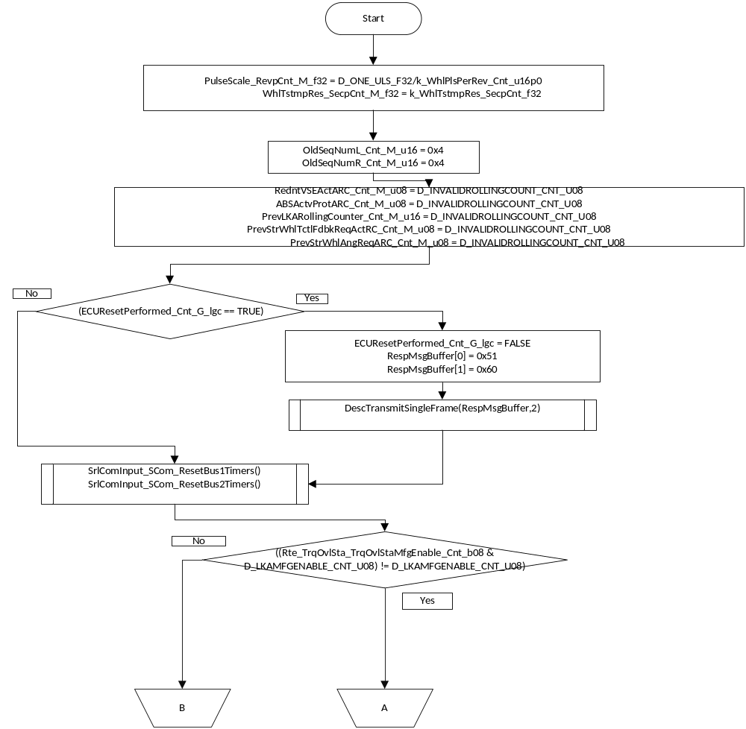

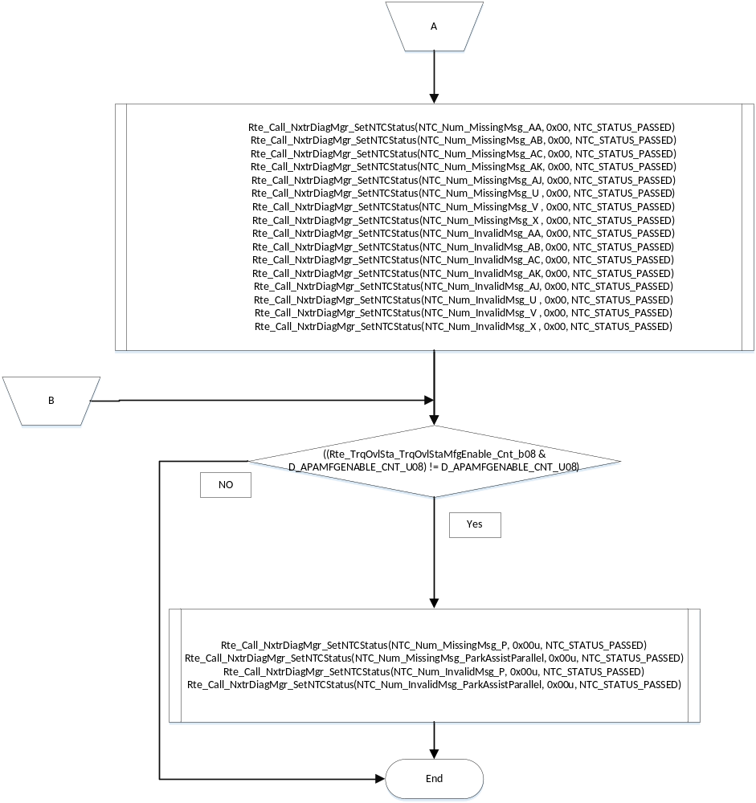

Store Local copy of outputs into Module Outputs
Rte_Write_SrlComAmbTemp_DegC_f32(k_AmbTempDflt_DegC_f32)
Rte_Write_SrlComEngTemp_DegC_f32(k_EngTempDflt_DegC_f32)

Periodic Functions

Per: SrlComInput_Per1

Design Rationale
Process and update Transmit signal data.

Program Flow Start
N/A

Store Module Inputs to Local copies

Description

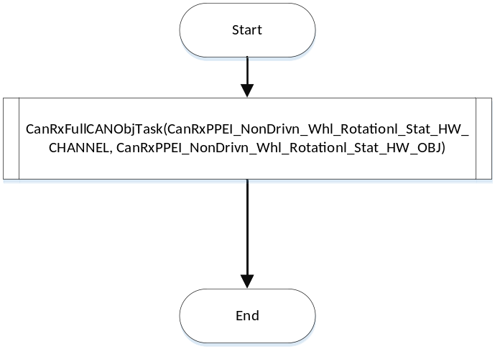

Store Local copy of outputs into Module Outputs

Program Flow End
N/A

Periodic Functions

6.3.1 Per: SrlComInput_Per2

Design Rationale
Process and update Transmit signal data.

Program Flow Start
Rte_Call_SrlComInput_Per2_CP0_CheckpointReached()

Store Module Inputs to Local copies
Rte_Read_RxMsgsSrlComSvcDft_Cnt_lgc(&RxMsgSrlComSvcDft_Cnt_T_lgc)
Rte_Read_WIREnabled_Cnt_lgc(&WIREnabled_Cnt_T_lgc)

Description

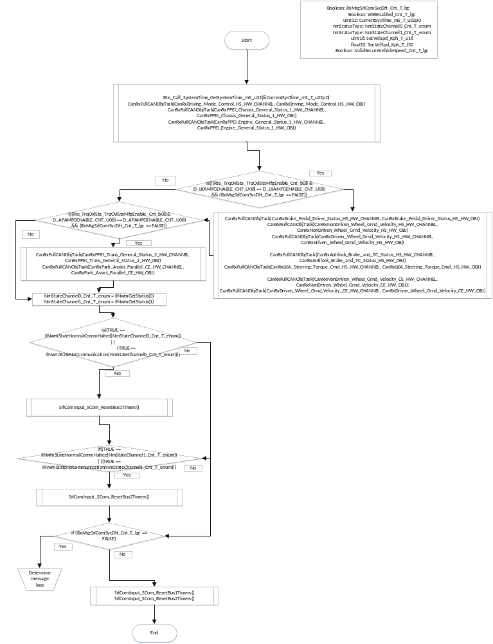

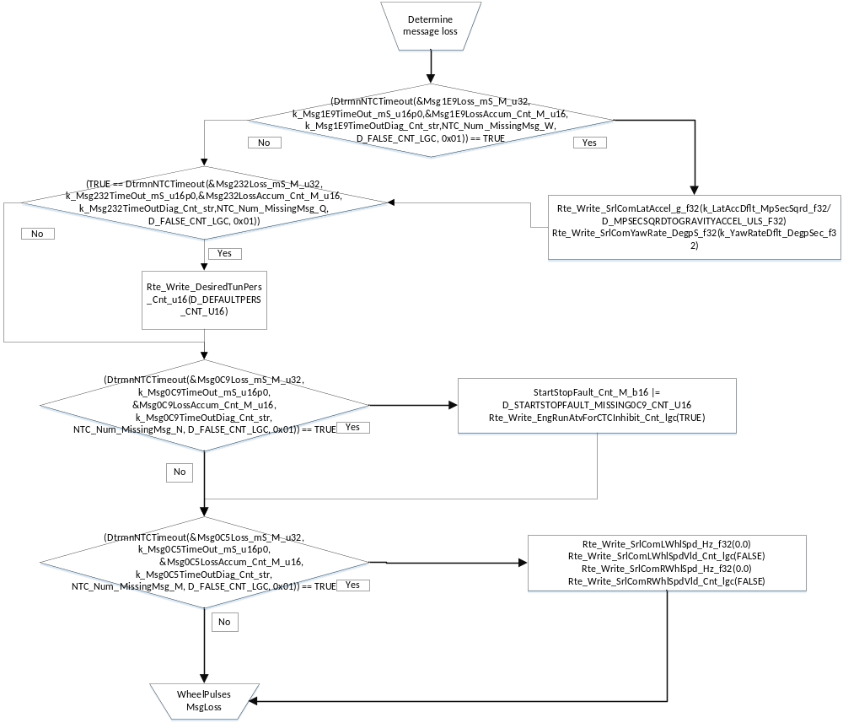

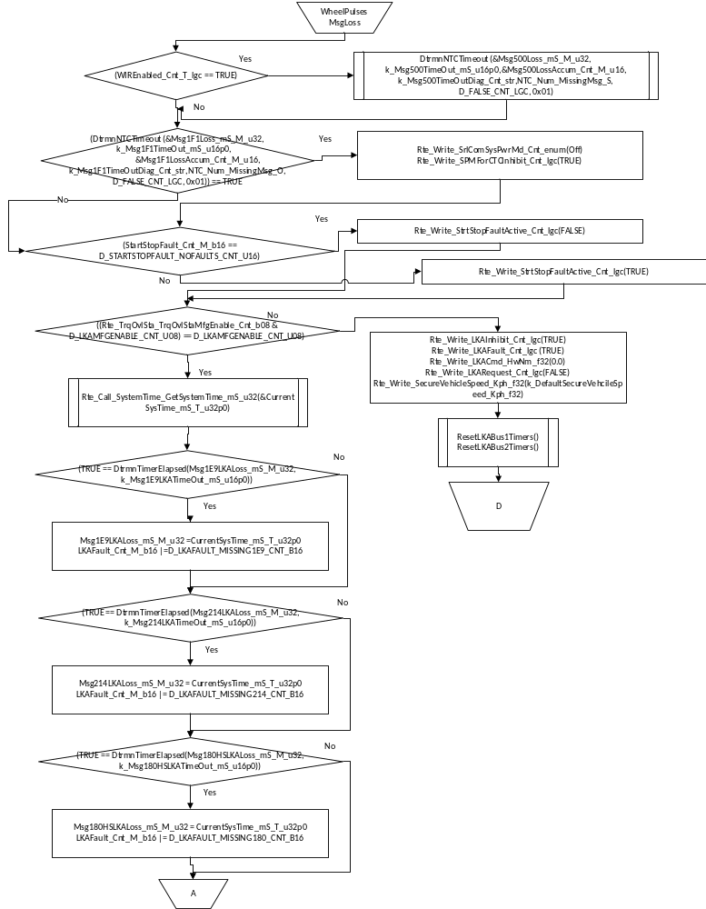

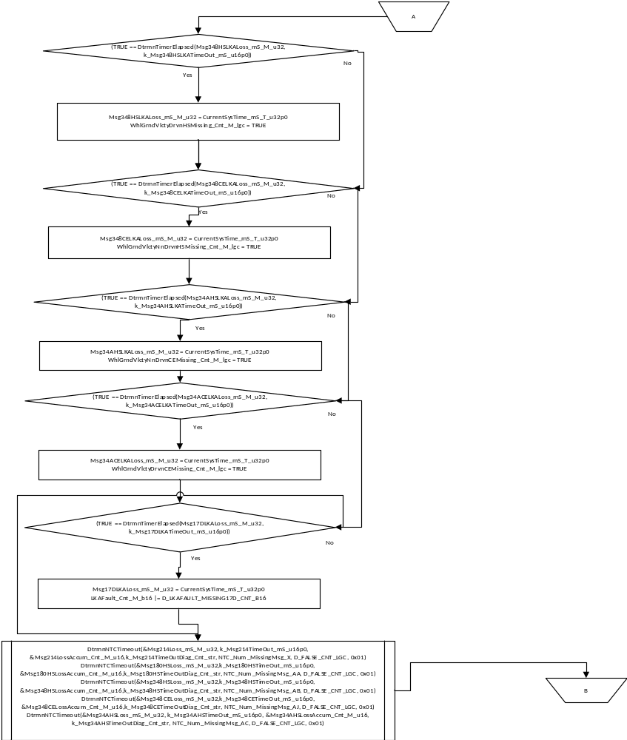

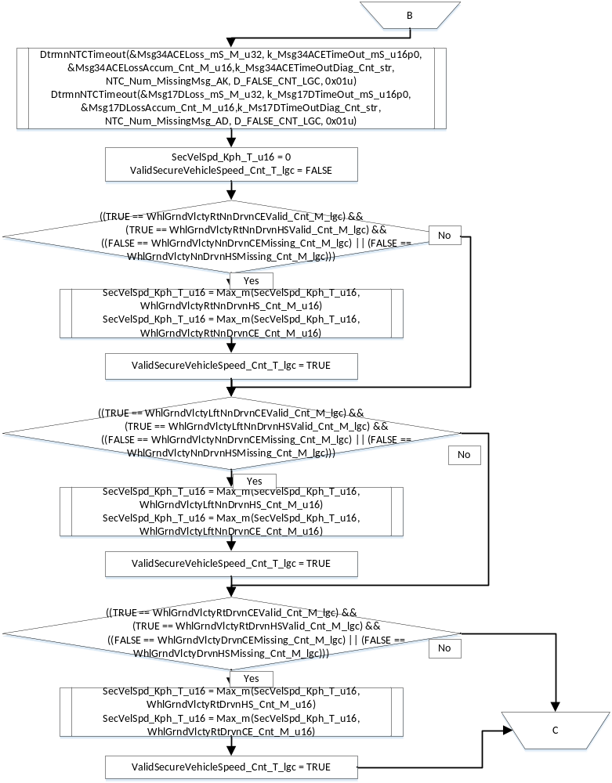

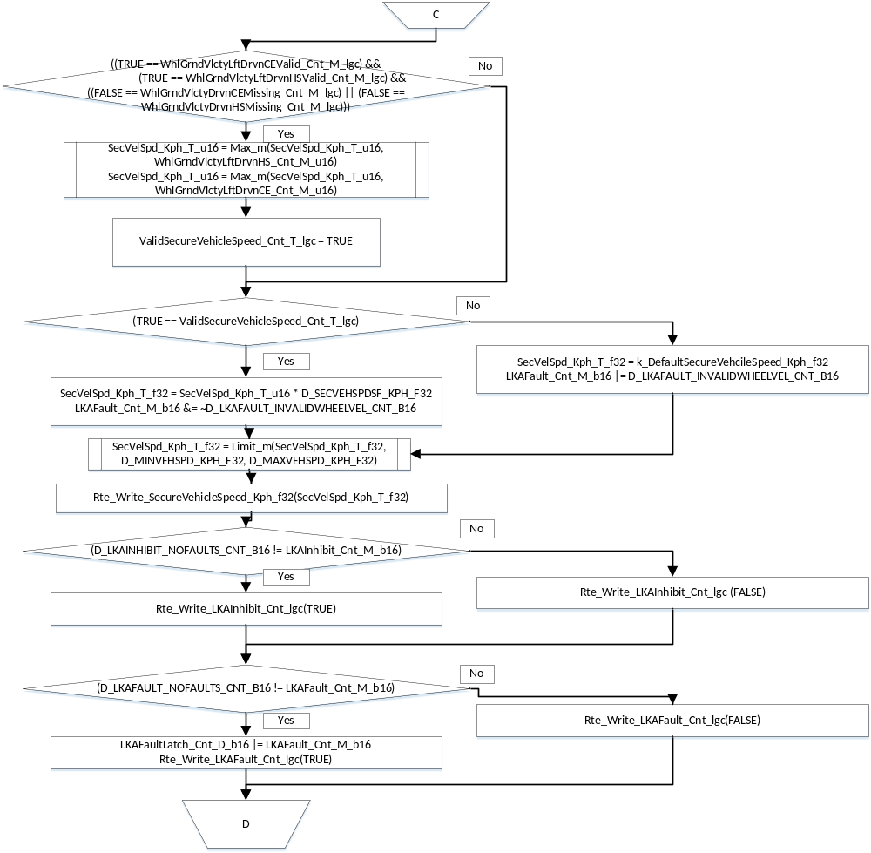

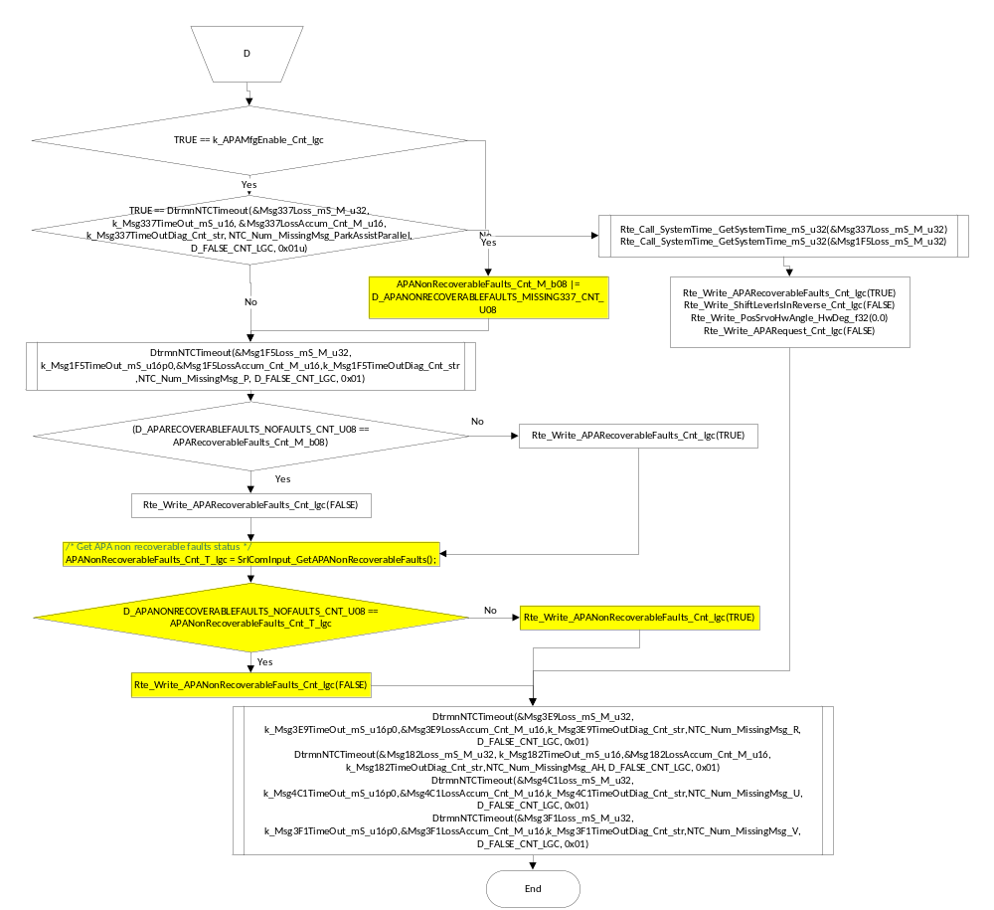

Store Local copy of outputs into Module Outputs

Program Flow End
NONE

Periodic Functions

6.4.1 Per: SrlComInput_Per3

Design Rationale
Process and update Transmit signal data.

Program Flow Start
N/A

Store Module Inputs to Local copies

Rte_Read_DiagStsDefVehSpd_Cnt_lgc(&DiagStsDefVehSpd_Cnt_T_lgc)

Description

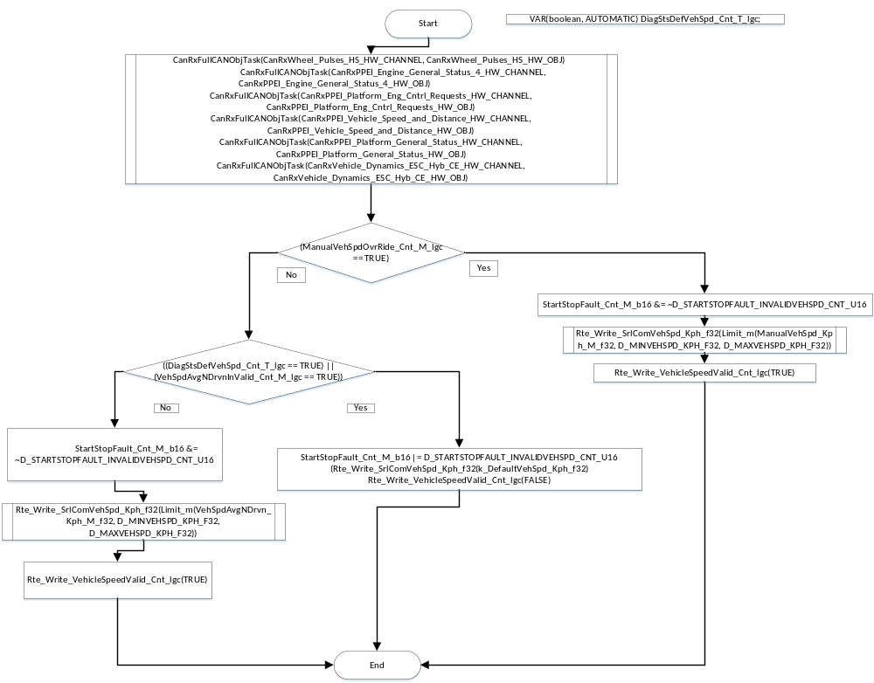

Store Local copy of outputs into Module Outputs

Program Flow End
NONE

Periodic Event Triggered Functions

SrlComInput_SCom_GetSrlComWIRFltStatus

Function Name | SrlComInput_SCom_GetSrlComWIRFltStatus | Type | Min | Max | UTP Tol.
Arguments Passed | SrlComWIRFltStatus | *UInt16 | 0 | FULL
Return Value | None

Design Rationale

Program Flow Start
N/A

Store Module Inputs to Local copies
*See below

Description

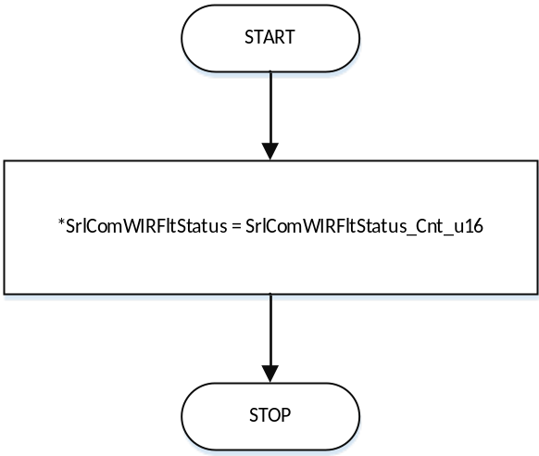

Store Local copy of outputs into Module Outputs
See section above.

Program Flow End
N/A

SrlComInput_SCom_ManualVehSpd

Function Name | SrlComInput_SCom_ManualVehSpd | Type | Min | Max | UTP Tol.
Arguments Passed | VehSpd_Kph_f32 | Float | 0 | 511.97
Return Value | None

Design Rationale

Program Flow Start
N/A

Store Module Inputs to Local copies
*See below

Description

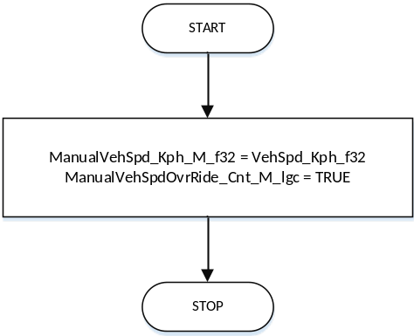

Store Local copy of outputs into Module Outputs
See section above.

Program Flow End
N/A

SrlComInput_SCom_ResetBus1Timers

Design Rationale

Program Flow Start
N/A

Store Module Inputs to Local copies
*See below

Description

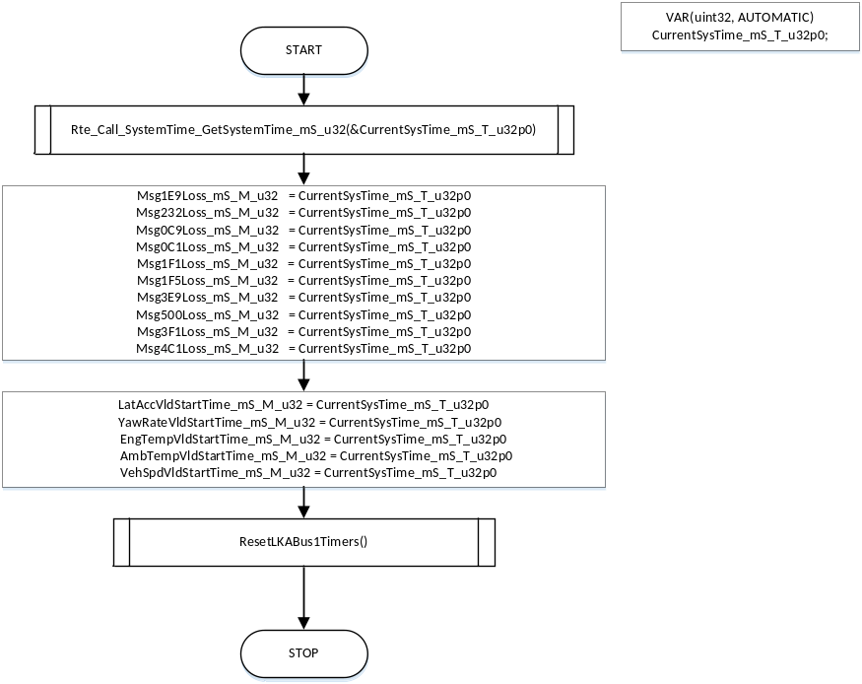

Store Local copy of outputs into Module Outputs
See section above.

Program Flow End
N/A

SrlComInput_SCom_ResetBus2Timers

Design Rationale

Program Flow Start
N/A

Store Module Inputs to Local copies
*See below

Description

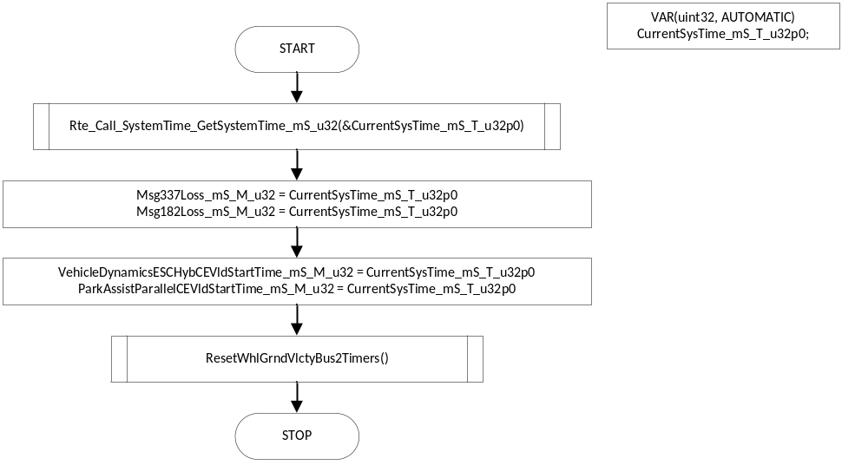

Store Local copy of outputs into Module Outputs
See section above.

Program Flow End
N/A

Local Function/Macro Definitions

ProcessWhlStatus

Function Name | ProcessWhlStatus | Type | Min | Max | UTP Tol.
Arguments Passed | WhlRotStatus | WhlRotStat
 | OldSeqNum_Ptr_T_u16 | uint16 | 0 | 3 | 0.00E+00
 | OldWhlDistTstm_Ptr_T_u16 | uint16 | 0 | 65535 | 0.00E+00
 | OldWhlPCntr_Ptr_T_u16 | uint16 | 0 | 1023 | 0.00E+00
 | OldRawWhlFreq_Ptr_T_f32 | float32 | 0 | 55.48 | 2.08E-02
 | WhlTstmpRes_SecpCnt_T_f32 | float32 | 0 | 2047000000
 | PulseScale_RevpCnt_T_f32 | float32 | 0.007874015748031496062992125984252 | 1
 | LastPlsChngTime_Ptr_T_u32 | uint32 | 0 | FULL | 0.00E+00
 | WIRFltStatus_Ptr_T_u16 | uint16 | 0 | 65535 | 0.00E+00
 | InvStartTime_Ptr_T_u32 | uint32 | 0 | FULL | 0.00E+00
Return Value | RawWhlFreq_Hz_T_f32 | float32 | 0 | 55.48 | 2.08E-02

Description

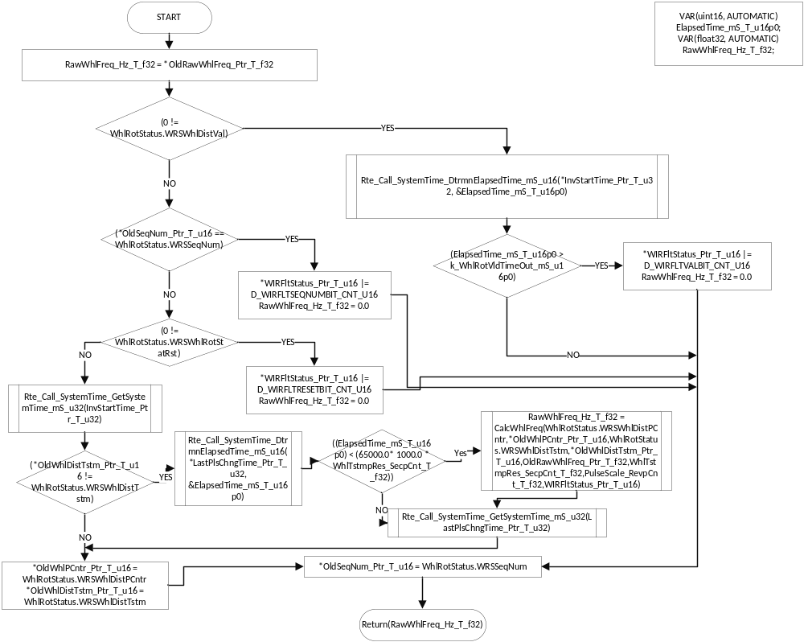

CalcWhlFreq

Function Name | CalcWhlFreq | Type | Min | Max | UTP Tol.
Arguments Passed | WRSWhlDistPCntr_Cnt_T_u16 | uint16 | 0 | 1023
 | OldWhlPCntr_Cnt_T_u16 | uint16 | 0 | 1023
 | WRSWhlDistTstm_Cnt_T_u16 | uint16 | 0 | 65535
 | OldWhlDistTstm_Cnt_T_u16 | uint16 | 0 | 65535
 | OldRawWhlFreq_Ptr_T_f32 | float32 | 0 | 55.48 | 2.08E-02
 | WhlTstmpRes_SecpCnt_T_f32 | float32 | 0 | 2047000000
 | PulseScale_RevpCnt_T_f32 | float32 | 0.007874015748031496062992125984252 | 1
 | WIRFltStatus_Ptr_T_u16 | uint16 | 0 | 65535
Return Value | RawWhlFreq_Hz_T_f32 | float32 | 0 | 55.48 | 2.08E-02

Description

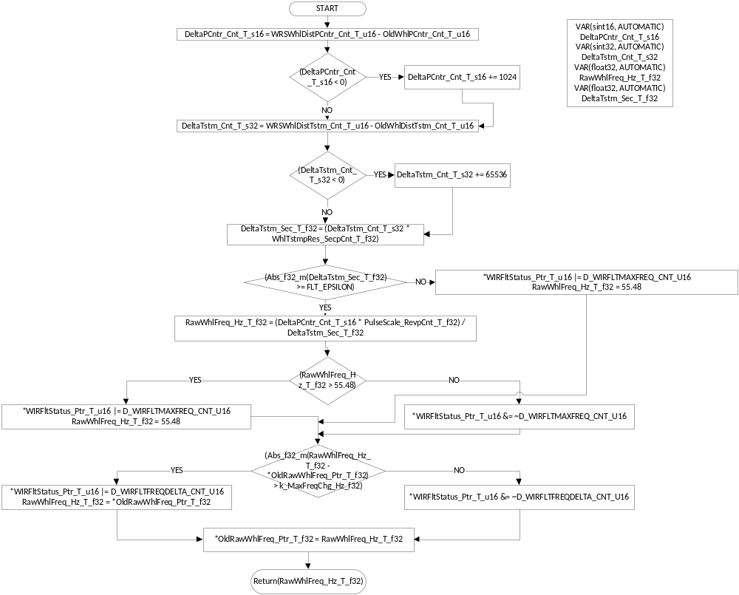

DtrmnNTCTimeout

Function Name | DtrmnNTCTimeout | Type | Min | Max | UTP Tol.
Arguments Passed | MsgLossTimer_mS_T_u32 | uint32 | 0 | FULL
 | RxMsgTimeoutCal_mS_T_u16p0 | uint16 | 0 | FULL
 | FaultAccumulator_Cnt_T_u16 | uint16 | 0 | FULL
 | DiagSettings_Cnt_T_str | DiagSettings_Str | 0 | FULL
 | NTCNum_Cnt_T_u16 | uint16 | 0 | FULL
 | InhibitNTCFlag_Cnt_T_lgc | boolean | FALSE | TRUE
 | NTCbit_Cnt_T_u8 | uint8 | 0 | FULL
Return Value | FaultPresent_Cnt_T_lgc | boolean | FALSE | TRUE

Description
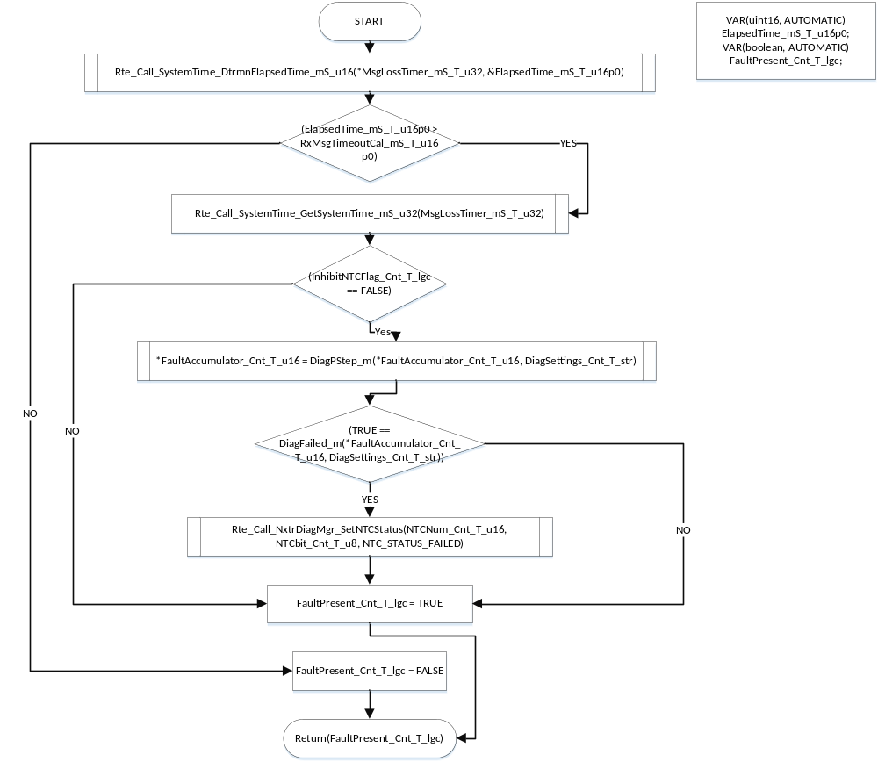

NTCCheckClear

Function Name | NTCCheckClear | Type | Min | Max | UTP Tol.
Arguments Passed | MsgLossTimer_mS_T_u32 | uint32 | 0 | FULL
 | FaultAccumulator_Cnt_T_u16 | uint16 | 0 | FULL
 | DiagSettings_Cnt_T_str | DiagSettings_Str | 0 | FULL
 | NTCNum_Cnt_T_u16 | uint16 | 0 | FULL
Return Value | FaultCleared_Cnt_T_lgc | boolean | FALSE | TRUE

Description

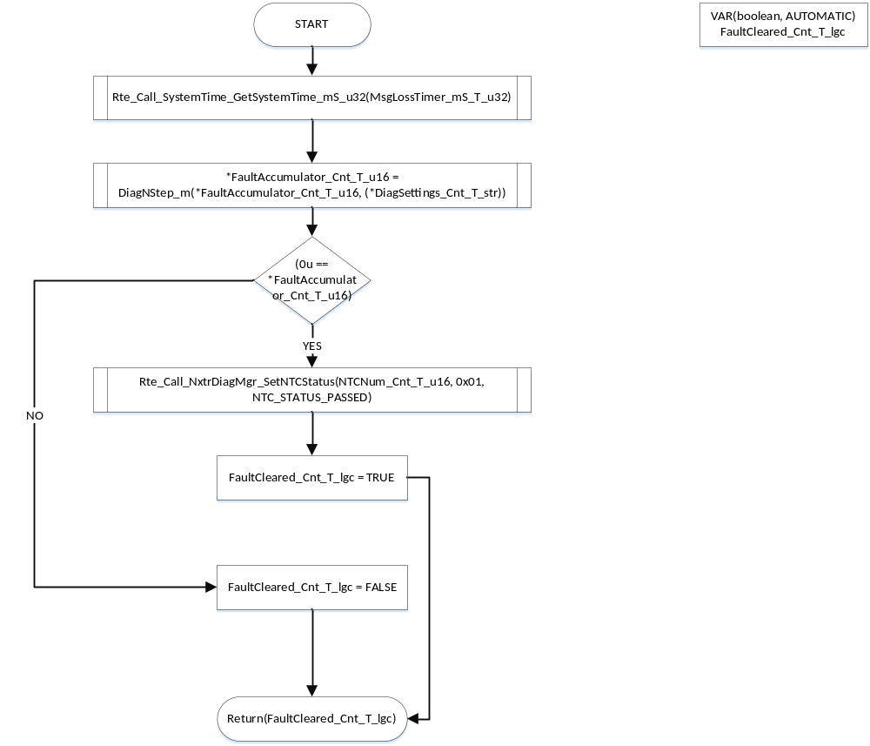

DtrmnTimerElapsed

Function Name | DtrmnTimerElapsed | Type | Min | Max | UTP Tol.
Arguments Passed | MsgLossTimer_mS_T_u32 | uint32 | 0 | FULL
 | RxMsgInhibitNTCTOCal_mS_T_u16p0 | uint16 | 0 | FULL
Return Value | NTCInhibit_Cnt_T_lgc | boolean | FALSE | TRUE

Description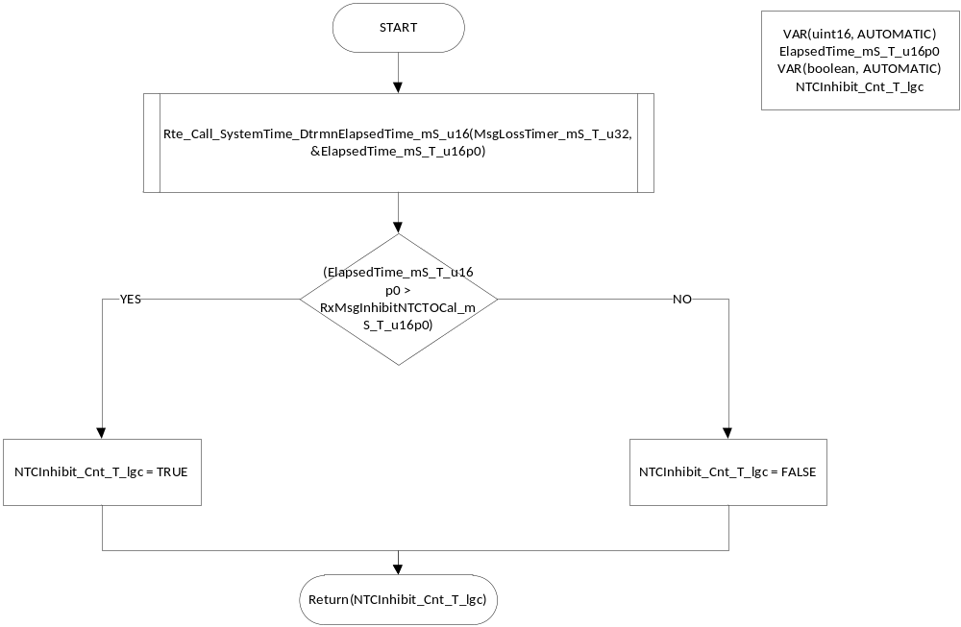

ResetLKABus1Timers

Description

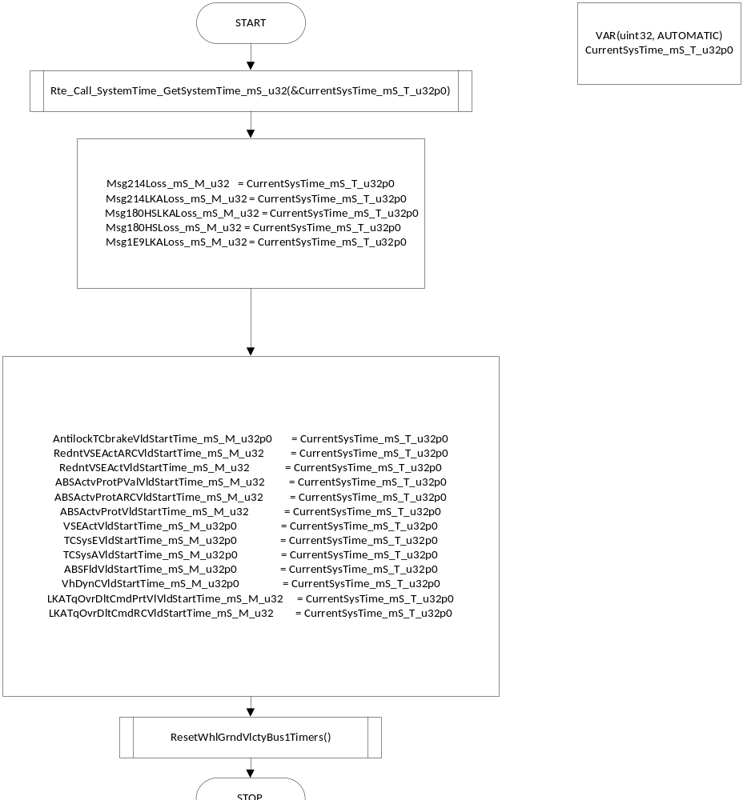

ResetWhlGrndVlctyBus1Timers

Description

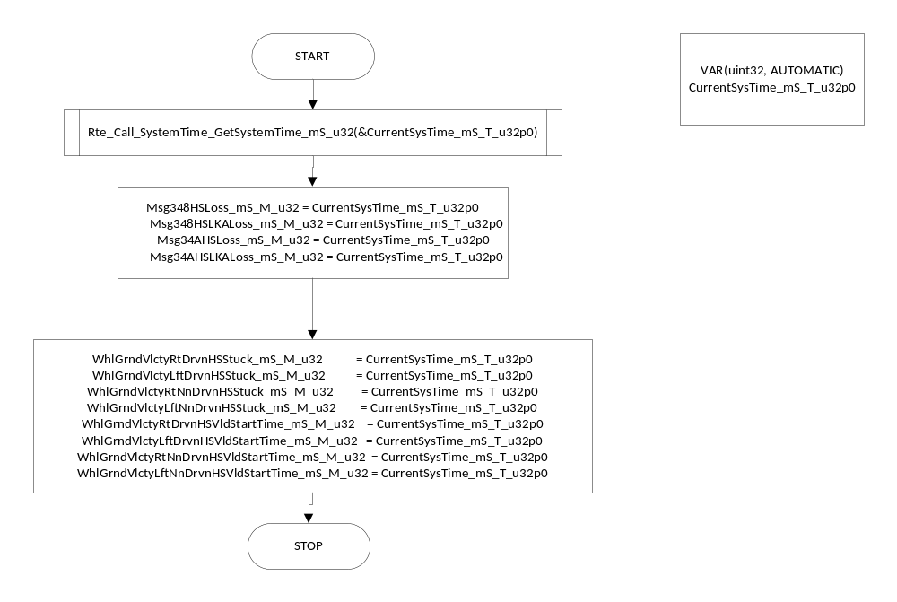

ResetWhlGrndVlctyBus2Timers

Description

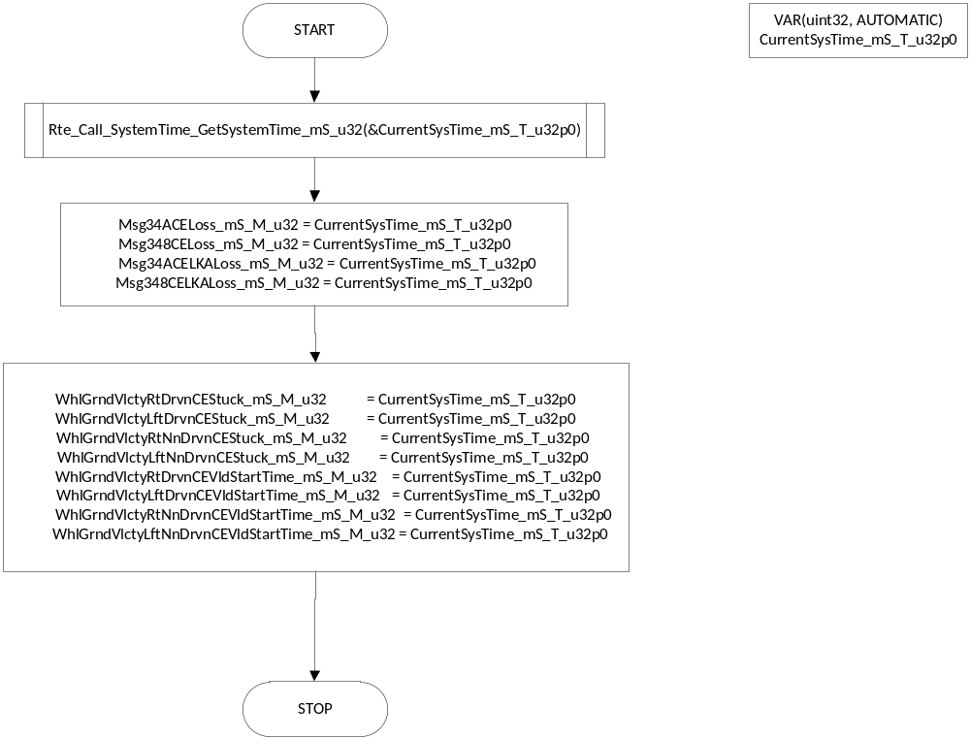

SrlComInput_GetAPANonRecoverableFaults

Description
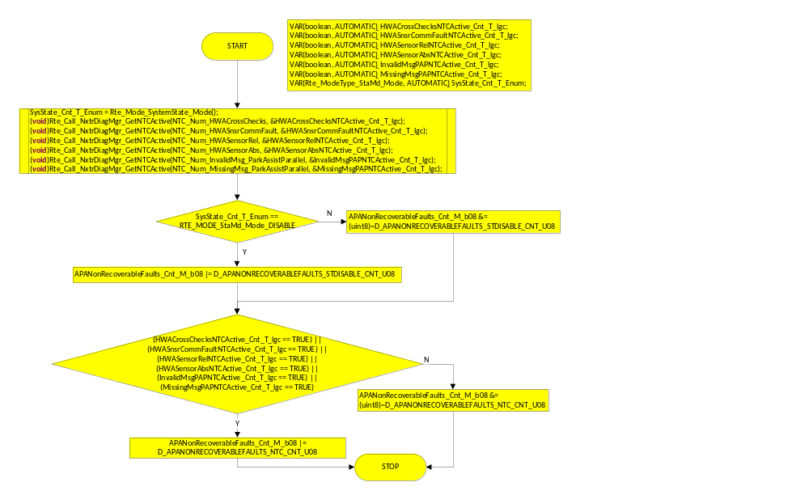

Serial Communication Functions

Design Rationale
The functions that process receive signal data are triggered by reception of the signal. These functions (SrlComInput_Rx”signalname”() ) are not called periodically in a scheduled task, but are triggered based on the indication flags that gets set when a message is polled to the message mailbox.

SrlComInput_MsgProcess_RxNonDrivnWhlRotationlStat_x0C1

Function Name | SrlComInput_MsgProcess_RxNonDrivnWhlRotationlStat_x0C1 | Type | Min | Max | UTP Tol.
Arguments Passed | rcvObject | CanReceiveHandle
Return Value

Design Rationale

Program Flow Start
N/A

Store Module Inputs to Local copies
Rte_Read_WIREnabled_Cnt_lgc(&WIREnabled_Cnt_T_lgc)
Rte_Read_RxMsgsSrlComSvcDft_Cnt_lgc(&RxMsgSrlComSvcDft_Cnt_T_lgc)

Description

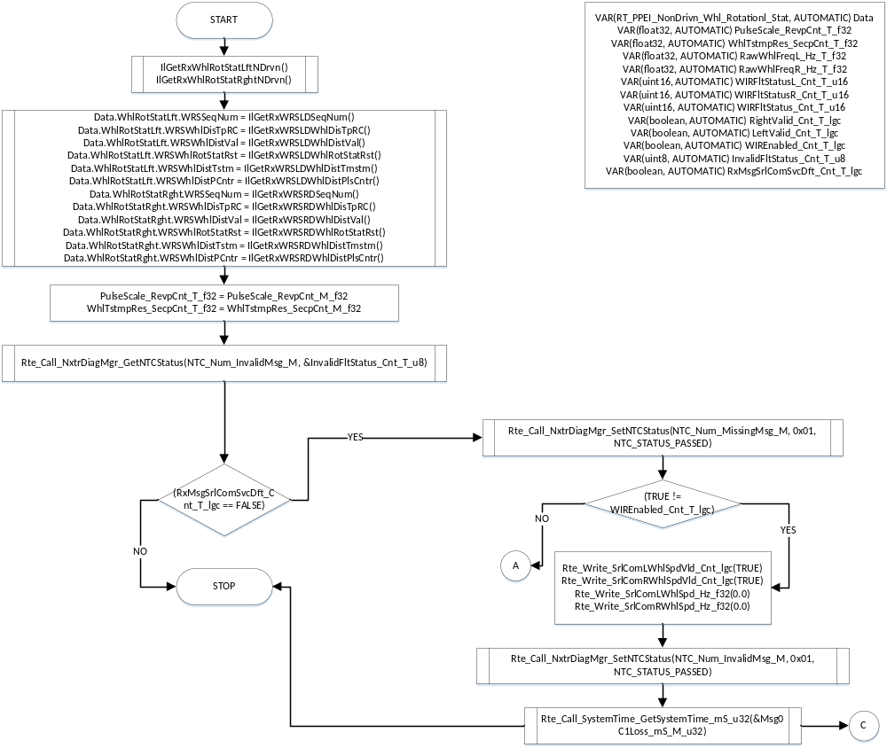

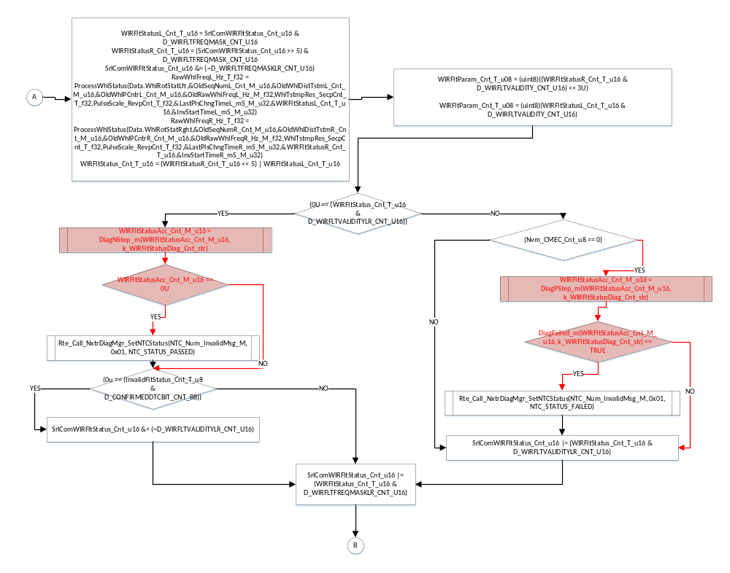

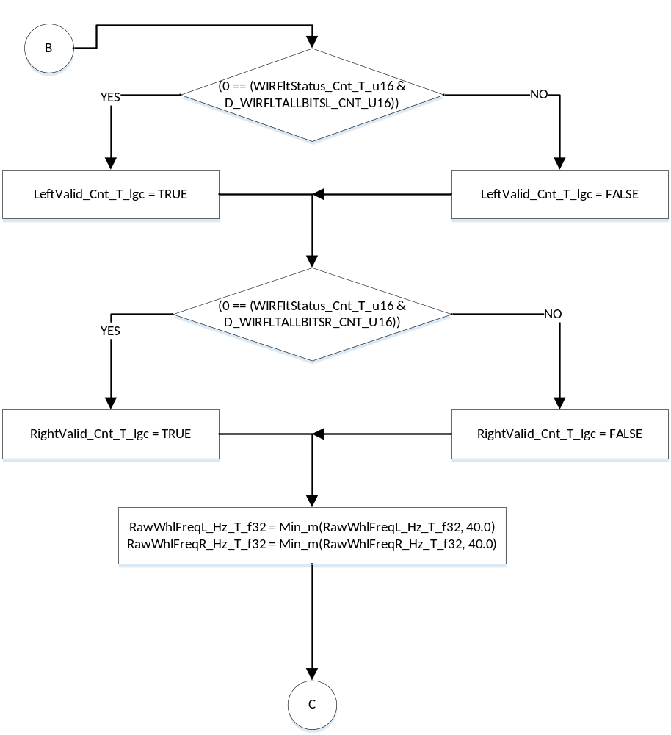

Store Local copy of outputs into Module Outputs
Rte_Write_SrlComLWhlSpdVld_Cnt_lgc(LeftValid_Cnt_T_lgc)
Rte_Write_SrlComRWhlSpdVld_Cnt_lgc(RightValid_Cnt_T_lgc)
Rte_Write_SrlComLWhlSpd_Hz_f32(RawWhlFreqL_Hz_T_f32)
Rte_Write_SrlComRWhlSpd_Hz_f32(RawWhlFreqR_Hz_T_f32)

Program Flow End
N/A

SrlComInput_MsgProcess_RxEngineGeneralStatus1_x0C9

Function Name | SrlComInput_MsgProcess_RxEngineGeneralStatus1_x0C9 | Type | Min | Max | UTP Tol.
Arguments Passed | rcvObject | CanReceiveHandle
Return Value

Design Rationale

Program Flow Start
N/A

Store Module Inputs to Local copies
Rte_Read_RxMsgsSrlComSvcDft_Cnt_lgc(&RxMsgSrlComSvcDft_Cnt_T_lgc)

Description

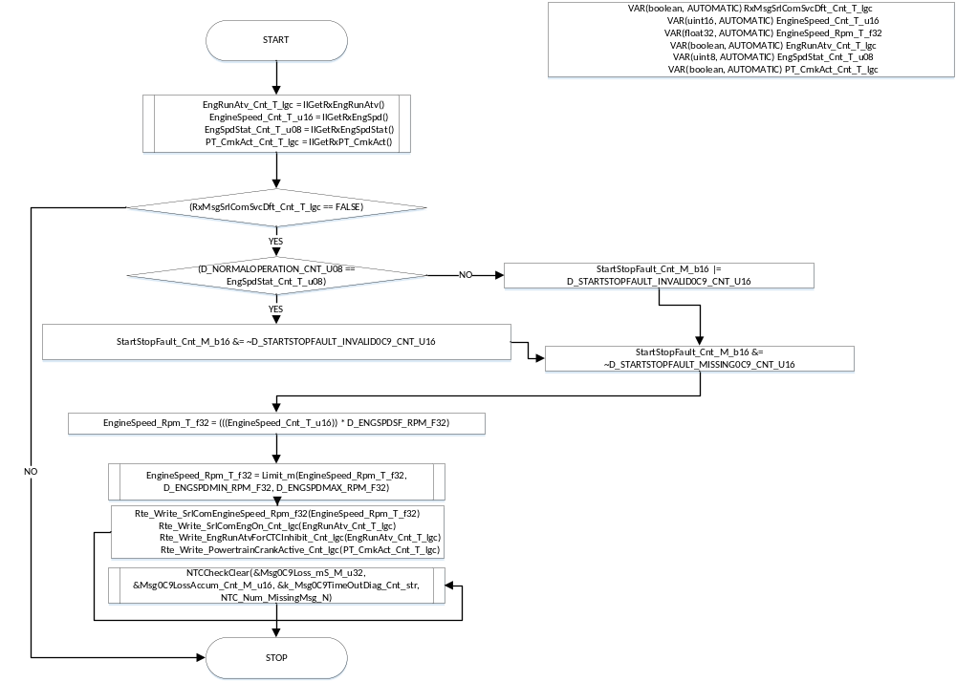

Store Local copy of outputs into Module Outputs
**See Section Above

Program Flow End
N/A

SrlComInput_MsgProcess_RxAntilockBrakeandTCStatusHS_x17D

Function Name | SrlComInput_MsgProcess_RxAntilockBrakeandTCStatusHS_x17D | Type | Min | Max | UTP Tol.
Arguments Passed | rcvObject | CanReceiveHandle
Return Value

Design Rationale

Program Flow Start
N/A

Store Module Inputs to Local copies
*See below

Description

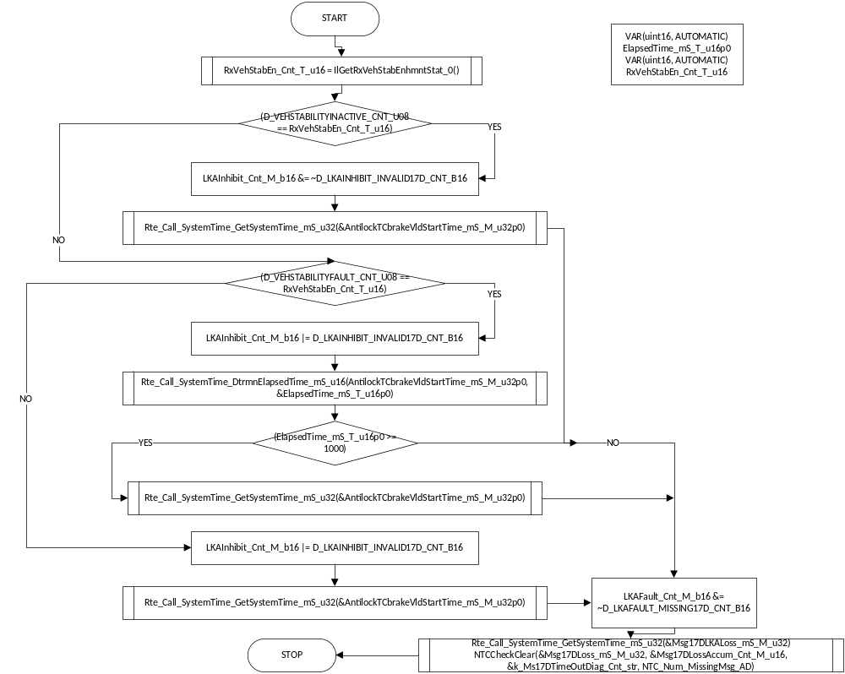

Store Local copy of outputs into Module Outputs
See section above.

Program Flow End
N/A

SrlComInput_MsgProcess_RxLKASteeringTorqueCmdHS_x180

Function Name | SrlComInput_MsgProcess_RxLKASteeringTorqueCmdHS_x180 | Type | Min | Max | UTP Tol.
Arguments Passed | rcvObject | CanReceiveHandle
Return Value

Design Rationale

Program Flow Start
N/A

Store Module Inputs to Local copies
*See below

Description

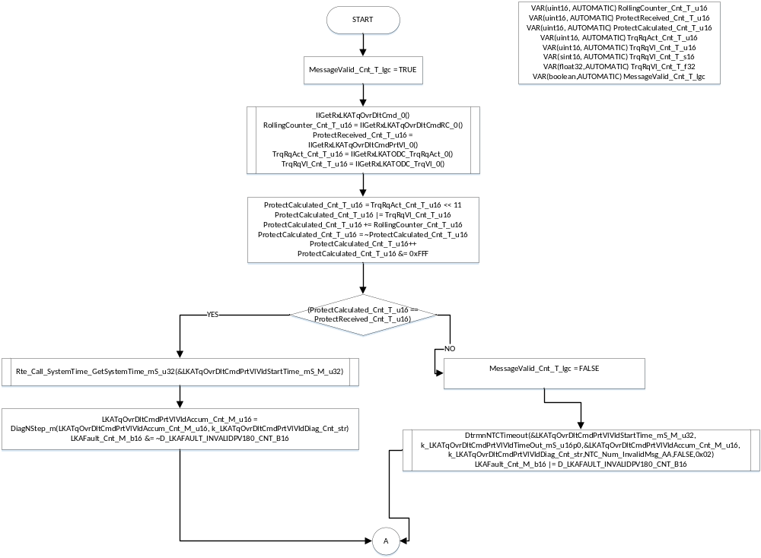

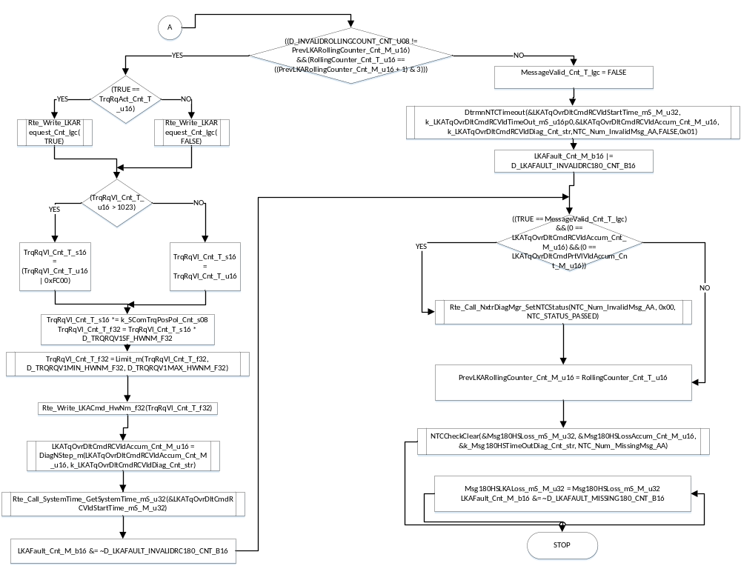

Store Local copy of outputs into Module Outputs
See section above.

Program Flow End
N/A

SrlComInput_MsgProcess_RxChassisGeneralStatus1_x1E9

Function Name | SrlComInput_MsgProcess_RxChassisGeneralStatus1_x1E9 | Type | Min | Max | UTP Tol.
Arguments Passed | rcvObject | CanReceiveHandle
Return Value

Design Rationale

Program Flow Start
N/A

Store Module Inputs to Local copies
Rte_Read_RxMsgsSrlComSvcDft_Cnt_lgc(&RxMsgSrlComSvcDft_Cnt_T_lgc)

Description

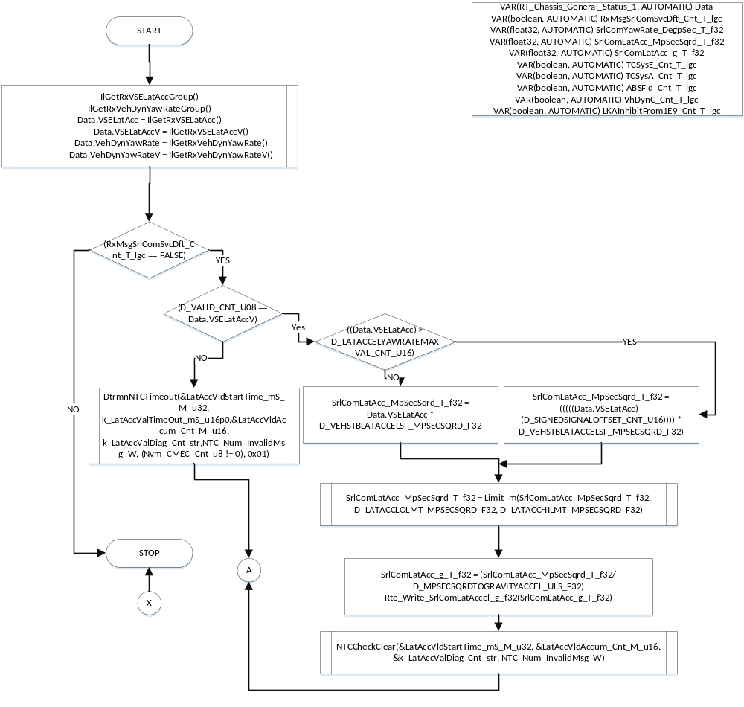

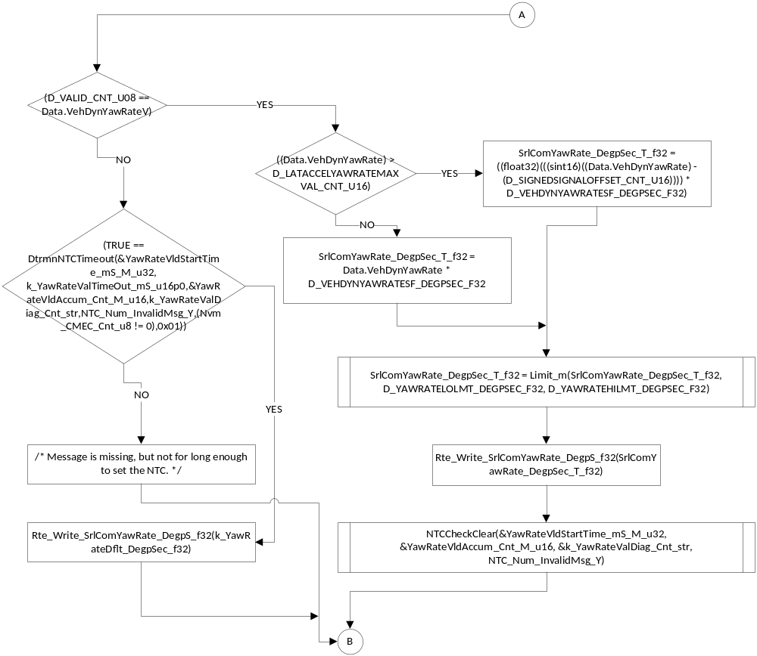

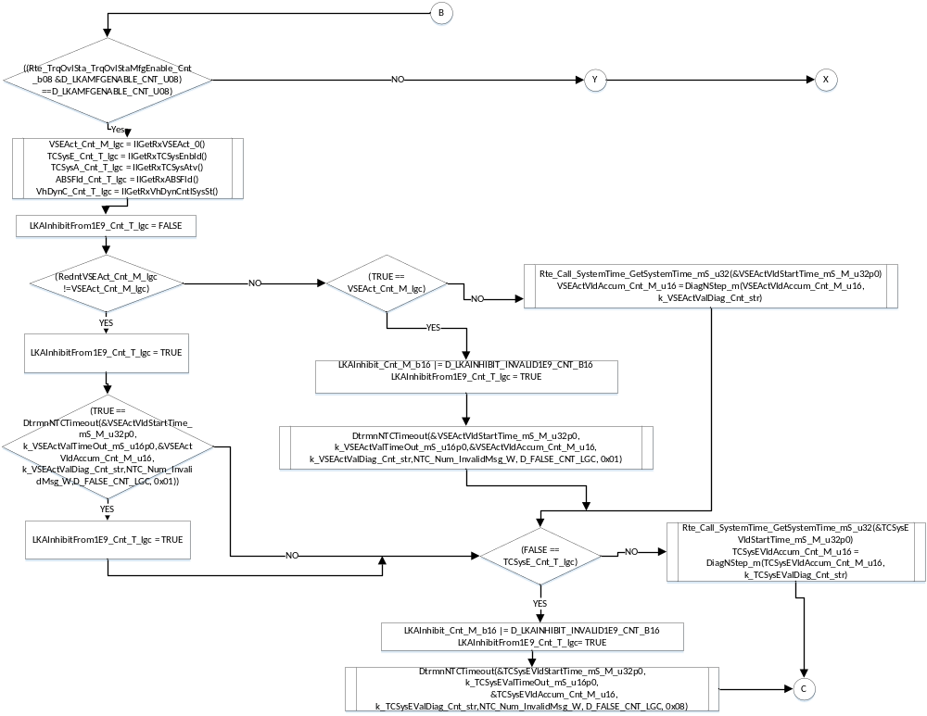

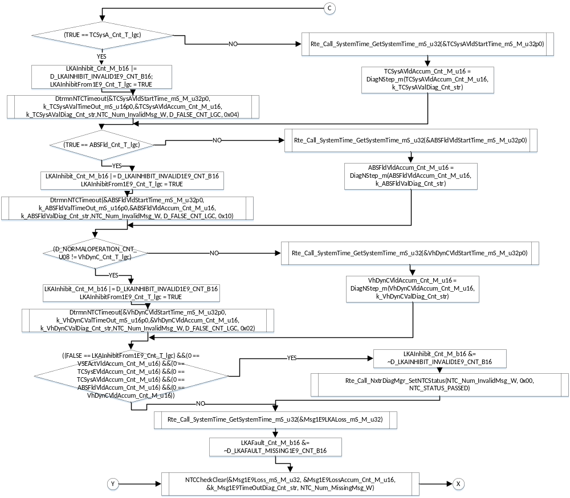

Store Local copy of outputs into Module Outputs
See section above.

Program Flow End
N/A

SrlComInput_MsgProcess_RxPlatformGeneralStatus_x1F1

Function Name | SrlComInput_MsgProcess_RxPlatformGeneralStatus_x1F1 | Type | Min | Max | UTP Tol.
Arguments Passed | rcvObject | CanReceiveHandle
Return Value

Design Rationale

Program Flow Start
N/A

Store Module Inputs to Local copies
Rte_Read_PrevSrlComEngOn_Cnt_lgc(&PrevSrlComEngOn_Cnt_T_lgc)
Rte_Read_RxMsgsSrlComSvcDft_Cnt_lgc(&RxMsgSrlComSvcDft_Cnt_T_lgc)

Description

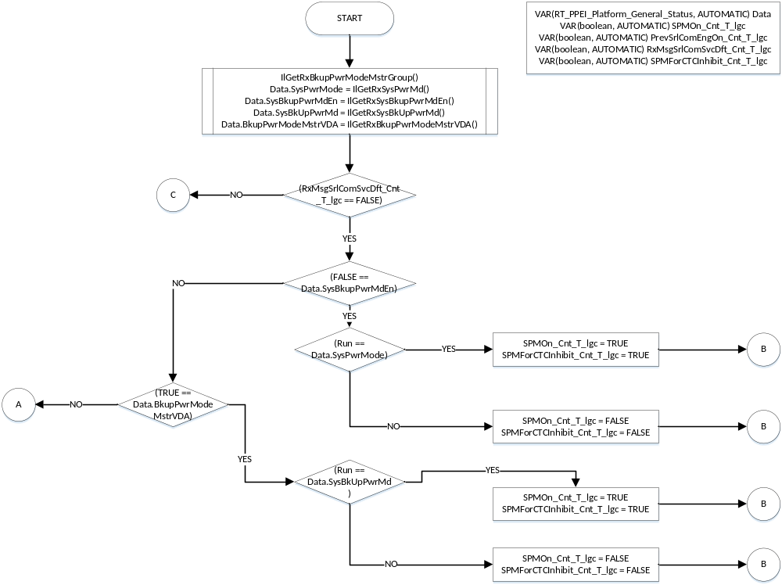

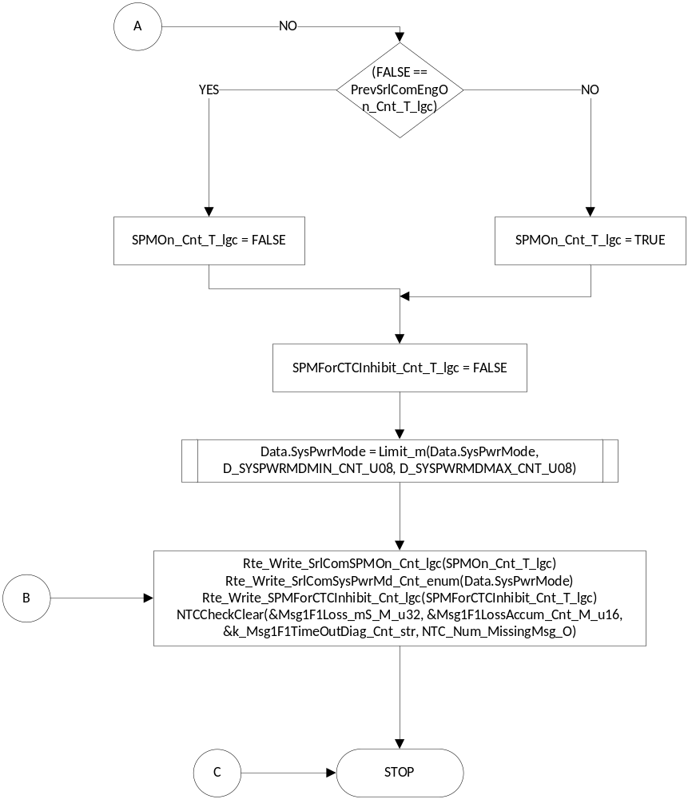

Store Local copy of outputs into Module Outputs
See section above.

Program Flow End
N/A

SrlComInput_MsgProcess_RxTransGeneralStatus2_x1F5

Function Name | SrlComInput_MsgProcess_RxTransGeneralStatus2_x1F5 | Type | Min | Max | UTP Tol.
Arguments Passed | rcvObject | CanReceiveHandle
Return Value

Design Rationale

Program Flow Start
N/A

Store Module Inputs to Local copies
Rte_Read_RxMsgsSrlComSvcDft_Cnt_lgc(&RxMsgSrlComSvcDft_Cnt_T_lgc)

Description

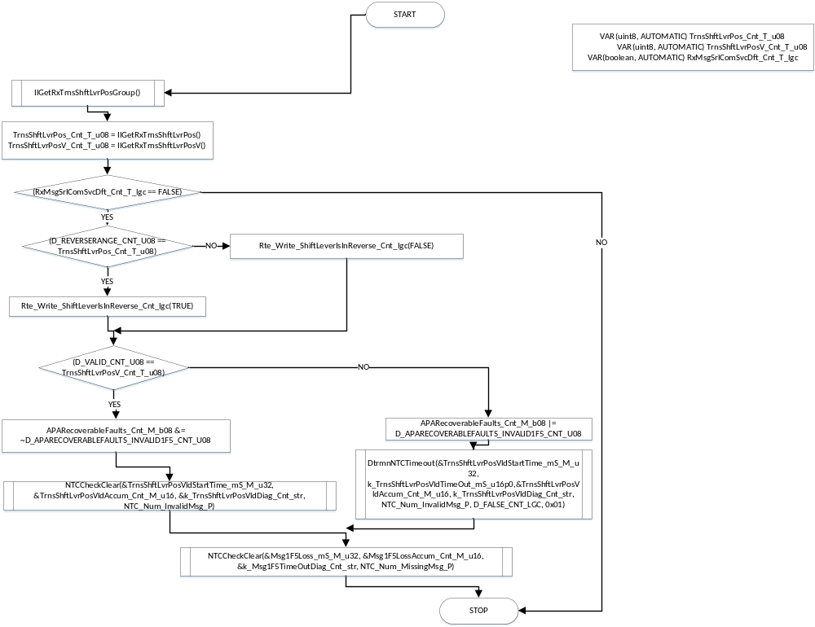

Store Local copy of outputs into Module Outputs
See section above.

Program Flow End
N/A

SrlComInput_MsgProcess_RxBrakePedalDriverStatusHS_x214

Function Name | SrlComInput_MsgProcess_RxBrakePedalDriverStatusHS_x214 | Type | Min | Max | UTP Tol.
Arguments Passed | rcvObject | CanReceiveHandle
Return Value

Design Rationale

Program Flow Start
N/A

Store Module Inputs to Local copies
*See below

Description

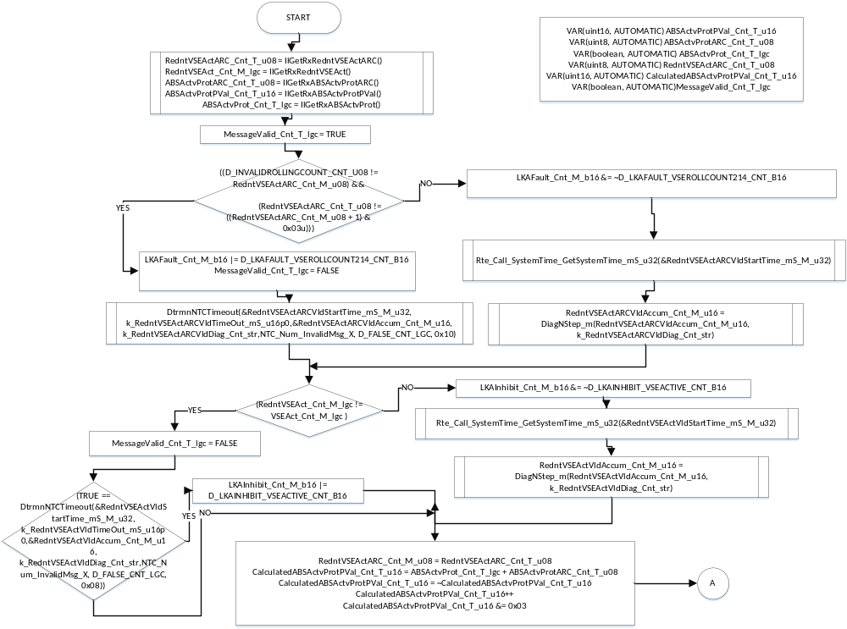

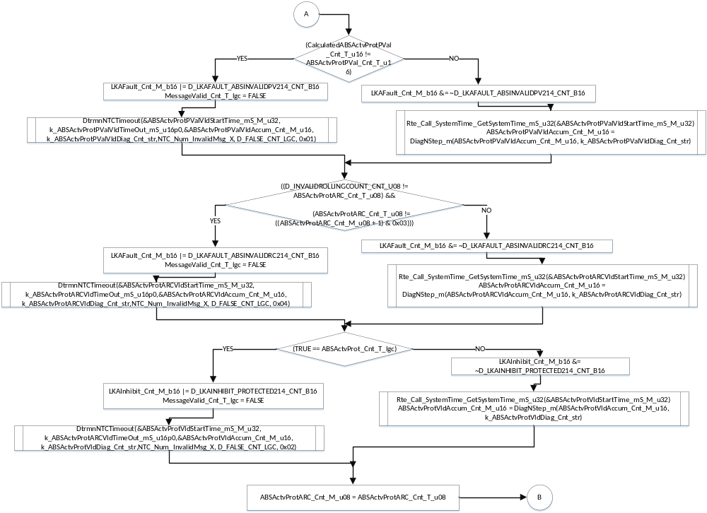

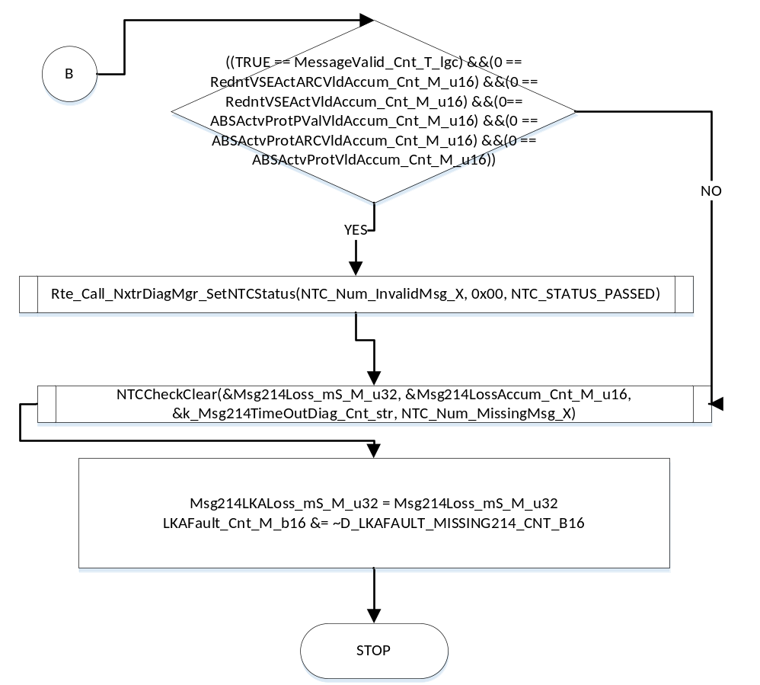

Store Local copy of outputs into Module Outputs
See section above.

Program Flow End
N/A

SrlComInput_MsgProcess_RxDrivingModeControlHS_x232

Function Name | SrlComInput_MsgProcess_RxDrivingModeControlHS_x232 | Type | Min | Max | UTP Tol.
Arguments Passed | rcvObject | CanReceiveHandle
Return Value

Design Rationale

Program Flow Start
N/A

Store Module Inputs to Local copies
*See below

Description

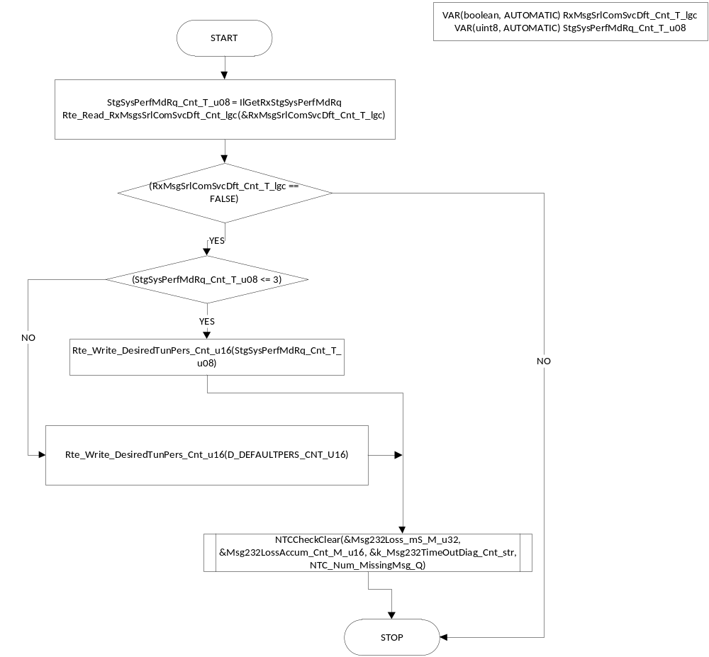

Store Local copy of outputs into Module Outputs
See section above.

Program Flow End
N/A

SrlComInput_MsgProcess_RxDrivenWheelGrndVelocityHS_x348

Function Name | SrlComInput_MsgProcess_RxDrivenWheelGrndVelocityHS_x348 | Type | Min | Max | UTP Tol.
Arguments Passed | rcvObject | CanReceiveHandle
Return Value

Design Rationale

Program Flow Start
N/A

Store Module Inputs to Local copies
*See below

Description

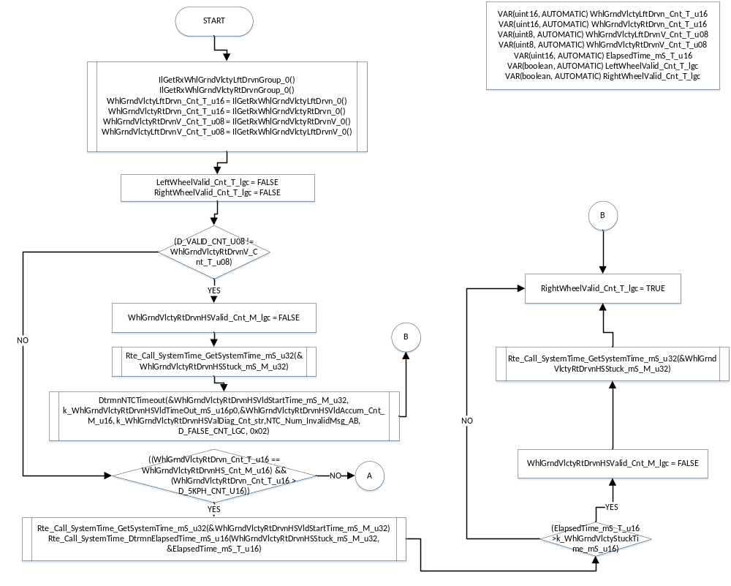

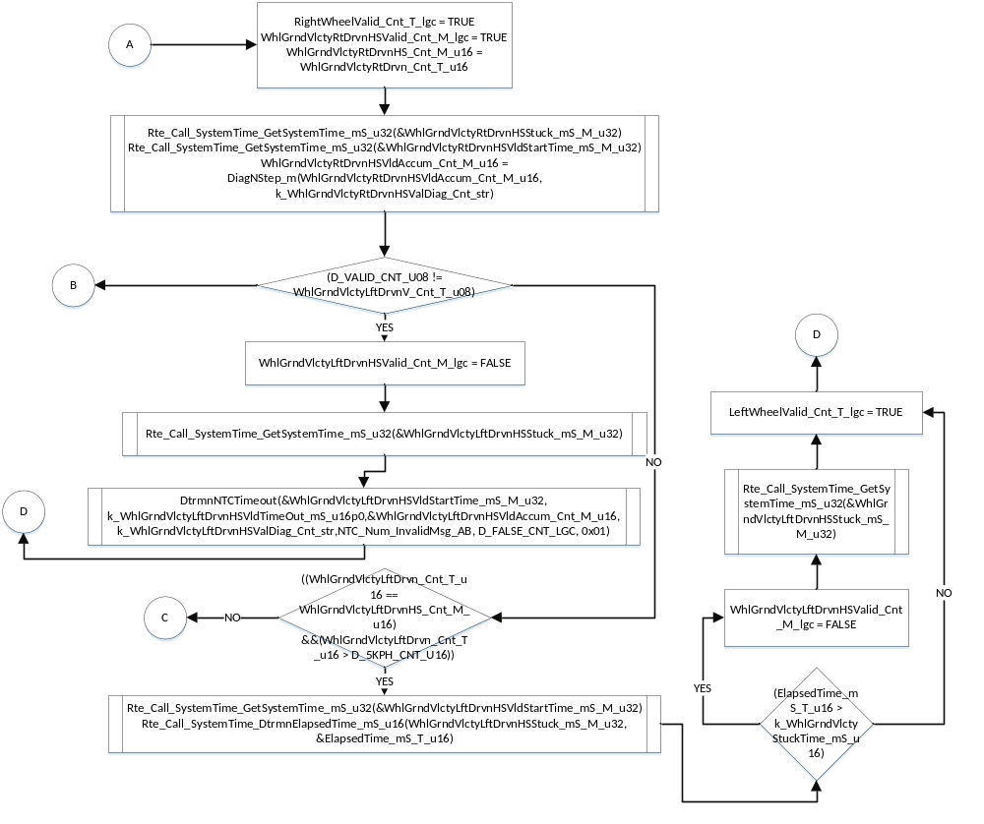

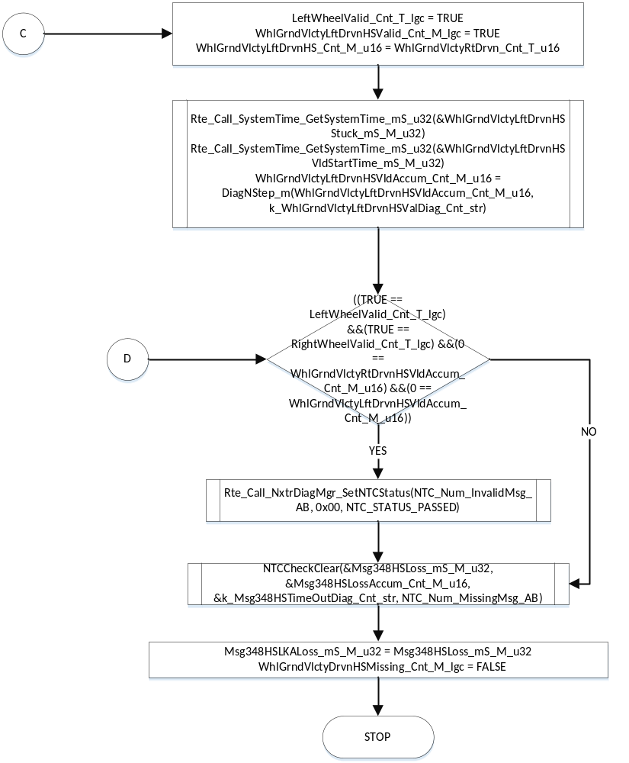

Store Local copy of outputs into Module Outputs
See section above.

Program Flow End
N/A

SrlComInput_MsgProcess_RxNonDrivenWheelGrndVelocityHS_x34A

Function Name | SrlComInput_MsgProcess_RxNonDrivenWheelGrndVelocityHS_x34A | Type | Min | Max | UTP Tol.
Arguments Passed | rcvObject | CanReceiveHandle
Return Value

Design Rationale

Program Flow Start
N/A

Store Module Inputs to Local copies
*See below

Description

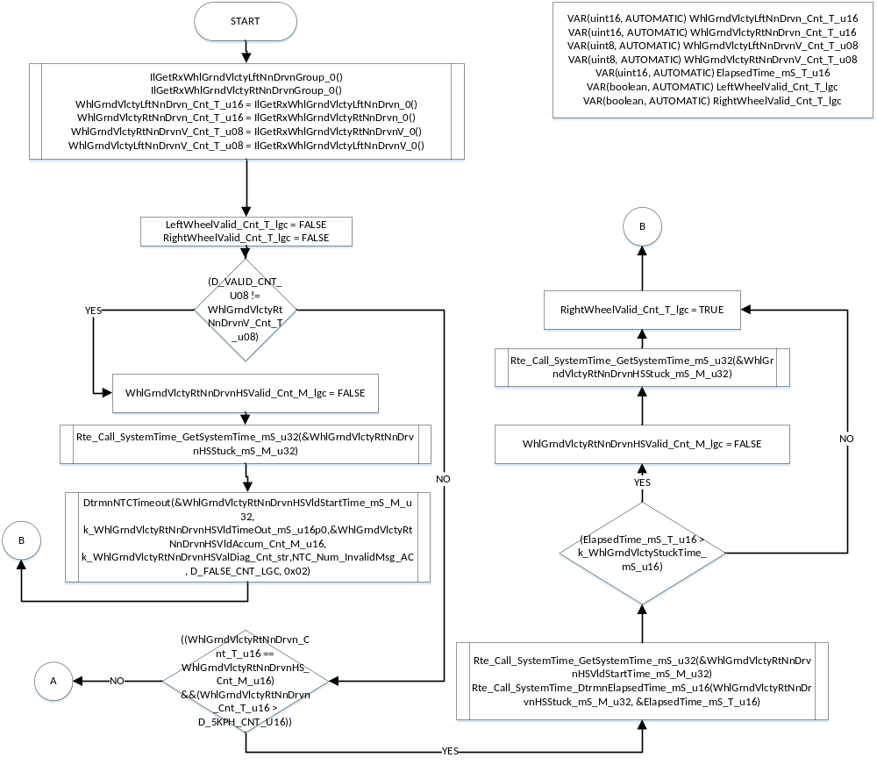

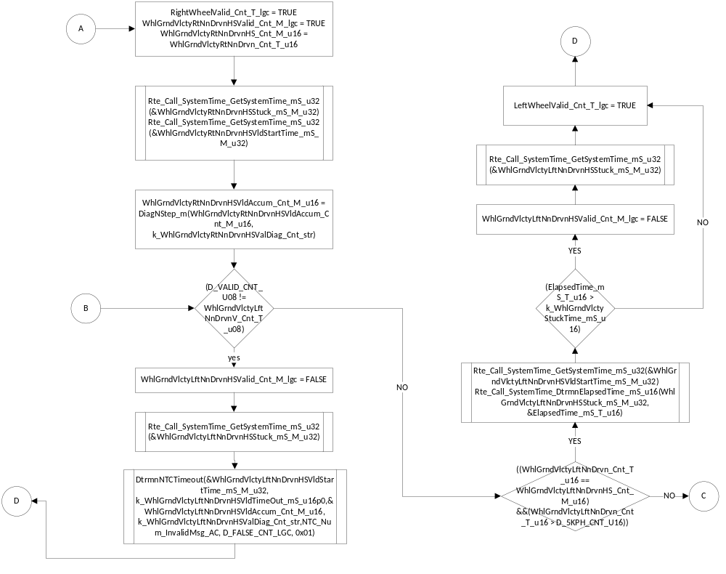

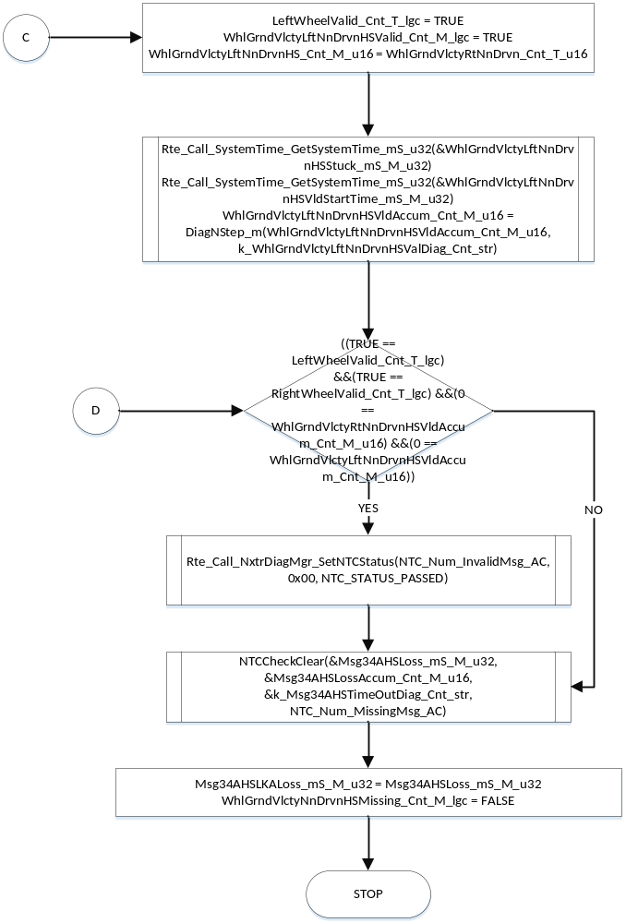

Store Local copy of outputs into Module Outputs
See section above.

Program Flow End
N/A

SrlComInput_MsgProcess_RxVehicleSpeedAndDistance_x3E9

Function Name | SrlComInput_MsgProcess_RxVehicleSpeedAndDistance_x3E9 | Type | Min | Max | UTP Tol.
Arguments Passed | rcvObject | CanReceiveHandle
Return Value

Design Rationale

Program Flow Start
N/A

Store Module Inputs to Local copies
Rte_Read_RxMsgsSrlComSvcDft_Cnt_lgc(&RxMsgSrlComSvcDft_Cnt_T_lgc)

Description

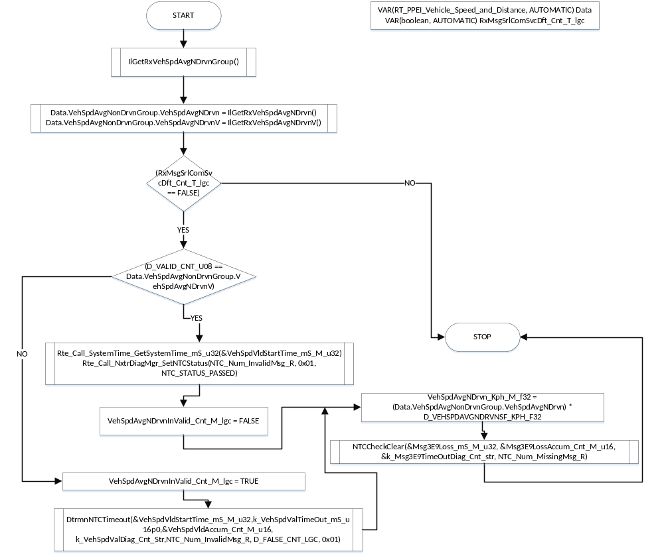

Store Local copy of outputs into Module Outputs
See section above.

Program Flow End
N/A

SrlComInput_MsgProcess_RxPlatformEngCntrlRequests_x3F1

Function Name | SrlComInput_MsgProcess_RxPlatformEngCntrlRequests_x3F1 | Type | Min | Max | UTP Tol.
Arguments Passed | rcvObject | CanReceiveHandle
Return Value

Design Rationale

Program Flow Start
N/A

Store Module Inputs to Local copies
Rte_Read_RxMsgsSrlComSvcDft_Cnt_lgc(&RxMsgSrlComSvcDft_Cnt_T_lgc)

Description

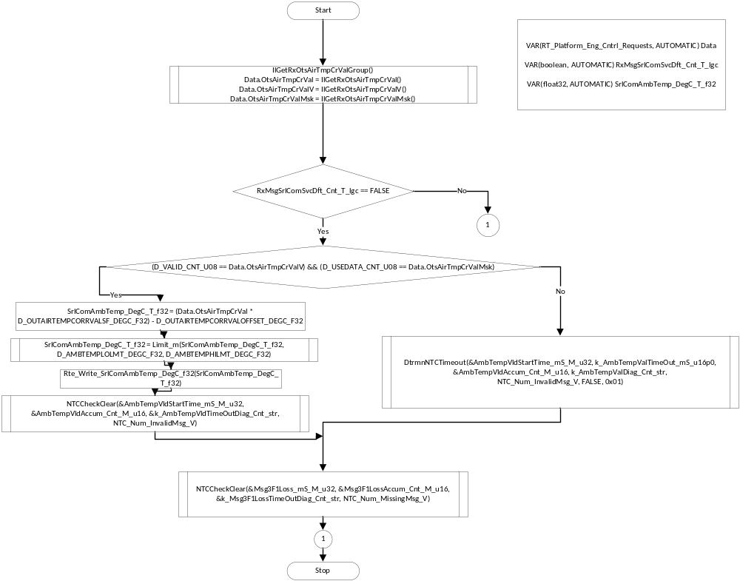

Store Local copy of outputs into Module Outputs
See Above section.

Program Flow End
N/A

SrlComInput_MsgProcess_RxEngineGeneralStatus4_x4C1

Function Name | SrlComInput_MsgProcess_RxEngineGeneralStatus4_x4C1 | Type | Min | Max | UTP Tol.
Arguments Passed | rcvObject | CanReceiveHandle
Return Value

Design Rationale

Program Flow Start
N/A

Store Module Inputs to Local copies
Rte_Read_RxMsgsSrlComSvcDft_Cnt_lgc(&RxMsgSrlComSvcDft_Cnt_T_lgc)

Description

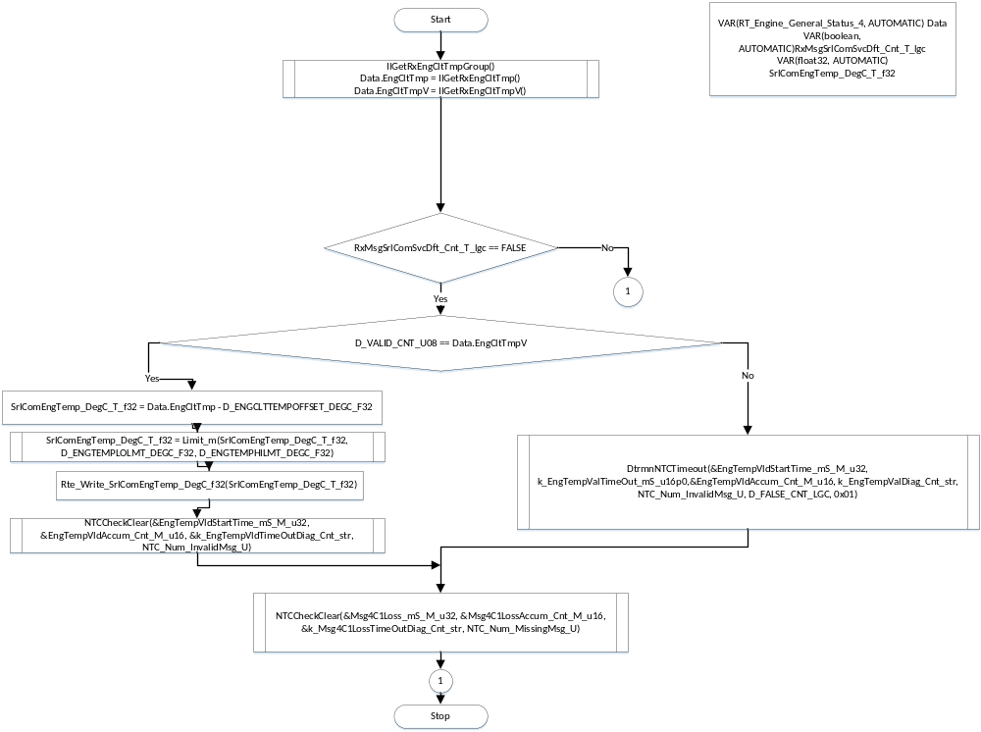

Store Local copy of outputs into Module Outputs
See Section Above

Program Flow End
N/A

SrlComInput_MsgProcess_RxWheelPulsesHS_x500

Function Name | SrlComInput_MsgProcess_RxWheelPulsesHS_x500 | Type | Min | Max | UTP Tol.
Arguments Passed | rcvObject | CanReceiveHandle
Return Value

Design Rationale

Program Flow Start
N/A

Store Module Inputs to Local copies
*See below

Description

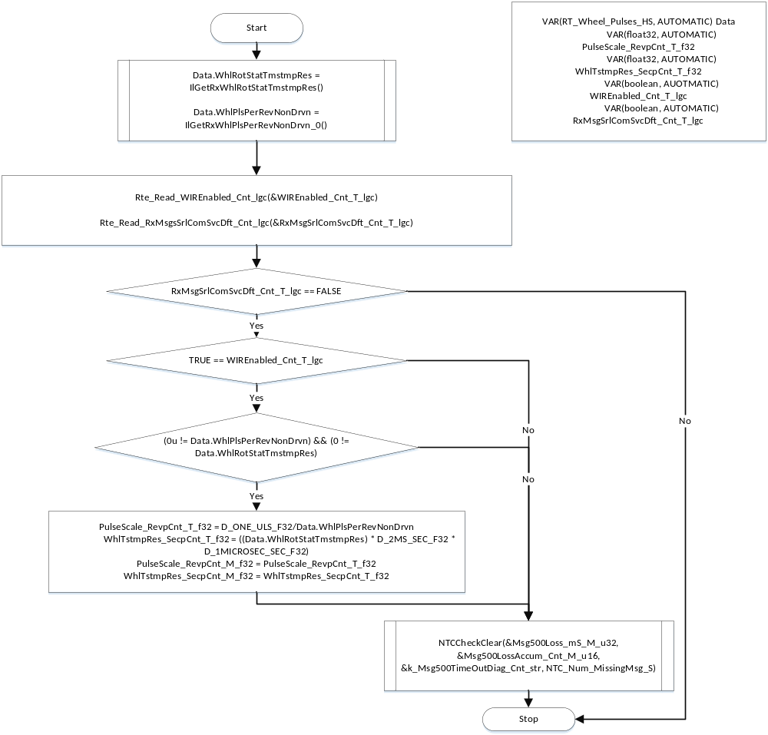

Store Local copy of outputs into Module Outputs
See section above.

Program Flow End
N/A

SrlComInput_MsgProcess_RxVehicleDynamicsESCHybCE_x182

Function Name | SrlComInput_MsgProcess_RxVehicleDynamicsESCHybCE_x182 | Type | Min | Max | UTP Tol.
Arguments Passed | rcvObject | CanReceiveHandle
Return Value

Design Rationale

Program Flow Start
N/A

Store Module Inputs to Local copies
Rte_Read_RxMsgsSrlComSvcDft_Cnt_lgc(&RxMsgSrlComSvcDft_Cnt_T_lgc)

Description

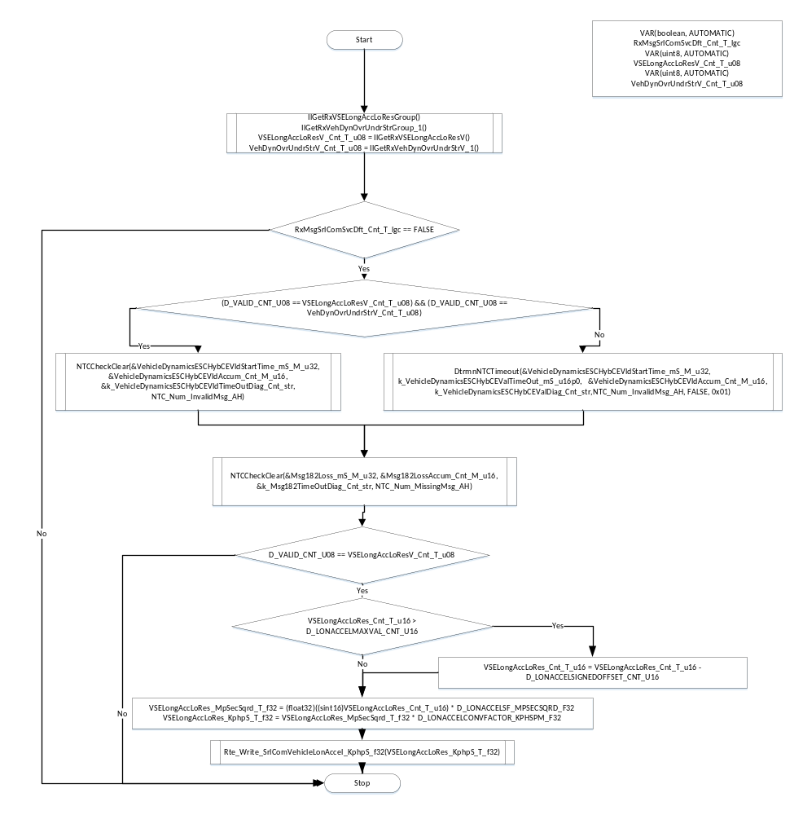

Store Local copy of outputs into Module Outputs
See section above.

Program Flow End
N/A

SrlComInput_MsgProcess_RxParkAssistParallelCE_x337

Function Name | SrlComInput_MsgProcess_RxParkAssistParallelCE_x337 | Type | Min | Max | UTP Tol.
Arguments Passed | rcvObject | CanReceiveHandle
Return Value

Design Rationale

Program Flow Start
N/A

Store Module Inputs to Local copies
Rte_Read_RxMsgsSrlComSvcDft_Cnt_lgc(&RxMsgSrlComSvcDft_Cnt_T_lgc)

Description
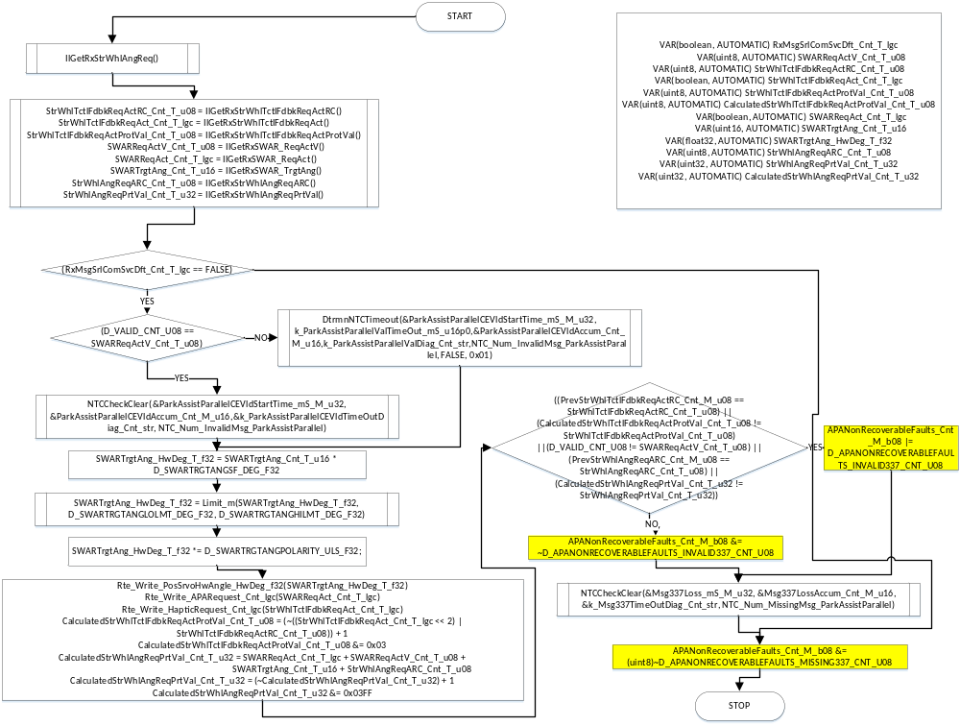

Store Local copy of outputs into Module Outputs
See section above.

Program Flow End
N/A

SrlComInput_MsgProcess_RxDrivenWheelGrndVelocityCE_x348

Function Name | SrlComInput_MsgProcess_RxDrivenWheelGrndVelocityCE_x348 | Type | Min | Max | UTP Tol.
Arguments Passed | rcvObject | CanReceiveHandle
Return Value

Design Rationale

Program Flow Start
N/A

Store Module Inputs to Local copies
*See below

Description

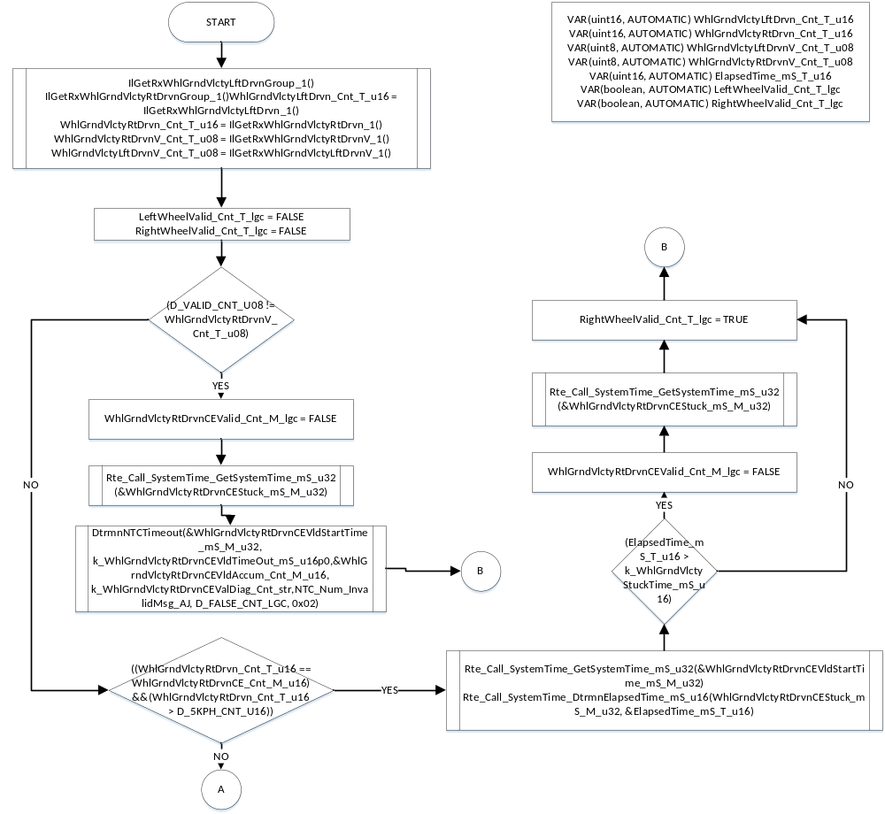

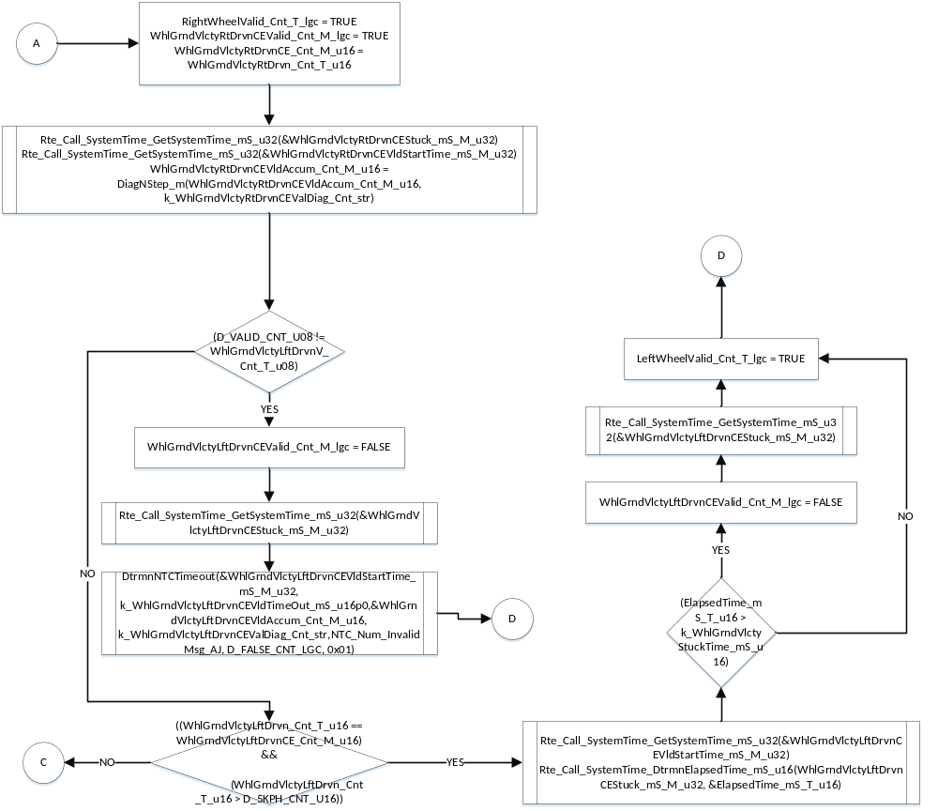

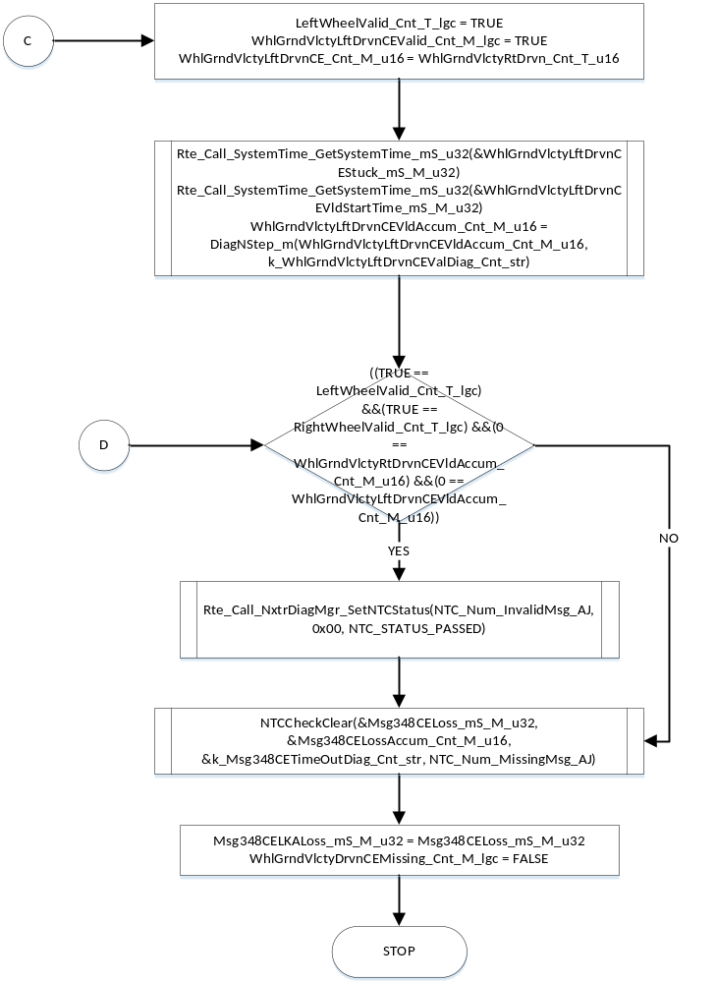

Store Local copy of outputs into Module Outputs
See section above.

Program Flow End
N/A

SrlComInput_MsgProcess_RxNonDrivenWheelGrndVelocityCE_x34A

Function Name | SrlComInput_MsgProcess_RxNonDrivenWheelGrndVelocityCE_x34A | Type | Min | Max | UTP Tol.
Arguments Passed | rcvObject | CanReceiveHandle
Return Value

Design Rationale

Program Flow Start
N/A

Store Module Inputs to Local copies
*See below

Description

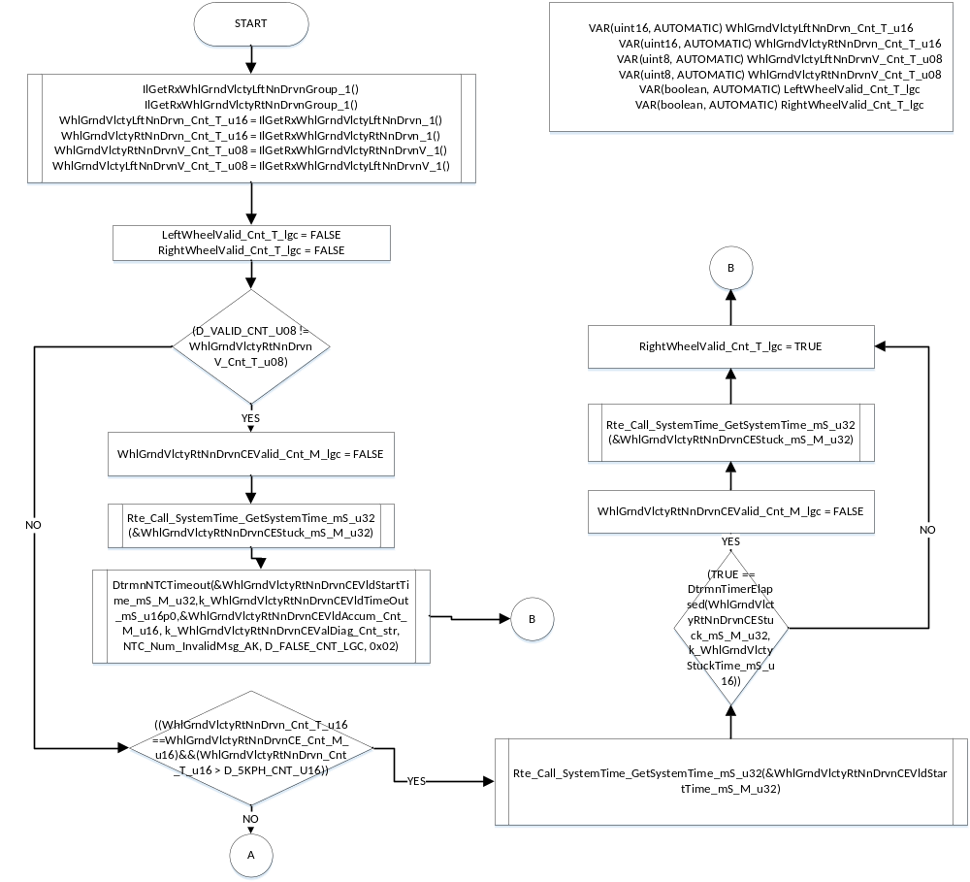

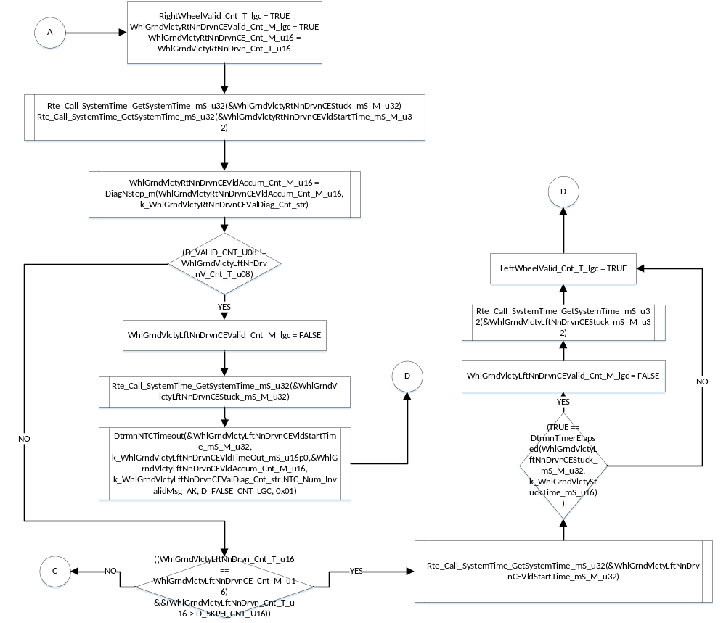

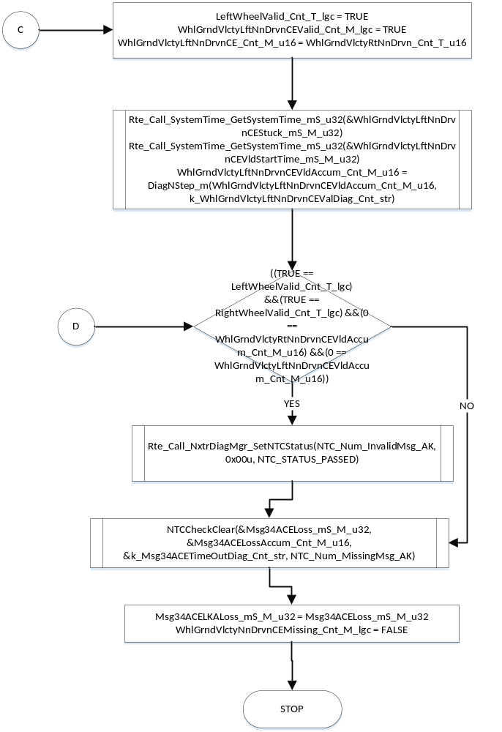

Store Local copy of outputs into Module Outputs
See section above.

Program Flow End
N/A

Execution Requirements

Execution Sequence of the Module
(Describe in words relevant details about the execution sequence of the different sub modules.)

Execution Rates for sub-modules called by the Scheduler
This table serves as reference for the Scheduler design
Function Name | Calling Frequency | System State(s) in which the function is called
SrlComInput_Init | On Event (Once) | On Entering WARMINIT
SrlComInput_Per1 | 2ms | ALL
SrlComInput_Per2 | 10ms | ALL
SrlComInput_Per3 | 100ms | ALL

Execution Requirements for Serial Communication Functions

Function Name | Sub-Module called by (Serial Comm Function Name)
SrlComInput_MsgProcess_RxNonDrivnWhlRotationlStat_x0C5 | RTE_AP_SRLCOMINPUT_APPL_CODE
SrlComInput_MsgProcess_RxEngineGeneralStatus1_x0C9 | RTE_AP_SRLCOMINPUT_APPL_CODE
SrlComInput_MsgProcess_RxAntilockBrakeandTCStatusHS_x17D | RTE_AP_SRLCOMINPUT_APPL_CODE
SrlComInput_MsgProcess_RxLKASteeringTorqueCmdHS_x180 | RTE_AP_SRLCOMINPUT_APPL_CODE
SrlComInput_MsgProcess_RxChassisGeneralStatus1_x1E9 | RTE_AP_SRLCOMINPUT_APPL_CODE
SrlComInput_MsgProcess_RxPlatformGeneralStatus_x1F1 | RTE_AP_SRLCOMINPUT_APPL_CODE
SrlComInput_MsgProcess_RxTransGeneralStatus2_x1F5 | RTE_AP_SRLCOMINPUT_APPL_CODE
SrlComInput_MsgProcess_RxBrakePedalDriverStatusHS_x214 | RTE_AP_SRLCOMINPUT_APPL_CODE
SrlComInput_MsgProcess_RxDrivingModeControlHS_x232 | RTE_AP_SRLCOMINPUT_APPL_CODE
SrlComInput_MsgProcess_RxDrivenWheelGrndVelocityHS_x348 | RTE_AP_SRLCOMINPUT_APPL_CODE
SrlComInput_MsgProcess_RxNonDrivenWheelGrndVelocityHS_x34A | RTE_AP_SRLCOMINPUT_APPL_CODE
SrlComInput_MsgProcess_RxVehicleSpeedAndDistance_x3E9 | RTE_AP_SRLCOMINPUT_APPL_CODE
SrlComInput_MsgProcess_RxPlatformEngCntrlRequests_x3F1 | RTE_AP_SRLCOMINPUT_APPL_CODE
SrlComInput_MsgProcess_RxEngineGeneralStatus4_x4C1 | RTE_AP_SRLCOMINPUT_APPL_CODE
SrlComInput_MsgProcess_RxWheelPulsesHS_x500 | RTE_AP_SRLCOMINPUT_APPL_CODE
SrlComInput_MsgProcess_RxVehicleDynamicsESCHybCE_x182 | RTE_AP_SRLCOMINPUT_APPL_CODE
SrlComInput_MsgProcess_RxParkAssistParallelCE_x337 | RTE_AP_SRLCOMINPUT_APPL_CODE
SrlComInput_MsgProcess_RxDrivenWheelGrndVelocityCE_x348 | RTE_AP_SRLCOMINPUT_APPL_CODE
SrlComInput_MsgProcess_RxNonDrivenWheelGrndVelocityCE_x34A | RTE_AP_SRLCOMINPUT_APPL_CODE

Memory Map Definition Requirements

Sub Modules (Functions)
This table identifies the software segments for functions identified in this module.
Name of Sub Module | Software Segment
SrlComInput_Init | RTE_AP_SRLCOMINPUT_APPL_CODE
SrlComInput_Per1 | RTE_AP_SRLCOMINPUT_APPL_CODE
SrlComInput_Per2 | RTE_AP_SRLCOMINPUT_APPL_CODE
SrlComInput_Per3 | RTE_AP_SRLCOMINPUT_APPL_CODE
SrlComInput_MsgProcess_RxNonDrivnWhlRotationlStat_x0C5 | RTE_AP_SRLCOMINPUT_APPL_CODE
SrlComInput_MsgProcess_RxEngineGeneralStatus1_x0C9 | RTE_AP_SRLCOMINPUT_APPL_CODE
SrlComInput_MsgProcess_RxAntilockBrakeandTCStatusHS_x17D | RTE_AP_SRLCOMINPUT_APPL_CODE
SrlComInput_MsgProcess_RxLKASteeringTorqueCmdHS_x180 | RTE_AP_SRLCOMINPUT_APPL_CODE
SrlComInput_MsgProcess_RxChassisGeneralStatus1_x1E9 | RTE_AP_SRLCOMINPUT_APPL_CODE
SrlComInput_MsgProcess_RxPlatformGeneralStatus_x1F1 | RTE_AP_SRLCOMINPUT_APPL_CODE
SrlComInput_MsgProcess_RxTransGeneralStatus2_x1F5 | RTE_AP_SRLCOMINPUT_APPL_CODE
SrlComInput_MsgProcess_RxBrakePedalDriverStatusHS_x214 | RTE_AP_SRLCOMINPUT_APPL_CODE
SrlComInput_MsgProcess_RxDrivingModeControlHS_x232 | RTE_AP_SRLCOMINPUT_APPL_CODE
SrlComInput_MsgProcess_RxDrivenWheelGrndVelocityHS_x348 | RTE_AP_SRLCOMINPUT_APPL_CODE
SrlComInput_MsgProcess_RxNonDrivenWheelGrndVelocityHS_x34A | RTE_AP_SRLCOMINPUT_APPL_CODE
SrlComInput_MsgProcess_RxVehicleSpeedAndDistance_x3E9 | RTE_AP_SRLCOMINPUT_APPL_CODE
SrlComInput_MsgProcess_RxPlatformEngCntrlRequests_x3F1 | RTE_AP_SRLCOMINPUT_APPL_CODE
SrlComInput_MsgProcess_RxEngineGeneralStatus4_x4C1 | RTE_AP_SRLCOMINPUT_APPL_CODE
SrlComInput_MsgProcess_RxWheelPulsesHS_x500 | RTE_AP_SRLCOMINPUT_APPL_CODE
SrlComInput_MsgProcess_RxVehicleDynamicsESCHybCE_x182 | RTE_AP_SRLCOMINPUT_APPL_CODE
SrlComInput_MsgProcess_RxParkAssistParallelCE_x337 | RTE_AP_SRLCOMINPUT_APPL_CODE
SrlComInput_MsgProcess_RxDrivenWheelGrndVelocityCE_x348 | RTE_AP_SRLCOMINPUT_APPL_CODE
SrlComInput_MsgProcess_RxNonDrivenWheelGrndVelocityCE_x34A | RTE_AP_SRLCOMINPUT_APPL_CODE
SrlComInput_SCom_GetSrlComWIRFltStatus | RTE_AP_SRLCOMINPUT_APPL_CODE
SrlComInput_SCom_ManualVehSpd | RTE_AP_SRLCOMINPUT_APPL_CODE
SrlComInput_SCom_ResetBus1Timers | RTE_AP_SRLCOMINPUT_APPL_CODE
SrlComInput_SCom_ResetBus2Timers | RTE_AP_SRLCOMINPUT_APPL_CODE

Local Functions
This table identifies the software segments for local functions identified in this module.

Name of Sub Module | Software Segment
ProcessWhlStatus | AP_SRLCOMINPUT_CODE
CalcWhlFreq | AP_SRLCOMINPUT_CODE
DtrmnNTCTimeout | AP_SRLCOMINPUT_CODE
NTCCheckClear | AP_SRLCOMINPUT_CODE
DtrmnTimerElapsed | AP_SRLCOMINPUT_CODE
ResetLKABus1Timers | RTE_AP_SRLCOMINPUT_APPL_CODE
ResetLKABus2Timers | RTE_AP_SRLCOMINPUT_APPL_CODE

9 Known Issues / Limitations with Design
- INLINE functions defined in globalmacro.h are not unit tested

10 Revision Control Log
Item # | Rev # | Change Description | Date | Author Initials
1 | 1.0 | Initial Version | 12-June-14 | KPIT-AB
2 | 2 | Added LonAccel output from x182 message | 25-Sept-14 | JWJ
3 | 3 | Plentiful updates for out of date MDD – including several anomaly corrections | 17-Oct-14 | JWJ
4 | 4 | Added negative polarity to 337 target angle | 22-Oct-14 | JWJ
5 | 5 | Added a P/N-step to WIR fault | 31-Mar-15 | JWJ
6 | 6 | APA Non Recoverable Faults | 14-May-15 | GMN

