Module -- PICurrCntrl

High-Level Description
Non-AUTOSAR PI driver required to perform EPS motor control PWM profiles.

Figures

Diagram – Function Data Sharing
This diagram shows all data that is shared between functions within the module.
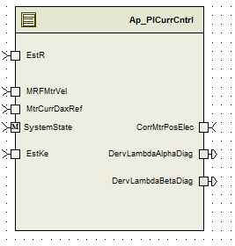

Module Inputs and Outputs
For details on module input / output variable, refer to the Data Dictionary for the application. Input / output variable names are listed here for reference.
(Note: Full variable names required in table.)
(Note: All global variables including End Of Line data used should be shown here)
Module Inputs (Global Variable Name) | Module Outputs (Global Variable Name)
Refer the Data Dictionary | Refer the Data Dictionary

Module Internal Variables
This section identifies the name, range and resolutions for module specific data created by this module. If there are no range restrictions on the variable, the term “FULL” is placed into the table for legal range.
(Note: If no module specific variables are used by the design, place the text “None” in the first Variable Name cell in the table)
Variable Name | Resolution | Legal Range  (min) | Legal Range  (max) | Software Segment
Refer the Data Dictionary | Refer the Data Dictionary | Refer the Data Dictionary | Refer the Data Dictionary | Refer the Data Dictionary

User defined typedef definition/declaration
This section documents any user types uniquely used for the module.
Typedef Name | Element Name | User Defined Type | Legal Range  (min) | Legal Range  (max)
LowPassFiltBilinear_Str | PrevInput_Uls_f32 | Single precision float | FULL RANGE | FULL RANGE
 | PrevOutput_Uls_f32 | Single precision float | FULL RANGE | FULL RANGE
 | TermN_Uls_f32 | Single precision float | FULL RANGE | FULL RANGE
 | TermD_Uls_f32 | Single precision float | FULL RANGE | FULL RANGE

Constant Data Dictionary

Calibration Constants
This section lists the calibrations used by the module. For details on calibration constants, refer to the Data Dictionary for the application.
(Note: If no calibrations are used by the design, place the text “None” in the first location in the table)
Constant Name
Refer the Data Dictionary

Program(fixed) Constants

Embedded Constants
All embedded constants whose values are provided in Eng units will be evaluated to the equivalent counts by using the FPM_InitFixedPoint_m() macro within the #define statement.

Local
Constant Name | Resolution | Units | Value
D_SCALERADTOCNTS_ULS_F32 | Single Precision Float | Unitless | 10430.3783505F
D_REVWITHROUND_ULS_F32 | Single Precision Float | Unitless | 65536.5F
D_ROUND_ULS_F32 | Single Precision Float | Unitless | 0.5F
D_DEG2RAD_ULS_F32 | Single Precision Float | Unitless | 0.0174532925199F
D_GAIN_ULS_F32 | Single Precision Float | Unitless | 0.5
D_VECUMAX_VOLTS_F32 | Single Precision Float | Volts | 31
D_SQRT3OVR2_ULS_F32 | Single Precision Float | Unitless | 0.866025403784
D_MTRCTRLISRRATE_MS_F32 | Single Precision Float | mSec | 0.00125
D_MTRCURRMIN_AMP_F32 | Single Precision Float | Amp | -220
D_MTRCURRMAX_AMP_F32 | Single Precision Float | Amp | 220
D_VECUDEFAULT_VOLT_F32 | Single Precision Float | Volt | 12

Global
This section lists the global constants used by the module. For details on global constants, refer to the Data Dictionary for the application.
Constant Name
D_ZERO_ULS_F32
D_VECUMIN_VOLTS_F32

Module specific Lookup Tables Constants
(This is for lookup tables (arrays) with fixed values, same name as other tables)
Constant Name | Resolution | Value | Software Segment
None

Functions/Macros used by the Sub-Modules

Library Functions / Macros
The library functions / Macros that are called by the various sub modules are identified below,
- IntplVarXY_u16_u16Xu16Y_Cnt_m()
- FPM_FloatToFixed_m
- Sign_f32_m
- Sqrtf
- Sinf
- Cosf

Data Hiding Functions
The data hiding functions / macros used in this module are identified below,
Rte_ModeType_StaMd_Mode
MtrCntrl_Read_MtrCurrQax_Amp_f32
MtrCntrl_Read_MtrCurrDax_Amp_f32

MtrCntrl_Read_Vecu_Volt_f32
MtrCntrl_Read_ModIdxSrlComSvcDft_Cnt_lgc
MtrCntrl_Read_SysState_Cnt_Enum
MtrCntrl_Read_MtrCurrOffComOffset_Cnt_u16
MtrCntrl_Read_MtrElecPol_Cnt_s8
MtrCntrl_Read_MtrPosElec_Rev_u0p16
MtrCntrl_Write_MtrCurrQaxFinalRef_Amp_f32
MtrCntrl_Write_MtrDaxVoltage_Volt_f32
MtrCntrl_Write_MtrQaxVoltage_Volt_f32
MtrCntrl_Write_ModIdx_Uls_u16p16
MtrCntrl_Write_PhaseAdvanceFinal_Rev_u0p16
MtrCntrl_Write_CommOffset_Cnt_u16

Local Functions/Macros Used by this MDD only
Header file: Ap_MtrCntrl_Cfg.h

Software Module Implementation

Initialization Functions

PICurrCntrl_MtrCurrDaxSatFluxRatio_Uls_M_f32 =D_ONE_ULS_F32
PICurrCntrl_MtrCurrQaxSatFluxRatio_Uls_M_f32 =D_ONE_ULS_F32

Initialise the output for State variables for Vecu filter:

PICurrCntrl_MtrVecuFilt_M_str.PrevOutput_Uls_f32 = D_VECUDEFAULT_VOLT_F32
PICurrCntrl_MtrVecuFilt_M_str.PrevInput_Uls_f32 = D_VECUDEFAULT_VOLT_F32

Initialise the Bilinear Filter:

CalLowPassFiltBilinearTerm(k_MtrVoltVecuFiltKn_Hz_f32, k_PiSamplingTs_Sec_f32 ,&PICurrCntrl_MtrVecuFilt_M_str)
CalLowPassFiltBilinearTerm(k_MtrVoltQaxFiltFFKn_Hz_f32, k_PiSamplingTs_Sec_f32 ,&PICurrCntrl_MtrVoltQaxFFFilt_M_str)

Periodic Functions

Per: PICurrCntrl_Per1

Design Rationale
This function is responsible for calculating the amount of current to be supplied to the motor. To control the PWM profiles generated for the motor. FastDataAccessBufIndex allows the buffer synchronization between data calculated on slower periodic loop time(2 milli seconds) and are read by faster periodic run time (ie 0.125ms)

Store Module Inputs to Local copies

MtrCntrl_Read_MtrCurrQax_Amp_f32(&MtrCurrQax_Amp_T_f32);
MtrCntrl_Read_MtrCurrDax_Amp_f32(&MtrCurrDax_Amp_T_f32);
MtrCntrl_Read_Vecu_Volt_f32(&Vecu_Volt_T_f32);
MtrCntrl_Read_ModIdxSrlComSvcDft_Cnt_lgc(&ModIdxSrlComSvcDft_Cnt_T_lgc);
MtrCntrl_Read_SysState_Cnt_Enum(&SysState_Cnt_T_Enum);
FwdDataAcessBuffer_Cnt_T_u16= (ActWriteAccBufIndex_Cnt_T_u16)
MtrCurrQaxRef_Amp_T_f32=MtrCurrQaxRef_Amp_M_f32[FwdDataAcessBuffer_Cnt_T_u16];
MtrCurrDaxRef_Amp_T_f32=MtrCurrDaxRef_Amp_M_f32[FwdDataAcessBuffer_Cnt_T_u16];
PIDaxIntegralGain_Uls_T_f32=MtrDaxIntegralGain_Uls_M_f32[FwdDataAcessBuffer_Cnt_T_u16];
PIDaxPropotionalGain_Uls_T_f32=MtrDaxPropotionalGain_Uls_M_f32[FwdDataAcessBuffer_Cnt_T_u16]
PIQaxIntegralGain_Uls_T_f32=MtrQaxIntegralGain_Uls_M_f32[FwdDataAcessBuffer_Cnt_T_u16];
PIQaxPropotionalGain_Uls_T_f32=MtrQaxPropotionalGain_Uls_M_f32[FwdDataAcessBuffer_Cnt_T_u16]
ElecPosDelayComp_Rad_T_f32=MtrPosComputationDelay_Rad_M_f32[FwdDataAcessBuffer_Cnt_T_u16]
MtrVoltDaxFF_Volt_T_f32=MtrVoltDaxFF_Volt_M_f32[FwdDataAcessBuffer_Cnt_T_u16]MtrVoltQaxFF_Volt_T_f32=MtrVoltQaxFF_Volt_M_f32[FwdDataAcessBuffer_Cnt_T_u16];

Program Flow Start
Refer FDD for flowcharts

Store Local copy of outputs into Module Outputs
MtrCntrl_Write_MtrCurrQaxFinalRef_Amp_f32(MtrCurrQaxFinalRef_Amp_T_f32)
MtrCntrl_Write_MtrDaxVoltage_Volt_f32(MtrDaxVoltage_Volt_T_f32)
MtrCntrl_Write_MtrQaxVoltage_Volt_f32(MtrQaxVoltage_Volt_T_f32)
MtrCntrl_Write_ModIdx_Uls_u16p16(FPM_FloatToFixed_m(ModIdx_Uls_T_u16p16))
MtrCntrl_Write_PhaseAdvanceFinal_Rev_u0p16(PhaseAdvanceFinal_Rev_T_u0p16)
MtrCntrl_Write_CommOffset_Cnt_u16(CommOffset_Cnt_T_u16)
MtrCntrl_Write_MtrVolt_Volt_f32(MtrVoltCmdFinal_Volt_T_f32)
MtrCntrl_Write_MtrCurrDaxIntg_Volt_f32(MtrCurrDaxIntg_Volt_T_f32)
MtrCntrl_Write_MtrCurrQaxIntg_Volt_f32(MtrCurrQaxIntg_Volt_T_f32)
MtrCurrQaxFinalRef_Amp_M_f32[SlowDataAccessBufIndex_Cnt_M_u16]= MtrCurrQaxFinalRef_Amp_T_f32;
MtrVoltDax_Volt_M_f32[SlowDataAccessBufIndex_Cnt_M_u16] = MtrDaxVoltage_Volt_T_f32;
MtrVoltQax_Volt_M_f32[SlowDataAccessBufIndex_Cnt_M_u16] = MtrQaxVoltage_Volt_T_f32

Program Flow End
N/A

Periodic Functions

Per: PICurrCntrl_Per2

Design Rationale
This function is responsible for calculating the amount of current to be supplied to the motor. To control the PWM profiles generated for the motor.
SlowDataAccessBufIndex allows the buffer synchronization between data calculated on faster periodic loop time(125 micro seconds) and are read by slower periodic run time (ie 2ms)

Store Module Inputs to Local copies

ReadBuffer_Cnt_T_u16 = SlowDataAccessBufIndex_Cnt_M_u16
WriteBuffer_Cnt_T_u16 = (ReadBuffer_Cnt_T_u16 & 1U) ^ 1U
SlowDataAccessBufIndex_Cnt_M_u16 = WriteBuffer_Cnt_T_u16
EstKe_VpRadpS_T_f32= Rte_IRead_PICurrCntrl_Per2_EstKe_VpRadpS_f32();
EstR_Ohm_T_f32 = Rte_IRead_PICurrCntrl_Per2_EstR_Ohm_f32();
MRFMtrVel_MtrRadpS_T_f32 = Rte_IRead_PICurrCntrl_Per2_MRFMtrVel_MtrRadpS_f32();
CorrMtrPosElec_Rev_T_f32 = Rte_IRead_PICurrCntrl_Per2_CorrMtrPosElec_Rev_f32();
MtrCurrDaxRef_Amp_T_f32 = Rte_IRead_PICurrCntrl_Per2_MtrCurrDaxRef_Amp_f32();
MtrVoltDax_Volt_T_f32 = MtrVoltDax_Volt_M_f32[ReadBuffer_Cnt_T_u16];
MtrVoltQax_Volt_T_f32 = MtrVoltQax_Volt_M_f32[ReadBuffer_Cnt_T_u16];
MtrCurrQaxFinalRef_Amp_T_f32 = MtrCurrQaxFinalRef_Amp_M_f32[ReadBuffer_Cnt_T_u16];

Program Flow Start
Rte_Call_PICurrCntrl_Per2_CP0_CheckpointReached()

Processing
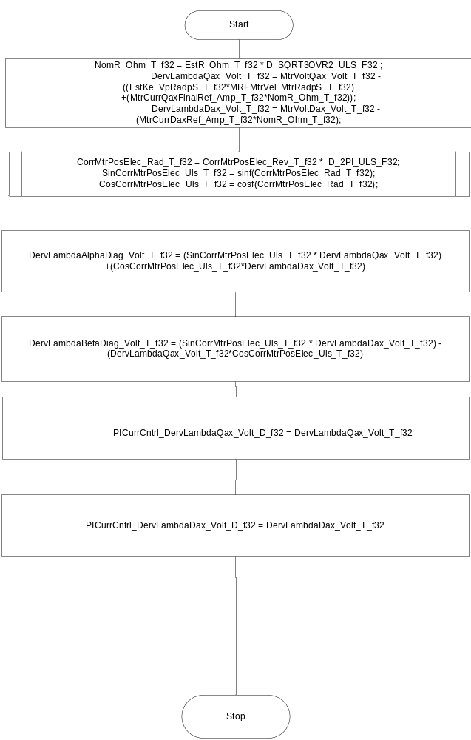

Store Local copy of outputs into Module Outputs
Rte_IWrite_PICurrCntrl_Per2_DervLambdaAlphaDiag_Volt_f32(DervLambdaAlphaDiag_Volt_T_f32);
Rte_IWrite_PICurrCntrl_Per2_DervLambdaBetaDiag_Volt_f32(DervLambdaBetaDiag_Volt_T_f32);

Program Flow End
Rte_Call_PICurrCntrl_Per2_CP1_CheckpointReached()

Local Functions

Local Function #1
Function Name | CalLowPassFiltBilinearOut | Type | Min | Max | UTP Tol.
Arguments Passed | Input_Uls_T_f32 | Float32 | -2147483648 | 2147483647
 | *LowPassFiltBilinear_T_Str | LowPassFiltBilinear_Str | -2147483648 | 2147483647
Return Value | Output_Uls_T_f32 | Float32 | FULL RANGE | FULL RANGE

Description
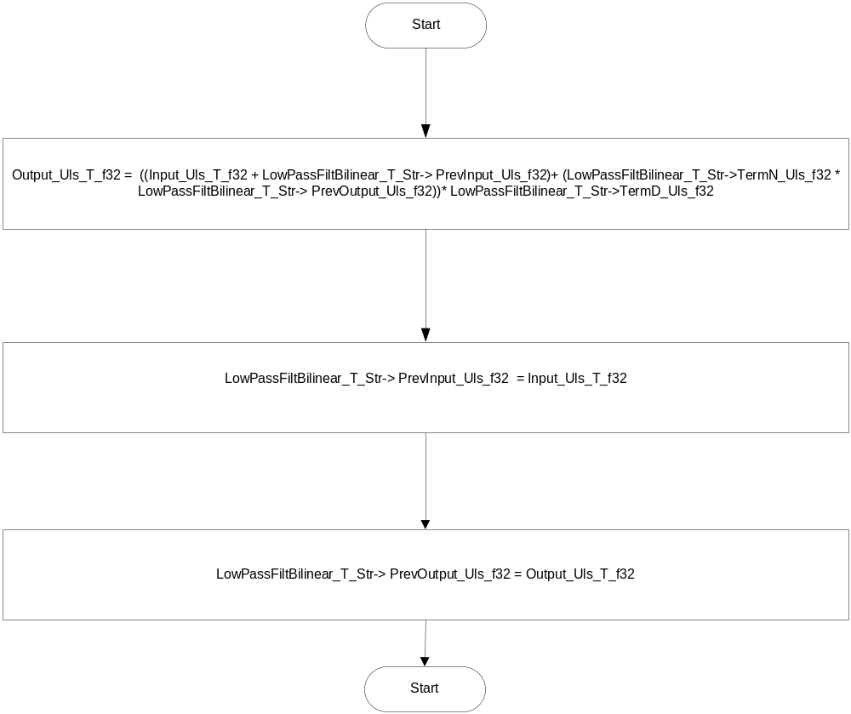

Local Function #2 CalLowPassFiltBilinearTerm
Function Name | CalLowPassFiltBilinearTerm | Type | Min | Max | UTP Tol.
Arguments Passed | Freq_Hz_T_f32 | Float32 | 0.1 | 2147483647-
 | TimeCons_Sec_T_f32 | Float32 | 0.0000625 | 0.1
Return Value | LowPassFiltBilinear_T_Str | LowPassFiltBilinear_Str | FULL RANGE | FULL RANGE

Description
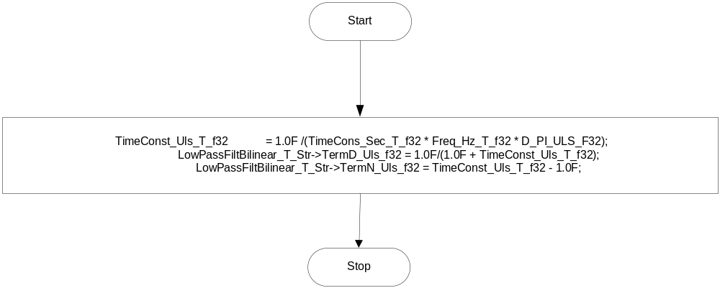

Local Function #3 IntegralStateVarNonOperState
Function Name | IntegralStateVarNonOperState | Type | Min | Max | UTP Tol.
Arguments Passed | SysState_Cnt_T_Enum | Rte_ModeType_StaMd_Mode | 1 | 4 | None
Return Value | None

Description
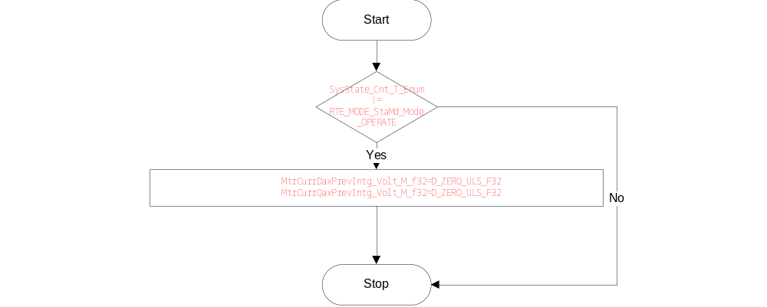

Local Function #4 CalLowPassFiltVecuOut
Function Name | CalLowPassFiltVecuOut | Type | Min | Max | UTP Tol.
Arguments Passed | *Vecu_Volt_T_f32 | float32 | 5 | 31
Return Value

Description
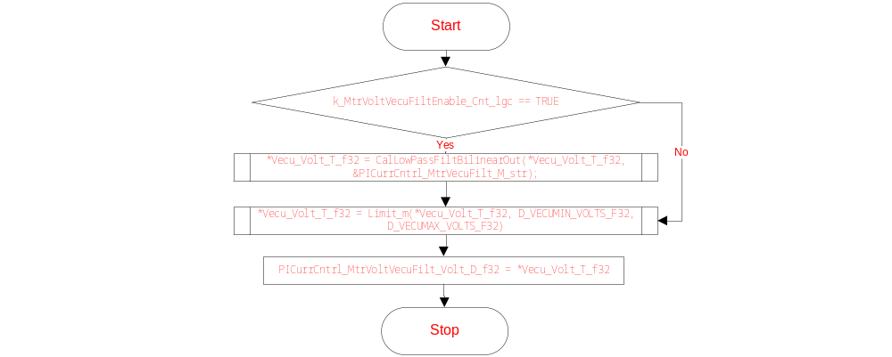

Local Function #5 LoaMtgtnSclFac
Function Name | LoaMtgtnSclFac | Type | Min | Max | UTP Tol.
Arguments Passed | MotCurrLoaMtgtnEn_Cnt_T_lgc | boolean | FALSE | TRUE
 | IvtrLoaMtgtnEn_Cnt_T_lgc | boolean | FALSE | TRUE
Return Value

Description
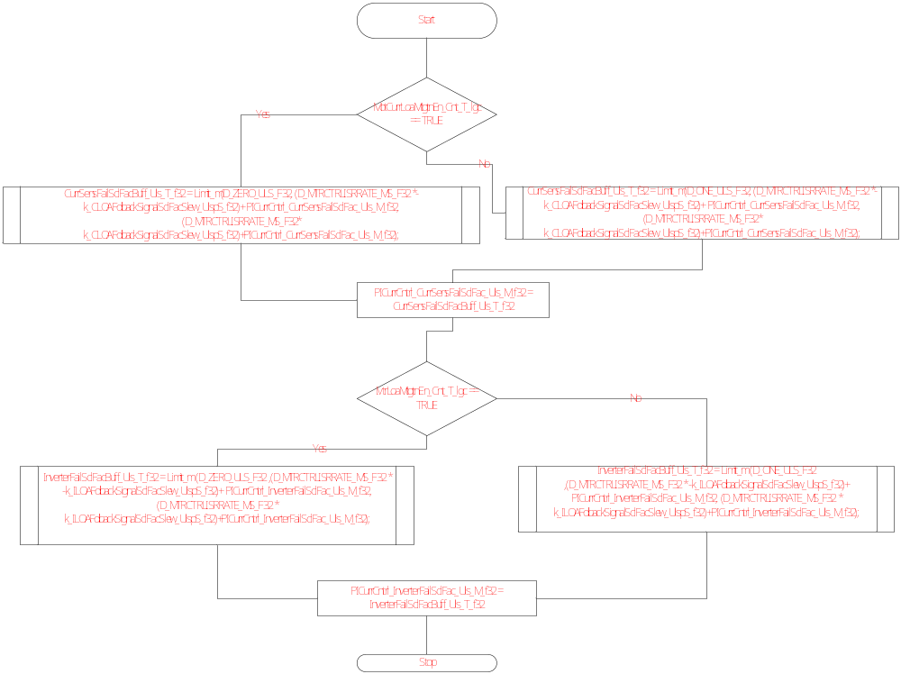

Execution Requirements

Execution Sequence of the Module
N/A

Execution Rates for sub-modules called by the Scheduler
This table serves as reference for the Scheduler design
Function Name | Calling Frequency | System State(s) in which the function is called
PICurrCntrl_Per1 | 0.125ms | All
PICurrCntrl_Per2 | 2ms | All

Execution Requirements for Serial Communication Functions
Function Name | Sub-Module called by (Serial Comm Function Name)
N/A

Memory Map Definition Requirements

Sub Modules (Functions)
This table identifies the software segments for functions identified in this module.
Name of Sub Module | Software Segment
PICurrCntrl_Per1 | PICurrCntrl_CODE
PICurrCntrl_Per2 | RTE_START_SEC_AP_PICURRCNTRL_APPL_CODE

Local Functions
This table identifies the software segments for local functions identified in this module.
- - Denotes functions that are vector call-backs only included to avoid compiler errors.
Name of Sub Module | Software Segment
N/A

Known Issues / Limitations With Design
The computation of commoffset and ModIndex service defeat part of FDD15D is implemented in this component inaddition to 99B requirements
The reason for the implementation is to keep the sine voltage driver common across components

Revision Control Log
Item # | Rev # | Change Description | Date | Author Initials
1 | 1.0 | Initial release with changes for IPM | 6/12/2012 | AD/KPIT
2 | 1.0 | Changes for memap statements added | 11/20/2012 | Selva
3 | 2.0 | Updated for SF99B –v8 with only changes needed for voltage command  integrity check for torque reasonableness | 02/24/2013 | Selva
4 | 3.0, | Updated for SF99B –v8 | 03/21/2013 | Selva
5 | 4.0 | Corrected for SF99B –v8 | 04/19/2013 | Selva
6 | 5.0 | Updated for SF99B –v10 | 21-Oct-13 | Selva
7 | 6.0 | Updated for SF99B –v10 | 7-Nov-13 | Selva
8 | 7.0 | Updated for V12 of FDD SF99 | 27-Nov-13 | Selva
9 | 8.0 | Updated for V15 of FDD SF99 | 27-Mar-15 | Selva
10 | 9.0 | Updated for V17 of FDD SF99 EA3#A283,EA3#1777 fixed | 21-Aug-15 | Selva
11 | 10.0 | Updated as per unit test findings | 15-Jan-16 | KPIT
12 | 11 | Updated for V18 of FDD SF99 | 17-Mar-16 | Selva

