Module Design Document
For
Torque Oscillation Function

VERSION: 1
DATE: April 3, 2014

Prepared By:
Software Group,
Nexteer Automotive,
Saginaw, MI, USA
Location: The official version of this document is stored in the Nexteer Configuration Management System and is uniquely identified by: <Project_ID>_<Config Id>

Revision History

Sl. No. | Description | Author | Version | Date
1 | Started initial version of the MDD | Lovepreet Kaur | 1 | 03:28:2014

Table of Contents
1 Abbrevations And Acronyms 5
2 References 6
3 Torque_Oscillation_Fuction & High-Level Description 7
4 Design details of software module 8
4.1 Graphical representation of Torque_Oscillation 8
4.2 Data Flow Diagram 8
4.2.1 Module level DFD 8
4.2.2 Sub-Module level DFD 8
4.3 COMPONENT FLOW DIAGRAM 8
5 Variable Data Dictionary 9
5.1 User defined typedef definition/declaration 9
5.2 Variable definition for enumerated types 9
6 Constant Data Dictionary 10
6.1 Program(fixed) Constants 10
6.1.1 Embedded Constants 10
6.1.1.1 Local 10
6.1.1.2 Global 10
6.1.2 Module specific Lookup Tables Constants 10
6.1.3 Library Functions / Macros 10
6.1.4 Data Hiding Functions 10
7 Software Module Implementation 11
7.1 Initialization Functions 11
7.1.1 Init: TrqOsc_Init 11
7.1.1.1 Design Rationale 11
7.1.1.2 Module Outputs 11
7.1.1.3 Module Internal 11
7.2 PERIODIC FUNCTIONS 11
7.2.1 Per: TrqOsc_Per1 11
7.2.1.1 Design Rationale 11
7.2.1.2 Store Module Inputs to Local copies 11
7.2.1.3 (Processing of function)……… 11
7.2.1.4 Store Local copy of outputs into Module Outputs 13
7.3 Interrupt Functions 13
7.3.1 Isr: <ModuleName>_Isr<n)> 13
7.3.1.1 Design Rationale 13
7.3.1.2 (Processing of the ISR function)….. 13
7.4 TRANSIENT FUNCTIONS 13
7.4.1 Per: <ModuleName>_Trns<n> 14
7.4.1.1 Design Rationale 14
7.4.1.2 Store Module Inputs to Local copies 14
7.4.1.3 (Processing of function)……… 14
7.4.1.4 Store Local copy of outputs into Module Outputs 14
7.5 Serial Communication Functions 14
7.5.1 SComm: <MODULENAME> 14
7.5.1.1 Design Rationale 14
7.5.1.2 Store Module Inputs to Local copies 14
7.5.1.3 (Processing of function)……… 14
7.5.1.4 Store Local copy of outputs into Module Outputs 14
7.6 Local Function/Macro Definitions 14
7.6.1 Local Function #1 14
7.6.1.1 Description 14
7.7 GLObAL Function/Macro Definitions 14
7.7.1 GLObAL Function #1 15
7.7.1.1 Description 15
8 Known Limitations With Design 16
9 UNIT TEST CONSIDERATION 17
10 Appendix 18

Abbrevations And Acronyms
Abbreviation | Description
DFD | Design functional diagram
MDD | Module design Document

References
This section Lists the title & version of all the documents that are referred for development of this document
Sr. No. | Title | Version
1 | MDD Guidelines | 1.0.0
2 | Software Naming Conventions | 1.0.0
3 | SF-43 Torque Oscillation | 1.0.0

Torque_Oscillation_Fuction & High-Level Description

This function lets motor to generate a sinusoidal torque command for a given frequency and fixed amplitude. This can be used to send a sudden alert to driver or for any other application. Frequency can assume only certain values and amplitude can be limited differently for each of those frequencies.

Design details of software module

Graphical representation of Torque_Oscillation
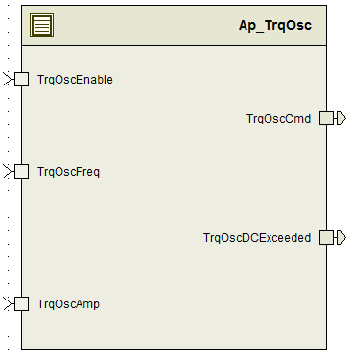

Data Flow Diagram

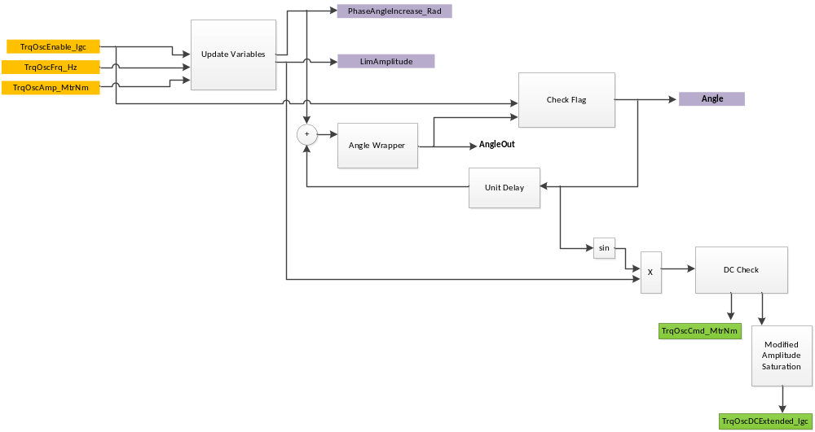

Module level DFD
None

Sub-Module level DFD
None

COMPONENT FLOW DIAGRAM
None

Variable Data Dictionary

User defined typedef definition/declaration
None

Typedef Name | Element Name | User Defined Type | Legal Range  (min) | Legal Range  (max)
None | None | None | None | None

Variable definition for enumerated types
Enum Name | Element Name | Value
None | None | None

Constant Data Dictionary

Program(fixed) Constants

Embedded Constants

Local
Constant Name | Resolution | Units | Value
D_TRQOSCPERMMAXFREQ_HZ_U12P4 | P4 | Hz | 50
D_TRQOSCPERMMINFREQ_HZ_U12P4 | P4 | Hz | 10
D_TRQOSCMAXAMP_MTRNM_F32 | Single Precision Float | MtrNm | 0.7
D_TRQOSCMINAMP_MTRNM_F32 | Single Precision Float | MtrNm | 0.0
D_TRQOSCMAXDC_MTRNM_F32 | Single Precision Float | MtrNm | 0.1
D_TRQOSCDCTRENDLPFKN_HZ_F32 | Single Precision Float | MtrNm | 0.32

Global
Constant Name
D_FALSE_CNT_LGC
D_2MS_SEC_F32
D_2PI_ULS_F32
D_ZERO_ULS_F32

Module specific Lookup Tables Constants

Constant Name | Resolution | Value | Software Segment
None | None | None | None

Library Functions / Macros
- FPM_InitFixedPoint_m
- LPF_KUpdate_f32_m
- LPF_OpUpdate_f32_m
- Abs_f32_m
- FPM_FloatToFixed_m
- FPM_FixedToFloat_m
- TableSize_m
- Limit_m

Data Hiding Functions
None

Software Module Implementation

Initialization Functions

Init: TrqOsc_Init

Design Rationale

SV didn’t need initialization because it is mapped to a cleared section in memory and therefore, LPF_KUpdate_f32_m function is used instead of the LPF complete macro.

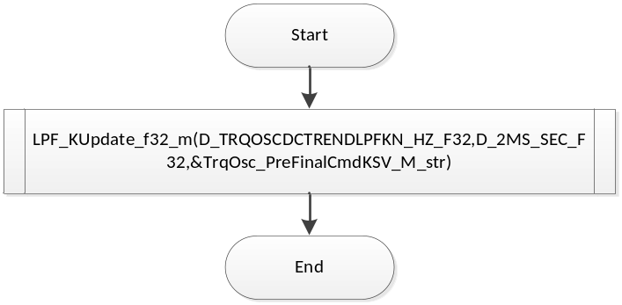

Module Outputs
None

Module Internal
None

PERIODIC FUNCTIONS

Per: TrqOsc_Per1

Design Rationale
Since, Unit Delay logic in DC Compare flag is basically latching the DCExceeded Flag with the OR operand, no previous DC Compare flag has been defined or used in the code in order to implement the Unit-Delay logic. Only TrqOsc_DCExceeded_Cnt_M_lgc variable is used which is able to perform the latching operation with fewer lines of code.

Store Module Inputs to Local copies
None

(Processing of function)………

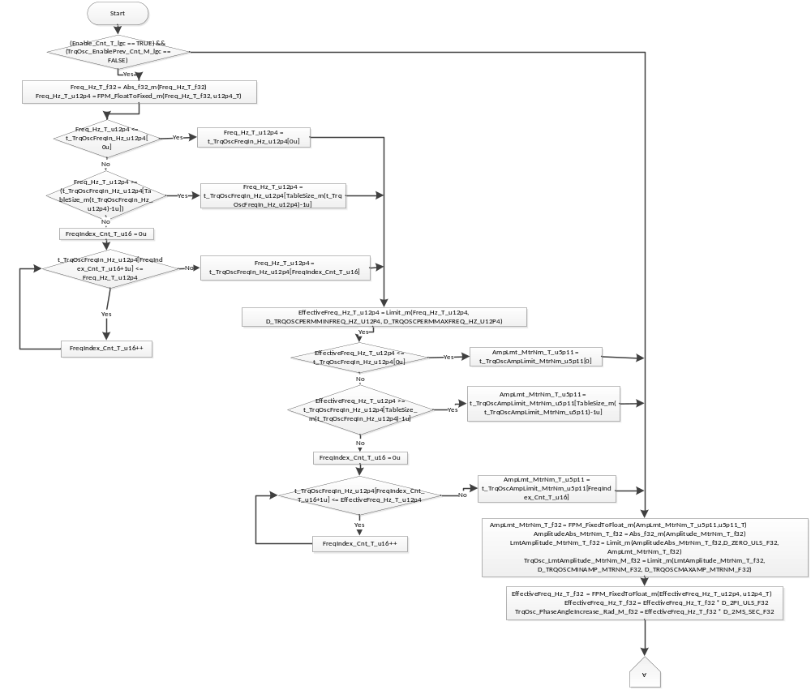

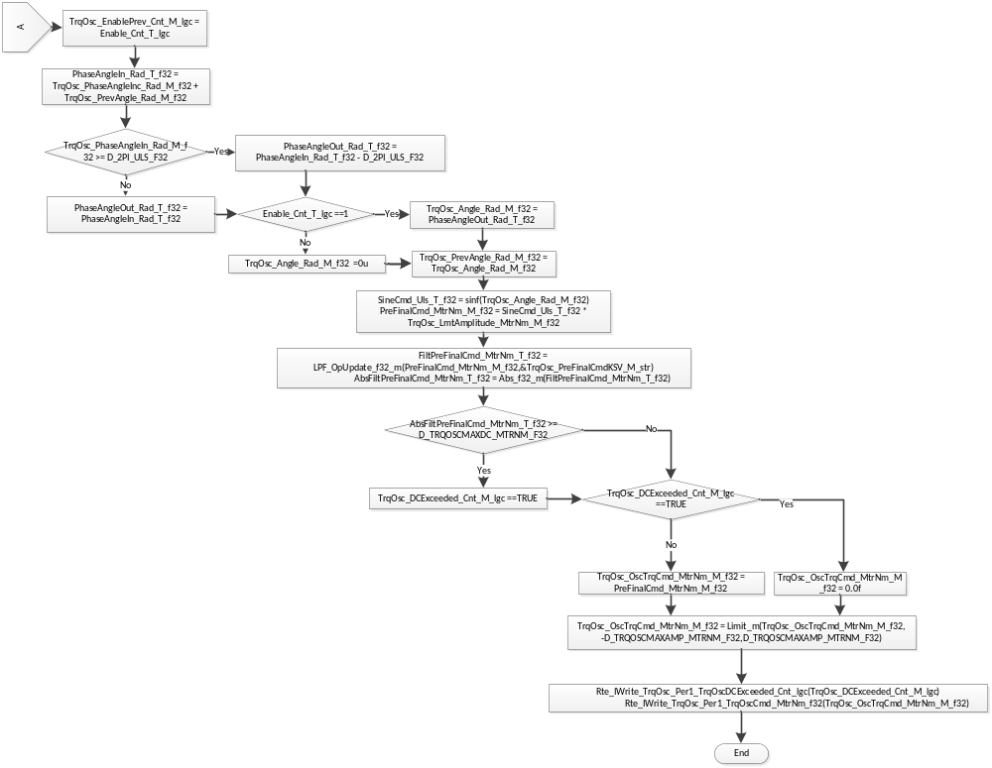

Store Local copy of outputs into Module Outputs
None

Interrupt Functions
None

Isr: <ModuleName>_Isr<n)>
None

Design Rationale
None

(Processing of the ISR function)…..
None

TRANSIENT FUNCTIONS
None

Per: <ModuleName>_Trns<n>

Design Rationale
None

Store Module Inputs to Local copies
None

(Processing of function)………
None

Store Local copy of outputs into Module Outputs
None

Serial Communication Functions
None

SComm: <MODULENAME>

Design Rationale
None

Store Module Inputs to Local copies
None

(Processing of function)………
None

Store Local copy of outputs into Module Outputs
None

Local Function/Macro Definitions
None

Local Function #1
Function Name | (Exact name used) | Type | Min | Max
Arguments Passed | (if none, write None) | <Refer MDD guidelines[1]> | <Refer MDD guidelines[1]> | <Refer MDD guidelines[1]>
 | (Insert more rows for additional passed arguments)
Return Value | (if no value returned, write N/A)

Description
None

GLObAL Function/Macro Definitions
None

GLObAL Function #1
Function Name | (Exact name used) | Type | Min | Max
Arguments Passed | (if none, write None) | <Refer MDD guidelines[1]> | <Refer MDD guidelines[1]> | <Refer MDD guidelines[1]>
 | (Insert more rows for additional passed arguments)
Return Value | (if no value returned, write N/A)

Description
(Place flowchart/design for local function)

Known Limitations With Design
- Explanation of what should be and should not be mentioned in design rationale limitations

UNIT TEST CONSIDERATION
None

Appendix
<This section is for appendix>

