Module Design Document
For
CDDInterface6

VERSION: 2
DATE: 20-Jul-2015
Revision History
Sl. No. | Description | Author | Version | Date
1 | Initial Version | Owen Tosh | 1 | 09-Oct-2014
2 | Updates for DSR 003A | Owen Tosh | 2 | 20-Jul-2015

Table of Contents
1 Abbrevations And Acronyms 5
2 References 6
3 CDD & High-Level Description 7
4 Design details of software module 8
4.1 Graphical representation of CDDInterface 8
4.2 Data Flow Diagram 8
4.2.1 Module level DFD 8
4.2.2 Sub-Module level DFD 8
4.3 COMPONENT FLOW DIAGRAM 8
5 Variable Data Dictionary 9
5.1 User defined typedef definition/declaration 9
5.2 Variable definition for enumerated types 9
6 Constant Data Dictionary 10
6.1 Program(fixed) Constants 10
6.1.1 Embedded Constants 10
6.1.1.1 Local 10
6.1.1.2 Global 10
6.1.2 Module specific Lookup Tables Constants 10
6.1.3 Library Functions / Macros 10
6.1.4 Data Hiding Functions 10
7 Software Module Implementation 11
7.1 Initialization Functions 11
7.1.1 Init: CDDInterface10_Init1 11
7.1.1.1 Design Rationale 11
7.1.1.2 Module Outputs 11
7.1.1.3 Module Internal 11
7.1.1.4 PROCESSING OF INIT FUNCTION 11
7.2 PERIODIC FUNCTIONS 11
7.2.1 Per: CDDInterface_Per1 12
7.2.1.1 Design Rationale 12
7.2.1.2 Store Module Inputs to Local copies 12
7.2.1.3 Processing of function 12
7.2.1.4 Store Local copy of outputs into Module Outputs 12
7.2.2 Per: CDDInterface_Per2 12
7.2.2.1 Design Rationale 12
7.2.2.2 Store Module Inputs to Local copies 12
7.2.2.3 Processing of Defeat Bits 13
7.2.2.4 Store Local copy of outputs into Module Outputs 16
7.3 Interrupt Functions 16
7.4 TRANSIENT FUNCTIONS 16
7.5 Serial Communication Functions 17
7.6 Local Function/Macro Definitions 17
7.7 GLObAL Function/Macro Definitions 17
7.7.1 Apply MtrElecMech Polarity 17
7.7.1.1 Description 17
8 Known Limitations With Design 18
9 UNIT TEST CONSIDERATION 19
10 Appendix 20

Abbrevations And Acronyms
Abbreviation | Description
DFD | Design functional diagram
MDD | Module design Document

References
This section Lists the title & version of all the documents that are referred for development of this document
Sr. No. | Title | Version
1 | MDD Guidelines | 1
2 | Software Naming Conventions | 1
3 | Coding standands | 1

CDD & High-Level Description
CDD Interface is a part of Complex Device Driver (CDD) in AUTOSAR which is an interface for data transfer between application layer and motor control Interrupt Service Routine(ISR). CDD Interface acts as a proxy for software components without a developer model, or connection to the RTE, to provide data to the RTE and be passed to other software components.

Design details of software module

Graphical representation of CDDInterface
None

Data Flow Diagram
None

Module level DFD
None

Sub-Module level DFD
None

COMPONENT FLOW DIAGRAM
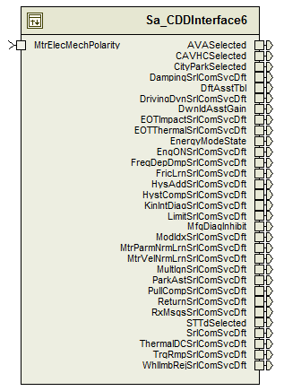

Variable Data Dictionary

User defined typedef definition/declaration
Typedef Name | Element Name | User Defined Type | Legal Range  (min) | Legal Range  (max)
None

Variable definition for enumerated types
Enum Name | Element Name | Value
None

Constant Data Dictionary

Program(fixed) Constants

Embedded Constants

Local
Constant Name | Resolution | Units | Value
D_DEFEATENGON_CNT_B32 | 1 | Count | 0x01
D_DEFEATFREQDEPDMP_CNT_B32 | 1 | Count | 0x02
D_DEFEATKININTDIAG_CNT_B32 | 1 | Count | 0x04u
D_DEFEATTHERMALDC_CNT_B32 | 1 | Count | 0x08
D_DEFEATEOTIMPACT_CNT_B32 | 1 | Count | 0x10
D_DEFEATEOTTHERMAL_CNT_B32 | 1 | Count | 0x20
D_DEFEATMTRVELNRMLRN_CNT_B32 | 1 | Count | 0x40
D_DEFEATMTRPARMNRMLRN_CNT_B32 | 1 | Count | 0x80u
D_DEFEATTRQRMP_CNT_B32 | 1 | Count | 0x0100
D_DEFEATMODIDX_CNT_B32 | 1 | Count | 0x0200
D_DEFEATPULLCOMP_CNT_B32 | 1 | Count | 0x0400
D_DEFEATWHLIMBREJ_CNT_B32 | 1 | Count | 0x0800
D_DEFEATPARKAST_CNT_B32 | 1 | Count | 0x1000
D_DEFEATDRIVINGDYN_CNT_B32 | 1 | Count | 0x2000
D_DEFEATHYSTCOMP_CNT_B32 | 1 | Count | 0x4000
D_DEFEATHYSTADD_CNT_B32 | 1 | Count | 0x8000
D_DEFEATRETURN_CNT_B32 | 1 | Count | 0x010000
D_DEFEATDAMPING_CNT_B32 | 1 | Count | 0x020000
D_DEFEATLIMIT_CNT_B32 | 1 | Count | 0x040000
D_DEFEATFRICLRN_CNT_B32 | 1 | Count | 0x100000
D_DEFEATRXMSGS_CNT_B32 | 1 | Count | 0x08000000
D_DEFEATMULTIGNMASK_CNT_B32 | 1 | Count | 0x50000000

Global

Constant Name
None

Module specific Lookup Tables Constants
Constant Name | Resolution | Value | Software Segment
None

Library Functions / Macros
None

Data Hiding Functions
None

Software Module Implementation

Initialization Functions

Init: CDDInterface6_Init1

Design Rationale
None

Module Outputs
Rte_IWrite_CDDInterface6_Init1_AVASelected_Cnt_lgc(CDD_AVASelected_Cnt_G_lgc)
Rte_IWrite_CDDInterface6_Init1_CAVHCSelected_Cnt_lgc(CDD_CAVHCSelected_Cnt_G_lgc)
Rte_IWrite_CDDInterface6_Init1_CityParkSelected_Cnt_lgc(CDD_CityParkSelected_Cnt_G_lgc)
Rte_IWrite_CDDInterface6_Init1_STTdSelected_Cnt_lgc(CDD_STTdSelected_Cnt_G_lgc)

Module Internal
MtrElecMechPolarity_Cnt_T_s08 = Rte_IRead_CDDInterface_Init1_MtrElecMechPolarity_Cnt_s08()

PROCESSING OF INIT FUNCTION
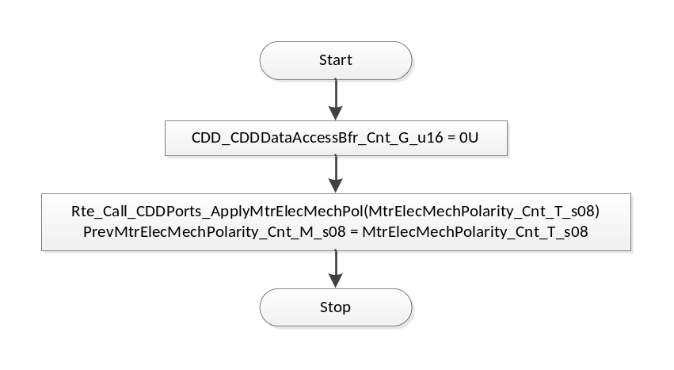
Flowchart 1: CDD Init1

PERIODIC FUNCTIONS

Per: CDDInterface6_Per1

Design Rationale
None

Store Module Inputs to Local copies
MtrElecMechPolarity_Cnt_T_s08 = Rte_IRead_CDDInterface10_Per2_MtrElecMechPolarity_Cnt_s08()

Processing of Defeat Bits
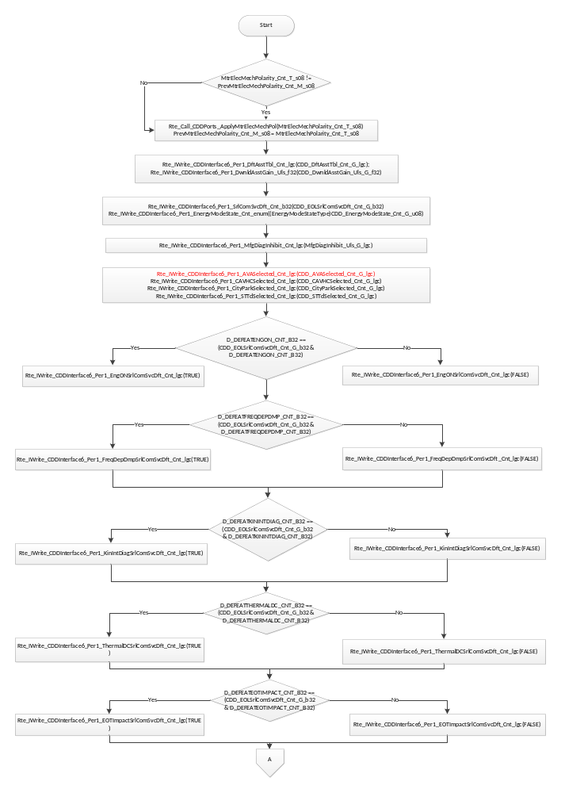
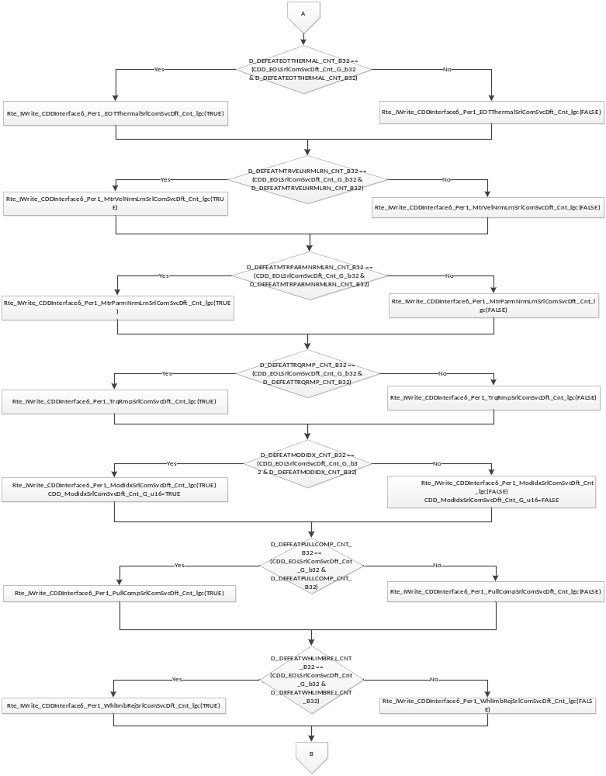
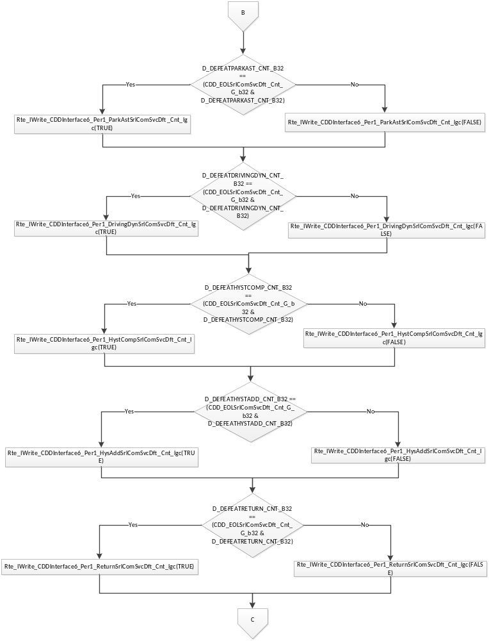
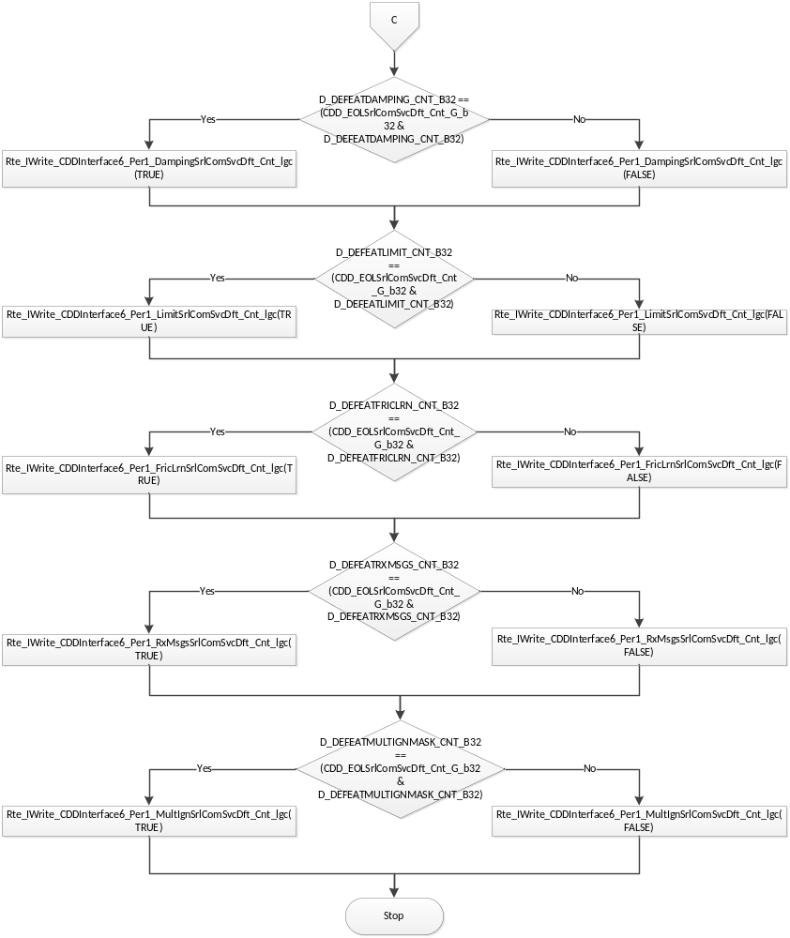

Store Local copy of outputs into Module Outputs

Interrupt Functions
None

TRANSIENT FUNCTIONS
None

Serial Communication Functions
None

Local Function/Macro Definitions
None

GLObAL Function/Macro Definitions

Apply MtrElecMech Polarity
Function Name | CDDPorts_ApplyMtrElecMechPol | Type | Min | Max
Arguments Passed | MtrElecMechPol_Cnt_s8 | sint8 | -1 | 1
Return Value | None

Description
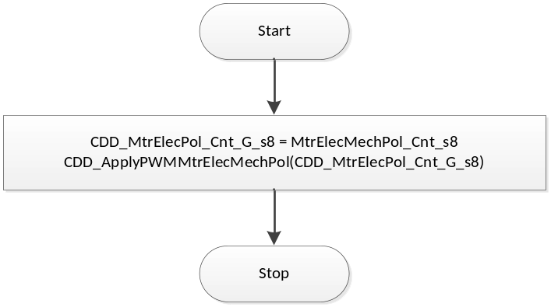
Flowchart 2: CDDPorts_ApplyMtrElecMechPol

Known Limitations With Design
None

UNIT TEST CONSIDERATION
None

Appendix
None

