Module Design Document
For
CDDInterface9

VERSION: 6
DATE: 10-Mar-2015

Revision History

Sl. No. | Description | Author | Version | Date
1 | Initial Version | Owen Tosh | 1 | 25-Aug-2014
2 | Updates for new city park messages | Owen Tosh | 2 | 17-Sep-2014
3 | Updates for other new SCom messages | Owen Tosh | 3 | 24-Sep-2014
4 | Updates for new customer services | Owen Tosh | 4 | 09-Oct-2014
5 | Updates for MechMtrPos1 signal | Owen Tosh | 5 | 20-Jan-2015
6 | Updates for DigMSB v8 | Owen Tosh | 6 | 10-Mar-2015

Table of Contents
1 Abbrevations And Acronyms 5
2 References 6
3 CDD & High-Level Description 7
4 Design details of software module 8
4.1 Graphical representation of CDDInterface 8
4.2 Data Flow Diagram 8
4.2.1 Module level DFD 8
4.2.2 Sub-Module level DFD 8
4.3 COMPONENT FLOW DIAGRAM 8
5 Variable Data Dictionary 9
5.1 User defined typedef definition/declaration 9
5.2 Variable definition for enumerated types 9
6 Constant Data Dictionary 10
6.1 Program(fixed) Constants 10
6.1.1 Embedded Constants 10
6.1.1.1 Local 10
6.1.1.2 Global 10
6.1.2 Module specific Lookup Tables Constants 10
6.1.3 Library Functions / Macros 10
6.1.4 Data Hiding Functions 10
7 Software Module Implementation 11
7.1 Initialization Functions 11
7.1.1 Init: CDDInterface9_Init1 11
7.1.1.1 Design Rationale 11
7.1.1.2 Module Internal 11
7.1.1.3 Module Outputs 11
7.2 PERIODIC FUNCTIONS 11
7.2.1 Per: CDDInterface9_Per1 11
7.2.1.1 Design Rationale 11
7.2.1.2 Store Module Inputs to Local copies 11
7.2.1.3 Processing of PhaseAdvFinal Signal 13
7.2.1.4 Store Local copy of outputs into Module Outputs 13
7.3 Interrupt Functions 14
7.4 TRANSIENT FUNCTIONS 14
7.5 Serial Communication Functions 14
7.6 Local Function/Macro Definitions 14
7.7 GLObAL Function/Macro Definitions 14
8 Known Limitations With Design 15
9 UNIT TEST CONSIDERATION 16
10 Appendix 17

Abbrevations And Acronyms
Abbreviation | Description
DFD | Design functional diagram
MDD | Module design Document

References
This section Lists the title & version of all the documents that are referred for development of this document
Sr. No. | Title | Version
1 | MDD Guidelines | 1
2 | Software Naming Conventions | 1
3 | Coding standands | 1

CDD & High-Level Description
CDD Interface is a part of Complex Device Driver (CDD) in AUTOSAR which is an interface for data transfer between application layer and motor control Interrupt Service Routine(ISR). CDD Interface acts as a proxy for software components without a developer model, or connection to the RTE, to provide data to the RTE and be passed to other software components.

Design details of software module

Graphical representation of CDDInterface
None

Data Flow Diagram
None

Module level DFD
None

Sub-Module level DFD
None

COMPONENT FLOW DIAGRAM
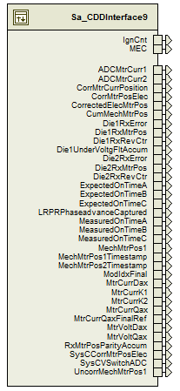

Variable Data Dictionary

User defined typedef definition/declaration

Typedef Name | Element Name | User Defined Type | Legal Range  (min) | Legal Range  (max)
None

Variable definition for enumerated types
Enum Name | Element Name | Value
None

Constant Data Dictionary

Program(fixed) Constants

Embedded Constants

Local
Constant Name | Resolution | Units | Value
D_PXACCUMMAX_CNT_U32 | 1 | Count | 536870911
D_PHSADVSCALE_ULS_F32 | Single Precision Float | Unitless | 6144.0/65536.0
D_HALFREV_CNT_U16 | 1 | Count | 32768
D_FULLREV_CNT_S32 | 1 | Count | 65536
D_PHASEA_CNT_U16 | 1 | Count | 0
D_PHASEB_CNT_U16 | 1 | Count | 1
D_PHASEC_CNT_U16 | 1 | Count | 2

Global

Constant Name
None

Module specific Lookup Tables Constants

Constant Name | Resolution | Value | Software Segment
None

Library Functions / Macros
None

Data Hiding Functions
None

Software Module Implementation

Initialization Functions

Init: CDDInterface9_Init1

Design Rationale
None

Module Internal
CDD_CDDDataAccessBfr_Cnt_G_u16 = 0
PXAccumPrev_Cnt_M_u32[D_PHASEA_CNT_U16] = HET_P1ACC_1.memory.data_word >> 3
PXAccumPrev_Cnt_M_u32[D_PHASEB_CNT_U16] = HET_P2ACC_1.memory.data_word >> 3
PXAccumPrev_Cnt_M_u32[D_PHASEC_CNT_U16] = HET_P3ACC_1.memory.data_word >> 3

Module Outputs
Rte_IWrite_CDDInterface9_Init1_IgnCnt_Cnt_u16(Nvm_IgnCntr_Cnt_u16)
Rte_IWrite_CDDInterface9_Init1_MEC_Cnt_enum(NxtrMEC_Uls_G_enum)

PERIODIC FUNCTIONS

Per: CDDInterface9_Per1

Design Rationale
As the CDDInterface module is the interface between RTE-level and lower-level software, a mechanism is needed to ensure data consistency across different time bases. To achieve this, CDDInterface implements a so-called “double buffer” system in which the shared variables are written and read from two separate buffers. CDDInterface controls which buffer is written to by use of the CDD_CDDDataAccessBfr_Cnt_G_u16 variable, reading the buffer that is not being written to by the faster time base loop.

Store Module Inputs to Local copies
ReadBuffer_Cnt_T_u16 = CDD_CDDDataAccessBfr_Cnt_G_u16
WriteBuffer_Cnt_T_u16 = (ReadBuffer_Cnt_T_u16 & 1u) ^ 1u
(void)Rte_Call_CDDPorts_ClearPhsReasSum(WriteBuffer_Cnt_T_u16)
CDD_CDDDataAccessBfr_Cnt_G_u16 = WriteBuffer_Cnt_T_u16

/* These NHET2 memory reads are performed immediately after the buffer swap for greatest possible synchronization */
PXAccum_Cnt_T_u32[D_PHASEA_CNT_U16] = HET_P1ACC_1.memory.data_word >> 3u
PXAccum_Cnt_T_u32[D_PHASEB_CNT_U16] = HET_P2ACC_1.memory.data_word >> 3u
PXAccum_Cnt_T_u32[D_PHASEC_CNT_U16] = HET_P3ACC_1.memory.data_word >> 3u

MtrCurr1_Volts_T_f32 = CDD_MtrCurr1_Volts_G_f32[ReadBuffer_Cnt_T_u16]
MtrCurr2_Volts_T_f32 = CDD_MtrCurr2_Volts_G_f32[ReadBuffer_Cnt_T_u16]
CorrMtrCurrPosition_Rev_T_f32 = CDD_CorrMtrCurrPosition_Rev_G_f32[ReadBuffer_Cnt_T_u16]
CorrMtrPosElec_Rev_T_f32 = FPM_FixedToFloat_m(CDD_CorrectedElecMtrPos_Rev_G_u0p16[ReadBuffer_Cnt_T_u16], u0p16_T)
CorrectedElecMtrPos_Rev_T_u0p16 = CDD_CorrectedElecMtrPos_Rev_G_u0p16[ReadBuffer_Cnt_T_u16]
CumMechMtrPos_Rev_T_f32 = FPM_FixedToFloat_m(CDD_CumMechMtrPos_Rev_G_s15p16[ReadBuffer_Cnt_T_u16], s15p16_T)
Die1RxError_Cnt_T_u16 = CDD_Die1RxError_Cnt_G_u16[ReadBuffer_Cnt_T_u16]
Die1RxMtrPos_Cnt_T_u16 = CDD_Die1RxMtrPos_Cnt_G_u16[ReadBuffer_Cnt_T_u16]
Die1RxRevCtr_Cnt_T_u16 = CDD_Die1RxRevCtr_Cnt_G_u16[ReadBuffer_Cnt_T_u16]
Die1UnderVoltgFltAccum_Cnt_T_u16 = CDD_Die1UnderVoltgFltAccum_Cnt_G_u16[ReadBuffer_Cnt_T_u16]
Die2RxError_Cnt_T_u16 = CDD_Die2RxError_Cnt_G_u16[ReadBuffer_Cnt_T_u16]
Die2RxMtrPos_Cnt_T_u16 = CDD_Die2RxMtrPos_Cnt_G_u16[ReadBuffer_Cnt_T_u16]
Die2RxRevCtr_Cnt_T_u16 = CDD_Die2RxRevCtr_Cnt_G_u16[ReadBuffer_Cnt_T_u16]
ExpectedOnTimeA_Cnt_T_u32 = CDD_PWMDutyCycleASum_Cnt_G_u32[ReadBuffer_Cnt_T_u16]
ExpectedOnTimeB_Cnt_T_u32 = CDD_PWMDutyCycleBSum_Cnt_G_u32[ReadBuffer_Cnt_T_u16]
ExpectedOnTimeC_Cnt_T_u32 = CDD_PWMDutyCycleCSum_Cnt_G_u32[ReadBuffer_Cnt_T_u16]
PhaseAdvFinal_Cnt_T_u16 = CDD_PhaseAdvFinal_Cnt_G_u16[ReadBuffer_Cnt_T_u16]
MechMtrPos1_Rev_T_f32 = FPM_FixedToFloat_m(CDD_MechMtrPos1_Rev_G_u0p16[ReadBuffer_Cnt_T_u16], u0p16_T)
MechMtrPos1Timestamp_uSec_T_u32 = CDD_MechMtrPos1TimeStamp_uSec_G_u32[ReadBuffer_Cnt_T_u16]
MechMtrPos2Timestamp_uSec_T_u32 = CDD_MechMtrPos2TimeStamp_uSec_G_u32[ReadBuffer_Cnt_T_u16]
ModIdx_Uls_T_f32 = FPM_FixedToFloat_m(CDD_ModIdxFinal_Uls_G_u16p16[ReadBuffer_Cnt_T_u16], u16p16_T)
MtrCurrDax_Amp_T_f32 = CDD_MtrCurrDax_Amp_G_f32[ReadBuffer_Cnt_T_u16]
MtrCurrK1_Amps_T_f32 = CDD_MtrCurrK1_Amps_G_f32[ReadBuffer_Cnt_T_u16]
MtrCurrK2_Amps_T_f32 = CDD_MtrCurrK2_Amps_G_f32[ReadBuffer_Cnt_T_u16]
MtrCurrQaxFinalRef_Amp_T_f32 = CDD_MtrCurrQaxFinalRef_Amp_G_f32[ReadBuffer_Cnt_T_u16]
MtrCurrQax_Amp_T_f32 = CDD_MtrCurrQax_Amp_G_f32[ReadBuffer_Cnt_T_u16]
MtrVoltDax_Volt_T_f32 = CDD_MtrVoltDax_Volt_G_f32[ReadBuffer_Cnt_T_u16]
MtrVoltQax_Volt_T_f32 = CDD_MtrVoltQax_Volt_G_f32[ReadBuffer_Cnt_T_u16]
RxMtrPosParityAccum_Cnt_T_u16 = CDD_RxMtrPosParityAccum_Cnt_G_u16[ReadBuffer_Cnt_T_u16]
SysCCorrMtrPosElec_Rev_T_f32 = FPM_FixedToFloat_m(CDD_SysCCorrectedElecMtrPos_Rev_G_u0p16[ReadBuffer_Cnt_T_u16], u0p16_T)
UncorrMechMtrPos1_Rev_T_u0p16 = CDD_UncorrMechMtrPos1_Rev_G_u0p16[ReadBuffer_Cnt_T_u16]

Processing of PhaseAdvFinal Signal
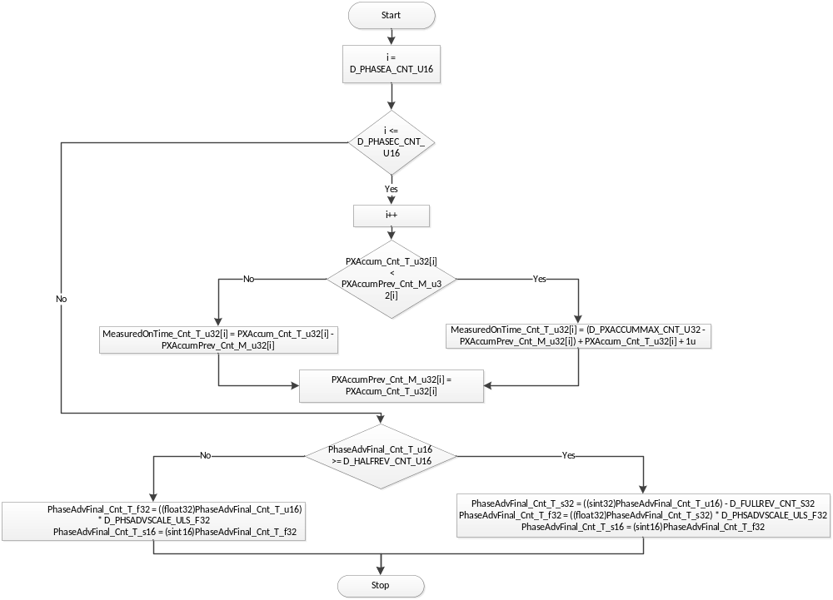
Flowchart 1:Processing Of Periodic Task

Store Local copy of outputs into Module Outputs
Rte_IWrite_CDDInterface9_Per1_ADCMtrCurr1_Volts_f32(MtrCurr1_Volts_T_f32)
Rte_IWrite_CDDInterface9_Per1_ADCMtrCurr2_Volts_f32(MtrCurr2_Volts_T_f32)
Rte_IWrite_CDDInterface9_Per1_CorrMtrCurrPosition_Rev_f32(CorrMtrCurrPosition_Rev_T_f32)
Rte_IWrite_CDDInterface9_Per1_CorrMtrPosElec_Rev_f32(CorrMtrPosElec_Rev_T_f32)
Rte_IWrite_CDDInterface9_Per1_CorrectedElecMtrPos_Rev_u0p16(CorrectedElecMtrPos_Rev_T_u0p16)
Rte_IWrite_CDDInterface9_Per1_CumMechMtrPos_Rev_f32(CumMechMtrPos_Rev_T_f32)
Rte_IWrite_CDDInterface9_Per1_Die1RxError_Cnt_u16(Die1RxError_Cnt_T_u16)
Rte_IWrite_CDDInterface9_Per1_Die1RxMtrPos_Cnt_u16(Die1RxMtrPos_Cnt_T_u16)
Rte_IWrite_CDDInterface9_Per1_Die1RxRevCtr_Cnt_u16(Die1RxRevCtr_Cnt_T_u16)
Rte_IWrite_CDDInterface9_Per1_Die1UnderVoltgFltAccum_Cnt_u16(Die1UnderVoltgFltAccum_Cnt_T_u16)
Rte_IWrite_CDDInterface9_Per1_Die2RxError_Cnt_u16(Die2RxError_Cnt_T_u16)
Rte_IWrite_CDDInterface9_Per1_Die2RxMtrPos_Cnt_u16(Die2RxMtrPos_Cnt_T_u16)
Rte_IWrite_CDDInterface9_Per1_Die2RxRevCtr_Cnt_u16(Die2RxRevCtr_Cnt_T_u16)
Rte_IWrite_CDDInterface9_Per1_ExpectedOnTimeA_Cnt_u32(ExpectedOnTimeA_Cnt_T_u32)
Rte_IWrite_CDDInterface9_Per1_ExpectedOnTimeB_Cnt_u32(ExpectedOnTimeB_Cnt_T_u32)
Rte_IWrite_CDDInterface9_Per1_ExpectedOnTimeC_Cnt_u32(ExpectedOnTimeC_Cnt_T_u32)
Rte_IWrite_CDDInterface9_Per1_LRPRPhaseadvanceCaptured_Cnt_s16(PhaseAdvFinal_Cnt_T_s16)
Rte_IWrite_CDDInterface9_Per1_MeasuredOnTimeA_Cnt_u32(MeasuredOnTime_Cnt_T_u32[D_PHASEA_CNT_U16])
Rte_IWrite_CDDInterface9_Per1_MeasuredOnTimeB_Cnt_u32(MeasuredOnTime_Cnt_T_u32[D_PHASEB_CNT_U16])
Rte_IWrite_CDDInterface9_Per1_MeasuredOnTimeC_Cnt_u32(MeasuredOnTime_Cnt_T_u32[D_PHASEC_CNT_U16])
Rte_IWrite_CDDInterface9_Per1_MechMtrPos1_Rev_f32(MechMtrPos1_Rev_T_f32)
Rte_IWrite_CDDInterface9_Per1_MechMtrPos1Timestamp_USec_u32(MechMtrPos1Timestamp_uSec_T_u32)
Rte_IWrite_CDDInterface9_Per1_MechMtrPos2Timestamp_USec_u32(MechMtrPos2Timestamp_uSec_T_u32)
Rte_IWrite_CDDInterface9_Per1_ModIdxFinal_Uls_f32(ModIdx_Uls_T_f32)
Rte_IWrite_CDDInterface9_Per1_MtrCurrDax_Amp_f32(MtrCurrDax_Amp_T_f32)
Rte_IWrite_CDDInterface9_Per1_MtrCurrK1_Amp_f32(MtrCurrK1_Amps_T_f32)
Rte_IWrite_CDDInterface9_Per1_MtrCurrK2_Amp_f32(MtrCurrK2_Amps_T_f32)
Rte_IWrite_CDDInterface9_Per1_MtrCurrQaxFinalRef_Amp_f32(MtrCurrQaxFinalRef_Amp_T_f32)
Rte_IWrite_CDDInterface9_Per1_MtrCurrQax_Amp_f32(MtrCurrQax_Amp_T_f32)
Rte_IWrite_CDDInterface9_Per1_MtrVoltDax_Volt_f32(MtrVoltDax_Volt_T_f32)
Rte_IWrite_CDDInterface9_Per1_MtrVoltQax_Volt_f32(MtrVoltQax_Volt_T_f32)
Rte_IWrite_CDDInterface9_Per1_RxMtrPosParityAccum_Cnt_u16(RxMtrPosParityAccum_Cnt_T_u16)
Rte_IWrite_CDDInterface9_Per1_SysCCorrMtrPosElec_Rev_f32(SysCCorrMtrPosElec_Rev_T_f32)
Rte_IWrite_CDDInterface9_Per1_UncorrMechMtrPos1_Rev_u0p16(UncorrMechMtrPos1_Rev_T_u0p16)

Interrupt Functions
None

TRANSIENT FUNCTIONS
None

Serial Communication Functions
None

Local Function/Macro Definitions
None

GLObAL Function/Macro Definitions
None

Known Limitations With Design
None

UNIT TEST CONSIDERATION
None

Appendix
None

