Module Design Document
For
SrlComDriver

VERSION: 11
DATE: 14-Dec-2015
Location: The official version of this document is stored in the Nexteer Configuration Management System.

Revision History

Sl. No. | Description | Author | Version | Date
1 | Initial Version | Owen Tosh | 1 | 09-Sep-2014
2 | Updates for new city park messages | Owen Tosh | 2 | 17-Sep-2014
3 | Updates for other new SCom messages | Owen Tosh | 3 | 29-Sep-2014
4 | Updates for new customer services | Owen Tosh | 4 | 09-Oct-2014
5 | Updates for remaining customer messages | Owen Tosh | 5 | 17-Oct-2014
6 | Updates for tuning sets | Owen Tosh | 6 | 21-Oct-2014
7 | Updates for fault logbook | Owen Tosh | 7 | 11-Nov-2014
8 | Removed ClearDTC logic from elec integration | Owen Tosh | 8 | 13-Jan-2015
9 | Added 2004 functionality | Owen Tosh | 9 | 1-May-2015
10 | Updates for message 552 DLC | Owen Tosh | 10 | 27-Oct-2015
11 | Added BusOff output | Owen Tosh | 11 | 14-Dec-2015

Table of Contents
1 Abbrevations And Acronyms 6
2 References 7
3 SrlComDriver & High-Level Description 8
4 Design details of software module 9
4.1 Graphical representation of SrlComDriver 9
4.2 Data Flow Diagram 9
4.3 COMPONENT DIAGRAM 9
5 Variable Data Dictionary 10
5.1 User defined typedef definition/declaration 10
5.2 Variable definition for enumerated types 10
6 Constant Data Dictionary 11
6.1 Program(fixed) Constants 11
6.1.1 Embedded Constants 11
6.1.1.1 Local 11
6.1.1.2 Global 11
6.1.2 Module specific Lookup Tables Constants 11
6.1.3 Library Functions / Macros 11
6.1.4 Data Hiding Functions 11
7 Software Module Implementation 13
7.1 Initialization Functions 13
7.1.1 Init: SrlComDriver_Init1 13
7.1.1.1 Design Rationale 13
7.1.1.2 Processing 13
7.2 PERIODIC FUNCTIONS 13
7.2.1 Per: SrlComDriver_Per1 13
7.2.1.1 Design Rationale 13
7.2.1.2 Store Module Inputs to Local copies 13
7.2.1.3 Enable Tx 14
7.2.1.4 Bus Off 15
7.2.1.5 Write Outgoing Signals 16
7.2.1.6 Call Driver Runnables 17
7.2.1.7 Store Local copy of outputs into Module Outputs 17
7.3 Interrupt Functions 18
7.4 TRANSIENT FUNCTIONS 18
7.4.1 TRNS: SrlComDriver_Trns1 18
7.4.1.1 Design Rationale 18
7.4.1.2 Store Module Inputs to Local copies 18
7.4.1.3 Start Tx 18
7.4.1.4 Store Local copy of outputs into Module Outputs 18
7.4.2 TRNS: SrlComDriver_Trns2 19
7.4.2.1 Design Rationale 19
7.4.2.2 Store Module Inputs to Local copies 19
7.4.2.3 Stop Tx 19
7.4.2.4 Store Local copy of outputs into Module Outputs 19
7.5 Serial Communication Functions 20
7.5.1 SCOM: SrlComDriver_SCom_ElecIntStart 20
7.5.1.1 Design Rationale 20
7.5.1.2 Stop Tx and Disable DEM 20
7.5.2 SCOM: SrlComDriver_SCom_ElecIntStOP 21
7.5.2.1 Design Rationale 21
7.5.2.2 Start TX and Enable DEM 21
7.6 Local Function/Macro Definitions 21
7.7 GLObAL Function/Macro Definitions 22
7.7.1 ApplCanBusOff 22
7.7.1.1 Description 22
7.7.2 ApplCanMsgDlcFailed 23
7.7.2.1 Description 23
7.7.3 SrlComDriver_PreRxISDYNABR 24
7.7.3.1 Description 24
7.7.4 SrlComDriver_RxISDYNCMM388 25
7.7.4.1 Description 25
7.7.5 SrlComDriver_RxISDYNCMM208 25
7.7.5.1 Description 25
7.7.6 SrlComDriver_RxISDYN2CMM 26
7.7.6.1 Description 26
7.7.7 SrlComDriver_PreRxISDYNABR 26
7.7.7.1 Description 26
7.7.8 SrlComDriver_PreRxISDYNABR 27
7.7.8.1 Description 27
7.7.9 SrlComDriver_RxISDAT4V2BSI552 28
7.7.9.1 Description 28
7.7.10 SrlComDriver_RxISDATBSI3F2 28
7.7.10.1 Description 28
7.7.11 SrlComDriver_RxISDATBSI412 29
7.7.11.1 Description 29
7.7.12 SrlComDriver_RxISDATBSI432 29
7.7.12.1 Description 29
7.7.13 SrlComDriver_PreTxISDATDIRA 30
7.7.13.1 Description 30
7.7.14 SrlComDriver_TxISDATDIRA 30
7.7.14.1 Description 30
7.7.15 SrlComDriver_PreTxISDYNDAE 30
7.7.15.1 Description 31
7.7.16 SrlComDriver_TxISDYNDAE 32
7.7.16.1 Description 32
8 Known Limitations With Design 33
9 UNIT TEST CONSIDERATION 34
10 Appendix 35

Abbrevations And Acronyms
Abbreviation | Description
DFD | Design functional diagram
MDD | Module design Document

References
This section Lists the title & version of all the documents that are referred for development of this document
Sr. No. | Title | Version
1 | MDD Guidelines | 1
2 | Software Naming Conventions | 1
3 | Coding standands | 1
4 | PSA BMPV SCIR | 003F

SrlComDriver & High-Level Description
This module provides an interface between the SCom signal processing components SrlComInput and SrlComOutput, and the drivers provided by Vector. This module handles all driver-level callback functions, as well as the BusOff NTC.

Design details of software module

Graphical representation of SrlComDriver
None

Data Flow Diagram
None

COMPONENT DIAGRAM
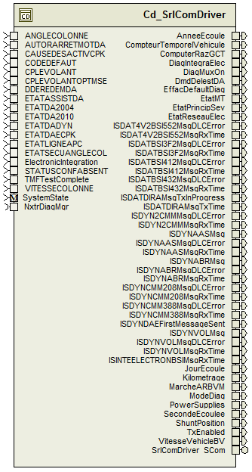

Variable Data Dictionary

User defined typedef definition/declaration
Typedef Name | Element Name | User Defined Type | Legal Range  (min) | Legal Range  (max)
None

Variable definition for enumerated types
Enum Name | Element Name | Value
None

Constant Data Dictionary

Program(fixed) Constants

Embedded Constants

Local
Constant Name | Resolution | Units | Value
None

Global
Constant Name
kCanInitObj1
CanRxIS_DYN_VOL
CanRxIS_DYN_CMM_388
CanRxIS_DYN_CMM_208
CanRxIS_DYN2_CMM_348
CanRxIS_DYN_AAS
CanRxIS_DYN_ABR
CanRxIS_DAT4_V2_BSI_552
CanRxIS_DAT_BSI_3F2
CanRxIS_DAT_BSI_412
CanRxIS_DAT_BSI_432
kCanNoCopyData
kCanCopyData
D_MANUFDATEINIT_CNT_STR

Module specific Lookup Tables Constants
Constant Name | Resolution | Value | Software Segment
None

Library Functions / Macros
GetSystemTime_mS_u32

Data Hiding Functions
Rte_Call_SystemTime_GetSystemTime_mS_u32
Rte_Call_SystemTime_DtrmnElapsedTime_mS_u16
Rte_Call_NxtrDiagMgr_SetNTCStatus
IlRxStart
IlTxStart
IlTxStop
IlPutTxSystem_Code
IlPutTxDownload_Day
IlPutTxDownload_Month
IlPutTxDownload_Year
IlPutTxApplication_Code
IlPutTxSoftware_Version
IlPutTxSoftware_Edition_MSB
IlPutTxSoftware_Edition_LSB
IlPutTxANGLE_COLONNE
IlPutTxAUTOR_ARRET_MOT_DA
IlPutTxCAUSE_DESACTIV_CPK
IlPutTxCODE_DEFAUT
IlPutTxCPLE_VOLANT_OPTMSE
IlPutTxCPLE_VOLANT
IlPutTxDDE_REDEM_DA
IlPutTxETAT_ASSIST_DA
IlPutTxETAT_DA_2004
IlPutTxETAT_DA_2010
IlPutTxETAT_DA_DYN
IlPutTxETAT_DAE_CPK
IlPutTxETAT_LIGNE_APC
IlPutTxETAT_SECU_ANGLE_COL
IlPutTxSTATUS_CONFABSENT
IlPutTxVITESSE_COLONNE
IlGetRxVITESSE_VEHICLE_BV
IlGetRxDIAG_MUX_ON
IlGetRxETAT_MT
IlGetRxDMD_DELEST_DA
IlGetRxMARCHE_AR_BVM
IlGetRxEFFAC_DEFAULT_DIAG
IlGetRxMODE_DIAG
IlGetRxDIAG_INTEGRA_ELEC
IlGetRxShunt_Position
IlGetRxPower_Supplies
IlGetRxETAT_PRINCIP_SEV
IlGetRxETAT_RESEAU_ELEC
CanRxActualDLC
CanResetBusOffStart
CanResetBusOffEnd
CanStart
CanStop
CanOnline
CanOffline
TpTxTask
IlTxTask
CanTask
IlRxTask
TpRxTask
DescTask
AppDesc_Init2
AppDesc_Per1
EPSDiagSrvcs_Task
IS_DYN_DAE

Software Module Implementation

Initialization Functions

Init: SrlComDriver_Init1

Design Rationale
None

Processing
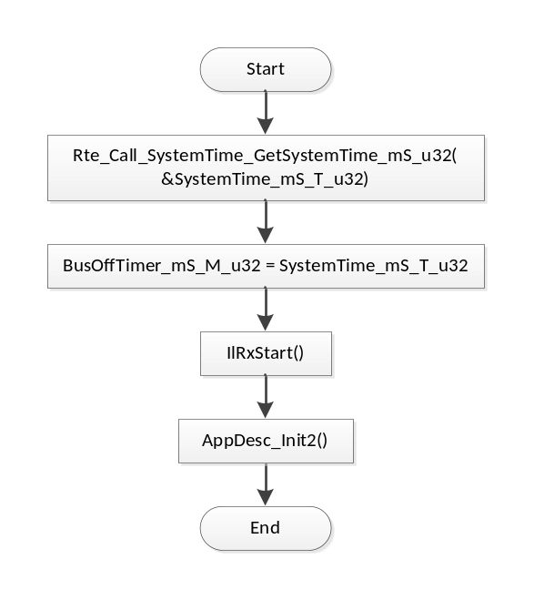

PERIODIC FUNCTIONS

Per: SrlComDriver_Per1

Design Rationale
This periodic is responsible for calling all the communications-related periodic functions of the drivers. These calls are placed between writing the outgoing signals and reading the incoming signals to/from the drivers. Note that because of this configuration, this periodic should be run after the SrlComOutput periodic and before the SrlComInput periodic for minimum latency.

Store Module Inputs to Local copies
ANGLECOLONNE_Cnt_T_u16 = Rte_IRead_SrlComDriver_Per1_ANGLECOLONNE_Cnt_u16()
AUTORARRETMOTDA_Cnt_T_u08 = Rte_IRead_SrlComDriver_Per1_AUTORARRETMOTDA_Cnt_u08()
CAUSEDESACTIVCPK_Cnt_T_u08 = Rte_IRead_SrlComDriver_Per1_CAUSEDESACTIVCPK_Cnt_u08()
CODEDEFAUT_Cnt_T_u08 = Rte_IRead_SrlComDriver_Per1_CODEDEFAUT_Cnt_u08()
CPLEVOLANTOPTMSE_Cnt_T_u08 = Rte_IRead_SrlComDriver_Per1_CPLEVOLANTOPTMSE_Cnt_u08()
CPLEVOLANT_Cnt_T_u08 = Rte_IRead_SrlComDriver_Per1_CPLEVOLANT_Cnt_u08()
DDEREDEMDA_Cnt_T_u08 = Rte_IRead_SrlComDriver_Per1_DDEREDEMDA_Cnt_u08()
ETATASSISTDA_Cnt_T_u08 = Rte_IRead_SrlComDriver_Per1_ETATASSISTDA_Cnt_u08()
ETATDA2_Cnt_T_u08 = Rte_IRead_SrlComDriver_Per1_ETATDA2_Cnt_u08()
ETATDADYN_Cnt_T_u08 = Rte_IRead_SrlComDriver_Per1_ETATDADYN_Cnt_u08()
ETATDAECPK_Cnt_T_u08 = Rte_IRead_SrlComDriver_Per1_ETATDAECPK_Cnt_u08()
ETATLIGNEAPC_Cnt_T_u08 = Rte_IRead_SrlComDriver_Per1_ETATLIGNEAPC_Cnt_u08()
ETATSECUANGLECOL_Cnt_T_u08 = Rte_IRead_SrlComDriver_Per1_ETATSECUANGLECOL_Cnt_u08()
STATUSCONFABSENT_Cnt_T_u32 = Rte_IRead_SrlComDriver_Per1_STATUSCONFABSENT_Cnt_u32()
TMFTestComplete_Cnt_T_lgc = Rte_IRead_SrlComDriver_Per1_TMFTestComplete_Cnt_lgc()
VITESSECOLONNE_Cnt_T_u16 = Rte_IRead_SrlComDriver_Per1_VITESSECOLONNE_Cnt_u16()

Enable Tx
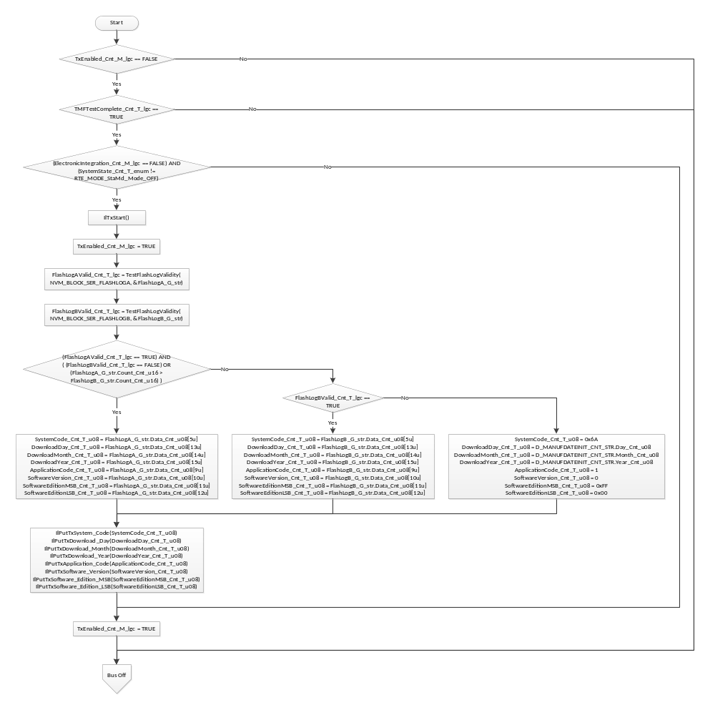

Bus Off
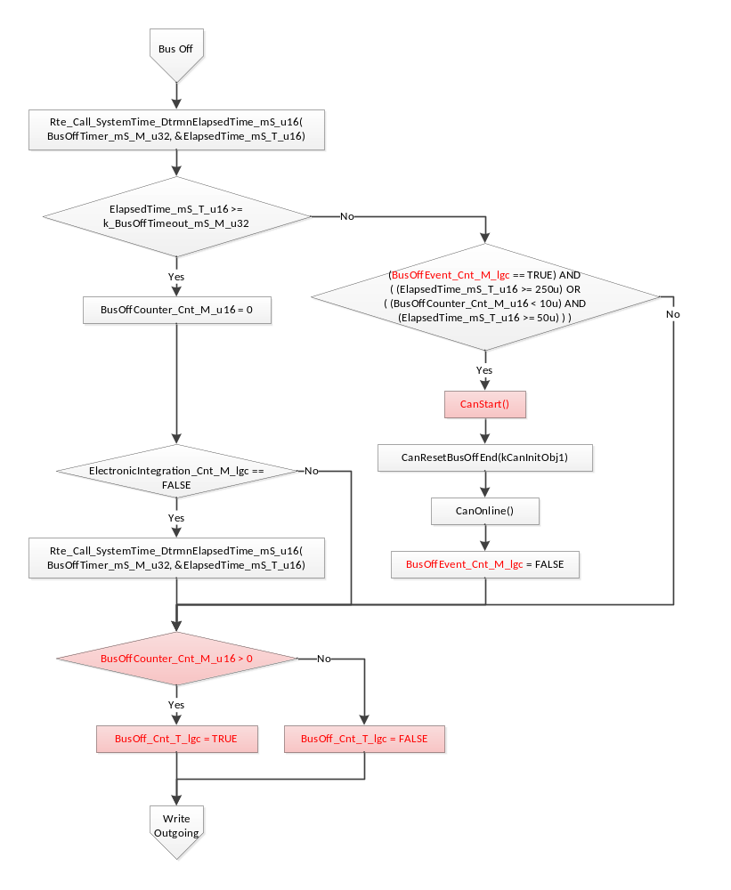

Write Outgoing Signals
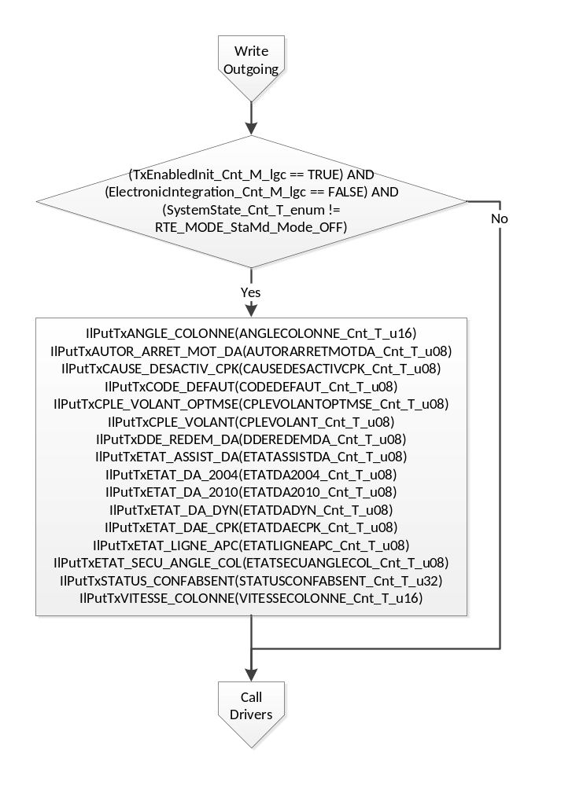

Call Driver Runnables
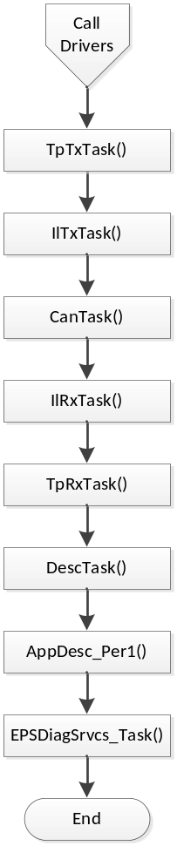

Store Local copy of outputs into Module Outputs
Rte_IWrite_SrlComDriver_Per1_AnneeEcoule_Cnt_u08(AnneeEcoule_Cnt_M_u08)
Rte_IWrite_SrlComDriver_Per1_BusOff_Cnt_lgc(BusOff_Cnt_T_lgc)
Rte_IWrite_SrlComDriver_Per1_CompteurTemporelVehicule_Cnt_u32(CompteurTemporelVehicule_Cnt_M_u32)
Rte_IWrite_SrlComDriver_Per1_ComputerRazGCT_Cnt_u08(ComputerRazGCT_Cnt_M_u08)
Rte_IWrite_SrlComDriver_Per1_DiagIntegraElec_Cnt_u08(DiagIntegraElec_Cnt_M_u08)
Rte_IWrite_SrlComDriver_Per1_DiagMuxOn_Cnt_u08(DiagMuxOn_Cnt_M_u08)
Rte_IWrite_SrlComDriver_Per1_DmdDelestDA_Cnt_u08(DmdDelestDA_Cnt_M_u08)
Rte_IWrite_SrlComDriver_Per1_EffacDefaultDiag_Cnt_u08(EffacDefaultDiag_Cnt_M_u08)
Rte_IWrite_SrlComDriver_Per1_EtatMT_Cnt_u08(EtatMT_Cnt_M_u08)
Rte_IWrite_SrlComDriver_Per1_EtatPrincipSev_Cnt_u08(EtatPrincipSev_Cnt_M_u08)
Rte_IWrite_SrlComDriver_Per1_EtatReseauElec_Cnt_u08(EtatReseauElec_Cnt_M_u08)
Rte_IWrite_SrlComDriver_Per1_ISDAT4V2BSI552MsgDLCError_Cnt_u08(ISDAT4V2BSI552MsgDLCError_Cnt_M_u08)
Rte_IWrite_SrlComDriver_Per1_ISDAT4V2BSI552MsgRxTime_MSec_u32(ISDAT4V2BSI552MsgRxTime_MSec_M_u32)
Rte_IWrite_SrlComDriver_Per1_ISDATBSI3F2MsgDLCError_Cnt_u08(ISDATBSI3F2MsgDLCError_Cnt_M_u08)
Rte_IWrite_SrlComDriver_Per1_ISDATBSI3F2MsgRxTime_MSec_u32(ISDATBSI3F2MsgRxTime_MSec_M_u32)
Rte_IWrite_SrlComDriver_Per1_ISDATBSI412MsgDLCError_Cnt_u08(ISDATBSI412MsgDLCError_Cnt_M_u08)
Rte_IWrite_SrlComDriver_Per1_ISDATBSI412MsgRxTime_MSec_u32(ISDATBSI412MsgRxTime_MSec_M_u32)
Rte_IWrite_SrlComDriver_Per1_ISDATBSI432MsgDLCError_Cnt_u08(ISDATBSI432MsgDLCError_Cnt_M_u08)
Rte_IWrite_SrlComDriver_Per1_ISDATBSI432MsgRxTime_MSec_u32(ISDATBSI432MsgRxTime_MSec_M_u32)
Rte_IWrite_SrlComDriver_Per1_ISDATDIRAMsgTxInProgress_Cnt_lgc(ISDATDIRAMsgTxInProgress_Cnt_M_lgc)
Rte_IWrite_SrlComDriver_Per1_ISDATDIRAMsgTxTime_MSec_u32(ISDATDIRAMsgTxTime_MSec_M_u32)
Rte_IWrite_SrlComDriver_Per1_ISDYN2CMMMsgDLCError_Cnt_u08(ISDYN2CMMMsgDLCError_Cnt_M_u08)
Rte_IWrite_SrlComDriver_Per1_ISDYN2CMMMsgRxTime_MSec_u32(ISDYN2CMMMsgRxTime_MSec_M_u32)
Rte_IWrite_SrlComDriver_Per1_ISDYNAASMsgDLCError_Cnt_u08(ISDYNAASMsgDLCError_Cnt_M_u08)
Rte_IWrite_SrlComDriver_Per1_ISDYNAASMsgRxTime_MSec_u32(ISDYNAASMsgRxTime_MSec_M_u32)
Rte_IWrite_SrlComDriver_Per1_ISDYNAASMsg_Cnt_u08(&ISDYNAASMsg_Cnt_M_u08)
Rte_IWrite_SrlComDriver_Per1_ISDYNABRMsgDLCError_Cnt_u08(ISDYNABRMsgDLCError_Cnt_M_u08)
Rte_IWrite_SrlComDriver_Per1_ISDYNABRMsgRxTime_MSec_u32(ISDYNABRMsgRxTime_MSec_M_u32)
Rte_IWrite_SrlComDriver_Per1_ISDYNABRMsg_Cnt_u08(&ISDYNABRMsg_Cnt_M_u08)
Rte_IWrite_SrlComDriver_Per1_ISDYNCMM208MsgDLCError_Cnt_u08(ISDYNCMM208MsgDLCError_Cnt_M_u08)
Rte_IWrite_SrlComDriver_Per1_ISDYNCMM208MsgRxTime_MSec_u32(ISDYNCMM208MsgRxTime_MSec_M_u32)
Rte_IWrite_SrlComDriver_Per1_ISDYNCMM388MsgDLCError_Cnt_u08(ISDYNCMM388MsgDLCError_Cnt_M_u08)
Rte_IWrite_SrlComDriver_Per1_ISDYNCMM388MsgRxTime_MSec_u32(ISDYNCMM388MsgRxTime_MSec_M_u32)
Rte_IWrite_SrlComDriver_Per1_ISDYNDAEFirstMessageSent_Cnt_lgc(ISDYNDAEFirstMessageSent_Cnt_M_lgc)
Rte_IWrite_SrlComDriver_Per1_ISDYNVOLMsgDLCError_Cnt_u08(ISDYNVOLMsgDLCError_Cnt_M_u08)
Rte_IWrite_SrlComDriver_Per1_ISDYNVOLMsgRxTime_MSec_u32(ISDYNVOLMsgRxTime_MSec_M_u32)
Rte_IWrite_SrlComDriver_Per1_ISDYNVOLMsg_Cnt_u08(&ISDYNVOLMsg_Cnt_M_u08)
Rte_IWrite_SrlComDriver_Per1_ISINTEELECTRONBSIMsgRxTime_MSec_u32(ISINTEELECTRONBSIMsgRxTime_MSec_M_u32)
Rte_IWrite_SrlComDriver_Per1_JourEcoule_Cnt_u16(JourEcoule_Cnt_M_u16)
Rte_IWrite_SrlComDriver_Per1_Kilometrage_Cnt_u32(Kilometrage_Cnt_M_u32)
Rte_IWrite_SrlComDriver_Per1_MarcheARBVM_Cnt_u08(MarcheARBVM_Cnt_M_u08)
Rte_IWrite_SrlComDriver_Per1_ModeDiag_Cnt_u08(ModeDiag_Cnt_M_u08)
Rte_IWrite_SrlComDriver_Per1_PowerSupplies_Cnt_u08(PowerSupplies_Cnt_M_u08)
Rte_IWrite_SrlComDriver_Per1_SecondeEcoulee_Cnt_u32(SecondeEcoulee_Cnt_M_u32)
Rte_IWrite_SrlComDriver_Per1_ShuntPosition_Cnt_u08(ShuntPosition_Cnt_M_u08)
Rte_IWrite_SrlComDriver_Per1_TxEnabled_Cnt_lgc(TxEnabled_Cnt_M_lgc)
Rte_IWrite_SrlComDriver_Per1_VitesseVehicleBV_Cnt_u16(VitesseVehicleBV_Cnt_M_u16)

Interrupt Functions
None

TRANSIENT FUNCTIONS

TRNS: SrlComDriver_Trns1

Design Rationale
None

Store Module Inputs to Local copies
None

Start Tx
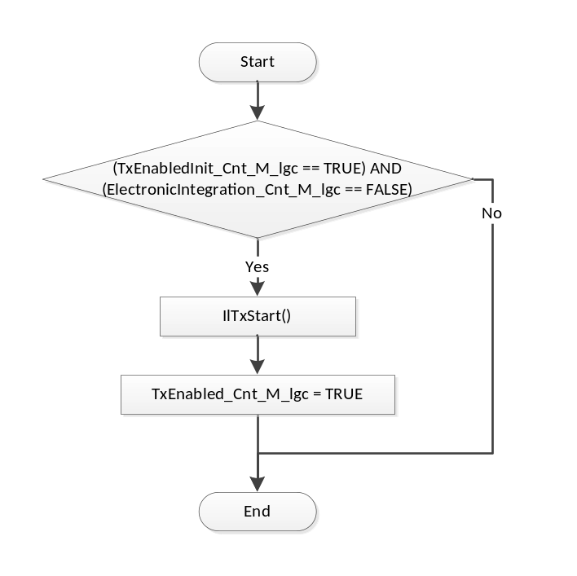

Store Local copy of outputs into Module Outputs
None

TRNS: SrlComDriver_Trns2

Design Rationale
None

Store Module Inputs to Local copies
None

Stop Tx
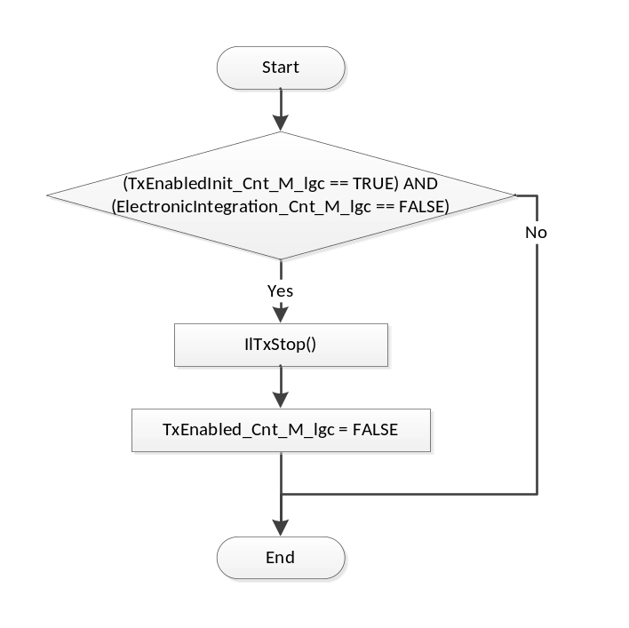

Store Local copy of outputs into Module Outputs
None

Serial Communication Functions

SCOM: SrlComDriver_SCom_ElecIntStart

Design Rationale
None

Stop Tx and Disable DEM
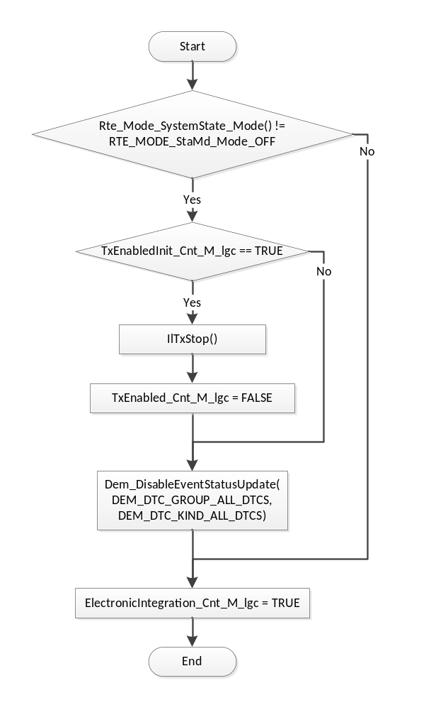

SCOM: SrlComDriver_SCom_ElecIntStOP

Design Rationale
None

Start TX and Enable DEM
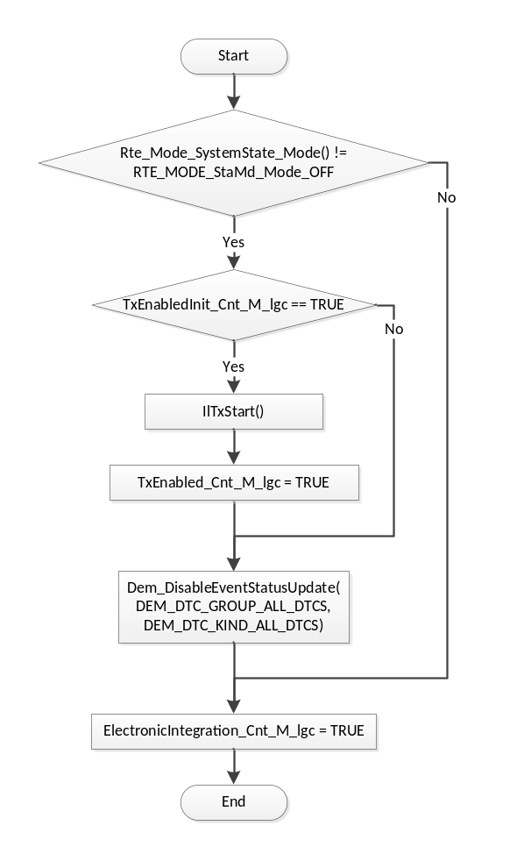

SCOM: SrlComDriver_SCom_GetBusOffCounter

Design Rationale
None

Return Bus Off Counter
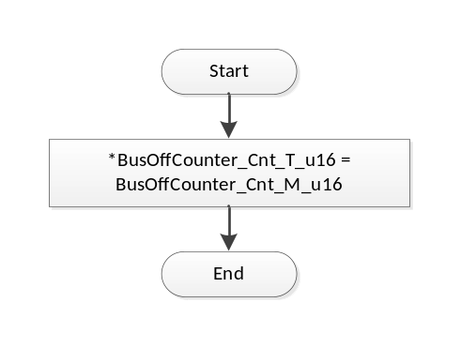

Local Function/Macro Definitions
None

GLObAL Function/Macro Definitions

ApplCanBusOff
Function Name | ApplCanBusOff | Type | Min | Max
Arguments Passed | None | N/A | N/A | N/A
Return Value | None | N/A | N/A | N/A

Description
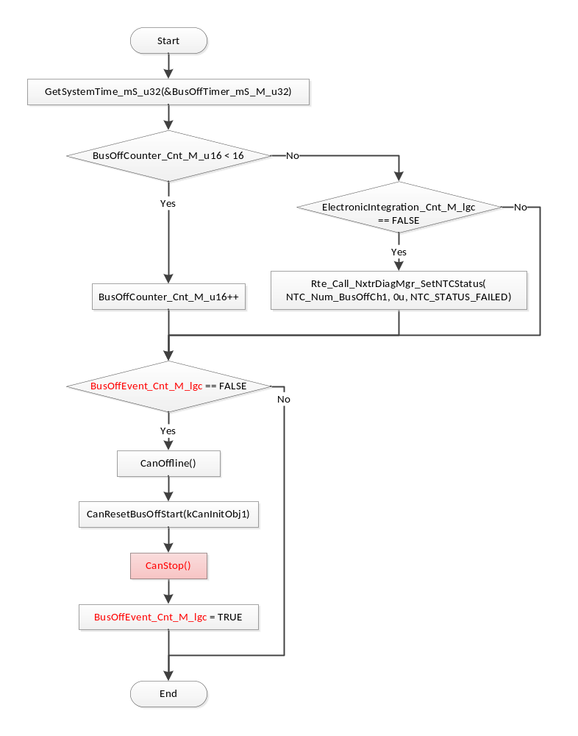

ApplCanMsgDlcFailed
Function Name | ApplCanMsgDlcFailed | Type | Min | Max
Arguments Passed | rxStruct | CanRxInfoStructPtr | N/A | N/A
Return Value | None | N/A | N/A | N/A

Description
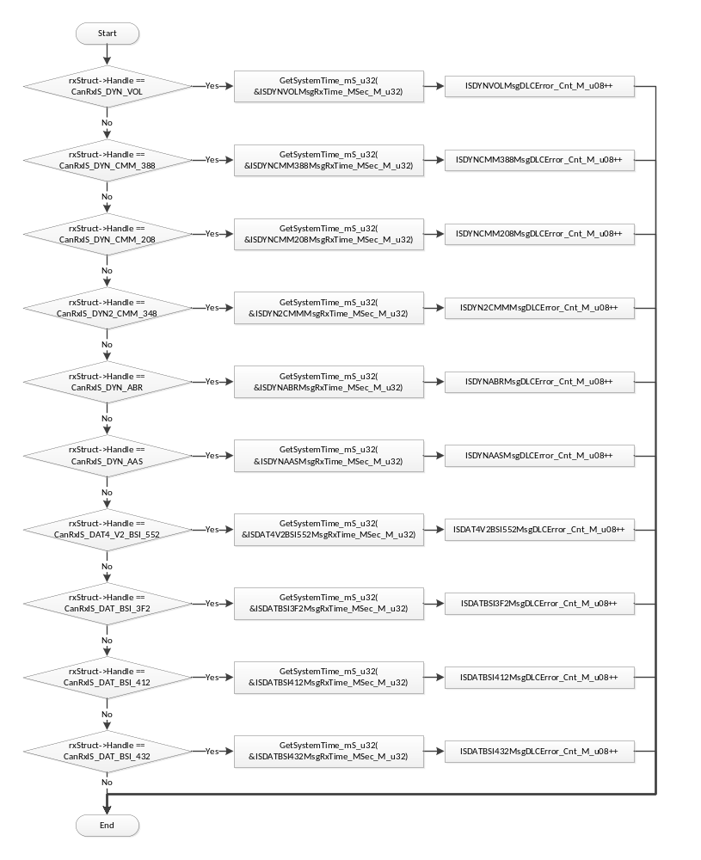

SrlComDriver_PreRxISDYNABR
Function Name | SrlComDriver_PreRxISDYNVOL | Type | Min | Max
Arguments Passed | rxStruct | CanRxInfoStructPtr | N/A | N/A
Return Value | kCanNoCopyData | uint8 | 0 | 1

Description
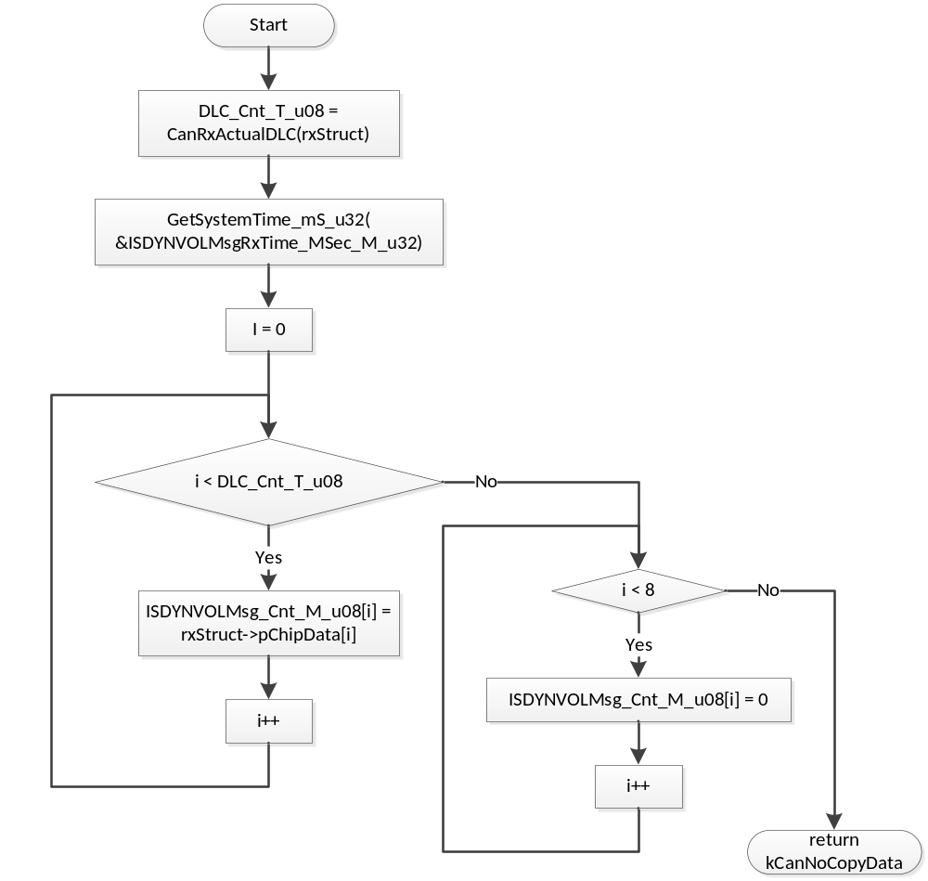

SrlComDriver_RxISDYNCMM388
Function Name | SrlComDriver_RxISDYNCMM388 | Type | Min | Max
Arguments Passed | rcvObject | CanReceiveHandle | N/A | N/A
Return Value | None | N/A | N/A | N/A

Description
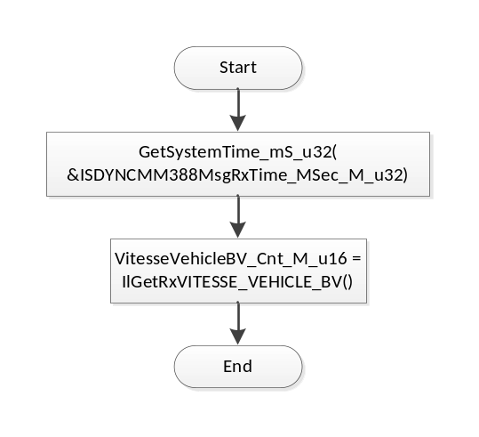

SrlComDriver_RxISDYNCMM208
Function Name | SrlComDriver_RxISDYNCMM208 | Type | Min | Max
Arguments Passed | rcvObject | CanReceiveHandle | N/A | N/A
Return Value | None | N/A | N/A | N/A

Description
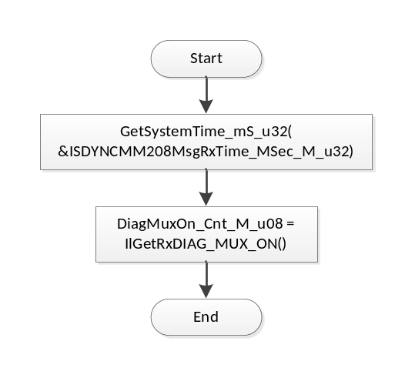

SrlComDriver_RxISDYN2CMM
Function Name | SrlComDriver_RxISDYN2CMM | Type | Min | Max
Arguments Passed | rcvObject | CanReceiveHandle | N/A | N/A
Return Value | None | N/A | N/A | N/A

Description
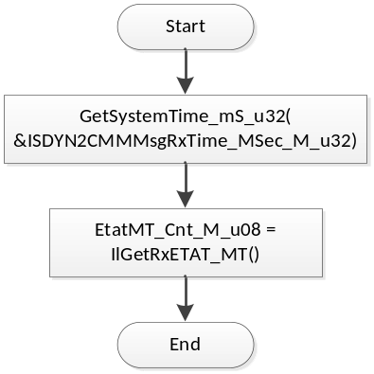

SrlComDriver_PreRxISDYNABR
Function Name | SrlComDriver_PreRxISDYNABR | Type | Min | Max
Arguments Passed | rxStruct | CanRxInfoStructPtr | N/A | N/A
Return Value | kCanNoCopyData | uint8 | 0 | 1

Description
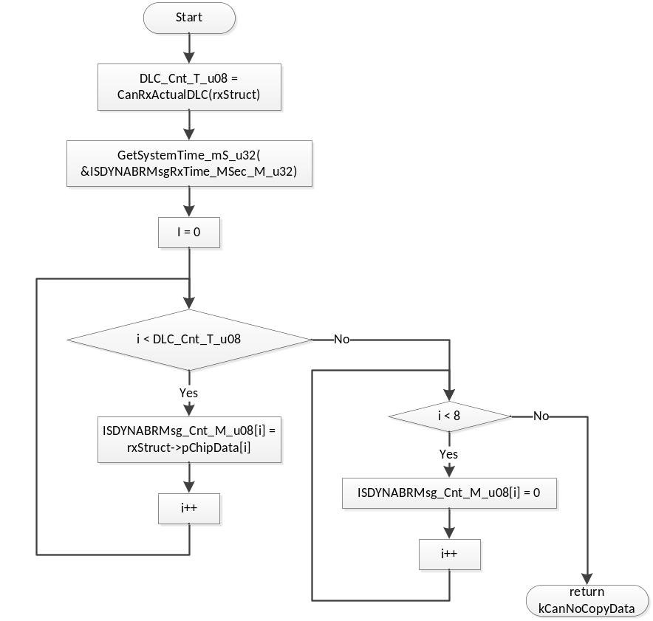

SrlComDriver_PreRxISDYNABR
Function Name | SrlComDriver_PreRxISDYNAAS | Type | Min | Max
Arguments Passed | rxStruct | CanRxInfoStructPtr | N/A | N/A
Return Value | kCanNoCopyData | uint8 | 0 | 1

Description
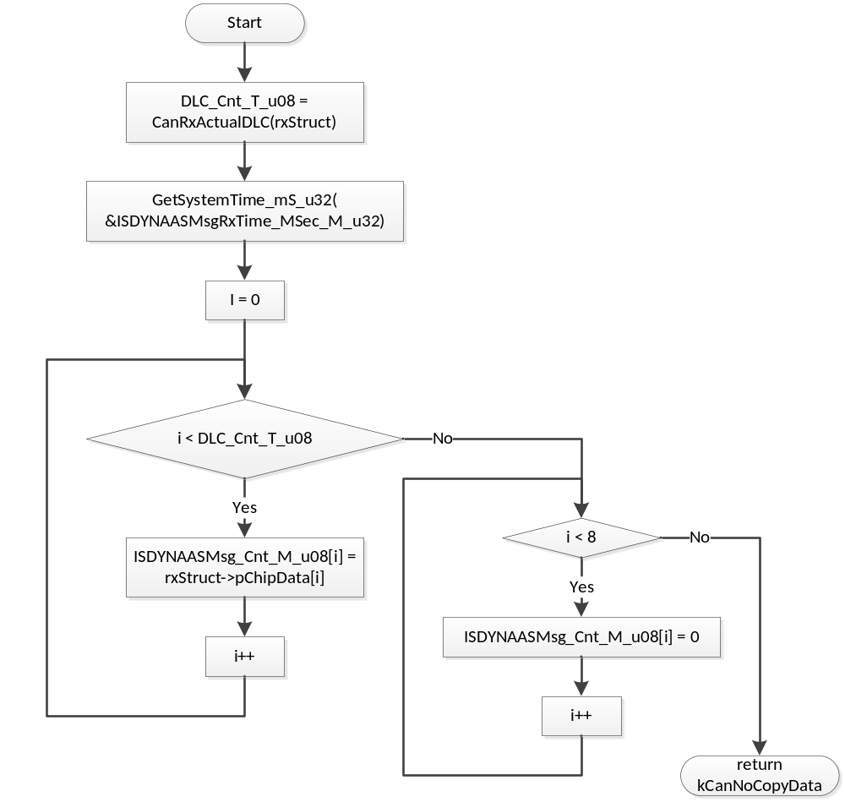

SrlComDriver_PreRxISDAT4V2BSI552
Function Name | SrlComDriver_PreRxISDAT4V2BSI552 | Type | Min | Max
Arguments Passed | rxStruct | CanRxInfoStructPtr | N/A | N/A
Return Value | kCanNoCopyData | uint8 | 0 | 1

Description
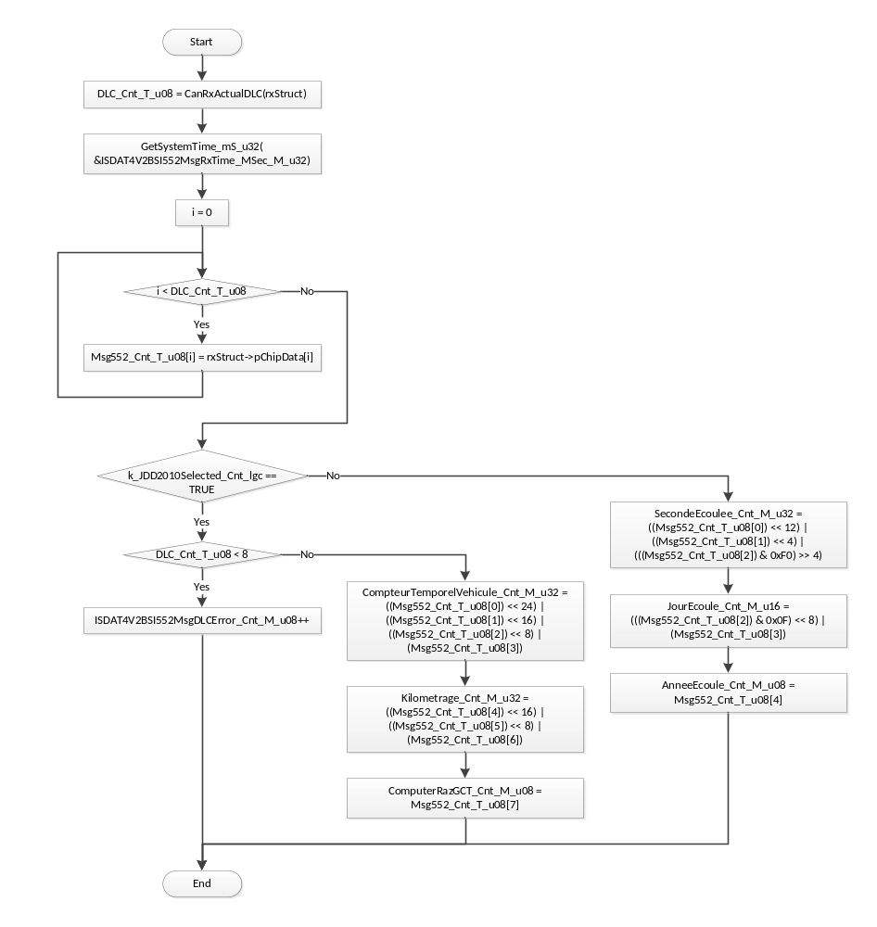

SrlComDriver_RxISDATBSI3F2
Function Name | SrlComDriver_RxISDATBSI3F2 | Type | Min | Max
Arguments Passed | rxStruct | CanReceiveHandle | N/A | N/A
Return Value | None | N/A | N/A | N/A

Description
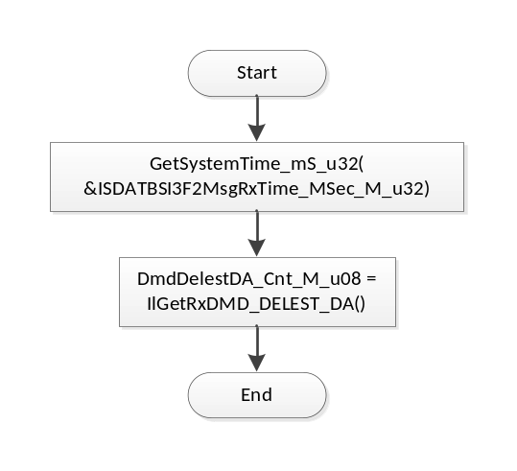

SrlComDriver_RxISDATBSI412
Function Name | SrlComDriver_RxISDATBSI412 | Type | Min | Max
Arguments Passed | rxStruct | CanReceiveHandle | N/A | N/A
Return Value | None | N/A | N/A | N/A

Description
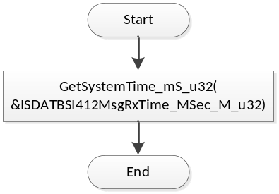

SrlComDriver_RxISDATBSI432
Function Name | SrlComDriver_RxISDATBSI432 | Type | Min | Max
Arguments Passed | rxStruct | CanReceiveHandle | N/A | N/A
Return Value | None | N/A | N/A | N/A

Description
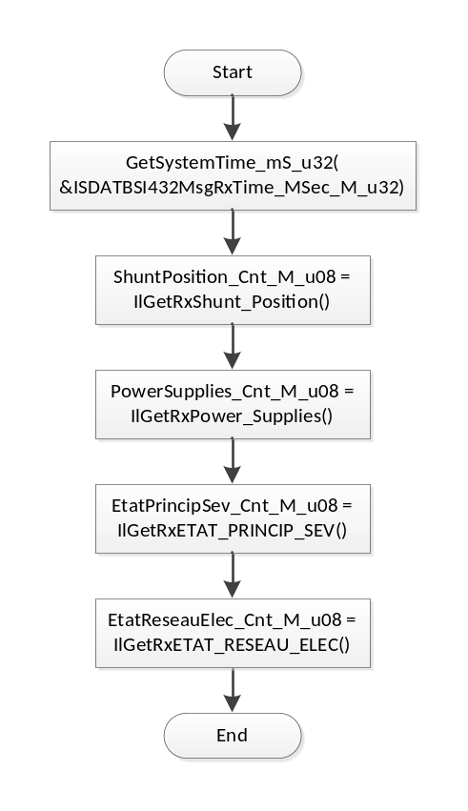

SrlComDriver_PreTxISDATDIRA
Function Name | SrlComDriver_PreTxISDATDIRA | Type | Min | Max
Arguments Passed | ctis | CanTxInfoStruct | N/A | N/A
Return Value | kCanCopyData | uint8 | 0 | 1

Description
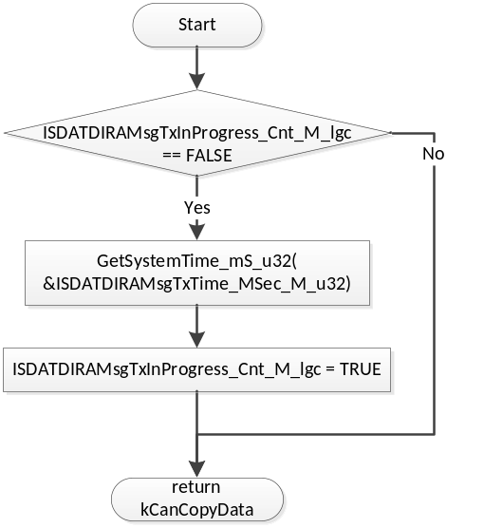

SrlComDriver_TxISDATDIRA
Function Name | SrlComDriver_TxISDATDIRA | Type | Min | Max
Arguments Passed | txObject | CanTransmitHandle | N/A | N/A
Return Value | None | N/A | N/A | N/A

Description
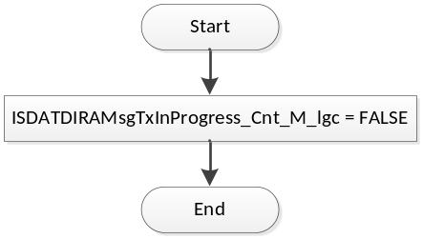

SrlComDriver_PreTxISDYNDAE
Function Name | SrlComDriver_PreTxISDYNDAE | Type | Min | Max
Arguments Passed | ctis | CanTxInfoStruct | N/A | N/A
Return Value | kCanCopyData | uint8 | 0 | 1

Description
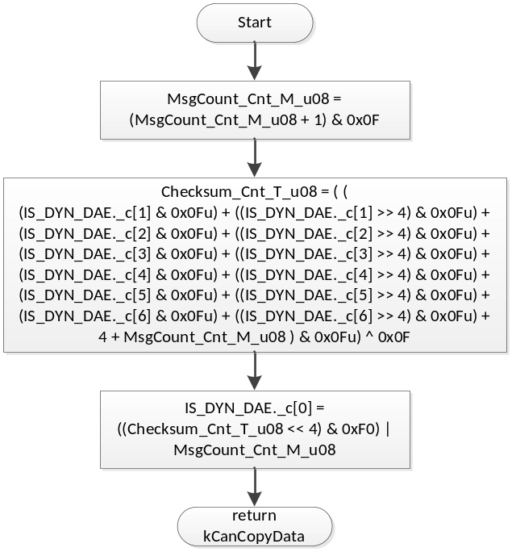

SrlComDriver_TxISDYNDAE
Function Name | SrlComDriver_TxISDYNDAE | Type | Min | Max
Arguments Passed | txObject | CanTransmitHandle | N/A | N/A
Return Value | None | N/A | N/A | N/A

Description
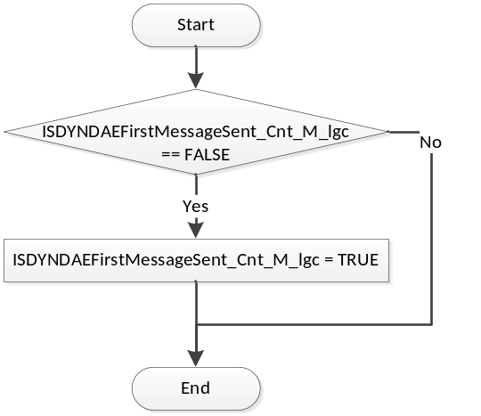

Known Limitations With Design
None

UNIT TEST CONSIDERATION
None

Appendix
None

