Module Design Document
For
SrlComInput

VERSION: 25
DATE: 14-Dec-2015

Revision History

Sl. No. | Description | Author | Version | Date
1 | Initial Version | Muhammed Shameel | 1 | 08-Aug-2014
2 | Updates for new MPU configuration | Owen Tosh | 2 | 09-Sep-2014
3 | Updates for new city park messages | Owen Tosh | 3 | 18-Sep-2014
4 | Fixes found after further review | Owen Tosh | 4 | 19-Sep-2014
5 | Updates for new SCom messages | Owen Tosh | 5 | 30-Sep-2014
6 | Updates for new customer services | Owen Tosh | 6 | 09-Oct-2014
7 | Updates for remaining customer services | Owen Tosh | 7 | 20-Oct-2014
8 | Anomaly fix for HwTrq comparison | Owen Tosh | 8 | 23-Oct-2014
9 | Various anomaly fixes | Owen Tosh | 9 | 30-Oct-2014
10 | Updates for fault logbook | Owen Tosh | 10 | 11-Nov-2014
11 | Updates to elec integration logic | Owen Tosh | 11 | 13-Jan-2015
12 | Various anomaly fixes | Owen Tosh | 12 | 15-Jan-2015
13 | Updates to elec integration logic | Owen Tosh | 13 | 03-Feb-2015
14 | Correction to elec integration logic | Owen Tosh | 14 | 05-Feb-2015
15 | Added 2004 functionality | Owen Tosh | 15 | 1-May-2015
16 | Corrected message 305 checksum logic | Owen Tosh | 16 | 7-Jul-2015
17 | Added condition to VehicleSpeedValid | Owen Tosh | 17 | 10-Jul-2015
18 | Updates for SCIR 003B | Owen Tosh | 18 | 20-Jul-2015
19 | Corrected CPK_OK criteria | Owen Tosh | 19 | 31-Jul-2015
20 | Updates for SCIR 003C | Owen Tosh | 20 | 18-Aug-2015
21 | Updated manual control logic | Owen Tosh | 21 | 24-Sep-2015
22 | Corrected ValidEngine reset conditions | Owen Tosh | 22 | 2-Oct-2015
23 | Set validity counters to zero on invalid DLC | Owen Tosh | 23 | 8-Oct-2015
24 | Updates for anomaly fixes | Owen Tosh | 24 | 23-Nov-2015
25 | Updates for more anomaly fixes | Owen Tosh | 25 | 14-Dec-2015

Table of Contents
1 Abbrevations And Acronyms 6
2 References 7
3 Serial Communications Input & High-Level Description 8
4 Design details of software module 9
4.1 Graphical representation of SrlComInput 9
4.2 Data Flow Diagram 9
4.2.1 Module level DFD 9
4.2.2 Sub-Module level DFD 9
4.3 COMPONENT FLOW DIAGRAM 10
5 Variable Data Dictionary 11
5.1 User defined typedef definition/declaration 11
5.2 Variable definition for enumerated types 11
6 Constant Data Dictionary 12
6.1 Program(fixed) Constants 12
6.1.1 Embedded Constants 12
6.1.1.1 Local 12
6.1.1.2 Global 12
6.1.2 Module specific Lookup Tables Constants 13
6.1.3 Library Functions / Macros 13
6.1.4 Data Hiding Functions 13
7 Software Module Implementation 15
7.1 Initialization Functions 15
7.1.1 Init: SrlComInput_Init 15
7.1.1.1 Design Rationale 15
7.1.1.2 Module Internal 15
7.1.1.3 Module Outputs 15
7.2 PERIODIC FUNCTIONS 16
7.2.1 Per: SrlComInput_Per1 16
7.2.1.1 Design Rationale 16
7.2.1.2 Store Module Inputs to Local copies 16
7.2.1.3 Timer and Cnt Initialization 18
7.2.1.4 SrlCom Message 19
7.2.1.5 diagon Processing 20
7.2.1.6 NTC Enable Criteria Processing 21
7.2.1.7 NTC 101 & 106 PROCESSING 22
7.2.1.8 NTC 102, 104, 108, & 110 PROCESSING 23
7.2.1.9 IS_DYN_VOL Message Handling 24
7.2.1.10 IS_DYN_ABR Message Handling 25
7.2.1.11 IS_DYN_CMM_388 Message Handling 26
7.2.1.12 IS_DYN_AAS Message Handling 27
7.2.1.13 IS_INTE_ELECTRON_BSI Message Handling 28
7.2.1.14 IS_DYN_CMM_208 Message Handling 29
7.2.1.15 IS_DYN2_CMM Message Handling 30
7.2.1.16 IS_DAT_BSI_3F2 Message Handling 31
7.2.1.17 IS_DAT_BSI_412 Message Handling 32
7.2.1.18 IS_DAT_BSI_432 Message Handling 33
7.2.1.19 IS_DAT4_V2_BSI_552 Message Handling 34
7.2.1.20 Serial Com Angle Validity 35
7.2.1.21 Vehicle Speed and Validity 36
7.2.1.22 APA Request 37
7.2.1.23 STTa Determination 38
7.2.1.24 CMM and BSI Info Pertinence 39
7.2.1.25 Vehicle Speed Control 39
7.2.1.26 Store Local copy of outputs into Module Outputs 40
7.3 Interrupt Functions 40
7.4 TRANSIENT FUNCTIONS 41
7.4.1 Trns: SrlComInput_Trns1 41
7.4.1.1 Design Rationale 41
7.4.1.2 Store Module Inputs to Local copies 41
7.4.1.3 Processing of function 41
7.4.1.4 Store Local copy of outputs into Module Outputs 41
7.5 Serial Communication Functions 42
7.5.1 SComm: SrlComInput_SCom_GetNetworkDiagFltAcc 42
7.5.1.1 Design Rationale 42
7.5.1.2 Store Module Inputs to Local copies 42
7.5.1.3 Processing of function 42
7.5.1.4 Store Local copy of outputs into Module Outputs 42
7.5.2 SComm: SrlComInput_SCom_ManualVehSpd 42
7.5.2.1 Design Rationale 42
7.5.2.2 Store Module Inputs to Local copies 42
7.5.2.3 Processing of function 42
7.5.2.4 Store Local copy of outputs into Module Outputs 42
7.5.3 SCOMM: SrlComInput_SCom_ResetTimers 42
7.5.3.1 DESIGN RATIONALE 42
7.5.3.2 STORE MODULE INPUTS TO LOCAL COPIES 43
7.5.3.3 PROCESSING OF FUNCTION 43
7.5.3.4 Store Local copy of outputs into Module Outputs 43
7.5.4 SComm: SrlComInput_SCom_VehSpdControl 43
7.5.4.1 Design Rationale 43
7.5.4.2 Store Module Inputs to Local copies 43
7.5.4.3 Processing of function 43
7.5.4.4 Store Local copy of outputs into Module Outputs 43
7.6 Local Function/Macro Definitions 44
7.6.1 Increment Counter to Threshold (Macro) 44
7.6.1.1 Description 44
7.6.2 Node ABsent NTC Processing 45
7.6.2.1 Description 45
7.6.3 Missing Message NTC Processing 46
7.6.3.1 Description 46
7.6.4 Validity NTC Processing 47
7.6.4.1 Description 47
7.6.5 Mixed Time Validity NTC Processing 48
7.6.5.1 Description 48
7.6.6 Reset Fault Accumulator 49
7.6.6.1 Description 49
7.7 GLObAL Function/Macro Definitions 49
8 Known Limitations With Design 50
9 UNIT TEST CONSIDERATION 51
10 Appendix 52

Abbrevations And Acronyms
Abbreviation | Description
DFD | Design functional diagram
MDD | Module design Document

References
This section Lists the title & version of all the documents that are referred for development of this document
Sr. No. | Title | Version
1 | MDD Guidelines | 1
2 | Software Naming Conventions | 1
3 | Coding standands | 1
4 | PSA BMPV SCIR | 003F

Serial Communications Input & High-Level Description

The Serial Communications Input module provides signal processing between the application layer and the serial communications software. This module will be responsible for converting the range and resolution of the associated serial communications signals to the range and resolution of the Application Layer variables, as well as handling NTCs related to serial communications.

This module processes the data for signals that are received by the EPS controller from other ECUs on the communication bus. Serial Communications signal input data is scaled appropriately and then transferred to the global application data for use by the EPS application software.

Design details of software module

Graphical representation of SrlComInput
None

Data Flow Diagram
None

Module level DFD
None

Sub-Module level DFD
None

COMPONENT FLOW DIAGRAM
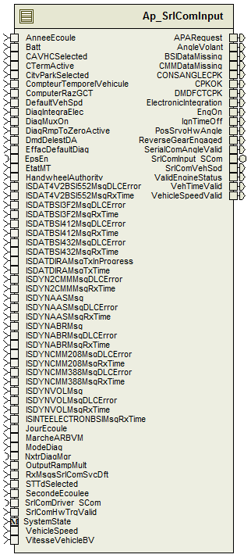
Figure 1: SrlComInput Component Diagram

Variable Data Dictionary

User defined typedef definition/declaration
Typedef Name | Element Name | User Defined Type | Legal Range  (min) | Legal Range  (max)
None

Variable definition for enumerated types
Enum Name | Element Name | Value
None

Constant Data Dictionary

Program(fixed) Constants

Embedded Constants

Local
Constant Name | Resolution | Units | Value
D_ISDYNVOLMSGTIMEOUT_MS_U16 | 1 | mS | 11
D_ISDYNABRMSGTIMEOUT_MS_U16 | 1 | mS | 44
D_ISDYNCMMMSGTIMEOUT_MS_U16 | 1 | mS | 44
D_ISDYNAASMSGTIMEOUT_MS_U16 | 1 | mS | 22
D_ISDYNCMM208MSGTIMEOUT_MS_U16 | 1 | mS | 11
D_ISDYN2CMMMSGTIMEOUT_MS_U16 | 1 | mS | 22
D_ISDATBSI3F2MSGTIMEOUT_MS_U16 | 1 | mS | 55
D_ISDATBSI412MSGTIMEOUT_MS_U16 | 1 | mS | 55
D_ISDATBSI432MSGTIMEOUT_MS_U16 | 1 | mS | 55
D_ISDAT4V2BSI552MSGTIMEOUT_MS_U16 | 1 | mS | 1100
D_TESTFAILED_CNT_U08 | 1 | Count | 0
D_TESTPASSED_CNT_U08 | 1 | Count | 1
D_ANGLEVOLANTSCALE_HWDEGPCNT_F32 | Single Precision Float | HwDeg/Cnt | 0.1
D_ANGLEVOLANTPOL_CNT_F32 | Single Precision Float | Count | -1
D_ANGLEVOLANTVALIDLO_CNT_U16 | 1 | Count | 0x1E78
D_ANGLEVOLANTVALIDHI_CNT_U16 | 1 | Count | 0xE188
D_VEHSPDSCALE_CNT_F32 | Single Precision Float | count | 0.01
D_CONSANGLECPKSCALE_CNT_F32 | Single Precision Float | count | 0.1
D_CONSANGLECPKPOL_CNT_F32 | Single Precision Float | Count | -1
D_CONSANGLECPKVALIDLO_CNT_U16 | 1 | Count | 0x1E78
D_CONSANGLECPKVALIDHI_CNT_U16 | 1 | Count | 0xE188
D_ELECINTCONSECMSGS_CNT_U08 | 1 | Count | 2
D_ELECINTCONSECTIMEOUT_MS_U16 | 1 | mS | 1000
D_COMPUTERRAZGCTINVALID_CNT_U08 | 1 | Count | 0xFF
D_COMPTEURTEMPORELVEHICULEINVALID_CNT_U32 | 1 | Count | 0xFFFFFFFF
D_ANNEEECOULEINVALID_CNT_U08 | 1 | Count | 0xFF
D_JOURECOULEINVALID_CNT_U16 | 1 | Count | 0x0FFF
D_SECONDEECOULEEINVALID_CNT_U32 | 1 | Count | 0x000FFFFF
D_SECONDSPERYEAR_CNT_U32 | 1 | Count | 31536000
D_SECONDSPERDAY_CNT_U32 | 1 | Count | 86400

Global
Constant Name
RTE_MODE_StaMd_Mode_WARMINIT
RTE_MODE_StaMd_Mode_OPERATE
RTE_MODE_StaMd_Mode_DISABLE
kETAT_MT_Cut
kETAT_MT_Starting
kETAT_MT_Engine_Running
kETAT_MT_Stopped
kETAT_MT_Driven_Restart
kETAT_MT_Autonomous_Restart
kETAT_MT_Degraded_Restart
kETAT_MT_Engine_Preparing
kETAT_MT_Autonomous_Starting
kDIAG_MUX_ON_Enable_SCom_Diagnostics
kVITESSE_VEHICULE_ROUES_Invalid
kETAT_DAE_CPK_Unavailable
kETAT_DAE_CPK_Available
kETAT_DAE_CPK_Control_In_Progress
kETAT_DAE_CPK_Invalid
kDMD_FCT_CPK_SCP9_Control_Request
kDMD_FCT_CPK_SCP6_Control_Request
kMARCHE_AR_BVM_Reverse_Gear_Engaged
kDMD_RELAXE_CPK_Relaxe_Request
kDMD_RELAXE_CPK_Reserved
kDMD_RELAXE_CPK_Invalid
kDMD_FCT_CPK_Invalid
kCONS_ANGLE_CPK_Invalid
kANGLE_VOLANT_Invalid
kVITESSE_ROT_VOL_Invalid
kVITESSE_VEHICLE_BV_Invalid
kMODE_DIAG_Operation_and_Comm_Inhibited
kDIAG_INTEGRA_ELEC_No_Frame_Transmission
kMODE_DIAG_No_Particular_Operation
kDIAG_INTEGRA_ELEC_No_Particular_Operation
kEFFAC_DEFAULT_DIAG_Default_Memory_Erase
kDMD_DELEST_DA_Power_Cut_Request
DEM_DTC_GROUP_ALL_DTCS
DEM_DTC_KIND_ALL_DTCS
DEM_DTC_ORIGIN_PRIMARY_MEMORY
DEM_DTC_PENDING

Module specific Lookup Tables Constants
Constant Name | Resolution | Value | Software Segment
None

Library Functions / Macros
None

Data Hiding Functions
Rte_Call_SystemTime_GetSystemTime_mS_u32()
Rte_Call_NxtrDiagMgr_GetNTCFailed()
Rte_Call_SystemTime_DtrmnElapsedTime_mS_u16()
Rte_Call_NxtrDiagMgr_SetNTCStatus()
Rte_Call_NxtrDiagMgr_GetNTCFailed()
Rte_Call_VHHTYPE_WriteBlock()
Rte_Call_SrlComDriver_SCom_ElecIntStart()
Rte_Call_SrlComDriver_SCom_ElecIntStop()
Rte_Pim_VVHTYPEData()
Rte_Pim_ElecIntData()
Rte_Pim_ShutdownTimeData()
NtWrapC_Dem_ClearDTC

Software Module Implementation

Initialization Functions

Init: SrlComInput_Init

Design Rationale
None

Module Internal
Rte_Call_SystemTime_GetSystemTime_mS_u32(&SystemTime_mS_T_u32)
EngOnAbsentTimer_mS_M_u32 = SystemTime_mS_T_u32
PrevEtatMT_Cnt_M_u08 = kETAT_MT_Cut
CMMNTCEnableTimer_mS_M_u32 = SystemTime_mS_T_u32
CMM388NTCEnableTimer_mS_M_u32 = SystemTime_mS_T_u32
ESPNTCEnableTimer_mS_M_u32 = SystemTime_mS_T_u32
BSI412NTCEnableTimer_mS_M_u32 = SystemTime_mS_T_u32
BSI552NTCEnableTimer_mS_M_u32 = SystemTime_mS_T_u32
BSI3F2NTCEnableTimer_mS_M_u32 = SystemTime_mS_T_u32
BSI432NTCEnableTimer_mS_M_u32 = SystemTime_mS_T_u32
ISDATDIRASentTimer_mS_M_u32 = SystemTime_mS_T_u32
ResetFltAcc(&ISDATDIRASentFltAcc_Cnt_M_u16, k_ISDATDIRASentDiag_Cnt_str, NTC_Num_BusOffCh1NodeMute)
ESPNodeAbsentTimer_mS_M_u32 = SystemTime_mS_T_u32
ResetFltAcc(&ESPNodeAbsentFltAcc_Cnt_M_u16, k_ESPNodeAbsentDiag_Cnt_str, NTC_Num_Node1BAbsent)
BSINodeAbsentTimer_mS_M_u32 = SystemTime_mS_T_u32
ResetFltAcc(&BSINodeAbsentFltAcc_Cnt_M_u16, k_BSINodeAbsentDiag_Cnt_str, NTC_Num_Node1CAbsent)
CMMNodeAbsentTimer_mS_M_u32 = SystemTime_mS_T_u32
ResetFltAcc(&CMMNodeAbsentFltAcc_Cnt_M_u16, k_CMMNodeAbsentDiag_Cnt_str, NTC_Num_Node1AAbsent)
CAVNodeAbsentTimer_mS_M_u32 = SystemTime_mS_T_u32
ResetFltAcc(&CAVNodeAbsentFltAcc_Cnt_M_u16, k_CAVNodeAbsentDiag_Cnt_str, NTC_Num_Node1DAbsent)
AASNodeAbsentTimer_mS_M_u32 = SystemTime_mS_T_u32
ResetFltAcc(&AASNodeAbsentFltAcc_Cnt_M_u16, k_AASNodeAbsentDiag_Cnt_str, NTC_Num_Node1EAbsent)
ISDYNVOLMsgTimer_mS_M_u32 = SystemTime_mS_T_u32
ISDYNAASMsgTimer_mS_M_u32 = SystemTime_mS_T_u32
ISDYNABRMsgTimer_mS_M_u32 = SystemTime_mS_T_u32
ISDYNCMM208MsgTimer_mS_M_u32 = SystemTime_mS_T_u32
ISDYNCMM388MsgTimer_mS_M_u32 = SystemTime_mS_T_u32
ISDYN2CMMMsgTimer_mS_M_u32 = SystemTime_mS_T_u32
ISDAT4V2BSI552MsgTimer_mS_M_u32 = SystemTime_mS_T_u32
ISDATBSI3F2MsgTimer_mS_M_u32 = SystemTime_mS_T_u32
ISDATBSI412MsgTimer_mS_M_u32 = SystemTime_mS_T_u32
ISDATBSI432MsgTimer_mS_M_u32 = SystemTime_mS_T_u32
DmdDelestDATimer_mS_M_u32 = SystemTime_mS_T_u32
CompteurTemporelVehiculeSigInvalidTimer_mS_M_u32 = SystemTime_mS_T_u32
ComputerRazGCTSigInvalidTimer_mS_M_u32 = SystemTime_mS_T_u32
DiagMuxOnAbsentTimer_mS_M_u32 = SystemTime_mS_T_u32
IgnOnTimer_mS_M_u32 = SystemTime_mS_T_u32
BattOk_Cnt_M_lgc = TRUE
ElectronicIntegrationCmd_Cnt_M_lgc = *Rte_Pim_ElecIntData()
CPKVehicleSpeedMsgTimer_mS_M_u32 = SystemTime_mS_T_u32
AngleVolantMsgTimer_mS_M_u32 = SystemTime_mS_T_u32
CityParkInputMsgTimer_mS_M_u32 = SystemTime_mS_T_u32

Clear NTCs
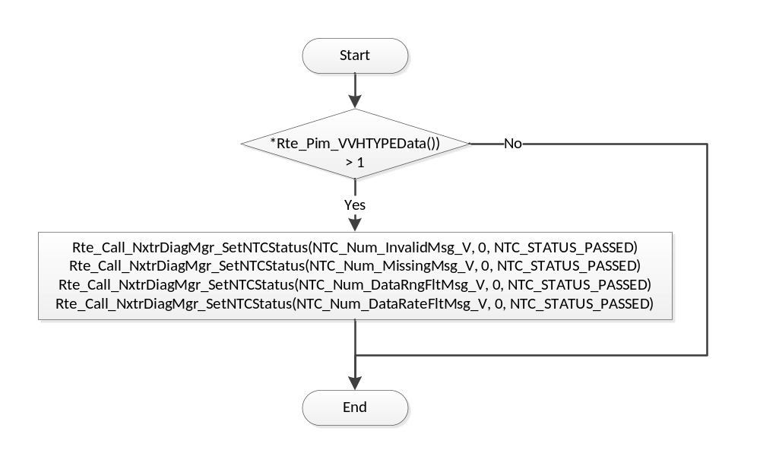

Module Outputs
Rte_IWrite_SrlComInput_Init_ElectronicIntegration_Cnt_lgc(*Rte_Pim_ElecIntData())

PERIODIC FUNCTIONS

Per: SrlComInput_Per1

Design Rationale
None

Store Module Inputs to Local copies
AnneeEcoule_Cnt_T_u08 = Rte_IRead_SrlComInput_Per1_AnneeEcoule_Cnt_u08()
Batt_Volt_T_f32 = Rte_IRead_SrlComInput_Per1_Batt_Volt_f32()
BusOffCh1_Cnt_T_lgc = Rte_IRead_SrlComInput_Per1_BusOff_Cnt_lgc()
CAVHCSelected_Cnt_T_lgc = Rte_IRead_SrlComInput_Per1_CAVHCSelected_Cnt_lgc()
CTermActive_Cnt_T_lgc = Rte_IRead_SrlComInput_Per1_CTermActive_Cnt_lgc()
CityParkSelected_Cnt_T_lgc = Rte_IRead_SrlComInput_Per1_CityParkSelected_Cnt_lgc()
CompteurTemporelVehicule_Cnt_T_u32 = Rte_IRead_SrlComInput_Per1_CompteurTemporelVehicule_Cnt_u32()
ComputerRazGCT_Cnt_T_u08 = Rte_IRead_SrlComInput_Per1_ComputerRazGCT_Cnt_u08()
DefaultVehSpd_Cnt_T_lgc = Rte_IRead_SrlComInput_Per1_DefaultVehSpd_Cnt_lgc()
DiagIntegraElec_Cnt_T_u08 = Rte_IRead_SrlComInput_Per1_DiagIntegraElec_Cnt_u08()
DiagMuxOn_Cnt_T_u08 = Rte_IRead_SrlComInput_Per1_DiagMuxOn_Cnt_u08()
DiagRmpToZeroActive_Cnt_T_lgc = Rte_IRead_SrlComInput_Per1_DiagRmpToZeroActive_Cnt_lgc()
DmdDelestDA_Cnt_T_u08 = Rte_IRead_SrlComInput_Per1_DmdDelestDA_Cnt_u08()
EffacDefaultDiag_Cnt_T_u08 = Rte_IRead_SrlComInput_Per1_EffacDefaultDiag_Cnt_u08()
EtatMT_Cnt_T_u08 = Rte_IRead_SrlComInput_Per1_EtatMT_Cnt_u08()
HandwheelAuthority_Uls_T_f32 = Rte_IRead_SrlComInput_Per1_HandwheelAuthority_Uls_f32()
ISDAT4V2BSI552MsgDLCError_Cnt_T_u08 = Rte_IRead_SrlComInput_Per1_ISDAT4V2BSI552MsgDLCError_Cnt_u08()
ISDAT4V2BSI552MsgRxTime_MSec_T_u32 = Rte_IRead_SrlComInput_Per1_ISDAT4V2BSI552MsgRxTime_MSec_u32()
ISDATBSI3F2MsgDLCError_Cnt_T_u08 = Rte_IRead_SrlComInput_Per1_ISDATBSI3F2MsgDLCError_Cnt_u08()
ISDATBSI3F2MsgRxTime_MSec_T_u32 = Rte_IRead_SrlComInput_Per1_ISDATBSI3F2MsgRxTime_MSec_u32()
ISDATBSI412MsgDLCError_Cnt_T_u08 = Rte_IRead_SrlComInput_Per1_ISDATBSI412MsgDLCError_Cnt_u08()
ISDATBSI412MsgRxTime_MSec_T_u32 = Rte_IRead_SrlComInput_Per1_ISDATBSI412MsgRxTime_MSec_u32()
ISDATBSI432MsgDLCError_Cnt_T_u08 = Rte_IRead_SrlComInput_Per1_ISDATBSI432MsgDLCError_Cnt_u08()
ISDATBSI432MsgRxTime_MSec_T_u32 = Rte_IRead_SrlComInput_Per1_ISDATBSI432MsgRxTime_MSec_u32()
ISDATDIRAMsgTxInProgress_Cnt_T_lgc = Rte_IRead_SrlComInput_Per1_ISDATDIRAMsgTxInProgress_Cnt_lgc()
ISDATDIRAMsgTxTime_MSec_T_u32 = Rte_IRead_SrlComInput_Per1_ISDATDIRAMsgTxTime_MSec_u32()
ISDYN2CMMMsgDLCError_Cnt_T_u08 = Rte_IRead_SrlComInput_Per1_ISDYN2CMMMsgDLCError_Cnt_u08()
ISDYN2CMMMsgRxTime_MSec_T_u32 = Rte_IRead_SrlComInput_Per1_ISDYN2CMMMsgRxTime_MSec_u32()
ISDYNAASMsgDLCError_Cnt_T_u08 = Rte_IRead_SrlComInput_Per1_ISDYNAASMsgDLCError_Cnt_u08()
ISDYNAASMsgRxTime_MSec_T_u32 = Rte_IRead_SrlComInput_Per1_ISDYNAASMsgRxTime_MSec_u32()
for( i = 0 to 7 )
{
ISDYNAASMsg_Cnt_T_u08[i] =Rte_IRead_SrlComInput_Per1_ISDYNAASMsg_Cnt_u08[i]
}
ISDYNABRMsgDLCError_Cnt_T_u08 = Rte_IRead_SrlComInput_Per1_ISDYNABRMsgDLCError_Cnt_u08()
ISDYNABRMsgRxTime_MSec_T_u32 = Rte_IRead_SrlComInput_Per1_ISDYNABRMsgRxTime_MSec_u32()
for( i = 0 to 7 )
{
ISDYNABRMsg_Cnt_T_u08[i] =Rte_IRead_SrlComInput_Per1_ISDYNABRMsg_Cnt_u08[i]
}
ISDYNCMM208MsgDLCError_Cnt_T_u08 = Rte_IRead_SrlComInput_Per1_ISDYNCMM208MsgDLCError_Cnt_u08()
ISDYNCMM208MsgRxTime_MSec_T_u32 = Rte_IRead_SrlComInput_Per1_ISDYNCMM208MsgRxTime_MSec_u32()
ISDYNCMM388MsgDLCError_Cnt_T_u08 = Rte_IRead_SrlComInput_Per1_ISDYNCMM388MsgDLCError_Cnt_u08()
ISDYNCMM388MsgRxTime_MSec_T_u32 = Rte_IRead_SrlComInput_Per1_ISDYNCMM388MsgRxTime_MSec_u32()
ISDYNVOLMsgDLCError_Cnt_T_u08 = Rte_IRead_SrlComInput_Per1_ISDYNVOLMsgDLCError_Cnt_u08()
ISDYNVOLMsgRxTime_MSec_T_u32 = Rte_IRead_SrlComInput_Per1_ISDYNVOLMsgRxTime_MSec_u32()
for( i = 0 to 7 )
{
ISDYNVOLMsg_Cnt_T_u08[i] =Rte_IRead_SrlComInput_Per1_ISDYNVOLMsg_Cnt_u08[i]
}
ISINTEELECTRONBSIMsgRxTime_MSec_T_u32 = Rte_IRead_SrlComInput_Per1_ISINTEELECTRONBSIMsgRxTime_MSec_u32()
JourEcoule_Cnt_T_u16 = Rte_IRead_SrlComInput_Per1_JourEcoule_Cnt_u16()
MarcheARBVM_Cnt_T_u08 = Rte_IRead_SrlComInput_Per1_MarcheARBVM_Cnt_u08()
ModeDiag_Cnt_T_u08 = Rte_IRead_SrlComInput_Per1_ModeDiag_Cnt_u08()
OutputRampMult_Uls_T_f32 = Rte_IRead_SrlComInput_Per1_OutputRampMult_Uls_f32()
RxMsgsSrlComSvcDft_Cnt_M_lgc = Rte_IRead_SrlComInput_Per1_RxMsgsSrlComSvcDft_Cnt_lgc()
STTdSelected_Cnt_T_lgc = Rte_IRead_SrlComInput_Per1_STTdSelected_Cnt_lgc()
SecondeEcoulee_Cnt_T_u32 = Rte_IRead_SrlComInput_Per1_SecondeEcoulee_Cnt_u32()
SrlComHwTrqValid_Cnt_T_lgc = Rte_IRead_SrlComInput_Per1_SrlComHwTrqValid_Cnt_lgc()
VehicleSpeed_Kph_T_f32 = Rte_IRead_SrlComInput_Per1_VehicleSpeed_Kph_f32()
VitesseVehicleBV_Cnt_T_u16 = Rte_IRead_SrlComInput_Per1_VitesseVehicleBV_Cnt_u16()
SystemState_Cnt_T_enum = Rte_Mode_SystemState_Mode()
ElectronicIntegration_Cnt_T_lgc = *Rte_Pim_ElecIntData()
VVHTYPE_Cnt_T_u08 = *Rte_Pim_VVHTYPEData()
Rte_Call_EpsEn_OP_GET(&EpsEn_Cnt_T_lgc)
Rte_Call_NxtrDiagMgr_GetNTCFailed(NTC_Num_EEPROMCloseFailed, &EEPROMCloseFailed_Cnt_T_lgc)

Rte_Call_SystemTime_GetSystemTime_mS_u32(&SystemTime_mS_T_u32)

Timer and Cnt Initialization
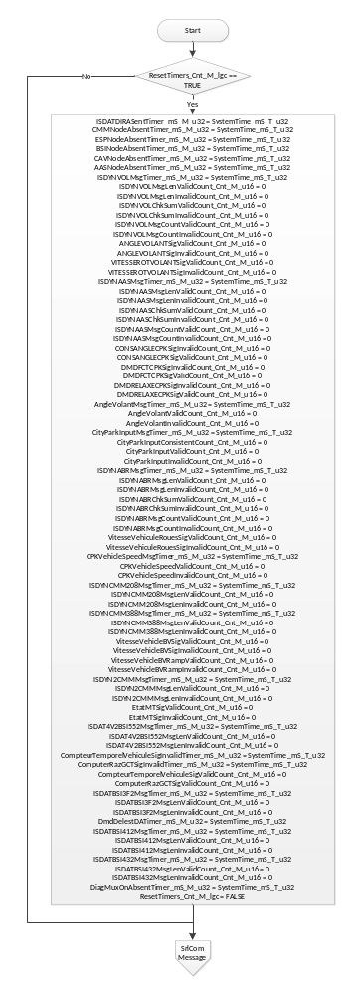
Flowchart 1: Timer and Cnt Init

SrlCom Message
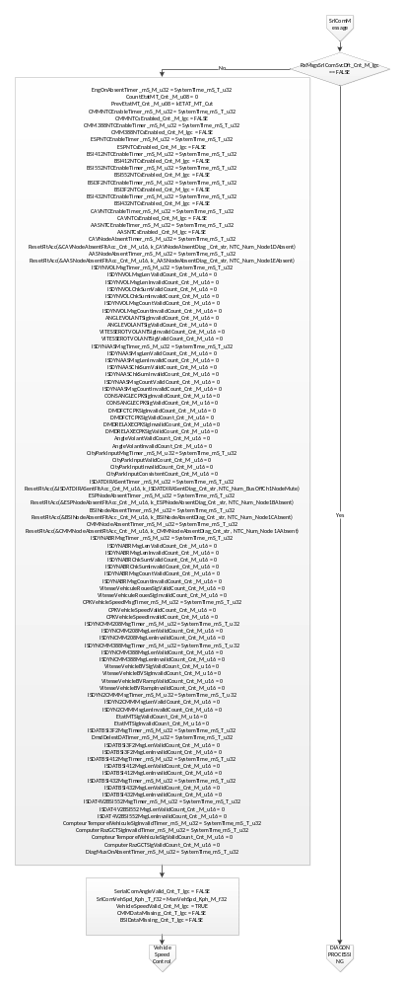
Flowchart 2: SrlComMsg

diagon Processing
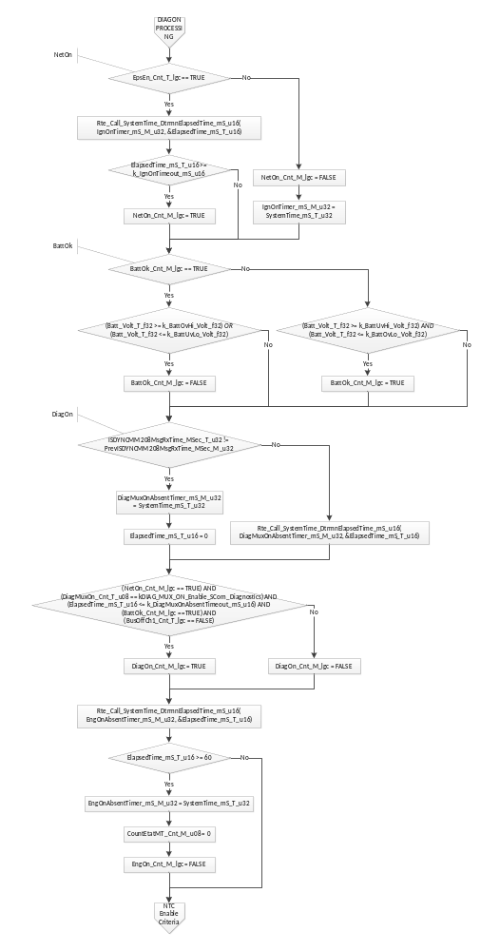
Flowchart 3: DiagOn Processing

NTC Enable Criteria Processing
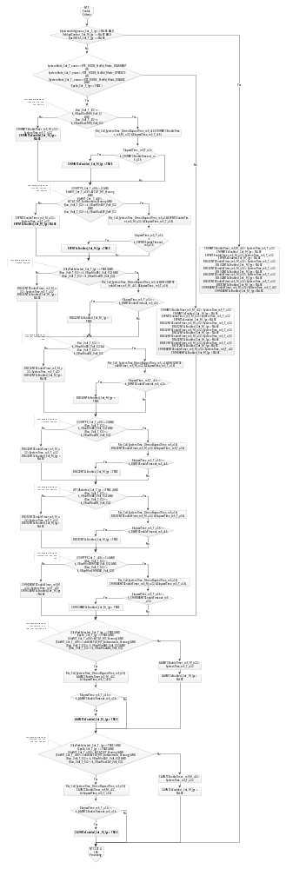
Flowchart 4: NTC Enable Criteria

NTC 101 & 106 PROCESSING
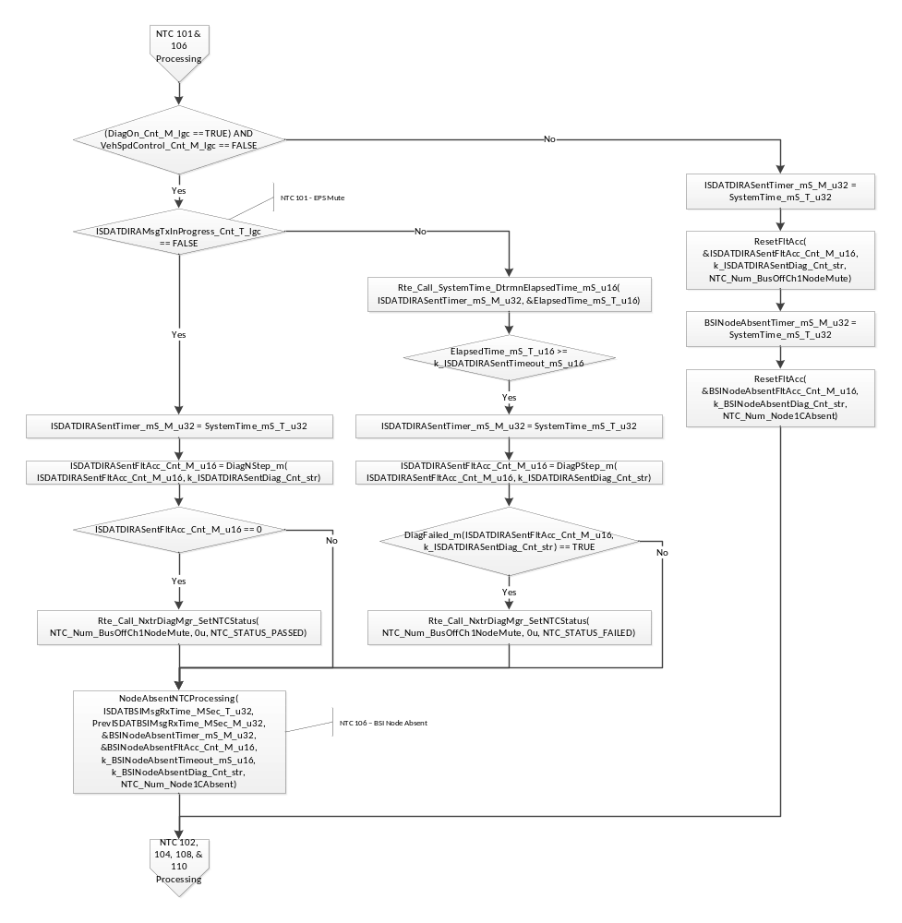
Flowchart 5: NTC 101 & 106

NTC 102, 104, 108, & 110 PROCESSING
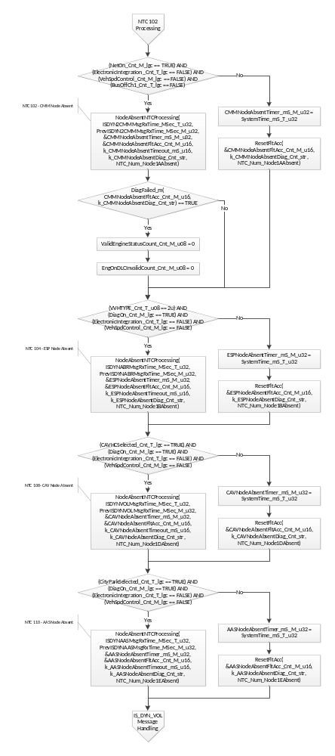
Flowchart 6:NTC 102 & 108 & 110 PROCESSING

IS_DYN_VOL Message Handling
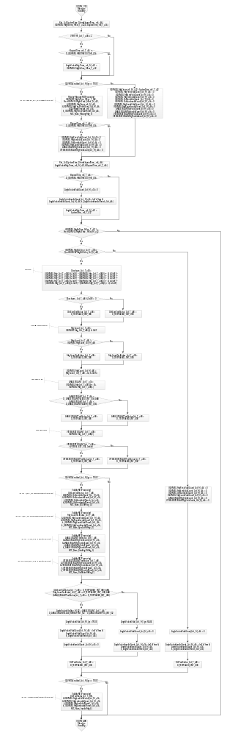
Flowchart 7: IS_DYN_VOL Message Handling

IS_DYN_ABR Message Handling
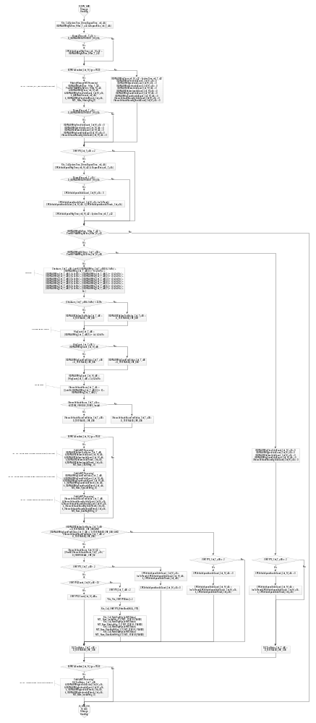
Flowchart 8: IS_DYN_ABR Message Handling

IS_DYN_CMM_388 Message Handling
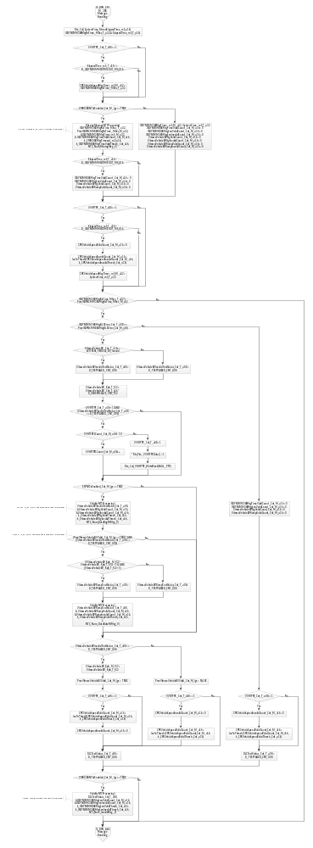
Flowchart 9: IS_DYN_CMM_388 Message Handling

IS_DYN_AAS Message Handling
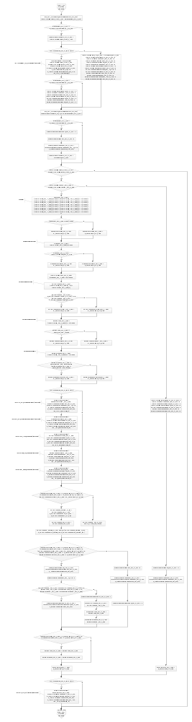
Flowchart 10: IS_DYN_AAS Message Handling

IS_INTE_ELECTRON_BSI Message Handling
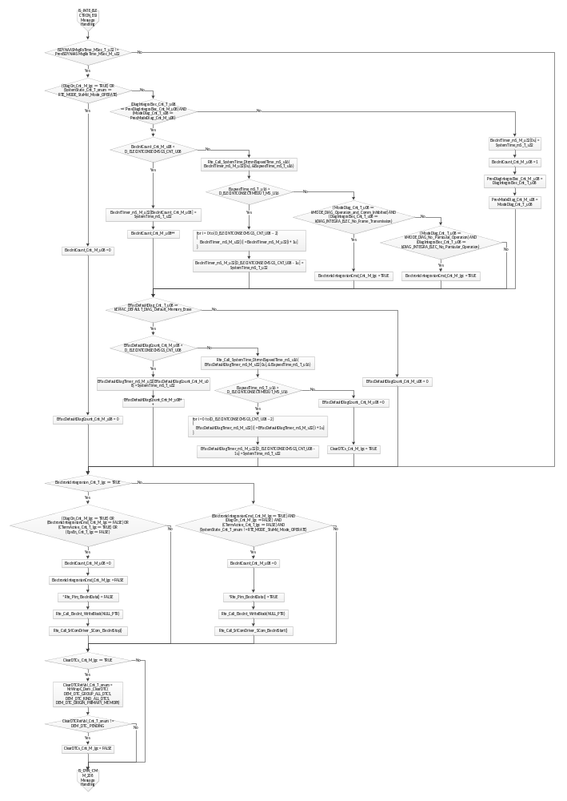
Flowchart 11: IS_INTE_ELECTRON_BSI Message Handling

IS_DYN_CMM_208 Message Handling
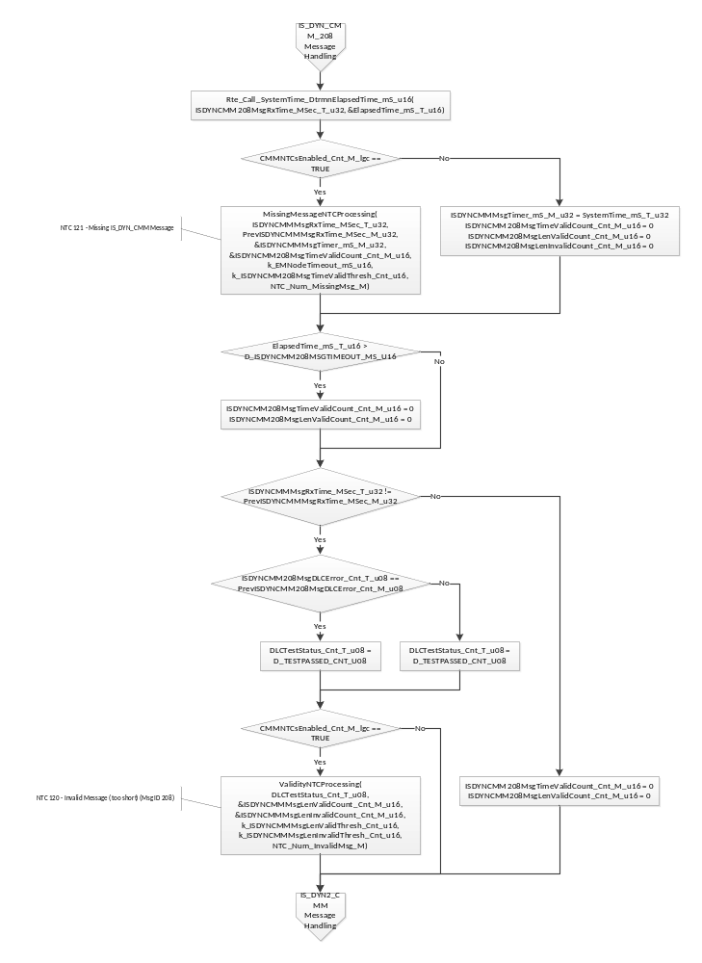
Flowchart 12: IS_DYN_CMM_208 Message Handling

IS_DYN2_CMM Message Handling
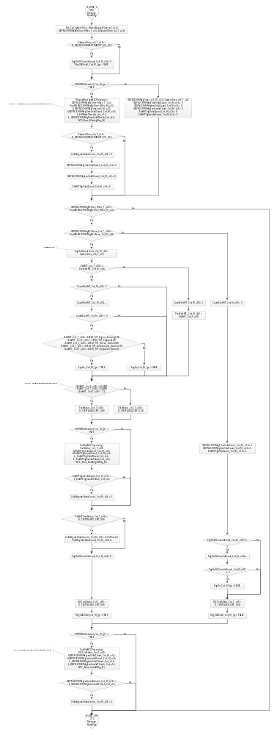
Flowchart 13: IS_DYN2_CMM Message Handling

IS_DAT_BSI_3F2 Message Handling
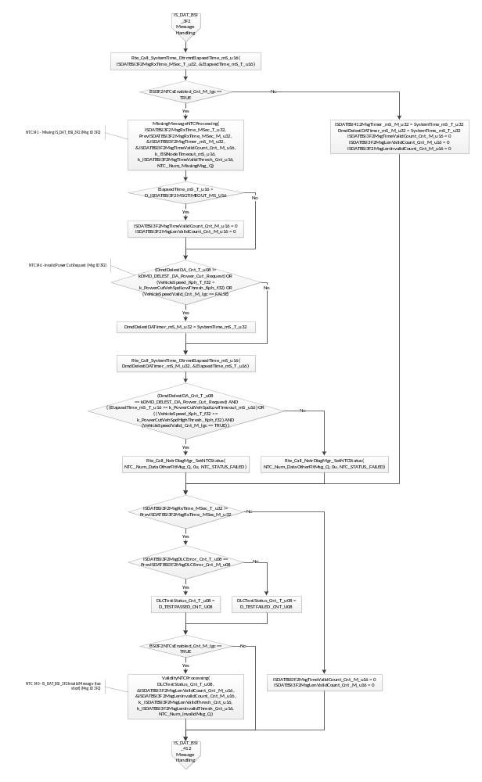
Flowchart 14: IS_DAT_BSI_3F2 Message Handling

IS_DAT_BSI_412 Message Handling
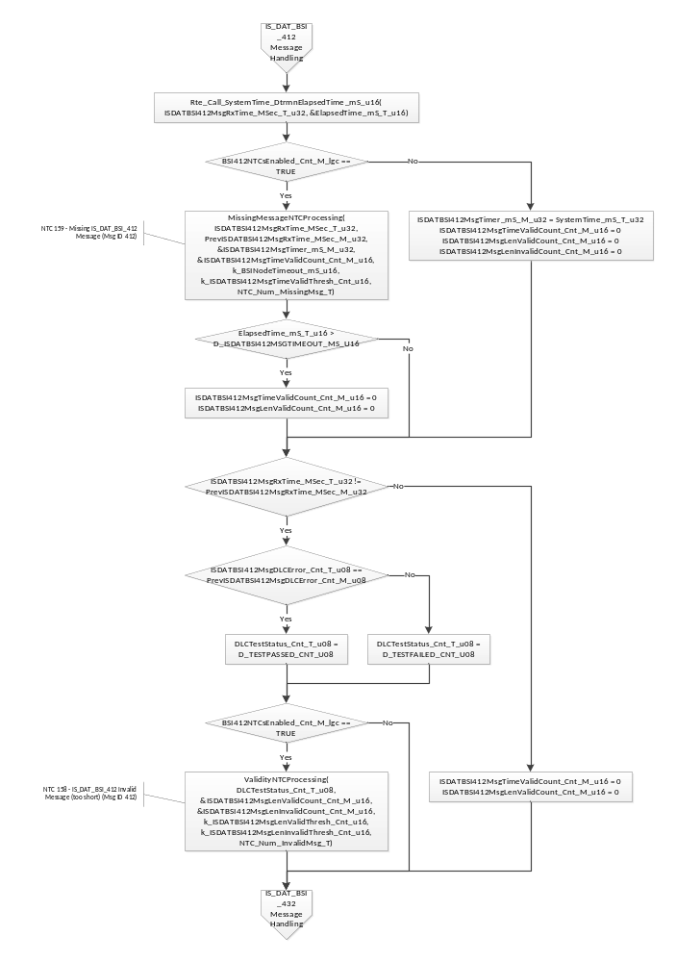
Flowchart 15: IS_DAT_BSI_412 Message Handling

IS_DAT_BSI_432 Message Handling
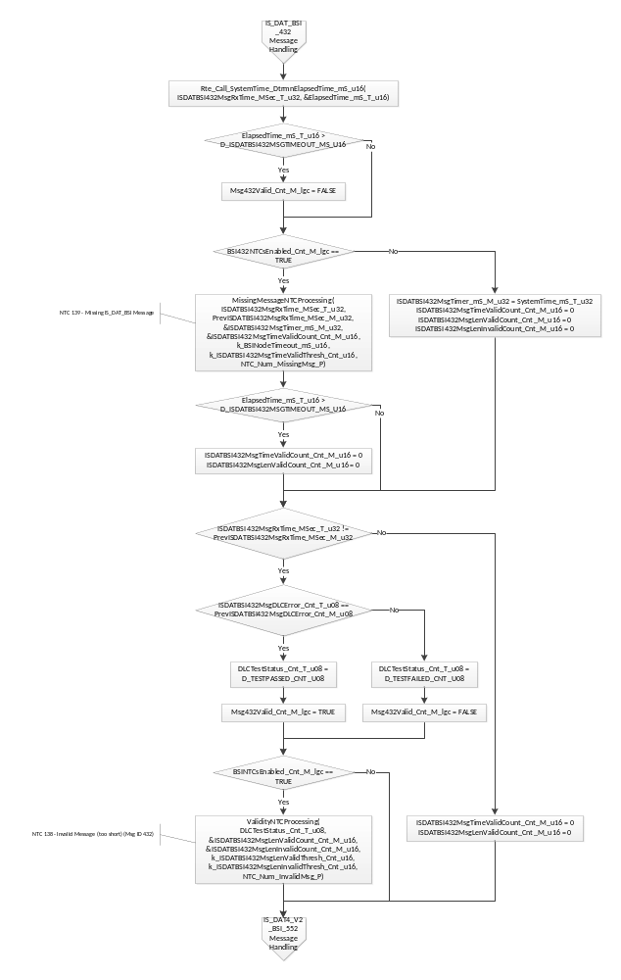
Flowchart 16: IS_DAT_BSI_432 Message Handling

IS_DAT4_V2_BSI_552 Message Handling
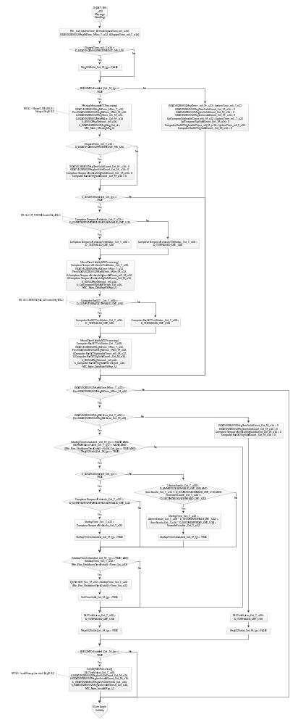
Flowchart 17: IS_DAT4_V2_BSI_552 Message Handling

Serial Com Angle Validity
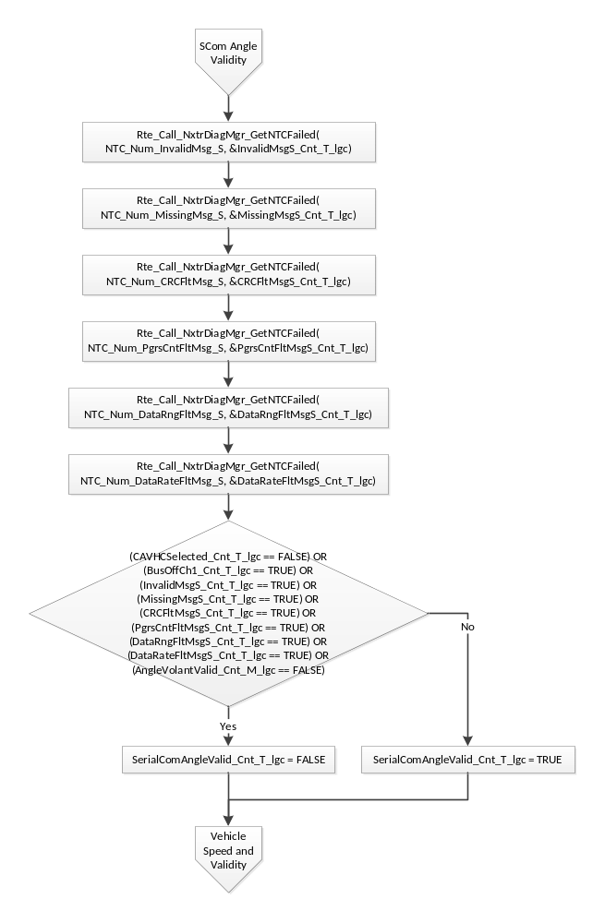

Vehicle Speed and Validity
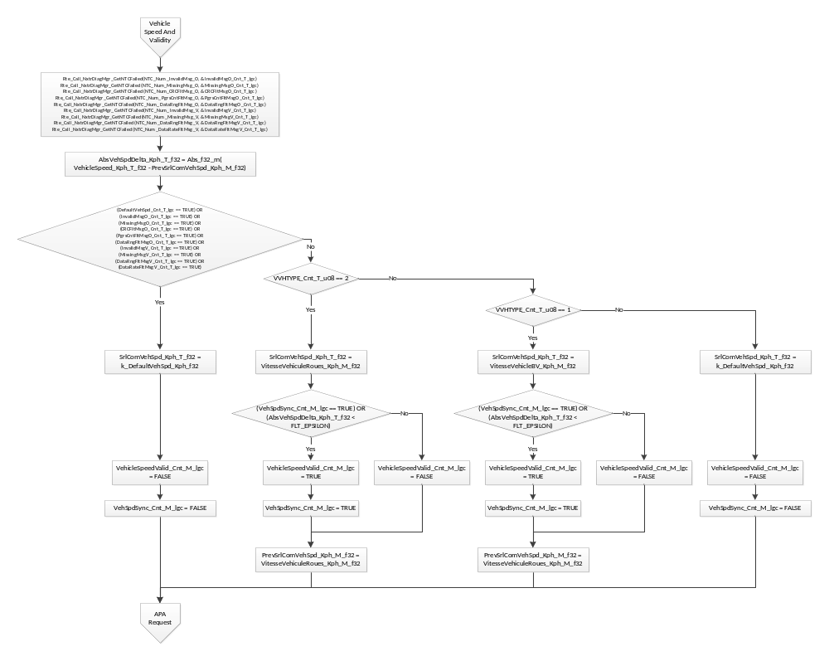
Flowchart 18: Vehicle Speed And Validity

APA Request
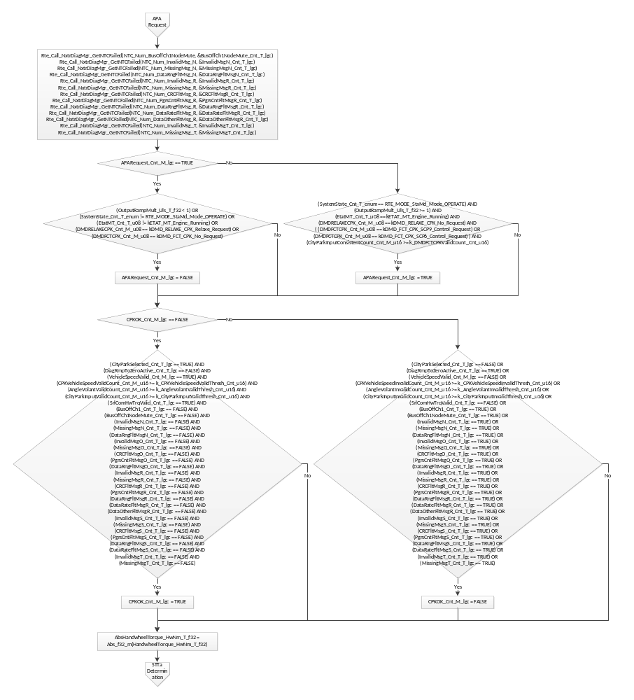
Flowchart 19: Position Servo Enable and Angle

STTa Determination
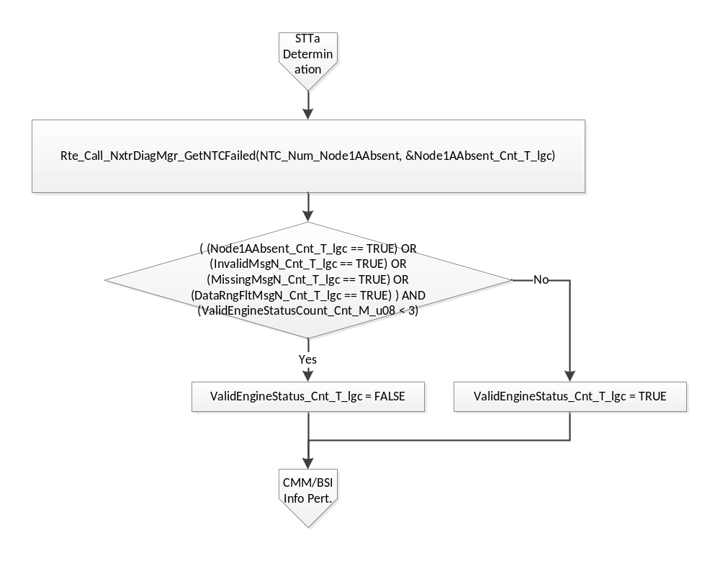
Flowchart 20: STTa Determination

CMM and BSI Info Pertinence
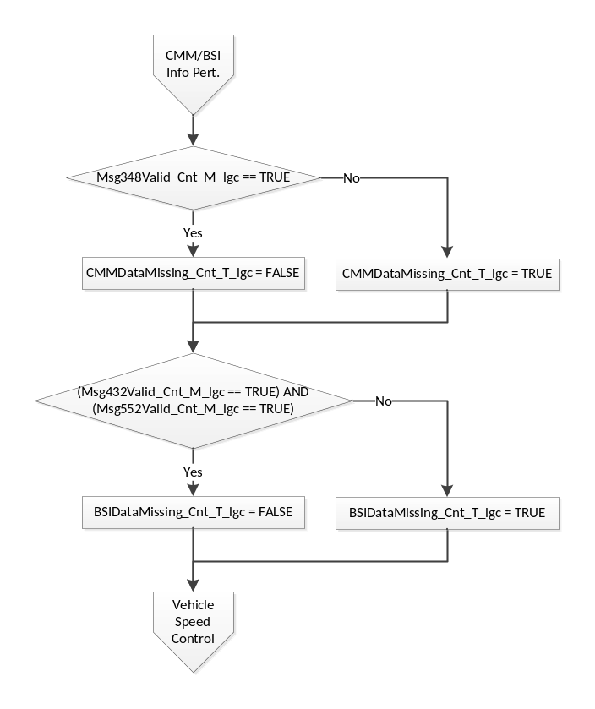

Vehicle Speed Control
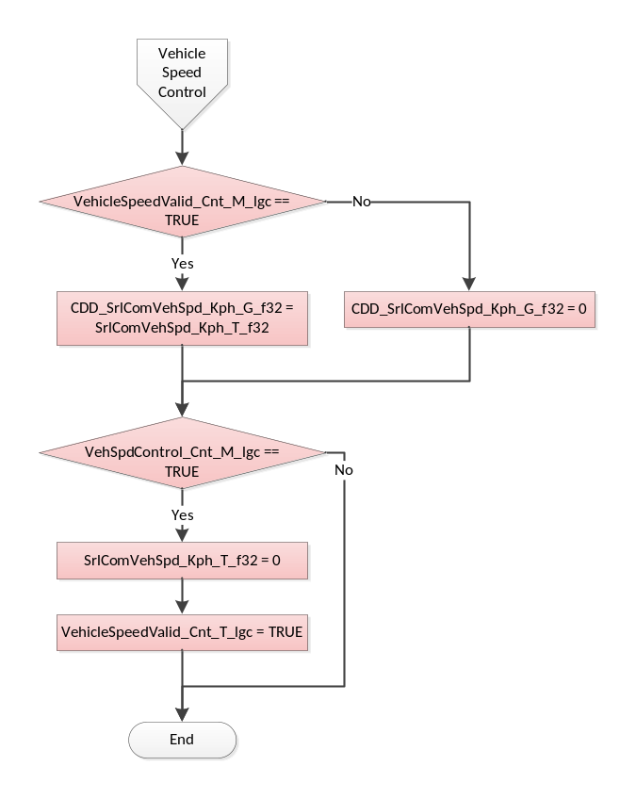

Store Local copy of outputs into Module Outputs
PrevISDAT4V2BSI552MsgRxTime_MSec_M_u32 = ISDAT4V2BSI552MsgRxTime_MSec_T_u32
PrevISDATBSI3F2MsgRxTime_MSec_M_u32 = ISDATBSI3F2MsgRxTime_MSec_T_u32
PrevISDATBSI412MsgRxTime_MSec_M_u32 = ISDATBSI412MsgRxTime_MSec_T_u32
PrevISDATBSI432MsgRxTime_MSec_M_u32 = ISDATBSI432MsgRxTime_MSec_T_u32
PrevISDYN2CMMMsgRxTime_MSec_M_u32 = ISDYN2CMMMsgRxTime_MSec_T_u32
PrevISDYNAASMsgRxTime_MSec_M_u32 = ISDYNAASMsgRxTime_MSec_T_u32
PrevISDYNABRMsgRxTime_MSec_M_u32 = ISDYNABRMsgRxTime_MSec_T_u32
PrevISDYNCMM208MsgRxTime_MSec_M_u32 = ISDYNCMM208MsgRxTime_MSec_T_u32
PrevISDYNCMM388MsgRxTime_MSec_M_u32 = ISDYNCMM388MsgRxTime_MSec_T_u32
PrevISDYNVOLMsgRxTime_MSec_M_u32 = ISDYNVOLMsgRxTime_MSec_T_u32
PrevISINTEELECTRONBSIMsgRxTime_MSec_M_u32 = ISINTEELECTRONBSIMsgRxTime_MSec_T_u32
PrevISDAT4V2BSI552MsgDLCError_Cnt_M_u08 = ISDAT4V2BSI552MsgDLCError_Cnt_T_u08
PrevISDATBSI3F2MsgDLCError_Cnt_M_u08 = ISDATBSI3F2MsgDLCError_Cnt_T_u08
PrevISDATBSI412MsgDLCError_Cnt_M_u08 = ISDATBSI412MsgDLCError_Cnt_T_u08
PrevISDATBSI432MsgDLCError_Cnt_M_u08 = ISDATBSI432MsgDLCError_Cnt_T_u08
PrevISDYN2CMMMsgDLCError_Cnt_M_u08 = ISDYN2CMMMsgDLCError_Cnt_T_u08
PrevISDYNAASMsgDLCError_Cnt_M_u08 = ISDYNAASMsgDLCError_Cnt_T_u08
PrevISDYNABRMsgDLCError_Cnt_M_u08 = ISDYNABRMsgDLCError_Cnt_T_u08
PrevISDYNCMM208MsgDLCError_Cnt_M_u08 = ISDYNCMM208MsgDLCError_Cnt_T_u08
PrevISDYNCMM388MsgDLCError_Cnt_M_u08 = ISDYNCMM388MsgDLCError_Cnt_T_u08
PrevISDYNVOLMsgDLCError_Cnt_M_u08 = ISDYNVOLMsgDLCError_Cnt_T_u08
Rte_IWrite_SrlComInput_Per1_APARequest_Cnt_lgc(APARequest_Cnt_M_lgc)
Rte_IWrite_SrlComInput_Per1_AngleVolant_HwDeg_f32(AngleVolant_HwDeg_M_f32)
Rte_IWrite_SrlComInput_Per1_BSIDataMissing_Cnt_lgc(BSIDataMissing_Cnt_T_lgc)
Rte_IWrite_SrlComInput_Per1_CMMDataMissing_Cnt_lgc(CMMDataMissing_Cnt_T_lgc)
Rte_IWrite_SrlComInput_Per1_CONSANGLECPK_Cnt_u16(CONSANGLECPK_Cnt_M_u16)
Rte_IWrite_SrlComInput_Per1_CPKOK_Cnt_lgc(CPKOK_Cnt_M_lgc)
Rte_IWrite_SrlComInput_Per1_DMDFCTCPK_Cnt_u08(DMDFCTCPK_Cnt_M_u08)
Rte_IWrite_SrlComInput_Per1_ElectronicIntegration_Cnt_lgc(*Rte_Pim_ElecIntData())
Rte_IWrite_SrlComInput_Per1_EngOn_Cnt_lgc(EngOn_Cnt_M_lgc)
Rte_IWrite_SrlComInput_Per1_IgnTimeOff_Cnt_u32(IgnTimeOff_Sec_M_u32)
Rte_IWrite_SrlComInput_Per1_PosSrvoHwAngle_HwDeg_f32(CONSANGLECPK_HwDeg_M_f32)
Rte_IWrite_SrlComInput_Per1_ReverseGearEngaged_Cnt_lgc(TRUE)
Rte_IWrite_SrlComInput_Per1_SerialComAngleValid_Cnt_lgc(SerialComAngleValid_Cnt_T_lgc)
Rte_IWrite_SrlComInput_Per1_SrlComVehSpd_Kph_f32(SrlComVehSpd_Kph_T_f32)
Rte_IWrite_SrlComInput_Per1_ValidEngineStatus_Cnt_lgc(ValidEngineStatus_Cnt_T_lgc)
Rte_IWrite_SrlComInput_Per1_VehTimeValid_Cnt_lgc(VehTimeValid_Cnt_M_lgc)
Rte_IWrite_SrlComInput_Per1_VehicleSpeedValid_Cnt_lgc(VehicleSpeedValid_Cnt_M_lgc)

Interrupt Functions
None

TRANSIENT FUNCTIONS

Trns: SrlComInput_Trns1

Design Rationale
None

Store Module Inputs to Local copies
Rte_Read_AnneeEcoule_Cnt_u08(&AnneeEcoule_Cnt_T_u08)
Rte_Read_CompteurTemporelVehicule_Cnt_u32(&CompteurTemporelVehicule_Cnt_T_u32)
Rte_Read_ISDAT4V2BSI552MsgRxTime_MSec_u32(&ISDAT4V2BSI552MsgRxTime_MSec_T_u32)
Rte_Read_JourEcoule_Cnt_u16(&JourEcoule_Cnt_T_u16)
Rte_Read_SecondeEcoulee_Cnt_u32(&SecondeEcoulee_Cnt_T_u32)
Rte_Call_NxtrDiagMgr_GetNTCFailed(NTC_Num_InvalidMsg_U, &InvalidMsgU_Cnt_T_lgc)
Rte_Call_NxtrDiagMgr_GetNTCFailed(NTC_Num_MissingMsg_U, &MissingMsgU_Cnt_T_lgc)
Rte_Call_NxtrDiagMgr_GetNTCFailed(NTC_Num_DataRngFltMsg_U, &DataRngFltMsgU_Cnt_T_lgc)
Rte_Call_NxtrDiagMgr_GetNTCFailed(NTC_Num_DataRateFltMsg_U, &DataRateFltMsgU_Cnt_T_lgc)

Processing of function
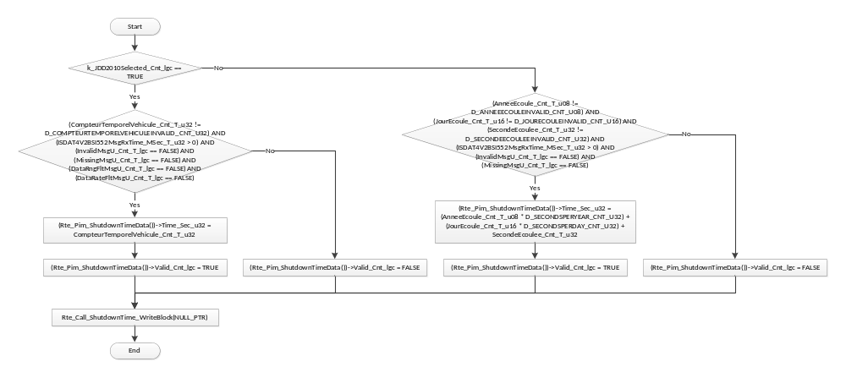

Store Local copy of outputs into Module Outputs
None

Serial Communication Functions

SComm: SrlComInput_SCom_GetNetworkDiagFltAcc

Design Rationale
None

Store Module Inputs to Local copies
None

Processing of function
None

Store Local copy of outputs into Module Outputs
*MuteFltAcc_Cnt_T_u16 = ISDATDIRASentFltAcc_Cnt_M_u16
*CAVNodeFltAcc_Cnt_T_u16 = CAVNodeAbsentFltAcc_Cnt_M_u16
*CMMNodeFltAcc_Cnt_T_u16 = CMMNodeAbsentFltAcc_Cnt_M_u16
*ESPNodeFltAcc_Cnt_T_u16 = ESPNodeAbsentFltAcc_Cnt_M_u16
*AASNodeFltAcc_Cnt_T_u16 = AASNodeAbsentFltAcc_Cnt_M_u16
*BSINodeFltAcc_Cnt_T_u16 = BSINodeAbsentFltAcc_Cnt_M_u16

SComm: SrlComInput_SCom_ManualVehSpd

Design Rationale
None

Store Module Inputs to Local copies
None

Processing of function
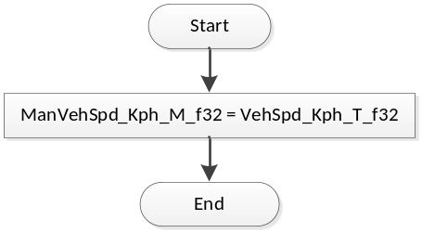
Flowchart 21: SrlComInput_SCom_ManualVehSpd

Store Local copy of outputs into Module Outputs
None

SCOMM: SrlComInput_SCom_ResetTimers

DESIGN RATIONALE
None

STORE MODULE INPUTS TO LOCAL COPIES
None

PROCESSING OF FUNCTION
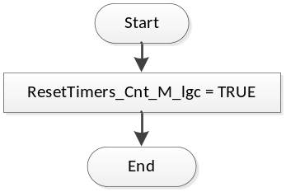
Flowchart 22: SrlComInput_SCom_ResetTimers

Store Local copy of outputs into Module Outputs
None

SComm: SrlComInput_SCom_VehSpdControl

Design Rationale
None

Store Module Inputs to Local copies
None

Processing of function
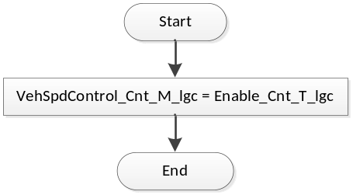
Flowchart 23: SrlComInput_SCom_VehSpdControl

Store Local copy of outputs into Module Outputs
None

Local Function/Macro Definitions

Increment Counter to Threshold (Macro)
Function Name | IncToThresh | Type | Min | Max
Arguments Passed | Counter | N/A | N/A | N/A
 | Thresh | N/A | N/A | N/A
Return Value | (return) | N/A | N/A | N/A

Description
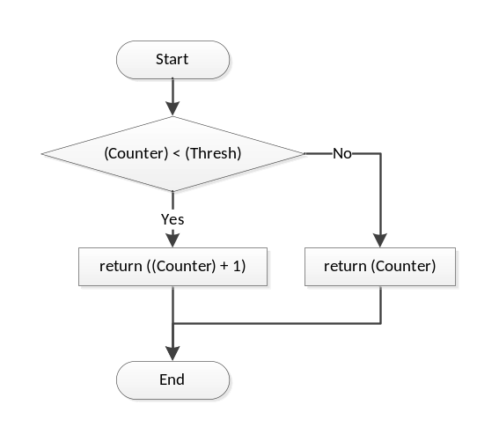

Node ABsent NTC Processing
Function Name | NodeAbsentNTCProcessing | Type | Min | Max
Arguments Passed | MsgRxTime_MSec_T_u32 | uint32 | 0 | 2³² – 1
 | PrevMsgRxTime_MSec_T_u32 | uint32 | 0 | 2³² – 1
 | MsgTimer_mS_T_u32 | uint32 * | 0 | 2³² – 1
 | FltAcc_Cnt_T_u16 | uint16 * | 0 | 255
 | Timeout_mS_T_u16 | uint16 | 0 | 2¹⁶ – 1
 | MsgDiag_Cnt_T_str | DiagSettings_Str | 0 | 255
 | NTCNum_Cnt_T_u16 | uint16 | 0 | 511
Return Value | N/A

Description
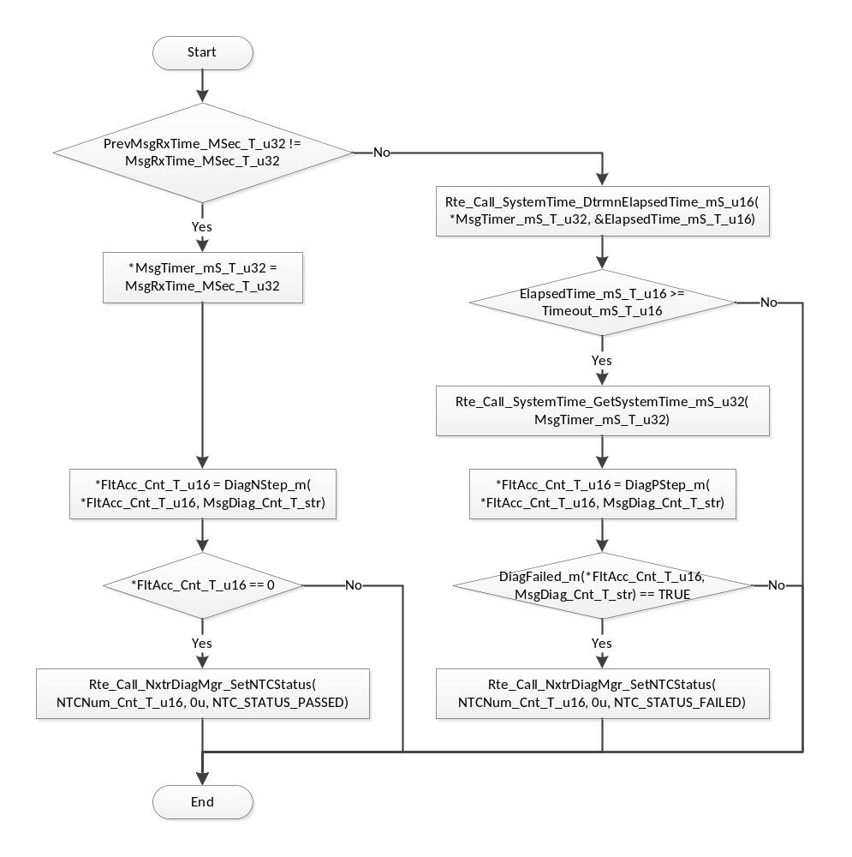
Flowchart 24: MissingMessageNTCProcessing

Missing Message NTC Processing
Function Name | MissingMessageNTCProcessing | Type | Min | Max
Arguments Passed | MsgRxTime_MSec_T_u32 | uint32 | 0 | 2³² – 1
 | PrevMsgRxTime_MSec_T_u32 | uint32 | 0 | 2³² – 1
 | MsgTimer_mS_T_u32 | uint32 * | 0 | 2³² – 1
 | ValidCount_Cnt_T_u16 | uint16 * | 0 | 65535
 | Timeout_mS_T_u16 | uint16 | 0 | 2¹⁶ – 1
 | ValidThresh_Cnt_T_u16 | uint16 | 0 | 65535
 | NTCNum_Cnt_T_u16 | uint16 | 0 | 511
Return Value | N/A

Description
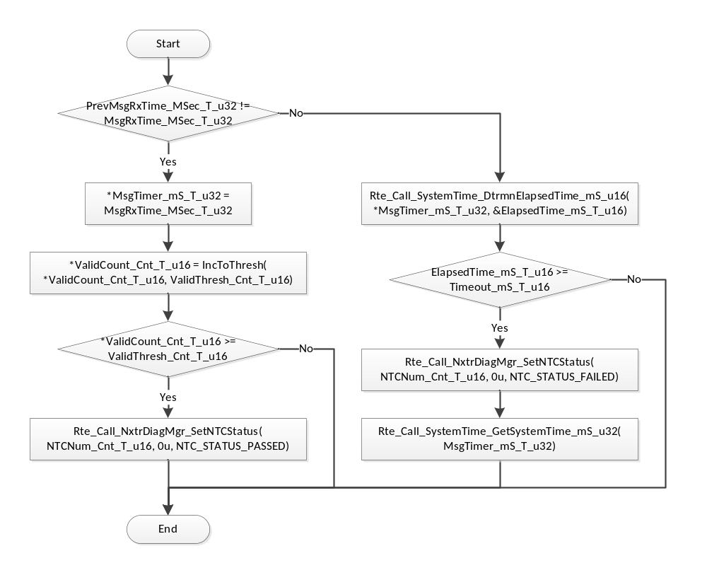

Validity NTC Processing
Function Name | ValidityNTCProcessing | Type | Min | Max
Arguments Passed | TestStatus_Cnt_T_u08 | uint8 | 0 | 1
 | ValidCount_Cnt_T_u16 | uint16 * | 0 | 2¹⁶ – 1
 | InvalidCount_Cnt_T_u16 | uint16 * | 0 | 2¹⁶ – 1
 | ValidThresh_Cnt_T_u16 | uint16 | 0 | 2¹⁶ – 1
 | InvalidThresh_Cnt_T_u16 | uint16 | 0 | 2¹⁶ – 1
 | NTCNum_Cnt_T_u16 | uint16 | 0 | 511
Return Value | N/A

Description
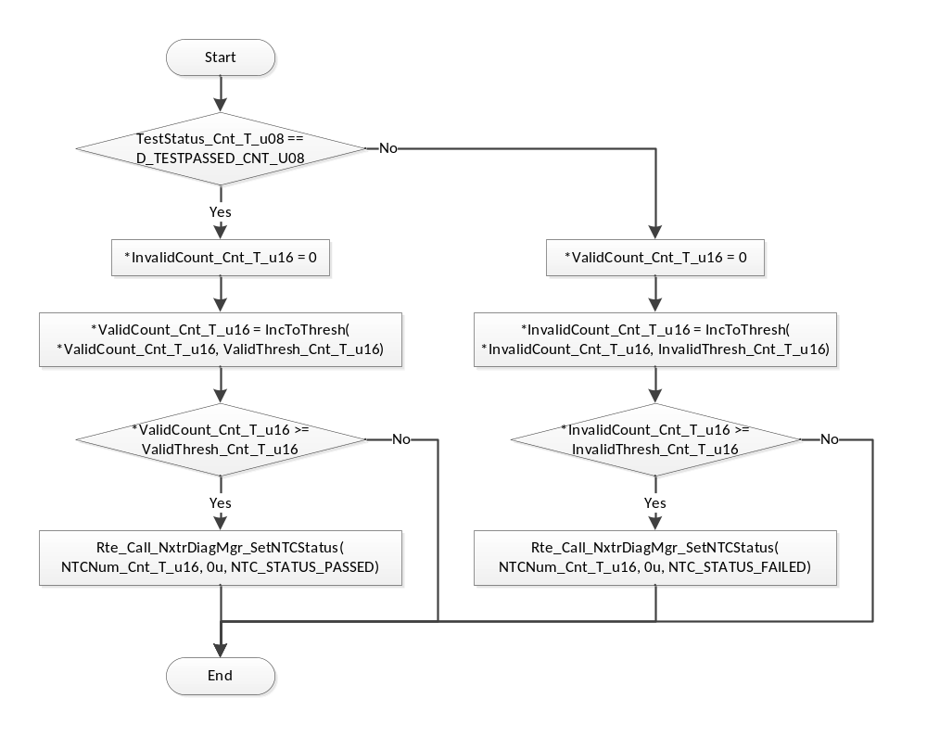
Flowchart 25: ValidityNTCProcessing

Mixed Time Validity NTC Processing
Function Name | MixedTimeValidityNTCProcessing | Type | Min | Max
Arguments Passed | TestStatus_Cnt_T_u08 | uint8 | 0 | 1
 | MsgRxTime_MSec_T_u32 | uint32 | 0 | 2³² – 1
 | PrevMsgRxTime_MSec_T_u32 | uint32 | 0 | 2³² – 1
 | SigTimer_mS_T_u32 | uint32 * | 0 | 2³² – 1
 | ValidCount_Cnt_T_u16 | uint16 * | 0 | 2¹⁶ – 1
 | Timeout_mS_T_u16 | uint16 | 0 | 2¹⁶ – 1
 | ValidThresh_Cnt_T_u16 | uint16 | 0 | 2¹⁶ – 1
 | NTCNum_Cnt_T_u16 | uint16 | 0 | 511
Return Value | N/A

Description
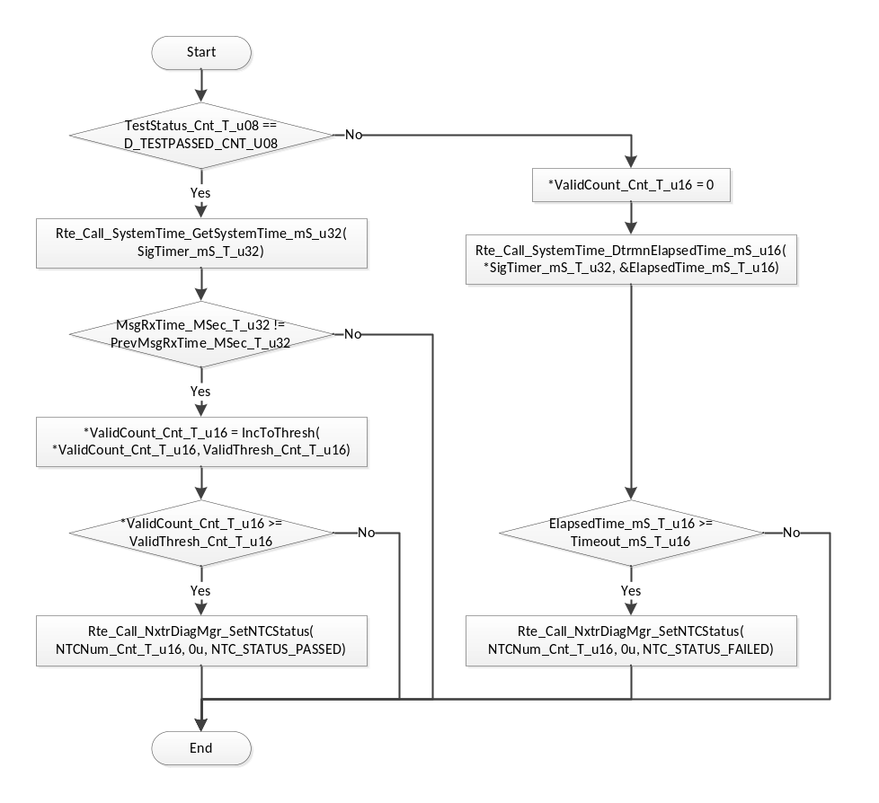
Flowchart 26: ValidityNTCProcessing

Reset Fault Accumulator
Function Name | ResetFltAcc | Type | Min | Max
Arguments Passed | FltAcc_Cnt_T_u16 | uint16 * | 0 | 2¹⁶ – 1
 | DiagSettings_Cnt_T_str | DiagSettings_Str | 0 | 255
 | NTCNum_Cnt_T_u16 | uint16 | 0 | 511
Return Value | N/A

Description
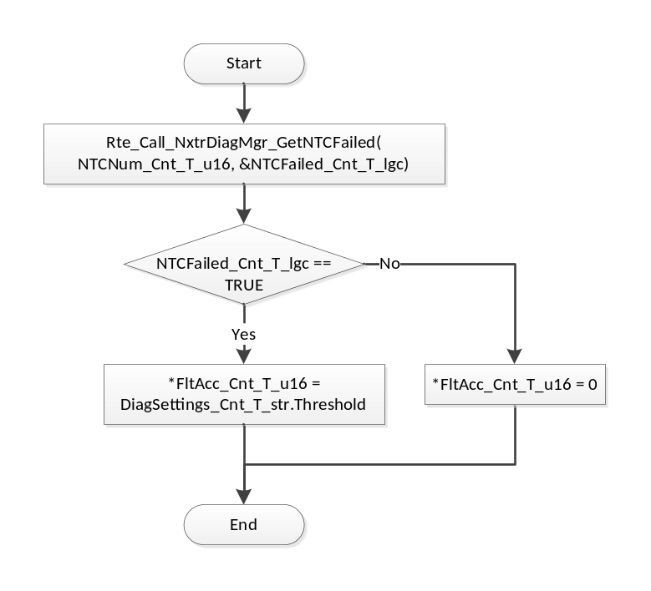
Flowchart 27: ResetFltAcc

GLObAL Function/Macro Definitions
None

Known Limitations With Design
None

UNIT TEST CONSIDERATION
None

Appendix
None

