Module Design Document
For
SrlComOutput

VERSION: 10
DATE: 2-Oct-2015

Revision History

Sl. No. | Description | Author | Version | Date
1 | Initial Version | Muhammed Shameel | 1 | 08-Aug-2014
2 | Updates for new MPU configuration | Owen Tosh | 2 | 08-Sep-2014
3 | Updates for new city park messages | Owen Tosh | 3 | 17-Sep-2014
4 | Updates for remaining customer messages | Owen Tosh | 4 | 17-Oct-2014
5 | Corrected HwVel scaling | Owen Tosh | 5 | 13-Jan-2015
6 | Updates for 2004 functionality | Owen Tosh | 6 | 8-Jun-2015
7 | Updated CODE_DEFAUT logic | Owen Tosh | 7 | 9-Jul-2015
8 | Implemented CityPark output signals | Owen Tosh | 8 | 31-Jul-2015
9 | Added rounding factors | Owen Tosh | 9 | 17-Sep-2015
10 | Corrected disable criteria for ETAT_SECU_ANGLE_COL | Owen Tosh | 10 | 2-Oct-2015

Table of Contents
1 Abbrevations And Acronyms 5
2 References 6
3 SrlComOutput & High-Level Description 7
4 Design details of software module 8
4.1 Graphical representation of SrlComOutput 8
4.2 Data Flow Diagram 8
4.3 COMPONENT DIAGRAM 8
5 Variable Data Dictionary 9
5.1 User defined typedef definition/declaration 9
5.2 Variable definition for enumerated types 9
6 Constant Data Dictionary 10
6.1 Program(fixed) Constants 10
6.1.1 Embedded Constants 10
6.1.1.1 Local 10
6.1.1.2 Global 10
6.1.2 Module specific Lookup Tables Constants 10
6.1.3 Library Functions / Macros 10
6.1.4 Data Hiding Functions 11
7 Software Module Implementation 12
7.1 Initialization Functions 12
7.1.1 Init: SrlComOutput_Init 12
7.1.1.1 Design Rationale 12
7.1.1.2 Module Outputs 12
7.1.1.3 Module Internal 12
7.2 PERIODIC FUNCTIONS 12
7.2.1 Per: SrlComOutput_Per1 12
7.2.1.1 Design Rationale 12
7.2.1.2 Store Module Inputs to Local copies 12
7.2.1.3 IS_DYN_DAE (Msg ID 2F5) PROCESSING 13
7.2.1.4 IS_DAT_DIRA (Msg ID 495) processing 14
7.2.1.5 IS_SUPV_DIRA (Msg ID 795) PROCESSING 15
7.2.1.6 Store Local copy of outputs into Module Outputs 16
7.3 Interrupt Functions 16
7.4 TRANSIENT FUNCTIONS 16
7.5 Serial Communication Functions 17
7.6 Local Function/Macro Definitions 17
7.7 GLObAL Function/Macro Definitions 17
8 Known Limitations With Design 18
9 UNIT TEST CONSIDERATION 19
10 Appendix 20

Abbrevations And Acronyms
Abbreviation | Description
DFD | Design functional diagram
MDD | Module design Document

References
This section Lists the title & version of all the documents that are referred for development of this document
Sr. No. | Title | Version
1 | MDD Guidelines | 1
2 | Software Naming Conventions | 1
3 | Coding standands | 1
4 | PSA BMPV SCIR | 003C

SrlComOutput & High-Level Description
The Serial Communications Output module provides signal processing between the EPS application layer and the serial communications software. This module will be customized for each distinct vehicle platform. This module will be responsible for converting the range and resolution of the Application Layer variables to the range and resolution of the associated serial communications signals.

This module processes the data for transmit signals that are sent from the EPS controller to other ECUs on the communication bus. Global application input data is scaled appropriately and then transferred to the serial communications Interaction Layer using function calls or macros provided.

Design details of software module

Graphical representation of SrlComOutput
None

Data Flow Diagram
None

COMPONENT DIAGRAM
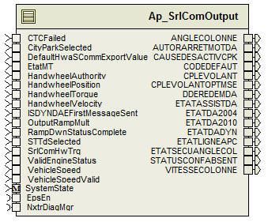
Figure 1: SrlComOutput component diagram

Variable Data Dictionary

User defined typedef definition/declaration

Typedef Name | Element Name | User Defined Type | Legal Range  (min) | Legal Range  (max)
None | None | None | None | None

Variable definition for enumerated types
Enum Name | Element Name | Value
None | None | None

Constant Data Dictionary

Program(fixed) Constants

Embedded Constants

Local
Constant Name | Resolution | Units | Value
D_CPLEVOLANTOPTMSELOLMT_HWNM_F32 | Single Precision Float | HwNm | -10
D_CPLEVOLANTOPTMSEHILMT_HWNM_F32 | Single Precision Float | HwNm | 10
D_CPLEVOLANTOPTMSESCALE_HWNMPCNT_F32 | Single Precision Float | HwNm/Cnt | 0.1
D_ANGLECOLONNELOLMT_HWDEG_F32 | Single Precision Float | HwDeg | -1630
D_ANGLECOLONNEHILMT_HWDEG_F32 | Single Precision Float | HwDeg | 1630
D_ANGLECOLONNESCALE_HWDEGPCNT_F32 | Single Precision Float | HwDeg/Cnt | 0.1
D_VITESSECOLONNELOLMT_HWDEGPS_F32 | Single Precision Float | HwDeg/s | -2000
D_VITESSECOLONNEHILMT_HWDEGPS_F32 | Single Precision Float | HwDeg/s | 2000
D_CPLEVOLANTLOLMT_HWNM_F32 | Single Precision Float | HwNm | -32
D_CPLEVOLANTHILMT_HWNM_F32 | Single Precision Float | HwNm | 31.5
D_CPLEVOLANTSCALE_HWNMPCNT_F32 | Single Precision Float | HwNm/Cnt | 0.25

Global
Constant Name
kETAT_ASSIST_DA_Nominal_Assist_Active
kETAT_ASSIST_DA_Assist_Not_Active
kETAT_LIGNE_APC_Ignition_On
kETAT_LIGNE_APC_Ignition_Off
kCPLE_VOLANT_Invalid
kETAT_DA_DYN_Normal_Mode
kETAT_DA_2004_Orange_LED
kETAT_DA_2004_No_Demand
kETAT_DA_2010_Orange_LED
kETAT_DA_2010_No_Demand
kAUTOR_ARRET_MOT_DA_No_Permission_to_Stop
kDDE_REDEM_DA_No_Reboot_Required
kCPLE_VOLANT_OPTMSE_Invalid
kCAUSE_DESACTIV_CPK_Angular_Error_Too_High
kETAT_DAE_CPK_Invalid
kANGLE_COLONNE_Invalid
kVITESSE_COLONNE_Invalid
kETAT_SECU_ANGLE_COL_Secure
kETAT_SECU_ANGLE_COL_Not_Secure
kETAT_ASSIST_DA_Dmg_Assist_Active

Module specific Lookup Tables Constants
Constant Name | Resolution | Value | Software Segment
None | None | None | None

Library Functions / Macros
None

Data Hiding Functions
Rte_Call_SystemTime_GetSystemTime_mS_u32()
Rte_Call_NxtrDiagMgr_GetNTCFailed()
Rte_Call_SystemTime_DtrmnElapsedTime_mS_u16()

Software Module Implementation

Initialization Functions

Init: SrlComOutput_Init

Design Rationale
None

Module Outputs
None

Module Internal
Rte_Call_SystemTime_GetSystemTime_mS_u32(&SystemTime_mS_T_u32)
ETATSECUANGLECOLSigTimer_mS_M_u32 = SystemTime_mS_T_u32
DDEREDEMDASigValidTimer_mS_M_u32 = SystemTime_mS_T_u32

PERIODIC FUNCTIONS

Per: SrlComOutput_Per1

Design Rationale
None

Store Module Inputs to Local copies
APAStateTransitionCause_Cnt_T_u08 = Rte_IRead_SrlComOutput_Per1_APAStateTransitionCause_Cnt_u08()
APAState_Cnt_T_u08 = Rte_IRead_SrlComOutput_Per1_APAState_Cnt_u08()
AVASelected_Cnt_T_lgc = Rte_IRead_SrlComOutput_Per1_AVASelected_Cnt_lgc()
CTCFailed_Cnt_T_lgc = Rte_IRead_SrlComOutput_Per1_CTCFailed_Cnt_lgc()
CityParkSelected_Cnt_T_lgc = Rte_IRead_SrlComOutput_Per1_CityParkSelected_Cnt_lgc()
DefaultHwaSCommExportValue_Cnt_T_lgc = Rte_IRead_SrlComOutput_Per1_DefaultHwaSCommExportValue_Cnt_lgc()
EtatMT_Cnt_T_u08 = Rte_IRead_SrlComOutput_Per1_EtatMT_Cnt_u08()
HandwheelAuthority_Uls_T_f32 = Rte_IRead_SrlComOutput_Per1_HandwheelAuthority_Uls_f32()
HandwheelPosition_HwDeg_T_f32 = Rte_IRead_SrlComOutput_Per1_HandwheelPosition_HwDeg_f32()
HandwheelTorque_HwNm_T_f32 = Rte_IRead_SrlComOutput_Per1_HandwheelTorque_HwNm_f32()
HandwheelVelocity_HwRadpS_T_f32 = Rte_IRead_SrlComOutput_Per1_HandwheelVelocity_HwRadpS_f32()
ISDYNDAEFirstMessageSent_Cnt_T_lgc = Rte_IRead_SrlComOutput_Per1_ISDYNDAEFirstMessageSent_Cnt_lgc()
OutputRampMult_Uls_T_f32 = Rte_IRead_SrlComOutput_Per1_OutputRampMult_Uls_f32()
RampDwnStatusComplete_T_lgc = Rte_IRead_SrlComOutput_Per1_RampDwnStatusComplete_Cnt_lgc()
STTdSelected_Cnt_T_lgc = Rte_IRead_SrlComOutput_Per1_STTdSelected_Cnt_lgc()
SrlComHwTrq_HwNm_T_f32 = Rte_IRead_SrlComOutput_Per1_SrlComHwTrq_HwNm_f32()
ValidEngineStatus_Cnt_T_lgc = Rte_IRead_SrlComOutput_Per1_ValidEngineStatus_Cnt_lgc()
VehicleSpeedValid_Cnt_T_lgc = Rte_IRead_SrlComOutput_Per1_VehicleSpeedValid_Cnt_lgc()
VehicleSpeed_Kph_T_f32 = Rte_IRead_SrlComOutput_Per1_VehicleSpeed_Kph_f32()
Rte_Call_EpsEn_OP_GET(&EPSEn_Cnt_T_lgc)
Rte_Call_NxtrDiagMgr_GetNTCFailed(NTC_Num_T1vsT2, &T1vsT2_Cnt_T_lgc)
Rte_Call_NxtrDiagMgr_GetNTCFailed(NTC_Num_T1OutofRange, &T1OutofRange_Cnt_T_lgc)
Rte_Call_NxtrDiagMgr_GetNTCFailed(NTC_Num_T2OutofRange, &T2OutofRange_Cnt_T_lgc)
Rte_Call_NxtrDiagMgr_GetNTCFailed(NTC_Num_ReducedAsstLowVoltage, &ReducedAsstLowVoltage_Cnt_T_lgc)
Rte_Call_NxtrDiagMgr_GetNTCFailed(NTC_Num_DutyCycleExceeded, &DutyCycleExceeded_Cnt_T_lgc)
Rte_Call_NxtrDiagMgr_GetNTCFailed(NTC_Num_AbsTempThermLimit, &AbsTempThermLimit_Cnt_T_lgc)
Rte_Call_NxtrDiagMgr_GetNTCFailed(NTC_Num_VLF_06, &LowVoltageStopMode_Cnt_T_lgc)
Rte_Call_NxtrDiagMgr_GetNTCFailed(NTC_Num_VLF_08, &IgnitionFailure_Cnt_T_lgc)
Rte_Call_NxtrDiagMgr_GetNTCFailed(NTC_Num_BusOffCh1, &BusOffCh1_Cnt_T_lgc)
Rte_Call_NxtrDiagMgr_GetNTCFailed(NTC_Num_BusOffCh1NodeMute, &BusOffCh1NodeMute_Cnt_T_lgc)
Rte_Call_NxtrDiagMgr_GetNTCFailed(NTC_Num_Node1AAbsent, &Node1AAbsent_Cnt_T_lgc)
Rte_Call_NxtrDiagMgr_GetNTCFailed(NTC_Num_Node1BAbsent, &Node1BAbsent_Cnt_T_lgc)
Rte_Call_NxtrDiagMgr_GetNTCFailed(NTC_Num_Node1CAbsent, &Node1CAbsent_Cnt_T_lgc)
Rte_Call_NxtrDiagMgr_GetNTCFailed(NTC_Num_Node1DAbsent, &Node1DAbsent_Cnt_T_lgc)
Rte_Call_NxtrDiagMgr_GetNTCFailed(NTC_Num_Node1EAbsent, &Node1EAbsent_Cnt_T_lgc)
Rte_Call_NxtrDiagMgr_GetNTCFailed(NTC_Num_InvalidMsg_Q, &InvalidMsgQ_Cnt_T_lgc)
Rte_Call_NxtrDiagMgr_GetNTCFailed(NTC_Num_MissingMsg_Q, &MissingMsgQ_Cnt_T_lgc)
Rte_Call_NxtrDiagMgr_GetNTCFailed(NTC_Num_DataOtherFltMsg_Q, &DataOtherFltMsgQ_Cnt_T_lgc)
Rte_Call_NxtrDiagMgr_GetNTCFailed(NTC_Num_TrqSensorNotTrimmed, &TrqSensorNotTrimmed_Cnt_T_lgc)
Rte_Call_ETATDA2_GetIndicatorStatus(&ETATDA2_Cnt_T_lgc)

IS_DYN_DAE (Msg ID 2F5) PROCESSING
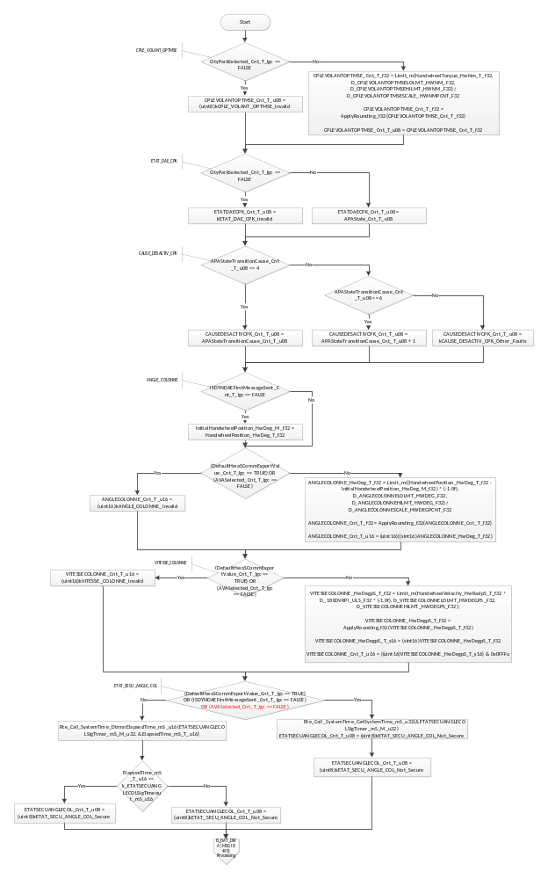
Flowchart 1: IS_DYN_DAE (MSG ID 2F5) PROCESSING

IS_DAT_DIRA (Msg ID 495) processing
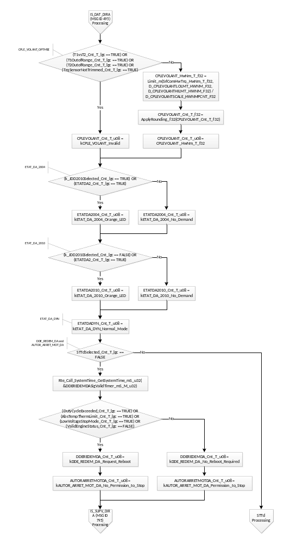
Flowchart 2:IS_DAT_DIRA (MSG ID 495) PROCESSING

STTd Processing
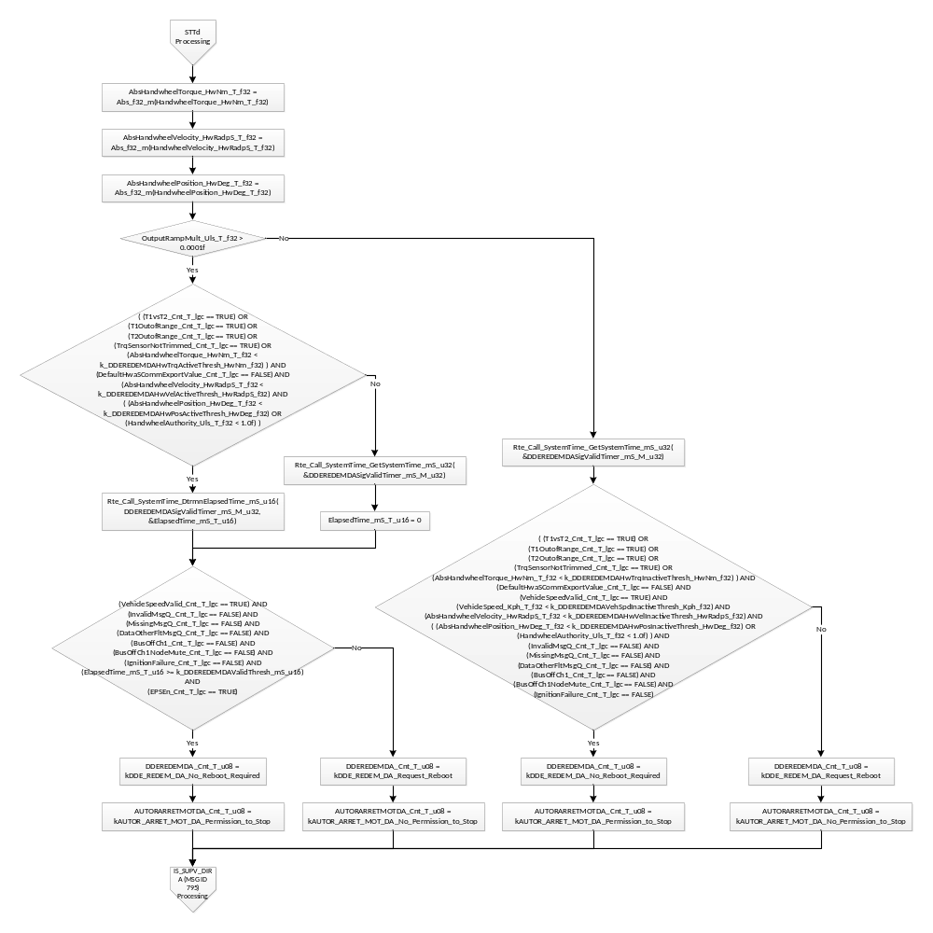
Flowchart 3: STTd Processing

IS_SUPV_DIRA (Msg ID 795) PROCESSING
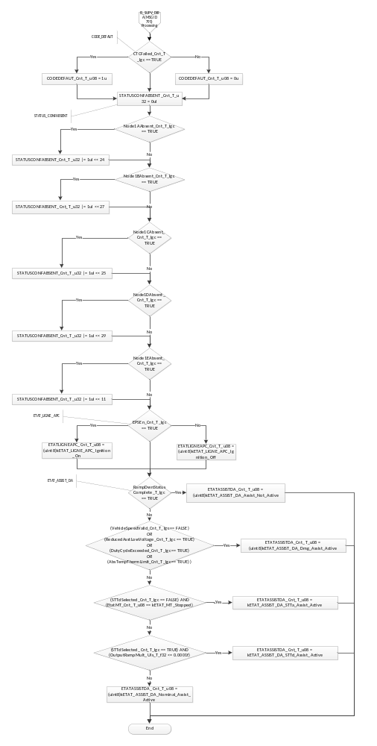
Flowchart 4: IS_SUPV_DIRA (Msg ID 795)

Store Local copy of outputs into Module Outputs
Rte_IWrite_SrlComOutput_Per1_ANGLECOLONNE_Cnt_u16(ANGLECOLONNE_Cnt_T_u16)
Rte_IWrite_SrlComOutput_Per1_AUTORARRETMOTDA_Cnt_u08(AUTORARRETMOTDA_Cnt_T_u08)
Rte_IWrite_SrlComOutput_Per1_CAUSEDESACTIVCPK_Cnt_u08(CAUSEDESACTIVCPK_Cnt_T_u08)
Rte_IWrite_SrlComOutput_Per1_CODEDEFAUT_Cnt_u08(CODEDEFAUT_Cnt_T_u08)
Rte_IWrite_SrlComOutput_Per1_CPLEVOLANTOPTMSE_Cnt_u08(CPLEVOLANTOPTMSE_Cnt_T_u08)
Rte_IWrite_SrlComOutput_Per1_CPLEVOLANT_Cnt_u08(CPLEVOLANT_Cnt_T_u08)
Rte_IWrite_SrlComOutput_Per1_DDEREDEMDA_Cnt_u08(DDEREDEMDA_Cnt_T_u08)
Rte_IWrite_SrlComOutput_Per1_ETATASSISTDA_Cnt_u08(ETATASSISTDA_Cnt_T_u08)
Rte_IWrite_SrlComOutput_Per1_ETATDA2004_Cnt_u08(ETATDA2004_Cnt_T_u08)
Rte_IWrite_SrlComOutput_Per1_ETATDA2010_Cnt_u08(ETATDA2010_Cnt_T_u08)
Rte_IWrite_SrlComOutput_Per1_ETATDADYN_Cnt_u08(ETATDADYN_Cnt_T_u08)
Rte_IWrite_SrlComOutput_Per1_ETATDAECPK_Cnt_u08(ETATDAECPK_Cnt_T_u08)
Rte_IWrite_SrlComOutput_Per1_ETATLIGNEAPC_Cnt_u08(ETATLIGNEAPC_Cnt_T_u08)
Rte_IWrite_SrlComOutput_Per1_ETATSECUANGLECOL_Cnt_u08(ETATSECUANGLECOL_Cnt_T_u08)
Rte_IWrite_SrlComOutput_Per1_STATUSCONFABSENT_Cnt_u32(STATUSCONFABSENT_Cnt_T_u32)
Rte_IWrite_SrlComOutput_Per1_VITESSECOLONNE_Cnt_u16(VITESSECOLONNE_Cnt_T_u16)

Interrupt Functions
None

TRANSIENT FUNCTIONS
None

Serial Communication Functions
None

Local Function/Macro Definitions

Apply Rounding
Function Name | ApplyRounding_f32 | Type | Min | Max
Arguments Passed | x | float32 | full | full
Return Value | (return) | float32 | full | full

Description
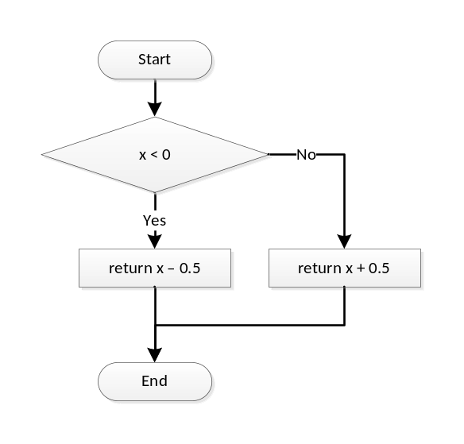

GLObAL Function/Macro Definitions
None

Known Limitations With Design
None

UNIT TEST CONSIDERATION
None

Appendix
None

