Module Design Document
For
VehPwrMd

VERSION: 5
DATE: 24-Sep-2015
Revision History
Sl. No. | Description | Author | Version | Date
1 | Initial Version | Muhammed Shameel | 1 | 08-Aug-2014
2 | Updates for STTd functionality | Owen Tosh | 2 | 17-Oct-2014
3 | Updates for SCIR 003B | Owen Tosh | 3 | 21-Jul-2015
4 | Updates for SCIR 003C | Owen Tosh | 4 | 17-Aug-2015
5 | Corrected SCom defeat logic | Owen Tosh | 5 | 24-Sep-2015
Table of Contents
1 Abbrevations And Acronyms 5
2 References 6
3 VehPwrMd & High-Level Description 7
4 Design details of software module 8
4.1 Graphical representation of VehPwrMd 8
4.2 Data Flow Diagram 8
4.2.1 Module level DFD 8
4.2.2 Sub-Module level DFD 8
4.3 COMPONENT DIAGRAM 8
5 Variable Data Dictionary 9
5.1 User defined typedef definition/declaration 9
5.2 Variable definition for enumerated types 9
6 Constant Data Dictionary 10
6.1 Program(fixed) Constants 10
6.1.1 Embedded Constants 10
6.1.1.1 Local 10
6.1.1.2 Global 10
6.1.2 Module specific Lookup Tables Constants 10
6.1.3 Library Functions / Macros 10
6.1.4 Data Hiding Functions 10
7 Software Module Implementation 11
7.1 Initialization Functions 11
7.1.1 Init: VehPwrMd_Init1 11
7.1.1.1 Design Rationale 11
7.1.1.2 Module Outputs 11
7.1.1.3 Module Internal 11
7.2 PERIODIC FUNCTIONS 11
7.2.1 Per: VehPwrMd _Per1 11
7.2.1.1 Design Rationale 11
7.2.1.2 Store Module Inputs to Local copies 11
7.2.1.3 ENGON PROCESSING 12
7.2.1.4 CTERM PROCESSING_1 (CTERM == False) 13
7.2.1.5 CTERM PROCESSING_2 (CTERM == TRUE) 14
7.2.1.6 aTERM and ramp logic processing 15
7.2.1.7 Store Local copy of outputs into Module Outputs 15
7.3 Interrupt Functions 15
7.4 TRANSIENT FUNCTIONS 15
7.5 Serial Communication Functions 16
7.6 Local Function/Macro Definitions 16
7.7 GLObAL Function/Macro Definitions 16
8 Known Limitations With Design 17
9 UNIT TEST CONSIDERATION 18
10 Appendix 19

Abbrevations And Acronyms
Abbreviation | Description
DFD | Design functional diagram
MDD | Module design Document

References
This section Lists the title & version of all the documents that are referred for development of this document
Sr. No. | Title | Version
1 | MDD Guidelines | 1
2 | Software Naming Conventions | 1
3 | Coding standands | 1
4 | PSA BMPV SCIR | 003C

VehPwrMd & High-Level Description
VehPwrMd is an application layer module which determines the states and modes A and C terms based on the EngOn value.

Design details of software module

Graphical representation of VehPwrMd
No shared data

Data Flow Diagram

Module level DFD
None

Sub-Module level DFD
None

COMPONENT DIAGRAM
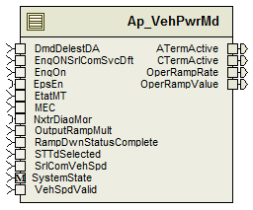
Figure 1: VehPwrMd component diagram

Variable Data Dictionary

User defined typedef definition/declaration
Typedef Name | Element Name | User Defined Type | Legal Range  (min) | Legal Range  (max)
None | None | None | None | None

Variable definition for enumerated types
Enum Name | Element Name | Value
None | None | None

Constant Data Dictionary

Program(fixed) Constants

Embedded Constants

Local
Constant Name | Resolution | Units | Value
D_STTDRAMPDOWNTARGET_ULS_F32 | Single Precision Float | Unitless | 0.0001
D_RAMPIDLE_CNT_U08 | 1 | Counts | 0
D_RAMPDOWN_CNT_U08 | 1 | Counts | 1
D_RAMPUP_CNT_U08 | 1 | Counts | 2

Global
Constant Name
D_ZERO_ULS_F32
D_ONE_ULS_F32

Module specific Lookup Tables Constants
Constant Name | Resolution | Value | Software Segment
None | None | None | None

Library Functions / Macros
None

Data Hiding Functions
Rte_Call_SystemTime_GetSystemTime_mS_u32()
Rte_Call_SystemTime_DtrmnElapsedTime_mS_u16()

Software Module Implementation

Initialization Functions

Init: VehPwrMd_Init1

Design Rationale
None

Module Internal
Rte_Call_SystemTime_GetSystemTime_mS_u32(&SystemTime_mS_T_u32)
ATermTimer_mS_M_u32 = SystemTime_mS_T_u32
CTermIgnOffTimer_mS_M_u32 = SystemTime_mS_T_u32
CTermIgnOnTimer_mS_M_u32 = SystemTime_mS_T_u32
CTermVehSpdInvalidTimer_mS_M_u32 = SystemTime_mS_T_u32

Module Outputs
Rte_IWrite_VehPwrMd_Init1_OperRampRate_XpmS_f32(k_RampDnRt_UlspmS_f32)
Rte_IWrite_VehPwrMd_Init1_OperRampValue_Uls_f32(D_ZERO_ULS_F32)

PERIODIC FUNCTIONS

Per: VehPwrMd _Per1

Design Rationale
None

Store Module Inputs to Local copies
DmdDelestDA_Cnt_T_u08 = Rte_IRead_VehPwrMd_Per1_DmdDelestDA_Cnt_u08()
EngONSrlComSvcDft_Cnt_T_lgc = Rte_IRead_VehPwrMd_Per1_EngONSrlComSvcDft_Cnt_lgc()
EngOn_Cnt_T_lgc = Rte_IRead_VehPwrMd_Per1_EngOn_Cnt_lgc()
EtatMT_Cnt_T_u08 = Rte_IRead_VehPwrMd_Per1_EtatMT_Cnt_u08()
MEC_Cnt_T_enum = Rte_IRead_VehPwrMd_Per1_MEC_Cnt_enum()
OutputRampMult_Uls_T_f32 = Rte_IRead_VehPwrMd_Per1_OutputRampMult_Uls_f32()
RampDwnStatusComplete_Cnt_T_lgc = Rte_IRead_VehPwrMd_Per1_RampDwnStatusComplete_Cnt_lgc()
STTdSelected_Cnt_T_lgc = Rte_IRead_VehPwrMd_Per1_STTdSelected_Cnt_lgc()
VehSpd_Kph_T_f32 = Rte_IRead_VehPwrMd_Per1_SrlComVehSpd_Kph_f32()
VehSpdValid_Cnt_T_lgc = Rte_IRead_VehPwrMd_Per1_VehSpdValid_Cnt_lgc()
Rte_Call_EpsEn_OP_GET(&EPSEn_Cnt_T_lgc)
Rte_Call_SystemTime_GetSystemTime_mS_u32(&SystemTime_mS_T_u32)
Rte_Call_NxtrDiagMgr_GetNTCFailed(NTC_Num_InvalidMsg_Q, &InvalidMsgQ_Cnt_T_lgc)
Rte_Call_NxtrDiagMgr_GetNTCFailed(NTC_Num_MissingMsg_Q, &MissingMsgQ_Cnt_T_lgc)
Rte_Call_NxtrDiagMgr_GetNTCFailed(NTC_Num_DataOtherFltMsg_Q, &DataOtherFltMsgQ_Cnt_T_lgc)

CTERM PROCESSING_1 (CTERM == False)
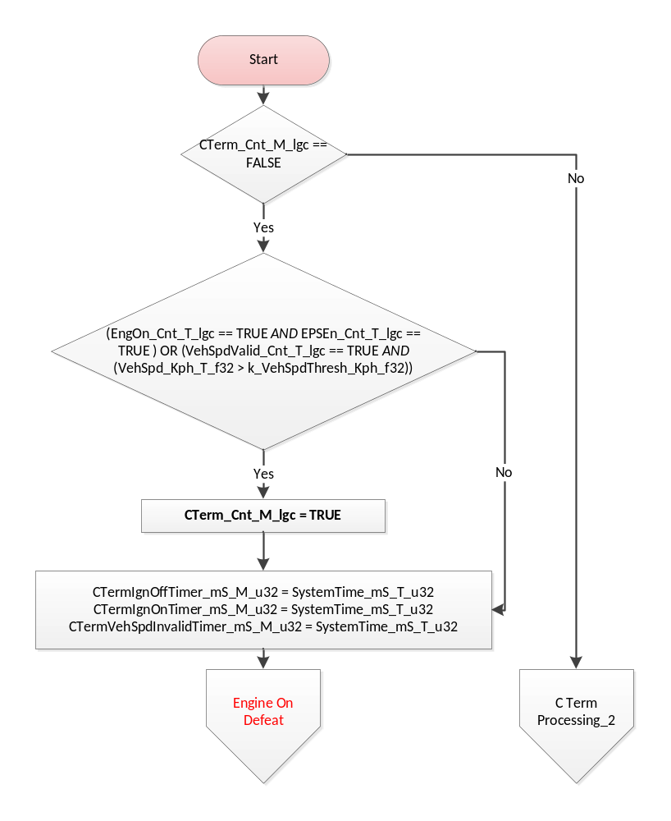
Flowchart 2: CTerm Processing when CTerm == False

CTERM PROCESSING_2 (CTERM == TRUE)
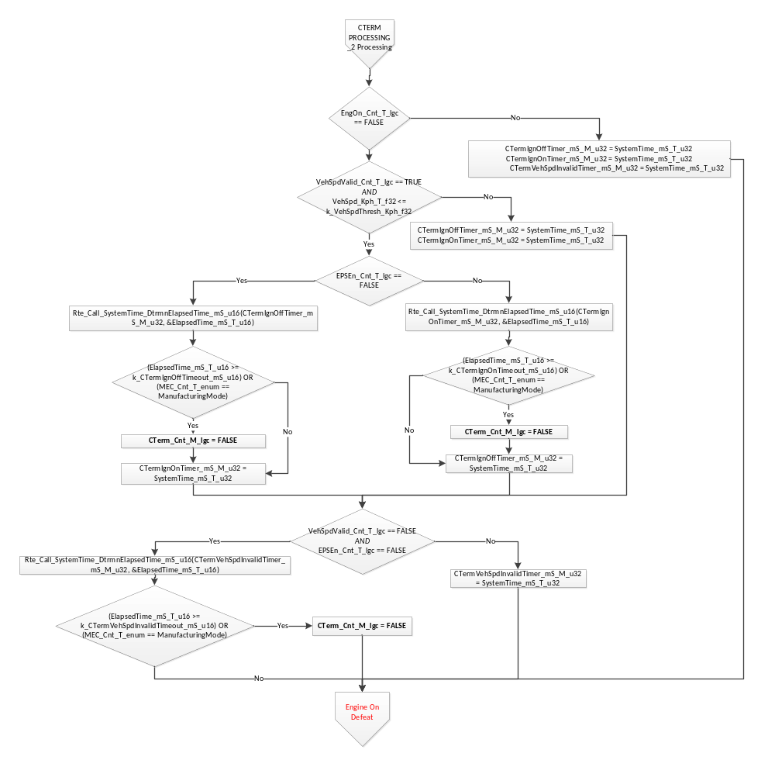
Flowchart 3: CTermProcessing when CTerm = TRUE

Engine On Defeat
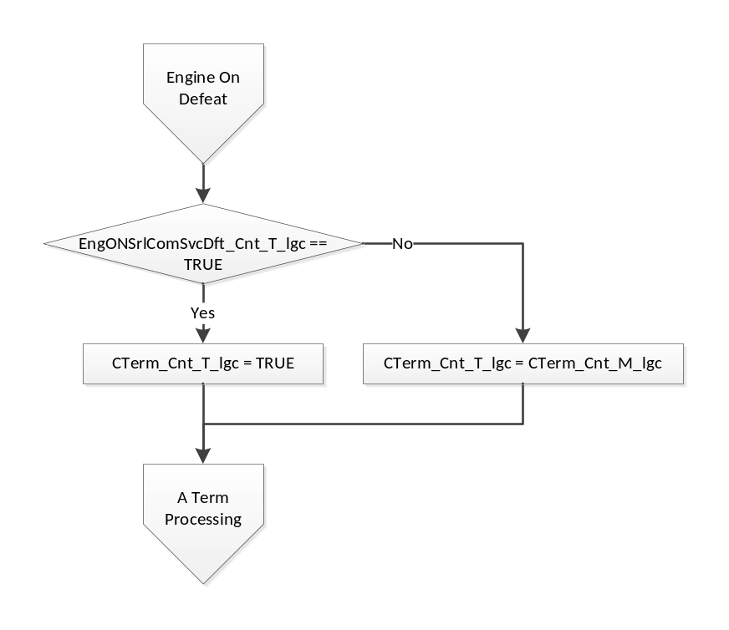

aTERM processing
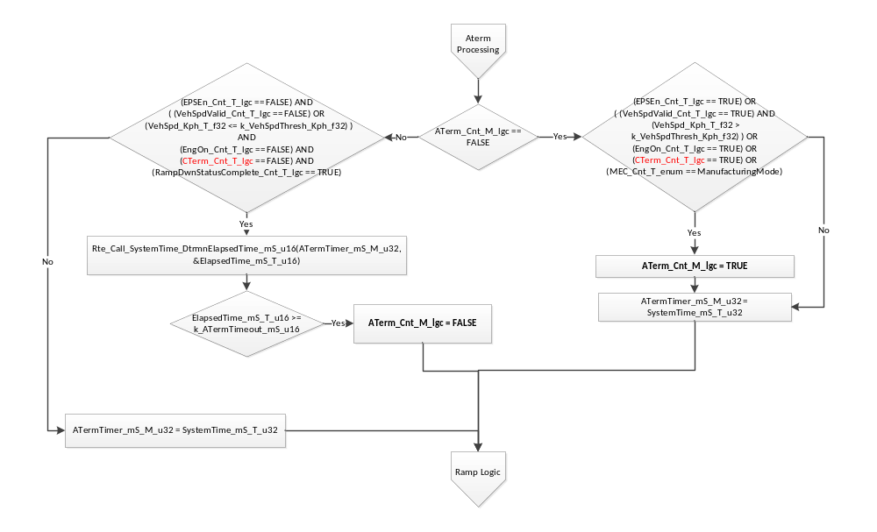
Flowchart 4: ATerm Processing

Ramp Logic
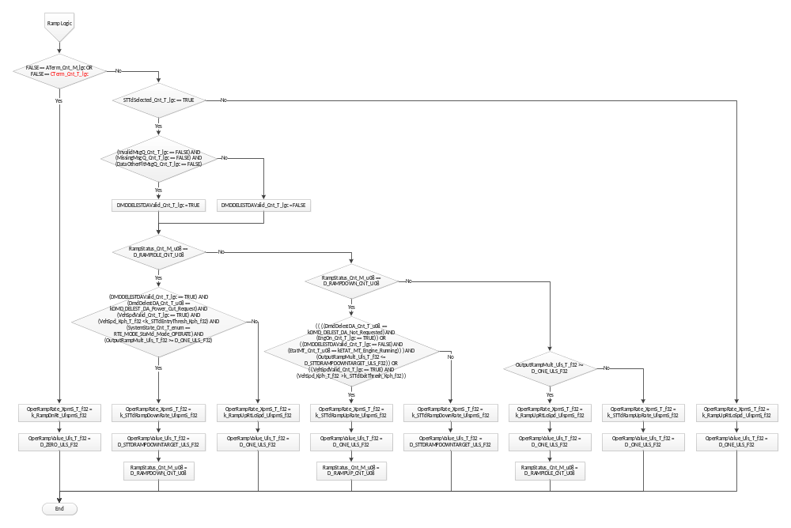
Flowchart 5: Ramp Logic

Store Local copy of outputs into Module Outputs
Rte_IWrite_VehPwrMd_Per1_ATermActive_Cnt_lgc(ATerm_Cnt_M_lgc)
Rte_IWrite_VehPwrMd_Per1_CTermActive_Cnt_lgc(CTerm_Cnt_T_lgc)
Rte_IWrite_VehPwrMd_Per1_OperRampRate_XpmS_f32(OperRampRate_XpmS_T_f32)
Rte_IWrite_VehPwrMd_Per1_OperRampValue_Uls_f32(OperRampValue_Uls_T_f32)

Interrupt Functions
None

TRANSIENT FUNCTIONS
None

Serial Communication Functions
None

Local Function/Macro Definitions
None

GLObAL Function/Macro Definitions
None

Known Limitations With Design
None

UNIT TEST CONSIDERATION
None

Appendix
None

