Module Design Document
For
FaultLog

VERSION: 4
DATE: 23-Oct-2015
Revision History

Sl. No. | Description | Author | Version | Date
1 | Initial Version | Owen Tosh | 1 | 12-Nov-2014
2 | Updates for 2004 functionality | Owen Tosh | 2 | 1-May-2015
3 | Updates for FCR 003A | Owen Tosh | 3 | 20-Jul-2015
4 | Corrected temperature offset | Owen Tosh | 4 | 23-Oct-2015
Table of Contents
1 Abbrevations And Acronyms 5
2 References 6
3 FaultLog & High-Level Description 7
4 Design details of software module 8
4.1 Graphical representation of FaultLog 8
4.2 Data Flow Diagram 8
4.2.1 Module level DFD 8
4.2.2 Sub-Module level DFD 8
4.3 COMPONENT FLOW DIAGRAM 8
5 Variable Data Dictionary 9
5.1 User defined typedef definition/declaration 9
5.2 Variable definition for enumerated types 9
6 Constant Data Dictionary 10
6.1 Program(fixed) Constants 10
6.1.1 Embedded Constants 10
6.1.1.1 Local 10
6.1.1.2 Global 11
6.1.2 Module specific Lookup Tables Constants 11
6.1.3 Library Functions / Macros 11
6.1.4 Data Hiding Functions 11
7 Software Module Implementation 12
7.1 Initialization Functions 12
7.1.1 Init: FaultLog_Init1 12
7.1.1.1 Design Rationale 12
7.1.1.2 Module Internal 12
7.1.1.3 Module Outputs 12
7.2 PERIODIC FUNCTIONS 12
7.2.1 Per: FaultLog_Per1 12
7.2.1.1 Design Rationale 12
7.2.1.2 Store Module Inputs to Local copies 12
7.2.1.3 Process local timer 12
7.2.1.4 Check for Sync Event 13
7.2.1.5 Transmission State Machine 13
7.2.1.6 Store Local copy of outputs into Module Outputs 13
7.3 Interrupt Functions 13
7.4 TRANSIENT FUNCTIONS 13
7.4.1 Trns: FaultLog_Trns1 13
7.4.1.1 Design Rationale 13
7.4.1.2 Store Module Inputs to Local copies 13
7.4.1.3 Store NvM Data 13
7.4.1.4 Store Local copy of outputs into Module Outputs 13
7.5 Serial Communication Functions 14
7.5.1 SComm: FaultLog_DTCStatusChanged 14
7.5.1.1 Design Rationale 14
7.5.1.2 Store Module Inputs to Local copies 14
7.5.1.3 Process BSI and CMM Pertinence Inputs 14
7.5.1.4 Check for Failed Bit and Look up CTC in DEM Tables 14
7.5.1.5 Determine New CTC Status, Process Queue 14
7.5.1.6 Add Entry to Queue 14
7.5.1.7 Store Local copy of outputs into Module Outputs 14
7.6 Local Function/Macro Definitions 15
7.6.1 GetByte0 15
7.6.2 GetByte1 15
7.6.3 GetByte2 15
7.6.4 GetByte3 15
7.6.5 Remove Queue Entry 15
7.6.5.1 Description 15
7.6.6 Send First Message 15
7.6.6.1 Description 15
7.6.7 Send Second Message 15
7.6.7.1 Description 15
7.7 GLObAL Function/Macro Definitions 16
7.7.1 IS_ACQ_NEW_JDD_55F Callback Handler 16
7.7.1.1 Description 16
8 Known Limitations With Design 17
9 UNIT TEST CONSIDERATION 18
10 Appendix 19

Abbrevations And Acronyms
Abbreviation | Description
DFD | Design functional diagram
MDD | Module design Document

References
This section Lists the title & version of all the documents that are referred for development of this document
Sr. No. | Title | Version
1 | MDD Guidelines | 1
2 | Software Naming Conventions | 1
3 | Coding standands | 1
4 | PSA BMPV SCIR | 003A

FaultLog & High-Level Description
Fault Logbook is a function that reports out CTCs that are set during the course of runtime. It relies on a customer message to “sync” before sending any messages. Faults are stored and sent out in the order they are received (FIFO), and messages that are not sent before an ignition cycle are sent during the next ignition cycle.

Design details of software module

Graphical representation of FaultLog
None

Data Flow Diagram
None

Module level DFD
None

Sub-Module level DFD
None

COMPONENT FLOW DIAGRAM
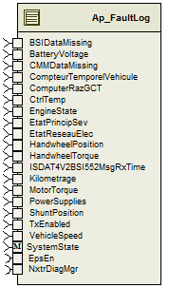

Variable Data Dictionary

User defined typedef definition/declaration
Typedef Name | Element Name | User Defined Type | Legal Range  (min) | Legal Range  (max)
FaultDataType | Byte1_Cnt_u08 | uint8 | 0 | 255
FaultDataType | Byte2_Cnt_u08 | uint8 | 0 | 255
FaultDataType | Byte3_Cnt_u08 | uint8 | 0 | 255
FaultDataType | Byte4_Cnt_u08 | uint8 | 0 | 255
FaultDataType | Byte5_Cnt_u08 | uint8 | 0 | 255
FaultDataType | Byte6_Cnt_u08 | uint8 | 0 | 255
FaultDataType | Reserved1_Cnt_u08 | uint8 | 0 | 255
FaultDataType | Reserved2_Cnt_u08 | uint8 | 0 | 255
QueueDataType | QueueEventIdx_Cnt_u08 | uint8 | 0 | 255
QueueDataType | Status_Cnt_u08 | uint8 | 0 | 255
FaultDataArrayType | N/A | FaultDataType[60] | N/A | N/A
QueueDataArrayType | N/A | QueueDataType[120] | N/A | N/A
FaultLogType | CTCFailData | FaultDataArrayType | N/A | N/A
FaultLogType | CTCPassData | FaultDataArrayType | N/A | N/A
FaultLogType | QueueData | QueueDataArrayType | N/A | N/A

Variable definition for enumerated types
Enum Name | Element Name | Value
None

Constant Data Dictionary

Program(fixed) Constants

Embedded Constants

Local
Constant Name | Resolution | Units | Value
D_NUMDTCS_CNT_U16 | 1 | Counts | 52
D_BUFSIZE_CNT_U16 | 1 | Counts | 120
D_WORDMASK_CNT_U32 | 1 | Counts | 0xFFFF
D_BYTEMASK_CNT_U32 | 1 | Counts | 0xFF
D_1BITMASK_CNT_U08 | 1 | Counts | 0x01
D_2BITMASK_CNT_U08 | 1 | Counts | 0x03
D_3BITMASK_CNT_U08 | 1 | Counts | 0x07
D_4BITMASK_CNT_U08 | 1 | Counts | 0x0F
D_BYTESHIFT_CNT_S16 | 1 | Counts | 8
D_0BITSHIFT_CNT_S16 | 1 | Counts | 0
D_3BITSHIFT_CNT_S16 | 1 | Counts | 3
D_4BITSHIFT_CNT_S16 | 1 | Counts | 4
D_5BITSHIFT_CNT_S16 | 1 | Counts | 5
D_6BITSHIFT_CNT_S16 | 1 | Counts | 6
D_7BITSHIFT_CNT_S16 | 1 | Counts | 7
D_FAILBITMASK_CNT_U08 | 1 | Counts | 1
D_BYTEWORDMASK_CNT_U32 | 1 | Counts | 0xFFFFFF
D_3BYTESHIFT_CNT_S16 | 1 | Counts | 24
D_FIRSTFRAMEID_CNT_U08 | 1 | Counts | 1
D_SECONDFRAMEID_CNT_U08 | 1 | Counts | 2
D_JDD2010EPSNODEID_CNT_U08 | 1 | Counts | 0x95
D_JDD2004EPSNODEID_CNT_U08 | 1 | Counts | 0x15
D_CTVINVALID_CNT_U32 | 1 | Counts | 0xFFFFFFFF
D_CTVUNKNOWN_CNT_U32 | 1 | Counts | 0xFFFFFFFE
D_RAZGCTUNKNOWN_CNT_U08 | 1 | Counts | 0xFF
D_RAZGCTINVALID_CNT_U08 | 1 | Counts | 0xFE
D_CTLMAX_CNT_U16 | 1 | Counts | 65535
D_RHINVALID_CNT_U32 | 1 | Counts | 0xFFFFFFFF
D_HUNDREDMSDELAYLOOPS_CNT_U16 | 1 | Counts | 10
D_ONESECDELAYLOOPS_CNT_U16 | 1 | Counts | 100
D_TXNUMOFATTEMPTS_CNT_U16 | 1 | Counts | 3
D_TXNUMOFPROCESSES_CNT_U16 | 1 | Counts | 3
D_JDD2010BYTE1INIT_CNT_U32 | 1 | Counts | 0xFF
D_JDD2010BYTE2INIT_CNT_U32 | 1 | Counts | 0xFF
D_JDD2010BYTE3INIT_CNT_U32 | 1 | Counts | 0xFF
D_JDD2010BYTE4INIT_CNT_U32 | 1 | Counts | 0xF8
D_JDD2010BYTE5INIT_CNT_U32 | 1 | Counts | 0x0F
D_JDD2010BYTE6INIT_CNT_U32 | 1 | Counts | 0xF0
D_JDD2010RESERVEDINIT_CNT_U08 | 1 | Counts | 0xFF
D_JDD2004BYTE1INIT_CNT_U08 | 1 | Counts | 0xFF
D_JDD2004BYTE2INIT_CNT_U08 | 1 | Counts | 0xFF
D_JDD2004BYTE3INIT_CNT_U08 | 1 | Counts | 0x7F
D_JDD2004BYTE4INIT_CNT_U08 | 1 | Counts | 0x7F
D_JDD2004BYTE5INIT_CNT_U08 | 1 | Counts | 0x7F
D_JDD2004BYTE6INIT_CNT_U08 | 1 | Counts | 0xFF
D_JDD2004RESERVED1INIT_CNT_U08 | 1 | Counts | 0xFF
D_JDD2004RESERVED2INIT_CNT_U08 | 1 | Counts | 0x7F
D_NUMBEROFFRAMES_CNT_U08 | 1 | Counts | 2
D_DTCSTATEPASSED_CNT_U08 | 1 | Counts | 0
D_DTCSTATEFAILED_CNT_U08 | 1 | Counts | 1
D_JDD2010TYPEOFMESSAGE_CNT_U08 | 1 | Counts | 1
D_JDD2004TYPEOFMESSAGE_CNT_U08 | 1 | Counts | 0
D_RCDAUTOMATESTATE_CNT_U08 | 1 | Counts | 7
D_KILOMETRAGEMSB_CNT_U32 | 1 | Counts | 0x800000
D_STATUSFAILED_CNT_U08 | 1 | Counts | 0x01
D_STATUSPASSED_CNT_U08 | 1 | Counts | 0x02
D_STATUSEMPTY_CNT_U08 | 1 | Counts | 0xFF
D_STATEIDLE_CNT_U08 | 1 | Counts | 0
D_STATEFIRSTMSGTX_CNT_U08 | 1 | Counts | 1
D_STATEWAITFORACK_CNT_U08 | 1 | Counts | 2
D_STATEONESECDELAY_CNT_U08 | 1 | Counts | 3
D_VEHSPDLOLMT_KPH_F32 | Single | Kph | 0
D_VEHSPDHILMT_KPH_F32 | Single | Kph | 254
D_HWTRQLOLMT_HWNM_F32 | Single | HwNm | -10
D_HWTRQHILMT_HWNM_F32 | Single | HwNm | 10
D_HWTRQSCALE_HWNMPCNT_F32 | Single | HwNm/Cnt | 0.125
D_HWPOSLOLMT_HWDEG_F32 | Single | HwDeg | -776
D_HWPOSHILMT_HWDEG_F32 | Single | HwDeg | 776
D_HWPOSSCALE_HWDEGPCNT_F32 | Single | HwDeg/Cnt | 8
D_MTRTRQLOLMT_MTRNM_F32 | Single | MtrNm | -3.5
D_MTRTRQHILMT_MTRNM_F32 | Single | MtrNm | 3.5
D_MTRTRQSCALE_MTRNMPCNT_F32 | Single | MtrNm/Cnt | 0.03125
D_VBATTLOLMT_VOLT_F32 | Single | Volt | 0
D_VBATTHILMT_VOLT_F32 | Single | Volt | 28
D_VBATTSCALE_VOLTPCNT_F32 | Single | Volt/Cnt | 0.125
D_CTRLTEMPLOLMT_DEGC_F32 | Single | DegC | -40
D_CTRLTEMPHILMT_DEGC_F32 | Single | DegC | 160
D_CTRLTEMPOFFSET_DEGC_F32 | Single | DegC | 40

Global
Constant Name
Dem_DTCNumberTable
Dem_DTC_FTB_Table

Module specific Lookup Tables Constants
Constant Name | Resolution | Value | Software Segment
None

Library Functions / Macros
NvM_GetErrorStatus
NvM_WriteBlock

Data Hiding Functions
Rte_Pim_FaultLog
IlGetRxDATA_ACQ_JDD_BSI_2
IlGetRxDATA_ACQ_JDD_BSI
IlPutTxNumber_of_Frames
IlPutTxType_of_Message
IlPutTxDTC_State
IlPutTxFrame_Number
IlPutTxJDD_Byte1
IlPutTxJDD_Byte2
IlPutTxJDD_Byte3
IlPutTxJDD_Byte4
IlPutTxJDD_Byte5
IlPutTxJDD_Byte6
IlPutTxJDD_Byte7

Software Module Implementation

Initialization Functions

Init: FaultLog_Init1

Design Rationale
The values for reference time (RH_Cnt_M_u32[]) and the transmit signal (Transmit_Cnt_M_lgc[]) are not stored in NvM, as any remaining items in the queue have these values set to invalid and FALSE, respectively. The entire array is initialized to these values on startup. JDD2004 does not use the “sync” concept, so any messages in the queue will be set to transmit on initialization.

Module Internal
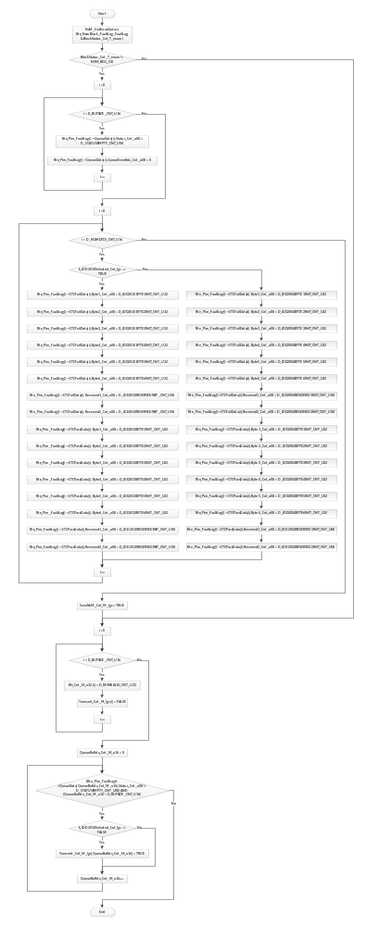

Module Outputs
None

PERIODIC FUNCTIONS

Per: FaultLog_Per1

Design Rationale
This periodic is designed to be run immediately before the SrlComDriver_Per1 runnable. This will allow any faults that have occurred to be sent out with as short a delay as possible. It is restricted from running in the OFF state, as this may result in inaccurate or corrupt NvM data.

This module uses several different buffers to keep track of fault data and queueing. Specifically, the QueueData (part of the FaultLog stored in NvM) tracks events that are to be sent out on the bus. The Transmit buffer logs whether a fault is ready to be transmitted, and the RH buffer tracks the time for each fault. Note that all of these buffers are indexed together, and the sizes must remain the same. These buffers are formatted such that the first element in the array is the next element to be sent on the bus (FIFO). Once the fault is considered transmitted, it is removed from the queue and the entire queue is shifted in a for() loop. This means that element 0 is always monitored for transmission.

The message transmission state machine is formatted such that it checks for the idle state again after all other states have been checked. This allows a new fault to be sent out immediately after processing ends for the previous fault.

The Tx message is triggered with the FrameNumber signal. When this value is written, the message is triggered to send. It is necessary, therefore, to ensure that this is the last signal that is written before sending the message.

Store Module Inputs to Local copies
CompteurTemporelVehicule_Cnt_T_u32 = Rte_IRead_FaultLog_Per1_CompteurTemporelVehicule_Cnt_u32()
ComputerRazGCT_Cnt_T_u08 = Rte_IRead_FaultLog_Per1_ComputerRazGCT_Cnt_u08()
ISDAT4V2BSI552MsgRxTime_mS_T_u32 = Rte_IRead_FaultLog_Per1_ISDAT4V2BSI552MsgRxTime_MSec_u32()
TxEnabled_Cnt_T_lgc = Rte_IRead_FaultLog_Per1_TxEnabled_Cnt_lgc()

Process local timer
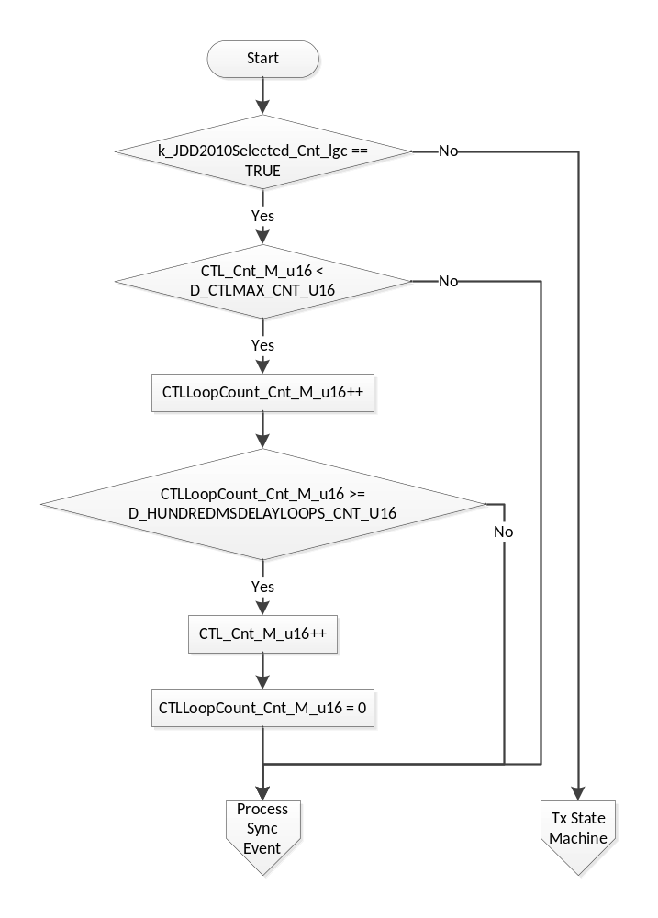

Process Sync Event
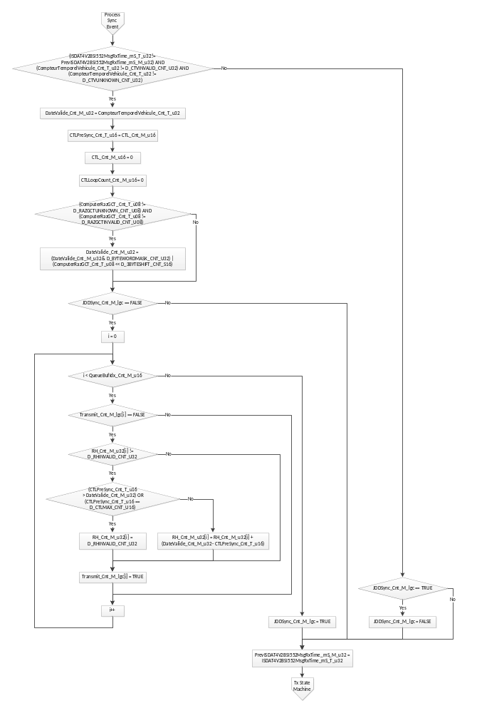

Transmission State Machine
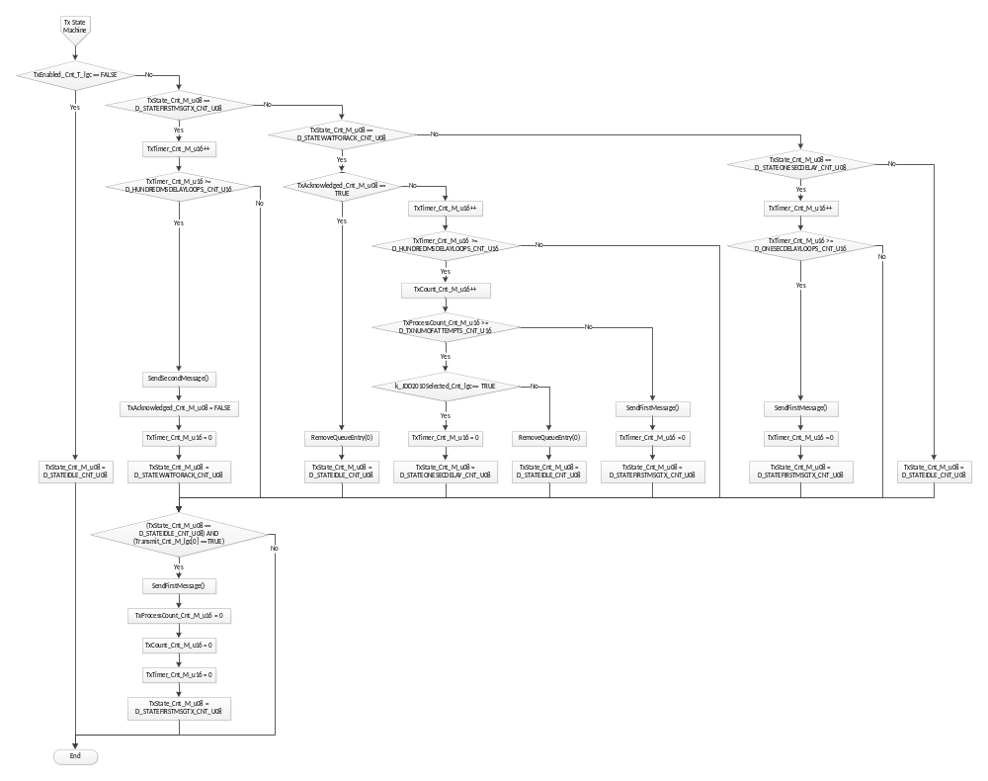

Store Local copy of outputs into Module Outputs
None

Interrupt Functions
None

TRANSIENT FUNCTIONS

Trns: FaultLog_Trns1

Design Rationale
If any changes have been made to NvM data, this function saves those changes in NvM.

Store Module Inputs to Local copies
None

Store NvM Data
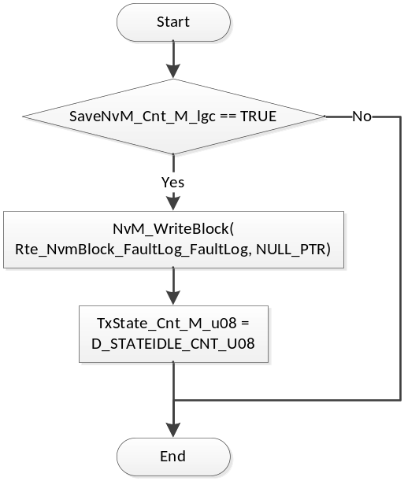

Store Local copy of outputs into Module Outputs
None

Serial Communication Functions

SComm: FaultLog_DTCStatusChanged

Design Rationale
This function is a callback from the DEM module. The function is called on any status change; it is required to test the old and new states to see whether there is a transition between Current and History (indicated by the Failed bit, bit 0).

When a failure is to be added to the queue, the queue is checked for any other events for the given CTC. If any are found, they are removed from the queue (as only the latest failure or the latest failure/history combination is reported). If the fault is passed, the queue is not checked (as it was already checked when the failure was logged). Note that if a transmission of this CTC is already in progress, it is allowed to complete.

The drivers for the PSA program are unable to handle multiplexed messages that are not sent periodically. It is necessary to handle message packing manually, so the interface to the message data is given in raw format (Byte1, Byte2, etc.). To allow for more efficient use of RAM and NvM, the stored data is “packed” according to the message format when the fault is logged, rather than when the message is to be transmitted. For JDD2010, the NvM values of Byte1 through Byte6 correspond to bytes 1 through 6 of the second transmission frame. For JDD2004, the bytes are used differently; bytes 1 through 3 correspond to those same bytes in the second frame. Bytes 4 through 6 correspond to the same bytes in the first frame. Reserved1 is used for byte 3 in the first frame, and Reserved2 is used for byte 7 in the first frame. Reserved bytes were added to the structure in the previous design for future expansion, and are now used as part of the 2004 functionality.

Store Module Inputs to Local copies
Rte_Read_BSIDataMissing_Cnt_lgc(&BSIDataMissing_Cnt_T_lgc)
Rte_Read_BatteryVoltage_Volt_f32(&BatteryVoltage_Volt_T_f32)
Rte_Read_CMMDataMissing_Cnt_lgc(&CMMDataMissing_Cnt_T_lgc)
Rte_Read_CtrlTemp_DegC_f32(&CtrlTemp_DegC_T_f32)
Rte_Read_EngineState_Cnt_u08(&EngineState_Cnt_T_u08)
Rte_Read_EtatPrincipSev_Cnt_u08(&EtatPrincipSev_Cnt_T_u08)
Rte_Read_EtatReseauElec_Cnt_u08(&EtatReseauElec_Cnt_T_u08)
Rte_Read_HandwheelPosition_HwDeg_f32(&HandwheelPosition_HwDeg_T_f32)
Rte_Read_HandwheelTorque_HwNm_f32(&HandwheelTorque_HwNm_T_f32)
Rte_Read_Kilometrage_Cnt_u32(&Kilometrage_Cnt_T_u32)
Rte_Read_MotorTorque_MtrNm_f32(&MotorTorque_MtrNm_T_f32)
Rte_Read_PowerSupplies_Cnt_u08(&PowerSupplies_Cnt_T_u08)
Rte_Read_ShuntPosition_Cnt_u08(&ShuntPosition_Cnt_T_u08)
Rte_Read_VehicleSpeed_Kph_f32(&VehicleSpeed_Kph_T_f32)
SystemState_Cnt_T_enum = Rte_Mode_SystemState_Mode()
Rte_Call_EpsEn_OP_GET(&EpsEn_Cnt_T_lgc)
Rte_Call_NxtrDiagMgr_GetNTCFailed(NTC_Num_DutyCycleExceeded, &DutyCycleExceeded_Cnt_T_lgc)
Rte_Call_NxtrDiagMgr_GetNTCFailed(NTC_Num_AbsTempThermLimit, &AbsTempThermLimit_Cnt_T_lgc)

Process Inputs
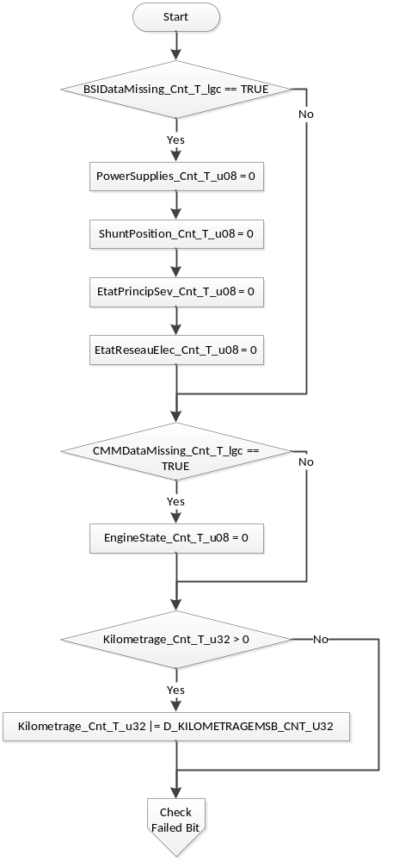

Check for Failed Bit and Look up CTC in DEM Tables
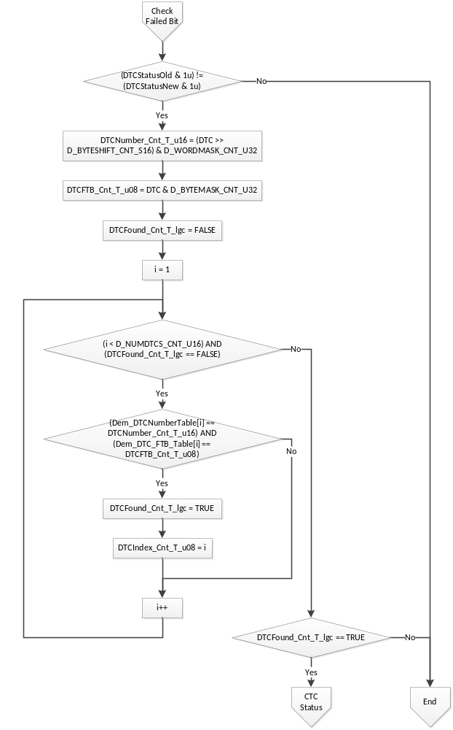

Determine New CTC Status, Process Queue
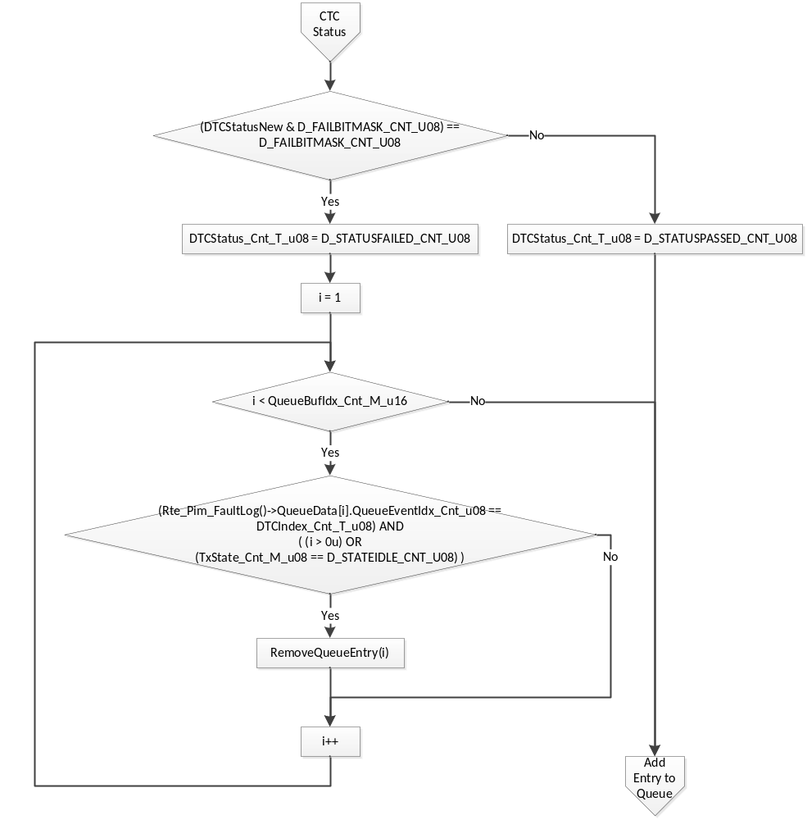

Add Entry to Queue
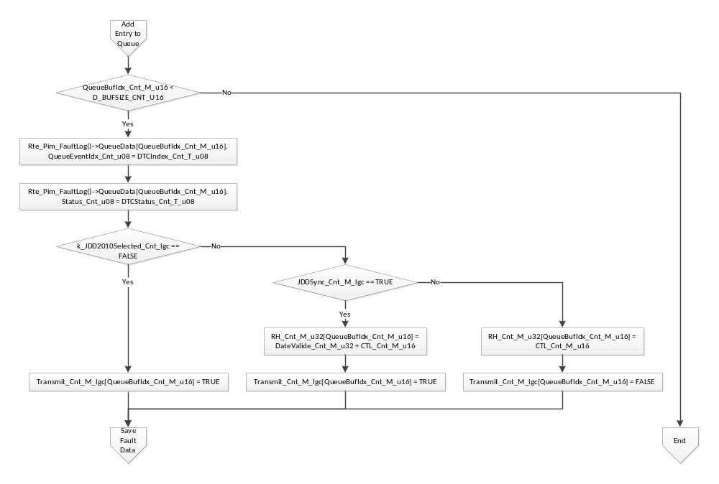

Save Fault Data
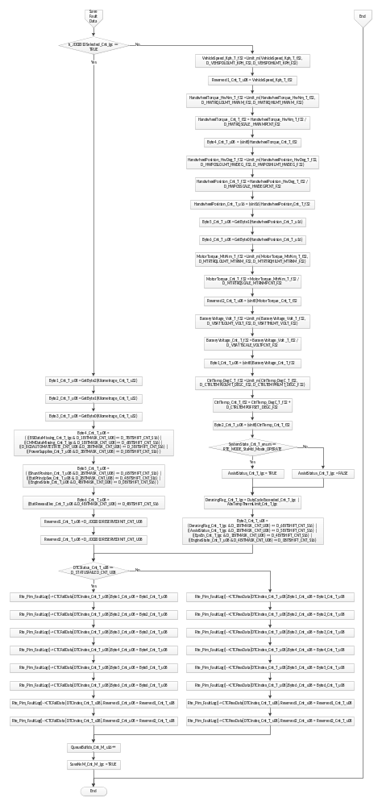

Store Local copy of outputs into Module Outputs
None

Local Function/Macro Definitions

GetByte0
Function Name | GetByte0 | Type | Min | Max
Arguments Passed | a | varies | varies | varies
Return Value | a & 0xFF | uint8 | 0 | 255

GetByte1
Function Name | GetByte1 | Type | Min | Max
Arguments Passed | a | varies | varies | varies
Return Value | (a >> 8) & 0xFF | uint8 | 0 | 255

GetByte2
Function Name | GetByte2 | Type | Min | Max
Arguments Passed | a | varies | varies | varies
Return Value | (a >> 16) & 0xFF | uint8 | 0 | 255

GetByte3
Function Name | GetByte3 | Type | Min | Max
Arguments Passed | a | varies | varies | varies
Return Value | (a >> 24) & 0xFF | uint8 | 0 | 255

Remove Queue Entry
Function Name | RemoveQueueEntry | Type | Min | Max
Arguments Passed | Index_Cnt_T_u16 | uint16 | 0 | 120
Return Value | N/A

Description
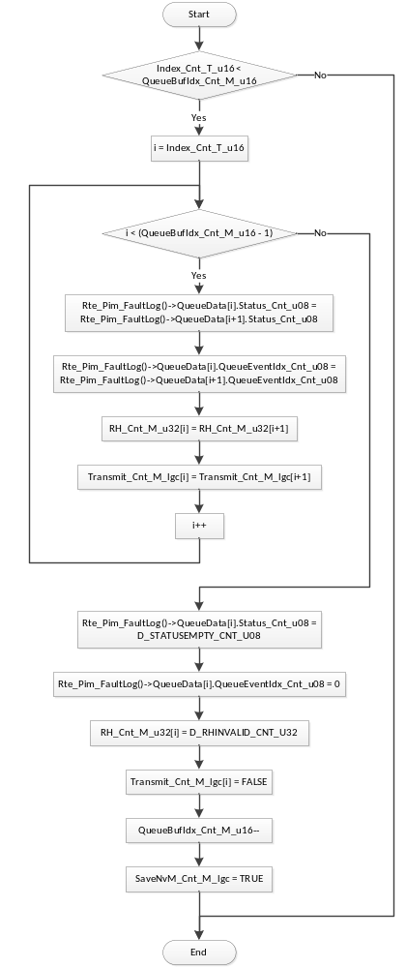

Send First Message
Function Name | SendFirstMessage | Type | Min | Max
Arguments Passed | None
Return Value | N/A

Description
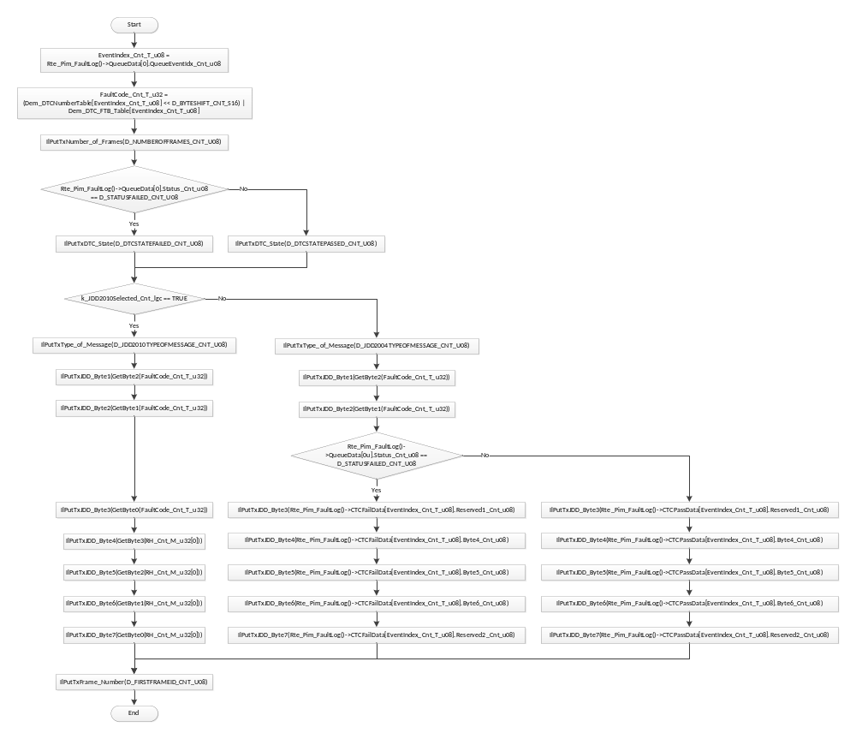

Send Second Message
Function Name | SendSecondMessage | Type | Min | Max
Arguments Passed | None
Return Value | N/A

Description
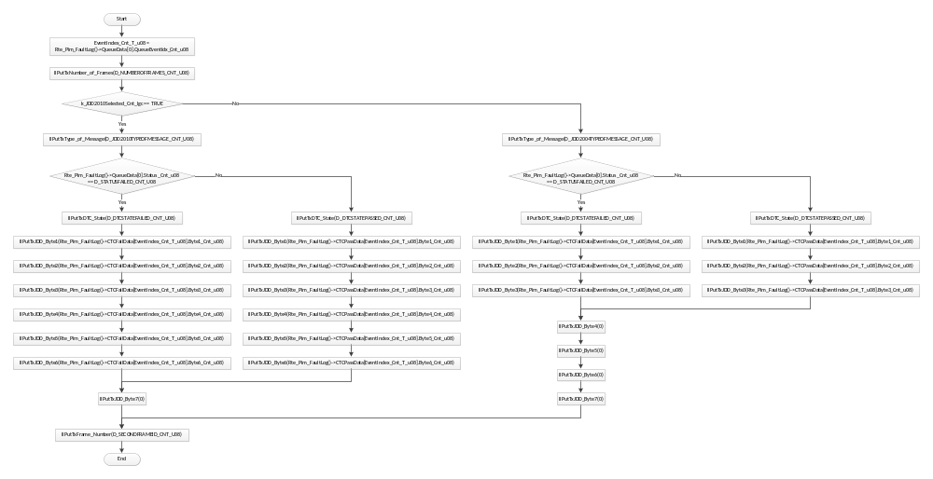

GLObAL Function/Macro Definitions

IS_ACQ_NEW_JDD_55F Callback Handler
Function Name | FaultLog_RxISACQNEWJDD55F | Type | Min | Max
Arguments Passed | rcvObject | CanReceiveHandle
Return Value | N/A

Description
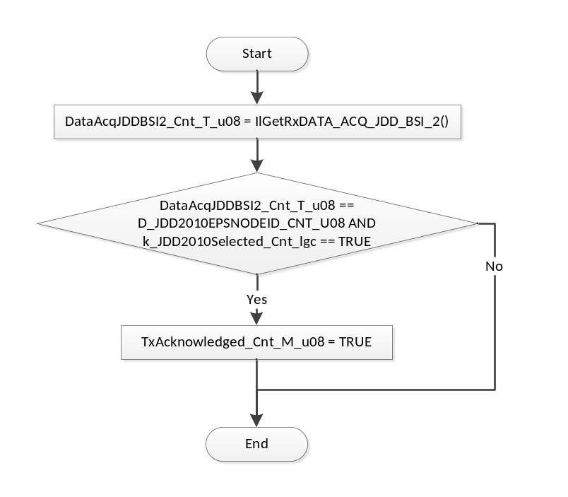

IS_ACQ_JDD_CAN_BSI_772 Callback Handler
Function Name | FaultLog_RxISACQJDDCANBSI772 | Type | Min | Max
Arguments Passed | rcvObject | CanReceiveHandle
Return Value | N/A

Description
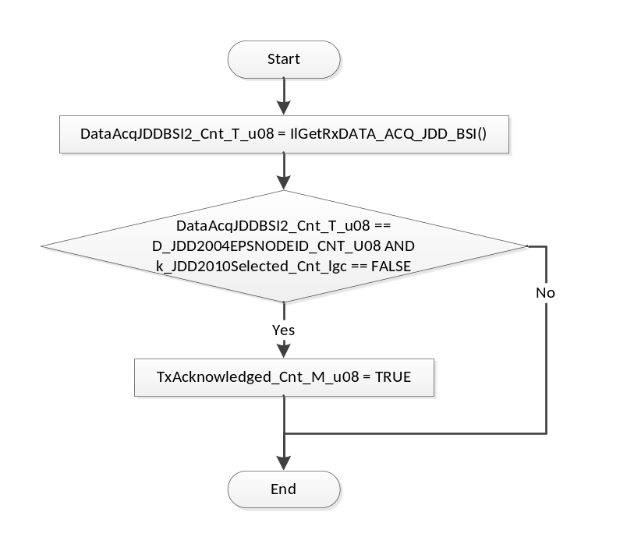

Known Limitations With Design
None

UNIT TEST CONSIDERATION
None

Appendix
None

