Module Design Document
For
SrlComDriver

VERSION: 7
DATE: 21-May-18
Location: The official version of this document is stored in the Nexteer Configuration Management System.

Revision History

Sl. No. | Description | Author | Version | Date
1 | Initial Version | Owen Tosh | 1 | 09-Sep-2014
2 | Updates for new city park messages | Owen Tosh | 2 | 17-Sep-2014
3 | Updates for other new SCom messages | Owen Tosh | 3 | 29-Sep-2014
4 | Updates for new customer services | Owen Tosh | 4 | 09-Oct-2014
5 | Updates for remaining customer messages | Owen Tosh | 5 | 17-Oct-2014
6 | Updates for tuning sets | Owen Tosh | 6 | 21-Oct-2014
7 | Updates for fault logbook | Owen Tosh | 7 | 11-Nov-2014
8 | Removed ClearDTC logic from elec integration | Owen Tosh | 8 | 13-Jan-2015
9 | Added 2004 functionality | Owen Tosh | 9 | 1-May-2015
10 | Updates for message 552 DLC | Owen Tosh | 10 | 27-Oct-2015
11 | Added BusOff output | Owen Tosh | 11 | 14-Dec-2015
12 | Added call-out functions to disable interrupts in supervisor mode | Akilan Rathakrishnan | 12 | 19-Dec-2016
13 | Added call-out function to block $305 transmit when Turns counter not enabled | Akilan Rathakrishnan | 13 | 13-Mar-2017
14 | Update to release VC1.1 SCIR ver. 2H | Robert Konieczny | 4 | 20-Dec-2017
15 | Fix for CAN Bus off recovery scenario | Robert Konieczny | 5 | 09-Feb-2018
16 | CTC Inhibition EA3#13314 | Robert Konieczny | 6 | 30-Mar-2018
17 | Update to SCIR 4C | Mateusz Bartocha | 7 | 21-May-2018

Be careful about those versios. It wasn’t reset as Synergy version when project was branched from BMPV.
Table of Contents
1 Abbrevations And Acronyms 7
2 References 8
3 SrlComDriver & High-Level Description 9
4 Design details of software module 10
4.1 Graphical representation of SrlComDriver 10
4.2 Data Flow Diagram 11
4.3 COMPONENT DIAGRAM 11
5 Variable Data Dictionary 12
5.1 User defined typedef definition/declaration 12
5.2 Variable definition for enumerated types 12
6 Constant Data Dictionary 13
6.1 Program(fixed) Constants 13
6.1.1 Embedded Constants 13
6.1.1.1 Local 13
6.1.1.2 Global 13
6.1.2 Module specific Lookup Tables Constants 13
6.1.3 Library Functions / Macros 13
6.1.4 Data Hiding Functions 13
7 Software Module Implementation 15
7.1 Initialization Functions 15
7.1.1 Init: SrlComDriver_Init1 15
7.1.1.1 Design Rationale 15
7.1.1.2 Processing 15
7.2 PERIODIC FUNCTIONS 16
7.2.1 Per: SrlComDriver_Per1 16
7.2.1.1 Design Rationale 18
7.2.1.2 Store Module Inputs to Local copies 18
7.2.1.3 Store Local copy of outputs into Module Outputs 18
7.3 Interrupt Functions 18
7.4 TRANSIENT FUNCTIONS 18
7.4.1 TRNS: SrlComDriver_Trns1 18
7.4.1.1 Design Rationale 18
7.4.1.2 Store Module Inputs to Local copies 18
7.4.1.3 Start Tx 19
7.4.1.4 Store Local copy of outputs into Module Outputs 19
7.4.2 TRNS: SrlComDriver_Trns2 19
7.4.2.1 Design Rationale 19
7.4.2.2 Store Module Inputs to Local copies 19
7.4.2.3 Stop Tx 20
7.4.2.4 Store Local copy of outputs into Module Outputs 20
7.5 Serial Communication Functions 21
7.5.1 SCOM: SrlComDriver_SCom_ElecIntStart 21
7.5.1.1 Design Rationale 21
7.5.1.2 Stop Tx and Disable DEM 21
7.5.2 SCOM: SrlComDriver_SCom_ElecIntStOP 22
7.5.2.1 Design Rationale 22
7.5.2.2 Start TX and Enable DEM 22
7.5.3 SCOM: SrlComDriver_SCom_SendMsgOnChange 22
7.5.3.1 Design Rationale 22
7.5.3.2 Return Bus Off Counter 23
7.6 Local Function/Macro Definitions 23
7.6.1 SCOM: SrlComDriver_SCom_GetBusOffCounter 23
7.6.1.1 Design Rationale 23
7.6.1.2 Return Bus Off Counter 23
7.7 Local Function/Macro Definitions 23
7.7.1 SCOM: SrlComDriver_Reinit 23
7.7.1.1 Design Rationale 23
7.7.1.2 Processing 23
7.8 GLObAL Function/Macro Definitions 26
7.8.1 SrlComDriver_BusOff 26
7.8.1.1 Description 26
7.8.2 ApplCanBusOff 26
7.8.2.1 Description 27
7.8.3 ApplCanMsgDlcFailed 28
7.8.3.1 Description 28
7.8.4 SrlComDriver_PreRxISDYNVOL 29
7.8.4.1 Description 29
7.8.5 SrlComDriver_RxISDYNCMM388 30
7.8.5.1 Description 30
7.8.6 SrlComDriver_RxISDYN2FRE3CD 30
7.8.6.1 Description 31
7.8.7 SrlComDriver_RxISDYNCDS34D 31
7.8.7.1 Description 32
7.8.8 SrlComDriver_RxISDATABR50D 32
7.8.8.1 Description 33
7.8.9 SrlComDriver_RxISDYNCMM208 33
7.8.9.1 Description 34
7.8.10 SrlComDriver_RxISDYN2CMM 35
7.8.10.1 Description 35
7.8.11 SrlComDriver_PreRxISDYNABR 35
7.8.11.1 Description 36
7.8.12 SrlComDriver_PreRxISDYNAAS 37
7.8.12.1 Description 37
7.8.13 SrlComDriver_PreRxISDAT4V2BSI552 38
7.8.13.1 Description 39
7.8.14 SrlComDriver_RxISDATBSI3F2 40
7.8.14.1 Description 41
7.8.15 SrlComDriver_PreRxISDATBSI 43
7.8.15.1 Description 43
7.8.16 SrlComDriver_RxISDATBSI412 43
7.8.16.1 Description 43
7.8.17 SrlComDriver_RxISDATBSI432 44
7.8.17.1 Description 45
7.8.18 SrlComDriver_RxISINTEELECTRONBSI 46
7.8.18.1 Description 46
7.8.19 SrlComDriver_SendIsSupvDira 46
7.8.19.1 Description 47
7.8.20 SrlComDriver_PreTxISSUPVDIRA 47
7.8.20.1 Description 47
7.8.21 SrlComDriver_PreTxISDATDIRA 47
7.8.21.1 Description 47
7.8.22 SrlComDriver_TxISDATDIRA 48
7.8.22.1 Description 49
7.8.23 SrlComDriver_PreTxISDYNDAE 50
7.8.23.1 Description 50
7.8.24 SrlComDriver_TxISDYNDAE 50
7.8.24.1 Description 51
7.8.25 ApplCanAddCanInterruptDisable 51
7.8.25.1 Description 51
7.8.26 ApplCanAddCanInterruptRestore 51
7.8.26.1 Description 51
7.8.27 ApplIlTxStart 51
7.8.27.1 Description 51
7.8.28 SrlComDriver_PreRxPROTOHS1DYNUCF5CD 51
7.8.28.1 Description 52
7.8.29 SrlComDriver_PreTxISDYNVOL 52
7.8.29.1 Description 53
7.8.30 SrlComDriver_RxISDATBSI572 54
7.8.30.1 Description 54
7.8.31 SrlComDriver_TXisdynvol 54
7.8.31.1 Description 54
8 Known Limitations With Design 55
9 UNIT TEST CONSIDERATION 56
10 Appendix 57

Abbrevations And Acronyms
Abbreviation | Description
DFD | Design functional diagram
MDD | Module design Document

References
This section Lists the title & version of all the documents that are referred for development of this document
Sr. No. | Title | Version
1 | MDD Guidelines | 1
2 | Software Naming Conventions | 1
3 | Coding standands | 1
4 | PSA CMP SCIR | 003B

SrlComDriver & High-Level Description
This module provides an interface between the SCom signal processing components SrlComInput and SrlComOutput, and the drivers provided by Vector. This module handles all driver-level callback functions, as well as the BusOff NTC.

Design details of software module

Graphical representation of SrlComDriver

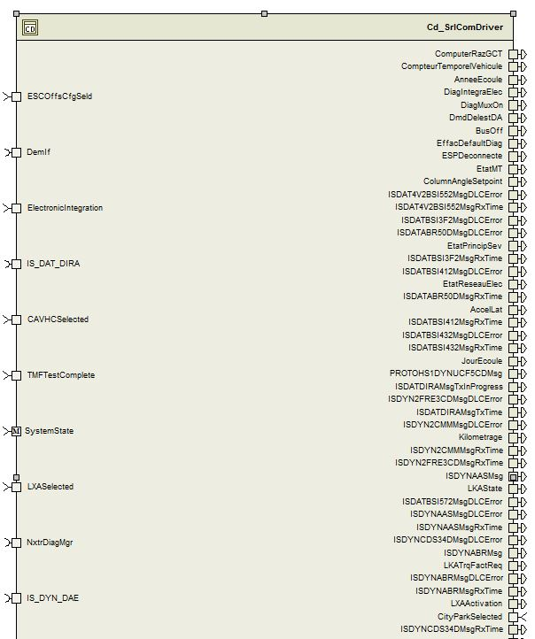
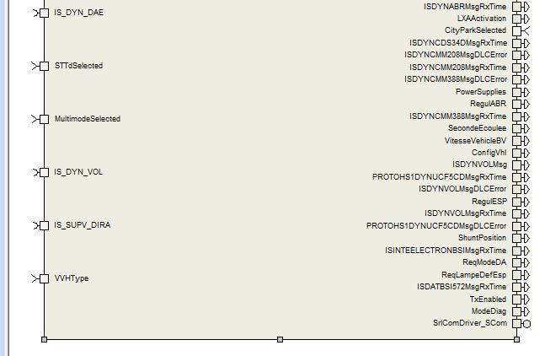

Data Flow Diagram
None

COMPONENT DIAGRAM

None

Variable Data Dictionary

User defined typedef definition/declaration
Typedef Name | Element Name | User Defined Type | Legal Range  (min) | Legal Range  (max)
None

Variable definition for enumerated types

Constant Data Dictionary

Program(fixed) Constants

Embedded Constants

Local
Constant Name | Resolution | Units | Value
D_BUSOFF_RECOVERY_TIME_SHORT_MS_U16 | 1 | ms | 50
D_BUSOFF_RECOVERY_TIME_LONG_MS_U16 | 1 | ms | 250
D_BUSOFF_RECOVERY_LIMIT_CNT_U16 | 1 | uls | 10
D_BUSOFF_NTC_LIMIT_CNT_U16 | 1 | uls | 16
D_BUSOFF_COUNTER_LIMIT_CNT_U16 | 1 | uls | 255

Global
Constant Name
kCanInitObj1
CanRxIS_DYN_VOL
CanRxIS_DYN_CMM_388
CanRxIS_DYN_CMM_208
CanRxIS_DYN2_CMM_348
CanRxIS_DYN_AAS
CanRxIS_DYN_ABR
CanRxIS_DAT4_V2_BSI_552
CanRxIS_DAT_BSI_3F2
CanRxIS_DAT_BSI_412
CanRxIS_DAT_BSI_432
kCanNoCopyData
kCanCopyData
D_MANUFDATEINIT_CNT_STR

Module specific Lookup Tables Constants
Constant Name | Resolution | Value | Software Segment
None

Library Functions / Macros
GetSystemTime_mS_u32

Data Hiding Functions
Rte_Call_SystemTime_GetSystemTime_mS_u32
Rte_Call_SystemTime_DtrmnElapsedTime_mS_u16
Rte_Call_NxtrDiagMgr_SetNTCStatus
IlRxStart
IlTxStart
IlTxStop
IlPutTxSystem_Code
IlPutTxDownload_Day
IlPutTxDownload_Month
IlPutTxDownload_Year
IlPutTxApplication_Code
IlPutTxSoftware_Version
IlPutTxSoftware_Edition_MSB
IlPutTxSoftware_Edition_LSB
IlPutTxANGLE_COLONNE
IlPutTxAUTOR_ARRET_MOT_DA
IlPutTxCAUSE_DESACTIV_CPK
IlPutTxCODE_DEFAUT
IlPutTxCPLE_VOLANT_OPTMSE
IlPutTxCPLE_VOLANT
IlPutTxDDE_REDEM_DA
IlPutTxETAT_ASSIST_DA
IlPutTxETAT_DA_2004
IlPutTxETAT_DA_2010
IlPutTxETAT_DA_DYN
IlPutTxETAT_DAE_CPK
IlPutTxETAT_LIGNE_APC
IlPutTxETAT_SECU_ANGLE_COL
IlPutTxSTATUS_CONFABSENT
IlPutTxVITESSE_COLONNE
IlGetRxVITESSE_VEHICLE_BV
IlGetRxDIAG_MUX_ON
IlGetRxETAT_MT
IlGetRxDMD_DELEST_DA
IlGetRxMARCHE_AR_BVM
IlGetRxEFFAC_DEFAULT_DIAG
IlGetRxMODE_DIAG
IlGetRxDIAG_INTEGRA_ELEC
IlGetRxShunt_Position
IlGetRxPower_Supplies
IlGetRxETAT_PRINCIP_SEV
IlGetRxETAT_RESEAU_ELEC
CanRxActualDLC
CanResetBusOffStart
CanResetBusOffEnd
CanStart
CanStop
CanOnline
CanOffline
TpTxTask
IlTxTask
CanTask
IlRxTask
TpRxTask
DescTask
AppDesc_Init2
AppDesc_Per1
EPSDiagSrvcs_Task
IS_DYN_DAE

Software Module Implementation

Initialization Functions

Init: SrlComDriver_Init1

Design Rationale
None

Processing
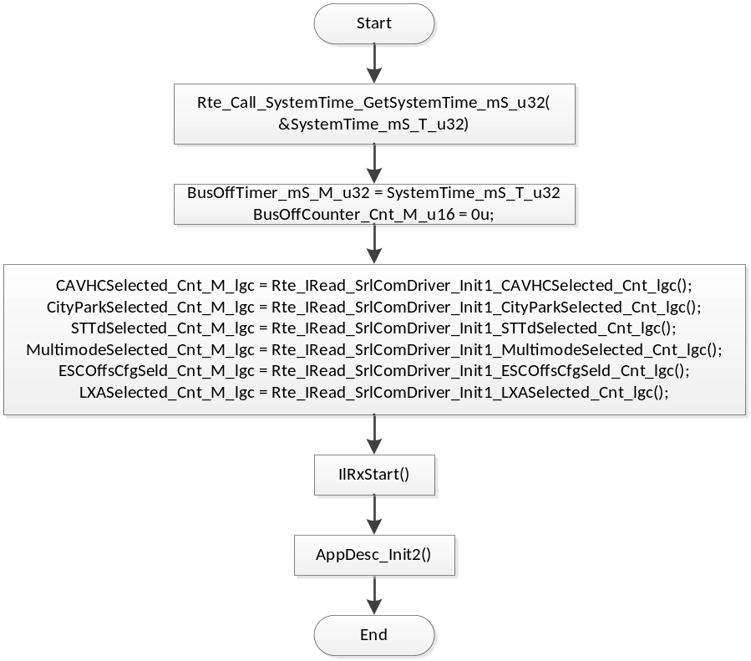

PERIODIC FUNCTIONS

Per: SrlComDriver_Per1
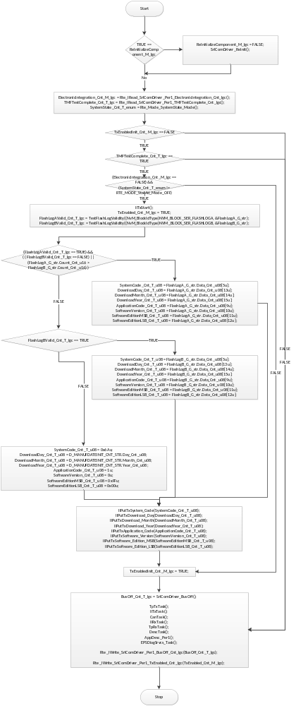

Design Rationale
This periodic is responsible for calling all the communications-related periodic functions of the drivers. These calls are placed between writing the outgoing signals and reading the incoming signals to/from the drivers. Note that because of this configuration, this periodic should be run after the SrlComOutput periodic and before the SrlComInput periodic for minimum latency.

Store Module Inputs to Local copies

CPLEVOLANT_Cnt_T_u08
Cnt_T_u08
ETATDA2010_Cnt_T_u08
SystemCode_Cnt_T_u08
DownloadDay_Cnt_T_u08
DownloadMonth_Cnt_T_u08
DownloadYear_Cnt_T_u08
ApplicationCode_Cnt_T_u08
SoftwareVersion_Cnt_T_u08
SoftwareEditionMSB_Cnt_T_u08
SoftwareEditionLSB_Cnt_T_u08
BusOff_Cnt_T_lgc
TMFTestComplete_Cnt_T_lgc
FlashLogAValid_Cnt_T_lgc
FlashLogBValid_Cnt_T_lgc

Store Local copy of outputs into Module Outputs
BusOff_Cnt_T_lgc
TxEnabled_Cnt_M_lgc

Interrupt Functions
Following function minght be called from Interrupt context:
SrlComDriver_PreTxISDATDIRA
SrlComDriver_PreTxISDYNDAE
SrlComDriver_PreTxISSUPVDIRA
SrlComDriver_PreTxISDYNVOL
ApplCanBusOff
ApplCanAddCanInterruptDisable
ApplCanAddCanInterruptRestore

TRANSIENT FUNCTIONS

TRNS: SrlComDriver_Trns1

Design Rationale
None

Store Module Inputs to Local copies
None

Start Tx
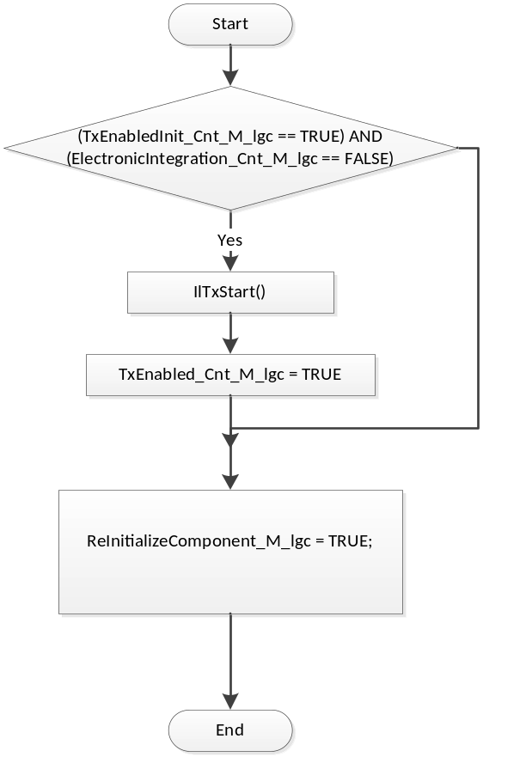

Store Local copy of outputs into Module Outputs
None

TRNS: SrlComDriver_Trns2

Design Rationale
None

Store Module Inputs to Local copies
None

Stop Tx
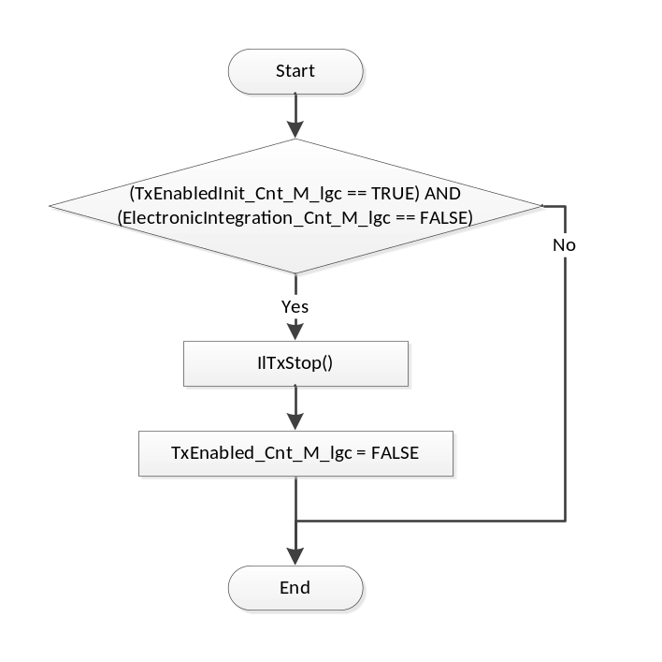

Store Local copy of outputs into Module Outputs
None

Serial Communication Functions

SCOM: SrlComDriver_SCom_ElecIntStart

Design Rationale
None

Stop Tx and Disable DEM
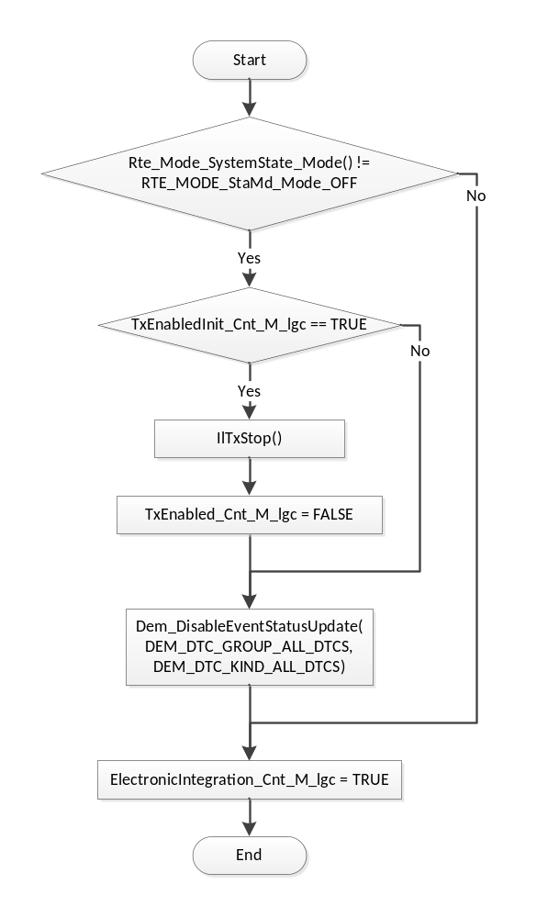

SCOM: SrlComDriver_SCom_ElecIntStOP

Design Rationale
None

Start TX and Enable DEM
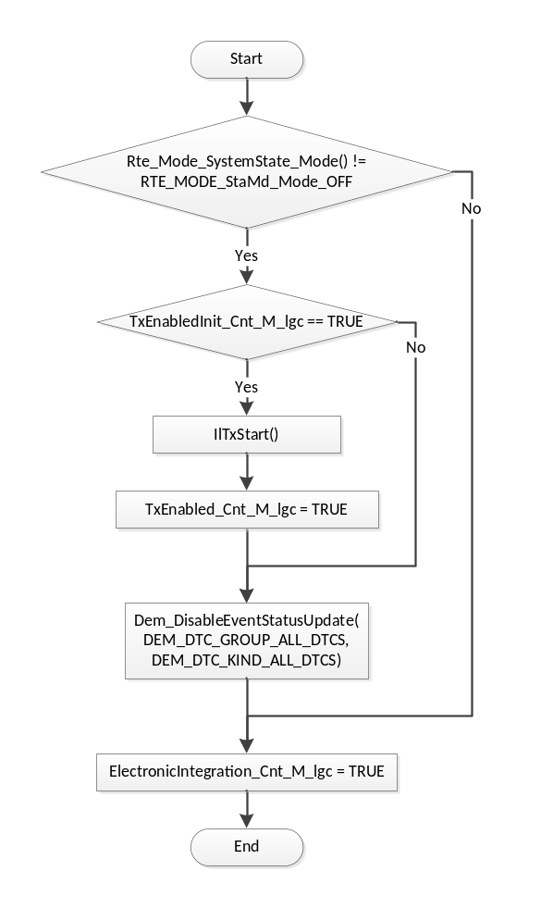

SCOM: SrlComDriver_SCom_SendMsgOnChange

Design Rationale
None

Return Bus Off Counter
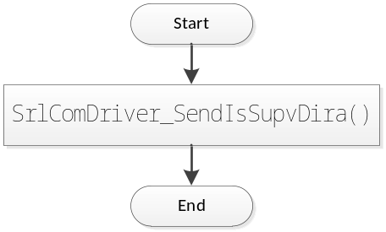

Local Function/Macro Definitions
None

SCOM: SrlComDriver_SCom_GetBusOffCounter

Design Rationale
None

Return Bus Off Counter
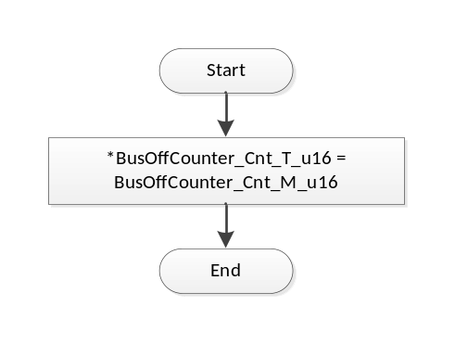

Local Function/Macro Definitions
None

SCOM: SrlComDriver_Reinit

Design Rationale
None

Processing

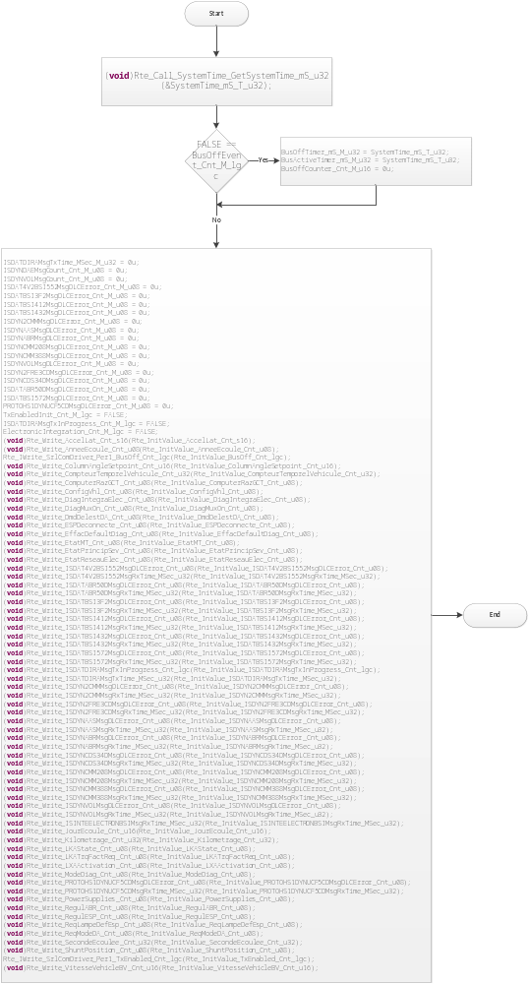

GLObAL Function/Macro Definitions

SrlComDriver_BusOff
Function Name | SrlComDriver_BusOff | Type | Min | Max
Arguments Passed | None | N/A | N/A | N/A
Return Value | BusOff_Cnt_T_lgc | boolean | FALSE | TRUE

Description
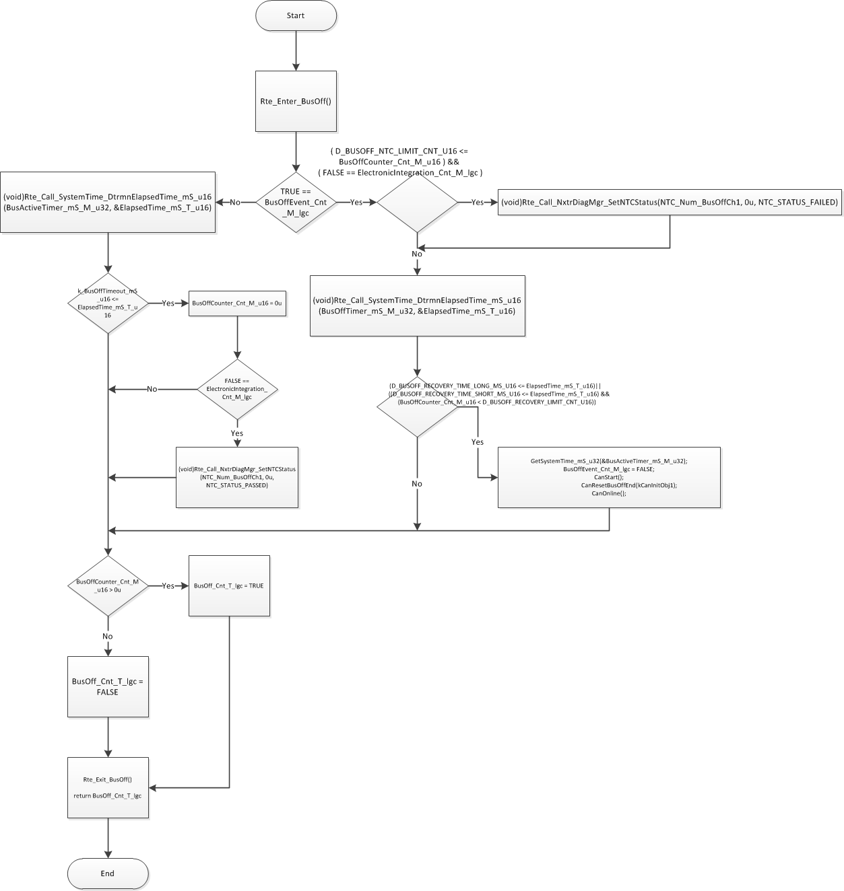

ApplCanBusOff
Function Name | ApplCanBusOff | Type | Min | Max
Arguments Passed | None | N/A | N/A | N/A
Return Value | None | N/A | N/A | N/A

Description
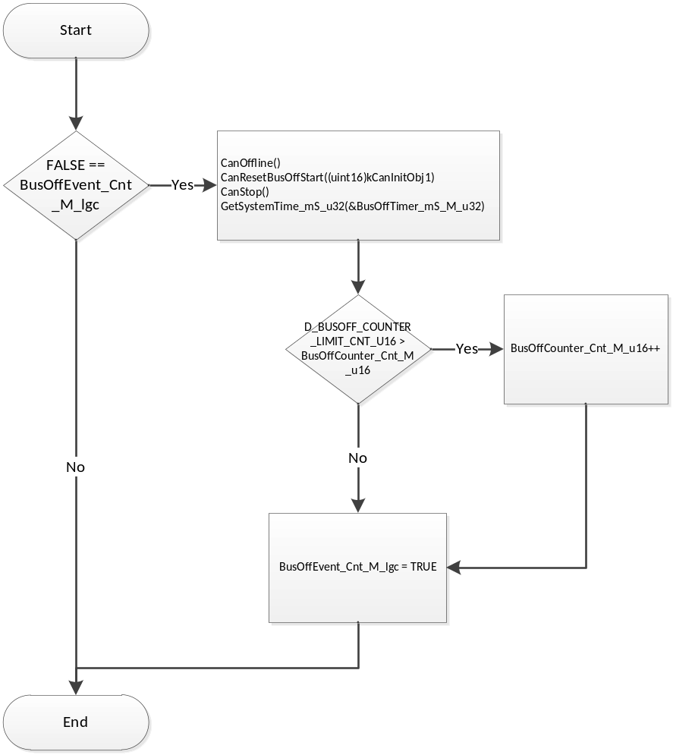

ApplCanMsgDlcFailed
Function Name | ApplCanMsgDlcFailed | Type | Min | Max
Arguments Passed | rxStruct | CanRxInfoStructPtr | N/A | N/A
Return Value | None | N/A | N/A | N/A

Description
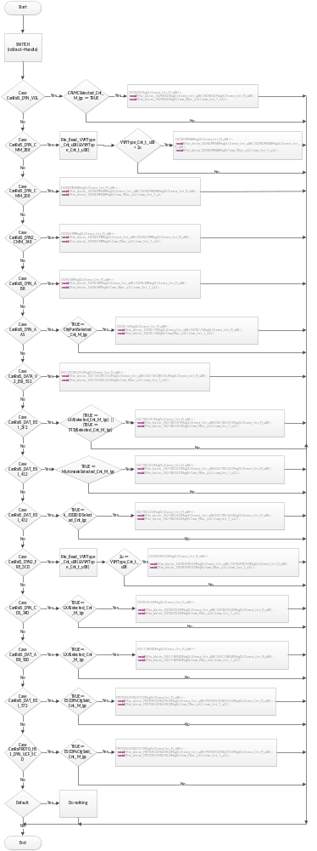

SrlComDriver_PreRxISDYNVOL
Function Name | SrlComDriver_PreRxISDYNVOL | Type | Min | Max
Arguments Passed | rxStruct | CanRxInfoStructPtr | N/A | N/A
Return Value | kCanNoCopyData | uint8 | 0 | 1

Description
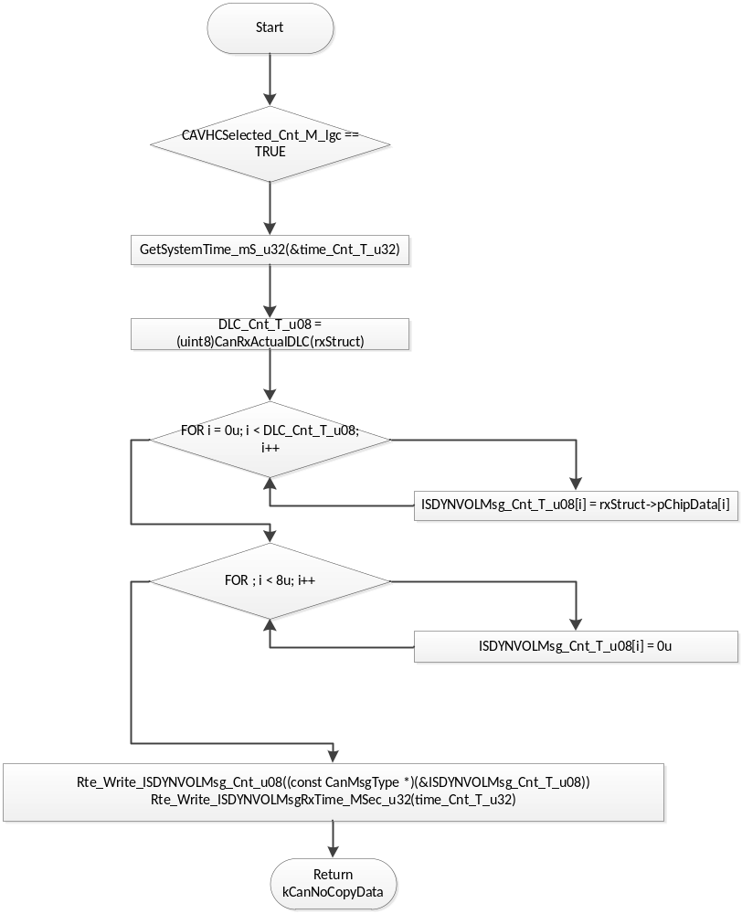

SrlComDriver_RxISDYNCMM388
Function Name | SrlComDriver_RxISDYNCMM388 | Type | Min | Max
Arguments Passed | rcvObject | CanReceiveHandle | N/A | N/A
Return Value | None | N/A | N/A | N/A

Description
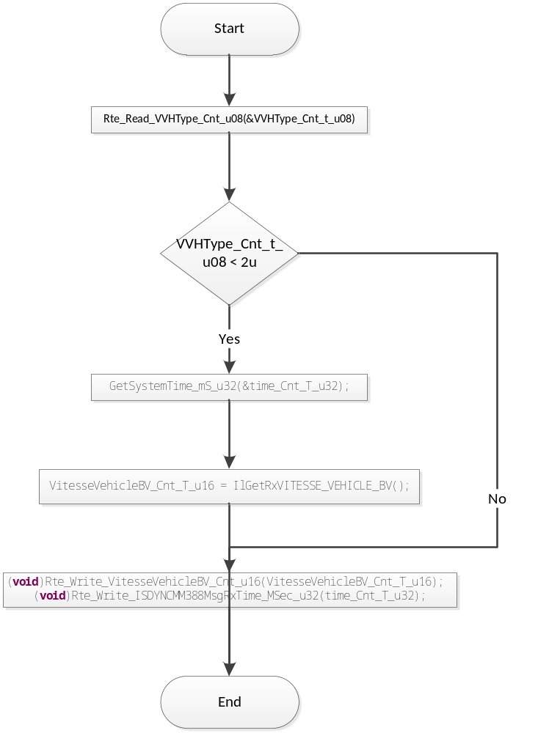

SrlComDriver_RxISDYN2FRE3CD
Function Name | SrlComDriver_RxISDYN2FRE3CD | Type | Min | Max
Arguments Passed | rcvObject | CanReceiveHandle | N/A | N/A
Return Value | None | N/A | N/A | N/A

Description
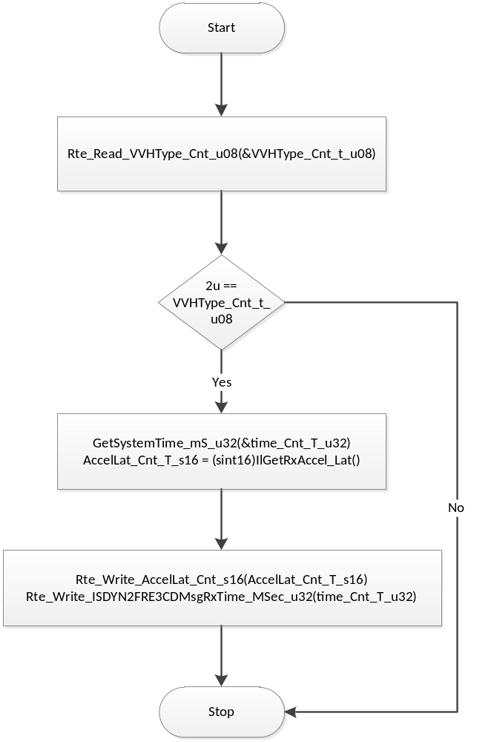

SrlComDriver_RxISDYNCDS34D
Function Name | SrlComDriver_RxISDYNCDS34D | Type | Min | Max
Arguments Passed | rcvObject | CanReceiveHandle | N/A | N/A
Return Value | None | N/A | N/A | N/A

Description
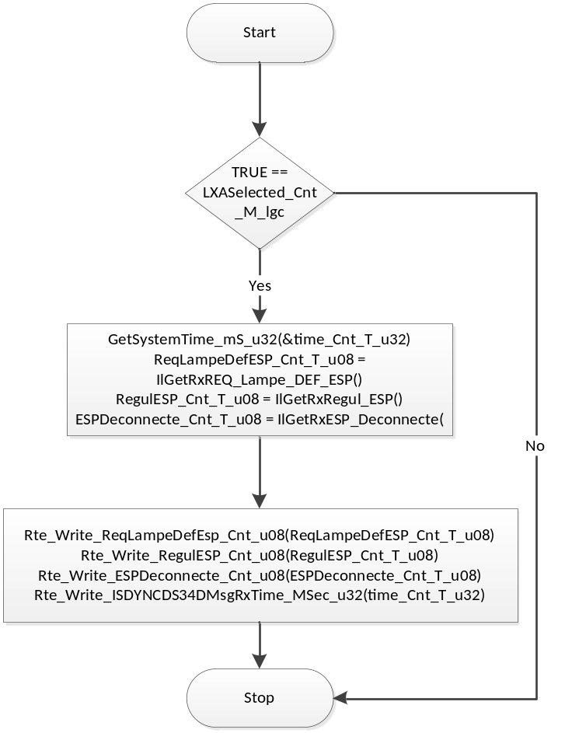

SrlComDriver_RxISDATABR50D
Function Name | SrlComDriver_RxISDATABR50D | Type | Min | Max
Arguments Passed | rcvObject | CanReceiveHandle | N/A | N/A
Return Value | None | N/A | N/A | N/A

Description
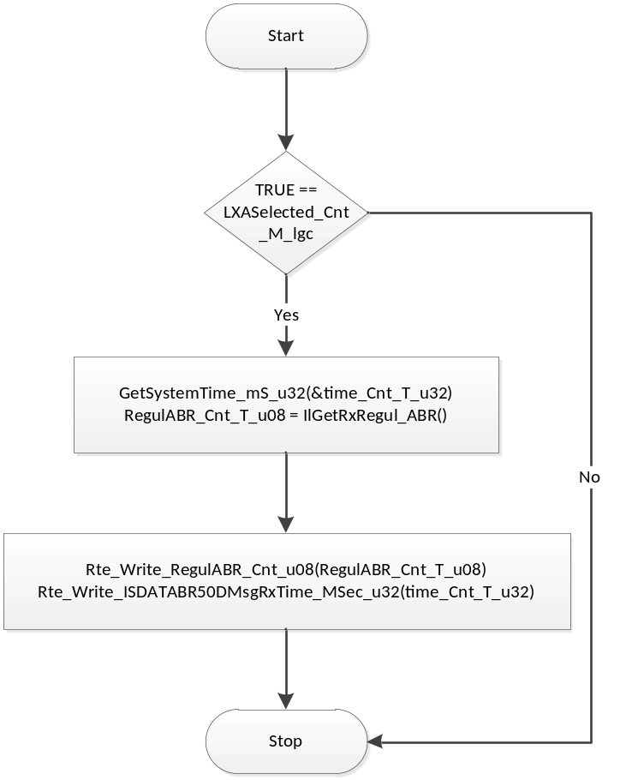

SrlComDriver_RxISDYNCMM208
Function Name | SrlComDriver_RxISDYNCMM208 | Type | Min | Max
Arguments Passed | rcvObject | CanReceiveHandle | N/A | N/A
Return Value | None | N/A | N/A | N/A

Description
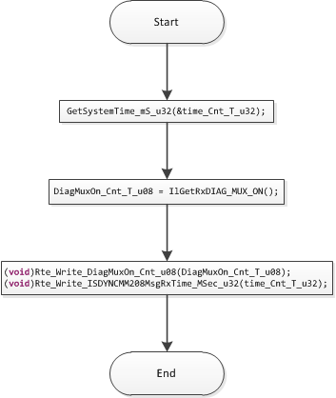

SrlComDriver_RxISDYN2CMM
Function Name | SrlComDriver_RxISDYN2CMM | Type | Min | Max
Arguments Passed | rcvObject | CanReceiveHandle | N/A | N/A
Return Value | None | N/A | N/A | N/A

Description
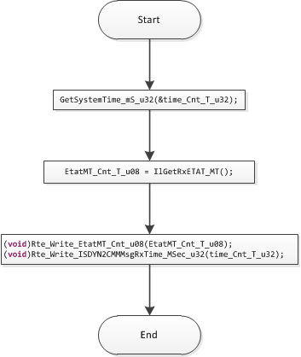

SrlComDriver_PreRxISDYNABR
Function Name | SrlComDriver_PreRxISDYNABR | Type | Min | Max
Arguments Passed | rxStruct | CanRxInfoStructPtr | N/A | N/A
Return Value | kCanNoCopyData | uint8 | 0 | 1

Description
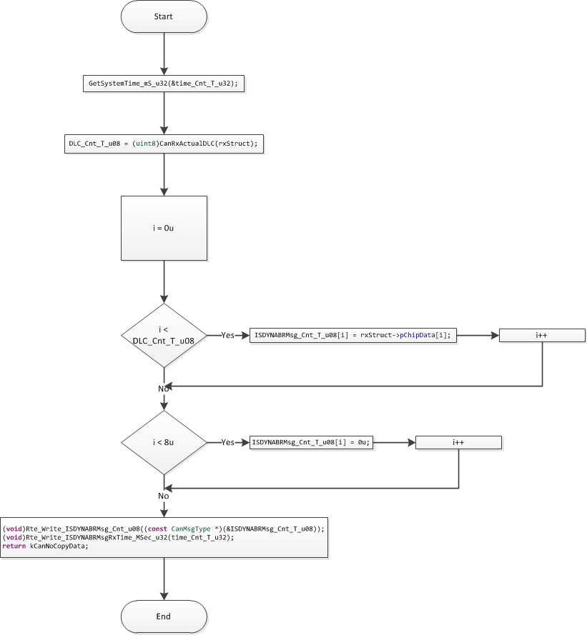

SrlComDriver_PreRxISDYNAAS
Function Name | SrlComDriver_PreRxISDYNAAS | Type | Min | Max
Arguments Passed | rxStruct | CanRxInfoStructPtr | N/A | N/A
Return Value | kCanNoCopyData | uint8 | 0 | 1

Description
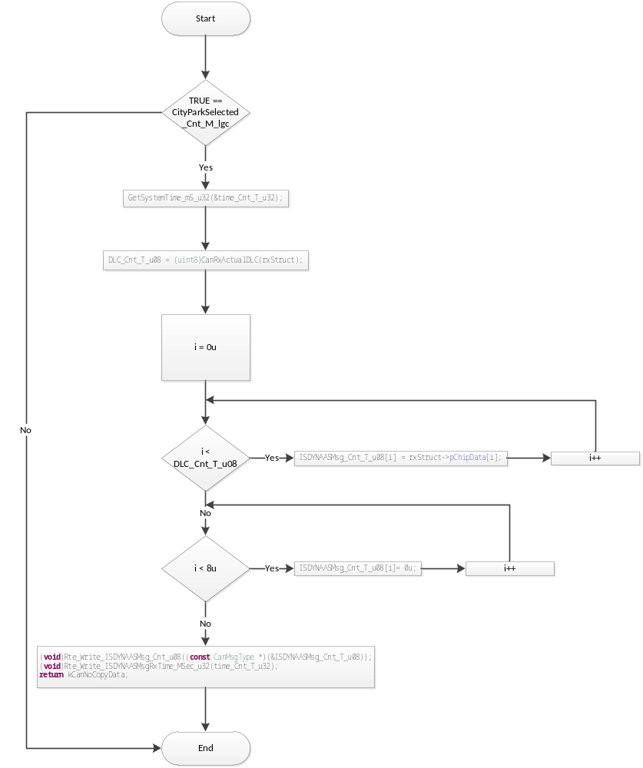

SrlComDriver_PreRxISDAT4V2BSI552
Function Name | SrlComDriver_PreRxISDAT4V2BSI552 | Type | Min | Max
Arguments Passed | rxStruct | CanRxInfoStructPtr | N/A | N/A
Return Value | kCanNoCopyData | uint8 | 0 | 1

Description
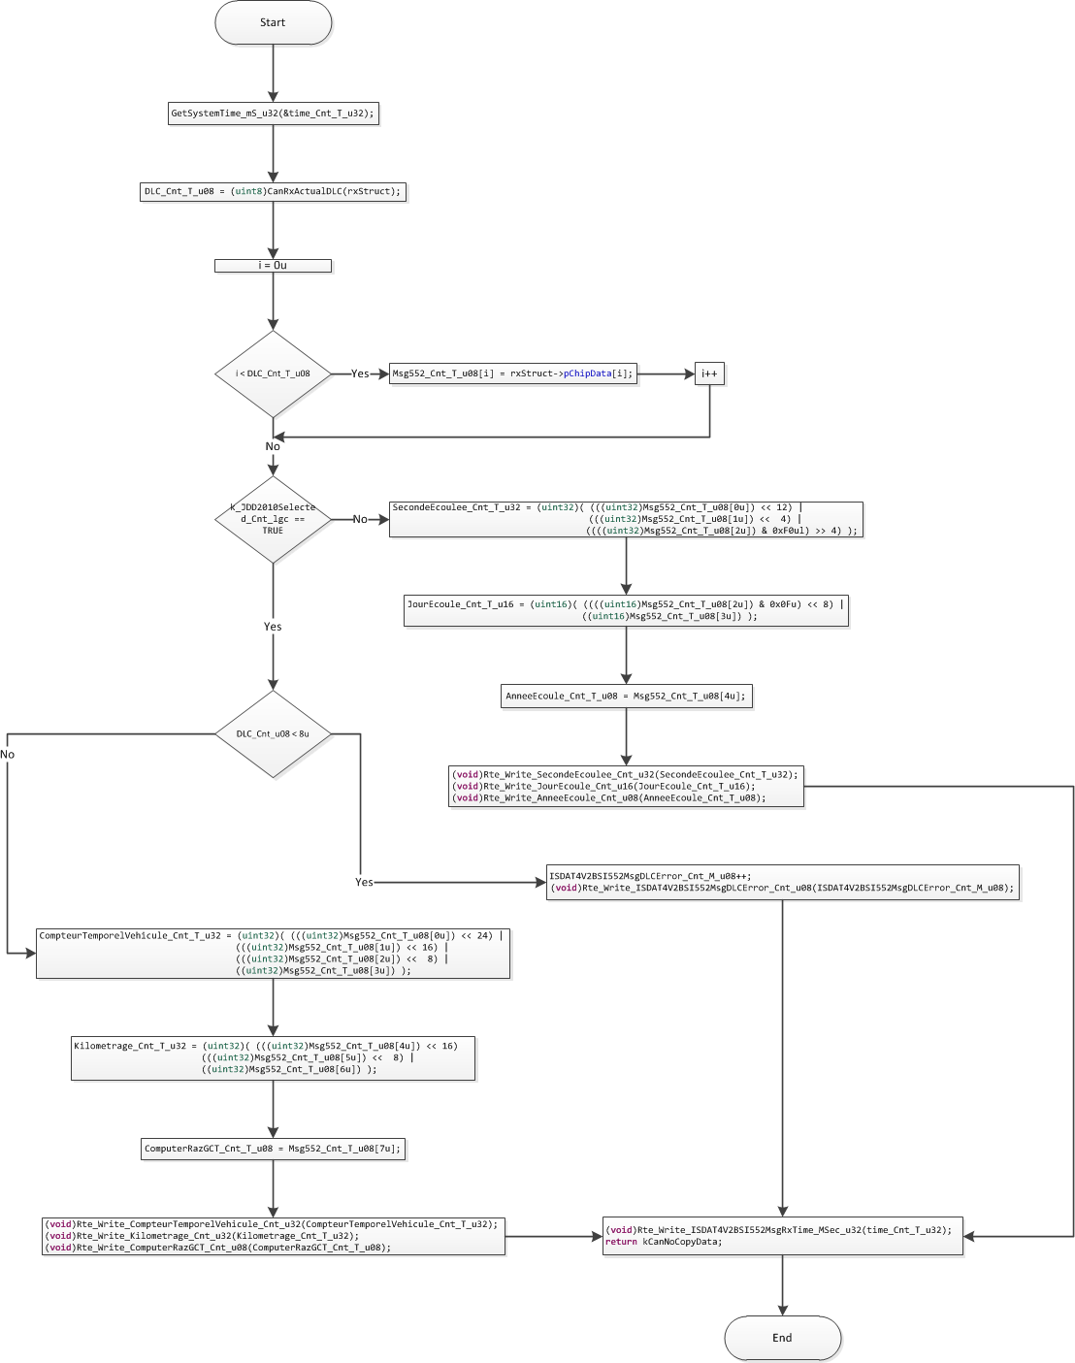

SrlComDriver_RxISDATBSI3F2
Function Name | SrlComDriver_RxISDATBSI3F2 | Type | Min | Max
Arguments Passed | rxStruct | CanReceiveHandle | N/A | N/A
Return Value | None | N/A | N/A | N/A

Description
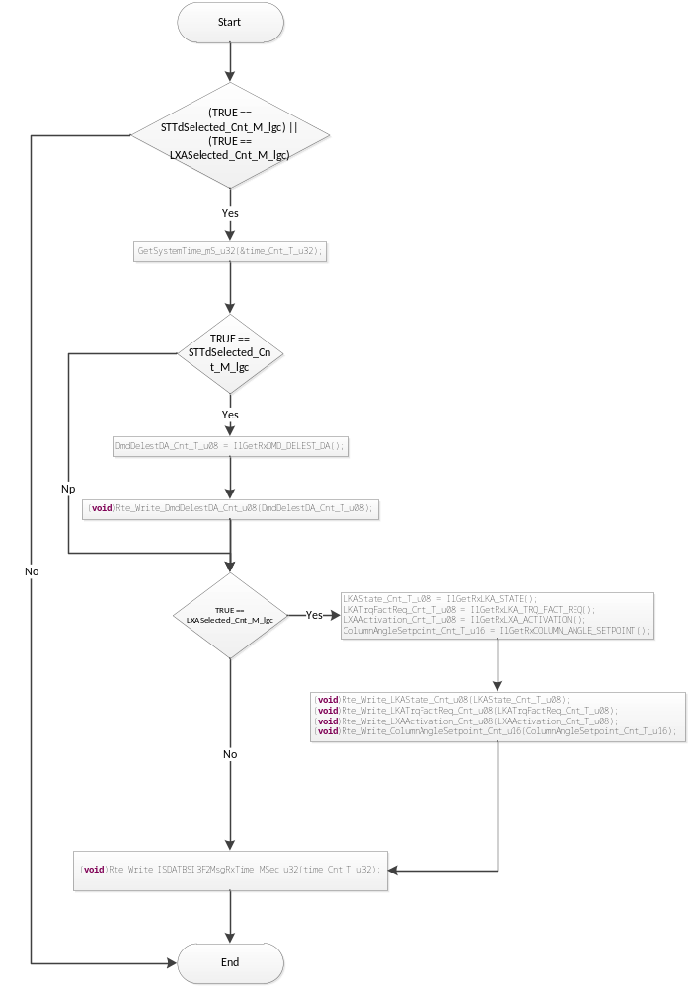

SrlComDriver_PreRxISDATBSI
Function Name | SrlComDriver_PreRxISDATBSI | Type | Min | Max
Arguments Passed | rxStruct | CanRxInfoStructPtr | N/A | N/A
Return Value | ContinueCanCopy | uint8 | 0 | 1

Description

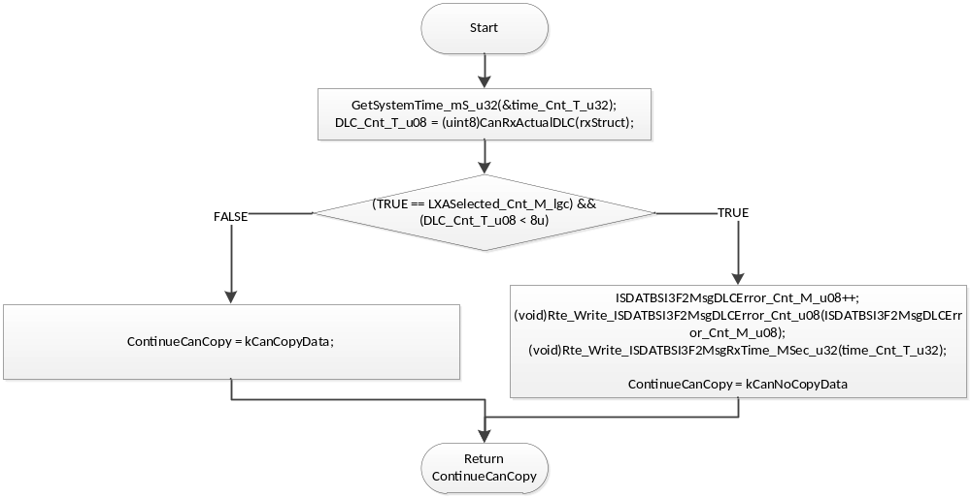

SrlComDriver_RxISDATBSI412
Function Name | SrlComDriver_RxISDATBSI412 | Type | Min | Max
Arguments Passed | rxStruct | CanReceiveHandle | N/A | N/A
Return Value | None | N/A | N/A | N/A

Description

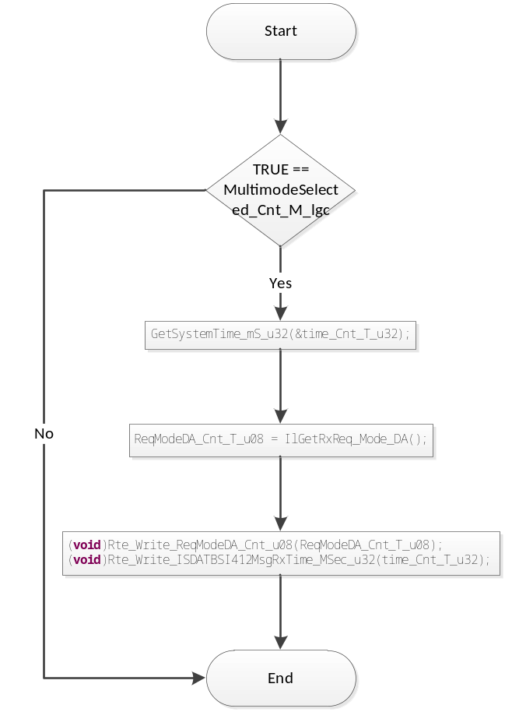

SrlComDriver_RxISDATBSI432
Function Name | SrlComDriver_RxISDATBSI432 | Type | Min | Max
Arguments Passed | rxStruct | CanReceiveHandle | N/A | N/A
Return Value | None | N/A | N/A | N/A

Description
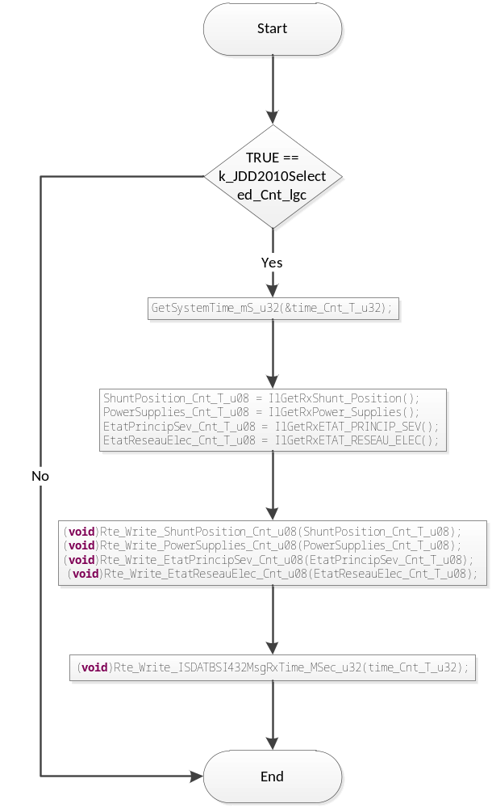

SrlComDriver_RxISINTEELECTRONBSI
Function Name | SrlComDriver_RxISINTEELECTRONBSI | Type | Min | Max
Arguments Passed | rcvObject | CanReceiveHandle | N/A | N/A
Return Value | None | N/A | N/A | N/A

Description
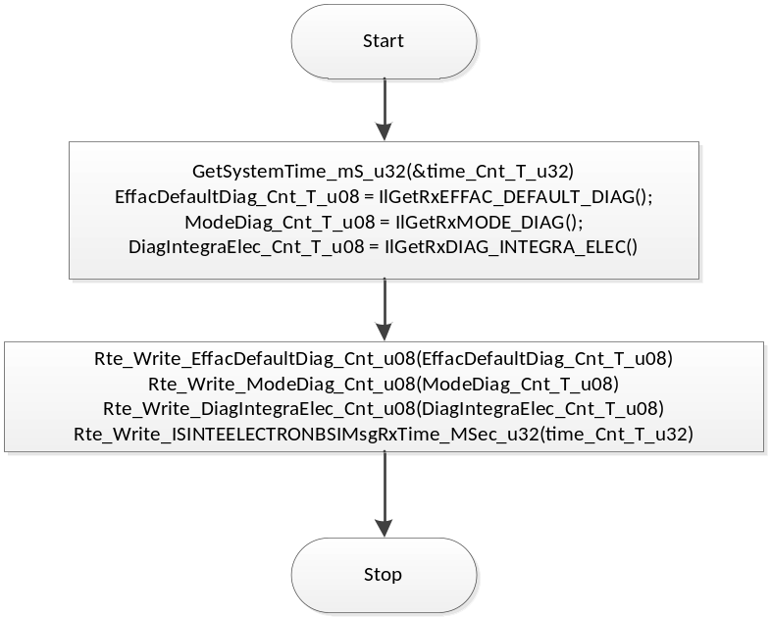

SrlComDriver_SendIsSupvDira
Function Name | SrlComDriver_SendIsSupvDira | Type | Min | Max
Arguments Passed | none
Return Value | none

Description
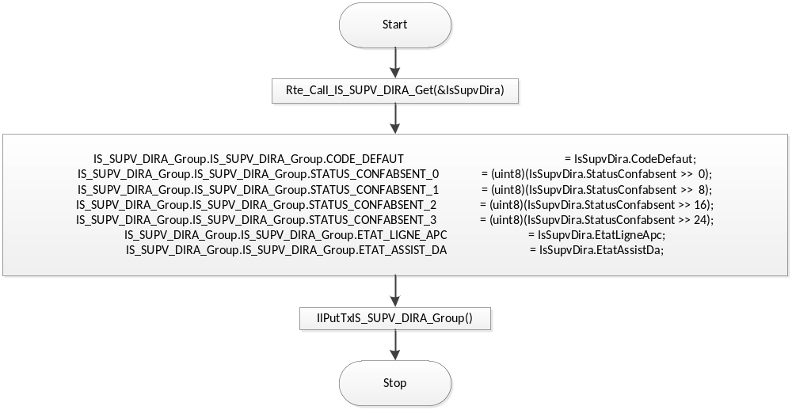

SrlComDriver_PreTxISSUPVDIRA
Function Name | SrlComDriver_PreTxISSUPVDIRA | Type | Min | Max
Arguments Passed | none
Return Value | none

Description
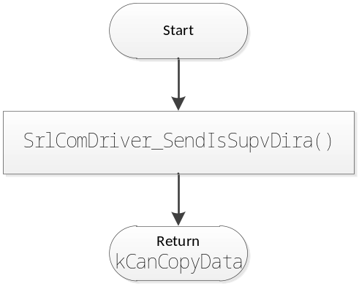

SrlComDriver_PreTxISDATDIRA
Function Name | SrlComDriver_PreTxISDATDIRA | Type | Min | Max
Arguments Passed | ctis | CanTxInfoStruct | N/A | N/A
Return Value | kCanCopyData | uint8 | 0 | 1

Description

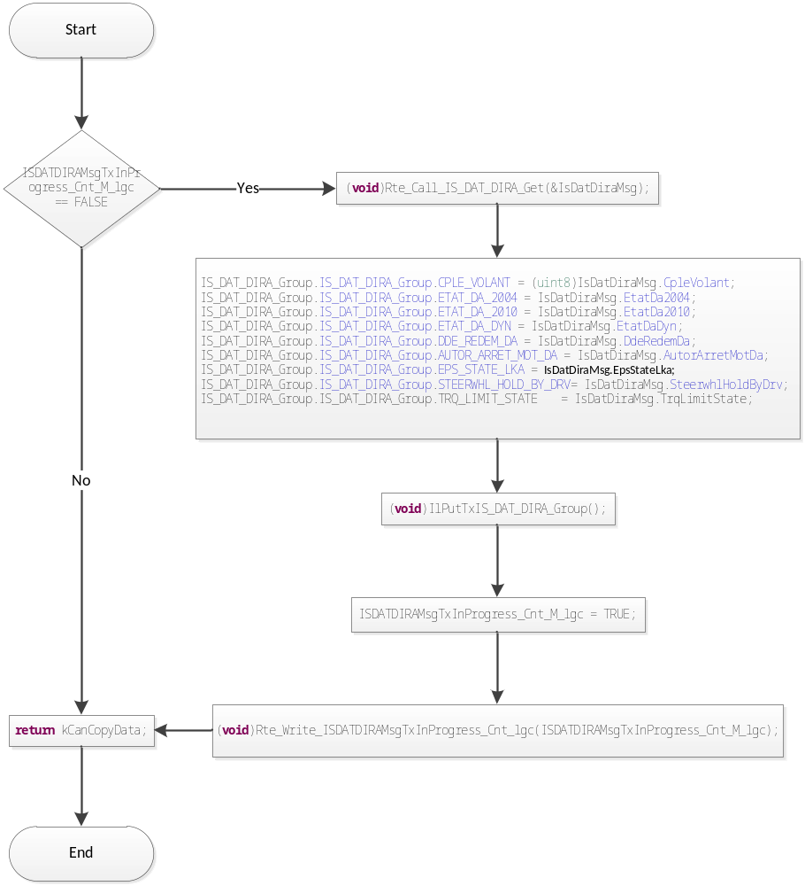

    - SrlComDriver_TxISDATDIRA
Function Name | SrlComDriver_TxISDATDIRA | Type | Min | Max
Arguments Passed | txObject | CanTransmitHandle | N/A | N/A
Return Value | None | N/A | N/A | N/A

Description
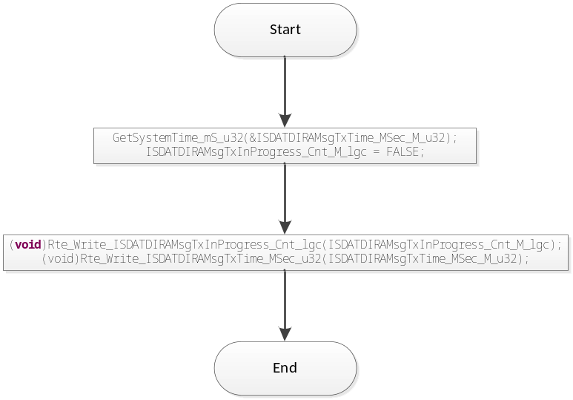

SrlComDriver_PreTxISDYNDAE
Function Name | SrlComDriver_PreTxISDYNDAE | Type | Min | Max
Arguments Passed | ctis | CanTxInfoStruct | N/A | N/A
Return Value | kCanCopyData | uint8 | 0 | 1

Description
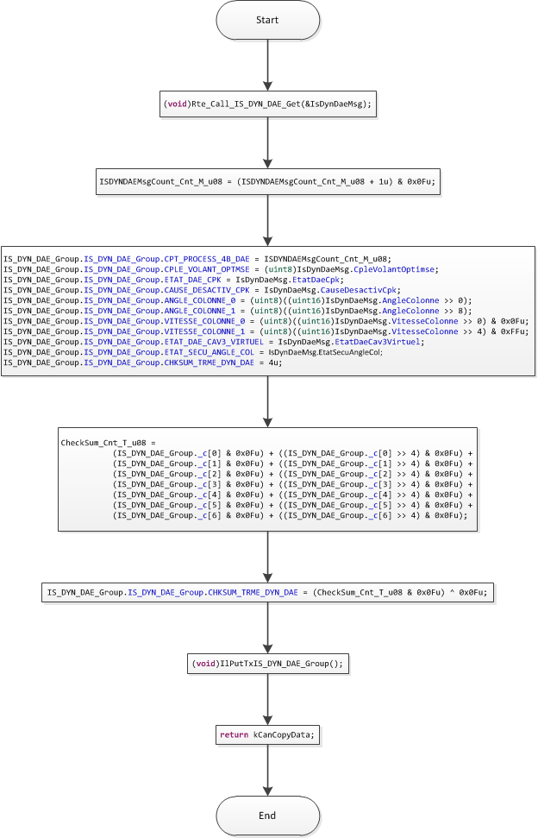

SrlComDriver_TxISDYNDAE
Function Name | SrlComDriver_TxISDYNDAE | Type | Min | Max
Arguments Passed | txObject | CanTransmitHandle | N/A | N/A
Return Value | None | N/A | N/A | N/A

Description

Empty function

ApplCanAddCanInterruptDisable
Function Name | ApplCanAddCanInterruptDisable | Type | Min | Max
Arguments Passed | channel | CanChannelHandle | N/A | N/A
Return Value | None | N/A | N/A | N/A

Description
Disables CAN interrupt in supervisor mode.

ApplCanAddCanInterruptRestore
Function Name | ApplCanAddCanInterruptRestore | Type | Min | Max
Arguments Passed | channel | CanChannelHandle | N/A | N/A
Return Value | None | N/A | N/A | N/A

Description
Enables CAN interrupt in supervisor mode.

ApplIlTxStart
Function Name | ApplIlTxStart | Type | Min | Max
Arguments Passed | None | None | N/A | N/A
Return Value | None | N/A | N/A | N/A

Description
Blocks transmission of 0x305 message when turns counter is not selected.
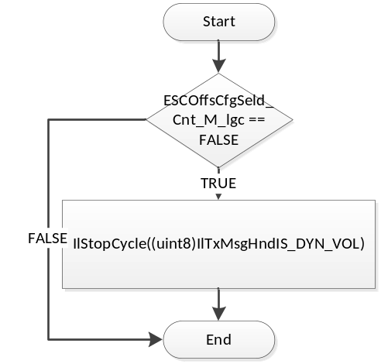

SrlComDriver_PreRxPROTOHS1DYNUCF5CD
Function Name | SrlComDriver_PreRxPROTOHS1DYNUCF5CD | Type | Min | Max
Arguments Passed | rxStruct | CanRxInfoStructPtr | N/A | N/A
Return Value | kCanNoCopyData | uint8 | 0 | 1

Description
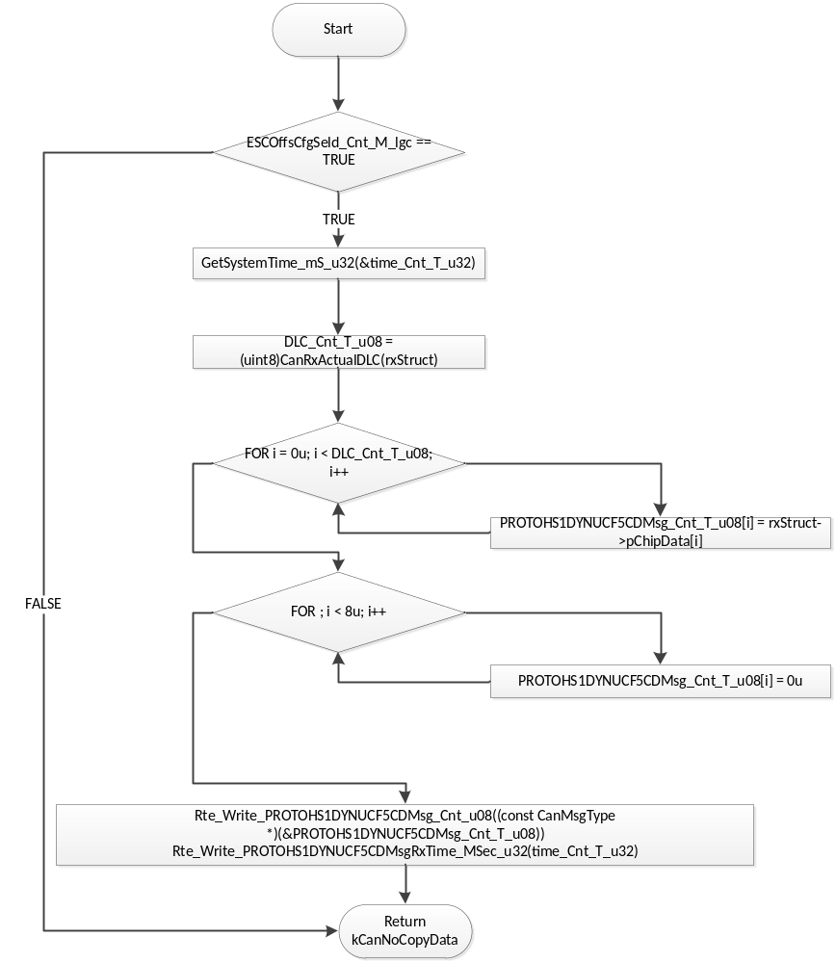

SrlComDriver_PreTxISDYNVOL
Function Name | SrlComDriver_PreTxISDYNVOL | Type | Min | Max
Arguments Passed | ctis | CanTxInfoStruct | N/A | N/A
Return Value | kCanCopyData | uint8 | 0 | 1

Description
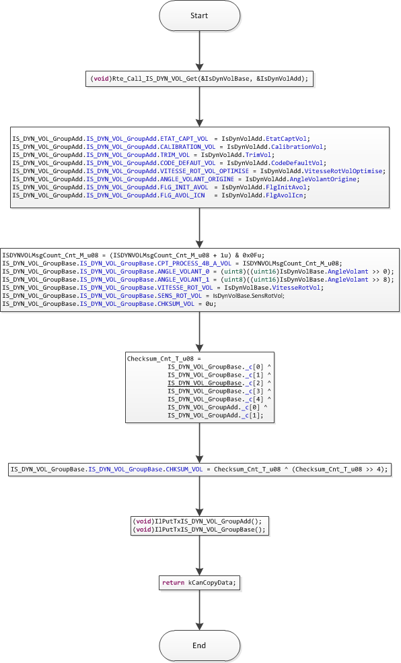

SrlComDriver_RxISDATBSI572
Function Name | SrlComDriver_RxISDATBSI572 | Type | Min | Max
Arguments Passed | rcvObject | CanReceiveHandle | N/A | N/A
Return Value | None | N/A | N/A | N/A

Description
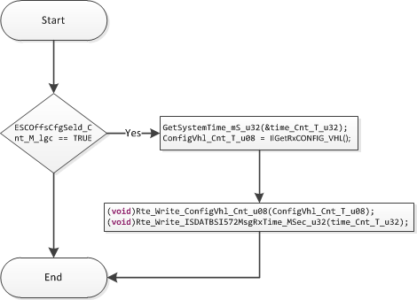

SrlComDriver_TXisdynvol
Function Name | SrlComDriver_TxISDYNVOL | Type | Min | Max
Arguments Passed | trxObject | CanTransmitHandle | N/A | N/A
Return Value | None | N/A | N/A | N/A

Description
Empty function

Known Limitations With Design
None

UNIT TEST CONSIDERATION
None

Appendix
None

