Module Design Document
For
SrlComInput

VERSION: 6
DATE: 6-Jun-18

Revision History

Sl. No. | Description | Author | Version | Date
1 | Initial Version | Muhammed Shameel | 1 | 08-Aug-2014
2 | Updates for new MPU configuration | Owen Tosh | 2 | 09-Sep-2014
3 | Updates for new city park messages | Owen Tosh | 3 | 18-Sep-2014
4 | Fixes found after further review | Owen Tosh | 4 | 19-Sep-2014
5 | Updates for new SCom messages | Owen Tosh | 5 | 30-Sep-2014
6 | Updates for new customer services | Owen Tosh | 6 | 09-Oct-2014
7 | Updates for remaining customer services | Owen Tosh | 7 | 20-Oct-2014
8 | Anomaly fix for HwTrq comparison | Owen Tosh | 8 | 23-Oct-2014
9 | Various anomaly fixes | Owen Tosh | 9 | 30-Oct-2014
10 | Updates for fault logbook | Owen Tosh | 10 | 11-Nov-2014
11 | Updates to elec integration logic | Owen Tosh | 11 | 13-Jan-2015
12 | Various anomaly fixes | Owen Tosh | 12 | 15-Jan-2015
13 | Updates to elec integration logic | Owen Tosh | 13 | 03-Feb-2015
14 | Correction to elec integration logic | Owen Tosh | 14 | 05-Feb-2015
15 | Added 2004 functionality | Owen Tosh | 15 | 1-May-2015
16 | Corrected message 305 checksum logic | Owen Tosh | 16 | 7-Jul-2015
17 | Added condition to VehicleSpeedValid | Owen Tosh | 17 | 10-Jul-2015
18 | Updates for SCIR 003B | Owen Tosh | 18 | 20-Jul-2015
19 | Corrected CPK_OK criteria | Owen Tosh | 19 | 31-Jul-2015
20 | Updates for SCIR 003C | Owen Tosh | 20 | 18-Aug-2015
21 | Updated manual control logic | Owen Tosh | 21 | 24-Sep-2015
22 | Corrected ValidEngine reset conditions | Owen Tosh | 22 | 2-Oct-2015
23 | Set validity counters to zero on invalid DLC | Owen Tosh | 23 | 8-Oct-2015
24 | Updates for anomaly fixes | Owen Tosh | 24 | 23-Nov-2015
25 | Updates for more anomaly fixes | Owen Tosh | 25 | 14-Dec-2015
26 | Updated for CMP SCIR 2C | Akilan Rathakrishnan | 26 | 13-Mar-2017
27 | Update for CMP SCIR 2H | Robert Konieczny | 3 | 11-Jan-2018
28 | Update for CMP SCIR 3F | Robert Konieczny | 4 | 19-Mar-18
29 | Update for CMP SCIR 4C | Mateusz Bartocha | 5 | 21-May-18
30 | Update for CMP SCIR 4E | Mateusz Bartocha | 6 | 6-Jun-18

Table of Contents
1 Abbrevations And Acronyms 7
2 References 8
3 Serial Communications Input & High-Level Description 9
4 Design details of software module 10
4.1 Graphical representation of SrlComInput 10
4.2 Data Flow Diagram 12
4.2.1 Module level DFD 12
4.2.2 Sub-Module level DFD 12
4.3 COMPONENT FLOW DIAGRAM 12
5 Variable Data Dictionary 13
5.1 User defined typedef definition/declaration 13
5.2 Variable definition for enumerated types 13
6 Constant Data Dictionary 14
6.1 Program(fixed) Constants 14
6.1.1 Embedded Constants 14
6.1.1.1 Local 14
6.1.1.2 Global 15
6.1.2 Module specific Lookup Tables Constants 16
6.1.3 Library Functions / Macros 16
6.1.4 Data Hiding Functions 16
7 Software Module Implementation 17
7.1 Initialization Functions 17
7.1.1 Init: SrlComInput_Init 17
7.1.1.1 Design Rationale 17
7.1.1.2 Module Internal 17
7.1.1.3 Clear NTCs 18
7.1.1.4 Module Outputs 22
7.1.2 Per: SrlComInput_Per1 23
7.1.2.1 Design Rationale 23
7.1.2.2 Store Module Inputs to Local copies 23
7.1.2.3 Timer and Cnt Initialization 25
7.1.2.4 SrlCom Message 26
7.1.2.5 diagon Processing 27
7.1.2.6 IS_DYN_VOL Message Handling 27
7.1.2.7 IS_DYN_ABR Message Handling 28
7.1.2.8 IS_DYN_CMM_388 Message Handling 29
7.1.2.9 IS_DYN_AAS Message Handling 29
7.1.2.10 IS_DYN_CMM_208 Message Handling 29
7.1.2.11 IS_DYN2_CMM Message Handling 30
7.1.2.12 IS_DAT_BSI_3F2 Message Handling 30
7.1.2.13 IS_DAT_BSI_412 Message Handling 31
7.1.2.14 IS_DAT_BSI_432 Message Handling 31
7.1.2.15 IS_DAT_BSI_572 Message Handling 32
7.1.2.16 IS_DAT4_V2_BSI_552 Message Handling 32
7.1.2.17 ISDYNDS34D 34
7.1.2.18 ISDATABR50D 34
7.1.2.19 ISDYN2FRE3CD 35
7.1.2.20 PROTO_HS1_DYN_UCF_5CD Message Handling 35
7.1.2.21 Store Local copy of outputs into Module Outputs 36
7.1.3 Per: SrlComInput_Per2 36
7.1.3.1 Design Rationale 36
7.1.3.2 Store Module Inputs to Local copies 36
7.1.3.3 SRLCOM Per2 Message 37
7.1.3.4 Serial Com Angle Validity 39
7.1.3.5 Multimode validity 39
7.1.3.6 LatAccel Validity 39
7.1.3.7 Lxa Validity 40
7.1.3.8 Vehicle Speed and Validity 40
7.1.3.9 Lka signals 41
7.1.3.10 APA Request 42
7.1.3.11 City park relax 42
7.1.3.12 City Park authorization 43
7.1.3.13 STTa Determination 44
7.1.3.14 CMM and BSI Info Pertinence 45
7.1.3.15 Vehicle Speed Control 46
7.1.3.16 Store Local copy of outputs into Module Outputs 47
7.2 Interrupt Functions 47
7.3 TRANSIENT FUNCTIONS 48
7.3.1 Trns: SrlComInput_Trns1 48
7.3.1.1 Design Rationale 48
7.3.1.2 Store Module Inputs to Local copies 48
7.3.1.3 Processing of function 48
7.3.1.4 Store Local copy of outputs into Module Outputs 48
7.3.2 Trns: SrlComInput_Trns2 48
7.3.2.1 Design Rationale 48
7.3.2.2 Store Module Inputs to Local copies 48
7.3.2.3 Processing of function 48
7.3.2.4 Store Local copy of outputs into Module Outputs 49
7.4 Serial Communication Functions 50
7.4.1 SComm: SrlComInput_SCom_GetNetworkDiagFltAcc 50
7.4.1.1 Design Rationale 50
7.4.1.2 Store Module Inputs to Local copies 50
7.4.1.3 Processing of function 50
7.4.1.4 Store Local copy of outputs into Module Outputs 50
7.4.2 SComm: SrlComInput_SCom_ManualVehSpd 50
7.4.2.1 Design Rationale 50
7.4.2.2 Store Module Inputs to Local copies 50
7.4.2.3 Processing of function 50
7.4.2.4 Store Local copy of outputs into Module Outputs 50
7.4.3 SCOMM: SrlComInput_SCom_ResetTimers 50
7.4.3.1 DESIGN RATIONALE 50
7.4.3.2 STORE MODULE INPUTS TO LOCAL COPIES 51
7.4.3.3 PROCESSING OF FUNCTION 51
7.4.3.4 Store Local copy of outputs into Module Outputs 51
7.4.4 SComm: SrlComInput_SCom_VehSpdControl 51
7.4.4.1 Design Rationale 51
7.4.4.2 Store Module Inputs to Local copies 51
7.4.4.3 Processing of function 51
7.4.4.4 Store Local copy of outputs into Module Outputs 51
7.4.5 SComm: SrlComInput_REINIT 51
7.4.5.1 Design Rationale 51
7.4.5.2 Store Module Inputs to Local copies 51
7.4.5.3 Processing of function 52
7.4.5.4 Store Local copy of outputs into Module Outputs 54
7.5 Local Function/Macro Definitions 55
7.5.1 Increment Counter to Threshold (Macro) 55
7.5.1.1 Description 55
7.5.2 Node ABsent NTC Processing 56
7.5.2.1 Description 56
7.5.3 Missing Message NTC Processing 57
7.5.3.1 Description 57
7.5.4 Validity NTC Processing 58
7.5.4.1 Description 58
7.5.5 Mixed Time Validity NTC Processing 59
7.5.5.1 Description 59
7.5.6 Reset Fault Accumulator 60
7.5.6.1 Description 60
7.6 GLObAL Function/Macro Definitions 60
8 Known Limitations With Design 61
9 UNIT TEST CONSIDERATION 62
10 Appendix 63

Abbrevations And Acronyms
Abbreviation | Description
DFD | Design functional diagram
MDD | Module design Document

References
This section Lists the title & version of all the documents that are referred for development of this document
Sr. No. | Title | Version
1 | MDD Guidelines | 1
2 | Software Naming Conventions | 1
3 | Coding standands | 1
4 | PSA CMP SCIR | 003F

Serial Communications Input & High-Level Description

The Serial Communications Input module provides signal processing between the application layer and the serial communications software. This module will be responsible for converting the range and resolution of the associated serial communications signals to the range and resolution of the Application Layer variables, as well as handling NTCs related to serial communications.

This module processes the data for signals that are received by the EPS controller from other ECUs on the communication bus. Serial Communications signal input data is scaled appropriately and then transferred to the global application data for use by the EPS application software.

Design details of software module

Graphical representation of SrlComInput

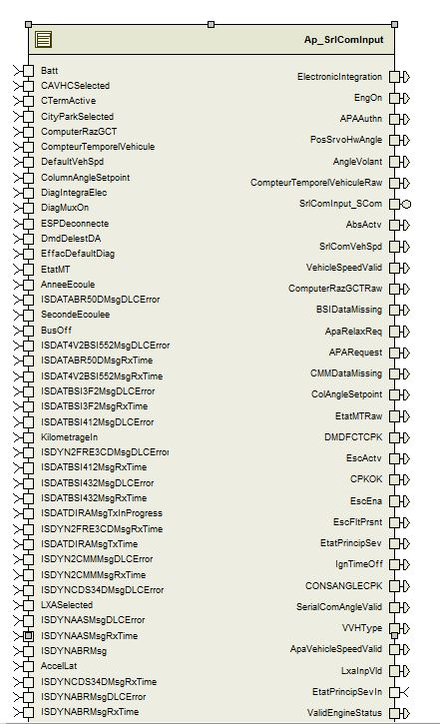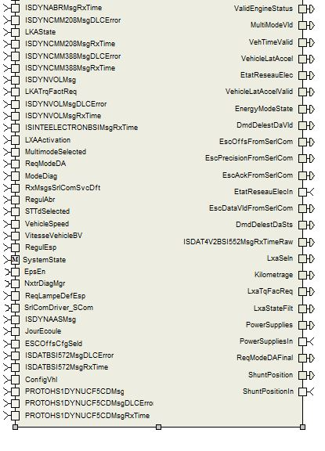

Data Flow Diagram
None

Module level DFD
None

Sub-Module level DFD
None

COMPONENT FLOW DIAGRAM

Variable Data Dictionary

User defined typedef definition/declaration
Typedef Name | Element Name | User Defined Type | Legal Range  (min) | Legal Range  (max)
None

Variable definition for enumerated types
Enum Name | Element Name | Value
EnergyModeState_Cnt_enum | NORMAL | 0
EnergyModeState_Cnt_enum | PRODUCTION | 1
EnergyModeState_Cnt_enum | TRANSPORTATION | 2
EnergyModeState_Cnt_enum | FLASH | 3
PsaLxaSt_Cnt_enum | PSALXAST_UNAV | 0
PsaLxaSt_Cnt_enum | PSALXAST_UNSELD | 1
PsaLxaSt_Cnt_enum | PSALXAST_SELD | 2
PsaLxaSt_Cnt_enum | PSALXAST_AUTHD | 3
PsaLxaSt_Cnt_enum | PSALXAST_ACTV | 4
PsaLxaSt_Cnt_enum | PSALXAST_DFCT | 5
PsaLxaSt_Cnt_enum | PSALXAST_COLLRISK | 6
PsaTunModSt_Cnt_enum | PSATUNMODST_NORM | 0
PsaTunModSt_Cnt_enum | PSATUNMODST_SPORT | 1
PsaTunModSt_Cnt_enum | PSATUNMODST_TUN | 2
PsaTunModSt_Cnt_enum | PSATUNMODST_FAILD | 3

Constant Data Dictionary

Program(fixed) Constants

Embedded Constants

Local
Constant Name | Resolution | Units | Value
D_ISDYNVOLMSGTIMEOUT_MS_U16 | 1 | mS | 11
D_ISDYNABRMSGTIMEOUT_MS_U16 | 1 | mS | 44
D_ISDYNCMMMSGTIMEOUT_MS_U16 | 1 | mS | 44
D_ISDYNAASMSGTIMEOUT_MS_U16 | 1 | mS | 22
D_ISDYNCMM208MSGTIMEOUT_MS_U16 | 1 | mS | 11
D_ISDYN2CMMMSGTIMEOUT_MS_U16 | 1 | mS | 22
D_ISDATBSI3F2MSGTIMEOUT_MS_U16 | 1 | mS | 55
D_ISDATBSI412MSGTIMEOUT_MS_U16 | 1 | mS | 55
D_ISDATBSI432MSGTIMEOUT_MS_U16 | 1 | mS | 55
D_ISDAT4V2BSI552MSGTIMEOUT_MS_U16 | 1 | mS | 1100
D_ISDYNCDS34DMSGTIMEOUT_MS_U16 | 1 | mS | 22
D_ISDATABR50DMSGTIMEOUT_MS_U16 | 1 | mS | 110
D_ISDYN2FRE3CDMSGTIMEOUT_MS_U16 | 1 | mS | 11
D_TESTFAILED_CNT_U08 | 1 | Count | 0
D_TESTPASSED_CNT_U08 | 1 | Count | 1
D_TESTDEADBAND_CNT_U08 | 1 | Count | 2
D_ANGLEVOLANTSCALE_HWDEGPCNT_F32 | Single Precision Float | HwDeg/Cnt | 0.1
D_ANGLEVOLANTPOL_CNT_F32 | Single Precision Float | Count | -1
D_ANGLEVOLANTVALIDLO_CNT_U16 | 1 | Count | -7800
D_ANGLEVOLANTVALIDHI_CNT_U16 | 1 | Count | 7800
D_VEHSPDSCALE_CNT_F32 | Single Precision Float | count | 0.01
D_CONSANGLECPKSCALE_CNT_F32 | Single Precision Float | count | 0.1
D_CONSANGLECPKPOL_CNT_F32 | Single Precision Float | Count | -1
D_COLANGLESETPOINTPOL_CNT_F32 | Single Precision Float | Count | -1
D_COLUMNANGLESETPOINTSCALE_CNT_U16 | Single Precision Float | Count | 0.1
D_CONSANGLECPKVALIDLO_CNT_U16 | 1 | Count | -7800
D_CONSANGLECPKVALIDHI_CNT_U16 | 1 | Count | 7800
D_ELECINTCONSECMSGS_CNT_U08 | 1 | Count | 2
D_ELECINTCONSECTIMEOUT_MS_U16 | 1 | mS | 1000
D_COMPUTERRAZGCTINVALID_CNT_U08 | 1 | Count | 0xFF
D_COMPTEURTEMPORELVEHICULEINVALID_CNT_U32 | 1 | Count | 0xFFFFFFFF
D_COMPTEURTEMPORELVEHICULESCALE_SECPCNT_U32 | 1 | Second/Count | 0x10
D_ANNEEECOULEINVALID_CNT_U08 | 1 | Count | 0xFF
D_JOURECOULEINVALID_CNT_U16 | 1 | Count | 0x0FFF
D_SECONDEECOULEEINVALID_CNT_U32 | 1 | Count | 0x000FFFFF
D_SECONDSPERYEAR_CNT_U32 | 1 | Count | 31536000
D_SECONDSPERDAY_CNT_U32 | 1 | Count | 86400
D_ACCELLATVALIDHI_CNT_S16 | 1 | Count | 300
D_ACCELLATVALIDLO_CNT_S16 | 1 | Count | -300
D_ACCELLATSCALE_CNT_f32 | Single Precision Float | Count | 0.05
D_COLANGLESETPOINTVALIDLO_CNT_U16 | 1 | Count | 0x1E78
D_COLANGLESETPOINTVALIDHI_CNT_U16 | 1 | Count | 0x2188
D_LKATRQFACTREQVALIDMAX_CNT_U16 | 1 | Count | 0x64
D_LKATRQFACTSCALE_CNT_F32 | Single Precision Float | Count | 0.01
D_OFFSETPOL_CNT_F32 | Single Precision Float | Count | -1.0
D_PROTOHS1DYNUCF5CDMSGTIMEOUT_MS_U16 | 1 | Count | 1100
D_OFFSETSCALE_CNT_F32 | Single Precision Float | Count | 0.1
D_OFFSETLOLIM_CNT_F32 | Single Precision Float | Count | -1630F
D_OFFSETHILIM_CNT_F32 | Single Precision Float | Count | 1630F
D_ISDATBSI572MSGTIMEOUT_MS_U16 | 1 | Count | 110
D_LKATRQFACREQUNAVAILABLE_CNT_U16 | 1 | Count | 0x7E
D_LKATRQFACREQINVALID_CNT_U16 | 1 | Count | 0x7F
D_NTC_TEST_COMPLETED_MASK | 1 | Count | (D_TESTFAILEDBIT_CNT_B8 | D_TESTNOTCOMPLETETHISOPCYCLEBIT_CNT_B8)
D_NTC_TEST_COMPLETED_PASSED | 1 | Count | 0
D_NTC_TEST_COMPLETED_FAILED | 1 | Count | D_TESTFAILEDBIT_CNT_B8
D_ESCPRECISIONFROMSERLCOM_INIT_VALUE | Single Precision Float | HwDeg | 29.0F

Global
Constant Name
RTE_MODE_StaMd_Mode_WARMINIT
RTE_MODE_StaMd_Mode_OPERATE
RTE_MODE_StaMd_Mode_DISABLE
kETAT_MT_Cut
kETAT_MT_Starting
kETAT_MT_Engine_Running
kETAT_MT_Stopped
kETAT_MT_Driven_Restart
kETAT_MT_Autonomous_Restart
kETAT_MT_Degraded_Restart
kETAT_MT_Engine_Preparing
kETAT_MT_Autonomous_Starting
kDIAG_MUX_ON_Enable_SCom_Diagnostics
kVITESSE_VEHICULE_ROUES_Invalid
kETAT_DAE_CPK_Unavailable
kETAT_DAE_CPK_Available
kETAT_DAE_CPK_Control_In_Progress
kETAT_DAE_CPK_Invalid
kDMD_FCT_CPK_SCP9_Control_Request
kDMD_FCT_CPK_SCP6_Control_Request
kMARCHE_AR_BVM_Reverse_Gear_Engaged
kDMD_RELAXE_CPK_Relaxe_Request
kDMD_RELAXE_CPK_Reserved
kDMD_RELAXE_CPK_Invalid
kDMD_FCT_CPK_Invalid
kCONS_ANGLE_CPK_Invalid
kANGLE_VOLANT_Invalid
kVITESSE_ROT_VOL_Invalid
kVITESSE_VEHICLE_BV_Invalid
kMODE_DIAG_Operation_and_Comm_Inhibited
kDIAG_INTEGRA_ELEC_No_Frame_Transmission
kMODE_DIAG_No_Particular_Operation
kDIAG_INTEGRA_ELEC_No_Particular_Operation
kEFFAC_DEFAULT_DIAG_Default_Memory_Erase
kDMD_DELEST_DA_Power_Cut_Request
DEM_DTC_GROUP_ALL_DTCS
DEM_DTC_KIND_ALL_DTCS
DEM_DTC_ORIGIN_PRIMARY_MEMORY
DEM_DTC_PENDING

Module specific Lookup Tables Constants
Constant Name | Resolution | Value | Software Segment
None

Library Functions / Macros
None

Data Hiding Functions
Rte_Call_SystemTime_GetSystemTime_mS_u32()
Rte_Call_NxtrDiagMgr_GetNTCFailed()
Rte_Call_SystemTime_DtrmnElapsedTime_mS_u16()
Rte_Call_NxtrDiagMgr_SetNTCStatus()
Rte_Call_NxtrDiagMgr_GetNTCFailed()
Rte_Call_VHHTYPE_WriteBlock()
Rte_Call_SrlComDriver_SCom_ElecIntStart()
Rte_Call_SrlComDriver_SCom_ElecIntStop()
Rte_Pim_VVHTYPEData()
Rte_Pim_ElecIntData()
Rte_Pim_ShutdownTimeData()
NtWrapC_Dem_ClearDTC

Software Module Implementation

Initialization Functions

Init: SrlComInput_Init

Design Rationale
None

Module Internal

Input read:

(void)Rte_Call_SystemTime_GetSystemTime_mS_u32(&SystemTime_mS_M_u32);
EngOnAbsentTimer_mS_M_u32 = SystemTime_mS_M_u32;
PrevEtatMT_Cnt_M_u08 = (uint8)kETAT_MT_Cut;
ISDATDIRASentTimer_mS_M_u32 = SystemTime_mS_M_u32;
ResetFltAcc(&ISDATDIRASentFltAcc_Cnt_M_u16, k_ISDATDIRASentDiag_Cnt_str, NTC_Num_BusOffCh1NodeMute);
ISDYNVOLMsgTimer_mS_M_u32 = SystemTime_mS_M_u32;
ISDYNAASMsgTimer_mS_M_u32 = SystemTime_mS_M_u32;
ISDYNABRMsgTimer_mS_M_u32 = SystemTime_mS_M_u32;
ISDYNCMM208MsgTimer_mS_M_u32 = SystemTime_mS_M_u32;
ISDYNCMM388MsgTimer_mS_M_u32 = SystemTime_mS_M_u32;
ISDYN2CMMMsgTimer_mS_M_u32 = SystemTime_mS_M_u32;
ISDAT4V2BSI552MsgTimer_mS_M_u32 = SystemTime_mS_M_u32;
ISDYNCDS34DMsgTimer_mS_M_u32 = SystemTime_mS_M_u32;
ISDATABR50DMsgTimer_mS_M_u32 = SystemTime_mS_M_u32;
ISDYN2FRE3CDMsgTimer_mS_M_u32 = SystemTime_mS_M_u32;
ISDATBSI3F2MsgTimer_mS_M_u32 = SystemTime_mS_M_u32;
ISDATBSI412MsgTimer_mS_M_u32 = SystemTime_mS_M_u32;
ISDATBSI432MsgTimer_mS_M_u32 = SystemTime_mS_M_u32;
DmdDelestDATimer_mS_M_u32 = SystemTime_mS_M_u32;
CompteurTemporelVehiculeSigInvalidTimer_mS_M_u32 = SystemTime_mS_M_u32;
ComputerRazGCTSigInvalidTimer_mS_M_u32 = SystemTime_mS_M_u32;
DateInvalidTimer_mS_M_u32 = SystemTime_mS_M_u32;
DiagMuxOnAbsentTimer_mS_M_u32 = SystemTime_mS_M_u32;
CityParkInputMsgTimer_mS_M_u32 = SystemTime_mS_M_u32;
ISDATBSI572MsgTimer_mS_M_u32 = SystemTime_mS_M_u32;
PROTOHS1DYNUCF5CDMsgTimer_mS_M_u32 = SystemTime_mS_M_u32;
IgnOnTimer_mS_M_u32 = SystemTime_mS_M_u32;
BattOk_Cnt_M_lgc = TRUE;
EscOffsFromSerlCom_HwDeg_M_f32 = 0.0F;
EscPrecisionFromSerlCom_HwDeg_M_f32 = D_ESCPRECISIONFROMSERLCOM_INIT_VALUE;
CPKOK_Cnt_M_lgc = TRUE;
AcqInterruptDae_Cnt_M_lgc = FALSE;
EscDataVldFromSerlCom_Cnt_M_lgc = FALSE;
DmdDelestDaSts_Cnt_M_u08 = (uint8)kDMD_DELEST_DA_Not_Requested;
DmdDelestDaVld_Cnt_M_lgc = FALSE;
DmdDelestDaStsTime_MSec_M_u32 = SystemTime_mS_M_u32;
MultimodeVld_Cnt_M_lgc = TRUE;
AngleVolant_HwDeg_M_f32 = 0.0F;
ElectronicIntegrationCmd_Cnt_M_lgc = *Rte_Pim_ElecIntData();
LXASelected_Cnt_M_lgc = CDD_LXASelected_Cnt_G_lgc;
STTdSelected_Cnt_M_lgc = CDD_STTdSelected_Cnt_G_lgc;
MultimodeSelected_Cnt_M_lgc = CDD_MultiModeSelected_Cnt_G_lgc;
ESCOffsCfgSeld_Cnt_M_lgc = CDD_ESCOffsCfgSeld_Cnt_G_lgc;
CAVHCSelected_Cnt_M_lgc = CDD_CAVHCSelected_Cnt_G_lgc;
CityParkSelected_Cnt_M_lgc = CDD_CityParkSelected_Cnt_G_lgc;
SrlComInput_UpdateVVHType(*Rte_Pim_VVHTYPEData());

Clear NTCs
        - NTCs 164,165,166,139,139

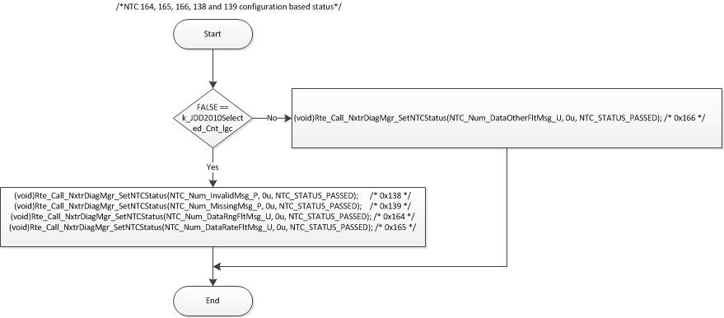
        - NTC 146

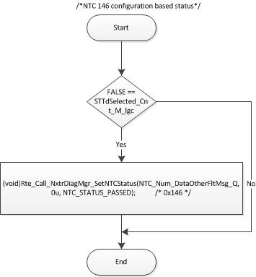

        - NTCs 140,141

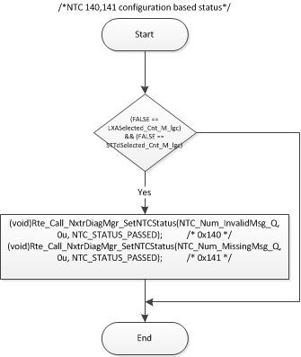

        - NTCs 178,179,170,171,144,145,147

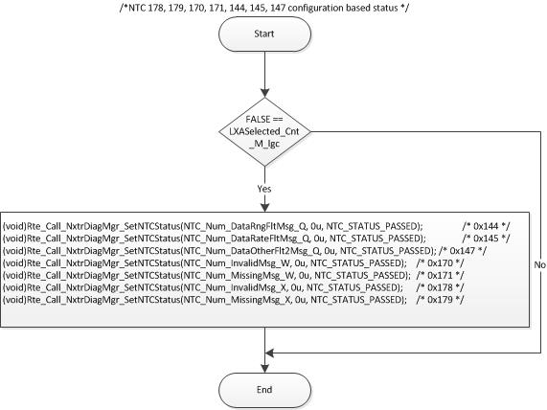

        - NTCs 158,159,15C

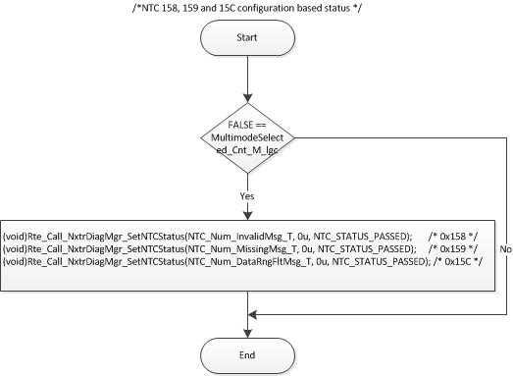

        - ESC

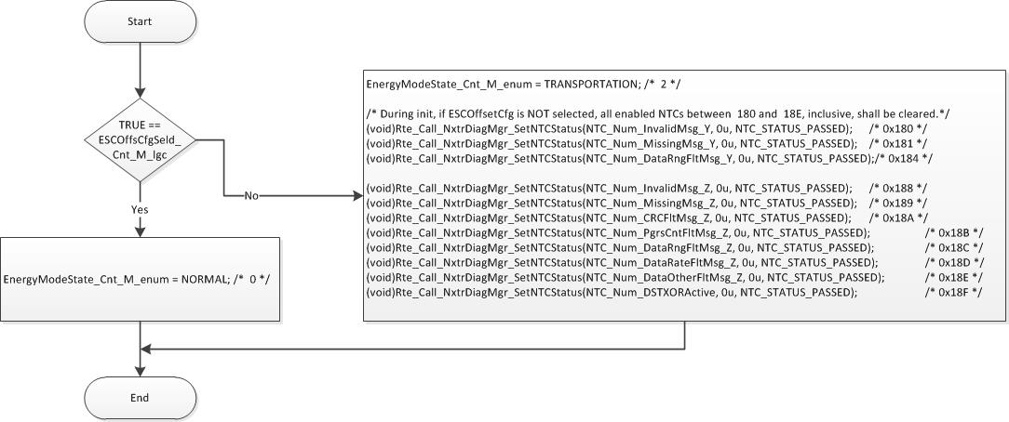

        - CAVH

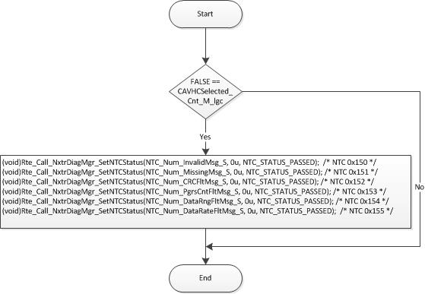

        - CityPark

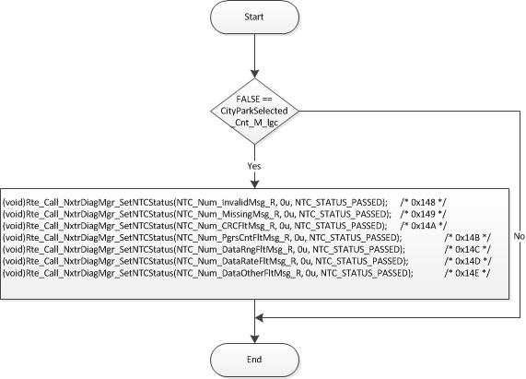

Module Outputs

ElectronicIntegrationWriteSucceeded_Cnt_M_lgc = E_OK;
Rte_IWrite_SrlComInput_Init_ElectronicIntegration_Cnt_lgc(*Rte_Pim_ElecIntData());
Rte_IWrite_SrlComInput_Init_EnergyModeState_Cnt_enum(EnergyModeState_Cnt_M_enum);
SrlComVehSpd_Kph_M_f32 = k_VehSpdInit_Kph_f32;
Rte_IWrite_SrlComInput_Init_SrlComVehSpd_Kph_f32(SrlComVehSpd_Kph_M_f32);
Rte_IWrite_SrlComInput_Init_CPKOK_Cnt_lgc(CPKOK_Cnt_M_lgc);
Rte_IWrite_SrlComInput_Init_LxaInpVld_Cnt_lgc(TRUE);
Rte_IWrite_SrlComInput_Init_MultiModeVld_Cnt_lgc(MultimodeVld_Cnt_M_lgc);
Rte_IWrite_SrlComInput_Init_EscPrecisionFromSerlCom_HwDeg_f32(EscPrecisionFromSerlCom_HwDeg_M_f32);
ApaVehicleSpeedValid_Cnt_M_lgc = TRUE;
Rte_IWrite_SrlComInput_Init_ApaVehicleSpeedValid_Cnt_lgc(ApaVehicleSpeedValid_Cnt_M_lgc);
PERIODIC FUNCTIONS

Per: SrlComInput_Per1

Design Rationale
None

Store Module Inputs to Local copies

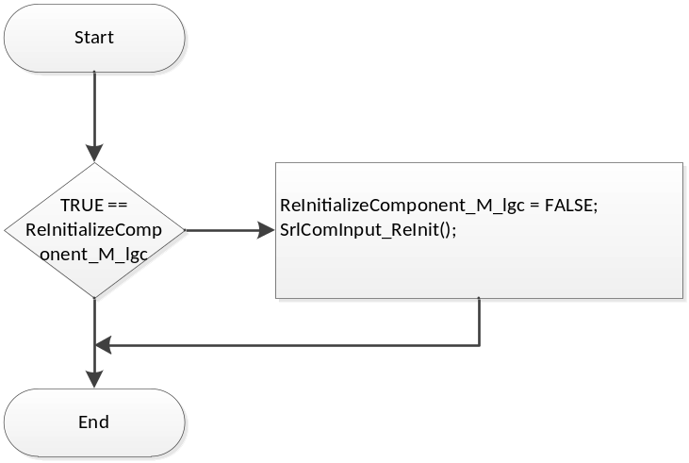

Read input:

(void)Rte_Read_AnneeEcoule_Cnt_u08(&AnneeEcoule_Cnt_T_u08);
Batt_Volt_T_f32 = Rte_IRead_SrlComInput_Per1_Batt_Volt_f32();
BusOffCh1_Cnt_T_lgc = Rte_IRead_SrlComInput_Per1_BusOff_Cnt_lgc();
CTermActive_Cnt_M_lgc = Rte_IRead_SrlComInput_Per1_CTermActive_Cnt_lgc();
(void)Rte_Read_CompteurTemporelVehicule_Cnt_u32(&CompteurTemporelVehicule_Cnt_T_u32); (void)Rte_Read_ComputerRazGCT_Cnt_u08(&ComputerRazGCT_Cnt_T_u08);
Rte_IWrite_SrlComInput_Per1_ComputerRazGCTRaw_Cnt_u08(ComputerRazGCT_Cnt_T_u08);
(void)Rte_Read_DiagMuxOn_Cnt_u08(&DiagMuxOn_Cnt_T_u08);
(void)Rte_Read_DmdDelestDA_Cnt_u08(&DmdDelestDA_Cnt_M_u08);
(void)Rte_Read_EtatMT_Cnt_u08(&EtatMT_Cnt_M_u08); /* PRQA S 3426 */ /* PRQA S 3417 */
Rte_IWrite_SrlComInput_Per1_EtatMTRaw_Cnt_u08(EtatMT_Cnt_M_u08);
(void)Rte_Read_ISDAT4V2BSI552MsgRxTime_MSec_u32(&ISDAT4V2BSI552MsgRxTime_MSec_T_u32);
(void)Rte_Read_ISDATBSI3F2MsgRxTime_MSec_u32(&ISDATBSI3F2MsgRxTime_MSec_T_u32);
(void)Rte_Read_ISDATBSI412MsgRxTime_MSec_u32(&ISDATBSI412MsgRxTime_MSec_T_u32);
(void)Rte_Read_ISDATBSI432MsgRxTime_MSec_u32(&ISDATBSI432MsgRxTime_MSec_T_u32);
(void)Rte_Read_ISDATDIRAMsgTxTime_MSec_u32(&ISDATDIRAMsgTxTime_MSec_T_u32);
(void)Rte_Read_ISDYN2CMMMsgRxTime_MSec_u32(&ISDYN2CMMMsgRxTime_MSec_T_u32);
(void)Rte_Read_ISDYNCDS34DMsgRxTime_MSec_u32(&ISDYNCDS34DMsgRxTime_MSec_T_u32);
(void)Rte_Read_ISDATABR50DMsgRxTime_MSec_u32(&ISDATABR50DMsgRxTime_MSec_T_u32);
(void)Rte_Read_ISDYN2FRE3CDMsgRxTime_MSec_u32(&ISDYN2FRE3CDMsgRxTime_MSec_T_u32);
(void)Rte_Read_ISDYNAASMsgRxTime_MSec_u32(&ISDYNAASMsgRxTime_MSec_T_u32);
(void)Rte_Read_ISDYNABRMsgRxTime_MSec_u32(&ISDYNABRMsgRxTime_MSec_T_u32);
(void)Rte_Read_ISDYNCMM208MsgRxTime_MSec_u32(&ISDYNCMM208MsgRxTime_MSec_T_u32);
(void)Rte_Read_ISDYNCMM388MsgRxTime_MSec_u32(&ISDYNCMM388MsgRxTime_MSec_T_u32);
(void)Rte_Read_ISDYNVOLMsgRxTime_MSec_u32(&ISDYNVOLMsgRxTime_MSec_T_u32);
(void)Rte_Read_ISDATDIRAMsgTxInProgress_Cnt_lgc(&ISDATDIRAMsgTxInProgress_Cnt_T_lgc);
(void)Rte_Read_ISDATBSI572MsgRxTime_MSec_u32(&ISDATBSI572MsgRxTime_MSec_T_u32);
(void)Rte_Read_PROTOHS1DYNUCF5CDMsgRxTime_MSec_u32(&PROTOHS1DYNUCF5CDMsgRxTime_MSec_T_u32);
(void)Rte_Read_JourEcoule_Cnt_u16(&JourEcoule_Cnt_T_u16);
RxMsgsSrlComSvcDft_Cnt_M_lgc = Rte_IRead_SrlComInput_Per1_RxMsgsSrlComSvcDft_Cnt_lgc();
(void)Rte_Read_SecondeEcoulee_Cnt_u32(&SecondeEcoulee_Cnt_T_u32);
VehicleSpeed_Kph_M_f32 = Rte_IRead_SrlComInput_Per1_VehicleSpeed_Kph_f32();
SystemState_Cnt_M_enum = Rte_Mode_SystemState_Mode();
(void)Rte_Call_EpsEn_OP_GET(&EpsEn_Cnt_M_lgc);
(void)Rte_Call_SystemTime_GetSystemTime_mS_u32(&SystemTime_mS_M_u32);

Timer and Cnt Initialization
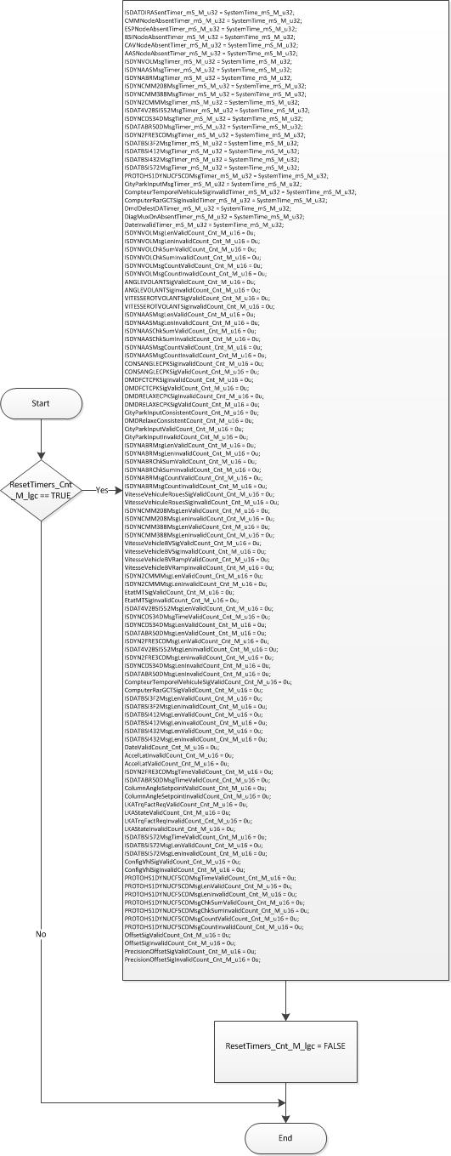

SrlCom Message
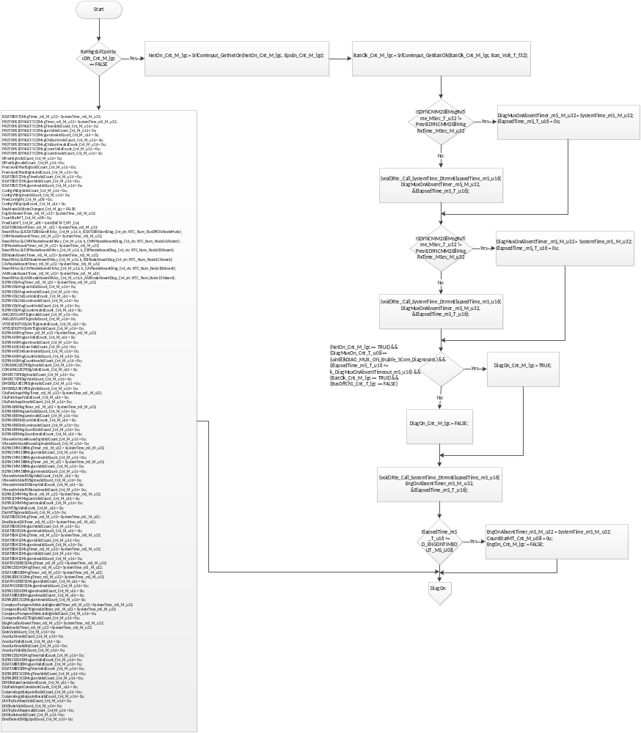

diagon Processing
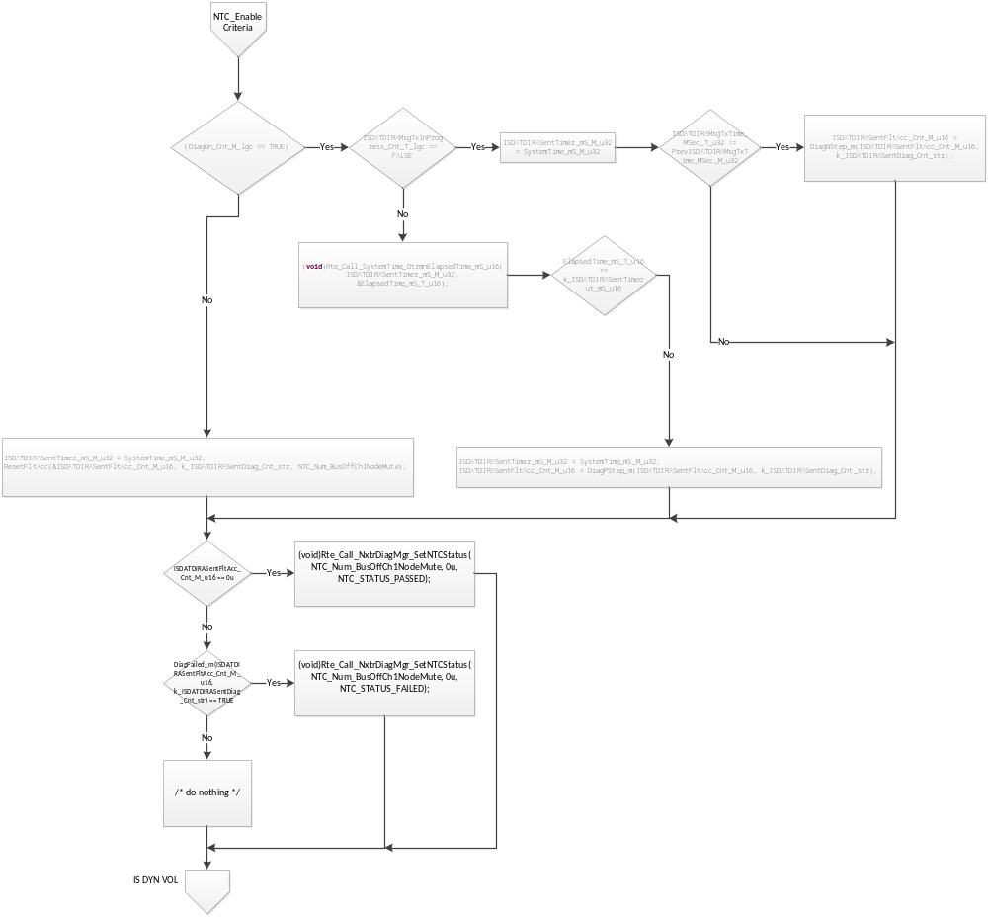

IS_DYN_VOL Message Handling
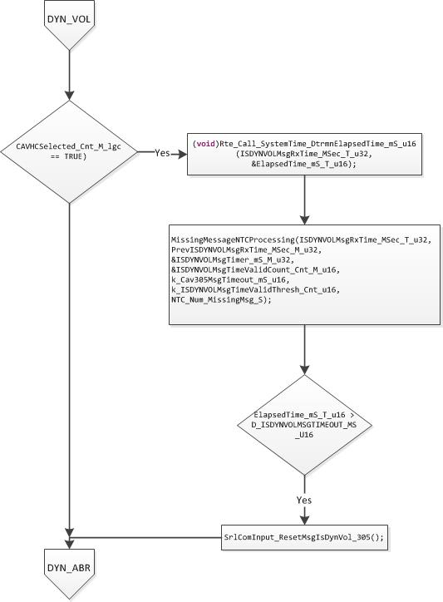

IS_DYN_ABR Message Handling
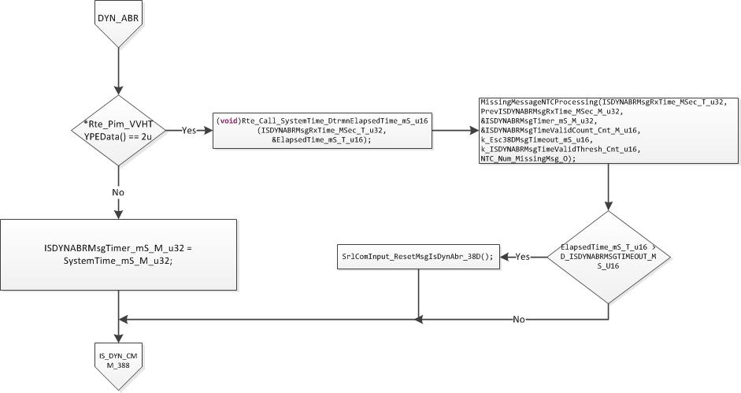

IS_DYN_CMM_388 Message Handling
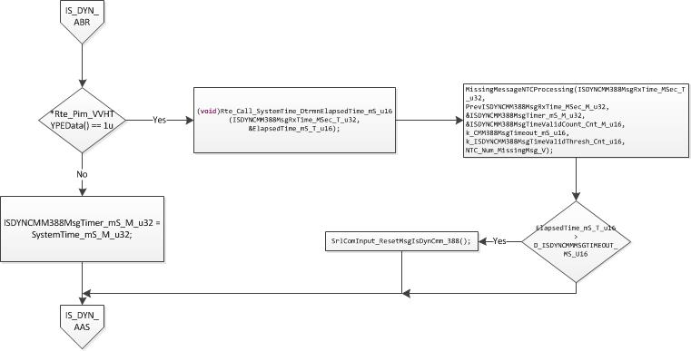

IS_DYN_AAS Message Handling

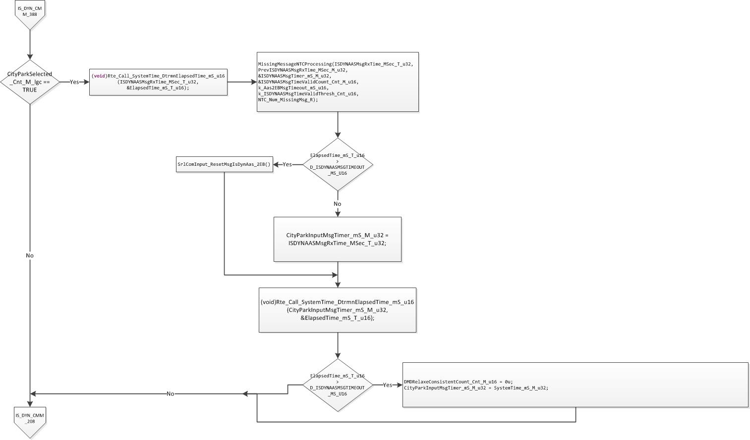

IS_DYN_CMM_208 Message Handling
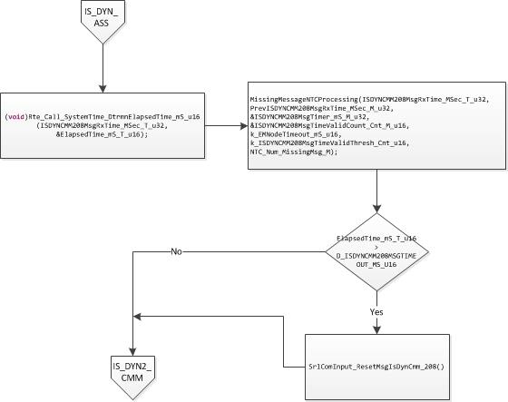

IS_DYN2_CMM Message Handling
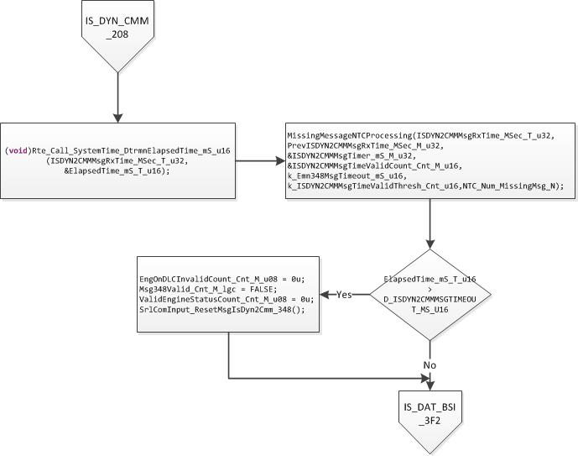

IS_DAT_BSI_3F2 Message Handling
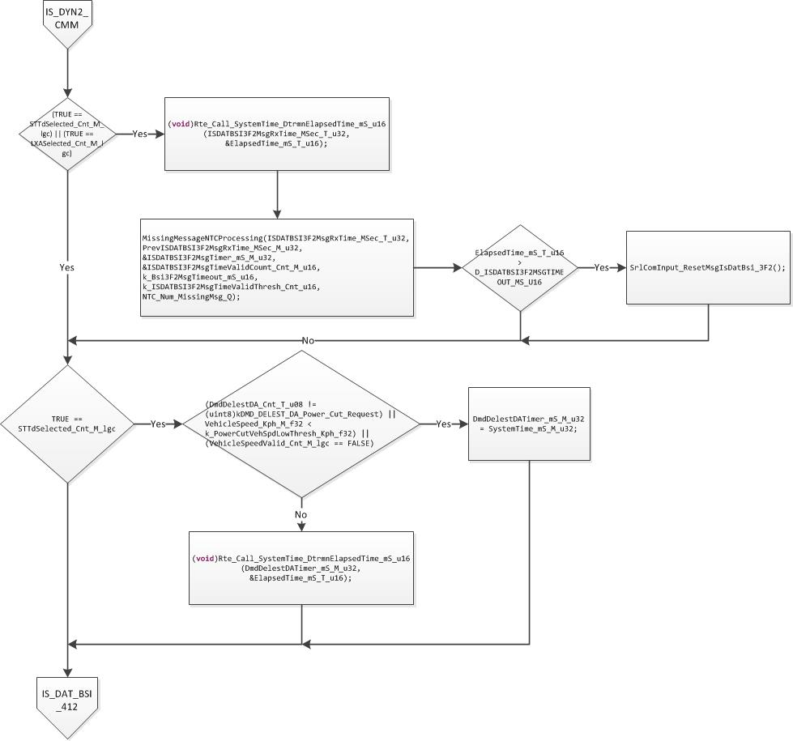

IS_DAT_BSI_412 Message Handling
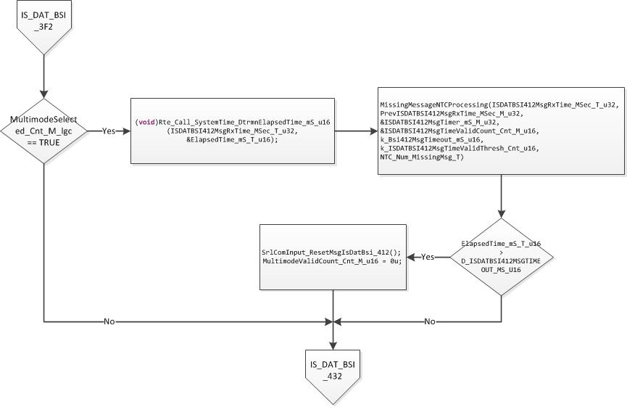

IS_DAT_BSI_432 Message Handling
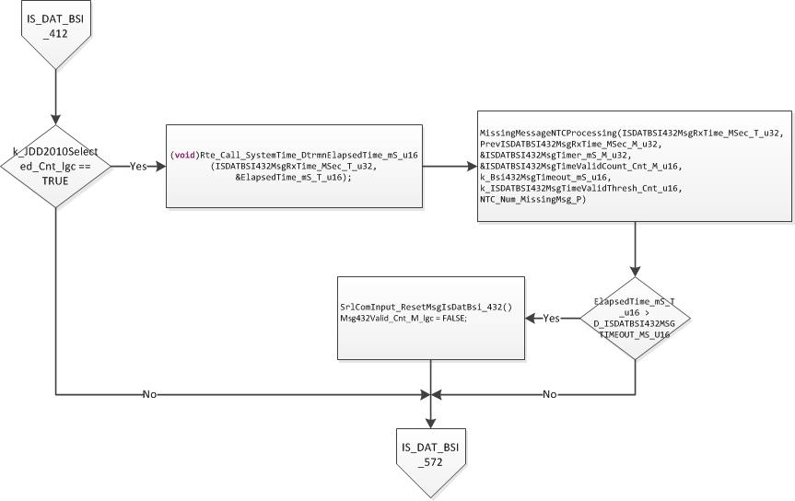

IS_DAT_BSI_572 Message Handling
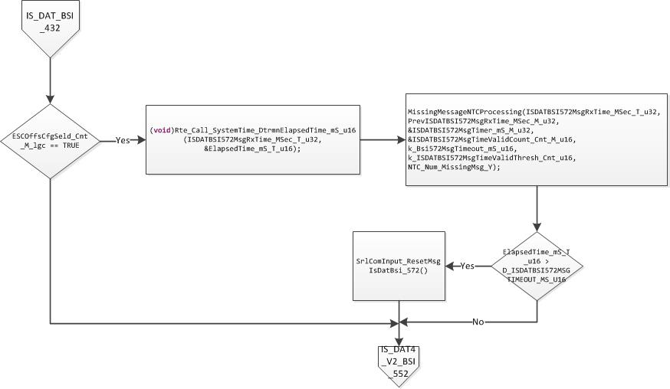

IS_DAT4_V2_BSI_552 Message Handling

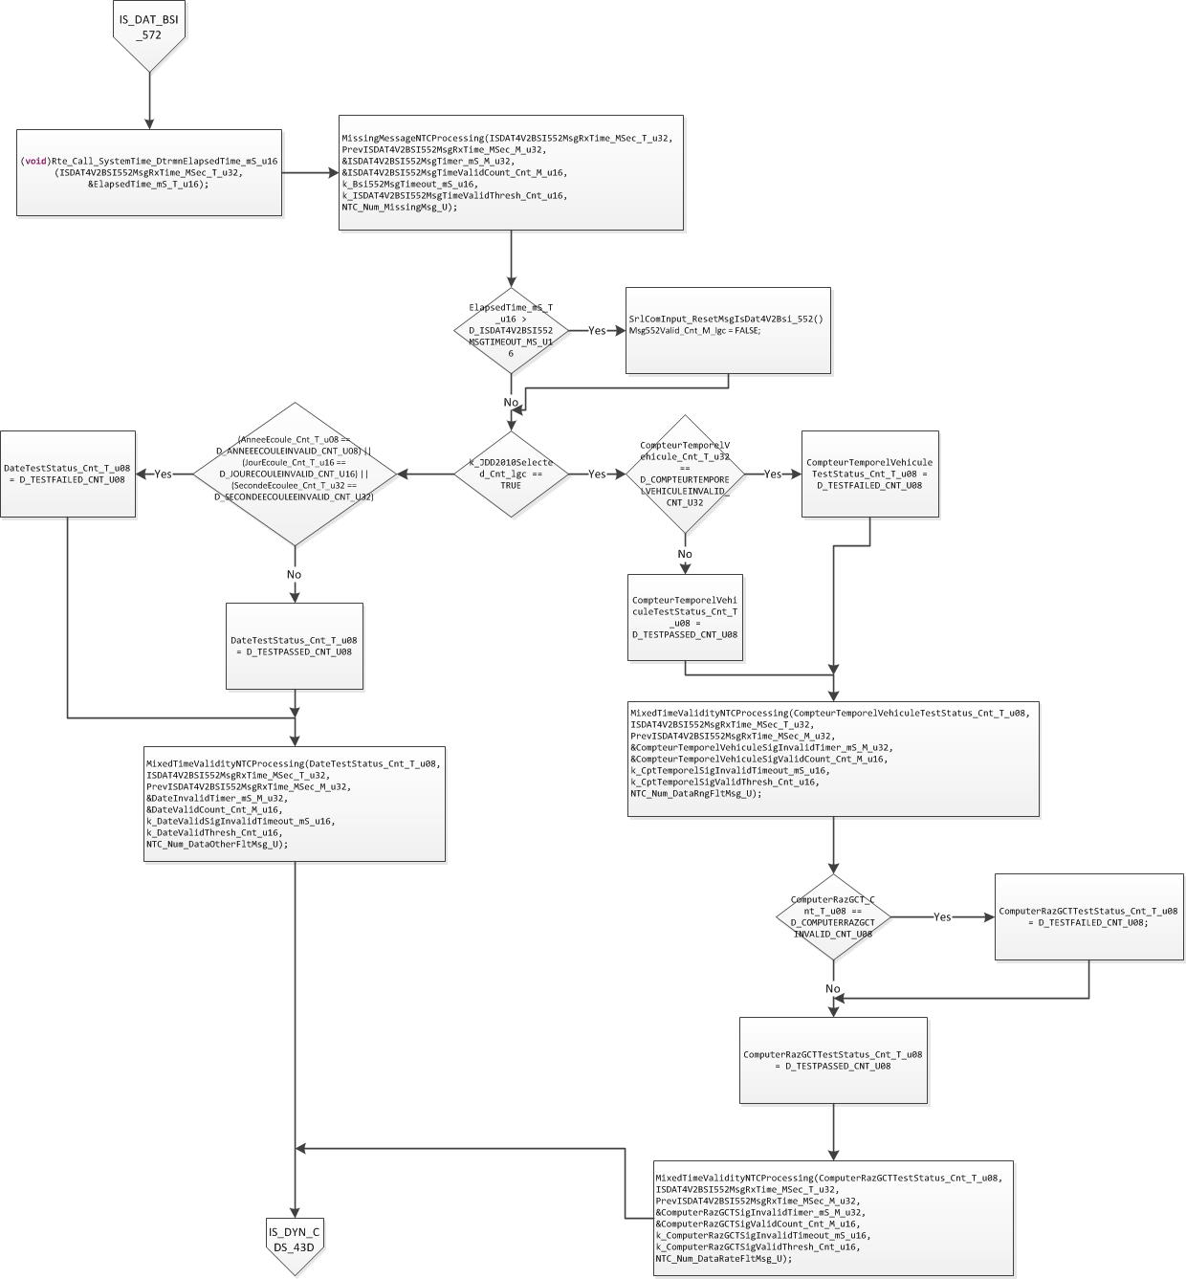

ISDYNDS34D
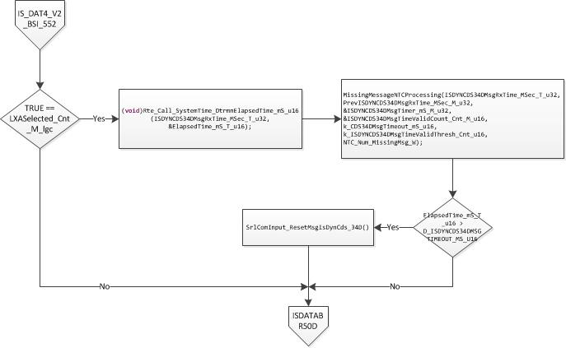

ISDATABR50D
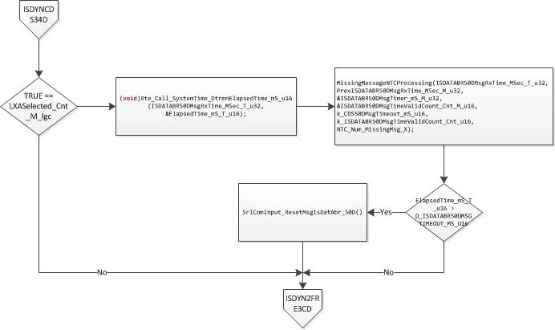

ISDYN2FRE3CD
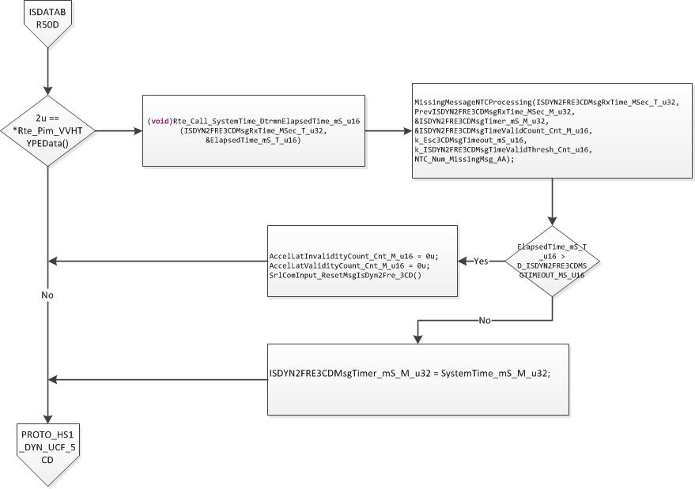

PROTO_HS1_DYN_UCF_5CD Message Handling
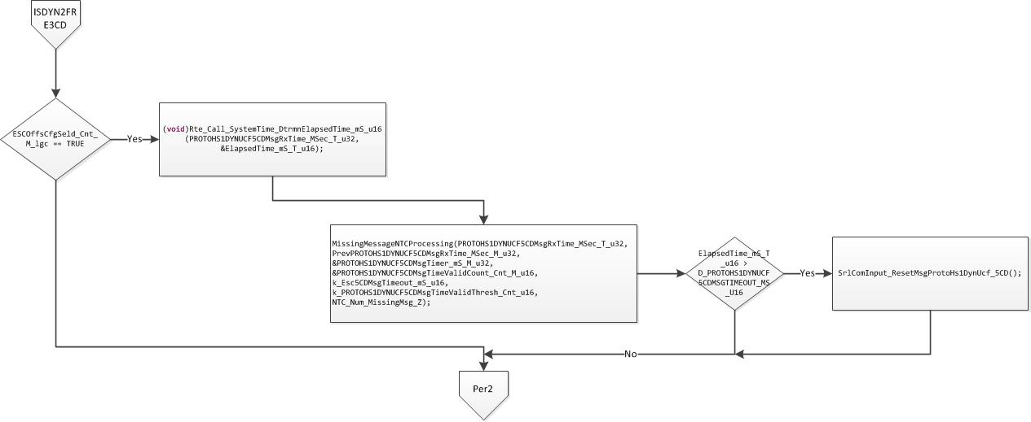

Store Local copy of outputs into Module Outputs
None

Per: SrlComInput_Per2

Design Rationale
None

Store Module Inputs to Local copies

Read inputs:

DefaultVehSpd_Cnt_T_lgc = Rte_IRead_SrlComInput_Per2_DefaultVehSpd_Cnt_lgc();
(void)Rte_Read_ESPDeconnecte_Cnt_u08(&ESPDeconnecte_Cnt_T_u08);
(void)Rte_Read_RegulAbr_Cnt_u08(&RegulAbr_Cnt_T_u08);
(void)Rte_Read_RegulEsp_Cnt_u08(&RegulEsp_Cnt_T_u08);
(void)Rte_Read_ReqLampeDefEsp_Cnt_u08(&ReqLampeDefEsp_Cnt_T_u08);
ElectronicIntegration_Cnt_T_lgc = *Rte_Pim_ElecIntData();

SRLCOM Per2 Message
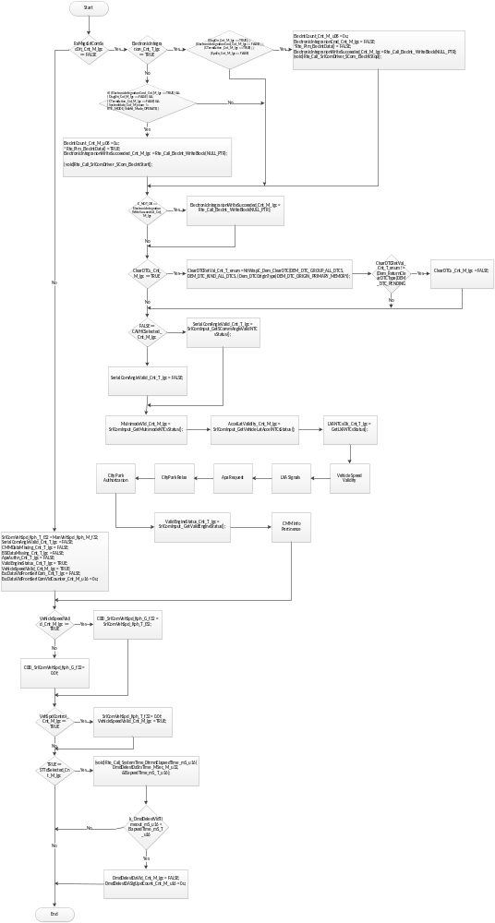

Serial Com Angle Validity

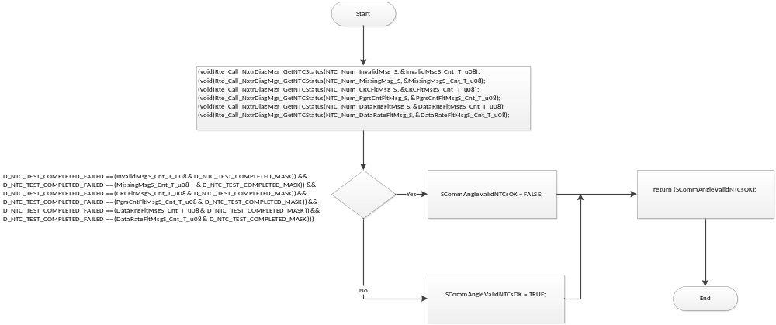

Multimode validity
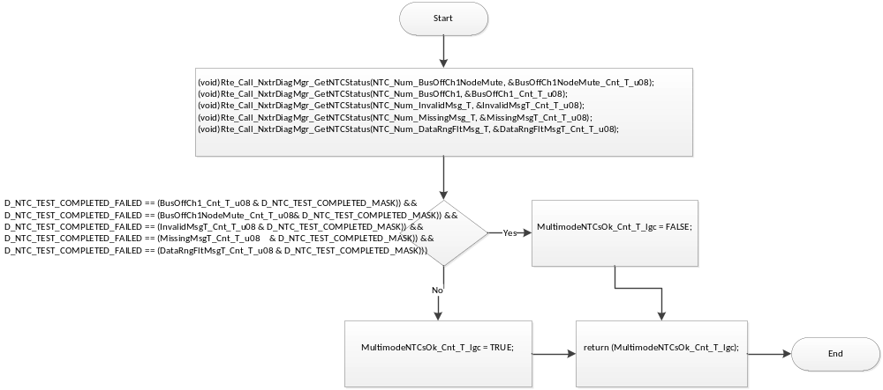

LatAccel Validity

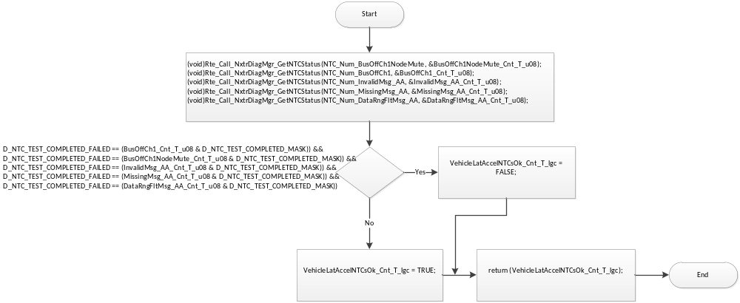

Lxa Validity
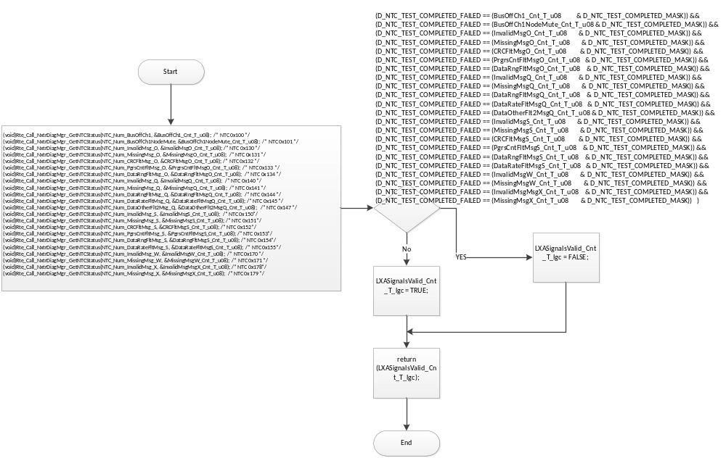

Vehicle Speed and Validity

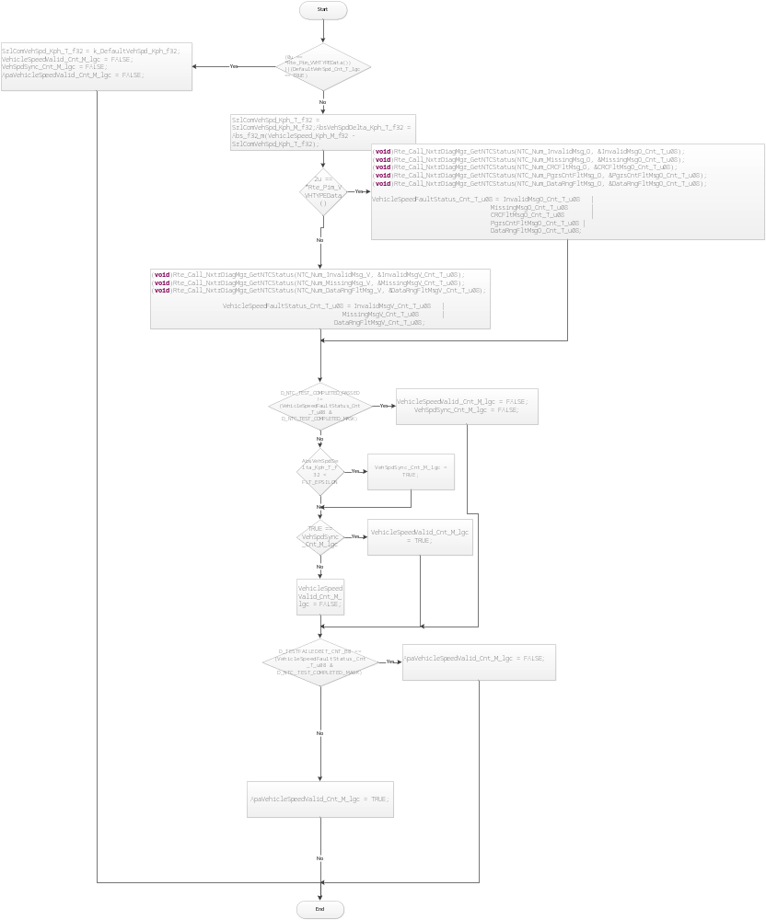

Lka signals

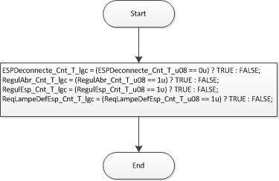

APA Request
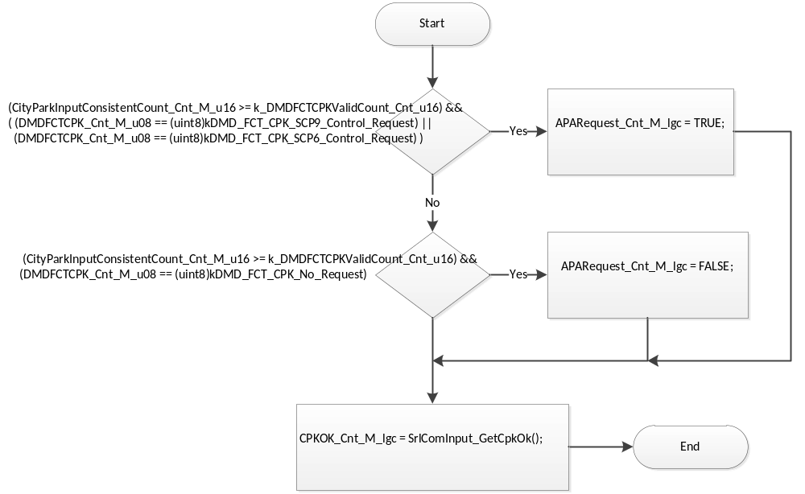

City park relax

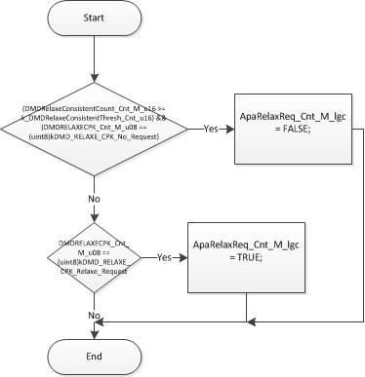

City Park authorization

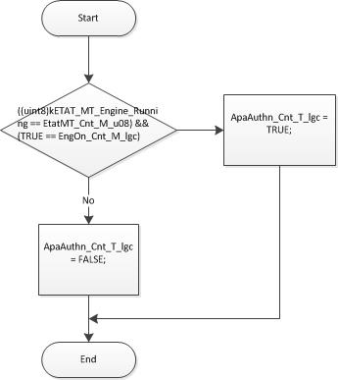

STTa Determination
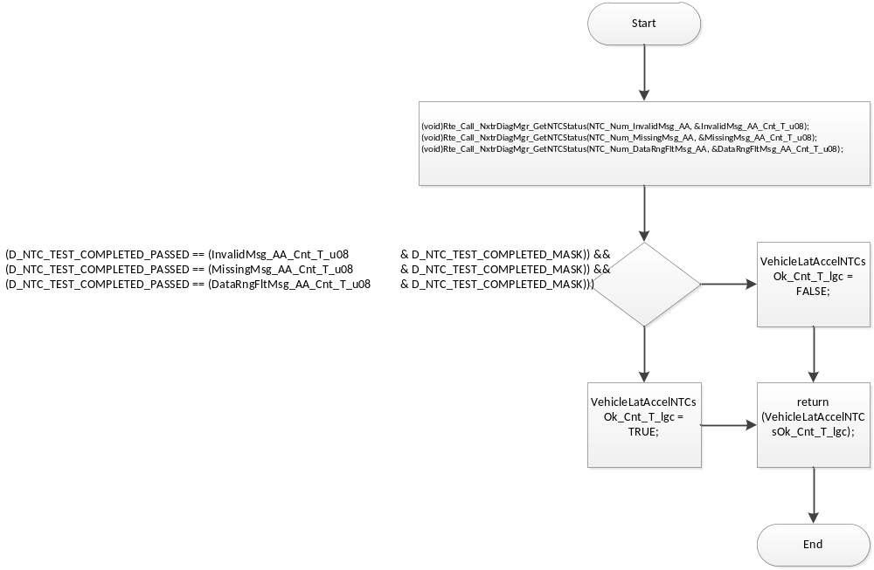

CMM and BSI Info Pertinence
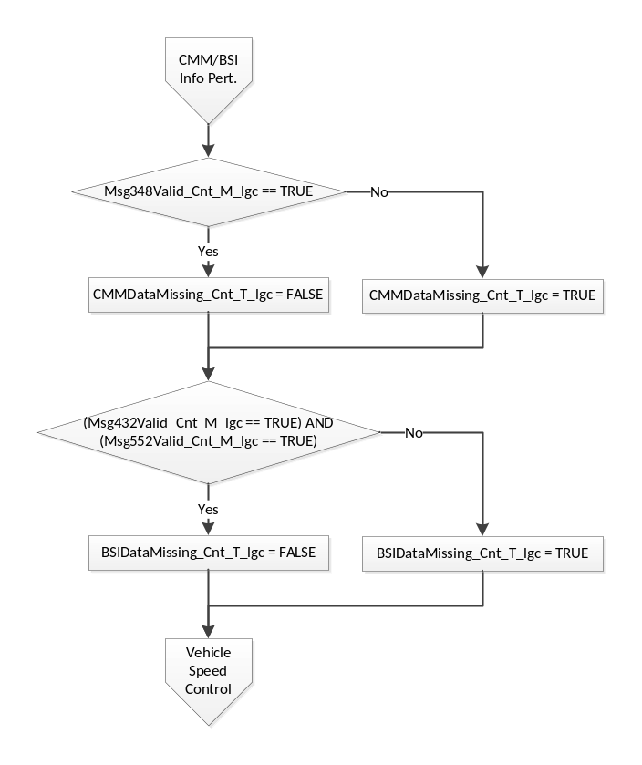

Vehicle Speed Control
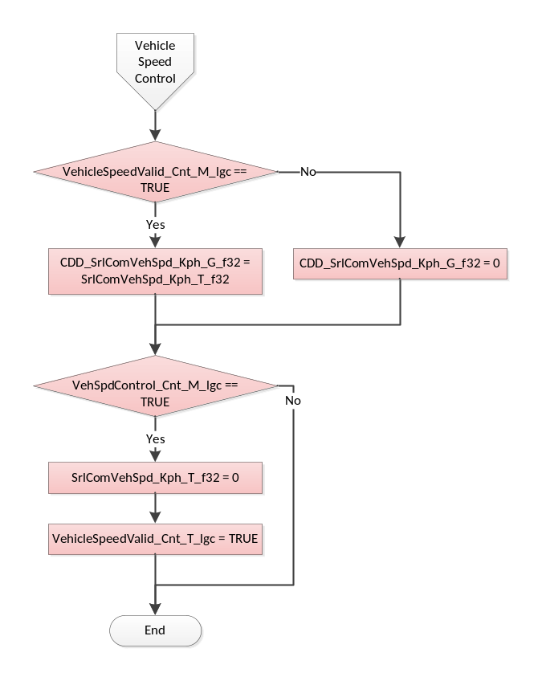

Store Local copy of outputs into Module Outputs
Write outpus:

Rte_IWrite_SrlComInput_Per2_MultiModeVld_Cnt_lgc(MultimodeVld_Cnt_M_lgc);
Rte_IWrite_SrlComInput_Per2_ReqModeDAFinal_Cnt_enum(MultimodeSwReq_Cnt_M_u08);
Rte_IWrite_SrlComInput_Per2_ColAngleSetpoint_HwDeg_f32(ColumnAngleSetpoint_HwDeg_M_f32);
Rte_IWrite_SrlComInput_Per2_LxaInpVld_Cnt_lgc(LXANTCsOk_Cnt_T_lgc);
Rte_IWrite_SrlComInput_Per2_VehicleLatAccel_MpSecSq_f32(AccelLat_MpSecSq_M_f32);
Rte_IWrite_SrlComInput_Per2_VehicleLatAccelValid_Cnt_lgc(AccelLatValidity_Cnt_M_lgc);
Rte_IWrite_SrlComInput_Per2_APARequest_Cnt_lgc(APARequest_Cnt_M_lgc);
Rte_IWrite_SrlComInput_Per2_ApaRelaxReq_Cnt_lgc(ApaRelaxReq_Cnt_M_lgc);
Rte_IWrite_SrlComInput_Per2_APAAuthn_Cnt_lgc(ApaAuthn_Cnt_T_lgc);
Rte_IWrite_SrlComInput_Per2_AngleVolant_HwDeg_f32(AngleVolant_HwDeg_M_f32);
Rte_IWrite_SrlComInput_Per2_BSIDataMissing_Cnt_lgc(BSIDataMissing_Cnt_T_lgc);
Rte_IWrite_SrlComInput_Per2_CMMDataMissing_Cnt_lgc(CMMDataMissing_Cnt_T_lgc);
Rte_IWrite_SrlComInput_Per2_CONSANGLECPK_Cnt_s16(CONSANGLECPK_Cnt_M_s16);
Rte_IWrite_SrlComInput_Per2_CPKOK_Cnt_lgc(CPKOK_Cnt_M_lgc);
Rte_IWrite_SrlComInput_Per2_DMDFCTCPK_Cnt_u08(DMDFCTCPK_Cnt_M_u08);
Rte_IWrite_SrlComInput_Per2_ElectronicIntegration_Cnt_lgc(*Rte_Pim_ElecIntData());
Rte_IWrite_SrlComInput_Per2_EngOn_Cnt_lgc(EngOn_Cnt_M_lgc);
Rte_IWrite_SrlComInput_Per2_IgnTimeOff_Cnt_u32(IgnTimeOff_Sec_M_u32);
Rte_IWrite_SrlComInput_Per2_PosSrvoHwAngle_HwDeg_f32(CONSANGLECPK_HwDeg_M_f32);
Rte_IWrite_SrlComInput_Per2_SerialComAngleValid_Cnt_lgc(SerialComAngleValid_Cnt_T_lgc);
Rte_IWrite_SrlComInput_Per2_SrlComVehSpd_Kph_f32(SrlComVehSpd_Kph_T_f32);
Rte_IWrite_SrlComInput_Per2_ValidEngineStatus_Cnt_lgc(ValidEngineStatus_Cnt_T_lgc);
Rte_IWrite_SrlComInput_Per2_VehTimeValid_Cnt_lgc(VehTimeValid_Cnt_M_lgc);
Rte_IWrite_SrlComInput_Per2_VehicleSpeedValid_Cnt_lgc(VehicleSpeedValid_Cnt_M_lgc);
Rte_IWrite_SrlComInput_Per2_ApaVehicleSpeedValid_Cnt_lgc(ApaVehicleSpeedValid_Cnt_M_lgc)
Rte_IWrite_SrlComInput_Per2_AbsActv_Cnt_lgc(RegulAbr_Cnt_T_lgc);
Rte_IWrite_SrlComInput_Per2_EscEna_Cnt_lgc(ESPDeconnecte_Cnt_T_lgc);
Rte_IWrite_SrlComInput_Per2_EscActv_Cnt_lgc(RegulEsp_Cnt_T_lgc);
Rte_IWrite_SrlComInput_Per2_EscFltPrsnt_Cnt_lgc(ReqLampeDefEsp_Cnt_T_lgc);
Rte_IWrite_SrlComInput_Per2_LxaStateFilt_Cnt_enum(LKAState_Cnt_M_u08);
Rte_IWrite_SrlComInput_Per2_EnergyModeState_Cnt_enum(EnergyModeState_Cnt_M_enum);
Rte_IWrite_SrlComInput_Per2_EscOffsFromSerlCom_HwDeg_f32(EscOffsFromSerlCom_HwDeg_M_f32);
Rte_IWrite_SrlComInput_Per2_EscPrecisionFromSerlCom_HwDeg_f32(EscPrecisionFromSerlCom_HwDeg_M_f32);
Rte_IWrite_SrlComInput_Per2_EscAckFromSerlCom_Cnt_lgc(EscAckFromSerlCom_Cnt_T_lgc);
Rte_IWrite_SrlComInput_Per2_EscDataVldFromSerlCom_Cnt_lgc(EscDataVldFromSerlCom_Cnt_T_lgc);
Rte_Enter_DmdDelestDa();
(void)Rte_Write_DmdDelestDaSts_Cnt_u08(DmdDelestDaSts_Cnt_M_u08);
(void)Rte_Write_DmdDelestDaVld_Cnt_lgc(DmdDelestDaVld_Cnt_M_lgc);
Rte_Exit_DmdDelestDa();

Interrupt Functions
None

TRANSIENT FUNCTIONS

Trns: SrlComInput_Trns1

Design Rationale
None

Store Module Inputs to Local copies
AnneeEcoule_Cnt_T_u08
CompteurTemporelVehicule_Cnt_T_u32
ISDAT4V2BSI552MsgRxTime_MSec_T_u32
JourEcoule_Cnt_T_u16
SecondeEcoulee_Cnt_T_u32
InvalidMsgU_Cnt_T_lgc
MissingMsgU_Cnt_T_lgc
DataRngFltMsgU_Cnt_T_lgc
DataRateFltMsgU_Cnt_T_lgc

Processing of function
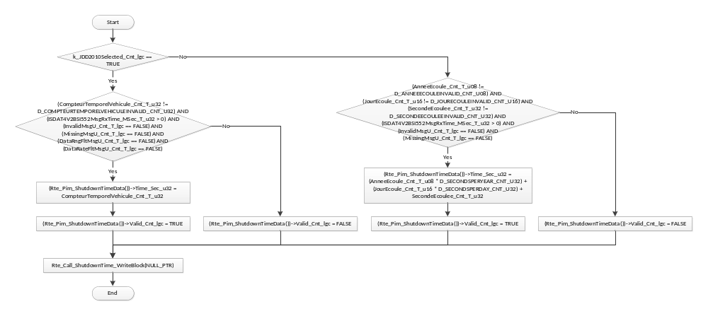

Store Local copy of outputs into Module Outputs
None

Trns: SrlComInput_Trns2

Design Rationale
None

Store Module Inputs to Local copies
None

Processing of function

Store Local copy of outputs into Module Outputs
PrevISDAT4V2BSI552MsgRxTime_MSec_M_u32 = Rte_InitValue_ISDAT4V2BSI552MsgRxTimeRaw_MSec_u32;
LxATqFacReq_Uls_M_f32 = Rte_InitValue_LxaTqFacReq_Uls_f32;
Rte_IWrite_SrlComInput_Trns2_CompteurTemporelVehiculeRaw_Cnt_u32(Rte_InitValue_CompteurTemporelVehiculeRaw_Cnt_u32);
Rte_IWrite_SrlComInput_Trns2_EtatPrincipSev_Cnt_u08(Rte_InitValue_EtatPrincipSev_Cnt_u08);
Rte_IWrite_SrlComInput_Trns2_EtatReseauElec_Cnt_u08(Rte_InitValue_EtatReseauElec_Cnt_u08);
Rte_IWrite_SrlComInput_Trns2_ISDAT4V2BSI552MsgRxTimeRaw_MSec_u32(PrevISDAT4V2BSI552MsgRxTime_MSec_M_u32);
Rte_IWrite_SrlComInput_Trns2_Kilometrage_Cnt_u32(Rte_InitValue_Kilometrage_Cnt_u32);
Rte_IWrite_SrlComInput_Trns2_LxaSeln_Cnt_lgc(Rte_InitValue_LxaSeln_Cnt_lgc);
Rte_IWrite_SrlComInput_Trns2_LxaTqFacReq_Uls_f32(LxATqFacReq_Uls_M_f32);
Rte_IWrite_SrlComInput_Trns2_PowerSupplies_Cnt_u08(Rte_InitValue_PowerSupplies_Cnt_u08);
Rte_IWrite_SrlComInput_Trns2_ShuntPosition_Cnt_u08(Rte_InitValue_ShuntPosition_Cnt_u08);
ReInitializeComponent_M_lgc = TRUE;

Serial Communication Functions

SComm: SrlComInput_SCom_GetNetworkDiagFltAcc

Design Rationale
None

Store Module Inputs to Local copies
None

Processing of function

*MuteFltAcc_Cnt_T_u16 = ISDATDIRASentFltAcc_Cnt_M_u16;
*CAVNodeFltAcc_Cnt_T_u16 = CAVNodeAbsentFltAcc_Cnt_M_u16;
*CMMNodeFltAcc_Cnt_T_u16 = CMMNodeAbsentFltAcc_Cnt_M_u16;
*ESPNodeFltAcc_Cnt_T_u16 = ESPNodeAbsentFltAcc_Cnt_M_u16;
*AASNodeFltAcc_Cnt_T_u16 = AASNodeAbsentFltAcc_Cnt_M_u16;
*BSINodeFltAcc_Cnt_T_u16 = BSINodeAbsentFltAcc_Cnt_M_u16;

Store Local copy of outputs into Module Outputs

SComm: SrlComInput_SCom_ManualVehSpd

Design Rationale
None

Store Module Inputs to Local copies
None

Processing of function
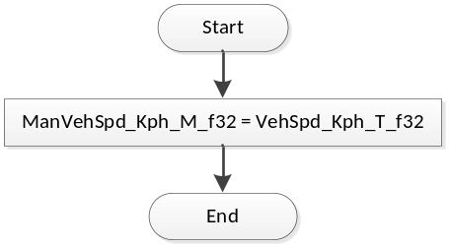
Flowchart 1: SrlComInput_SCom_ManualVehSpd

Store Local copy of outputs into Module Outputs
None

SCOMM: SrlComInput_SCom_ResetTimers

DESIGN RATIONALE
None

STORE MODULE INPUTS TO LOCAL COPIES
None

PROCESSING OF FUNCTION
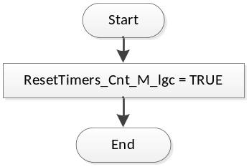
Flowchart 2: SrlComInput_SCom_ResetTimers

Store Local copy of outputs into Module Outputs
None

SComm: SrlComInput_SCom_VehSpdControl

Design Rationale
None

Store Module Inputs to Local copies
None

Processing of function
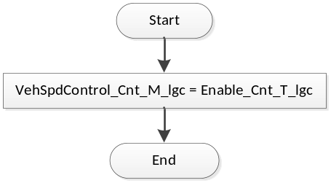
Flowchart 3: SrlComInput_SCom_VehSpdControl

Store Local copy of outputs into Module Outputs

None

SComm: SrlComInput_REINIT

Design Rationale
None

Store Module Inputs to Local copies
None

Processing of function

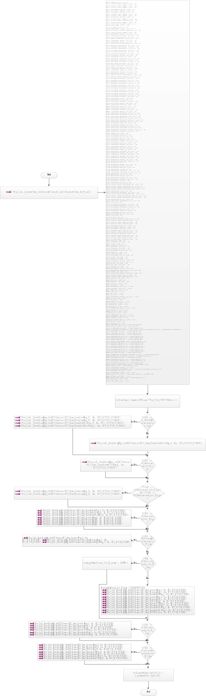

Store Local copy of outputs into Module Outputs

Local Function/Macro Definitions

Increment Counter to Threshold (Macro)
Function Name | IncToThresh | Type | Min | Max
Arguments Passed | Counter | N/A | N/A | N/A
 | Thresh | N/A | N/A | N/A
Return Value | (return) | N/A | N/A | N/A

Description
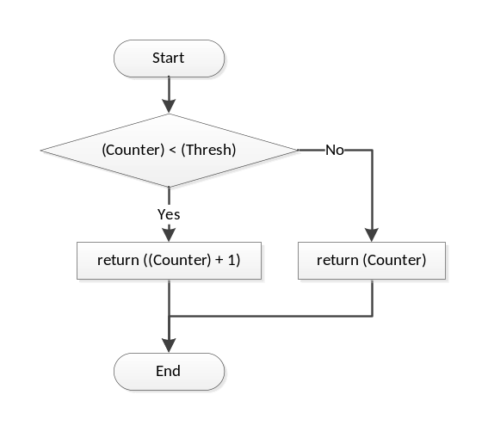

Node ABsent NTC Processing
Function Name | NodeAbsentNTCProcessing | Type | Min | Max
Arguments Passed | MsgRxTime_MSec_T_u32 | uint32 | 0 | 2³² – 1
 | PrevMsgRxTime_MSec_T_u32 | uint32 | 0 | 2³² – 1
 | MsgTimer_mS_T_u32 | uint32 * | 0 | 2³² – 1
 | FltAcc_Cnt_T_u16 | uint16 * | 0 | 255
 | Timeout_mS_T_u16 | uint16 | 0 | 2¹⁶ – 1
 | MsgDiag_Cnt_T_str | DiagSettings_Str | 0 | 255
 | NTCNum_Cnt_T_u16 | uint16 | 0 | 511
Return Value | N/A

Description
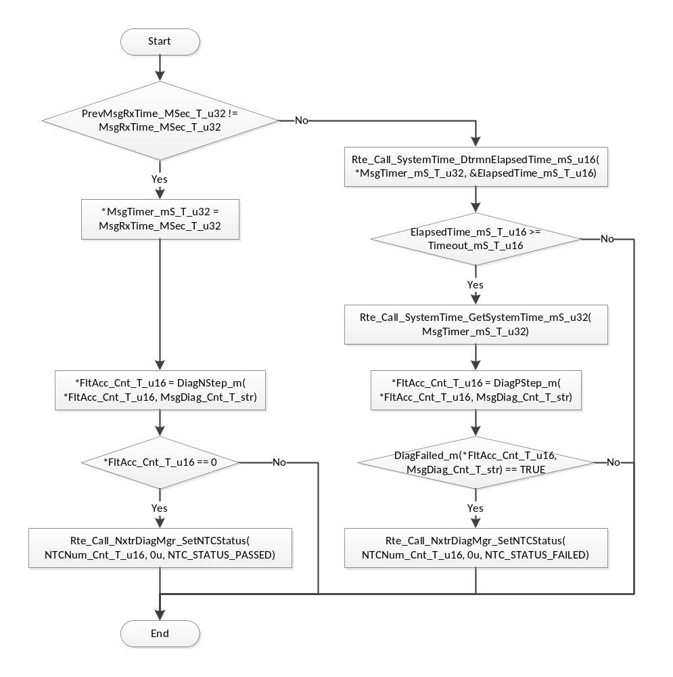
Flowchart 4: MissingMessageNTCProcessing

Missing Message NTC Processing
Function Name | MissingMessageNTCProcessing | Type | Min | Max
Arguments Passed | MsgRxTime_MSec_T_u32 | uint32 | 0 | 2³² – 1
 | PrevMsgRxTime_MSec_T_u32 | uint32 | 0 | 2³² – 1
 | MsgTimer_mS_T_u32 | uint32 * | 0 | 2³² – 1
 | ValidCount_Cnt_T_u16 | uint16 * | 0 | 65535
 | Timeout_mS_T_u16 | uint16 | 0 | 2¹⁶ – 1
 | ValidThresh_Cnt_T_u16 | uint16 | 0 | 65535
 | NTCNum_Cnt_T_u16 | uint16 | 0 | 511
Return Value | N/A

Description
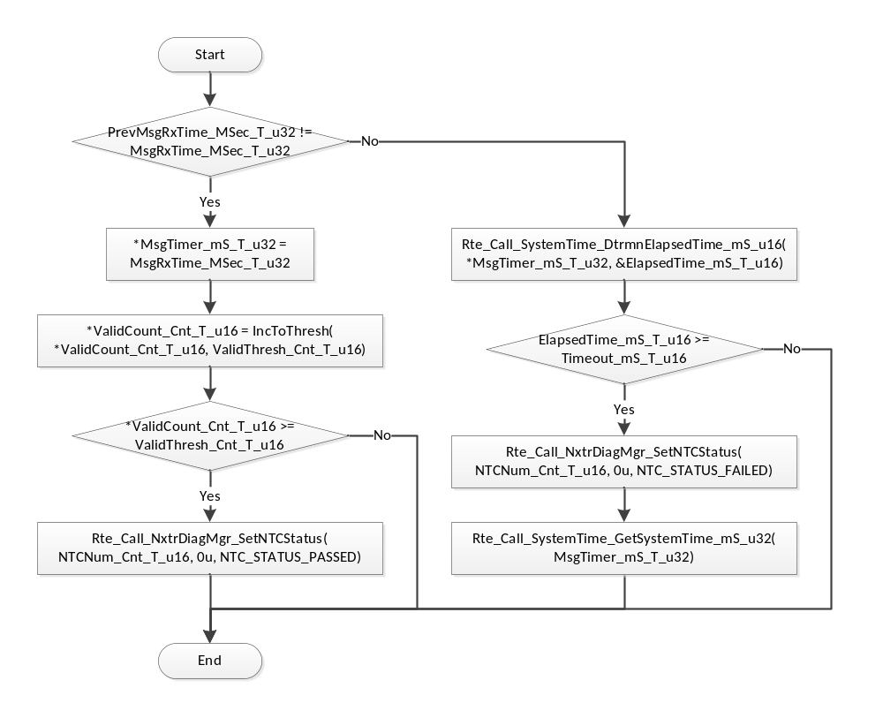

Validity NTC Processing
Function Name | ValidityNTCProcessing | Type | Min | Max
Arguments Passed | TestStatus_Cnt_T_u08 | uint8 | 0 | 1
 | ValidCount_Cnt_T_u16 | uint16 * | 0 | 2¹⁶ – 1
 | InvalidCount_Cnt_T_u16 | uint16 * | 0 | 2¹⁶ – 1
 | ValidThresh_Cnt_T_u16 | uint16 | 0 | 2¹⁶ – 1
 | InvalidThresh_Cnt_T_u16 | uint16 | 0 | 2¹⁶ – 1
 | NTCNum_Cnt_T_u16 | uint16 | 0 | 511
Return Value | N/A

Description
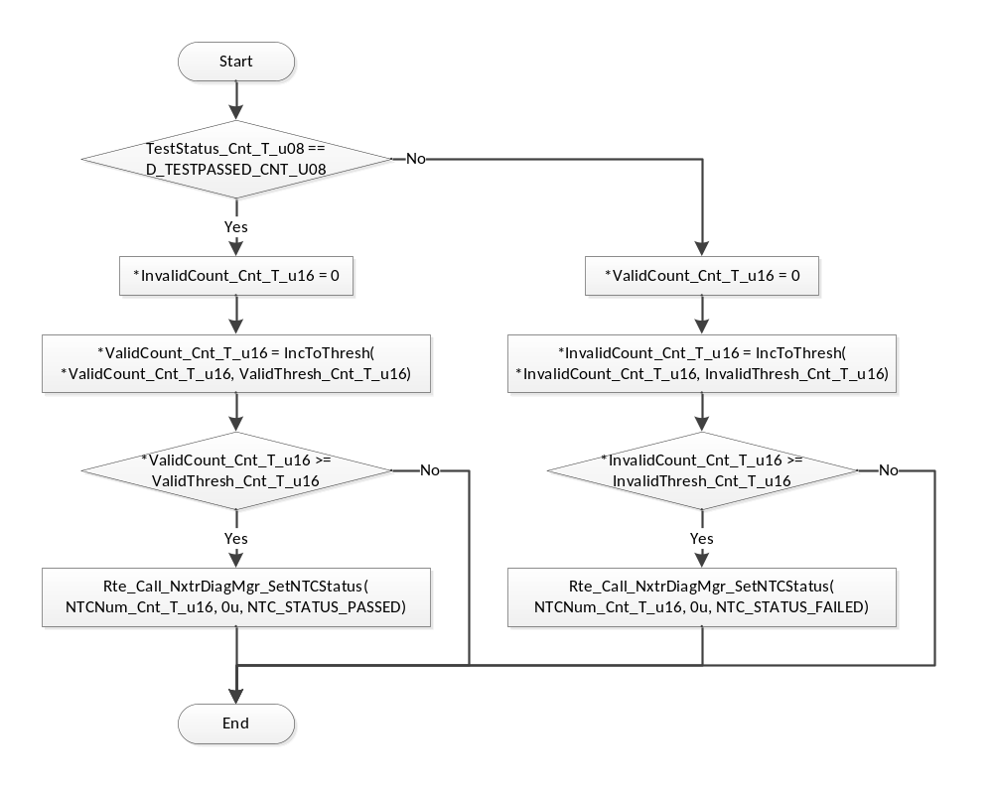
Flowchart 5: ValidityNTCProcessing

Mixed Time Validity NTC Processing
Function Name | MixedTimeValidityNTCProcessing | Type | Min | Max
Arguments Passed | TestStatus_Cnt_T_u08 | uint8 | 0 | 1
 | MsgRxTime_MSec_T_u32 | uint32 | 0 | 2³² – 1
 | PrevMsgRxTime_MSec_T_u32 | uint32 | 0 | 2³² – 1
 | SigTimer_mS_T_u32 | uint32 * | 0 | 2³² – 1
 | ValidCount_Cnt_T_u16 | uint16 * | 0 | 2¹⁶ – 1
 | Timeout_mS_T_u16 | uint16 | 0 | 2¹⁶ – 1
 | ValidThresh_Cnt_T_u16 | uint16 | 0 | 2¹⁶ – 1
 | NTCNum_Cnt_T_u16 | uint16 | 0 | 511
Return Value | N/A

Description
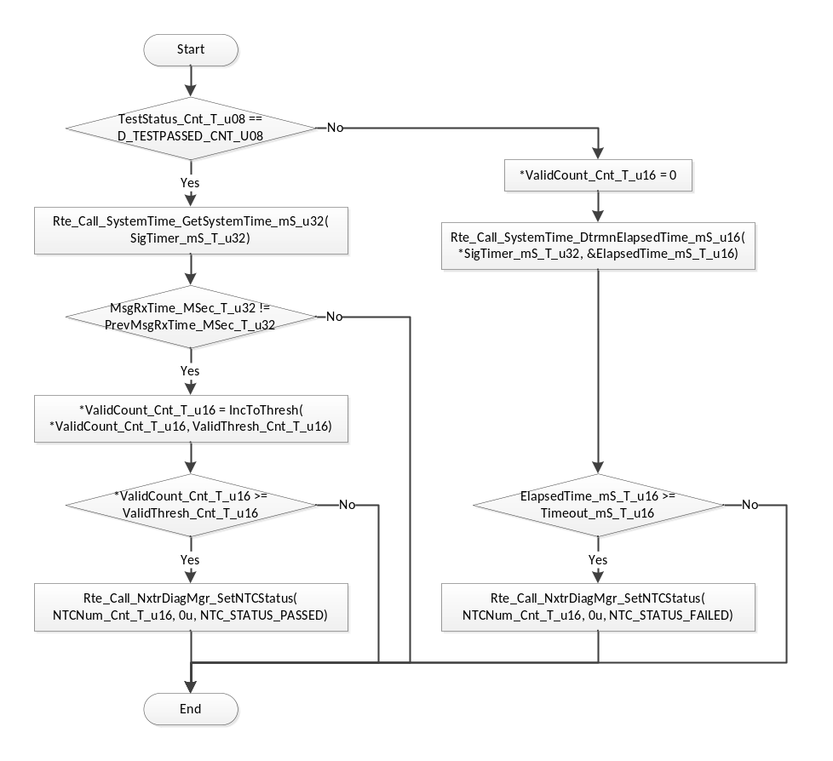
Flowchart 6: ValidityNTCProcessing

Reset Fault Accumulator
Function Name | ResetFltAcc | Type | Min | Max
Arguments Passed | FltAcc_Cnt_T_u16 | uint16 * | 0 | 2¹⁶ – 1
 | DiagSettings_Cnt_T_str | DiagSettings_Str | 0 | 255
 | NTCNum_Cnt_T_u16 | uint16 | 0 | 511
Return Value | N/A

Description
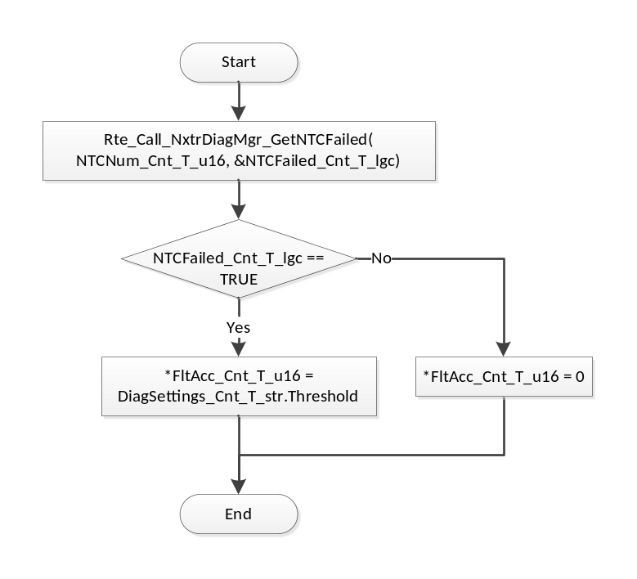
Flowchart 7: ResetFltAcc

GLObAL Function/Macro Definitions
None

Known Limitations With Design
None

UNIT TEST CONSIDERATION
None

Appendix
None

