Module Design Document
For
SrlComOutput

VERSION: 6
DATE: 21-May-18

Revision History

Sl. No. | Description | Author | Version | Date
1 | Initial Version | Muhammed Shameel | 1 | 08-Aug-2014
2 | Updates for new MPU configuration | Owen Tosh | 2 | 08-Sep-2014
3 | Updates for new city park messages | Owen Tosh | 3 | 17-Sep-2014
4 | Updates for remaining customer messages | Owen Tosh | 4 | 17-Oct-2014
5 | Corrected HwVel scaling | Owen Tosh | 5 | 13-Jan-2015
6 | Updates for 2004 functionality | Owen Tosh | 6 | 8-Jun-2015
7 | Updated CODE_DEFAUT logic | Owen Tosh | 7 | 9-Jul-2015
8 | Implemented CityPark output signals | Owen Tosh | 8 | 31-Jul-2015
9 | Added rounding factors | Owen Tosh | 9 | 17-Sep-2015
10 | Corrected disable criteria for ETAT_SECU_ANGLE_COL | Owen Tosh | 10 | 2-Oct-2015
11 | Updated for VC1 Release – SCIR Version 2C | Akilan Rathakrishnan | 11 | 13-Mar-2017
12 | Updated for VC1 Release – SCIR Version 2F | Akilan Rathakrishnan | 12 | 19-May-2017
13 | Updateted for VC1.1 Release – SCIR Version 2H | Robert Konieczny | 4 | 11-Jan-2018
14 | Updated for VC2 Release S1 – SCIR Version 3B | Robert Konieczny | 5 | 09-Feb-2018
15 | Updated for VC2 Relese S4 – SCIR Version 4C | Mateusz Bartocha | 6 | 21-May-18

Watch out those revision numbers. After copy from BMPV it wasn't reset as it was in Synergy
Table of Contents
1 Abbrevations And Acronyms 5
2 References 6
3 SrlComOutput & High-Level Description 7
4 Design details of software module 8
4.1 Graphical representation of SrlComOutput 8
4.2 Data Flow Diagram 8
4.3 COMPONENT DIAGRAM 8
5 Variable Data Dictionary 9
5.1 User defined typedef definition/declaration 9
5.2 Variable definition for enumerated types 9
6 Constant Data Dictionary 10
6.1 Program(fixed) Constants 10
6.1.1 Embedded Constants 10
6.1.1.1 Local 10
6.1.1.2 Global 10
6.1.2 Module specific Lookup Tables Constants 11
6.1.3 Library Functions / Macros 11
6.1.4 Data Hiding Functions 11
7 Software Module Implementation 12
7.1 Initialization Functions 12
7.1.1 Init: SrlComOutput_Init 12
7.1.1.1 Design Rationale 12
7.1.1.2 Module Outputs 12
7.1.1.3 Module Internal 12
7.2 PERIODIC FUNCTIONS 13
7.2.1 Per: SrlComOutput_Per1 13
7.2.1.1 Design Rationale 13
7.2.1.2 Store Module Inputs to Local copies 13
7.2.1.3 IS_DYN_DAE (Msg ID 2F5) PROCESSING 14
7.2.1.4 IS_DAT_DIRA (Msg ID 495) processing 16
7.2.1.5 IS_SUPV_DIRA (Msg ID 795) PROCESSING 21
7.2.1.6 IS_DYN_VOL (Msg ID $305) PROCESSING 24
7.2.1.7 Store Local copy of outputs into Module Outputs 25
7.3 Interrupt Functions 25
7.4 TRANSIENT FUNCTIONS 25
7.4.1.1 Design Rationale 25
7.4.1.2 Module Outputs 25
7.4.1.3 Module Internal 25
7.5 Server Runnables 25
7.5.1 SrlComOutput_IS_DAT_DIRA_Get 25
7.5.1.1 Design Rationale 25
7.5.1.2 Module Outputs 26
7.5.1.3 Module Internal 26
7.5.2 SrlComOutput_IS_DYN_DAE_Get 26
7.5.2.1 Design Rationale 26
7.5.2.2 Module Outputs 26
7.5.2.3 Module Internal 26
7.5.3 SrlComOutput_IS_DYN_VOL_Get 27
7.5.3.1 Design Rationale 27
7.5.3.2 Module Outputs 27
7.5.3.3 Module Internal 27
7.5.4 SrlComOutput_IS_SUPV_DIRA_Get 28
7.5.4.1 Design Rationale 28
7.5.4.2 Module Outputs 28
7.5.4.3 Module Internal 28
7.6 Serial Communication Functions 29
7.6.1 SrlComOutput_ReInit 29
7.6.1.1 Design Rationale 29
7.6.1.2 Module Outputs 29
7.6.1.3 Processing 29
7.6.1.4 Module Internal 30
7.7 Local Function/Macro Definitions 30
7.7.1 Apply Rounding 30
7.7.1.1 Description 31
7.8 GLObAL Function/Macro Definitions 31
8 Known Limitations With Design 32
9 UNIT TEST CONSIDERATION 33
10 Appendix 34

Abbrevations And Acronyms
Abbreviation | Description
DFD | Design functional diagram
MDD | Module design Document

References
This section Lists the title & version of all the documents that are referred for development of this document
Sr. No. | Title | Version
1 | MDD Guidelines | 1
2 | Software Naming Conventions | 1
3 | Coding standands | 1
4 | PSA CMP SCIR | 003B

SrlComOutput & High-Level Description
The Serial Communications Output module provides signal processing between the EPS application layer and the serial communications software. This module will be customized for each distinct vehicle platform. This module will be responsible for converting the range and resolution of the Application Layer variables to the range and resolution of the associated serial communications signals.

This module processes the data for transmit signals that are sent from the EPS controller to other ECUs on the communication bus. Global application input data is scaled appropriately and then transferred to the serial communications Interaction Layer using function calls or macros provided.

Design details of software module

Graphical representation of SrlComOutput
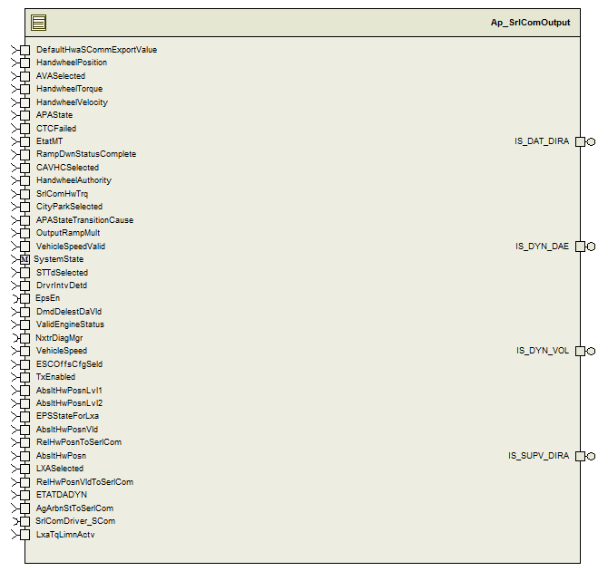
Figure 1: SrlComOutput component diagram

Data Flow Diagram
None

COMPONENT DIAGRAM

None

Variable Data Dictionary

User defined typedef definition/declaration

Typedef Name | Element Name | User Defined Type | Legal Range  (min) | Legal Range  (max)
None | None | None | None | None

Variable definition for enumerated types
Enum Name | Element Name | Value
PsaApaSt_Cnt_enum | PSAAPAST_UNAVL | 0
PsaApaSt_Cnt_enum | PSAAPAST_AVL | 1
PsaApaSt_Cnt_enum | PSAAPAST_CTRLPRGS | 2
PsaApaSt_Cnt_enum | PSAAPAST_DFCT | 3
PsaAgArbnSt_Cnt_enum | PSAAGARBNST_STININ | 1
PsaAgArbnSt_Cnt_enum | PSAAGARBNST_STPND | 2
PsaAgArbnSt_Cnt_enum | PSAAGARBNST_STNOSYNCN | 3
PsaAgArbnSt_Cnt_enum | PSAAGARBNST_STESCSYNCN | 3
PsaAgArbnSt_Cnt_enum | PSAAGARBNST_STDIAGSYNCN | 4
PsaAgArbnSt_Cnt_enum | PSAAGARBNST_STALTVSYNCN | 5
PsaAgArbnSt_Cnt_enum | PSAAGARBNST_UNUSED | 6
PsaAgArbnSt_Cnt_enum | PSAAGARBNST_STFAIL | 7
PsaApaTranCause_Cnt_enum | PSAAPATRANCAUSE_NOINTRPT | 0
PsaApaTranCause_Cnt_enum | PSAAPATRANCAUSE_DRVRINTV | 1
PsaApaTranCause_Cnt_enum | PSAAPATRANCAUSE_VEHSPDHI | 2
PsaApaTranCause_Cnt_enum | PSAAPATRANCAUSE_AGLERR | 3
PsaApaTranCause_Cnt_enum | PSAAPATRANCAUSE_MTRSTALL | 4
PsaApaTranCause_Cnt_enum | PSAAPATRANCAUSE_UNUSED | 5
PsaApaTranCause_Cnt_enum | PSAAPATRANCAUSE_THERMLIM | 6
PsaApaTranCause_Cnt_enum | PSAAPATRANCAUSE_OTHERERR | 7
PsaEpsStLxa_Cnt_enum | PSAEPSSTLXA_UNAUTHD | 0
PsaEpsStLxa_Cnt_enum | PSAEPSSTLXA_AUTHD | 1
PsaEpsStLxa_Cnt_enum | PSAEPSSTLXA_AVL | 2
PsaEpsStLxa_Cnt_enum | PSAEPSSTLXA_ACTV | 3
PsaEpsStLxa_Cnt_enum | PSAEPSSTLXA_DFCT | 4
PsaTunModSt_Cnt_enum | PSATUNMODST_NORM | 0
PsaTunModSt_Cnt_enum | PSATUNMODST_SPORT | 1
PsaTunModSt_Cnt_enum | PSATUNMODST_TUN | 2
PsaTunModSt_Cnt_enum | PSATUNMODST_FAILD | 3

Constant Data Dictionary

Program(fixed) Constants

Embedded Constants

Local
Constant Name | Resolution | Units | Value
D_CPLEVOLANTOPTMSELOLMT_HWNM_F32 | Single Precision Float | HwNm | -10
D_CPLEVOLANTOPTMSEHILMT_HWNM_F32 | Single Precision Float | HwNm | 10
D_CPLEVOLANTOPTMSESCALE_HWNMPCNT_F32 | Single Precision Float | HwNm/Cnt | 0.1
D_ANGLECOLONNELOLMT_HWDEG_F32 | Single Precision Float | HwDeg | -1630
D_ANGLECOLONNEHILMT_HWDEG_F32 | Single Precision Float | HwDeg | 1630
D_ANGLECOLONNESCALE_HWDEGPCNT_F32 | Single Precision Float | HwDeg/Cnt | 0.1
D_VITESSECOLONNELOLMT_HWDEGPS_F32 | Single Precision Float | HwDeg/s | -2000
D_VITESSECOLONNEHILMT_HWDEGPS_F32 | Single Precision Float | HwDeg/s | 2000
D_CPLEVOLANTLOLMT_HWNM_F32 | Single Precision Float | HwNm | -32
D_CPLEVOLANTHILMT_HWNM_F32 | Single Precision Float | HwNm | 31.5
D_CPLEVOLANTSCALE_HWNMPCNT_F32 | Single Precision Float | HwNm/Cnt | 0.25
D_ABSHWPOSHILIM_HWDEG_F32 | Single Precision Float | HwDeg | 780
D_ABSHWPOSLOLIM_HWDEG_F32 | Single Precision Float | HwDeg | -780
D_VITESSEROTVOLLOLMT_HWDEGPS_F32 | Single Precision Float | HwDeg/s | 0.0
D_VITESSEROTVOLHILMT_HWDEGPS_F32 | Single Precision Float | HwDeg/s | 1016.0
D_ANGLEVOLANTSCALE_HWDEG_F32 | Single Precision Float | HwDeg | 0.1
D_ANGLEVOLANTSCALE_HWDEGPS_F32 | Single Precision Float | HwDeg | 4.0

Global
Constant Name
kETAT_ASSIST_DA_Nominal_Assist_Active
kETAT_ASSIST_DA_Assist_Not_Active
kETAT_LIGNE_APC_Ignition_On
kETAT_LIGNE_APC_Ignition_Off
kCPLE_VOLANT_Invalid
kETAT_DA_DYN_Normal_Mode
kETAT_DA_2004_Orange_LED
kETAT_DA_2004_No_Demand
kETAT_DA_2010_Orange_LED
kETAT_DA_2010_No_Demand
kAUTOR_ARRET_MOT_DA_No_Permission_to_Stop
kDDE_REDEM_DA_No_Reboot_Required
kCPLE_VOLANT_OPTMSE_Invalid
kCAUSE_DESACTIV_CPK_Angular_Error_Too_High
kETAT_DAE_CPK_Invalid
kANGLE_COLONNE_Invalid
kVITESSE_COLONNE_Invalid
kETAT_SECU_ANGLE_COL_Secure
kETAT_SECU_ANGLE_COL_Not_Secure
kETAT_ASSIST_DA_Dmg_Assist_Active
kVITESSE_ROT_VOL_Invalid

Module specific Lookup Tables Constants
Constant Name | Resolution | Value | Software Segment
None | None | None | None

Library Functions / Macros
None

Data Hiding Functions
Rte_Call_SystemTime_GetSystemTime_mS_u32()
Rte_Call_NxtrDiagMgr_GetNTCFailed()
Rte_Call_SystemTime_DtrmnElapsedTime_mS_u16()

Software Module Implementation

Initialization Functions

Init: SrlComOutput_Init
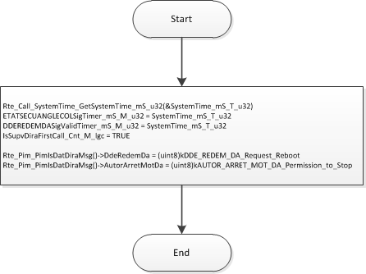

Design Rationale
None

Module Outputs
None

Module Internal
SystemTime_mS_T_u32
ETATSECUANGLECOLSigTimer_mS_M_u32
DDEREDEMDASigValidTimer_mS_M_u32

PERIODIC FUNCTIONS

Per: SrlComOutput_Per1
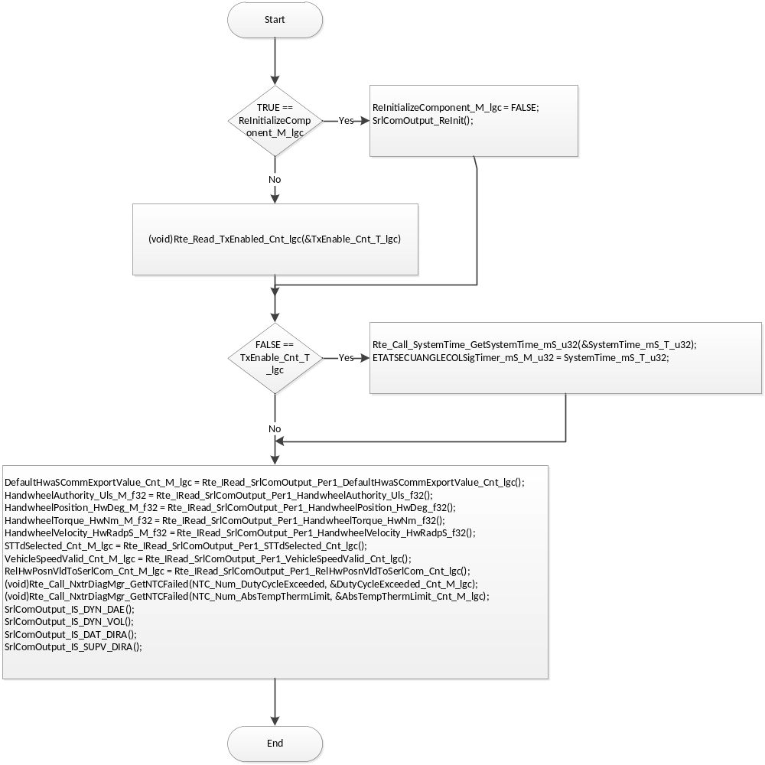

Design Rationale
Periodic function prepars signals for server runables which provides them outside. Those signals are exchanged with between periodic and servers via static memory. Periodic function is provider of data (write). Server runables are consumers (only read). Each write access to this static memory shall be protected with Exclusive Area (critical section) to prevent inconsistency of signals due to server calls happening at any time.

Store Module Inputs to Local copies

None

IS_DYN_DAE (Msg ID 2F5) PROCESSING
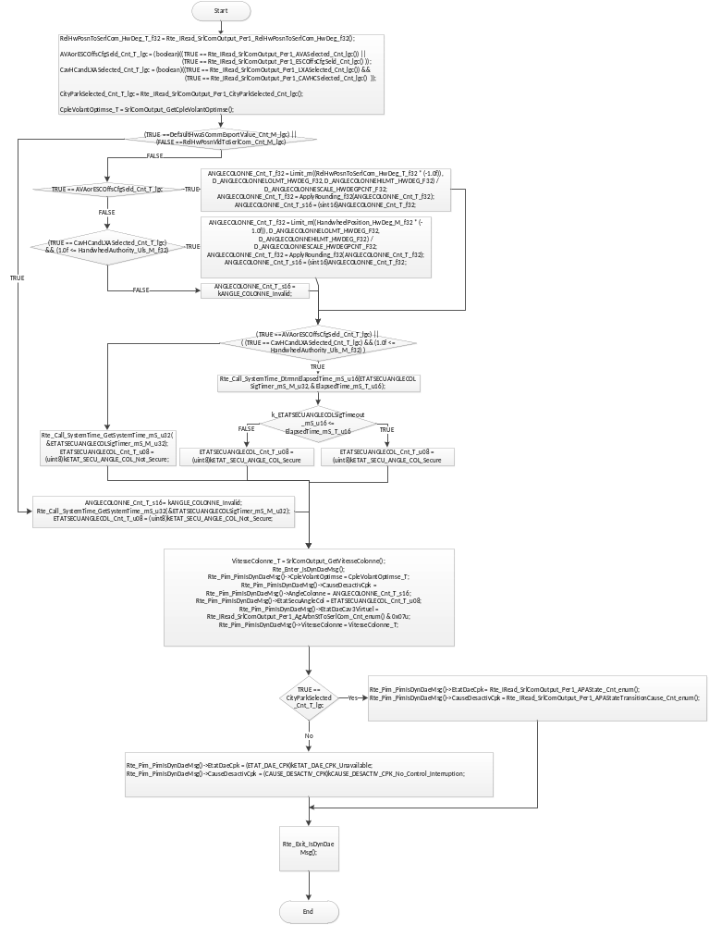

Flowchart 1: IS_DYN_DAE (MSG ID 2F5) PROCESSING

sRLCOMOUTPUT_GETvITESSECOLONNE
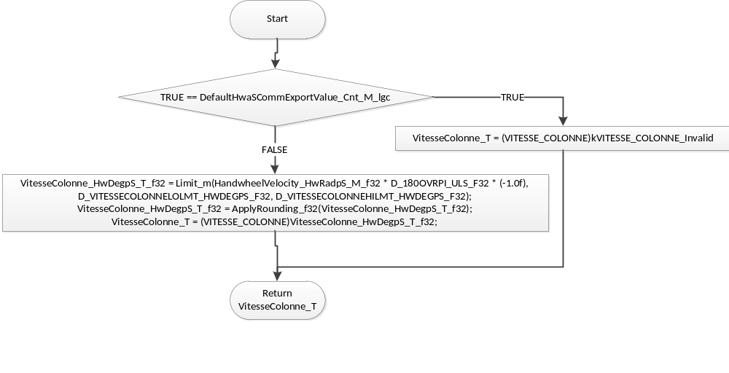

SRLCOMOUTPUT_GETCPLEVOLANTOPTIMSE
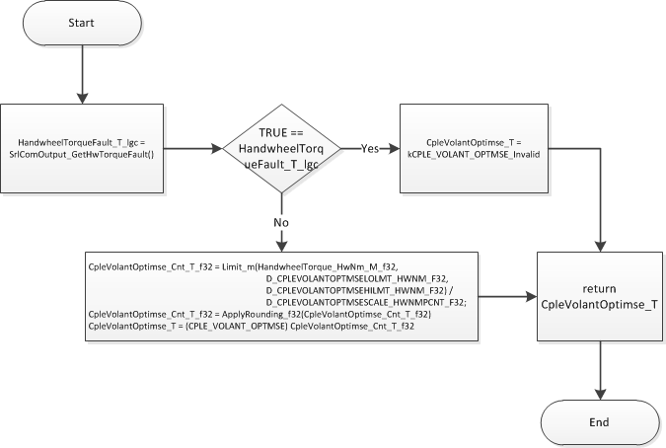

IS_DAT_DIRA (Msg ID 495) processing
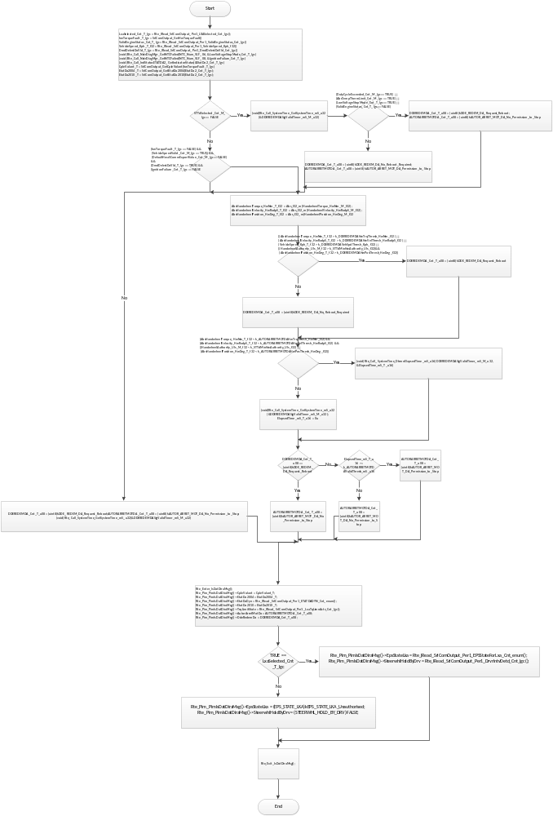
Flowchart 2:IS_DAT_DIRA (MSG ID 495) PROCESSING

SRLCOMOUTPUT_GETCPLEVOLAT
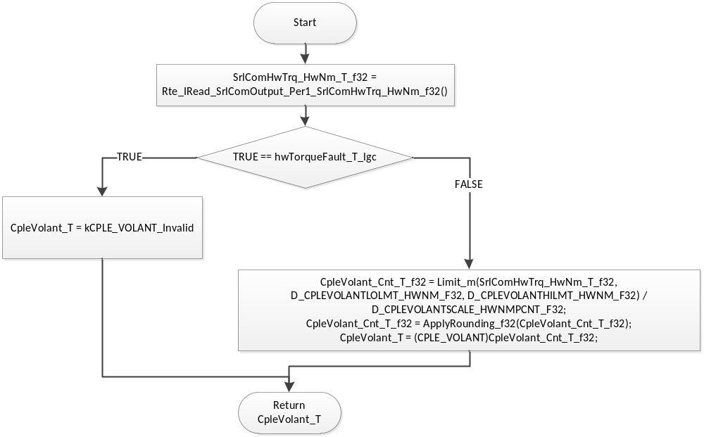

SRLCOMOUTPUT_GETETATDA2004
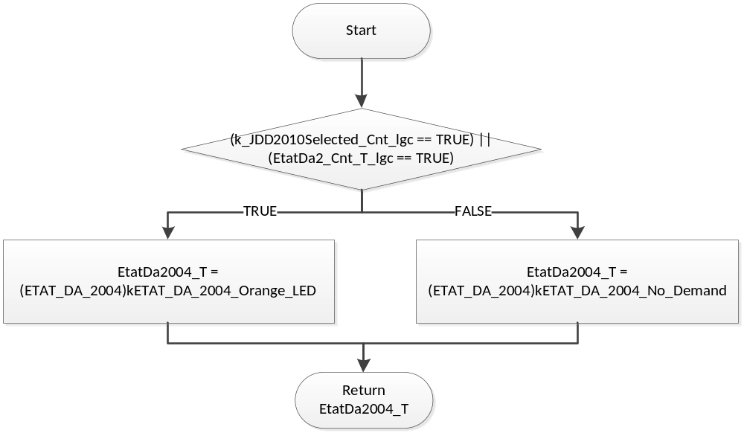

SRLCOMOUTPUT_GETETATDA2010
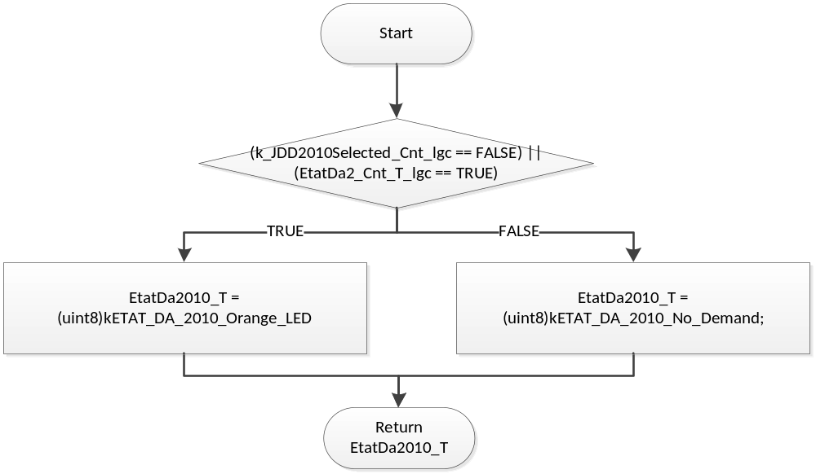

SRLCOMOUTPUT_GETHWTORQUEFAULT
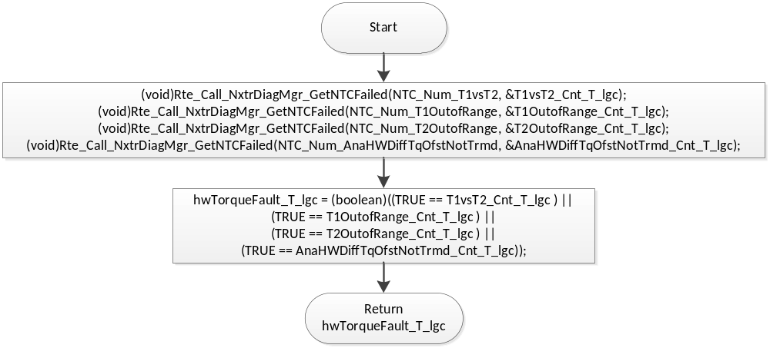

IS_SUPV_DIRA (Msg ID 795) PROCESSING
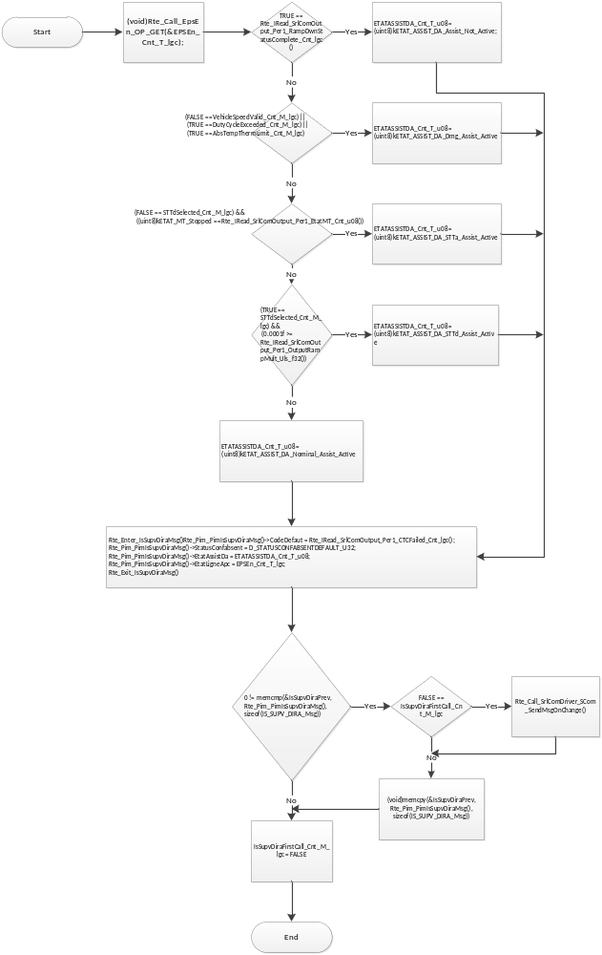
Flowchart 3: IS_SUPV_DIRA (Msg ID 795)

IS_DYN_VOL (Msg ID $305) PROCESSING
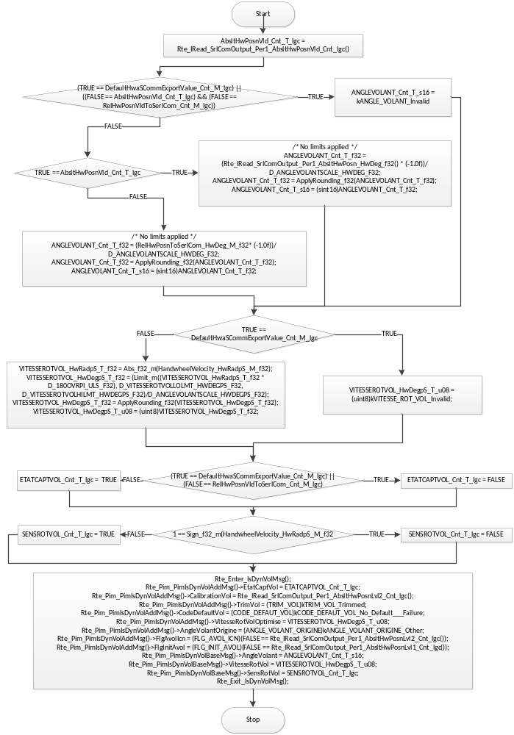

Store Local copy of outputs into Module Outputs
None

Interrupt Functions
None

TRANSIENT FUNCTIONS
    - SrlComOutput_Trns1

Design Rationale
None

Module Outputs
None

Module Internal
ReInitializeComponent_M_lgc = TRUE;

Server Runnables

SrlComOutput_IS_DAT_DIRA_Get
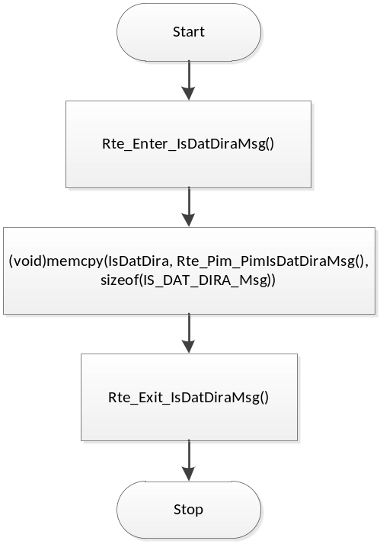

Design Rationale
Server to be called asynchroniously to periodic function of this component. It could be called from various Applications so then it shall have only read access to static memory of this component, additionaly protected with Exclusive Area (critical section) to not collide with periodic function which provides data to this static memory.

Module Outputs
None

Module Internal
None

SrlComOutput_IS_DYN_DAE_Get
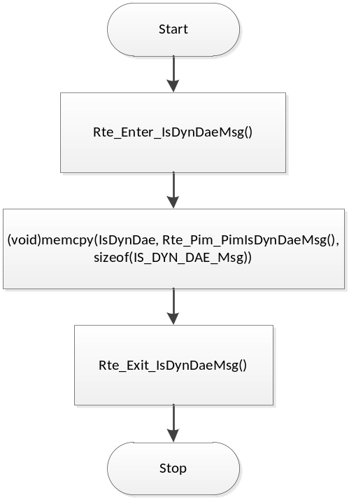

Design Rationale
Server to be called asynchroniously to periodic function of this component. It could be called from various Applications so then it shall have only read access to static memory of this component, additionaly protected with Exclusive Area (critical section) to not collide with periodic function which provides data to this static memory.

Module Outputs
None

Module Internal
None

SrlComOutput_IS_DYN_VOL_Get
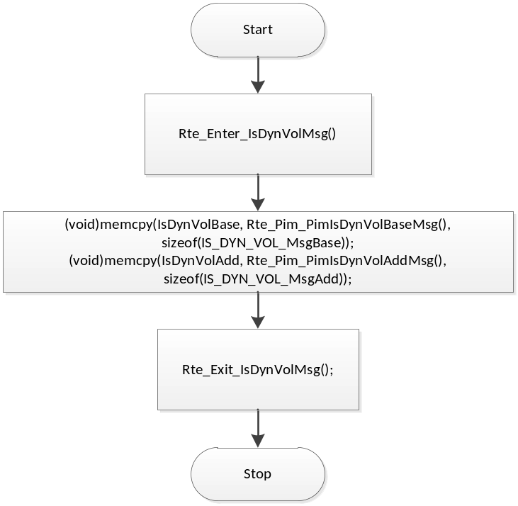

Design Rationale
Server to be called asynchroniously to periodic function of this component. It could be called from various Applications so then it shall have only read access to static memory of this component, additionaly protected with Exclusive Area (critical section) to not collide with periodic function which provides data to this static memory.

Module Outputs
None

Module Internal
None

SrlComOutput_IS_SUPV_DIRA_Get
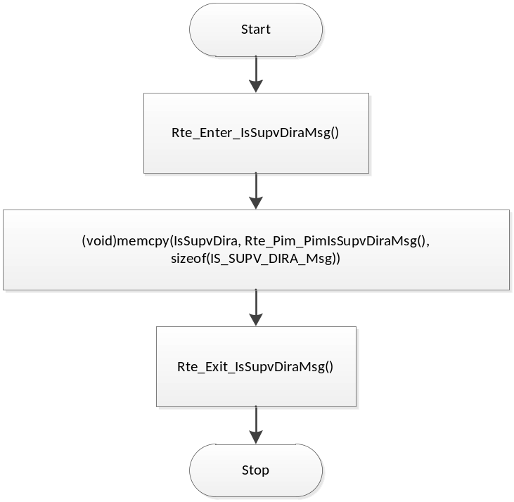

Design Rationale
Server to be called asynchroniously to periodic function of this component. It could be called from various Applications so then it shall have only read access to static memory of this component, additionaly protected with Exclusive Area (critical section) to not collide with periodic function which provides data to this static memory.

Module Outputs
None

Module Internal
None

Serial Communication Functions

7.6.1 SrlComOutput_ReInit

Design Rationale
None

Module Outputs
None

Processing

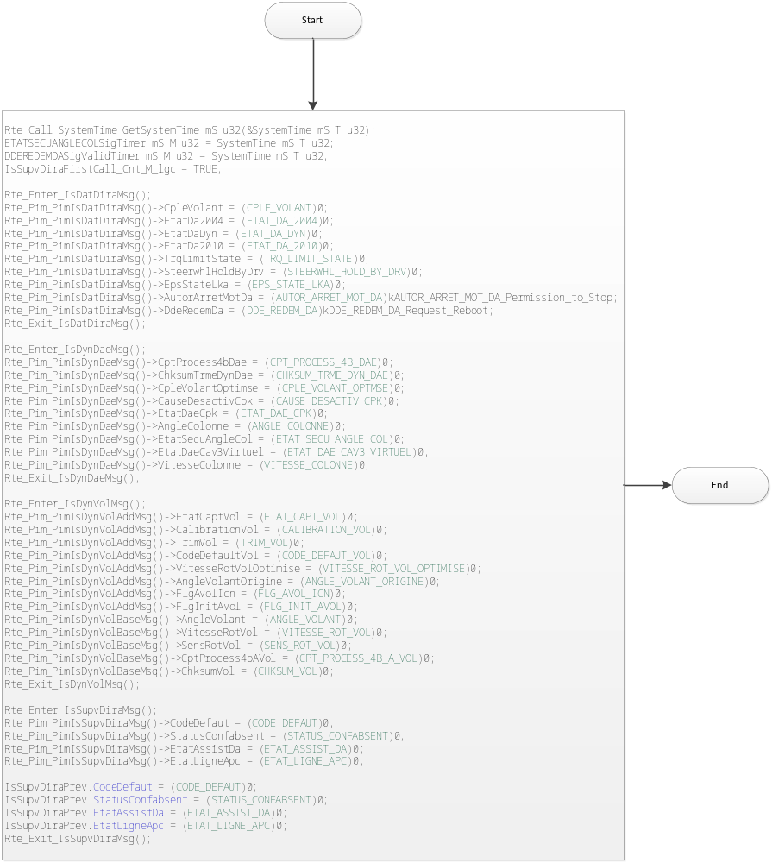

Module Internal
None

  - Local Function/Macro Definitions

Apply Rounding
Function Name | ApplyRounding_f32 | Type | Min | Max
Arguments Passed | x | float32 | full | full
Return Value | (return) | float32 | full | full

Description
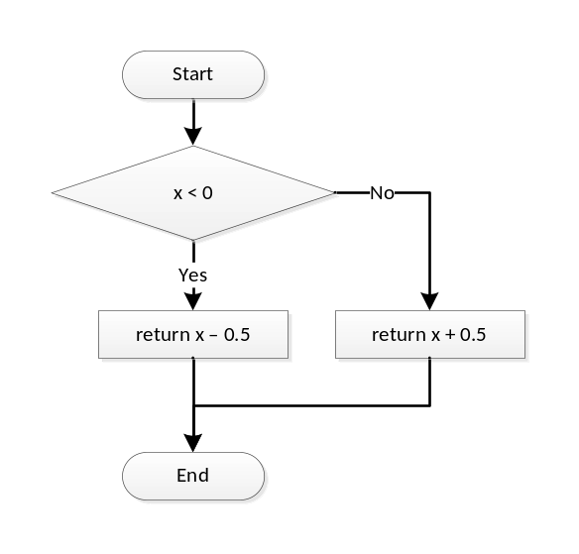

GLObAL Function/Macro Definitions
None

Known Limitations With Design
None

UNIT TEST CONSIDERATION
None

Appendix
None

