Name: Ghulamjillani
Assignment 3
Professor: Sajid Anwar

Domain Model
Project: Skill-Based Project Collaboration System

1. Introduction
A domain model represents the key concepts of the system, their attributes, and the relationships between them. It helps us understand how real-world entities interact within the Skill-Based Project Collaboration System. This model will be used as the foundation for database design and system development.

2. Key Domain Classes
The system contains the following main classes:

2.1 User
Represents any person using the system.

User
Attributes:
userID | Unique identifier for the user
name | Full name of the user
email | Email address (used for login)
password | Encrypted password
role | Guest / Registered User / Project Owner / Admin
Relationships:
• A User can create or join multiple Projects
• A User can have multiple Skills
• A User can send and receive Messages

2.2 Skill
Represents a specific ability or area of expertise.

Skill
Attributes:
skillID | Unique identifier for the skill
skillName | Name of the skill (e.g. Python, UI/UX)
Relationships:
• Many Users can have many Skills (Many-to-Many relationship)

2.3 Project
Represents a collaborative project posted by a project owner.

Project
Attributes:
projectID | Unique identifier for the project
title | Short title of the project
description | Details about the project
requiredSkills | List of skills needed for the project
status | Open / In Progress / Completed
Relationships:
• A Project is created by one Project Owner
• A Project can receive many Applications
• A Project requires multiple Skills
• A Project has multiple Team Members

2.4 Application
Represents a request by a user to join a project.

Application
Attributes:
applicationID | Unique identifier for the application
status | Pending / Accepted / Rejected
appliedDate | Date when the application was submitted
Relationships:
• An Application is submitted by one User
• An Application belongs to one Project

2.5 Message
Represents a message sent between two users.

Message
Attributes:
messageID | Unique identifier for the message
content | Text content of the message
timestamp | Date and time the message was sent
Relationships:
• A Message is sent by one User
• A Message is received by one User

2.6 Admin
A special type of user who manages the system.

Admin
Attributes:
adminID | Unique identifier for the admin
name | Full name
email | Admin email address
Relationships:
• Admin can add, edit, or delete Skills
• Admin can manage User accounts

3. Relationships Summary

Entities | Type | Description
User ↔ Skill | Many-to-Many | A user can have many skills and vice versa
User → Project | One-to-Many | A user can create many projects
Project ↔ User | Many-to-Many | A project can have many team members
User → Application | One-to-Many | A user can submit many applications
Project → Application | One-to-Many | A project can receive many applications
User → Message | One-to-Many | A user can send/receive many messages
Admin → Skill | One-to-Many | Admin manages the list of skills

4. Domain Model Diagram
The diagram below shows all the main classes and their relationships:

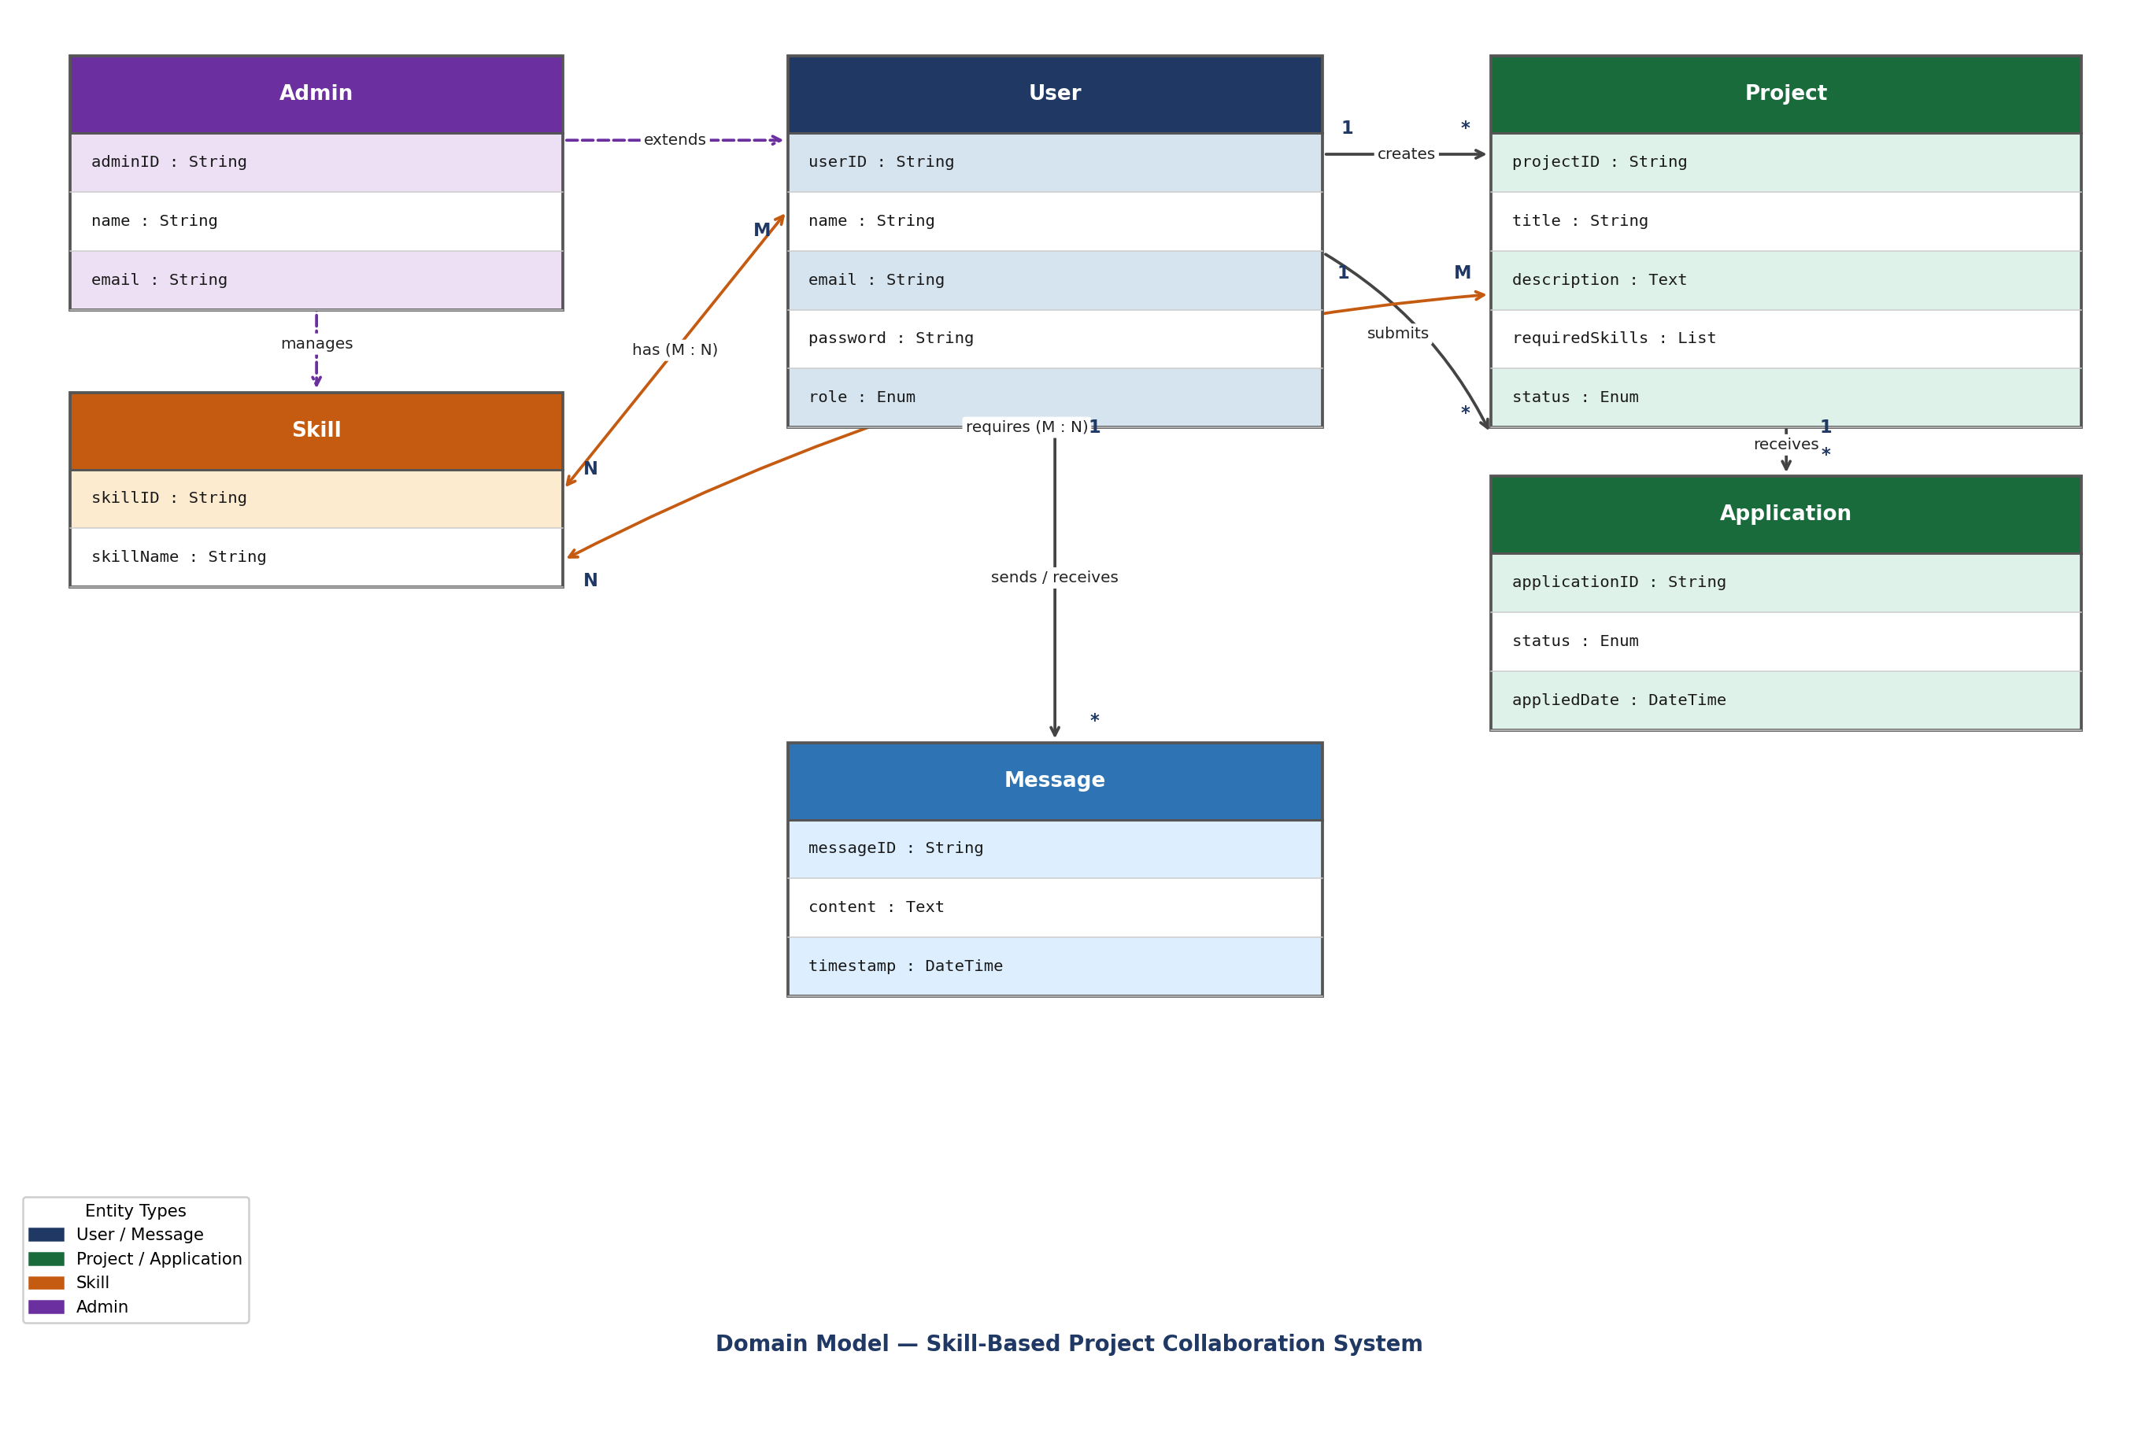

5. Textual Domain Model Representation
The relationships in the system can also be written as:

- User ----< creates >---- Project
- User ----< applies >---- Application ----< belongs to >---- Project
- User ----< has >---- Skill
- User ----< sends/receives >---- Message
- Admin ----< manages >---- Skill

6. Conclusion
The domain model clearly shows all the main entities in the Skill-Based Project Collaboration System and how they are related to each other. It includes six classes: User, Skill, Project, Application, Message, and Admin. Each class has its own attributes and relationships. This model will be helpful when designing the database and building the actual system.

