INSTITUTE OF MANAGEMENT SCIENCES

Assignment 6
System Sequence Diagrams

Project | Skill-Based Project Collaboration System
Submitted By | Ghulam Jillani
Submitted To | Sajid Anwar
Course | Software Engineering
Date | 15 May 2026

1. Introduction
A System Sequence Diagram (SSD) is an interaction diagram used to represent how external users interact with a system during a specific use case. It shows the order of messages exchanged between actors and the system and helps in understanding how the system behaves during execution.

Purpose: SSDs serve as a bridge between requirements (use cases) and design (collaboration/interaction diagrams). They clearly show:
- What input the actor provides to the system
- What internal operations the system performs
- What output or response is returned to the actor
- The chronological order of all interactions

This assignment includes System Sequence Diagrams for the eight major use cases identified in the Skill-Based Project Collaboration System.

2. SSD Notation and Conventions
Notation Element | Meaning
Actor Box (Blue) | An external party interacting with the system (e.g., User, Admin)
System Box (Yellow) | The software system being designed
Solid Arrow → | Message sent FROM the actor TO the system (input/request)
Dashed Arrow ← | Message returned FROM the system TO the actor (response/output)
Internal Box [italic] | Internal system operation or computation (not visible externally)
Top-to-bottom order | Messages are ordered chronologically from top to bottom

3. System Actors
Guest: An unregistered visitor who can register for an account
Registered User: A logged-in user who can manage profiles, search projects, apply, and message
Project Owner: A registered user who creates and manages projects and reviews applications
Admin: A system administrator who manages the master skill list

4. System Sequence Diagrams
Each subsection below presents the essential information and System Sequence Diagram for one use case.

UC01 — Register and Login
UC01 — Register and Login
Description | A guest creates a new account by providing required credentials and then logs into the system to access features.
Actor(s) | Guest / Registered User
Sequence of Messages
1. Actor → System | openRegistrationPage()
2. System → Actor | displayRegistrationForm()
3. Actor → System | submitDetails(username, email, password)
4. [Internal] | validateInput()
5. [Internal] | checkEmailUniqueness()
6. System → Actor | accountCreatedSuccessfully()
7. Actor → System | enterLoginCredentials(email, password)
8. [Internal] | verifyCredentials()
9. System → Actor | redirectToDashboard()

System Sequence Diagram — UC01
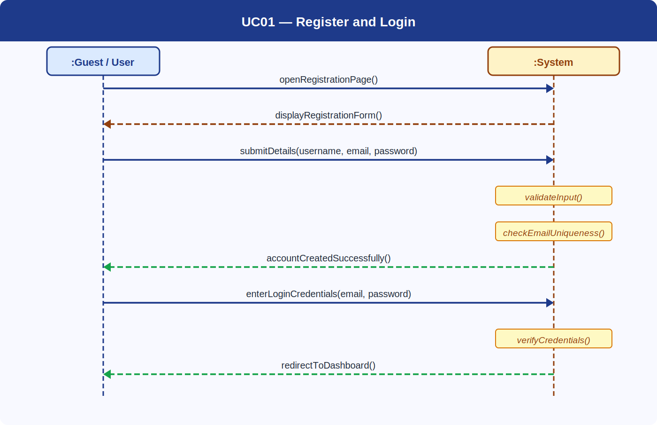

UC02 — Manage Profile and Skills
UC02 — Manage Profile and Skills
Description | A registered user updates their personal profile information and selects relevant skills from the master skill list.
Actor(s) | Registered User
Sequence of Messages
1. Actor → System | openProfilePage()
2. System → Actor | displayProfileInformation()
3. Actor → System | submitProfileUpdate(bio, skills)
4. [Internal] | validateData()
5. [Internal] | updateUsersTable()
6. [Internal] | updateUserSkillsTable()
7. System → Actor | profileUpdatedSuccessfully()

System Sequence Diagram — UC02
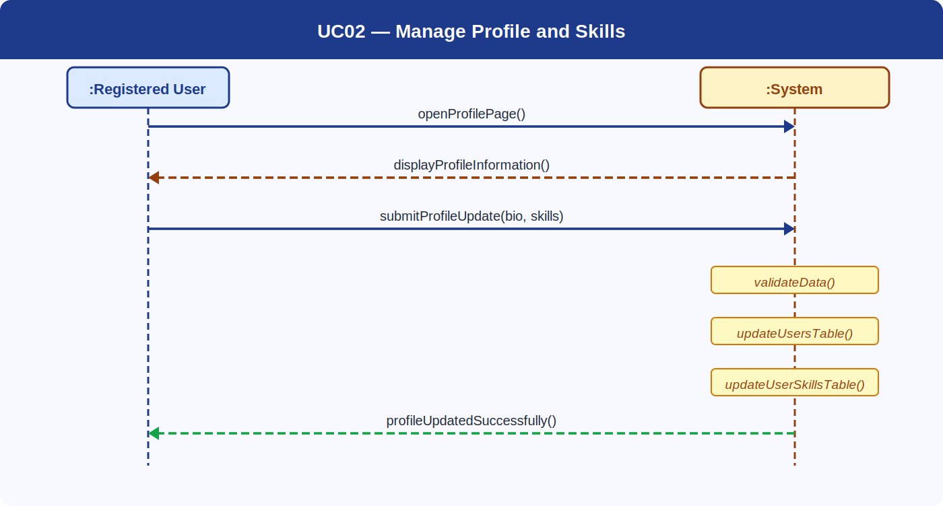

UC03 — Browse and Search Projects
UC03 — Browse and Search Projects
Description | A registered user searches for available projects using skill keywords to find relevant collaboration opportunities.
Actor(s) | Registered User
Sequence of Messages
1. Actor → System | openSearchPage()
2. System → Actor | displaySearchInterface()
3. Actor → System | enterSearchQuery(skill/keyword)
4. [Internal] | queryDatabase()
5. [Internal] | retrieveMatchingProjects()
6. System → Actor | displaySearchResults(projects)

System Sequence Diagram — UC03
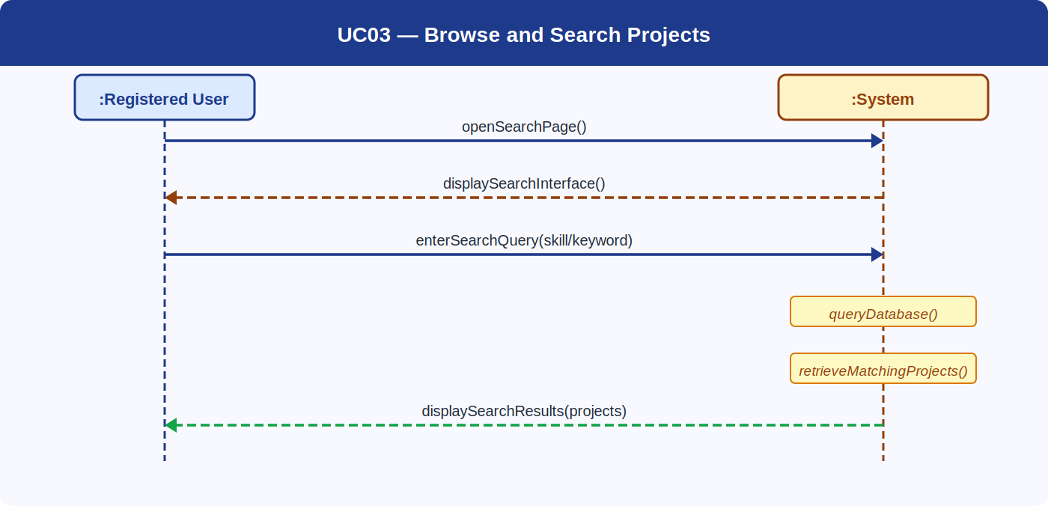

UC04 — Apply to Join a Project
UC04 — Apply to Join a Project
Description | A registered user views project details and submits an application to join an open project.
Actor(s) | Registered User
Sequence of Messages
1. Actor → System | openProjectDetails(projectId)
2. System → Actor | displayProjectInformation()
3. Actor → System | clickApply()
4. [Internal] | checkDuplicateApplication()
5. [Internal] | verifyProjectStatus()
6. [Internal] | saveApplication()
7. System → Actor | applicationSubmittedSuccessfully()

System Sequence Diagram — UC04
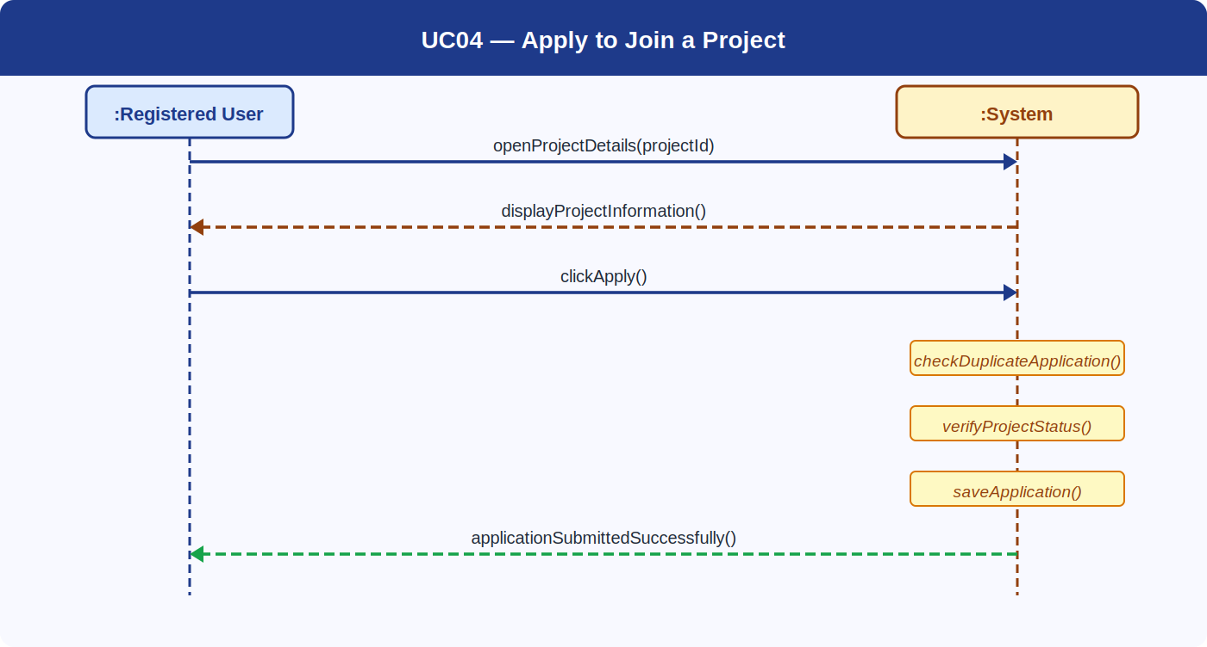

UC05 — Create and Manage a Project
UC05 — Create and Manage a Project
Description | A project owner creates a new project, specifying required skills, description, and project details.
Actor(s) | Project Owner
Sequence of Messages
1. Actor → System | openCreateProjectForm()
2. System → Actor | displayProjectForm()
3. Actor → System | submitProjectDetails(title, description, requiredSkills)
4. [Internal] | validateInput()
5. [Internal] | saveProjectData()
6. [Internal] | saveRequiredSkills()
7. System → Actor | projectCreatedSuccessfully()

System Sequence Diagram — UC05
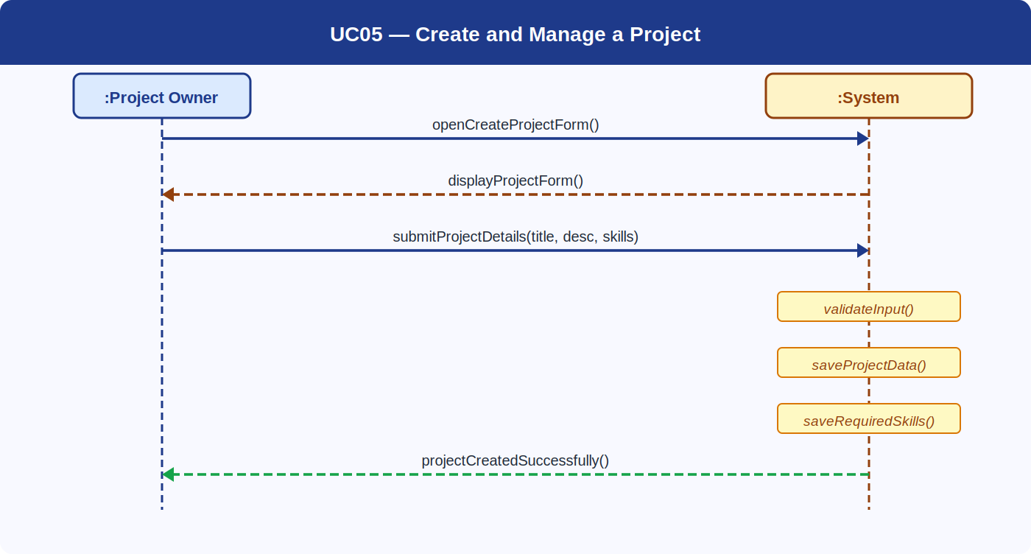

UC06 — Review Applications
UC06 — Review Applications
Description | A project owner views pending applications for their project and accepts or rejects each applicant.
Actor(s) | Project Owner
Sequence of Messages
1. Actor → System | openApplicationsPage(projectId)
2. System → Actor | displayPendingApplications()
3. Actor → System | selectDecision(applicationId, accept/reject)
4. [Internal] | updateApplicationStatus()
5. System → Actor | statusUpdatedSuccessfully()

System Sequence Diagram — UC06
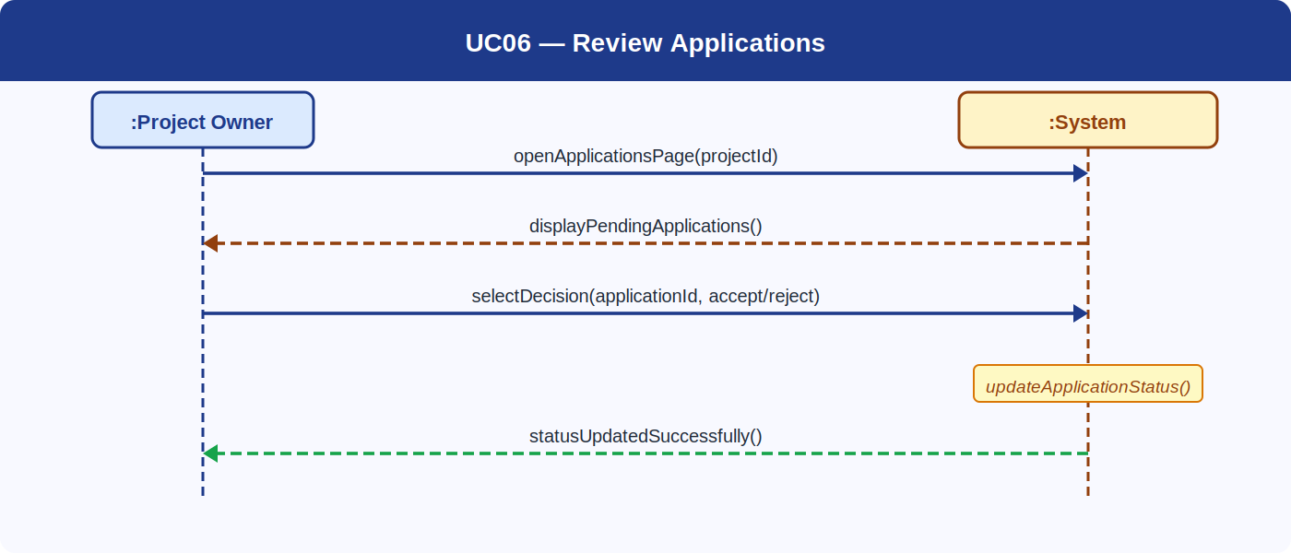

UC07 — Send and Receive Messages
UC07 — Send and Receive Messages
Description | Registered users communicate with project members through an internal messaging system.
Actor(s) | Registered User (Sender & Receiver)
Sequence of Messages
1. Actor → System | openMessagingSection()
2. System → Actor | displayInbox()
3. Actor → System | selectReceiver(userId)
4. Actor → System | enterMessageContent(text)
5. [Internal] | verifyProjectMembership()
6. [Internal] | saveMessage()
7. System → Actor | newMessageNotification() → Receiver
8. System → Actor | messageSentSuccessfully()

System Sequence Diagram — UC07
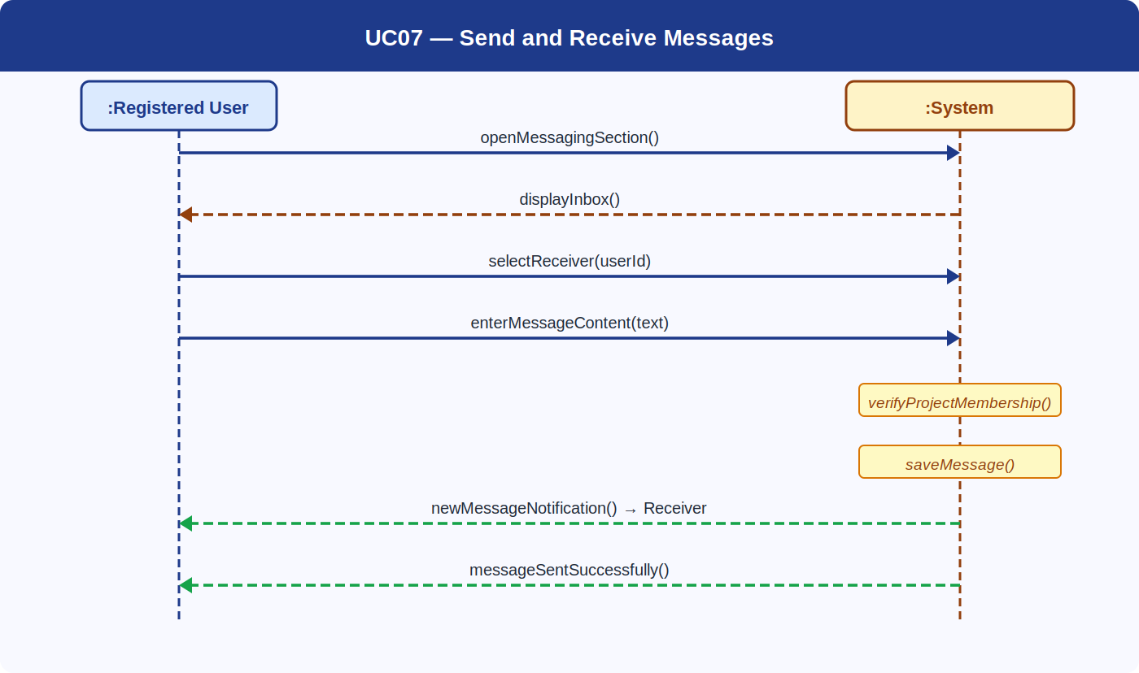

UC08 — Manage Master Skill List
UC08 — Manage Master Skill List
Description | An administrator adds or removes skills from the system-wide master skill list used across all user profiles.
Actor(s) | Admin
Sequence of Messages
1. Actor → System | openSkillsManagement()
2. System → Actor | displaySkillList()
3. Actor → System | submitSkillChange(skillName, add/remove)
4. [Internal] | validateSkillName()
5. [Internal] | updateSkillsTable()
6. System → Actor | skillListUpdatedSuccessfully()

System Sequence Diagram — UC08
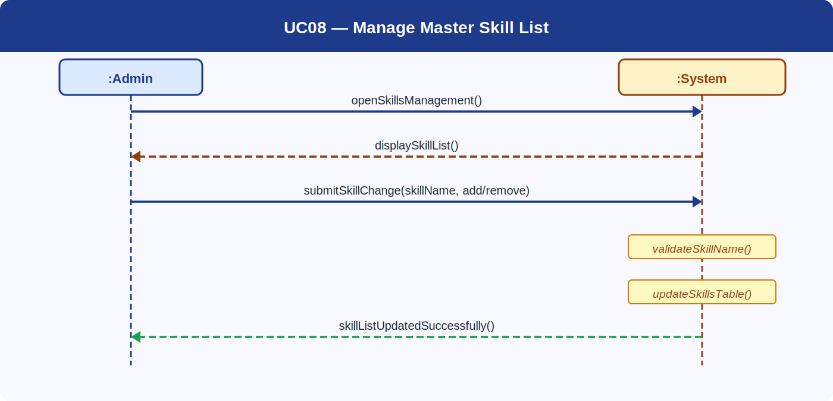

5. Conclusion
The System Sequence Diagrams developed in this assignment provide a comprehensive view of how external actors interact with the Skill-Based Project Collaboration System across all major use cases. Each diagram clearly distinguishes between actor-initiated messages, system responses, and internal system operations.

These diagrams are important because they connect system requirements with the design phase. They also help in identifying system operations, defining interfaces, and preparing operation contracts and interaction diagrams for future development.

