SkillHub — Use Case Diagram
Three actors (Learner, Instructor, Administrator) and their use cases inside the SkillHub system boundary.
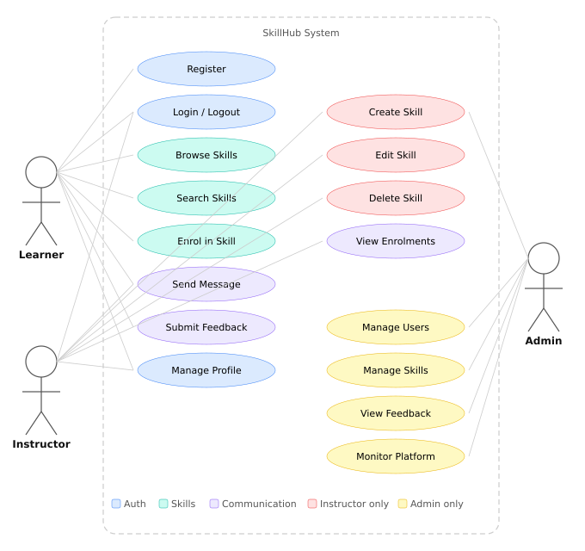
Legend: ■ Blue = Auth ■ Teal = Skills ■ Purple = Communication ■ Red = Instructor only ■ Amber = Admin only

