Bight 2023 SAV QA/QC checks
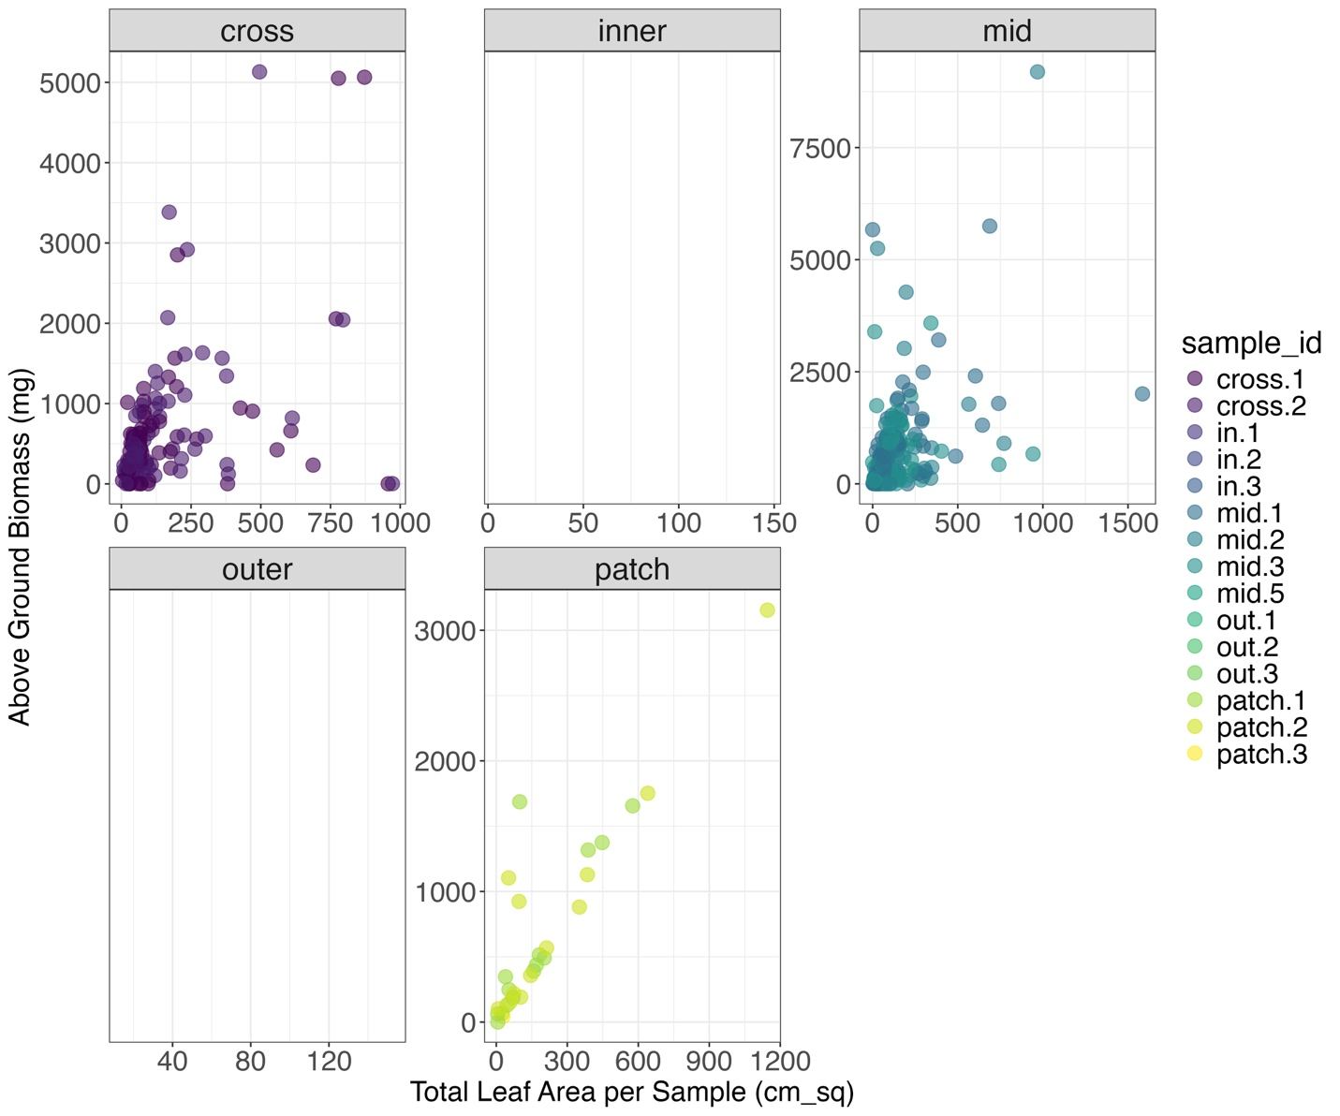Figure 1. Total leaf area (sum of all leaf areas per sample_id) vs above ground biomass measured. Data points missing from facets were leaf area measurements that did not have concurrent biomass measurements.

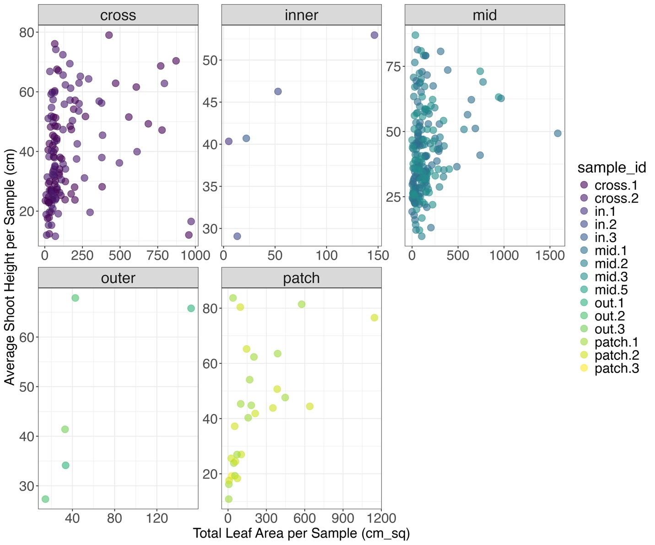Figure 2. Total leaf area (sum of all leaf area measurements per sample_id) vs. Average shoot height measured in each sample_id.

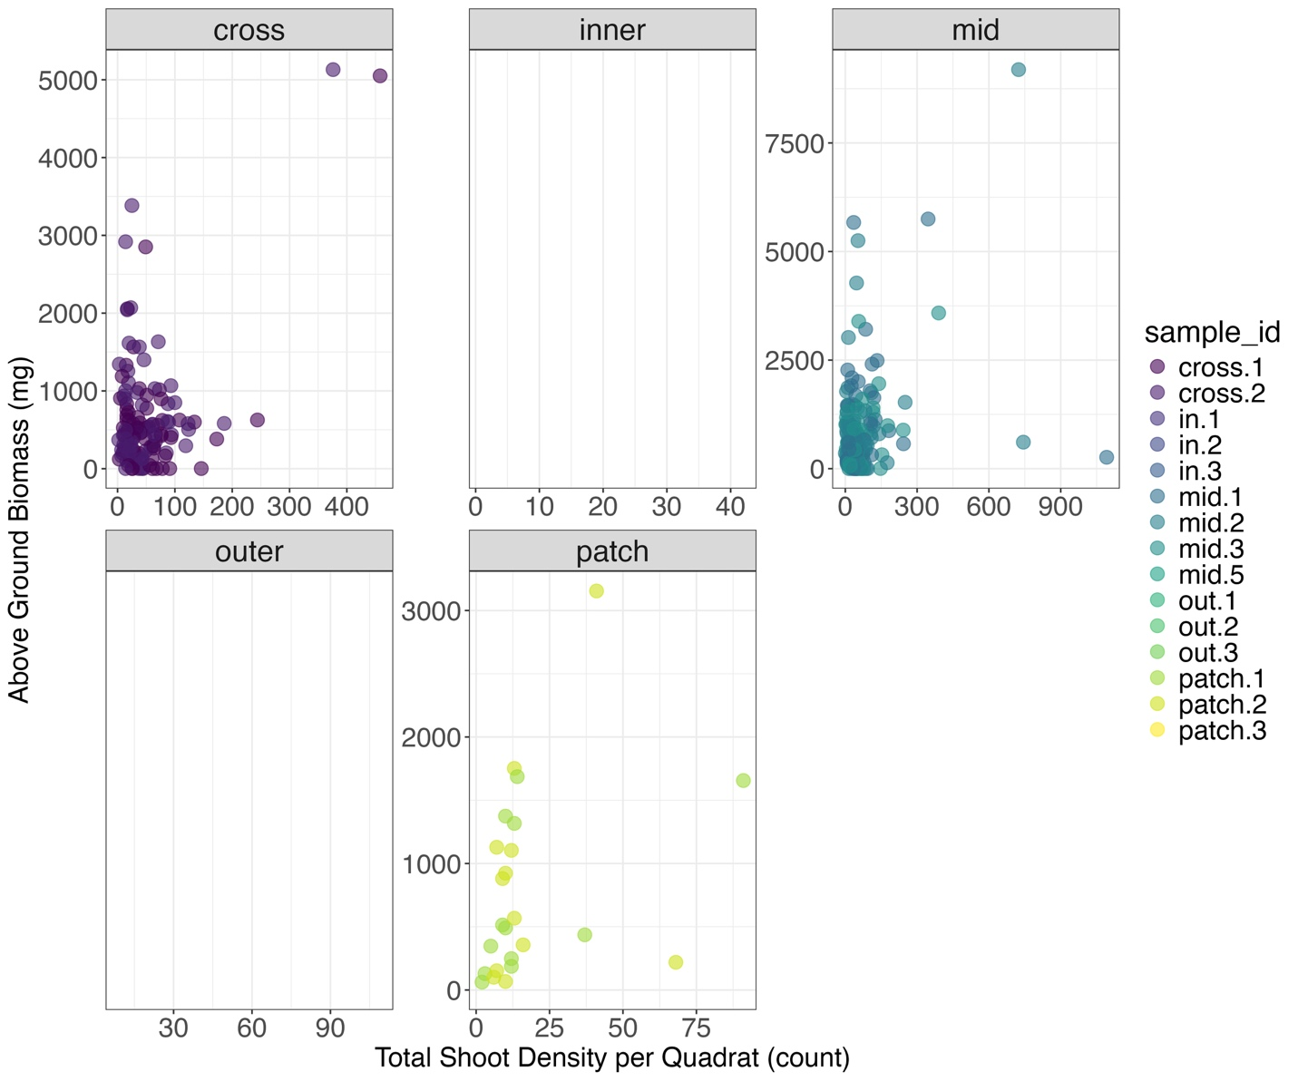Figure 3. Total shoot density per field quadrat vs above ground biomass per sample_id.

