CABW draft abstract
The California Estuary Monitoring Program (CalEMP) uses a function-based framework to assess the quality and condition of California estuaries statewide. Historically, CalEMP has characterized the nekton habitat function by sampling fish communities with seines. The program has recently expanded this approach to include concurrent collection and filtration of estuary water for environmental DNA (eDNA) metabarcoding. Preliminary data from Morro Bay reveal seasonal shifts in fish communities that correspond with patterns observed in seine samples. eDNA metabarcoding also provides similar taxonomic coverage to seines while detecting roving predators that are unlikely to be captured by seine sampling. Challenges related to contamination and false-positive and false-negative detections require continued evaluation, however, these results demonstrate the potential of eDNA metabarcoding as a rigorous approach for characterizing estuarine fish communities and assessing nekton habitat function. This approach could strengthen statewide monitoring of estuarine condition while complementing established sampling methods.

Some preliminary figs
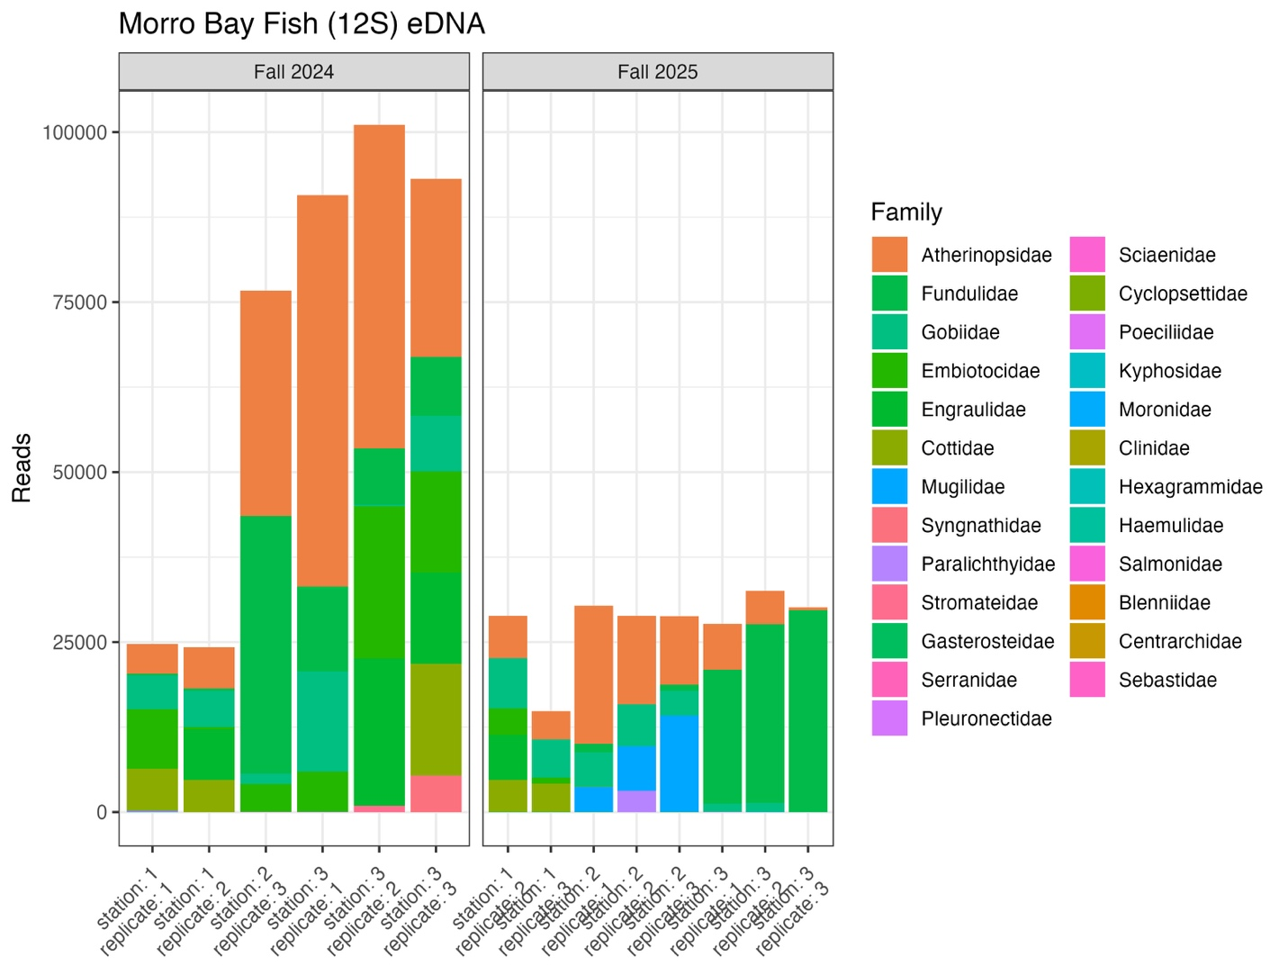
Figure 1. Fish families detected with eDNA metabarcoding in Morro Bay.
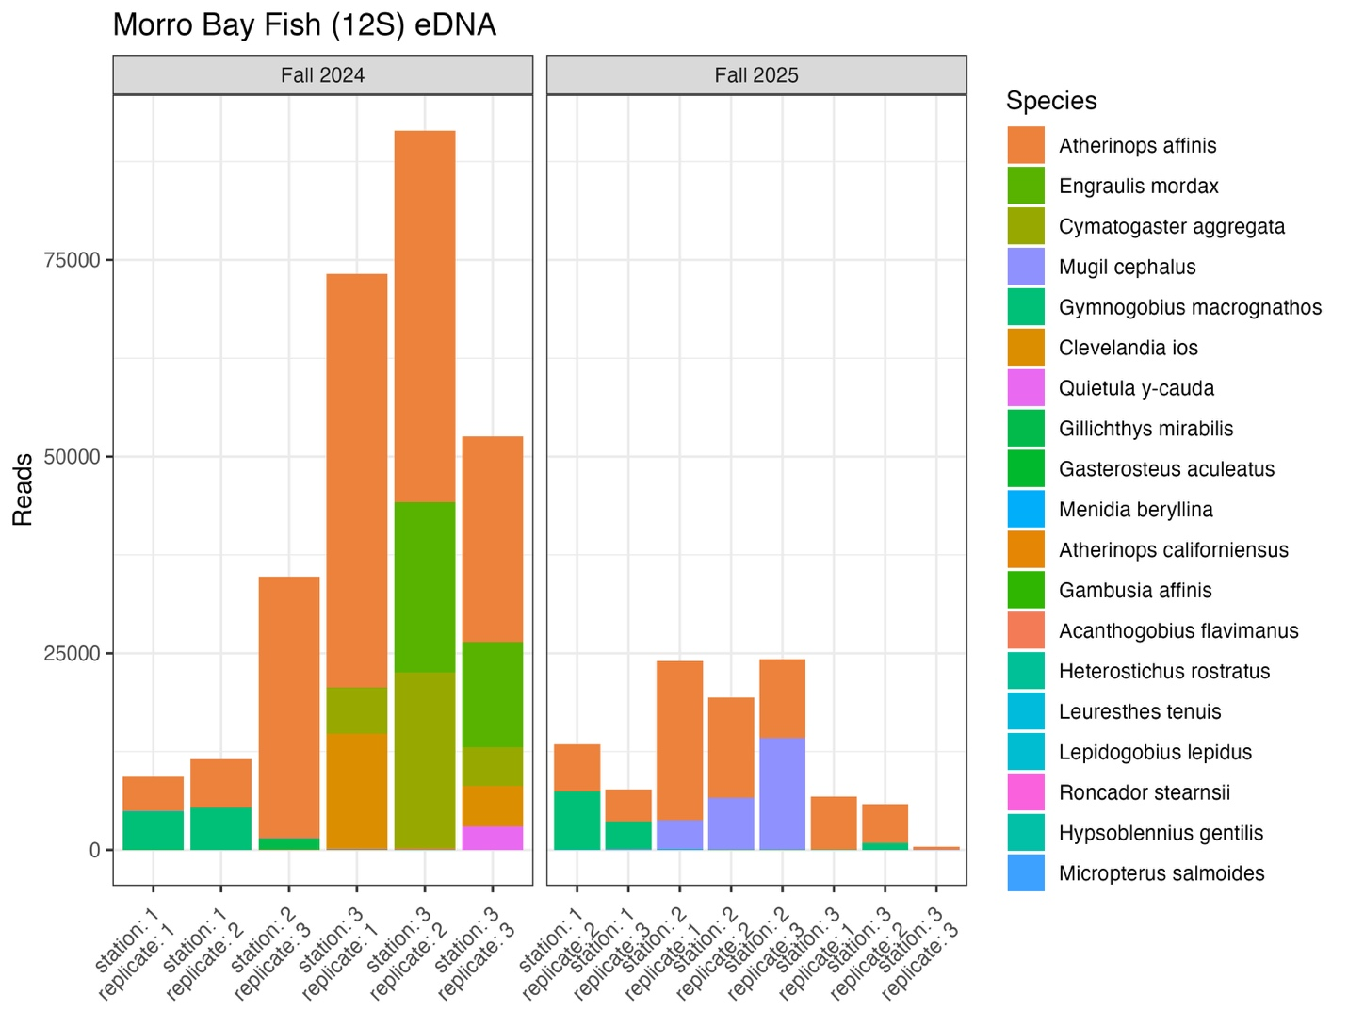
Figure 2. Fish species detected with eDNA metabarcoding in Morro Bay.

Figure 3. Seine vs eDNA detect-nondetect heatmap in Morro Bay (not done yet)
Figure 4. nMDS of eDNA vs seine in Morro Bay (not done yet)
Figure 5. Map
Figure 6. Total read vs abundance of most common species
Figure 7. Something on contamination/invasives

