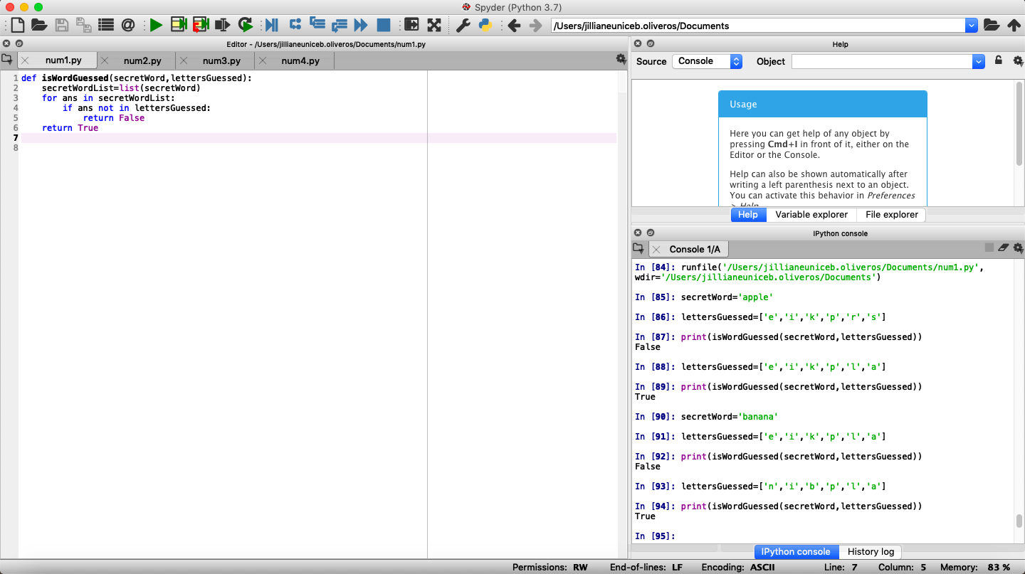

For: ﻿def isWordGuessed(secretWord,lettersGuessed)

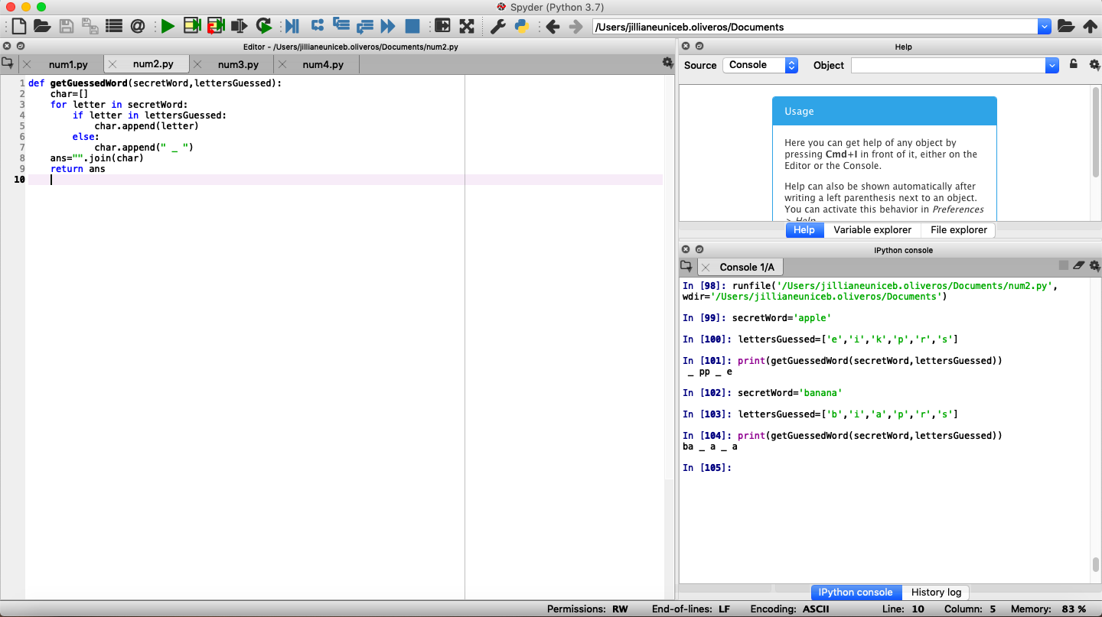

﻿For: def getGuessedWord(secretWord,lettersGuessed)

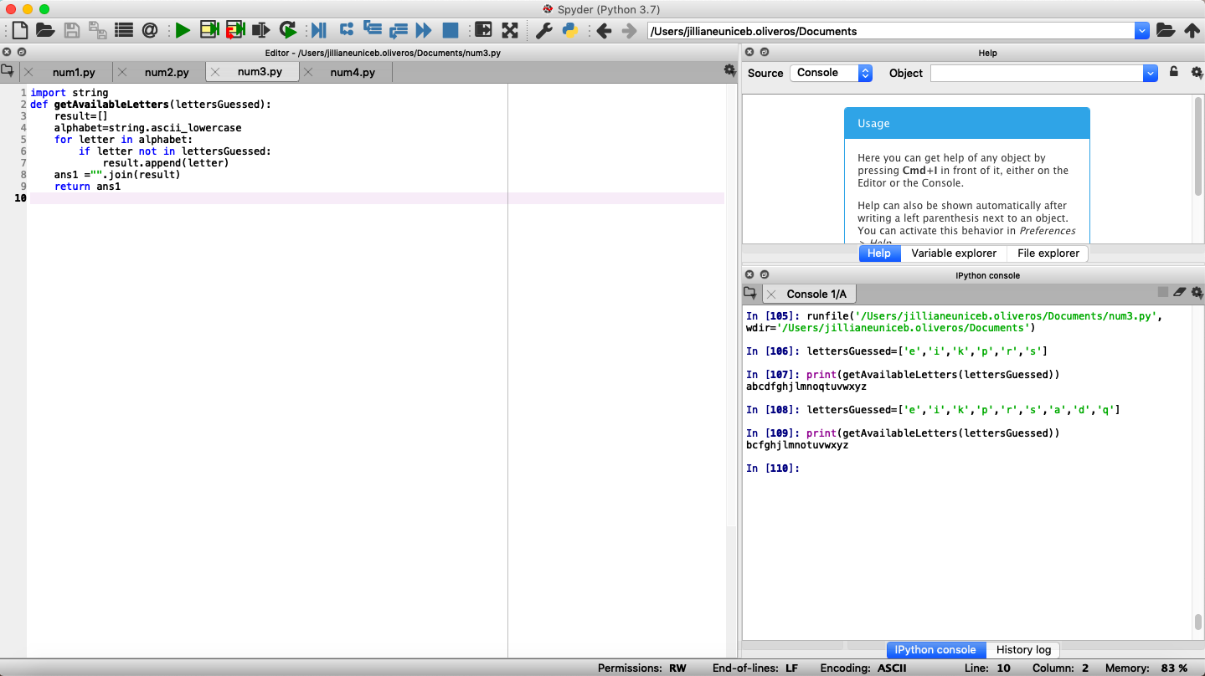﻿

For: def getAvailableLetters(lettersGuessed)

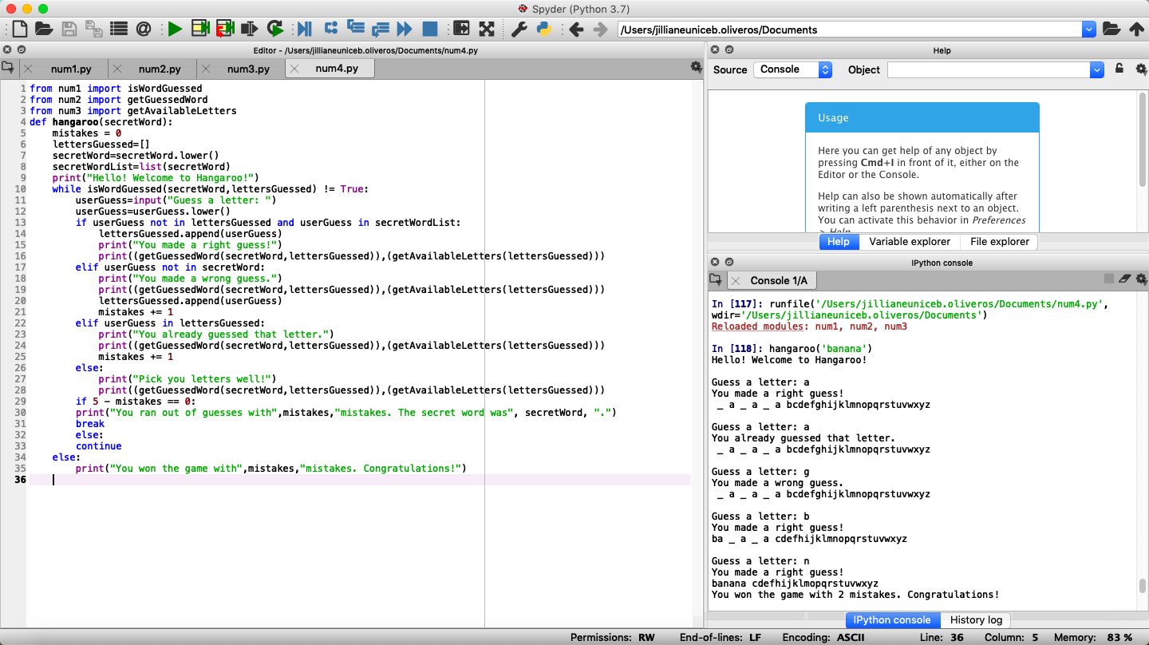

For: ﻿def hangaroo(secretWord)