NCTU CN2018 Lab. 1 – Packet Manipulation via Scapy

Student name: 郭競友 Student ID: 0610025 Department: EECS

Part A. Question

1. What is your command to filter the packet with customized header on Wireshark?

ip.src==10.0.1.1 and ip.dst==10.0.1.2 and frame.len==70

1. Show the screenshot of filtering the packet with customized header.

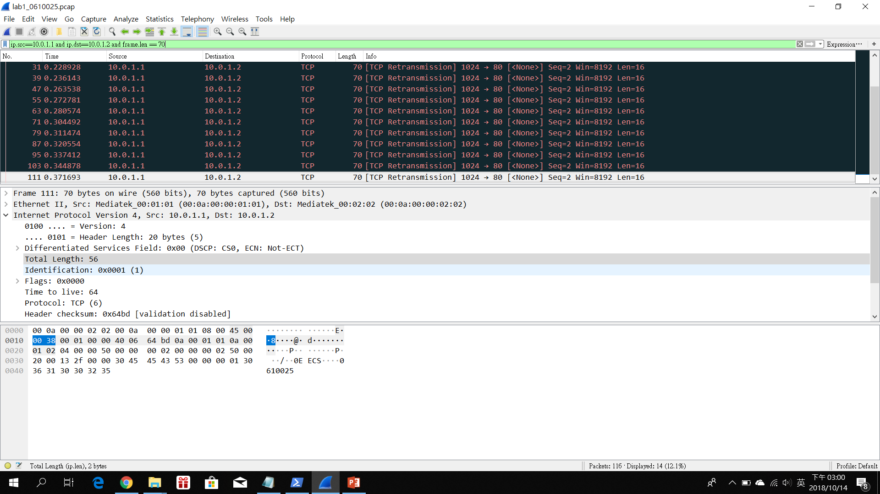

1. What is your command to filter the packet with “secret” payload on Wireshark?

ip.src==10.0.1.1 and ip.dst==10.0.1.2 and frame.len>=84

1. Show the screenshot of filtering the packet with “secret” payload.

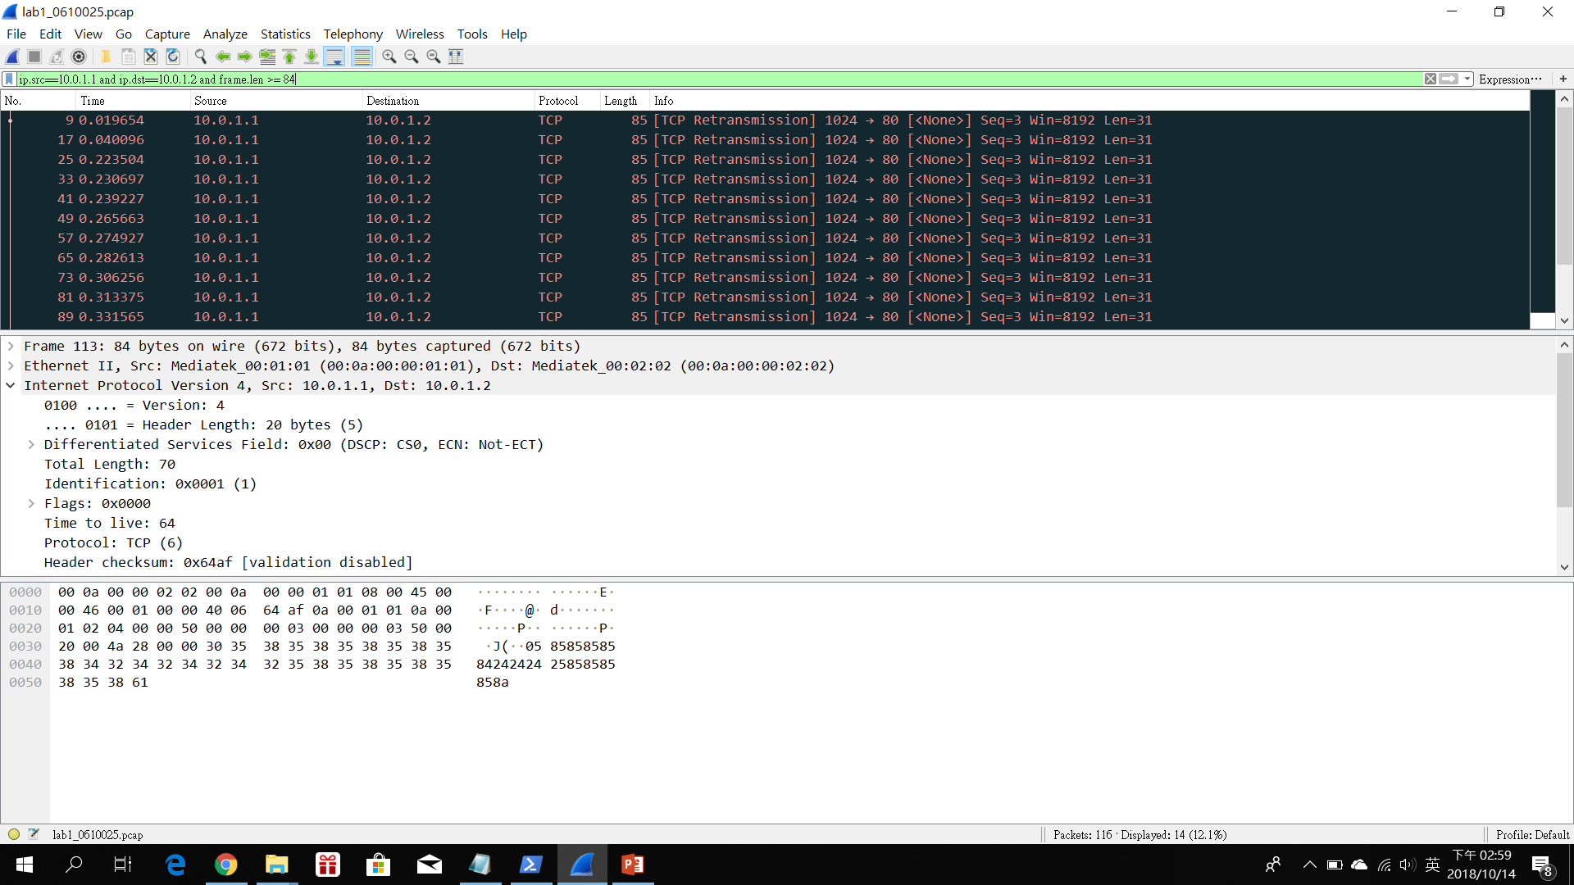

1. Show the result after decoding the “secret” payload.

52001605200160

Part B. Description

Task 1 –Environment setup

* Configure Dockerfile
* Download base image
* Update software respository
* Install the respository that we update
* Install pip package
* Set the port
* Download the required files from TA’s GitHub
* Build the container with Dockerfile
* Open the CMD and change the path to ./docker/
* Build a container at cn2018, named cn2018_c
* Set the port 22 to map on cn2018_c
* XDD