Low Inhalation Routing Calculation - East LA

1. Prepare network data, assuming using TomTom Multinet.
2. Select network zone of interest, in this step, you can keep only FRC from 0 to 6 and assume trucks can go on them. Project the network coordinates to NAD_1983_2011_UTM_Zone_11N. Label truck routes based on city maps as 1.
3. Add three new fields (text type) IDtxt, F_JID, T_JID, calculate fields as equal to ID, F_JNCTID, T_JNCTID to preserve the ID.
4. Select only the attributes needed (METERS FRC NAME ONEWAY FREEWAY RAMP KPH MINUTES LANES TruckRoute IDtxt F_JID T_JID FFS). Export the area to a geodatabase to preserve all the IDs. Export the attribute table as “multinet_location_FRCxxx.txt”. network_id is unique.
5. In geodatabase, Generalize (use 10 or 20 meters, the larger the parameters is, the more generalized it is) and Split Line At Vertices 1c for dispersion calculation. Add a new field ‘BHID’ (short type) as nominal ID (from 1 to number of links n) and calculate as FID+1.Use ‘Feature vertices to points’ to find two ends of network links. Use “Add XY” to find XYZ coordinates of two ends (the network should be projected to UTM coordinates already).
6. Use WriteLinkAttribute.m to write “LinkAttribute.csv”. There will be duplicated IDtxt (network_id) in this table, that will be summarized when calculating inhaled mass.
7. Go to EMFAC and download emission factor file for selected vehicle categories. Format the file as “new_EMFAC2007and2012Class-LOSANGELES-2018-Annual.csv” in folder “../EMFAC”.
8. Prepare facility and residential block data as the receptors

Sensitive facilities include daycares, schools (elementary to high schools), assisted living homes, and public parks. Points can be extracted from Google Places API, or ESRI North America. School enrollment can be obtained from National Lunch program ([1]) or estimated based on census, ACS.

Other facilities population should be estimated based on census, ACS.

1. Calculate “facility.csv” with the following attributes: uniqueid, x, y, z, population at certain time frame.
2. Calculate “block.csv” with the following attributes: uniqueid, x, y, z, population at certain time frame.
3. Prepare dispersion calculation.
4. Download R-LINE from website and put in “../RLINE/RLINE” folder
5. Determine what date, time, year of model. Go to SCAQMD AERMOD meteorological parameters website to download data of that year at the nearest MET station to the study area. Use functions in folder “RLINE\MET” to find the correct weather entry and extract surface meteorological data of selected time into a “Location_JdayxxxHrxxsfc.txt” file. Place the file in in “../RLINE/RLINE” folder.
6. In “../RLINE/RunRLINE_Script” folder, collect table 1b., 2a, 3b. The use “WriteLinkAttribute.m” to write link attribute table.
7. Run “RunRLINE_xx.m” to calculate concentration and inhaled mass at the facilities. “xx” refers to the location abbreviation, for example, “RunRLINE_LB.m” means Long Beach – Carson area.
8. Run “RunRLINE_xx.m” to calculate concentration and inhaled mass at the blocks.
9. Prepare weights for routing
10. Go to folder “..\..\Routing\weights”, use CalculateWeight.m to calculate all the weights of the network needed for routing calculation. The script will do the following: add the inhalation at both block and facility level, and check for saturation issues; generate “length_duration_weights_unique_id.csv” file that includes link length, duration at 10 am and 10 pm, speed at 10 am and 10 pm, and other critical information; generate “inhaled_mass_weights.csv” file with all the inhalation weights for selected model year vehicles at both 10 am and 10 pm; generate “CO2_weights.xlsx” with the CO2 weights for each link for CO2 comparison.
11. Save the links’ NetworkID where the border exit/entry points are on as “borderPOI_linkID.mat”
12. Save the links’ NetworkID where the stores are on as “storePOI_linkID.mat”
13. Run routing scripts

With all the weights prepared, we can go to folder “..\..\Routing” , save

1. Use RunRouting.m to calculate trips with OD pairs that start with “borderPOI_linkID.mat” and end with “storePOI_linkID.mat”, then switch OD and run again. The script will calculate fastest trips, shortest trips, shortest trips based on city truck routes (STCTR), and low exposure trips for each OD.
2. Use PostProcessTrips.m to post-process the trips from the previous results.
3. CompareResults will compare the STCTR with the low exposure route at 10 am or 10 pm.
4. DisplayRoutes can display routes after you select OD number.

Facility

Field description: FacID, Pop, Class, (Name), (Address), Lat, Long

Parks, Assisted Living Facilities, and elementary/middle/high schools extracted from Google Maps Platform

Census 2010

ACS 2017

<https://factfinder.census.gov/faces/nav/jsf/pages/searchresults.xhtml?refresh=t#acsST>

10 a.m. on Tuesday May 10, 2016, shortest distance based on preliminarily selected city truck route

Jday: 131

Downtown LA MET station

KCQT 34.051N 118.235W

*Ws* = 1.13, *Wd* = 106 degree, *temp=16.8 C*

*year, month, day, j_day, hour, H, u*, w*, VPTG, Zic, Zim, L, zo, Bo, r, Ws, Wd, zref, temp, ztemp, ipcode,*

1 2 3 4 5 6 7 8 9 10 11 12 13 14 15 16 17 18

*pamt, rh, pres, ccvr, WSADJ*

*34.051N 118.235W UA_ID: 3190 SF_ID: 93134 OS_ID: VERSION: 16216 THRESH_1MIN = 0.50 m/s; ADJ_U* CCVR_Sub TEMP_Sub*

*16 5 10 131 10 61.9 0.193 1.026 0.013 629. 204. -10.5 0.2680 1.33 0.18 1.13 106.0 5.8 290.9 2.0 0 0.00 67. 1009. 10 ADJ-A1 NoSubs*

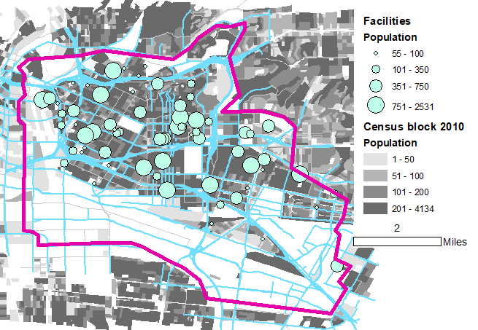

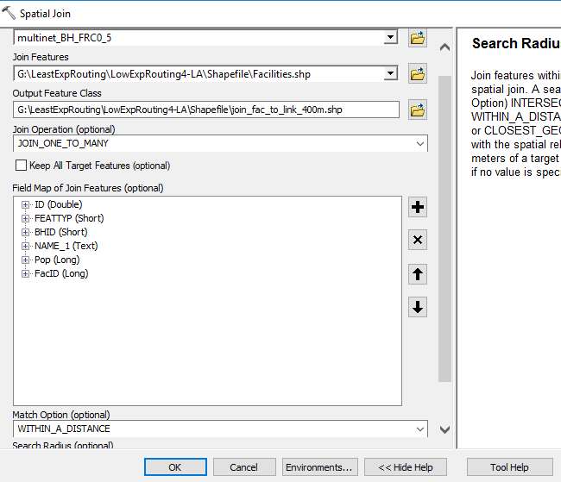

Save NetworkID, F_JuncID, T_JuncID as txt in geodatabase, then export them out.

1. National Lunch program