**Name: Jill Patel**

**TxState Id: A04778917**

**How to run my php file?**

Step-1: Go to the project location, where you save this folder.

For Ex:

I have put my Project on University Linux server.

Path of my Project is: /home/Students/jvp21/MiniProject (Jill Patel)

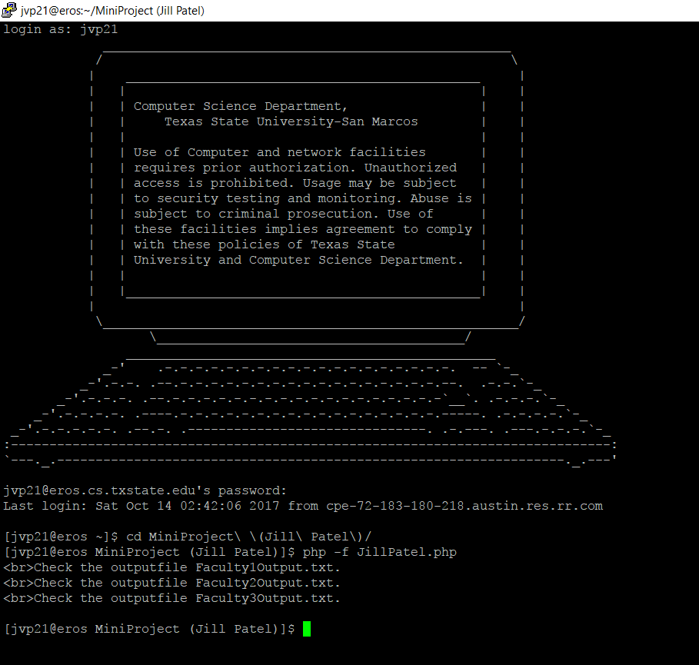

Step -2: Type the command:

php -f JillPatel.php

My Input files are:

Faculty1.html

Faculty2.html

Faculty3.html

(I have use input file names as function parameters. So you dont need to give any argument while running .php file)

(Before running the php file, all output files are empty.)

You can see the output to the following files:

Faculty1Output.txt

Faculty2Output.txt

Faculty3Output.txt