# AreYouWorkingHardToday

Group Member YeZixuan 1509853M-I011-0024 [386118572@qq.com](mailto:386118572@qq.com)

Shengruijie 15098533-I011-0076 [jillsheng@foxmail.com](mailto:jillsheng@foxmail.com)

Programming Language (s): JAVA

**1.** **Introduction:**

**Overview**

Nowadays, people have to handle more and more affair severy single day. It is important for everyone to solve problem sefficient and fast. Our product can help people manage their time and improve their work efficiency.

**Objectives**

1. **Allow users to make their learning plan**
2. **Enable students to plan their time properly**
3. **Strengthen student self-discipline**

**2.** **Design and Implementation**

**2.1 Requirement Analysis**

AreYouWorkingHardToday is a time management application which is very easy to use and requires minimal setup.

On the main screen, you see the complete user defined task list and the overview of today’s time spending. You can set alarm simply by tapping a task.

It only needs a name and to setup a unique task, with advanced settings as optional. So you can focus on own work instead of wasting time on mastering the app.

AreYouWorkingHardToday creates beautiful reports in coconuts calendar which you can share via Facebook, Twitter and Wechat.

**2.2 Design and Modeling**

AreYouWorkingHardToday ，modifying settings are basic functions. And sharing that how many coconut you have got.

|  |  |
| --- | --- |
| **Compenents** | **Description** |
| **Schedule activity** | **Allow user to choose a day** |
| **Setting activity** | **Allow user to add some events** |
| **General activity** | **Container for fragments below** |
| **Post fragment** | **Allow user to post new pictures, voices and texts from their album on phone or capturing picture with camera** |
| **Community fragment** | **Show coconuts you have got** |
| **Setting fragment** | **Allow user to set alarm** |

## **2.3 Implementation**

图片包含 屏幕截图

自动生成的说明

图片包含 屏幕截图

自动生成的说明  
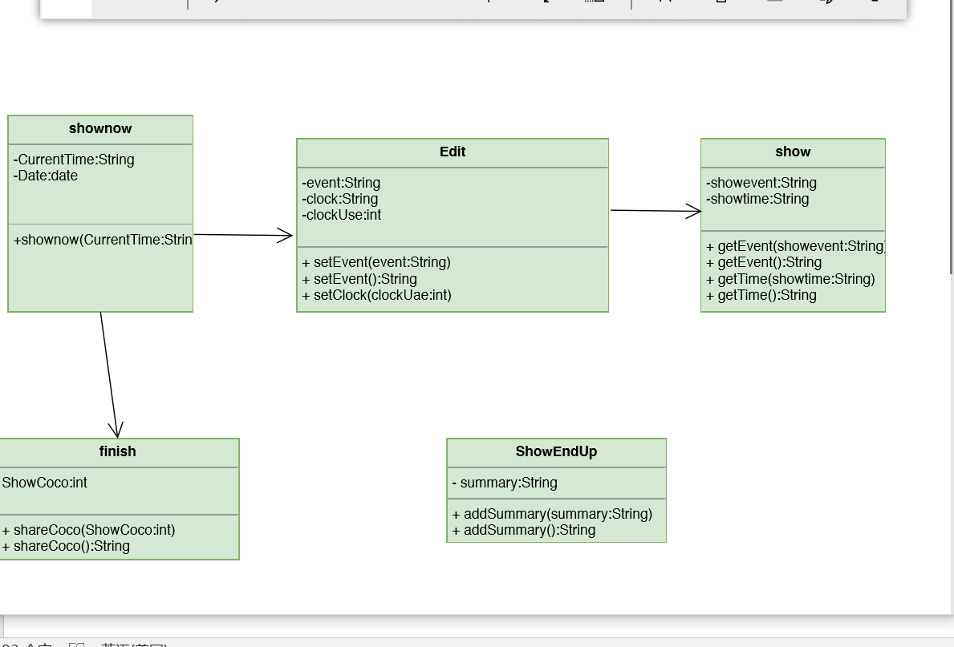

**2.3.1**  **Database**

We use Android SQLite as our database of app.

## **2.3.1.4 Shared Preferences**

To enhance the user experience, we make use of the Shared Preferences to store user’s login information inside the phone.

## 

**3. Conclusions:**

From this project, we gain much knowledge in server and UI programming. We spent much time on exploring Android programming, and get to learn much technique and terms, such as use listview and getting image from user.

Besides, as our apps require neat and clean display to users, UI programming such as the implementation of customized listview and gridview allows us to get familiar with structuring and manipulating UI.

We also learn to make use of device component.. We also learn to use camera and gallery for getting images to post.

Last but not least, AreYouWorkingHardToday is an app with much potential.It’s a very useful app in our life.