SCHEDULE OF EVENTS

Beach Clean-up
On Saturday, June 6, at 9AM, come to the Beach with your family and/or friends. Bring a large trash bag and a pair of gloves and help to clean up the beach. It’s a great way to meet your neighbors.

Annual (Adult’s) Party
We are looking for a volunteer to host this year’s Annual Cocktail Party. The date is open but usually held on a Saturday or Sunday in July at 4pm. Those interested, can contact Martha Guzikowski at 508 888 8715.
Annual Business Meeting
The Annual Meeting of the Carleton Shores Association is scheduled for Sunday, August 23rd, 4PM. We again hope to have the meeting at the home of Ms. Deborah O’Malley at 52 Carleton Drive. A notice confirming time, date, and location will be sent in August as well as being posted on the CSA website.
Please make an effort to attend the Annual Meeting as last year, we came close to not having enough members present to have a quorum.
25% of the membership constitutes a quorum.
Notice
Sale of Property: This is a reminder that if you sell your home or lot, please notify Joy Carleton, Treasurer, of the change so that she may update the records. Please mail all notifications to Joy Carleton, c/o Carleton Shores Association, Inc. Box 306, E. Sandwich, MA 02537

Carleton Shores Website
CSA website is: www.CarletonShores.com. Please visit the site for answers to many questions relative to dues, tennis, meetings, building etc.
If you would like to add a photo to the CSA website or something else that you feel is important and should be included, e-mail me at mzguzik1@comcast.net

BOARD of DIRECTORS

MEMBERSHIP & TERMS

David Byrnes (2011)
Joy Carleton, Treas. (2011)
Julie Curran (2010)
Eleanor Gaffney (2010)
Carleton
Shores
Newsletter © Carleton Shores Association
Peggy Gorton, Sec’y (2009)
Kathy Siranosian (2009)
Brian Urban President (2010)
Helen Jillson (2011)
John Jillson (2009)

MEETING DATES
January, 2009
Volume 46 Number 1
Published by:
Carleton Shores Association, Inc.
P.O. Box 306,
East Sandwich, MA 02537-0306
0000.doc - 11/07/26

08 May (Friday) 7 PM
12 June (Friday) 7 PM
10 July (Friday) 7 PM
21 August (Friday) 7 PM
23 August Annual Meeting 4 PM
09 October (Friday) 7 PM

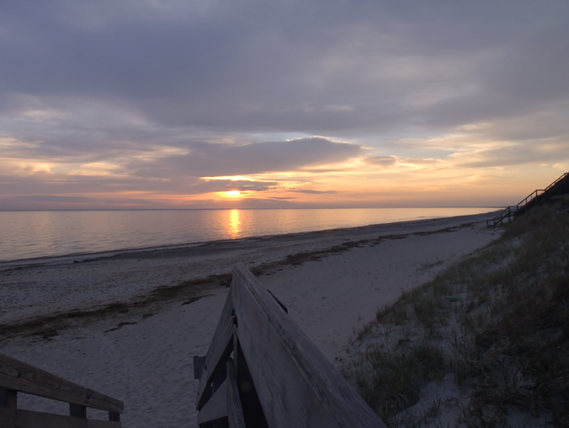

COMMITTEES
Area Development & House Approval:
Barry Hall (Chair), Jack Jillson, Alan Jones,
Roads & Grounds:
Jack Jillson (Chair), Eleanor Gaffney, Julie Curran
Departments:
Beach Parking : Kathy Siranosian
Clerk & Website: Zig Guzikowski mzguzik1@comcast.net

NEWS
Annual Dues: The annual dues for the year 2009 is set at $300 per lot. An invoice for the lot/lots you own is enclosed.
2009 Annual Budget: A copy of FY2009 Annual Budget listing how your dollars are used to properly maintain the common grounds, roads, and beach is enclosed for your review.
By-Laws: A copy of the By-Laws or a guideline booklet for use in designing new dwellings, or adding to your existing home is now available on the Carleton Shores website, www.CarletonShores.com
Election of Board Members: At the 2008 Annual Meeting , Joy Carleton and Helen Jillson were re-elected to 3 year terms. Mr. David Byrnes was elected to the board for a 3year term. Congratulations David.
Eleanor Vander Mel decided not to run for reelection to the board. The Board wishes to thank Ellie for her many years of outstanding service.

Landscaping: The Roads and Grounds Committee would like to remind you that mowing grass and clearing brush from the edge of the road adjacent to your lot is your responsibility.
A Word about speeding: In order to keep the roads in our neighborhood safe for all, we have posted speed limit signs, stop signs and have also implemented speed bumps. For the most part, these measures do work and do lower the speed of vehicles that use our roads. From time to time, the board receives complaints that contractors hired by CSA members for regular maintenance of their property “speed” through the neighborhood. We ask that you inform the companies that you hire that they observe CSA Speed limits while in the neighborhood. We also ask that for the safety of your children as well as your neighbor’s children, you do the same.
Tennis Club: The Carleton Shores Tennis Club would like to invite any interested neighbors to join them. Tennis membership is separate from CSA membership and use of the tennis courts is limited to Tennis Club members, their families and guests. The club has 2 tennis courts, in excellent condition, located just off Lost Meadow Rd. Annual dues for the 2009 season is $150. Even if you aren’t a tennis player yourself please consider joining as a show of support. For details call Martha Guzikowski, President 508 888 8715.
Parking Lot: We are pleased to announce that Kathy Siranosian is now in charge of scheduling the beach parking lot duties for the upcoming season. Kathy is looking for new members to join our group of volunteers that watch the Beach Parking Lot on summer weekends. Each year, the same loyal people volunteer. We’re asking for your support! Remember that this all volunteer effort helps to keep our budget low and keeps outsiders from using our beach and parking facility. This year, get involved and volunteer!! Please return the enclosed parking form.

Dogs on the Beach: This is the annual nagging reminder message: Unleashed dogs on the beach are illegal under town regulations and in violation of CSA rules.

Beach Sticker Policy in effect
As you are all aware, a new beach sticker and parking policy was implemented a couple of summers ago. Last season 3 unauthorized vehicles were towed from the lot. We are pleased to report that due to this policy, along with a heightened vigilance of all CSA members, the number of incidents at the beach was significantly reduced.
Eleanor Vander Mel will continue to work closely with Davis Towing, the other neighborhood associations located north of 6A and the Sandwich Police Dept (Police Beach patrol) the purpose of which is to minimize vandalism on our beach as well as eliminate the unauthorized use of the parking lot by people outside of our association.
This is a reminder that Davis Towing regularly patrols our parking lot 7 days a week. The patrols are done on a random basis. IT IS IMPERATIVE THAT YOUR VEHICLE OR THE VEHICLE OF YOUR GUEST PROPERLY DISPLAYS THE CSA PARKING TAG REGARDLESS OF THE DAY OR TIME.

Sincerely,

CSA Board

