CHAPTER ONE: INTRODUCTION

1.1 Introduction
Green Market is a web-based digital platform designed to connect agricultural stakeholders within a unified and interactive ecosystem. In many developing economies, including Ghana, agriculture remains a key driver of economic growth and employment. However, the sector is often characterized by fragmented communication channels, inefficient market systems, and limited access to professional agricultural support. Green Market is designed to address these challenges by leveraging modern web technologies and artificial intelligence.
The platform is built around three core pillars. The first is a direct marketplace for farm produce, which allows farmers to connect directly with buyers without relying heavily on intermediaries. The second pillar is access to agricultural experts as a service, enabling users to consult professionals such as agronomists and veterinarians on demand. The third pillar is AI-powered insights, which provide intelligent recommendations, predictions, and analytics to support better decision-making in farming and trade activities.
The system is designed to improve efficiency in agricultural operations by integrating these services into a single platform. It aims to reduce communication barriers, enhance transparency in transactions, and promote data-driven agricultural practices. Ultimately, Green Market seeks to modernize agricultural engagement and improve productivity across the value chain.

1.2 Problem Statement
The agricultural sector remains a fundamental pillar of economic development, food security, and employment creation, particularly within developing economies such as Ghana. Despite its significance, the sector continues to be constrained by a range of structural, operational, and informational inefficiencies that collectively undermine productivity, equitable income distribution, and overall market performance.
A major challenge is the entrenched reliance on intermediaries within the agricultural value chain. These middlemen often exploit existing market inefficiencies by purchasing produce directly from farmers at significantly reduced prices and reselling to end consumers or bulk buyers at substantially higher margins. This practice not only diminishes farmer profitability but also discourages reinvestment into production, thereby limiting long-term agricultural sustainability and growth.
In parallel, buyers including households, retailers, restaurants, and agro-based industries—frequently encounter difficulties in accessing a stable supply of fresh, high-quality agricultural produce at fair and predictable prices. The absence of a centralized and transparent marketplace contributes to fragmented trading systems, inconsistent pricing mechanisms, and inefficiencies in demand-supply matching. Consequently, trust deficits emerge between producers and consumers, further weakening market coordination.
Another critical constraint is the limited accessibility of professional agricultural expertise, particularly for smallholder farmers in rural and underserved communities. Essential services such as agronomic advisory, veterinary support, pest and disease management, and modern farming techniques are often inaccessible or inadequately distributed. This knowledge gap compels farmers to depend largely on traditional practices and experiential decision-making, which may not be sufficient in addressing contemporary agricultural challenges.
Furthermore, decision-making within the sector is predominantly intuitive rather than data-driven. The lack of digital systems that provide real-time analytics, predictive modeling, and market intelligence significantly impairs the ability of stakeholders to make informed decisions regarding production planning, pricing strategies, and market engagement. This results in suboptimal productivity, increased risk exposure, and inefficiencies across the agricultural value chain.
In light of these challenges, there exists a clear and pressing need for an integrated, technology-driven platform that consolidates market access, expert advisory services, and intelligent data analytics. Such a system would enhance transparency, improve efficiency, and promote evidence-based decision-making, ultimately contributing to a more resilient and sustainable agricultural ecosystem.

1.3 Aim of the Project
The aim of this project is to design and develop a comprehensive, integrated agricultural platform that enhances efficient market access for agricultural produce, facilitates seamless access to verified agricultural expertise, and supports informed decision-making through the incorporation of artificial intelligence-driven tools and data analytics.
The proposed system seeks to unify key components of the agricultural value chain into a single digital ecosystem, thereby improving communication between stakeholders, reducing operational inefficiencies, and promoting transparency in agricultural transactions. By leveraging modern web technologies and intelligent systems, the platform aims to empower farmers, buyers, and agricultural experts with the necessary tools to improve productivity, optimize resource utilization, and make data-informed decisions that enhance overall agricultural outcomes.

1.4 Objectives of the Project
The primary objective of this project is to develop an integrated digital agricultural platform that addresses inefficiencies within the agricultural value chain by leveraging modern web technologies and artificial intelligence. To achieve this overarching goal, the project is guided by the following specific objectives:
- To design and develop a robust and user-friendly digital marketplace that enables direct interaction between farmers and buyers, thereby reducing dependence on intermediaries and improving profit margins for producers while ensuring fair pricing for consumers.
- To implement a structured system that provides users with seamless access to verified agricultural experts, including agronomists, veterinarians, and other specialists, allowing for on-demand consultations that support improved farming practices and decision-making.
- To integrate artificial intelligence-driven tools and algorithms capable of providing meaningful insights such as market analytics, demand forecasting, pricing recommendations, and personalized suggestions to enhance operational efficiency for both farmers and buyers.
- To enhance transparency, trust, and accountability within agricultural transactions through features such as user verification, order tracking, and rating systems, thereby fostering a more reliable and efficient marketplace environment.
- To design and develop a responsive, secure, and scalable web-based application that ensures optimal performance across different devices, protects user data, and can accommodate future system expansion and increased user demand.
These objectives collectively define the scope and direction of the development process. They ensure that the final system is not only technically functional but also practically relevant in addressing the key challenges identified within the agricultural sector, ultimately contributing to improved efficiency, accessibility, and sustainability in agricultural operations.

1.5 Core Features of the System

1.5.1 Marketplace
The marketplace serves as the central component of the Green Market platform. It enables farmers to register and list their agricultural products with detailed descriptions, pricing, and availability. Buyers can browse, search, and filter products based on their needs.
The system also supports order placement and tracking, ensuring that transactions are properly managed from initiation to completion. In addition, a rating and review system is included to build trust and accountability between buyers and sellers. This feature encourages transparency and improves user confidence in the platform.

1.5.2 Expert Services
The expert services module provides users with access to verified agricultural professionals such as agronomists, veterinarians, and crop specialists. This feature bridges the knowledge gap in the agricultural sector by allowing users to receive expert guidance when needed.
Users can book consultations either through chat-based communication or scheduled virtual meetings. The system also incorporates a paid consultation model, ensuring that experts are compensated for their services while maintaining service quality and sustainability of the platform.

1.5.3 AI Integration
The AI component of Green Market enhances the platform’s intelligence and usability. It includes a chatbot that provides basic agricultural guidance and answers common user questions.
Additionally, the system features a sales analytics dashboard that helps farmers and sellers track performance, identify trends, and make informed decisions. Demand prediction and pricing insights are also provided to help users understand market behavior and optimize their sales strategies.

1.6 Target Users
The Green Market platform is designed to serve a diverse range of stakeholders within the agricultural ecosystem, each playing a distinct role in the production, distribution, and consumption of agricultural goods and services. The system is structured to ensure that every category of user derives maximum value based on their specific needs and interactions within the platform.
Farmers:
Farmers represent the primary producers within the agricultural value chain. This category includes both smallholder farmers and large-scale commercial farmers who are engaged in the cultivation and production of agricultural commodities. Through the platform, farmers are empowered to list their products, access broader markets, receive expert guidance, and utilize data-driven insights to improve productivity and profitability.
Buyers:
Buyers constitute individuals and organizations that purchase agricultural products for consumption, resale, or processing. This group includes households, restaurants, retailers, supermarkets, and agro-based industries. The platform provides buyers with direct access to fresh and quality produce, enabling them to compare products, place orders, and engage directly with farmers, thereby ensuring fair pricing and improved supply consistency.
Agricultural Experts:
Agricultural experts include professionals such as agronomists, veterinarians, soil scientists, and agricultural consultants who provide specialized knowledge and technical support. These users play a critical advisory role within the platform by offering consultations, diagnosing agricultural challenges, and guiding best practices to improve productivity and sustainability.
Each category of users interacts with the system in a role-specific manner, ensuring a structured, efficient, and personalized experience. This role-based design enhances usability, improves system organization, and ensures that the platform effectively meets the unique requirements of all stakeholders within the agricultural value chain.

1.7 Value Proposition
Green Market delivers substantial value across all stakeholders within the agricultural ecosystem by addressing key inefficiencies in production, distribution, knowledge access, and decision-making. The platform is designed to transform traditional agricultural practices into a more efficient, transparent, and technology-driven system.
A primary value proposition of the system is the elimination of intermediaries (middlemen) in the agricultural supply chain. By enabling direct interaction between farmers and buyers, the platform allows farmers to sell their produce at fairer prices, thereby increasing their profit margins and improving income stability. This also reduces price distortion commonly associated with traditional distribution channels.
For buyers, the platform provides direct access to fresh, high-quality agricultural produce at competitive and transparent prices. This enhances trust in the purchasing process, reduces uncertainty regarding product quality, and ensures more consistent supply availability. As a result, buyers benefit from improved reliability and better value for money.
In addition, Green Market significantly improves access to agricultural expertise by connecting users with verified professionals such as agronomists and veterinarians. This democratization of expert knowledge ensures that farmers, regardless of location or scale of operation, can obtain timely and relevant guidance. Consequently, this contributes to improved farming practices, reduced crop losses, and enhanced productivity.
Most importantly, the platform introduces data-driven decision-making into the agricultural sector through the integration of artificial intelligence tools. These tools provide users with predictive insights, market trends, and personalized recommendations, enabling more informed planning and strategic decision-making. This shift from intuition-based to data-informed agriculture enhances operational efficiency, reduces risks, and promotes long-term sustainability within the sector.
Overall, Green Market creates a holistic value system that improves profitability, accessibility, knowledge distribution, and intelligence-driven decision-making within the agricultural value chain.

1.8 Scope of the System
The scope of this project is defined within the development of a web-based agricultural platform that integrates key services within the agricultural value chain into a unified digital environment. The system is designed to operate as an end-to-end digital solution that facilitates interaction between farmers, buyers, and agricultural experts through a structured and secure web application.
The platform incorporates user authentication and role-based access control mechanisms to ensure that each category of user—farmers, buyers, and agricultural experts—has access only to relevant functionalities. This enhances system security, data integrity, and proper management of user interactions within the platform.
Functionally, the system supports three core modules: a digital marketplace for agricultural produce, an expert consultation booking system, and an AI-powered intelligence module that includes chatbot services, analytics, demand forecasting, and recommendation features. These components collectively aim to improve efficiency, transparency, and decision-making within the agricultural ecosystem.
However, the scope of this project is intentionally limited to the digital and software-based aspects of agricultural interaction. It does not extend to physical logistics such as transportation, warehousing, delivery services, or supply chain infrastructure management. Additionally, the system does not cover offline agricultural operations or direct field implementation of farming activities.
The primary focus, therefore, is on the digital transformation of agricultural engagement, with emphasis on improving communication, market access, knowledge sharing, and data-driven decision-making through a centralized web-based platform.

1.9 Project Deliverables
Upon successful completion of the project, a set of well-defined deliverables will be produced to demonstrate both the practical implementation and academic documentation of the Green Market system. These deliverables serve as tangible evidence of the system’s development process, functionality, and overall effectiveness in addressing the identified problem within the agricultural sector.
The key deliverables include a fully functional web-based agricultural platform known as Green Market, which integrates all core modules such as the marketplace, expert consultation services, and AI-driven features into a unified system. This platform represents the final operational product of the project.
In addition, the complete source code of the system will be provided. This includes all frontend and backend components, database configurations, and supporting scripts necessary for system deployment and maintenance. The source code ensures transparency and allows for further development or enhancement of the system in the future.
A comprehensive project documentation report will also be submitted. This document provides detailed explanations of the system design, development process, methodologies used, system architecture, and testing procedures. It serves as the academic backbone of the project.
Furthermore, a user manual will be included to guide end-users on how to effectively operate the system. This manual provides step-by-step instructions on system usage, including account creation, product listing, consultation booking, and interaction with AI features.
Finally, presentation slides for the final project defense will be prepared. These slides summarize the entire project, highlighting the problem statement, system design, implementation, and outcomes, and are used to communicate the project effectively during academic evaluation.
Collectively, these deliverables reflect both the technical depth and academic rigor of the project, demonstrating its completeness and readiness for deployment and assessment.

1.10 Conclusion of Chapter
This chapter has provided a comprehensive introduction to the Green Market system by outlining its background, problem statement, aim, and specific objectives. It has further described the core features of the system, identified the target users, and defined the scope and expected deliverables of the project.
From the discussions presented, it is evident that the Green Market platform is designed to address key inefficiencies within the agricultural sector by integrating market access, expert consultation services, and AI-driven decision support into a single digital ecosystem. The chapter also establishes the foundational context necessary for understanding the system’s purpose and relevance.

CHAPTER TWO
REVIEW OF RELATED WORKS / REVIEW OF SIMILAR SYSTEMS.

2.1 Introduction
This chapter presents a comprehensive review of related systems, technologies, and existing research relevant to the development of the Green Market platform. The purpose of this review is to examine current agricultural and digital marketplace solutions, analyze their operational processes, and identify the strengths and limitations that influence the design of the proposed system. By studying existing systems, the project establishes a strong foundation for understanding the technological gaps and practical challenges within the agricultural sector that Green Market seeks to address.
The chapter explores various agricultural technology platforms, online marketplaces, and digital service systems that provide functionalities such as product listing, online transactions, farmer support services, expert consultation, and data management. Particular attention is given to how these systems facilitate communication and interaction among stakeholders within the agricultural value chain, including farmers, buyers, and agricultural professionals. The review also evaluates the efficiency, usability, scalability, and technological capabilities of these existing platforms.
In addition, this chapter discusses the processes and operational workflows of existing systems, including their key features, advantages, and shortcomings. This analysis helps to identify critical limitations such as fragmented agricultural services, lack of intelligent decision-support systems, overreliance on intermediaries, and limited accessibility to agricultural expertise. Understanding these weaknesses provides justification for the development of a more integrated and intelligent solution.
Furthermore, the chapter introduces the proposed Green Market system and explains its conceptual design and architectural structure. The proposed platform is designed as a centralized digital ecosystem that integrates an agricultural marketplace, expert consultation services, and AI-powered analytics into a unified web-based application. The conceptual and architectural discussions provide insight into how the system components interact to support secure, scalable, and efficient operations.
The chapter also presents detailed descriptions of the major components within the proposed architecture, explaining the responsibilities and functions of each module, including the marketplace component, authentication system, database management system, AI integration layer, and expert consultation services. Although detailed algorithms and implementation procedures are reserved for Chapter Four, this chapter provides a high-level explanation of how each component operates within the overall system.
Additionally, the proposed software features, development tools, and implementation environment are discussed. Technologies such as Next.js, TypeScript, Tailwind CSS, PostgreSQL, Drizzle ORM, and Supabase are introduced as the core technologies that will support the development of the platform. Finally, the chapter highlights the expected benefits of implementing the Green Market system, particularly in improving market accessibility, enhancing transparency, supporting data-driven agricultural decision-making, and increasing operational efficiency within the agricultural ecosystem.

2.2 Review of Related Works / Review of Similar Systems
Several agricultural technology platforms and digital marketplace systems have been developed to improve agricultural productivity, market accessibility, and farmer support services. Examples of such platforms include Grow For Me, Farmcrowdy, and DeHaat. These systems provide digital solutions that help connect farmers, investors, buyers, and agricultural stakeholders within the agricultural value chain.
Grow For Me mainly focuses on agricultural crowdfunding and investment opportunities, allowing individuals to sponsor farming activities while supporting farmers financially. Farmcrowdy also provides agricultural financing and digital farmer support services through sponsorship and investment models. Similarly, DeHaat offers agricultural services such as market linkage, farm input supply, and advisory support to farmers.
Although these platforms have contributed significantly to agricultural digitalization, many of them focus mainly on specific services such as crowdfunding, financing, or marketplace operations. Most existing systems lack a fully integrated environment that combines marketplace services, expert consultation, and AI-powered analytics within one platform.
In addition, some existing systems provide limited personalization and data-driven recommendations for users. Farmers in rural communities may still experience difficulties accessing verified agricultural experts and reliable market insights. Some platforms also have limited transparency in transactions and communication between stakeholders. These challenges create the need for a more comprehensive and intelligent agricultural platform.
The proposed Green Market system seeks to address these limitations by integrating an agricultural marketplace, expert consultation services, and AI-driven insights into a single web-based platform. This approach is intended to improve efficiency, enhance transparency, support better decision-making, and create a more connected agricultural ecosystem.

2.3 Processes of Existing Systems
Existing agricultural and digital marketplace systems generally support functionalities such as user registration, product listing, online transactions, communication systems, ratings and reviews, and basic farmer support services. Users typically create accounts on the platform and are assigned specific roles such as farmers, buyers, or administrators. After registration, farmers can upload and manage product listings by providing details such as product name, quantity, pricing, and availability.
Buyers interact with the system by browsing available products, searching for specific items, and placing orders through the platform. Most systems also include communication features that allow users to interact with sellers or customer support teams regarding transactions and product inquiries. In addition, rating and review systems are commonly implemented to improve transparency, accountability, and trust between users.
Some agricultural platforms further provide support services such as market price updates, farming tips, financial assistance, and basic advisory services. These services are intended to improve agricultural productivity and market accessibility for farmers. However, many existing systems operate with limited integration between their various services, resulting in fragmented user experiences and reduced operational efficiency.
Although these systems have improved digital participation in agriculture, several platforms still face challenges related to scalability, intelligent analytics, personalized recommendations, and centralized expert consultation services. These limitations highlight the need for a more integrated and intelligent agricultural platform such as Green Market.

2.3.1 Advantages of Existing Systems
Existing agricultural technology platforms and digital marketplace systems provide several important benefits to stakeholders within the agricultural sector. One major advantage is the improved accessibility to agricultural products and services. Through digital platforms, farmers and buyers can interact regardless of their geographical locations, thereby expanding market reach and reducing barriers to trade.
Another advantage is faster communication between stakeholders such as farmers, buyers, investors, and agricultural service providers. Most platforms include communication and notification systems that enable users to exchange information efficiently and manage transactions more effectively. This improves coordination within the agricultural value chain.
Existing systems also improve market visibility for farmers by allowing them to showcase their products to a wider audience through online marketplaces. This creates more opportunities for sales and increases awareness of available agricultural products. In addition, many systems incorporate ratings and review mechanisms that promote transparency and trust between users by allowing buyers to provide feedback on products and services received.
Furthermore, digital agricultural systems help reduce manual operational processes by automating activities such as product listing, order management, and user registration. This improves efficiency, reduces paperwork, and minimizes delays associated with traditional agricultural trading methods.

2.3.2 Limitations of Existing Systems
Despite the numerous advantages provided by existing agricultural platforms, several limitations still exist. One major limitation is the continued dependence on intermediaries in some systems, which often reduces farmer profitability and creates unfair pricing structures within the agricultural market.
Another significant challenge is the limited access to verified agricultural experts. Many existing systems do not provide structured or centralized consultation services, making it difficult for farmers, especially those in rural areas, to obtain timely professional guidance and technical support.
In addition, most existing systems lack AI-powered insights and predictive analytics that can support intelligent decision-making. Features such as demand forecasting, personalized recommendations, pricing analysis, and market trend predictions are either limited or completely absent in many agricultural platforms.
Many agricultural services are also fragmented across multiple independent systems. Users often need to rely on different platforms for marketplace operations, expert consultation, communication, and analytics, resulting in poor user experience and reduced operational efficiency. Furthermore, there is often poor integration between marketplace systems and consultation services, limiting effective collaboration and information sharing among stakeholders within the agricultural ecosystem.

2.4 The Proposed System
The proposed system, Green Market, is a web-based integrated agricultural platform designed to improve efficiency, accessibility, and transparency within the agricultural sector. The system combines three major services a digital agricultural marketplace, agricultural expert consultation services, and AI-powered analytics into a single unified ecosystem. The platform is intended to address the major challenges faced by farmers, buyers, and other agricultural stakeholders by leveraging modern web technologies and intelligent digital solutions.
The marketplace component of the system enables farmers and sellers to list agricultural products with detailed descriptions, pricing, and availability information. Buyers can browse products, search for specific items, compare prices, place orders, and interact directly with farmers without excessive dependence on intermediaries. This direct interaction is expected to improve farmer profitability while ensuring fair pricing and better product accessibility for buyers.
The expert consultation module provides users with access to verified agricultural professionals such as agronomists, veterinarians, and crop specialists. Through the platform, users can book consultations, seek professional advice, and receive guidance on farming practices, pest control, crop management, and other agricultural challenges. This feature improves access to agricultural expertise, particularly for farmers in rural and underserved communities.
In addition, the proposed system incorporates AI-powered analytics and intelligent recommendation systems to support data-driven decision-making. The AI module provides features such as market trend analysis, demand prediction, pricing insights, sales analytics, and personalized recommendations for users. The platform also includes an AI chatbot that assists users by providing quick responses to common agricultural questions and guidance.
The Green Market platform is designed with a role-based access structure that supports different categories of users including farmers, buyers, agricultural experts, and administrators. Each user category is provided with functionalities and permissions that align with their responsibilities within the system. Furthermore, the system is designed to be responsive, scalable, secure, and user-friendly, ensuring efficient performance across different devices and user environments.
Overall, the proposed system seeks to create a centralized digital agricultural ecosystem that enhances market accessibility, improves communication between stakeholders, promotes intelligent agricultural practices, and contributes to sustainable agricultural development.

2.5 Conceptual Design
The conceptual design of Green Market illustrates how farmers, buyers, agricultural experts, and administrators interact with the platform through a web interface. Farmers can list products, manage orders, and access expert advice, while buyers can browse products, place orders, and receive recommendations. Agricultural experts provide consultation services, and administrators manage the overall system activities.The web interface communicates with backend services responsible for authentication, marketplace operations, consultation management, AI analytics, and database processing. The system database stores user information, products, orders, consultations, and analytics data, while the AI module provides intelligent insights such as recommendations, demand prediction, and chatbot assistance.Overall, the conceptual design presents Green Market as a centralized digital agricultural ecosystem that integrates marketplace services, expert consultation, and AI-powered decision support into one unified platform.
Figure 2.1: Conceptual Design of Green Market
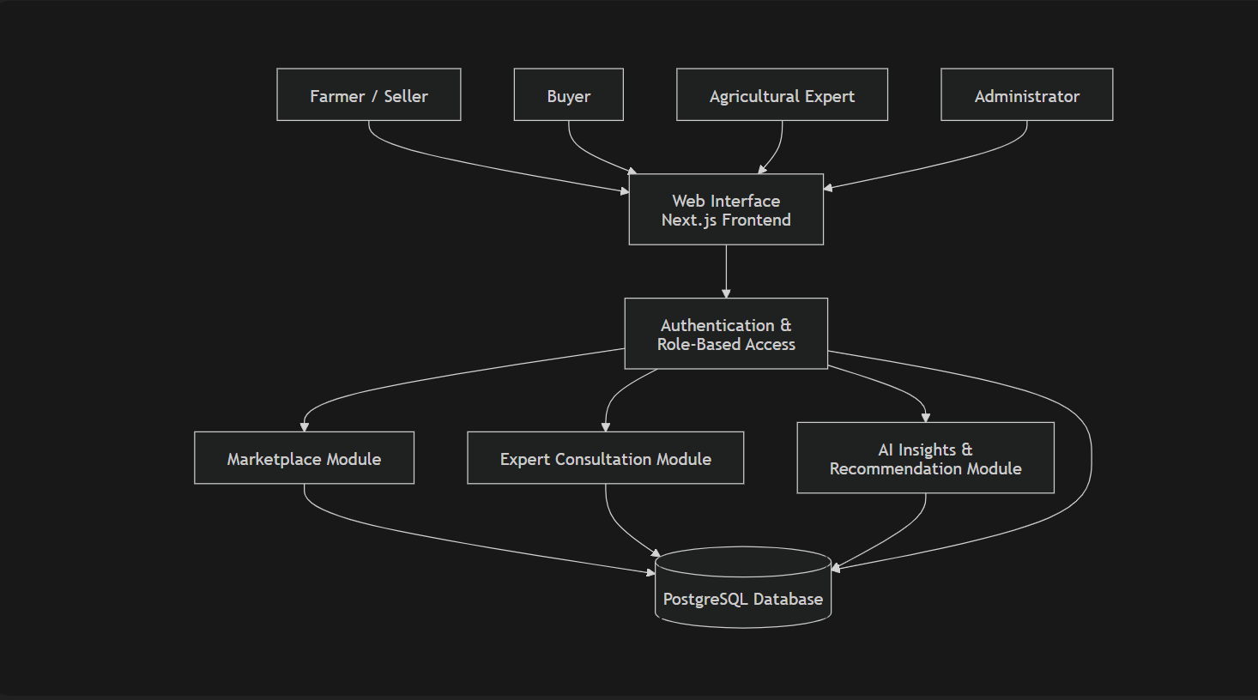
This conceptual design demonstrates that Green Market operates as a centralized digital agricultural ecosystem. All users interact with the system through the web interface, while the backend components manage authentication, marketplace operations, expert consultation services, AI-powered recommendations, and database management. The integration of these components ensures efficient communication, secure data processing, and smooth agricultural operations within the platform.

2.6 Architecture of the Proposed System
The Green Market platform follows a layered full-stack architecture consisting of a frontend layer, backend/API layer, authentication layer, ORM layer, database layer, and AI integration layer. The architecture is designed to ensure scalability, security, maintainability, and good system performance.Users interact with the system through the frontend interface built with Next.js, TypeScript, Tailwind CSS, and shadcn/ui. The frontend sends user requests to the backend/API layer, where business logic such as product management, order processing, expert booking, and AI-related requests are handled.The authentication layer manages login, registration, user sessions, and role-based access control for farmers, buyers, experts, and administrators. The ORM layer, implemented using Drizzle ORM, connects the backend to the PostgreSQL database hosted on Supabase. The AI integration layer supports intelligent features such as chatbot assistance, demand prediction, pricing insights, and personalized recommendations.

Figure 2.2: Architecture of the Proposed System

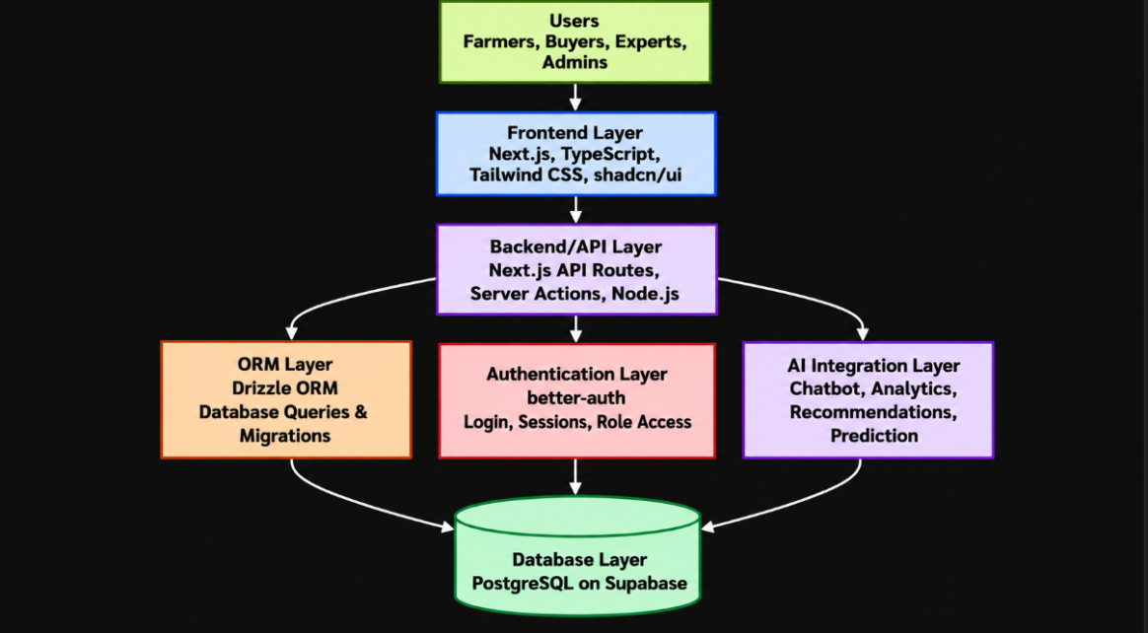
This architecture demonstrates how the major system layers of Green Market interact to support efficient and secure agricultural operations. The frontend layer allows users to interact with the platform, while the backend/API layer processes requests and manages business logic. The authentication layer ensures secure user access and role-based authorization, whereas the ORM and database layers handle data storage, retrieval, and management. In addition, the AI integration layer provides intelligent features such as chatbot assistance, recommendations, analytics, and demand prediction. Together, these layers create a scalable, secure, and reliable agricultural platform that supports smooth marketplace activities, expert consultation services, and data-driven decision-making.

2.7 Components Designs and Components Descriptions
The Green Market system consists of several major components that work together to ensure efficient and reliable platform operations. These components include the marketplace module, expert consultation module, authentication and authorization system, AI recommendation engine, database management system, and API communication layer. Each component performs specific responsibilities within the system architecture and contributes to the overall functionality of the platform.

2.7.1 Marketplace Module
The marketplace module serves as the core trading component of the system. It allows farmers and sellers to upload agricultural products with details such as product name, pricing, quantity, category, description, and availability. Buyers can browse available products, search and filter items based on their preferences, compare prices, and place orders through the platform.
The module also manages important marketplace operations such as order processing, product updates, ratings, reviews, and transaction tracking. Farmers are able to manage inventory and monitor product performance, while buyers can track purchases and provide feedback on products received. The inclusion of ratings and reviews improves trust, transparency, and accountability between users within the platform.In addition, the marketplace module interacts with the authentication system to verify users and ensure that only authorized sellers can upload or manage products. The component also communicates with the database system to store product information, order records, and transaction details securely. Overall, this module improves accessibility, reduces dependence on intermediaries, and creates a more efficient digital agricultural marketplace.
Figure 2.3: Marketplace Module Design
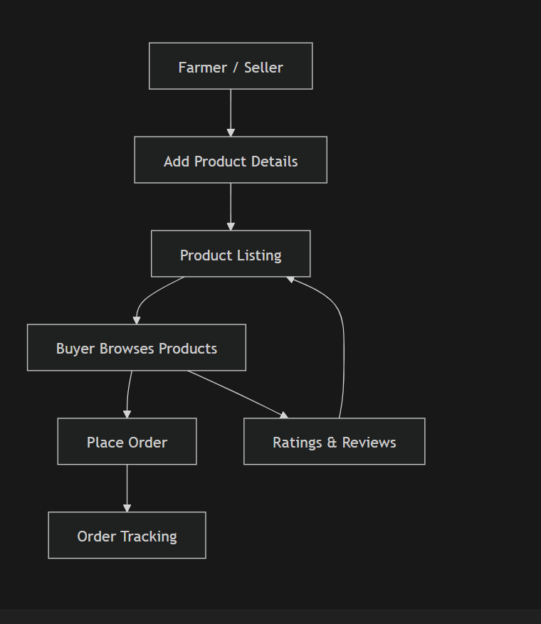

2.7.2 Expert Consultation Module
The expert consultation module connects users with verified agricultural experts such as agronomists and veterinarians. Users can book consultations, communicate with experts, and receive professional agricultural guidance.The module manages consultation scheduling, expert profiles, bookings, and communication processes. This improves access to agricultural expertise, especially for rural farmers who may have limited access to professional support.
Figure 2.4: Expert Consultation Module Design
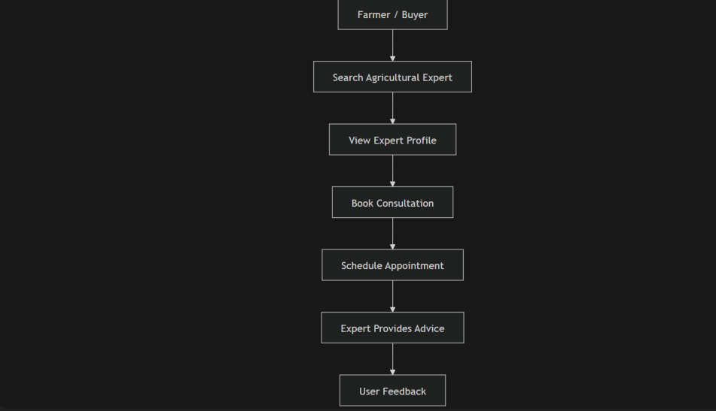

2.7.4 AI Recommendation Engine
The AI recommendation engine provides intelligent insights and decision-support services within the platform. The component processes user activities, sales records, and market data to generate personalized recommendations, pricing insights, and demand predictions.The AI module also powers the chatbot system, which provides users with basic agricultural assistance and quick responses to common questions
Figure 2.6: AI Recommendation Engine Design
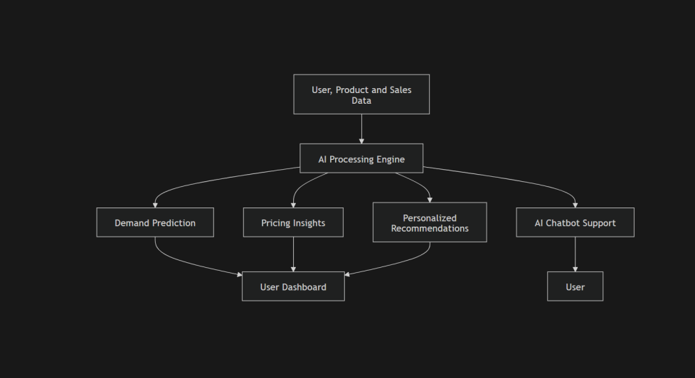

.7.5 Database Management System
The database management component stores and manages all system data including user accounts, products, orders, consultations, reviews, and analytics records. The system uses PostgreSQL hosted on Supabase for reliable and scalable data storage.Drizzle ORM is used to manage database queries, relationships, and migrations efficiently. This component ensures data consistency, security, and efficient retrieval of information.
Figure 2.7: Database Management System Design
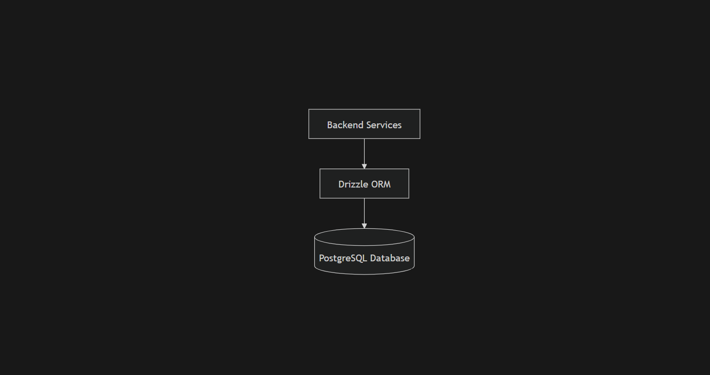

2.7.6 API Communication Layer
The API communication layer enables interaction between the frontend interface and backend services. This component processes requests from users, communicates with the database and AI modules, and returns responses to the frontend.The API layer handles operations such as product management, authentication, consultation bookings, analytics processing, and order management. It plays an important role in ensuring smooth communication across all system layers.

Figure 2.8: API Communication Layer Design
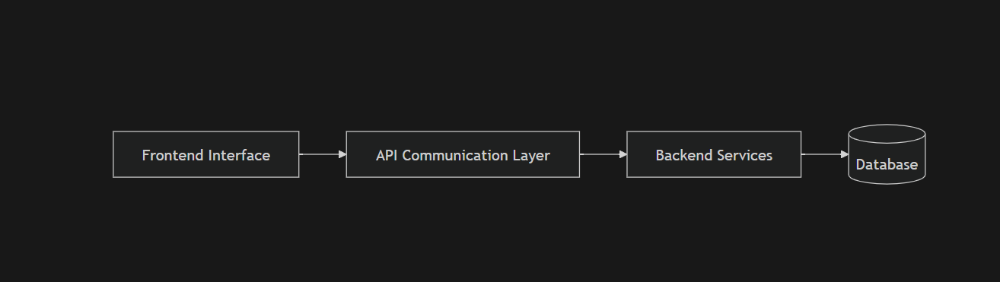
Together, these components form the core structure of the Green Market platform and ensure smooth, secure, and efficient agricultural operations within the system.

2.8 Proposed System/Software Features
The Green Market system will include several features designed to improve agricultural trade, expert support, and intelligent decision-making. These features are developed to support the different roles within the platform, including farmers, buyers, agricultural experts, and administrators.The system will provide user registration and authentication to allow users to securely create accounts and access the platform. It will also include role-based access control to ensure that each user can only access features relevant to their role. For example, farmers can manage products, buyers can place orders, experts can manage consultations, and administrators can monitor the system.The platform will also include product listing and management features that allow farmers to upload agricultural products with details such as product name, price, quantity, description, and availability. Buyers will be able to browse, search, and filter products before placing orders. In addition, the system will support expert consultation booking, allowing users to schedule sessions with verified agricultural professionals.Another important feature is the AI chatbot, which will provide basic agricultural guidance and quick responses to common user questions. The system will also include a sales analytics dashboard, demand prediction system, pricing insights, and personalized recommendations to help users make better decisions. Ratings and reviews will be included to promote trust and transparency between users.Finally, the system will be designed with responsive interfaces to ensure usability across desktops, tablets, and mobile devices. Secure database management will also be implemented to protect user data, product records, orders, consultations, and analytics information. Overall, these features will make Green Market a reliable, intelligent, and user-friendly agricultural platform

2.9 Development Tools and Environment
The development of the Green Market platform will utilize modern web development tools and technologies to ensure scalability, security, maintainability, and efficient system performance. The system will be developed using Next.js with TypeScript for both frontend and backend development. Next.js provides a full-stack development environment that supports server-side rendering, API routes, routing, and efficient web application performance.For the user interface design, Tailwind CSS and shadcn/ui will be used to create responsive, modern, and user-friendly interfaces. These tools will help improve the visual appearance, responsiveness, and usability of the platform across different devices including desktops, tablets, and mobile phones.The database system for the project will be PostgreSQL hosted on Supabase. PostgreSQL will provide reliable and scalable relational database management for storing user records, product information, consultations, orders, reviews, and analytics data. Supabase will serve as the cloud database hosting platform and backend service provider.Database interactions and schema management will be handled using Drizzle ORM together with drizzle-kit for migrations and database version control. This will allow efficient query management, type-safe database operations, and easier maintenance of database structures throughout development.
Authentication and authorization functionalities will be implemented using better-auth to support secure login, user registration, session management, and role-based access control for farmers, buyers, experts, and administrators. In addition, GitHub will be used for version control and collaboration, while Visual Studio Code will serve as the primary development environment for coding, debugging, and project management.
Overall, these tools and technologies provide a modern and efficient development environment capable of supporting the successful implementation of the Green Market platform.

2.10 Benefits of Implementation of the Proposed System
The implementation of the Green Market platform is expected to provide several important benefits to stakeholders within the agricultural sector. One major benefit is the improvement of farmer profitability through direct interaction between farmers and buyers. By reducing excessive dependence on intermediaries, farmers can sell products at fair prices and gain better access to larger markets.The system will also enhance market accessibility by providing a centralized digital marketplace where buyers can easily search, browse, and purchase agricultural products online. This improves product visibility and creates more business opportunities for farmers and agricultural businesses.Another important benefit is easier access to agricultural expertise. Through the expert consultation module, farmers and buyers can connect with verified agricultural professionals for advice on farming practices, pest control, crop management, and other agricultural challenges. This can help improve productivity and reduce farming risks.In addition, the integration of AI-powered analytics and recommendation systems will support data-driven decision-making. Features such as demand prediction, pricing insights, personalized recommendations, and sales analytics will help users make informed agricultural and business decisions.The proposed system will also improve transparency and accountability through ratings, reviews, and transaction tracking features. Automated digital processes such as product management, order processing, and consultation booking will reduce operational inefficiencies and minimize manual work.Furthermore, the platform will promote better communication and collaboration among farmers, buyers, experts, and administrators within the agricultural ecosystem. Overall, the implementation of Green Market is expected to contribute to sustainable agricultural growth, improved efficiency, enhanced productivity, and increased digital transformation within the agricultural sector.

CHAPTER THREE

METHODOLOGY

3.1 Chapter Overview
This chapter presents the methodology used in the design and development of the Green Market platform. It discusses the system requirements, stakeholders involved, requirement gathering process, functional and non-functional requirements, UML diagrams, security concepts, software process models, project design considerations, database design, user interface design, and development tools used for the implementation of the proposed system.The chapter also explains the selected software development methodology and provides justification for its adoption in the development of the Green Market platform. In addition, various system models and diagrams are presented to illustrate the structure, behavior, and interactions within the system.

3.2 Requirement Specification
Requirement specification refers to the process of identifying, analyzing, and documenting the functionalities and constraints of the proposed system. The requirement specification for Green Market was developed to ensure that the system satisfies the needs of farmers, buyers, agricultural experts, and administrators.The requirements were grouped into functional requirements and non-functional requirements to clearly define the operations, performance expectations, security needs, and usability standards of the platform.

3.3 Stakeholders of the System
The Green Market platform consists of several stakeholders who interact with the system directly or indirectly to ensure efficient agricultural operations and smooth platform activities. These stakeholders include farmers/sellers, buyers, agricultural experts, and administrators, each performing specific responsibilities within the system.

3.3.1 Farmers/Sellers
Farmers and sellers are primary users of the platform who use the system to upload and manage agricultural products, monitor inventory, track orders, manage sales activities, and interact directly with buyers. They can also access AI-powered insights, market recommendations, and consultation services from agricultural experts to improve productivity and decision-making. The platform helps farmers increase market reach and reduce dependence on intermediaries.

3.3.2 Buyers
Buyers interact with the platform to browse available agricultural products, search and filter items, place orders, track purchases, and provide ratings and reviews. Buyers can also receive personalized recommendations and market insights generated by the AI recommendation system. The platform improves accessibility to agricultural products and promotes transparent transactions between buyers and sellers.

3.3.3 Agricultural Experts
Agricultural experts provide professional consultation services and agricultural guidance to users of the platform. These experts may include agronomists, veterinarians, crop specialists, and other agricultural professionals. They manage consultation appointments, respond to inquiries, and provide recommendations on farming practices, pest control, crop management, and other agricultural challenges.

3.3.4 Administrators
Administrators are responsible for managing and monitoring the overall operations of the Green Market platform. Their duties include managing users, verifying experts, monitoring transactions, generating reports, maintaining system security, and ensuring smooth platform performance. Administrators help enforce system policies and ensure that the platform operates efficiently and reliably.

3.4 Requirement Gathering Process
The requirement gathering process involved collecting information from potential users and analyzing existing agricultural systems to identify the major challenges within the agricultural ecosystem.
The following techniques were used:
- Observation of existing agricultural marketplace systems.
- Review of related agricultural platforms such as Grow For Me, Farmcrowdy, and DeHaat.
- Informal discussions with students, farmers, and online agricultural communities.
- Analysis of agricultural business processes and digital marketplace operations.
The information gathered helped identify the major system requirements and functionalities needed for the development of Green Market.

3.5 Functional Requirements
The functional requirements describe the major operations and services the system must provide.
The Green Market platform should be able to:
- Allow users to register and log into the system.
- Support role-based access control.
- Allow farmers to upload and manage products.
- Allow buyers to browse and purchase products.
- Allow users to book consultations with experts.
- Provide AI chatbot assistance.
- Generate analytics and recommendations.
- Allow users to rate and review products.
- Manage orders and transactions.
- Store and retrieve system data securely.

3.6 UML Diagrams
UML diagrams are used to visually represent the structure and behavior of the Green Market system.

3.6.1 Use Case Diagram (Frontend Models)
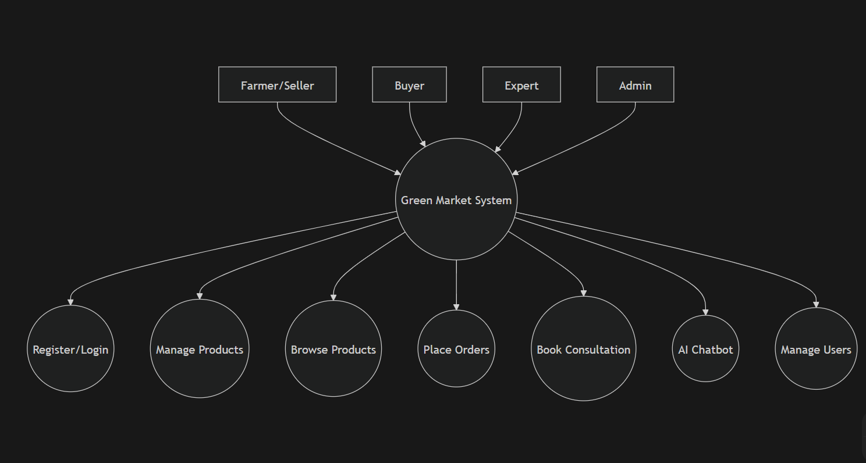

3.6.2 Use Case Description

Farmer
The farmer uploads products, manages orders, books consultations, and receives AI recommendations.

Buyer
The buyer browses products, places orders, tracks purchases, and interacts with the AI chatbot.

Expert
The agricultural expert manages consultation appointments and provides agricultural advice.

Administrator
The administrator manages users, reports, and system monitoring activities.
3.6.3 Activity Diagram
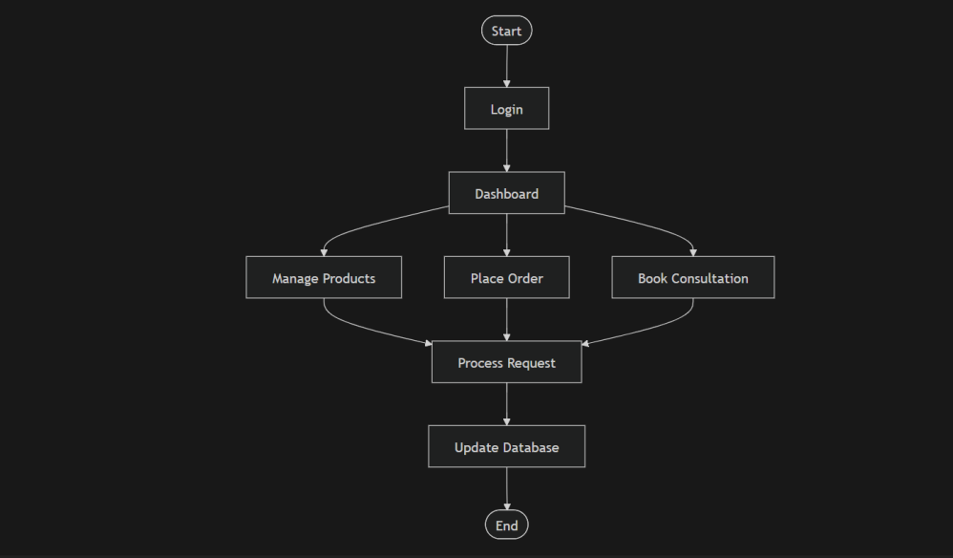
3.6.4 Sequence Diagram
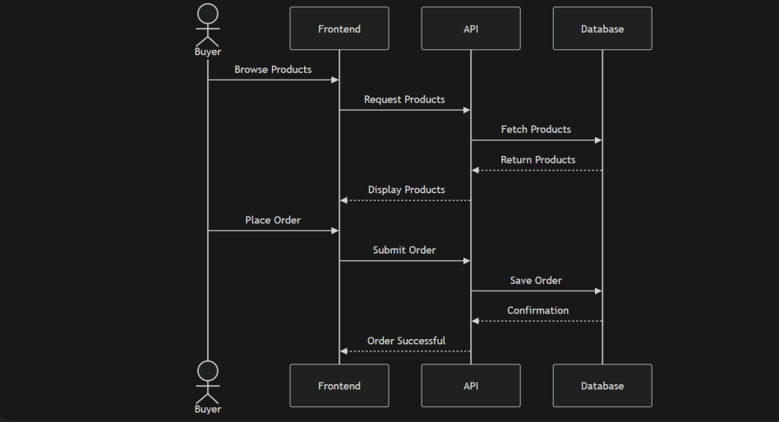
3.6.5 Class Diagram
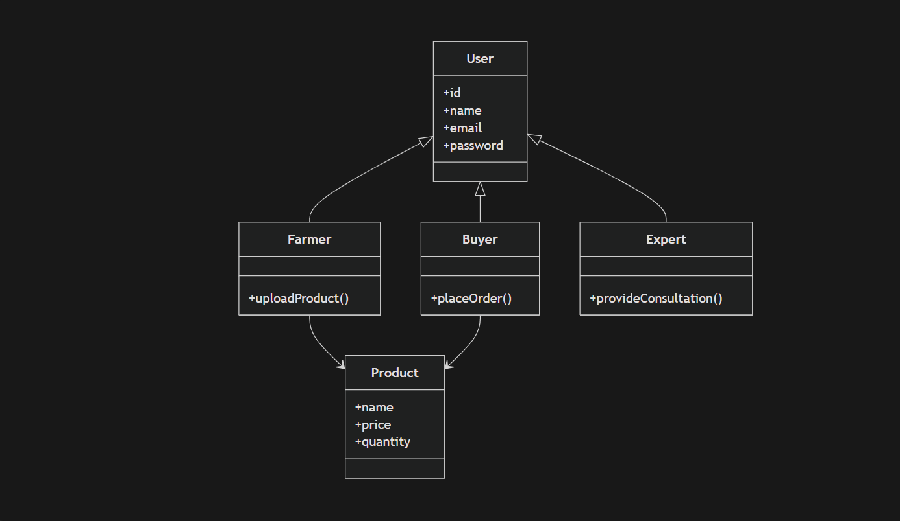

3.7 Non-Functional Requirements
Non-functional requirements describe the quality standards, performance expectations, and operational characteristics of the Green Market platform. These requirements define how the system should perform rather than the specific functionalities it provides. The non-functional requirements are important in ensuring that the platform remains secure, reliable, scalable, efficient, and user-friendly for all stakeholders.

3.7.1 Performance
The Green Market platform should provide fast and efficient processing of user requests and system operations. The system must be capable of handling multiple users simultaneously without significant delays or reduction in performance. Activities such as user authentication, product browsing, order placement, consultation booking, and AI recommendation generation should execute within reasonable response times to ensure a smooth user experience.
The use of modern technologies such as Next.js, PostgreSQL, and Drizzle ORM is expected to improve overall application performance and optimize data processing operations. Efficient database queries and API communication will also help minimize latency and improve system responsiveness.

3.7.2 Security
Security is a critical requirement of the Green Market platform because the system manages sensitive user information, transactions, consultation records, and marketplace activities. The system should provide secure authentication, encrypted sessions, protected database access, and secure communication between all system components.
The platform will implement role-based access control to ensure that users can only access functionalities permitted for their specific roles. Authentication and session management will be handled securely using better-auth. Passwords and sensitive credentials will be encrypted to reduce the risk of unauthorized access and data breaches.
Furthermore, secure APIs, input validation, and controlled database interactions will help protect the platform against malicious attacks such as SQL injection, unauthorized access, and data manipulation.

3.7.3 Scalability
The Green Market system should be scalable enough to support future expansion and increasing numbers of users, products, consultations, and transactions. The platform architecture is designed to accommodate growth without requiring major structural changes to the system.
The layered full-stack architecture, cloud-based database hosting on Supabase, and modular system design allow additional features and services to be integrated easily in the future. This scalability ensures that the platform can continue to perform effectively as user demand increases over time.

3.7.4 Usability
The platform should provide a responsive, user-friendly, and intuitive interface that is easy to understand and operate. Users should be able to navigate the system efficiently regardless of their technical background or level of digital literacy.
The interface will be designed using Tailwind CSS and shadcn/ui to provide a clean, modern, and responsive user experience across desktops, tablets, and mobile devices. Proper layout organization, clear navigation menus, and accessible interface elements will improve overall usability and user satisfaction.

3.7.5 Reliability
The Green Market platform should provide reliable and stable operations with minimal downtime or system failures. The system should consistently perform expected operations such as authentication, product management, order processing, consultation booking, and analytics generation without interruption.
Reliable database management, secure cloud hosting, and proper error handling mechanisms will help maintain system stability and data integrity. Backup and recovery mechanisms will also help protect important system data against accidental loss or corruption

3.8 Security Concepts
The Green Market platform implements several security mechanisms to protect user data, transactions, and overall system operations. Since the platform handles sensitive information such as user accounts, product transactions, consultations, and AI-generated insights, proper security measures are necessary to maintain confidentiality, integrity, and system reliability.
One of the primary security mechanisms implemented in the system is user authentication and authorization using better-auth. This ensures that only verified users can access the platform and perform authorized activities based on their assigned roles. Farmers, buyers, agricultural experts, and administrators are each provided with specific permissions and access rights within the system.
The system also implements password encryption and secure session management to protect user credentials and maintain secure login sessions. Sensitive user information is encrypted before storage to reduce the risk of credential theft and unauthorized access.
In addition, role-based access control is used to restrict users from accessing functionalities outside their assigned responsibilities. For example, only administrators can manage users and system reports, while only experts can manage consultation services.
Protected database access is implemented using secure APIs and controlled backend communication to prevent unauthorized interaction with the PostgreSQL database. The API layer validates requests before processing them to ensure data security and consistency.
The platform further implements input validation and sanitization techniques to reduce malicious attacks such as SQL injection, cross-site scripting, and invalid data submission. All user inputs are checked and validated before being processed by the backend system.
Secure communication between the frontend and backend services is also maintained through protected API requests and secure session handling. These security mechanisms collectively help protect the system against unauthorized access, data breaches, cyber threats, and malicious activities while ensuring safe and reliable platform operations.

3.9 Project Methods
Software development methodologies provide structured approaches for designing and developing software systems. The major software process models include the Waterfall Model, Spiral Model, Prototype Model, Agile Model, and Incremental Model. Each model provides different approaches for system planning, development, testing, and maintenance.

3.10 Chosen Model and Justification
The Agile software development model was selected for the development of Green Market. Agile supports iterative development, continuous testing, flexibility, and regular feedback throughout the project lifecycle.
The model was chosen because the Green Market platform contains multiple integrated modules such as the marketplace system, expert consultation services, AI features, and analytics dashboard. Agile makes it easier to develop and improve these modules gradually while identifying and fixing issues during development.

3.11 Project Design Considerations (Logical Designs)
Project design considerations describe the logical structure and visual organization of the Green Market platform.

3.11.1 UI Design
The user interface design focuses on simplicity, responsiveness, accessibility, and good user experience across different devices.
The main UI wireframes include:
- Login and Registration Pages
- Farmer Dashboard
- Buyer Dashboard
- Product Listing Pages
- Consultation Booking Interface
- Analytics Dashboard
- Admin Management Pages

3.11.2 DB Design
The Green Market database design consists of several related entities used to manage system data efficiently.
The major database entities include:
- Users
- Products
- Orders
- Consultations
- Reviews
- Analytics
The database is implemented using PostgreSQL and managed through Drizzle ORM for efficient and secure database operations.
E-R Diagram
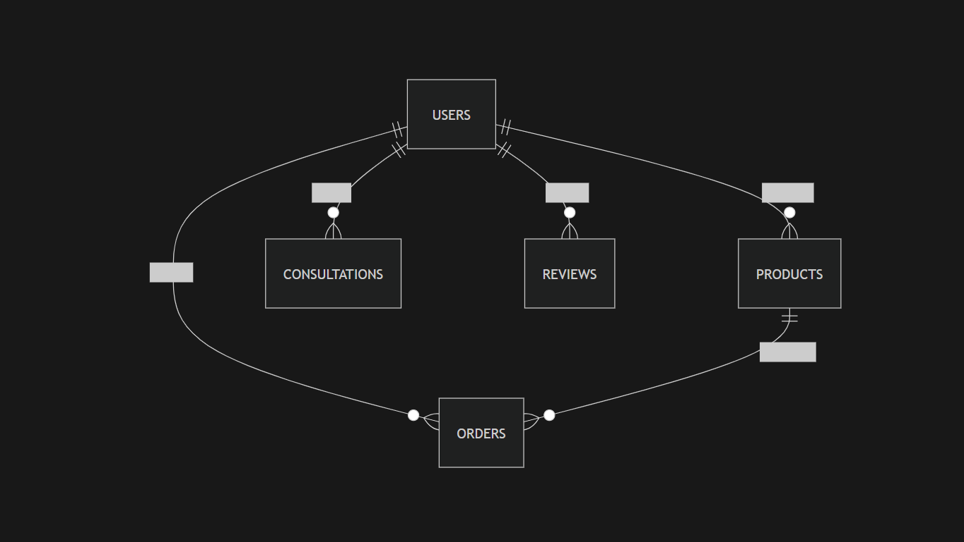

3.12 Developmental Tools
- Next.js — Used for building both the frontend interface and backend API services.
- TypeScript — Used to improve code quality, readability, and maintainability.
- Tailwind CSS — Used for creating responsive and modern user interfaces.
- shadcn/ui — Used for reusable and consistent UI components.
- PostgreSQL — Used for secure and reliable relational database management.
- Supabase — Used for cloud database hosting and backend support services.
- Drizzle ORM — Used for database queries, schema management, and migrations.
- better-auth — Used for secure authentication and role-based access control.
- GitHub — Used for version control, collaboration, and project backup.
- Visual Studio Code — Used as the primary environment for coding, debugging, and testing.

