Newark vs Jersey City

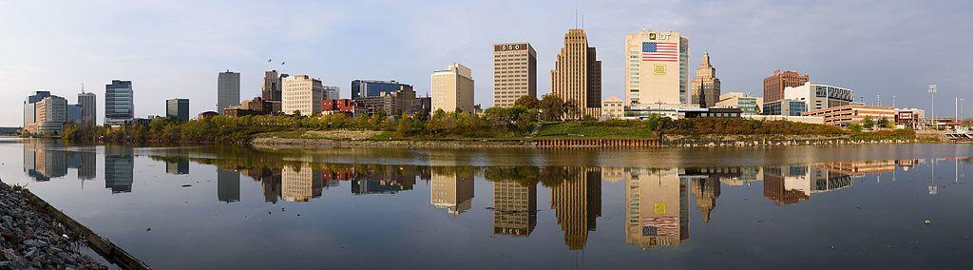

Table of Contents

1. Introduction
2. Data used
3. Methodology:
   1. Newark vs. Jersey City - number of high schools
   2. Apartments - best location → Bar Chart matplotlib
   3. Economy / Murders - is there a link?
4. Results
5. Conclusions

**Introduction**

I am an SAT tutor, and am starting a business. I want to find out which city is best to start in. I want to see how many schools there are. I will count the number of schools in the two cities, the more the better. I will also try to narrow it down to type of schools, for instance high schools, not colleges. I like ice cream. Especially McDonald’s Ice Cream. Students also like ice cream. I will search the winning city for place to open my SAT tutoring center. I will search for all the McDonals within a radius of 1000 meters from each location, the more the better. I will also be doing advanced statistical methods also to determine population trends, and safety trends, to see if it is a good idea where to be located. More specifically, I will see if long term GDP growth in our country, along with increasing education, can keep reducing crime over time.

**Data Used**

Most of the data used is from the foursquare search. I did queries on schools, just high schools ( needed special custom search), and apartments. I also did advanced statistical reaseach. I looked up on the internet stats for the number of murders in Newark, to analyze trends. The website I used was : [ttp://www.city-data.com/crime/crime-Newark-New-Jersey.html](http://www.city-data.com/crime/crime-Newark-New-Jersey.html).

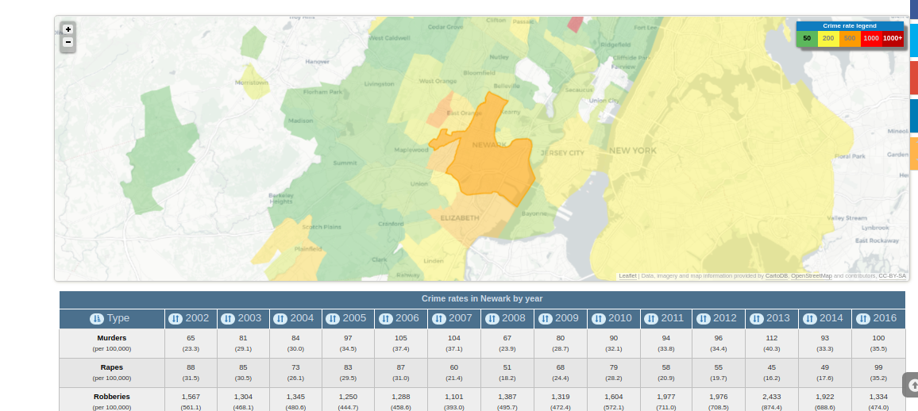

**Newark vs. Jersey City - number of high schools**

I counted the total number of McDonald’s in Newark. At first there was a problem of a limit of over 50, since more than just the search term of McDonald’s was coming up. So what I did was alter the search for only high schools in the query, not all schools. he total number of high schools in Newark was 18. The total number of McDonals’s in Jersey City was 8.

**Apartments - best location → Bar Chart matplotlib**

I did a search for all the apartments in Newark to find the best location. I chose to search for rent places. So far I looked up New Hope apartments, and Nevada Street apartments. I wanted to be close to a McDonalds, because I like ice cream, and so do students. I looked for how many Mcdonalds there was in a 1000 meter radius from both locations.

**Economy / Murders - is there a link?**

I researched how many murders there were. I also compared the GDP of America, to compare it to.

**Results**

Starting out with the two cities, Jersey City and Newark, Jersey City has 8 high schools, Newark has 18. More high schools means more business potential. I narrowed it down to a specific locations. There was New Hope Tower and Nevada Street Apartments. I did a seach within a 1000 foot radius. New Hope has 2 McDonalds closeby, Nevada Street has 4. as a place to set up. It has a lot of McDonalds closeby. Newark isn’t the safest city, so I used statistical methods to determine if a growing economy helps. I was able to predict! The Jcard score was .66, so the data that I have will show that in the future, crime can keep getting lower and lower as more people are weathier, and has more education. So a growing economy means a safer Newark!

**Conclusion**

I am choosing Newark over Jersey City. There are more high schools. More High Schools means more business! Also, Nevada Street to rent is the way to go, as there are more McDonals closeby. I am watching the safety, as a bigger US GDP/economy means more safety for Newark! So as the years go by the city will be safer and safer!