A Compilation of Notes from Borel the Elder’s

The Ancient Lands of the Aeduni
By Ando Foragi

A note to the reader:
Any person, layman or scholar, who has an interest in the Aeduni peoples, their lands, histories, and cultures, would not find a more clear and comprehensive account than Borel the Elder’s excellent “The Ancient Lands of the Aeduni” in three volumes. It is the world’s great misfortune that there exists but one known copy of this seminal work, that residing under lock and key within the private library of House Kai in the sprawling metropolis called Haven. Endeavoring to study this singular work, the hopeful and intrepid reader, having ventured to cross the vast, miasmic, poison-vapored bogs surrounding the molding, labyrinthine pile that is Haven, having avoided or outrun the numerous cutthroats and thieves that plague the city’s winding streets, having at last managed to gain admittance to House Kai’s library, infamous for their jealous hording of texts rare or arcane, and finally sitting before this unique manuscript, will be stopped short in their erudite ambitions, abruptly and without doubt, by the inescapable fact that, as a gift to the Lords of the Dragon Isles for their ancient friendship and kindnesses, Borel wrote his magnificent opus in Old Draconic, a runic system that is perfectly impenetrable to all but a very few scholars specializing in such ancient tongues.
As such a scholar, my ambition was to pen a complete and definitive translation of Borel’s epic work into Aeduni (what we, in our arrogance, call “the common tongue”) and to bring to the modern reader, in some small measure, as a cup from a deep well, the knowledge contained in his great creation. I find it necessary at this point to confess that my ambition far exceeded my capability. My mastery of Old Draconic is not perhaps as complete as I had supposed, and I remind the reader that my time in the library of House Kai was, by no wish of my own, quite limited. Far less than a translation, what follows cannot be accurately termed even a synopsis or summary but is rather a mere compilation of notes to which I have added my own amendments to account for notable events that have occurred since Borel’s time. Any mistakes or inconsistencies in the pages that follow are entirely my own and should not reflect on Borel’s legacy.
Ando Foragi
Year of the New Sun 1932

Contents
Maps of the Lands of Aedun 7
Chronology of major events 11
The Aedunaic Calendar 12
Regions of Aedun 14
The Ambersea 14
The Dead Pools 16
The Dragon Isles 17
Kingdom of Durany 18
The Elderwood 20
The Great Deep 21
Greenvale and Cormar 22
Haven 23
Lake Heron 25
The High Watch Mountains 26
Iceland 27
The Night Country 28
Skye and the Guarded Forest 29
Stoneport 30
The White Waste 31
Zhendohar 32
The Races of Aedun 32
Dwarves 32
Hill Dwarves 33
Mountain Dwarves 33
Frost Dwarves 34
Elves 34
High Elves 34
Wood Elves 35
Dark Elves 35
Dawn Elves 36
Halflings 37
Lightfoot Halflings 37
Stout Halflings 37
Briar Halflings 38
Humans 39
Duran 39
Shane 39
Tombe 40
Ravaine 40
Kaylish 40
Bindhu 41
Arathane 41
An-chan 41
Formari 42
Dragonborn 42
Sea Drakken Dragonborn 43
Gnomes 44
Forest gnomes 44
Rock gnomes 45
Shadow gnomes 45
Half-Elves 46
Wayfarer half-elf 46
Half-orcs 47
Tide orcs 47
Tieflings 48
Night-haunt tieflings 49
Variant classes and sub-classes of Aedun 49
Barbarian: Path of the Beast 50
Beast form 50
Beast sense 50
Beast agility 50
Blood sense 51
Bard: College of Secrets 51
Tradecraft 51
Inspiring Word 51
Spy craft 52
Vicious riposte 52
Cleric: Shadow Domain 52
Shadow domain spells 52
Shadow initiate 53
Shadow channeler 53
Shadow ward 53
Death strike 53
Reaper 53
Druid: Circle of Fire 54
Bonus cantrip 54
Rage fire 54
Circle spells 54
Quick fire 54
Fire shape 55
Cleansing fire 55
Fighter: Warder 55
Spellcasting 56
Warder initiate 57
Warder acolyte 57
Warder veteran 57
Master warder 57
Highmaster warder 58
Monk: Way of the Tempest 58
Tempest technique 58
Fist of Hamattan 59
Breath of the cloud dragon 59
Wind gyre form 59
Hands of Samiel 59
Tempest strike 59
Paladin: Oath of Enlightenment 60
Tenets of Enlightenment 60
Oath spells 61
Channel Divinity 61
Knight exemplar 61
Lord arcanist 62
Epiphany of the arch-inquisitor 62
Ranger: Partisan 62
Partisan awareness 63
Hidden weapon 63
Angry mob 63
Partisan survival 63
Partisan network 63
Quick-witted 64
Ruthless partisan 64
Rogue: Confidence Artist 64
Showman 64
Fast talker 64
Lucky 64
Big finish 65
Sorcerer: Channeler 65
Channeling sensitive 66
Channeling initiate 66
Channeling adept 66
Channeling master 67
Warlock: Pact of the Ancestors 67
Ancestors expanded spells 67
Watchful ancestors 68
Spirit door 68
Passage through the spirit realm 68
Awaken the elder spirit 68
Wizard: School of Patterning 68
Patterner Savant 69
Aegis Pattern 69
Arcane Resonance Pattern 69
Pattern Bound Spell Trap 69
Cheval Pattern 69
Languages 70
Aedunaic (Common) 70
Elvish 70
Ruic (Dwarven) 71
Gaizhan (Tiefling) 71
Daymu 71
Sea Bash 71
Draconic 71
Shadow Talk 72
Currency in Aedun 72
The Faiths of Aedun 73
The Old Gods 73
Raweni (Raven) 74
Honu (Turtle) 74
Koyote (Coyote) 74
Paya (Bear) 74
Waro (Crane) 74
Kawau (Cormorant) 75
Ekara (Eagle) 75
Pi (Bee) 75
Oru (Owl) 75
Rapeti (Rabbit) 75
Otur (Otter) 76
Nakahi (Snake) 76
Aimok (Ox) 76
Hati (Stag) 76
Meijok (Wolf) 76
Mahoi (Mouse) 77
Ayat Light Bringer 77
Early History 77
The Purge of Ayat 78
Other Belief Systems 78
Notable Institutions 79
Citadel of the Seven Houses 79
Schools of Wizardry 79
Military Academies 80
Bard Colleges 81
Monasteries 82
Criminal Syndicates 82

Maps of the Lands of Aedun

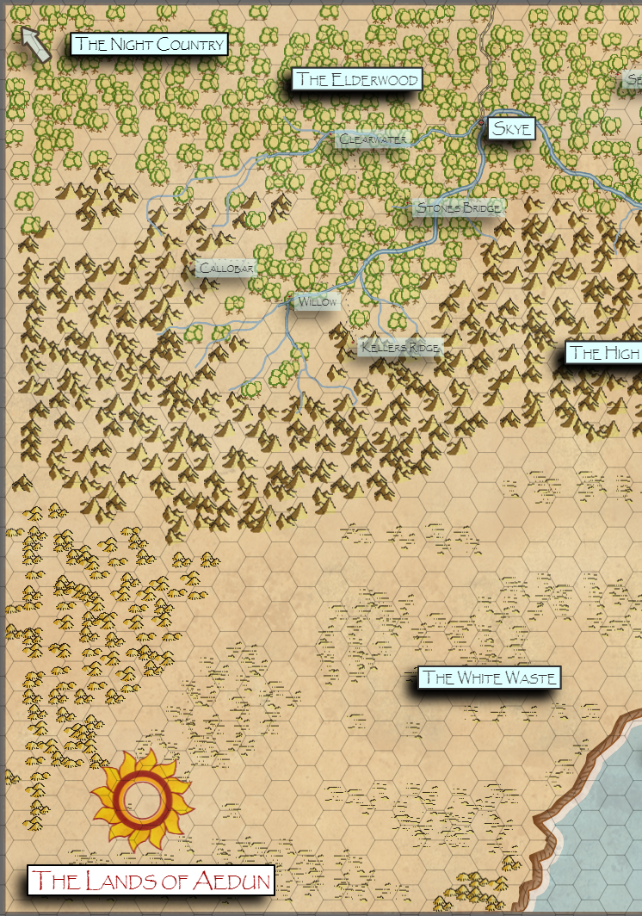
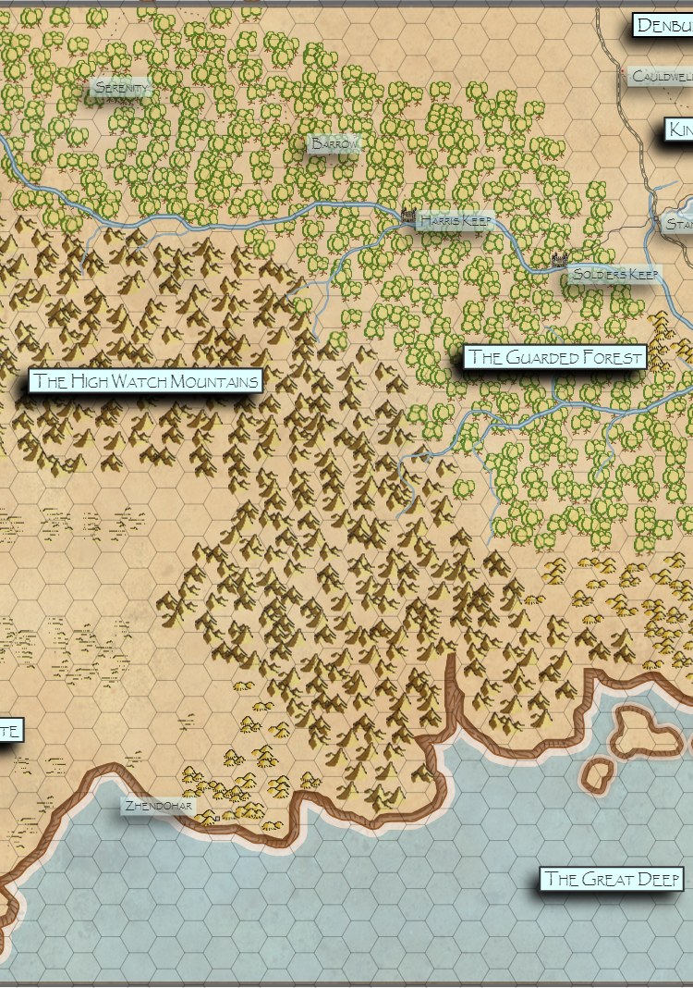
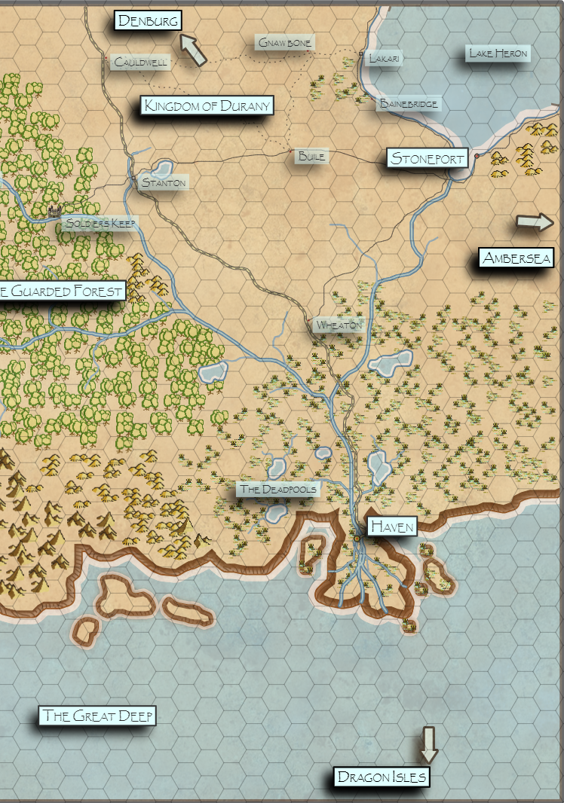

Chronology of major events
Recorded history of the lands of Aedun begins when Ronan Aubret, chieftain of the Durans, united his tribe, together with the Tombes, the Shanes, the elves of the Guarded Forest and the dwarves of the High Watch Mountains under a single banner to decisively defeat the hordes of the ungartten, driving them from Aedun back to the far western land called the Night Country. Ronan, returning from war, was crowned Ronan the New Sun, first King of Durany and established Denburg as the fixed capital of the new kingdom of Durany. This is numbered Year 1 of the Aeduni calendar.
Only myths and legends survive the eons before this time, known as the Long Night. It is said of this dark time that the ungartten, the soul-less, reigned supreme. These beings, said to assume many forms but all with a burning hatred for all other living things, roamed freely, hunting, torturing, and killing, all that came before them.
It is said of the Long Night that the gods, magic, and even the sun itself abandoned the Aeduni and only when the ungartten were destroyed did sunlight, enchantment, and the grace of the gods return, growing slowly stronger with each passing year of the new sun.
Chronology
Year 1 | Denburg established. Ronan Aubret crowned The New Sun, King of Durany.
87 | Town of Stoneport established by the Shanes on the shores of Lake Heron.
94 | Town of Skye established by the Tombes on the banks of the Grey River in the Guarded Forest.
111 | Start of the First Peace. Trade networks built across Durany. Numerous towns and villages established.
476 | Shanes begin ship building and start exploration of Lake Heron and the Seareach river.
498 | Ungartten raids begin to be reported along the western provinces of Durany.
502 | First Temple of Ayat established in Denburg.
509 | Traders from Stoneport reach Haven for the first time. Trade established with the Noble Houses of Haven.
718 | Elana Tombe proposes an agreement between all the peoples of the Aeduni to oppose and defend against the ungartten. League of Nations Treaty ratified later in the year by Durany, Skye, Stoneport, the Elves of the Elderwood, the Elves of the Guarded Forest, and the Dwarves of the High Watch Mountains.
844 | First contact with the Sea Kings of the Dragon Isles in Haven.
1251 | Invasion of the Ungartten. Border defenses of western Durany overrun. Death and destruction all across the west of Durany. The Elves of the Elderwood driven deep into the forest. Skye is cut off from Durany. End of the first peace.
1289 | Aerek Shane forges alliance with the Five Tribes of the Ambersea.
1301 | Owaine Jens and Aylice Tombe voyage to the Dragon Isles.
1306 | Battle of Woods End. The armies of Durany, Skye, and Stoneport, in retreat after brutal losses, are surrounded at Woods End and face annihilation by fresh hordes of ungartten from the west. Only the unlooked-for arrival of the Dragonborn, having sailed up the Grey River in their armored longboats ten-thousand strong with mercenaries from Haven, turned the tides. The ungartten are routed. Beginning of the second peace.
1832 | House Fallon, exiled from Haven, settle Zhendohar on the edge of White Waste. First contact with the Dark Elves of the Waste.
1844 | Emmet Duran establishes trade relations with the Frost Dwarves of Iceland north of Lake Heron.
1851 | Dwarves of the High Watch discover rich veins of gold and iron. Expand trade with Skye.
1912 | The Purge of Ayat. Non-humans expelled from Durany.

The Aedunaic Calendar
The Aedunaic Calendar pre-dates written histories and is used almost universally across all of Aedun as far east as the Ambersea and as far south as Haven and to lands beyond. It is even in common usage amongst the Drow of the White Waste who must regard many of the natural creature references as fanciful animals of myth.
The calendar is divided into four seasons, each sub-divided into ten-day “reigns”. A reign consists of the following named days:
Sun Day
Moon Day
Wind Day
Earth Day
Fire Day
Water Day
Star Day
Free Day
Dues Day
Truth Day
Each season is divided into nine ten-day reigns. The fifth reign, marking the high point of the season, is called a dragon reign and often marks seasonal festivals or major holidays. The reigns for each of the four seasons are listed below.

- Spring  Reign of the Shrew  Reign of the Coyote  Reign of the Falcon  Reign of the Deer  Reign of the Green Dragon  Reign of the Toad  Reign of the Pig  Reign of the Tortoise  Reign of the Serpent | - Summer  Reign of the Rat  Reign of the Jackal  Reign of the Lion  Reign of the Spider  Reign of the Gold Dragon  Reign of the Eagle  Reign of the Trout  Reign of the Vulture  Reign of the Scorpion
- Autumn  Reign of the Fox  Reign of the Mole  Reign of the Lynx  Reign of the Horse  Reign of the Red Dragon  Reign of the Ox  Reign of the Raven  Reign of the Bear  Reign of the Mouse | - Winter  Reign of the Owl  Reign of the Marten  Reign of the Otter  Reign of the Wolf  Reign of the Silver Dragon  Reign of the Ram  Reign of the Hawk  Reign of the Mammoth  Reign of the Hare

Regions of Aedun

The Ambersea
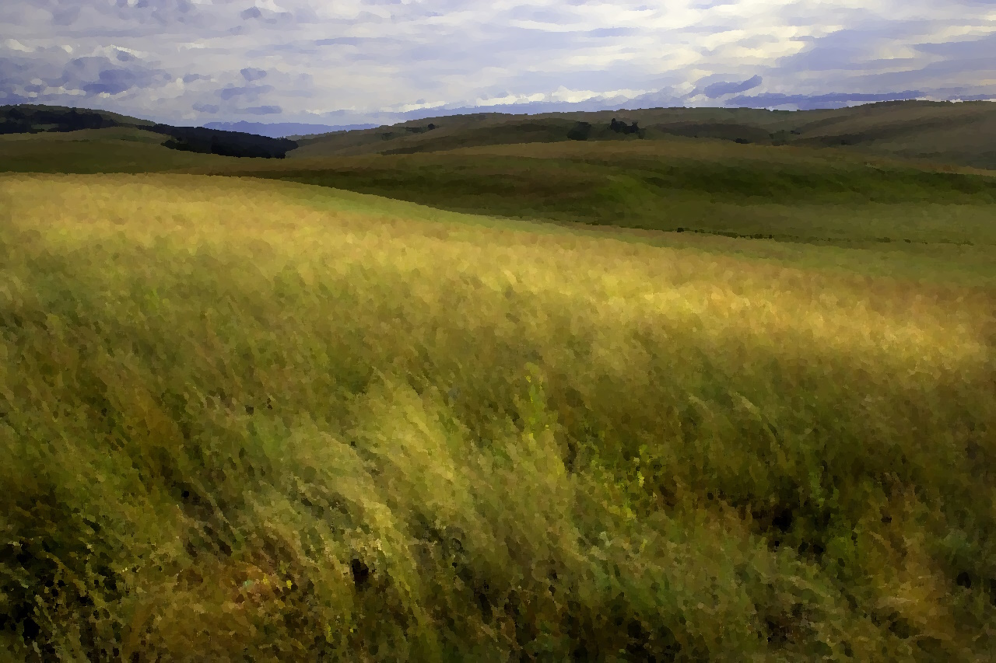
The Ambersea is a wide grassland and steppe. It is considered to start at the Seareach river and stretches eastward to an unknown extent. It is bordered to the north by Lake Heron and to the south by the Sea of Reeds. The westernmost area is a rich and gently sloping grassland dominated by endless fields of a species of giant rye known as Stockgrass which grows to a heigh of over 6 feet by the end of the summer and turning a rich golden amber color giving the region its namesake. Traveling eastward, the land gradually rises in elevation through a series of rolling hills interspersed with ravines and gullies with small watercourses surrounded by light forest or wetland. The rich and flowing grassland on the hillsides is gradually replaced by shorter and more sparsely growing scrub grasses. Rain is frequent in the spring with frequent storms. Dangerous storms with strong winds and even tornadoes are most common in late spring or early summer. Late summer and autumn are generally dry and clear before snow begins to fall in winter. The heaviest snow falls in late winter reigns generally making the region impassable. The great fields of Stockgrass support huge herds of deer, antelope, bison, and wild horses. It is even rumored that herds of mammoth are to be found in the unexplored wilderness of the far eastern Ambersea. Travelers on the Seareach River can often see large herds all along the east bank from late summer through autumn before they begin to migrate back to the east.
The Ambersea is sparsely populated by tribes of nomads. The tribes form a loose confederacy which meet twice a year to share news and settle disputes. The people of the Ambersea are expert horse riders and hunters. There are six known tribes that inhabit the western Ambersea:
Otter
The Otter tribe hunt and fish the eastern and southern Ambersea. Their birchbark canoes are commonly seen on the Seareach River and they are expert navigators of the vast Sea of Reeds. They are generally an open and friendly people and can help facilitate communication with other tribes of the Ambersea.
Crow
The Crow, rarely seen in large numbers, are expert horse riders and roam far and wide across the Ambersea. They generally follow the bison and other herd animals as they migrate, season to season, but they are also known for long journeys made out of pure curiosity and a love of the natural world.
Wolf
The Wolf tribe inhabits the central Ambersea. An insular tribe and suspicious of strangers, the Wolf tribe are renowned warriors.
Bear
The Bear people inhabit the north of the Ambersea fishing Lake Heron and hunting the woods and hills near the eastern shores of the lake. Some of their warriors are said to be able to assume bear form.
Coyote
The territories of the Coyote people are found in eastern Ambersea but, like the Crow people, they migrate seasonally with the bison and are sometimes to be found in the west. They are on friendly terms with the other tribes.
The Dawn People
The dawn people or dawn elves (the wullah na sai in their own language), are a subrace of elves unique to the Ambersea. The dawn people are revered by the other tribes of the Ambersea. They are seldom encountered for they are said to wander far, far into the eastern steppe, but they are beloved for their generosity and openness, for their deep knowledge of the natural world, and for their frank affections for the other inhabitants of the Ambersea.

Wullah is the name of the language of the dawn elves and is the most common language of the Ambersea. Most tribes will also have some members who speak common especially those tribes in the regions closest to the Seareach river or Lake Heron who deal frequently with people from other regions of Aedun.
The people of the Ambersea share a strong shamanic tradition and generally worship the Old Gods.

The Dead Pools
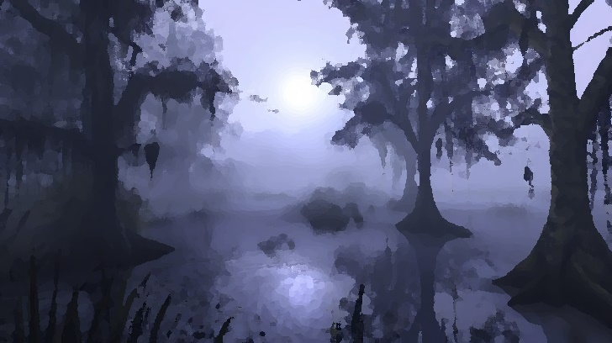
The dreary wetlands southwest of the Guarded Forest between the Seareach River and the foothills of the High Watch Mountains are known as the Dead Pools. Everywhere in this swampland, water stands in dank, mosquito-infested ponds, overgrown bogs, or sluggish, winding, weed-choked streams interspersed with islands of drier ground where huge cypress trees hang over the dark waters surrounding. The insects, together with the suffocating heat and humidity make this region all but impassible in the summer months. Rain and dense fog are common in autumn and winter. The Dead Pools are not well-explored. People living adjacent to the Dead Pools tell stories of unnatural deadly creatures that make their lair here and that creep forth to prey on the unwary. It is known that many travelers who stray accidentally into this area never return to drier, more hospitable country.

The Dragon Isles
The precise location of the Dragon Isles in the vastness of the Great Deep has not been set down on any maps known. The dragonborn sea captions and navigators visiting Haven or other mainland locations offer only vague information and the journal of Owaine Jens, a member of the only successful voyage to the Dragon Isles by mainlanders, pointedly, does not include notes on navigation. From Owaine's journal and from spoken descriptions offered by dragonborn sailors, the Dragon Isles are thought to lie south and east from Haven and a voyage to the Dragon Isles from there can take as long as one hundred and twenty days.
The islands are described as a large archipelago spanning hundreds of sea miles with a handful of large islands and many smaller islets. Many of the smaller islands are low, sandy atolls with light tropical forest, often with a lagoon and a barrier reef. There are also larger islands that are more mountainous and marked by dramatic sea cliffs and with significant mountains and dense jungle interiors.
The inhabitants of the Dragon Isles enjoy a mild and pleasant climate all year long. Aylice Tombe describes her time on the islands as "the finest of summer days, all year long." The autumn season may bring occasional storms with rain and mild winds. Significant storms are rare, but dragonborn sailors share stories of whole fleets wrecked by a sudden black typhoon raised from the Great Deep.
A visitor to the Dragon Isles seeking dragons would not be disappointed. Every color variation of dragon known to the Aeduni through myth and legend seem to be represented in the islands. The dragonborn say that each major island in the archipelago is ruled over by a dragon. The dragons are remote and not often seen, but the towns and villages of the dragonborn are built only on islands where the blessing of the resident dragon has been secured. These communities enjoy the protection of their dragon from other dragons through a complex web of pacts and contracts known in full only by the most ancient of the dragons. Some dragons do not wish to share their island with others and are uninhabited except for the dragon ruler and its spawn. The dragonborn usually know which islands and trade routes are protected by compact and, when in doubt, are careful to consult first with their dragon before visiting.
Each small town and village, scattered across the archipelago, manages its own local affairs, but the islands as a whole are ruled by a monarch from the capital city, Kerakorem. Kerakorem is described as a large city with many tall towers and broad streets, surrounded by rich forests and farmland and with a wide naturally protected harbor, all under the protective gaze of Aiahi, the ancient gold dragon protector of the island.

Kingdom of Durany
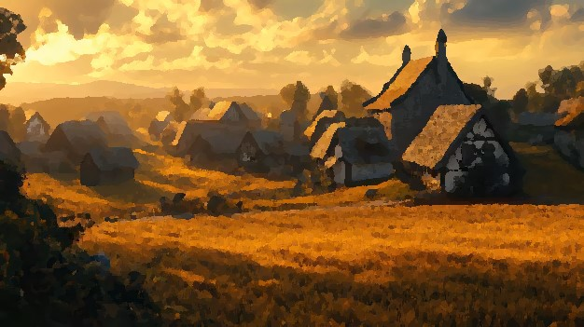
Between the Guarded Forest to the south and the snow-cloaked boreal wilderness to the north, and between the Seareach River and Lake Heron to the east and the forbidding Night Country to the west, are found the central lands of Aedun called Durany. This is a land of rolling hills with grassy meadows and light forests, interspersed with occasional wetlands. Small lakes and streams are common, and the region is dotted with small villages and farmsteads. Summers are hot, winters are cold. The region is typically snow covered for most of the winter.
Durany is populated almost entirely by humans. Pale skin and dark hair are common. Men wear their hair cut short while women usually wear their hair long.

Durany is a kingdom governed with a rigid feudal system and dominated by a handful of noble families.
The Durans
The Durans are the leading royal family and maintain powerful estates in and around the capital Denburg. A black mace on a yellow field is their insignia.
The Taivans
The Taivan have most of their land holdings in the southeast portion of Durany and have grown rich by leveraging trading interests between Durany, Haven, and Stoneport. Their symbol is an eagle on an orange field.
The LeClare
The LeClare lands lie to the North of Denburg where they manage large tracts of forest and farmland providing foodstuffs and lumber to the rest of the kingdom. A blue wand on a black field is the sign of LeClare.
The Mullers
Muller is a family famous for its warriors. Their land holdings lie to the south of Denburg and border upon the Guarded Forest.
The Beskers
Like the Mullers, their neighbors to the east, the Beskers are renowned fighters. The Beskers and their vassals defend the kingdom’s western border with the Night Country. They have no device; their flag is a simple black field.
The Negara
The Negara are a mercantile family with most of their lands east and south of Denburg stretching to the shores of Lake Heron. They have cultivated a rich shipping trade with Stoneport and with the Frost Dwarves of Iceland. The symbol for Negara is a silver net on a blue field.

Although the Old Gods are still honored by many in the farm holds and small villages of Durany, Ayat the Light Bringer is worshipped most commonly, especially in the larger villages and towns. With many devout worshippers in the kingdom, amongst both commoners and nobility, the priesthood of Ayat in Durany is a powerful political force. After the Invasion of the Ungartten, church doctrine regards all non-humans, including elves, dwarves, gnomes, and the dragonborn as impure beings not to be tolerated. Most non-humans that once lived in Durany have either been driven from the country, enslaved, or killed. This church doctrine, together with Durany’s recent interest in empire building has made relations with the Guarded Forest and Stoneport very tense.

The Elderwood
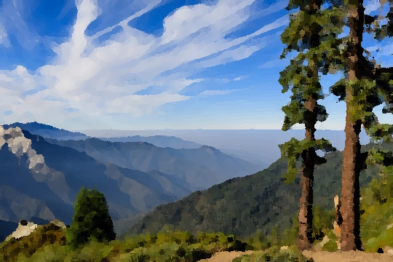
The Elderwood does not have a precise border but is generally considered to consist of the deeply forested lands west of Skye and the North Road. The forests North of the Gray River are mostly flat or gently rolling hills punctuated by deep ravines containing small streams feeding into the river. All of this land is thickly forested with mixed hard and soft woods. South of the Gray and entering the Seven Rivers region, the land rises steadily entering a country dominated by high hills and ridges which grow in height and are topped with rocky crags as one enters the foothills of the High Watch mountains. The country is drier in the higher regions of the forest as it climbs above the fog and mists which are frequent near the river valley. The oak, maple, elm, and willow of the lowlands give way to aspen and towering pine trees as one enters the highlands.
The deep valley where the Seven Rivers flow, at the foot of the High Watch Mountains, is known as the Deep Elder and is a unique environment where the fabled Medras and Lyra trees are to be found. The Medras are towering, smooth-barked, giants, which may grow up to three hundred feet tall and are notable for their unique, broad-leafed, but evergreen foliage which forms a thick canopy high above the forest floor. The Medras blanket much of the lower Seven Rivers region and are said to guard the region from unwholesome influence. At the higher elevations, as the land rises into high ridges, the Medras give way to Lyra trees which have a rough bronze-colored bark and light green leaves changing to gold in autumn which fall in the spring as they are replaced with new leaves. The High Elves of the region revere the Lyra trees and attribute them with powerful healing and regenerative properties.
The Elderwood is sparsely populated. North of the Gray River, humans mingle with the Treesong (Assoma) clan of High Elves and with families of gnomes that have fled in recent years from Durany. South of the Gray River is the country of the reclusive Brightleaf (Lorreshem) High Elves.
The people of the Elderwood worship the Old Ones and generally hold great reverence for the natural world. They are independent-minded people but have joined with Skye and the people of the Guarded Forest to form a republic for mutual defense from incursions from the Night Country and recent aggression from Durany.

The Great Deep
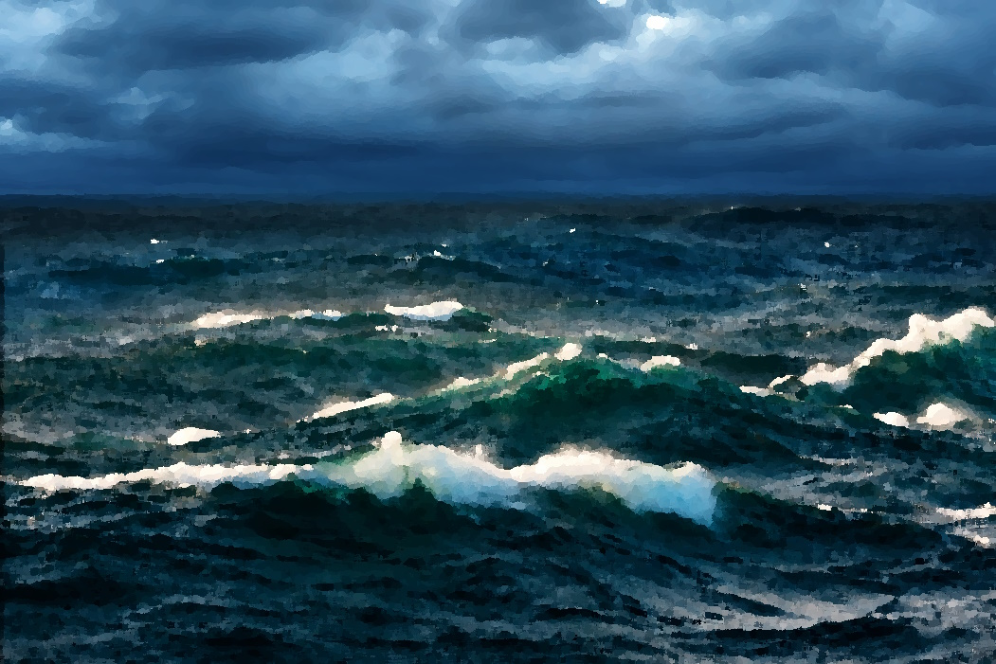
The Great Deep is the name the Aeduni have for the vast ocean south of their country. The Aeduni are not a sea-faring people and do not venture far from shore. There are myths and legends of exotic cultures inhabiting far shores but also stories of leviathans from the deep attacking ships which venture too far out to sea and dragging sailors down to a watery grave. The people of Haven fish the sea near the mouth of the Seareach river and there is some sea-going trade along the coast as far south and west as Zhendohar. Only the dragonborn of the Dragon Isles venture across the Great Deep out of sight of land.

Greenvale and Cormar
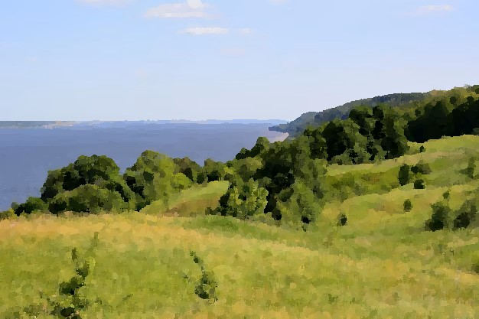
The hill country wedged between the Dead Pools and the High Watch Mountains to east and west, and the Guarded Forest and the Great Deep to the north and south is known as Greenvale and is the homeland of the halflings of Aedun. It is a region that is difficult to get to for travelers. The dwarves of the High Watch are on good terms with the halflings of Greenvale and guard the switch-backed mountain trails leading to Greenvale from the west. Likewise, the wood-elves of the Guarded Forest keep careful watch along their secret ways to Greenvale from the north. Both the elves and the dwarves are staunch allies of the halflings and maintain a protective border around Greenvale. Visitors to Greenvale describe it as a land of gentle hills and light forest interspersed with small farms and villages. The halflings of Greenvale are a welcoming people, hungry for news of the wider realm and renowned for their fine ales, food, and hospitality.
The seaward approaches to Greenvale too are guarded by perhaps the most unusual of alliances, that between the halflings of Greenvale and the semi-piratical community of Deal on the island of Cormar. The residents of the island of Cormar are of many races. Humans, elves, dwarves, halflings, tieflings, and half-orcs all mingle and work together freely. More half-orcs are found in Cormar than anywhere else in Aedun. The buccaneers of Cormar will attempt to “tax” any and all vessels that sail within their reach upon the Great Deep but rely on Greenvale for a reliable trade in common foodstuffs and other commodities. By all accounts the free-booters of Cormar have a great affection for the “little folk” of Greenvale. And for their part, the briar halflings of Greenvale regard the questionable providence of goods from Cormar with only a wink and a knowing nod.

Haven
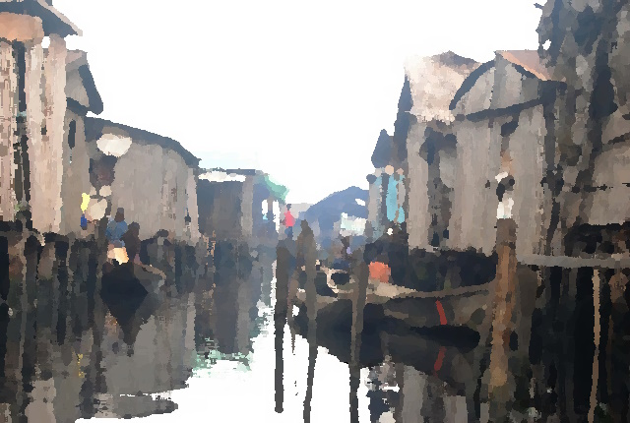
The ancient port city of Haven is situated on the banks of the Seareach river, near its mouth where its broad delta empties into the Great Deep. It is surrounded on three sides by marshlands and on the fourth by brackish water where the Seareach River mingles with the tidal waters of the Great Deep. To the west are the murky labyrinths of the Dead Pools and to the east the marshland wilderness known as the Sea of Reeds.

Haven is very hot and humid from late spring through early autumn until the rainy season arrives, typically around the fifth reign in autumn. The rains usually last through the first half of the winter season. Haven is occasionally lashed by hurricanes with flooding during the rainy season. During the coldest part of the winter, sleet is common and even snow is not unheard of. The end of the winter season and the beginning of spring are easily the most pleasant times to visit Haven when everything seems to blossom, and Haven appears as a lush tropical garden.
The wetlands immediately surrounding Haven are largely cultivated with rice or fish farms organized into large plantations controlled by the old noble families of Haven; Tieflings that have controlled the city for all recorded history. The sea within a day’s sail is also fished extensively.

Haven is by far the largest city in Aedun. The city walls, the seawall protecting its harbor, and some of the central towers of the city are made of an unknown material. It is not known who created these mysterious constructs and, made without seams or fasteners, how they were constructed. They apparently pre-date the Long Night. Over time, the more mundane wooden piles supporting many of the buildings, wooden streets, and walkways of the city sink or rot away causing portions of the city to flood at high tide. As this happens, new buildings and streets are built atop the old forming a multi-level maze of twisting streets and alleyways. The wealthier citizens have their residences and businesses on the top levels, while the poor contend with tides and the darkness in the lower levels of the city.

All the races of Aedun can be found in Haven but the Tieflings are the original, or at least, the oldest inhabitants. They make up the largest segment of the population and control most of the noble houses of Haven. The governance of the city can be chaotic and haphazard. The thirteen major noble houses of the city compete for resources and influence, each controlling a portion of the city and specific industries or trades. Their conflicts usually do not escalate into open warfare but there are frequent assassination attempts and other forms of covert political violence. Here are the thirteen noble houses of Haven with their house colors and sigil:

Elahime - Green gondola on maroon
Ezharion - White heron on maroon
Hona - Olive rat on maroon
Kai - Blue lizard on white
Kenric - Black fly on white
Kessel - Red spider on white
Lithen - Brass frog on turquoise
Marik - White centipede on turquoise
Morotai - Brown vulture on turquoise
Penochi - Copper butterfly on brown
Sarma - Blue raven on brown
Wikken - Blue cattail on gold
Yuzo - White alligator on gold

Lake Heron
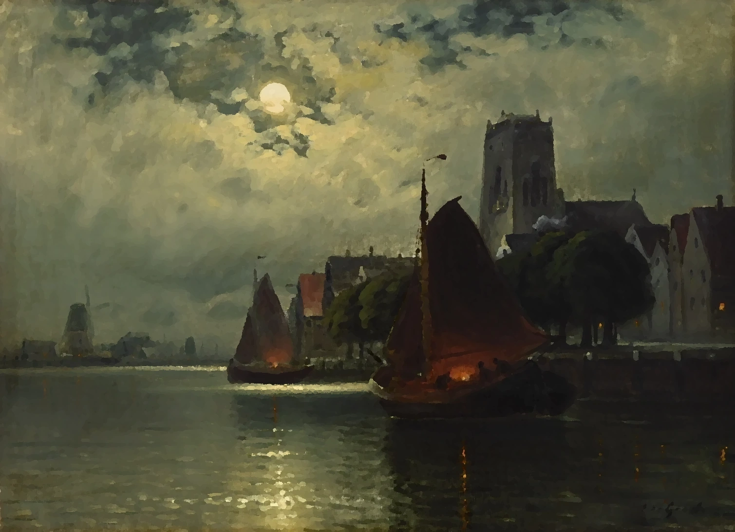
Lake Heron is a very large freshwater lake situated in the northeast region of Aedun. The north shore of Lake Heron laps against the base of the vast northern glacier that covers much of the extreme north. The portion of the glacier and highlands that tower over the lake is called Iceland and is where the Frost Dwarves have carved out their mines and homes in the rocky peaks slowly emerging from the retreating glacier. The mines of the Frost Dwarves are rich in ore and precious gems, and they have developed a lucrative trade with the Negara of Durany and with the Shanes of Stoneport. The Negarans are found along the western shore of Lake Heron, a region considered to belong to Durany, in the towns of Bainebridge and Lakari and other smaller villages to the north. Stoneport is the Shane’s impregnable fortress city perched on the south shore of the lake, not far from where the Seareach river starts its flow from Lake Heron to the sea. Stoneport is a bustling port city and a trade hub, and for the Shanes living in the hillside communities on the south shore of Lake Heron, its fortified walls and harbor is a refuge in times of war. The eastern shores of Lake Heron are, for the most part, rocky and forbidding. The land here is a deeply wooded wilderness with many swift, icy rivers, often streaming over cliffs in tall waterfalls into the lake waters below. This sparsely populated region is home to the Bear tribe of the Ambersea. Much of the lake freezes in the winter season enabling trade over the ice by sled. But shifting winds can cause the ice to break up suddenly so most wary travelers stay near to shore.

The High Watch Mountains

The High Watch are an imposing range of mountains that begin in unexplored regions far to the west of Aedun and stretch in a long arc eastward dividing, as a high wall, the rich green lands of the Elderwood and the Guarded Forest in the north from the desiccated barrens of the White Waste to the south, until they end abruptly in high cliffs where they meet the Great Deep.
The High Watch are home to the four clans of the Mountain Dwarves: Highrock, Stonemight, Craghold, and Earthward.

Iceland
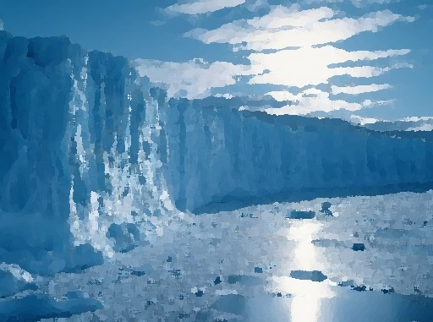
In the northeast of Aedun, north of Lake Heron, a massive glacier standing thousands of feet high is slowly receding revealing in its wake the black granite peaks of a forgotten mountain range. This region is known as Iceland and is the home of the Frost Dwarves. The dwarves here are distant relations to the dwarven clans of the High Watch Mountains, far to the south and west, but were sundered from their kinsman during the eons of the Long Night when ice and darkness covered all of Aedun. The Frost Dwarves are well-adapted to the extreme cold of the region but have also exploited secret hot spring locations in the mountains where they are rumored to grow food crops using ingenious growing houses.

The Night Country
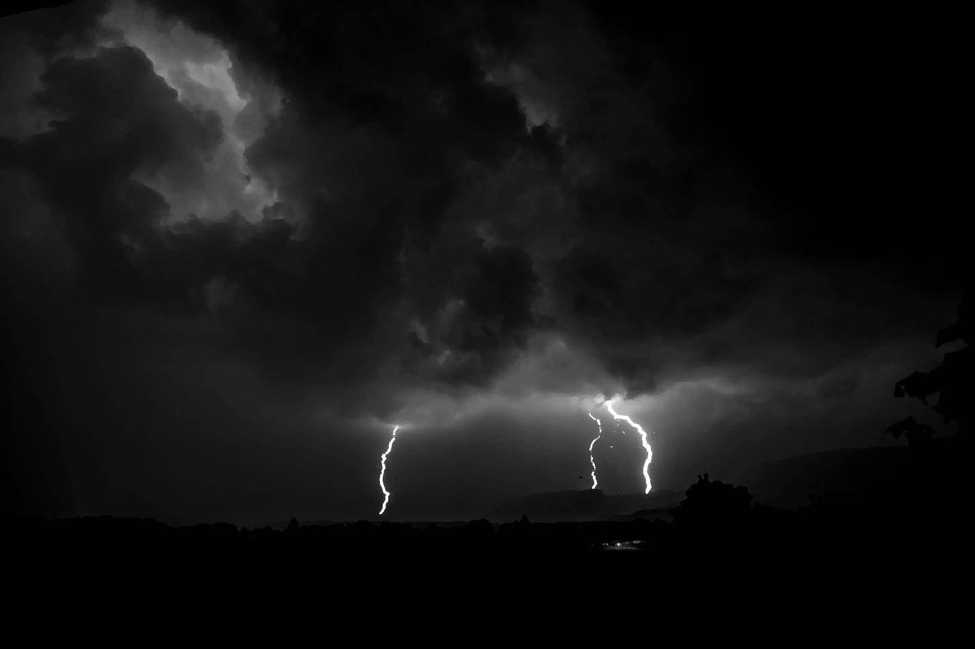
Little is really known of the dreadful lands to the west of Durany known as the Night Country. The region, whose borders shift and change over time, is perpetually blanketed in thick, roiling clouds casting the land into a deep twilight interrupted only by powerful electrical storms that arc across the sky or strike the ground, briefly illuminating the grim landscape. Sparse grasses and a few scrubby trees struggle to survive in these harsh conditions. Some say that powerful volcanoes far to the west spew ash into the air and are the cause of the long darkness here, others remember the Long Night and claim supernatural, diabolic forces are at work.
It is known that the loathsome, malformed beings known as Ungartten emerge occasionally from the Night Country to plague surrounding lands. The Durans have built a system of watch towers near to where the Night Country starts to guard against solitary Ungartten that wander out of the darkness and to send swift riders to sound the alarm in the event of a larger incursion.

Skye and the Guarded Forest
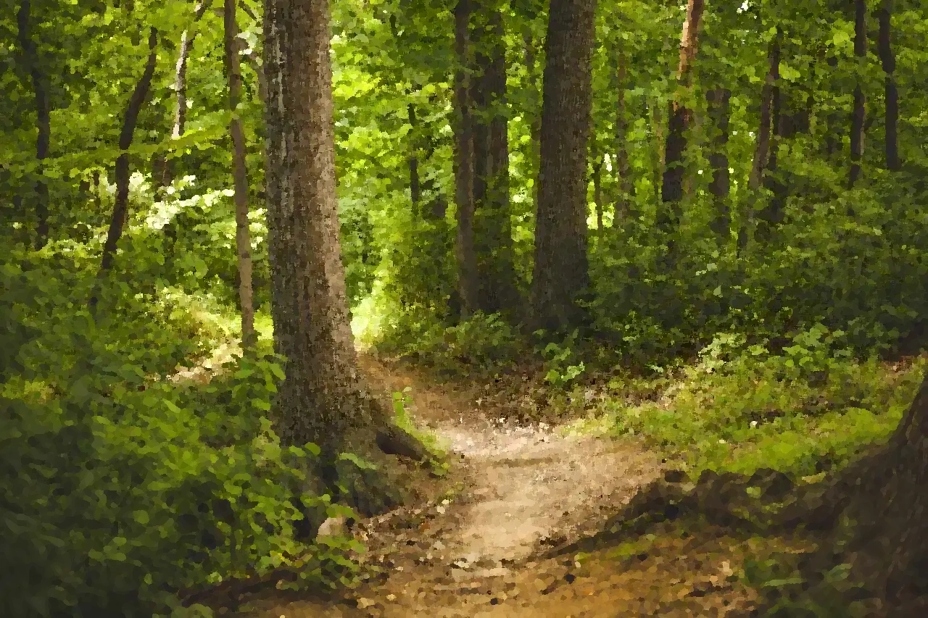
With the Elderwood to the west and the plains of Durany to the north, the Guarded Forest stretches from the city of Skye and the north road leading to Durany in a long arc to the east and south, blanketing the foothills of the High Watch Mountains and coming to a gradual end where the trees give way to the dismal, fetid swamplands of the Dead Pools. It is a vast wooded region, with many oak, maple, and ash hardwoods at lower elevations, giving way to aspen and pine in higher elevations closer to the mountains. In the broad river valleys of the Redwater and the Gray River, willows and cottonwood are common and as the land drops away to wetlands in the east, many large cypress trees are found.
The Gray River is broad in most places, deep, clear, and cold. Extensive river traffic flows between Skye and communities downstream. The Redwater, a shallower river, slower moving, and tinged red from its clay banks is still navigable far into the depths of the forest. Snowfalls are common in the winter months with heavy accumulation common in the higher altitudes. The southeastern regions of the forest encompassing the Redwater valley is milder, and snow here is uncommon.
In addition to the large town of Skye there are several smaller independent communities of humans, wood elves, dwarves, halflings, and gnomes. Skye is considered the capital city and is where the seven clans representing all of the communities gather to make important decisions. Here are the names, sigils, and areas of influence of the clans in the Guarded Forest:
Tombe - Skye (emerald dragon on olive field)
Ravain - Sender’s Watch (black raven on olive field)
Aruchai - Rainy Castle (centaur on gold)
Winhome - Bending Hold (wolf on gold)
Hiltmark - Tarn Hold (stag on gold)
Kelen - Woodhall (lynx on gold)
Mhoram - Grimm’s Retreat (bear on gold)

Stoneport
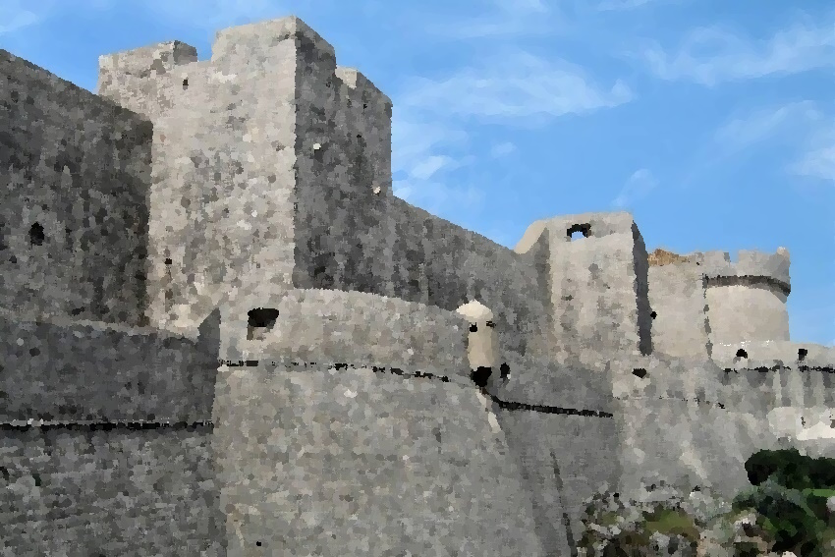
Stoneport is the heavily fortified, walled harbor town of the Shanes on the south shore of Lake Heron. Stoneport is populated mostly by humans, but some dwarves also make their home here. Stoneport is a city state that is governed as a republic by citizens owning shares in the large mercantile enterprises based in the city. The city controls most of the hill country on the south shore of Lake Heron as well as the upper portions of the Seareach river valley. Stoneport's small navy patrols both the river and the lake.

The White Waste

The White Waste is the name of the vast desert land south of the High Watch Mountains. This desert is largely unexplored and its extent to the south and west is unknown except perhaps by its native inhabitants, the Drow or Dark Elves.
The Drow here are superbly adapted to the extreme heat and dryness of the landscape and are said to have well-hidden encampments at secret oases. The Drow have very limited contact with the other people of Aedun. The Tieflings of Zhendohar have made some contact and have established a guarded relationship with the Drow who still occasionally raid caravans that venture too far from the city.

Zhendohar
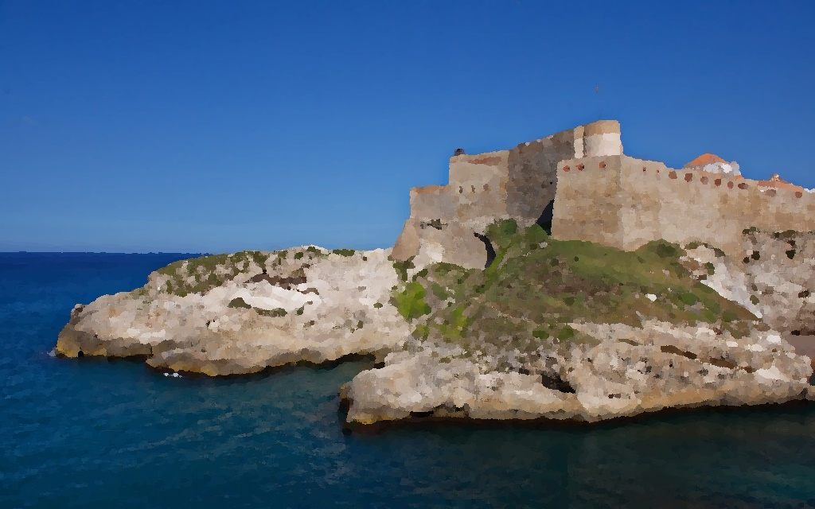
When House Fallon was exiled and driven out of Haven, the still rich noble family established a fortified outpost town on the coast of the Great Deep far to the west of Haven on the edge of the White Waste. The town is still controlled by house Fallon and has a mixed population with tieflings, humans, and half-orcs forming the largest racial groups. Zhendohar trades overland with the desert-dwelling Drow and by sea with the Dragon Isles, Cormar, and Haven.

The Races of Aedun
The nomadic tribesman of the Ambersea refer to themselves and the other races of people they’ve encountered and conversed with as the uqallak maji, the Talking Animals. Aedun is home to nine such races of beings and while humans are the most common overall, the makeup of the population varies widely by region.

Dwarves
The dwarves are thought to have inhabited the lands of Aedun from times long before even they themselves have record. The time of the Long Night divided the clans and drove them from the plains and forests to their mountain strongholds in the High Watch Mountains and to the icy crags far to the north in the Icelands. There are today three subraces of dwarves in Aedun.

Hill Dwarves
Hill dwarves make their homes in the foothills, both north and south of the High Watch Mountains. They are known to travel widely, often driven by an entrepreneurial spirit to establish new trade partnerships or to hire out their skills as highly paid masons and builders. When away from home they often travel in bands of twenty or more and may settle for a season in temporary encampments before moving on. The Stonemight clan is a prominent clan of hill dwarves with territories in the hills above the Guarded Forest and adjacent to Greenvale. South of the mountains, where the hills gradually descend to the wide desert pans of the White Waste, are found the territories of the Earthward clan of hill dwarves.
Male names: Abbán, Áedán, Berach, Broccán, Cainnech, Cóem, Declán, Diarmait, Eógan, Finnbarr, Gallcobar, Iarlaithe, Lochlainn, Máedóc, Nuadu, Odrán, Rúadán, Senán, Túathal, Ultán
Female names: Áednat, Aíbinn, Bébinn, Brigit, Cáelfind, Ciar, Damnat, Derbáil, Eithne, Étaín, Fedelm, Flann, Gormlaith, Íte, Luigsech, Mairenn, Órlaith, Rathnat, Síthmaith, Tuileflaith

Mountain Dwarves
The High Watch Mountains are home to the mountain dwarves, and they are seldom seen outside their alpine realm. The Highrock clan of dwarves hold territory in the mountains south of Skye while the Craghold clan is a prominent clan whose territories lie in the mountains further to the north and west.
Male names: Agni, Brandr, Dagfinnr, Egill, Fróði, Geirmundr, Hálfdan, Ívarr, Jóarr, Ketill, Leifr, Mundi, Njáll, Oddbjǫrn, Ragnarr, Snorri, Tófi, Úlfr, Vragi, Yngvarr
Female names: Ása, Auðrhildr, Birna, Bóthildr, Dagrún, Edda, Fríða, Gunnhildr, Halla, Ingríðr, Jórunnr, Katla, Málmfríðr, Oddrún, Ragna, Sigrún, Tófa, Unnr, Vígdís, Yrsa

Frost Dwarves
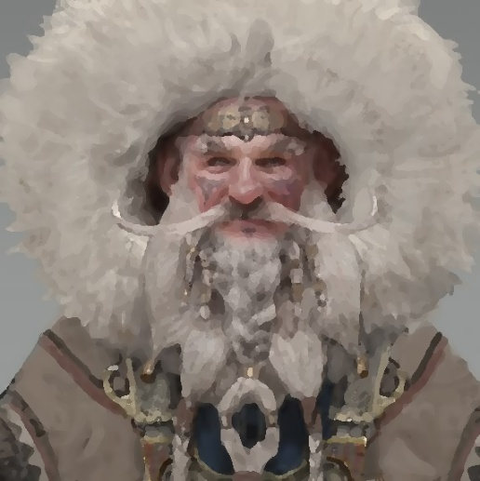 | Ability Score Increase. Strength score increases by 1.  Dwarven Survival. +5 bonus to Medicine and Survival checks.  Languages. Ruic (dwarven), Common

Far to the north, in Iceland, are found the Frost Dwarves. Notable for their strength and incredible hardiness in cold weather, they are known to journey across Lake Heron as far south as Stoneport and are the only dwarves known to ever travel by boat.
Male names: Aapo, Benjamin, Daniel, Eero, Frans, Hannu, Ismo, Jalo, Kaj, Launo, Marko, Niclas, Oiva, Panu, Raimo, Sami, Tahvo, Ukko, Valdemar, Yrjö
Female names: Anja, Aura, Brita, Cecilia, Eeva, Fredrika, Hanna, Ida, Jaana, Kaija, Lahja, Maarika, Nea, Oona, Pihla, Rauni, Seela, Taika, Ulla, Viivi

Elves
Like the dwarves, the elves have inhabited Aedun since time immemorial. Once, the elves roamed freely across all of the wide lands of Aedun. But it is said that when the Long Night came the families of elves became scattered and forced to retreat to hidden woodland enclaves, remote desert oasis, or far distant steppes and became estranged from one another. There are three subraces of elves in Aedun

High Elves
When the Long Night drew its dark curtain over the lands of Aedun, some elves retreated to the remote wooded highland of the Elderwood and found sanctuary under the arcane protection of the Noble Medras trees. These elves became known as High Elves. The high elves are a reclusive race and are seldom encountered in large numbers outside of the Elderwood. They sometimes venture into the High Watch mountains where they partner with Craghold dwarves to defend the western mountains and forests where they approach the borders of the Night Country and they can also be seen at times in the Guarded Forest where they come to visit their wood elf cousins and certain clans of humans with whom they are on friendly terms.
Languages. Incanta (high elvish) and common.
Male names: Adad, Anu, Baal, Bel, Dagan, Dumuzid, Elagabalus, Enki, Hadad, Ishkur, Lugalbanda, Mot, Nabu, Ninurta, Pumay, Shamash, Tammuz, Utu, Yam, Zababa
Female names: Anatu, Asherah, Ashtoreth, Aya, Bau, Cybele, Ereshkigal, Gula, Inanna, Ki, Kybele, Lilith, Nanaya, Ninisina, Ningal, Ninsumun, Nuha, Shamis, Tanis, Tanith

Wood Elves
Wood elves make their home in the Guarded Forest. Like high elves, wood elves (perhaps due to their long life span) can seem to other races to be remote and possessed of an unearthly calm. But where the high elves tend to be reclusive, living separately from other races, the wood elves live in close partnership with the humans and other races who also make their homes in the Guarded Forest. They are respected as fierce protectors of the woodland realm and actively participate in the federation of peoples that govern and defend this region.
Languages. Sylvan (wood elvish) and common.
Male names: Ayele, Bekele, Berhanu, Dejen, Desta, Ermias, Eskender, Eyob, Haile, Henok, Jemal, Kebede, Lishan, Sisay, Tadesse, Tafari, Tariku, Tamrat, Workneh, Yishak
Female names: Abeba, Aberash, Alemayehu, Almaz, Berhane, Desta, Etenesh, Haregewoin, Hiwot, Kidist, Konjit, Lishan, Lulit, Meklit, Sara, Seble, Selamawit, Werknesh, Worknesh, Yewubdar

Dark Elves
To most who live in Aedun, the mysterious dark elves of the White Waste are a people known only by myth and legend. It is said that before the time of the Long Night, the land of the drow was a rich forestland, similar to the Elderwood north of the High Watch Mountains and that the drow roamed and tended these woodlands much as the high elves tend their forest today. But, as described in the old tales, the forests of this region were destroyed by the darkness of the Long Night, and the land gradually became the parched, windswept desert that it is today. Rather than abandon their homeland, the elves adapted. They are said to have discovered secret oases, carefully guarded, where life-giving water can still be found. They became a nocturnal people, learning to hunt and gather food only at night to avoid the terrible heat of the day. Few outsiders have dealings with the dark elves. The Earthward clan of hill dwarves are said to have guarded exchanges with the drow in the foothills at the northern edge of the waste. And in the city of Zhendohar, perched on its great cliffs overlooking the Great Deep, upon the eastern edge of the White Waste, the drow sometimes call upon the tiefling lords of the city on secret errands in the dead of night.
Languages. Drow (dark elvish) and common.
Names (male or female): Alinafe, Chimwemwe, Dumisani, Enzokuhle, Farai, Ganizani, Itumeleng, Jabulani, Kefilwe, Lesego, Mandla, Onalerona, Pilirani, Refilwe, Sekani, Takondwa, Unathi, Xolani, Yamikani, Zikomo

Dawn Elves
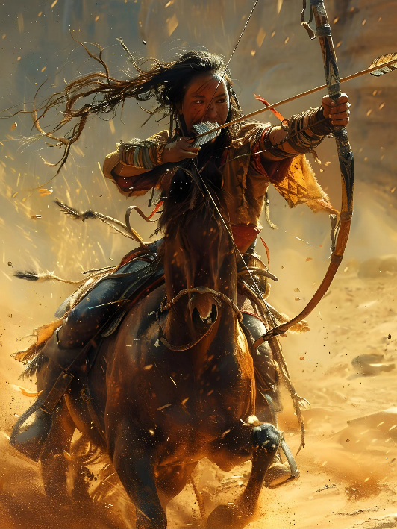 | Ability Score Increase. Strength score increases by 1.  Dawn Elf Weapon Training. Proficiency with the war pick, scimitar, longbow, and shortbow.  Animal Kinship. +5 to Animal Handling skill checks.  Dawn Elf Horsemanship. Mount or dismount with no movement cost and gain advantage on any effect that might cause the rider to be dismounted.  Languages. Wullah (dawn elvish), Common
Male names: Ashkii, Baishan, Cuauhtémoc, Dasoda-hae, Eluney, Goyaałé, Hokolesqua, Itzamna, Kenojuak, Lef-Traru, Ma'tano, Nehuén, Ojigkwanong, Pachakutiq, Quanah, Shikoba, Tahlako, Ujaraq, Wawatam, Yuraq
Female names: Anangikwe, Calfuray, Galilahi, Hauzini, Iara, Jacira, Kawisenhawe, Maiara, Naira, Pipaluk, Qinnuajuaq, Rayen, Sayen, Tashina, Ulloriaq, Vanaheo'o, Walela, Xiadani, Yara, Zyanya
Far to the east, amongst the grass and steppe lands of the deep Ambersea live a subrace of elves known as the dawn elves. Like their brethren in the forests of the west, the dawn elves are a long-lived race that have a sacred affinity with the natural world. But where other elves are aloof and reserved, the dawn elves are a warm and gregarious people. They delight in storytelling and in feats of skill involving athletics and horsemanship and while still slender by human standards, they are more sturdily built than other subraces of elves. They are seldom found west of the Seareach river for they have a deep and abiding love of the open grasslands and steppe of the Ambersea.and are known to be great travelers, returning to the western Ambersea with exotic tales of the far east.

Halflings
The blight to the land of Aedun brought on by the Long Night is said to have been especially devastating to the halfling race. Halfling lore, passed down in story form from generation to generation, tells that the halflings were almost completely erased from Aedun during this time, but that luckily a few families, with help from the dwarves and elves, were able to find refuge in caverns beneath the High Watch Mountains. When the Long Night passed, the halflings ventured out again and discovered the sheltered meadows and forested hillsides of Greenvale overlooking the Great Deep, now known as the land of the halflings. There are three subraces of halflings in Aedun.

Lightfoot Halflings
Lightfoot Halflings tend to be olive-skinned and of a more slender build than other halflings. There are several small villages of lighfoot halflings in the Guarded Forest, south of the Redwater, and in the northern reaches of Greenvale. They are on friendly terms with the other inhabitants of the Guarded Forest and with the other halflings in Greenvale but seldom leave their small villages and farmsteads.
Languages. Common, Sylvan (wood elvish)
Male names: Alan, Brendan, Corentin, Deniel, Elouan, Erwan, Frañsez, Gwilherm, Herve, Hoel, Jodoc, Judikael, Kaourintin, Loïc, Mazhe, Per, Ronan, Tanguy, Winoc, Yann
Female names: Alana, Anna, Annaig, Annick, Enora, Frañseza, Gaëlle, Gwenn, Katarin, Katell, Maela, Mai, Maïwenn, Mari, Nolwenn, Oanez, Rozenn, Yanna, Yanick, Yannig

Stout Halflings
Stout halflings tend to be a touch shorter and more solidly built than other halflings. They also tend to have a darker skin tone, with brown hair and brown eyes most common. Like their lightfoot cousins, the stouts seldom leave their own country, which is the western Greenvale into the foothills of the High Watch Mountains. The stouts are famous for their hospitality and have close friendships with the other halflings of Greenvale and with the Stonemight clan of hill dwarves.
Languages. Common and Ruic (dwarven).
Male names: Abe, Age, Alle, Bent, Durk, Fedde, Fen, Friso, Gerrit, Hauke, Heiko, Japik, Joris, Klaes, Lourens, Pitter, Remme, Sjoerd. Tjaard, Wessel
Female names: Antje, Bet, Dieuwer, Dieuwke, Elke, Elske, Famke, Fenna, Ime, Inka, Jeltje, Jip, Mareike, Maria, Minke, Nienke, Nine, Sietske, Wiebke, Yfke

Briar Halflings
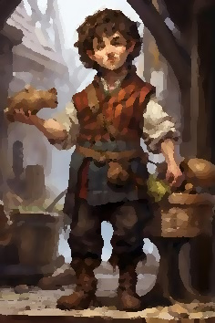 | Ability Score Increase. Intelligence score increases by 1.  Briar sense. +5 to Nature and Investigation checks. +5 on initiative rolls.  Languages. Common and either Sylvan (wood elvish) or Sea Bash.  Male names: Aodh, Aonghus, Bedivere, Beli, Conall, Culann, Dylan, Eoghan, Fergus, Gwydion, Heber, Kay, Llew, Macsen, Nechtan, Oscar, Pwyll, Sweeney, Taran, Uther  Female names: Áine, Aranrhod, Bébinn, Blodeuwedd, Brighid, Clíodhna, Deirdre, Doireann, Eithne, Feidhelm, Gwenhwyfar, Maeve, Matrona, Muirenn, Muirgen, Nessa, Olwen, Rhiannon, Sabia, Sionann

It is unclear whether briar halflings are a strict subrace of halflings, but they are most certainly a distinct cultural sub-group. In both dress and manner, briar halflings appear a bit “wilder” than other halflings. They tend to have dark hair and eyes like their cousins the stouts, and they are of a similar height, but they are slighter of build than stouts, more similar to lightfoot halflings in this regard. Where other halflings tend to establish themselves in one location, seldom travel far from their home, and inhabit villages where their family roots go back many generations, briar halflings typically live without a fixed abode and rarely stay in one location for longer than a season. Briar halflings are famous travelers and are well known for living out of their colorful and ramshackle covered wagons. Briar halflings are common in the southern Greenvale near the coast and in the eastern Greenvale where they tend the Eastern Hedge, a dense and tall briar hedge stretching in a long winding path along the last line of the rolling hills of Greenvale before the land descends to the dank marshlands of the Deadpools to the east.
Large extended families of briar halflings travel by caravan seasonally throughout Greenvale and the Guarded Forest and often venture by boat to Cormar and Haven and up the Seareach river as far as Stoneport on Lake Heron. Briar halflings have formed a close alliance and unlikely friendship with the tide orcs of Cormar. Like the stouts, briar halflings are a generous and hospitable people but they also have unusual views regarding personal property which cause many to keep them at arm’s length.

Humans
Humans are the most populous and commonly encountered race of people in Aedun. There are 5 ethnic sub-groups of humans in Aedun.

Duran
The rolling hills and farmlands of Durany are the homelands of the Duran people. They are of moderate height and build generally, with pale skin and brown or black hair. Eye color varies, but blue and brown are common.
Languages. Common.
Male names: Aaron, Bastian, Clemens, Dagobert, Eckart, Falk, Gerhold, Harald, Ingomar, Jakob, Karlmann, Manfred, Norbert, Ottmar, Poldi, Sepp, Till, Ulrich, Volker, Walter
Female names: Adele, Bianka, Carina, Daniela, Elise, Franka, Gerda, Heida, Inka, Janina, Kasimira, Larissa, Magdalena, Natascha, Renata, Sabine, Thea, Ursel, Valeska, Zenzi

Shane
The Shanes settled in the lands bordering the southern shores of Lake Heron. They tend to be taller and more heavily built than other humans. They often have blonde or red hair. Blue or brown eyes are common.
Languages. Common.
Male names: Aldus, Amis, Col, Daw, Elric, Firmin, Hamo, Hob, Ilbert, Jan, Law, Mack, Noll, Ode, Pate, Ranulf, Stace, Tenney, Wilkin, Wyot
Female names: Aldith, Aldreda, Amice, Amphelise, Diot, Dye, Eda, Etheldred, Ethelfleda, Hawise, Ibb, Jocosa, Kinborough, Malle, Matty, Meggy, Rohese, Rohesia, Royse, Wilmot

Tombe
The Tombes live in the lands of the Guarded Forest. They tend to have a taller, more slender build than other humans and have a tawny skin tone with brown or black hair. Blue, brown, green, and gray eye color are all common.
Languages. Sylvan (wood elvish), common.
Male names: Aled, Brynmor, Cadfael, Dai, Einion, Folant, Goronwy, Hywel, Iolyn, Leolin, Madoc, Nye, Owain, Pedr, Reece, Siorus, Taliesin, Vaughan, Wynn, Yorath
Female names: Aeronwen, Angharad, Branwen, Cadi, Cerys, Delyth, Efa, Eleri, Ffion, Gwyneth, Heledd, Llewela, Mari, Morwen, Nerys, Olwyn, Rhonwen, Siana, Tegwen, Winifred

Ravaine
Like the Tombe, the Ravaine people live largely within the bounds of the Guarded Forest. They are often of medium height and build with brown or blonde hair color. Brown or blue eyes are common.
Languages. Sylvan (wood elvish), common.
Male names: Agustí, August, Bonaventura, Climent, Daniel, Enric, Ferran, Gerard, Hèctor, Ignasi, Joan Pau, Lluc, Mateu, Nicolau, Oriol, Pere, Raül, Salvador, Víctor, Ximo
Female names: Abril, Blanca, Clara, Dàlia, Esperança, Francesca, Gemma, Helena, Iris, Jana, Lluïsa, Mar, Noèlia, Ona, Remei, Sònia, Txell, Valèria, Xènia, Zoè
Kaylish
In the Ambersea, the Wolf, Crow, and Otter tribes are all ethnic Kaylish. Kaylish are tall and slim with golden brown skin, dark hair, and eyes that are brown or hazel.
Languages. Wullah (dawn elvish), common.
Male names: Anaru, Ata, Hemi, Hohepa, Kaitoa, Kauri, Koa, Manaaki, Manu, Mikaere, Nīkau, Paora, Piripi, Rangi, Rāwiri, Tama, Te Ariki, Te Rangi, Tipene, Wiremu
Female names: Anahera, Aroha, Āwhina, Hine, Huhana, Kahurangi, Kiri, Kiwa, Mahina, Māia, Mere, Miriama, Ngaio, Ngaire, Nikora, Rangimārie, Ruiha, Tui, Waimarie, Whetū
Bindhu
The Coyote tribe, found most commonly in the eastern Ambersea, are ethnic Bindhu people. The Bindhu are slim with dark hair and brown or hazel eyes like the Kaylish but are slighter in build and have darker brown skin tones.
Languages. Wullah (dawn elvish), common.
Male names: Altan, Anar, Ankhbayar, Baatar, Batu, Bilgüün, Chingis, Dölgöön, Enkh, Erdem, Ganbaatar, Ganbold, Gantulga, Jargal, Naranbaatar, Nergüi, Otgonbayar, Temüülen, Tögöldör, Tömörbaatar
Female names: Altansarnai, Bolormaa, Bolortuyaa, Davaa, Enkhtuya, Erdene, Erdenechimeg, Gerel, Khulan, Maral, Mönkhzayaa, Narangerel, Narantsetseg, Odonchimeg, Odtsetseg, Sarantuya, Sarnai, Tsetseg, Uyanga, Zaya

Arathane
The Bear tribe of the Ambersea are ethnic Arathane. Arathane have a golden-brown skin tone and dark hair color similar to the Kaylish but tend to be taller and more powerfully built. Brown, hazel, and even golden eye color is common.
Languages. Wullah (dawn elvish), common.
Male names: Agron, Bashkim, Dren, Edmond, Festim, Gazmend, Hamit, Ismet, Jozef, Kostandin, Luan, Mehmet, Naser, Osman, Qemal, Roland, Skënder, Thoma, Vladimir, Zef
Female names: Agnesa, Bora, Dajana, Erjona, Flora, Gentiana, Hanife, Irena, Jehona, Klea, Lumturi, Manushaqe, Nadire, Pranvera, Ramize, Suada, Teuta, Valmira, Yllka, Zamira

An-chan
The An-chan are found in the city of Haven, in the surrounding plantations, and in small fishing villages in the Sea of Reeds. They are generally slight of build with olive or bronze skin tones, black hair, and brown eyes.
Languages. Common and either Gaizhan (tiefling) or Daymu.
Male names: Anh, Bảo, Bình, Cam, Công, Đạt, Đớc, Hạnh, Hào, Khôi, Lâm, Liêm, Minh, Nam, Phong, Quân, Sơn, Thanh, Văn, Xuân
Female names: Chi, Duyên, Hạnh, Huyền, Khôi, Kim, Liên, Mai, Nguyệt, Nhi, Phương, Quyên, Thi, Thu, Tiên, Trinh, Tuyến, Tuyết, Vi, Yên

Formari
The Formari people are found mostly in the cities of Haven and Zhendohar. They are often shorter and more broadly built than other humans with thick dark hair, dark eyes, and an olive skin tone.
Languages. Common and either Gaizhan (tiefling) or Daymu.
Male names: Abdelaziz, Abdellah, Abdessalam, Brahim, Djamel, Driss, Hédi, Hicham, Ismaïl, Jaouad, Kaïs, Messaoud, Mourad, Naïm, Oualid, Rayane, Salaheddine, Toufik, Youcef, Zinedine
Female names: Assia, Beya, Chaïma, Dounia, Essil, Fatiha, Hanane, Houda, Imane, Kenza, Kheira, Laïla, Maïssa, Mariem, Naïma, Oum, Rachida, Soumaya, Yamina, Zohra

Dragonborn
The dragonborn, natives of the Dragon Isles, are common visitors to the port cities and coastal regions of Aedun. While most dragonborn dislike being far from the sea for long periods, some dragonborn are passionate explorers. So, while dragonborn are uncommon in inland areas they are not unknown, even in very remote areas of Aedun.

Sea Drakken Dragonborn
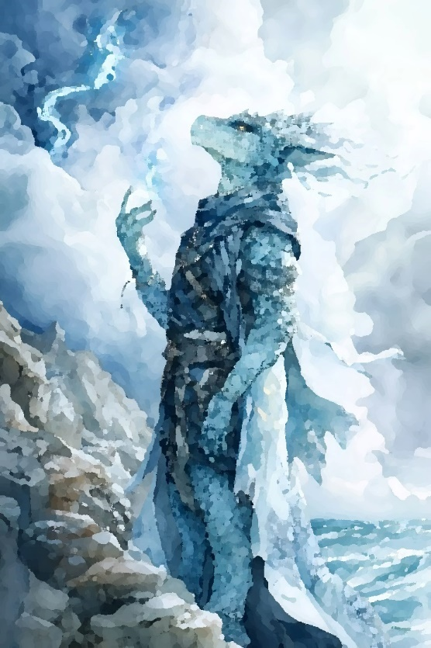 | Ability Score Increase. Strength score increases by 1. Constitution score increases by 2.  Bond of the Sea. May breathe underwater. Swimming speed equals walking speed.  Bite. Make an attack role adding your proficiency bonus plus either Strength or Dexterity bonus. Bite damage is 1d6 piercing, plus either Strength or Dexterity bonus.  Kiss of the Deep. Upon touching a willing creature, the creature gains 2d6 hit points and the dragonborn loses hit points equal to one half of the total. Alternatively, after a successful bite attack, the creature makes a constitution save (8 + Constitution modifier + proficiency bonus). Upon a failed save, the creature takes an additional 2d6 necrotic damage and the dragonborn regains one half of the total necrotic damage. Half-damage upon a successful save. Whether touching a willing creature or attacking a foe, the effect increases to 3d6 at 6th level, 4d6 at 11th level, and 5d6 at 16th level. After using Kiss of the Deep, it can’t be used again until after completing a short or long rest.
Languages. Draconic and common.
Male names: Byeong-ho, Dae-jung, Do-yun, Eun-woo, Gun-woo, Ha-joon, Hwan, I-jun, Il-seong, Jae-seong, Jeong-hun, Kun-woo, Kyung, Min-ho, Moon, Pyong-ho, Seo-jin, U-jin, Woo-jin, Yeong-hwan
Female names: Bo-ra, Chae-won, Chae-yeong, Da-eun, Du-ri, Eun-ji, Eun-jeong, Gyeong-hui, Gyeong-ja, Ha-na, Hyun-joo, I-seul, Ji-an, Ji-ho, Kyung-hee, Myeong, Na-ri, Sang, Un-ju, Ye-won
During adolescence, some dragonborn develop an especially strong affinity to the sea and mature with different characteristics from most other dragonborn. These special dragonborn are known as Sea Drakken. The cultural standing of sea drakken dragonborn varies greatly in different parts of the archipelago. Some islands consider sea drakken to be greatly auspicious and hold them in high regard, while on other islands, sea drakken are thought of as untouchable and are outcast.
Sea drakken dragonborn are generally smaller in stature and lack a breath weapon but are often capable of great feats of stamina. They can breathe water and are equally comfortable swimming in the water as walking or running on dry land. Most notably they have an ability called the Kiss of the Deep that can transfer vitality with a touch (or bite), either healing others at personal cost or draining health from others.

Gnomes
The plains of Durany are the ancestral homeland for most gnomes in Aedun. Until fairly recently, they were common there, especially in the rocky highlands north and west of the capital city of Denburg. But the gnomes of Durany were decimated in the Purge of Ayat and are now only very rarely encountered there, either as outlaws or slaves. Those who weren’t slain or enslaved in the first few bloody days of the purge were driven out of Durany. Many fled south to find refuge within the Guarded Forest. There are considered to be three sub-races of gnomes.

Forest gnomes
Of those gnomes who fled to the wooded fastnesses of the Guarded Forest, most are forest gnomes. The elves, humans, dwarves, and halflings who dwelt within the forest bounds greeted the gnomish refugees from Durany with open arms and the forest gnomes became full partners in the nurturing and defense of the forest domain. They live in small, hidden villages in the densest regions of the forest but maintain strong relationships with their neighbors and are generous hosts when called upon.
Languages. Sylvan (wood elvish), common.
Male names: Akachi, Amadi, Azubuike, Chibuzo, Chidike, Chinwendu, Ebuka, Ekwueme, Enyinnaya, Fumnanya, Ikechukwu, Ikenna, Kelechi, Nnamdi, Nonso, Obi, Okafor, Tochukwu, Udo, Uzochi
Female names: Adaeze, Adanna, Amara, Anuli, Chichi, Chidimma, Chinenye, Ebere, Fumnanya, Ifeoma, Ijeoma, Kelechi, Ngozi, Nkechi, Nkiru, Ogechi, Oluchi, Tochukwu, Ugochi, Uju

Rock gnomes
The purge of Ayat was disastrous for the rock gnomes. Since the forest gnomes tended to live in remote rural communities, they were not the first to be targeted and had more of an opportunity to escape. The rock gnomes of Durany typically made their homes within larger communities of humans where they often worked as skilled artisans. They were completely surprised by the purge, and most were either killed or enslaved in the first few days. Today, there are still rumored to be bands of rock gnomes living as outlaws in remote corners of Durany, but most are enslaved, sometimes working as masons or skilled craftsmen but much more commonly they are put to work in the mines.
Languages. Sylvan (wood elvish), common.
Names (male or female): Alinafe, Chifundo, Chisomo, Dalitso, Fatsani, Ganizani, Khumbo, Kondwani, Limbani, Limbikani, Madalitso, Mavuto, Mayeso, Pemphero, Pilirani, Takondwa, Thoko, Wongani, Yamikani, Zikomo

Shadow gnomes
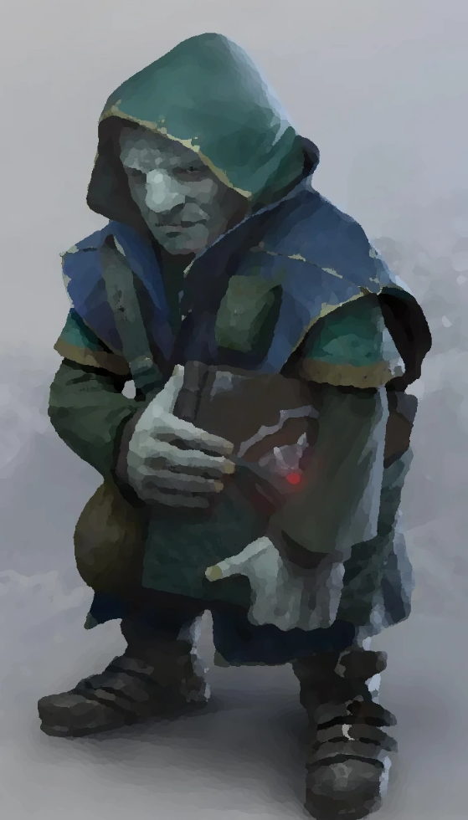 | Ability Score Increase. Wisdom score increases by 1.  Dark sense. +5 to Perception and Stealth checks.  Shadow walk. As an action, you may become invisible. The invisibility lasts until you attack or cast a spell. After using Shadow walk, it can’t be used again until after completing a short or long rest.  Languages. Shadow talk, common.  Names (male or female): Amogelang, Boitumelo, Itumeleng, Kabelo, Karabo, Kefilwe, Kgosi, Khumo, Lesedi, Lethabo, Modise, Neo, Onalerona, Refilwe, Tau, Tebogo, Thabang, Thabo, Tumelo, Tumisang

Gnomes are adaptable creatures. Some rock gnomes deprived of natural sunlight, growing to adulthood in the darkness of the mines, and conditioned to avoid others develop an uncanny knack for observation and stealth. These are called shadow gnomes. Shadow gnomes dislike bright light and loud noises and have developed a sign language for conversing with their fellows.

Half-Elves
Unions between elves and humans, while uncommon, happen often enough that the half-elven are considered a distinct race of Aedunaic people. The half-elven are most commonly found in the Guarded Forest where humans and elven communities have been cooperating closely for many years, but they can be found throughout Aedun.

Wayfarer half-elf
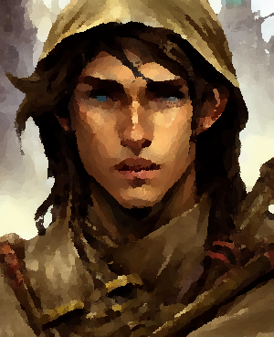 | Ability Score Increase. Wisdom score increases by 2, and two other ability scores of your choice increase by 1.  Darkvision. You can see in dim light within 60 feet as if it were bright daylight and in darkness as if it were dim light.  Fey ancestry. You have advantage on saving throws against being charmed, and magic can’t put you to sleep.  Wayfarer guise. Once per long rest, you can take an action to cast a minor illusion on yourself to appear fully human. The guise requires concentration and lasts one hour.  Wayfarer resolve. +5 to Insight and Survival checks.  Languages. Sylvan (wood elvish), Common, and one other language of your choice.
After the Purge of Ayat, the half-elven, like all other non-humans, were a persecuted race in Durany. An underground network of people sympathetic to the plight of non-humans in Durany, called Wayfarers, formed quickly and the half-elven community was central to this secret group. Where other half-elves tend to be demonstratively extroverted, center stage, wayfarer half-elves are more cautious and retiring, preferring to observe and guide others from the fringes. Wayfarer half-elves in Durany developed traits and skills distinct from their brethren in other parts of Aedun. They do not like to call attention to themselves and have a well-honed ability to disguise their appearance to pass for human.

Half-orcs
In the time of myths and legends, even before the Long Night, stories tell of powerful demi-gods at war with each other who bred tribes of orcs and savage humans to create the first half-orcs. Most half-orcs found in Aedun today are children of half-orcs. But in some far, remote regions, savage tribes of orcs raid human settlements. Half-orcs can be found in these regions both among the orc tribes and sometimes among the human settlers.

Tide orcs
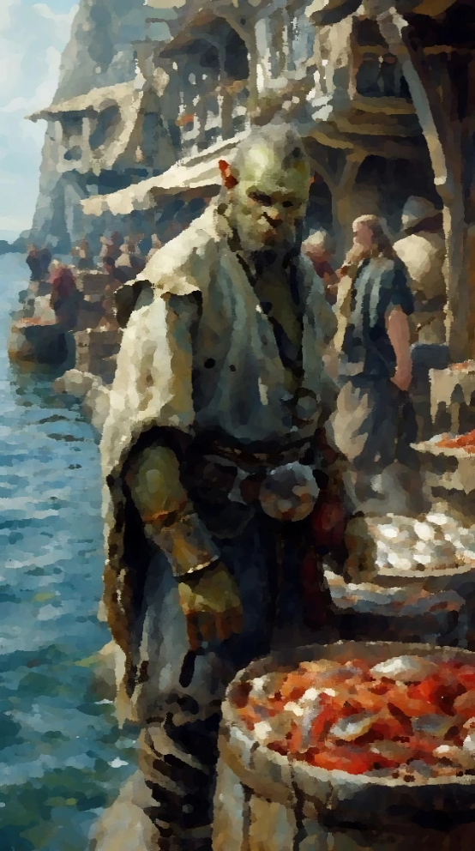 | Ability Score Increase. Strength score increases by 2, Dexterity increases by 1.  Darkvision. You can see in dim light within 60 feet as if it were bright daylight and in darkness as if it were dim light.  Tide orc agility. +5 bonus to Acrobatics checks.  Dirty fighter. After a successful melee attack, the target makes an opposed Dexterity check. On a failed check, the target takes an additional 2d6 weapon damage, half that on a successful check. The damage increases to 3d6 at 6th level, 4d6 at 11th level, and 5d6 at 16th level. This trait can be used once per encounter.  Languages. Sea Bash, common.

Male names: Amphon, Arthit, Arun, Kaeo, Kamon, Klahan, Kulap, Mongkut, Narong, Prasoet, Pricha, Sakchai, Sombat, Somchai, Somsak, Suchart, Suriya, Thaksin, Udom, Wichian
Female names: Amphon, Anong, Intira, Kanchana, Kanda, Kulap, Ladda, Lalita, Malee, Nittaya, Pakpao, Pranee, Ratree, Sasithorn, Sombat, Somboon, Sukanya, Sunan, Ubon, Wattana
Tide orcs are a variant race of half-orcs found most often in the coastal communities of Aedun: Zhendohar, Cormar, and Haven. The earliest accounts of tide orcs come from a time just before the end of the Long Night. Fisherman from Haven, sheltering from a storm behind the island of Cormar encountered a great flotilla of rafts constructed of storm-rack and what appeared to be the strangely wrought timbers and wreckage of much larger ships. On these rafts, half-starved and half-drowned were the tide orcs. These first tide orcs could not converse in the common tongue of Aedun, speaking only their own guttural language, unknown to others at the time. The question of their origin, conveyed through sketches, was answered only by shaken heads, vague pointing to the southwest, and warding gestures. The tide orcs settled first on the island of Cormar and on the mainland shores opposite the island where they met and were befriended by the briar halflings. Later many tide orcs migrated to Haven to serve as inexpensive labor and as mercenaries in the petty wars waged amongst the noble houses of Haven. When House Fallon was exiled to Zhendohar, the Fallons brought many half-orcs with them.
Since those earliest accounts, the tide orcs have thrived. They took the skills they learned as marines and mercenaries in Haven back to Cormar where they slowly built a small but potent pirate fleet based out of the freebooting city of Deal.
Tide orcs are often of a thinner build than other half-orcs and have darker skin with thick black or reddish hair. Extensive tattoos and piercings are common among tide orcs.

Tieflings
Most believe that tieflings are derived from human bloodlines infected long ago by some mysterious and infernal corruption. In Aedun, legends say that in the early days of the Long Night, the human citizens of Haven made a pact with one of the old powers in the earth: service for protection. The humans of Haven were altered in the bargain and became the race that is known as Nighthaunt Tieflings.

Night-haunt tieflings
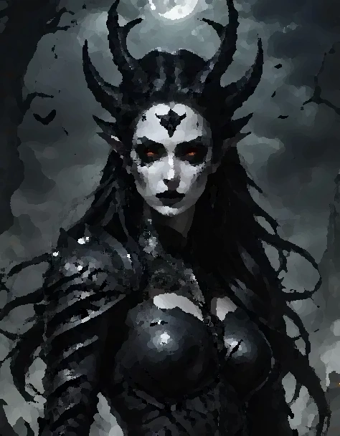 | Ability Score Increase. Wisdom score increases by 2, Dexterity increases by 1.  Darkvision. You can see in dim light within 60 feet as if it were bright daylight and in darkness as if it were dim light.  Necrotic resistance. You have resistance to necrotic damage.  Nighthaunt legacy. You know the Spare the Dying cantrip. When you reach 3rd level, you can cast Malignant Retort as a 2nd-level spell once with this trait and regain the ability to do so when you finish a long rest. When you reach 5th-level you can cast the Detect Thoughts spell once with this trait and regain the ability to do so when you finish a long rest. Wisdom is your spellcasting ability for these spells.
Languages. Gaizhan, Common
Male names: Acacius, Basilius, Callias, Demophon, Erastos, Galenos, Heraclius, Iason, Karpos, Lycurgus, Menander, Nicander, Onesimos, Paramonos, Serapion, Sosigenes, Telemachus, Tychon, Xanthos, Zeno
Female names: Antikleia, Aspasia, Berenike, Chariclea, Demetria, Epiktesis, Gaiana, Hypatia, Isidora, Kallisto, Lysandra, Menodora, Nike, Ophelia, Pelagia, Rhode, Soteria, Theokleia, Xanthippe, Zenais
Night-haunt tieflings are uncommon but are found in Haven and in Zhendohar and are very rare elsewhere in Aedun. Some of the noble houses of Haven are made up of night-haunt tieflings.
Night-haunt tieflings are physically like other tieflings in most aspects but have very white skin rather than the reddish tone common in other tieflings.

Variant classes and sub-classes of Aedun
All the core character classes from the player’s handbook are available to players. In addition, there are new variants or sub-classes of each of the core classes, specific to Aedun, that are available for play.

Barbarian: Path of the Beast
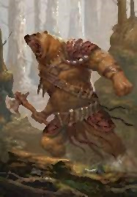 | In the Ambersea, warriors who display a ferocious battle frenzy in combat may be initiated into an ancient, primal tradition called the Path of the Beast. Initiates of this path, when entering a battle rage, physically transform into a frightening animal-human hybrid form. Wolf-human, bear-human, boar-human and other hybrid forms have all been reported. The fighter is initiated into this path by an older Path of the Beast warrior. The initiate’s animal-human hybrid form will be the same as the form of the initiating warrior. The Bear and Wolf tribes of the Ambersea each have a long history with the Path of the Beast and have a cadre of elite warriors who all assume a similar bear-human or wolf-human form respectively.

Beast form
Starting when you enter this path at 3rd level, you physically transform to an animal-hybrid form when entering a rage. When entering this form you gain the following benefits:
- 1d12 + Constitution modifier of temporary hit points which lasts while raging
- +1 bonus to your armor class
- As a bonus action, make an unarmed bite attack for 1d6 + Strength and Rage modifiers piercing damage

Beast sense
Beginning at 6th level, you gain the following additional benefits when in beast form:
- You have advantage on all Wisdom checks
- You gain darkvision. You can see in dim light within 60 feet as if it were bright daylight and in darkness as if it were dim light.

Beast agility
Beginning at 10th level you gain the following additional benefits when in beast form:
- Movement through non-magical difficult terrain costs you no extra movement
- You can move stealthily at a normal pace.
- Opponents have disadvantage on opportunity attacks
- You can take the Dash action as a bonus action

Blood sense
Beginning at 14th level you gain the following additional benefits when in beast form:
- You are aware of the location of creatures within 30 feet of you that you cannot see and attacking such a creature does not impose disadvantage
- After taking damage from a creature within 5 feet of you, you may use your reaction to make a bite attack.

Bard: College of Secrets
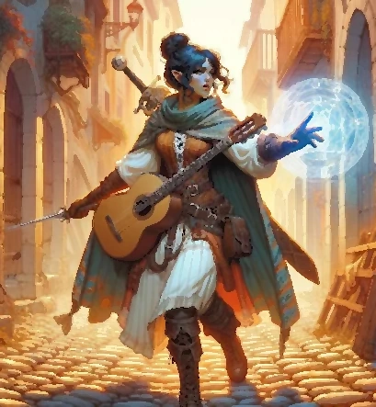 | The college of secrets is a clandestine organization rumored to be headquartered in the city of Skye in the Guarded Forest. The organization is made up of traveling bards, actors, and entertainers who lead a secret double life as political agents. They are active in helping non-humans to escape from Durany and in protecting the interests of the Guarded Forest from external forces of tyranny. When you join the College of Secrets, you are recruited by a handler and become part of a small cell with whom you meet from time to time in arranged, secret rendezvous.

Tradecraft
When you join the College of Secrets at 3rd level you gain the following benefits:
- The ability to read lips
- +5 bonus to Perception and Insight checks
- You can create written cyphers. Others can’t decipher a coded message you create unless you teach them, or magic is used to decipher the text.

Inspiring Word
Also at 3rd level, you gain the ability to use your wit, insight, and magic to inspire confidence and competence in others. When a creature within 60 feet, that can hear and understand you, makes an attack roll, an ability check, or a damage roll, you can use your reaction to expend one of your uses of Bardic Inspirations, rolling a Bardic Inspiration die and adding the number rolled to the creature’s roll. This feature can be used after the roll but before the DM has determined whether the attack roll or ability check has succeeded.

Spy craft
Starting at 6th level you gain the following additional abilities:
- You learn 3 languages of your choice
- +5 bonus to Deception and Performance checks
- You can mimic the speech of another person, or the sounds made by other creatures. You must have heard the person speaking for at least one minute. A successful Insight check contested by your Deception check allows a listener to identify the deception.

Vicious riposte
Starting at 14th level, when you are targeted by a melee attack you can use your reaction to cast the Vicious Mockery cantrip targeting the attacker.

Cleric: Shadow Domain
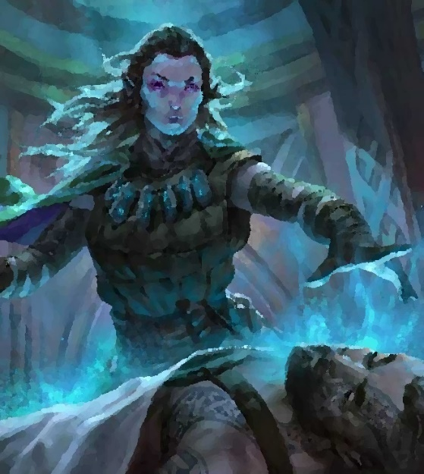 | The Shadow Domain focuses on the shadowy boundary between life and death. The gods associated with this domain may have evil intent or good but generally have influence over the migration of souls from the sunlit realm of life through the shadowy realm of death and on to whatever afterlife awaits the dying.

Shadow domain spells
Cleric Level | Spells
1st | armor of Agathys, inflict wounds
3rd | darkness, gentle repose
5th | animate dead, speak with dead
7th | blight, death ward
9th | antilife shell, raise dead

Shadow initiate
When you choose this domain at 1st level you gain the following:
- Proficiency with the Medicine skill
- +5 bonus to Medicine checks
- You know the Spare the dying cantrip

Shadow channeler
Beginning at 2nd level, you can use your Channel Divinity to draw the living closer to death’s door. Each hostile creature within 30 feet of you must make a Constitution saving throw. A creature takes necrotic damage equal to 2d10 + your cleric level on a failed saving throw and half as much on success. Creatures having total cover are not affected.

Shadow ward
Beginning at 6th level, you and creatures within 5 feet of you are resistant to necrotic damage.

Death strike
At 8th level, you gain the ability to infuse your weapon strikes with divine energy. Once on each of your turns when you hit a creature with a weapon attack, you can cause the attack to deal an extra 1d8 necrotic damage. When you reach 14th level, the extra damage increases to 2d8.

Reaper
At 17th level, as an action you can cast the Finger of death spell. Once used, this feature cannot be reused until after completing a long rest.

Druid: Circle of Fire
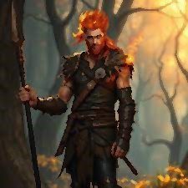 | The Circle of Fire is comprised of zealous defenders of the natural world who invoke the cleansing destruction of fire as a means of protecting the land from unnatural forces. Most druids of the Circle of Fire are found in the Ambersea and tend to lead a nomadic life but gather at sacred sites to celebrate the solstice with ritual ceremony and a massive bonfire.

Bonus cantrip
When you choose this circle at 2nd level, you gain the Produce flame cantrip.

Rage fire
Starting at 2nd level, when you are damaged by a creature you can see within 60 feet, you can use your reaction to cast Hellish rebuke as a 2nd level spell. Once you have used this feature, it cannot be used again until after completing a short or long rest.

Circle spells
Your elemental connection to fire grants you the ability to access certain spells. Once you gain access to a circle spell, you always have it prepared, and it doesn’t count against the number of spells you can prepare each day.
Druid Level | Circle Spells
3rd | flame blade, heat metal
5th | fireball, protection from energy (fire)
7th | fire shield, wall of fire
9th | conjure elemental (fire), flame strike

Quick fire
Starting at 6th level, when you attack with a melee weapon you may attack twice instead of once and your attacks count as magical.

Fire shape
At 10th level you can expend two uses of Wild Shape at the same time to transform into a fire elemental.

Cleansing fire
At 14th level, when you damage a creature as a result of your Rage fire reaction, you regain hit points equal to the creature’s damage.

Fighter: Warder
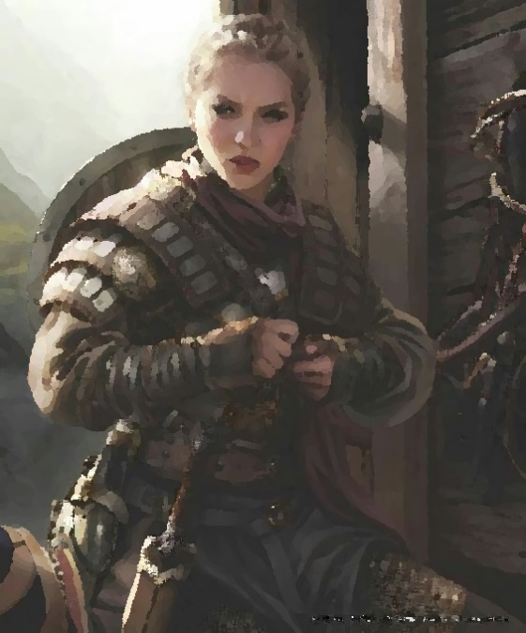 | At the end of the Long Night, the people of Aedun drove the ungartten back into the Night Country. But the ungartten are restless. Constant vigilance has been necessary at all points of the long western frontier of Aedun where it borders the Night Country. In this border country, the western front, corrosive magical energies emanating from the Night Country are in constant, invisible conflict with the Pattern and Channel magics created by gifted practitioners in Aedun to guard the sunlit realms. In this environment, certain soldiers seem to develop a sensitivity and a limited facility for magic and spell casting.
Such soldiers are trained to become Warders, also known as Field Mages. Warders, or Field Mages, are fighters first and foremost, but because of their sensitivity to magical energies have developed a limited form of casting focused on spells that are of practical use on the front: wards, guards, and healing magic. Warders lack the spellcasting range and power of clerics, wizards, and other true spellcasters. But there are very few of those gifted individuals and they are exceedingly rare on the front lines. Warders fill the gap on the battlefield when fighting against unnatural forces and provide much needed magical bolstering to those protecting the realms of Aedun.
Field mages typically do not understand or care how or why certain spells work, only that when rested and when certain words are spoken in conjunction with certain gestures involving runic symbols, a power can be sensed and invoked for specific effect. New warders are typically identified among the soldiery of the western front by more advanced warders who train them in the arts and teach them to make the iron or bronze runes required for warden spellcasting. Not every unit of soldiers on the front has a field mage. Those units who have value them highly.

Spellcasting
When you reach 3rd level, you gain the ability to cast the following cantrips: Blade ward, Mending, Resistance, and Spare the dying.
Also at 3rd level, you gain the ability to cast spells. You have only a limited number of spells of each level that you cast between long rests according to the table below.
Fighter Level | Spell level 1 | Spell level 2 | Spell level 3 | Spell level 4
3rd | 2 | - | - | -
4th | 3 | - | - | -
7th | 4 | 2 | - | -
10th | 4 | 3 | - | -
13th | 4 | 3 | 2 | -
16th | 4 | 3 | 3 | -
19th | 4 | 3 | 3 | 1

You draw from a limited pool of spells that warders, over the years, have learned to cast with the warder rune technique:
1st level warder spells: bless, cure wounds, detect evil and good, detect magic, detect poison and disease, healing word, identify*, magic missile, protection from evil and good, purify food and drink, sanctuary, shield, shield of faith
2nd level warder spells: aid, calm emotions, gentle repose, knock, lesser restoration, magic weapon, prayer of healing, protection from poison, warding bond*
3rd level warder spells: beacon of hope, counterspell, glyph of warding*, magic circle*, mass healing word, protection from energy, slow
4th level warder spells: arcane eye, locate creature
The spells above marked with * do not require the normal material components when cast by a warder but only the warder’s rune symbols.
Wisdom is your spellcasting ability, and you use your Wisdom modifier when setting the saving throw DC.
Spell save DC = 8 + your proficiency bonus + your Wisdom modifier
Spell attack modifier = your proficiency bonus + your Wisdom modifier

Warder initiate
At 3rd level, you choose one kind of creature, aberrations, celestials, dragons, elementals, fey, fiends, monstrosities, or undead and you gain the ability to cast Wards against those kinds of creatures. As an action, you present a rune of warding and speak a magical command naming the creature type. This creates a magical boundary that prevents the named kinds of creatures from approaching. Each creature of the type named in the ward that can see or hear you within 30 feet must make a Wisdom saving throw. If the creature fails to save, it is warded for 1 minute or until the creature takes melee damage from the warder. A warded creature cannot approach closer than 30 feet and if it starts its turn closer than 30 feet when warded it must spend its entire turn moving away if possible so that it is at least 30 feet away. The creature may make ranged attacks on subsequent turns. A warded creature that cannot move 30 feet away is considered incapacitated while warded. You must finish a short or long rest to use this capability again.

Warder acolyte
At 7th level you learn to ward a second kind of creature, and you can perform a ward twice between rests. Also, your wards become more potent. If a creature is warded and its challenge rating is at or below a certain threshold, as shown in the table below, the creature must spend all its turns while warded moving as far away from you as it can and if it can’t move further away it is considered incapacitated while warded.
Fighter Level | Challenge rating
7th | 1 or lower
10th | 2 or lower
15th | 3 or lower
18th | 4 or lower

Warder veteran
At 10th level you learn to ward a third kind of creature. Also, you can replace one of your weapon attacks with a cantrip.

Master warder
At 15th level you learn to ward a fourth kind of creature. Also, you can replace one of your weapon attacks with a spell.

Highmaster warder
At 18th level you learn to ward a fifth kind of creature. Also, your wards become more potent. Warded creatures of challenge level 2 or lower are instantly destroyed.

Monk: Way of the Tempest
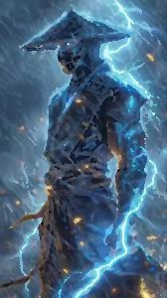 | Somewhere amidst the high, rugged hills and labyrinthine canyons of the wild lands north of the White Waste and south of the High Watch mountains, lies an ancient monastery known as the Tower of Khamsin. It is here that the drow monks of Khamsin have practiced and perfected the remarkable and deadly martial art form called the Way of the Tempest.  The Tower of Khamsin lies in a land where hot, dusty winds from the desert often rise and clash with icy winds rushing down from the mountain heights generating storms of terrifying, electric violence. Through patient, spiritual contemplation of the natural world and by immersing themselves in the power of these fierce storms, the monks of Khamsin have learned to harness the power of the tempest.

Tempest technique
Starting when you choose the Way of the Tempest at 3rd level, darts and blowguns count as monk’s weapons. Also, whenever you hit a creature with one of the attacks granted by your Flurry of Blows, you can impose one of the following effects on the target:
- It must succeed on a Dexterity saving throw or be disarmed.
- It must succeed on a Wisdom saving throw or be distracted. The next attack roll against the target by an attacker other than you has advantage if the attack is made before your next turn.
- It must succeed on a Strength saving throw or be grappled.

Fist of Hamattan
Also at 3rd level, whenever you hit with an unarmed strike, you may channel the power of the storm and spend 1 ki point to cause lightning to spring from your fingers inflicting an additional 1d8 lightning damage to the target.

Breath of the cloud dragon
Beginning at 6th level, you have learned to stoke the inner fire of your life essence and breathe out a dense cloud of fog. By spending 2 ki points, you can breathe out fog in a 20-foot radius sphere. The fog lasts for 1 minute or until dispersed by wind and the area is heavily obscured. Creatures in the fog cloud are considered to have total cover from ranged attacks. However, because the fog is imbued with your ki energy you can still sense the locations of creatures within the fog, and it does not impair your ability to target creatures.

Wind gyre form
Also at 6th level, when you take the attack action you can spend 2 ki points to make a melee attack against any number of creatures within reach. Alternatively, you may make a ranged attack against any number of targets within 10 feet of a point you can see within range. You must have ammunition for each target.

Hands of Samiel
Beginning at 11th level, when you hit with any melee or ranged attack you may spend 1 ki point to add 1d8 lightning damage to the target. By spending 4 ki, as an action you can cause a stroke of lightning to form from your outstretched fist in a line 100 feet long and 5 feet wide. Each creature in the line must make a Dexterity saving throw. A creature takes 8d6 lightning damage on a failed save, or half as much on success. The lightning ignites flammable objects in the area that aren’t being worn or carried.

Tempest strike
At 17th level you have learned to channel the elemental fury of the tempest. By spending 6 ki points, you bring your hands together and gesture outward invoking the tempest strike. First, a bolt of lightning arcs toward a target you can see within 150 feet and three bolts arc from the first target to three other targets within 30 feet of the first target. Each targeted creature makes a Dexterity saving throw. Each target takes 10d8 damage on a failed save, or half as much damage on a successful one. Secondly, a wave of thunderous force emanates out from you in a 15-foot cube. Each creature in the area of effect makes a Constitution saving throw. On a failed save, the creature takes 2d8 thunder damage and is pushed 10 feet away from you. On a successful save, the creature takes half as much damage and isn’t pushed. Any unsecured objects in the area of effect are pushed 10 feet.

Paladin: Oath of Enlightenment
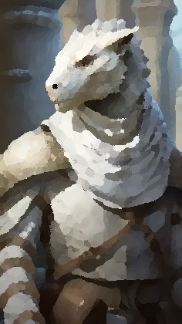 | Whether striving to achieve an earthly paradise for all or simply trying to carve out a small patch where one could raise a family in peace, a paladin who has taken the Oath of Enlightenment believes that the righteous path for a just society lies in the free communion of enlightened minds.  The Royal Society of Kerakorem is an independent academic group dedicated to exploration and the increase of knowledge, practical and arcane, for the benefit of all thinking beings. It is comprised of natural philosophers, explorers, and wizards, and is the most well-known institution of paladins dedicated to the Oath of Enlightenment.

Tenets of Enlightenment
Enlightenment – Strive to know yourself, your physical capabilities and limits, your fears and desires, your deepest spiritual essence.
Curiosity – Find joy in exploring new places, learning new things, and meeting new people. Seek to understand the underlying reason for the existence and behavior of things.
Humility – Remind yourself to keep an open mind and to revise your thinking when faced with new facts.
Charity – Help others find their own paths to enlightenment. Heal the sick, feed the hungry, teach the unknowing, fight tyranny where you find it, and nurture freedom everywhere.

Oath spells
Paladin Level | Spells
3rd | comprehend languages, identify
5th | locate object, see invisibility
9th | Leomund’s tiny hut, tongues
13th | freedom of movement, locate creature
17th | legend lore, scrying

Channel Divinity
When you take this oath at 3rd level, you gain the following two Channel Divinity options:
Arcane captain – As an action, you present your holy symbol and speak a prayer of inspiration. You and all allied spell-casters within 60 feet, that can hear you, gain the following features for the next minute.
- You have advantage on Constitution saving throws that you make to maintain your concentration on a spell when you take damage.
- When a hostile creature's movement provokes an opportunity attack from you, you can use your reaction to cast a spell at the creature, rather than making an opportunity attack. The spell must have a casting time of 1 action and must target only that creature.
Additionally, after speaking your prayer of inspiration, you may cast a spell as a bonus action.
Aura of clarity – As a bonus action, you raise your holy symbol and speak a mystic word of protection. For the next minute, allies within 30 feet, that can see you, have advantage on effects that frighten or charm and have resistance to psychic damage.

Knight exemplar
By 7th level, your pursuit of knowledge has granted you both practical skills and access to arcane powers. You have learned two wizard cantrips and have gained the following abilities:
- You have advantage on Wisdom (Perception) and Intelligence (Investigation) checks made to detect the presence of secret doors.
- You have advantage on saving throws made to avoid or resist traps.
- You have resistance to the damage dealt by traps.
- Travelling at a fast pace doesn't impose the normal -5 penalty on your passive Wisdom (Perception) score.

Lord arcanist
Starting at 15th level, you cast your spells with uncanny accuracy and to deadly effect. You gain a +2 bonus on attack rolls made for spell attacks and when you roll a 1 or a 2 on a damage die you may reroll the die and must use the new roll.

Epiphany of the arch-inquisitor
At 20th level, your knowledge and wisdom are legendary. As a reaction to a spell attack by you or an ally who can hear you, you speak a mystic word of insight. If the spell requires an attack roll, the caster has advantage on the roll. If the spell requires a saving throw, the targets have disadvantage on the save. Damage from the attack roll is always the maximum possible result of the damage dice rolled. Once you use this feature, it can’t be used again until after a long rest.

Ranger: Partisan
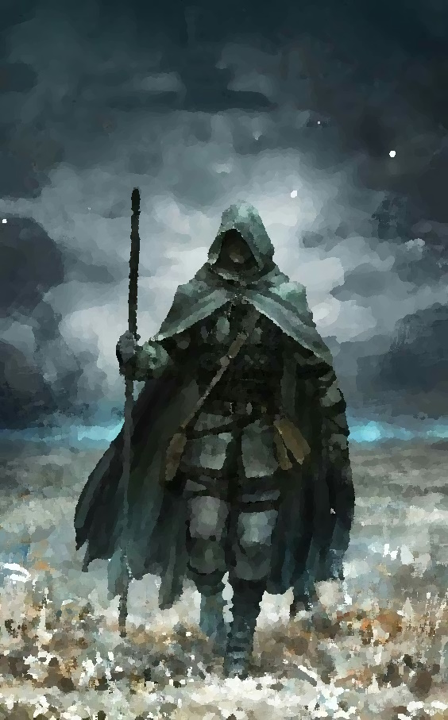 | The partisan is a ranger skilled in the clandestine arts of spy-craft and experienced with the deadly, cold necessities of covert warfare. If the bard of the College of Secrets is the brilliant spymaster, pulling the strings and directing secret missions against their enemies, the partisan is the tip of the spear; the ruthless and implacable warrior operating deep behind enemy lines.

Partisan awareness
At 3rd level, you can use your action and expend one spell slot to focus your awareness on the region around you. For 1 minute per level of the spell slot you expend, you can sense any creatures within 1 mile of you (or within up to 6 miles if you are in your favored terrain) that are tracking you or are aware of your presence. This feature doesn’t reveal the creature’s location or number.

Hidden weapon
Also at 3rd level, you are proficient with artisan’s tools and have learned to craft hidden weapons. The weapon appears as a cane, a map case, fishing tackle, a shepherd’s crook, a spyglass, a musical instrument, or any other such common item. The hidden weapon will not be detected unless it is being closely examined. In that case, the examiner makes an Intelligence (Investigation) check contested by the ranger’s Wisdom to detect the true nature of the item. The ordinary rules for crafting items apply to hidden weapons. A hidden weapon has a cost twice that of an ordinary weapon of the same kind. For example, a longsword costs 15 gp. A hidden longsword costs 30 gp and takes 6 days to craft (5gp of value per day of downtime).

Angry mob
Also at 3rd level, once on each of your turns when you make a weapon attack, an ally of your choice can make a weapon attack against the same creature using its reaction.

Partisan survival
At 7th level, you gain the following benefits:
- +5 bonus to deception and survival checks
- You gain the ability to craft common disguises. When you or an ally is wearing one of your disguises you may pass as a common citizen of the current region. Your disguise will not be detected unless you are closely examined. In that case, the examiner makes an Intelligence (Investigation) check contested by the ranger’s Wisdom to detect the falsity of the disguise. It takes 30 minutes to craft an effective disguise and the raw materials (clothing, etc.) must be available.

Partisan network
At 11th level, you have learned the secret codes and pass phrases allowing you to find and identify sleeper agents in your organization and can use these contacts to gain access to safe houses, food, shelter, and information.

Quick-witted
Also at 11th level, on each of your turns in combat you may take a bonus action to take the Dash, Disengage, Dodge, Hide, or Use an Object action.

Ruthless partisan
Beginning at 15th level, once per turn when you roll damage for a melee weapon attack, you can reroll the weapon’s damage dice and use either total.

Rogue: Confidence Artist
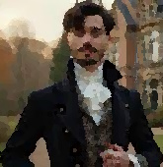 | A confidence artist is a rogue who has honed their instincts for misdirection and deception to the level of an art form. Where other rogues strive to be unseen and keep to the shadows, the confidence artist is the center of attention, a flashy showman who distracts the marks while his accomplices escape notice. Haven is infamous for its confidence artists, ringleaders who orchestrate small crews of cutpurses and card sharps, preying on the unwary traveler.

Showman
Starting at 3rd level, as a bonus action, you execute an eye-catching, flamboyant, flourish or trick. A flash and small puff of colored smoke, a sudden spray of paper flower petals, a surprisingly convincing animal noise, etc. For one round, creatures who are not your allies, who are within 30 feet of you, and can see or hear you (depending on the nature of your flourish) have a -2 penalty to their armor class and a -2 penalty to saving throws from attacks made by your allies. In addition, an unallied creature that is concentrating on a spell must save (with a -2 penalty) or lose concentration on their spell. You can use this feature a number of times equal to your Charisma modifier between short rests.

Fast talker
Starting at 9th level, you gain a +5 to deception and persuasion skill checks.

Lucky
Starting at 13th level, you have inexplicable luck that seems to kick in at just the right moment. Whenever you make an attack roll, an ability check, or a saving throw, you can spend one luck point to roll an additional d20. You can choose to spend one of your luck points after you roll the die, but before the outcome is determined. You choose which of the d20s is used for the attack roll, ability check, or saving throw. You may use this feature three times between long rests.

Big finish
By 17th level, your showmanship has reached epic heights. You astound, you amaze, you stun! You literally stun. As a bonus action, you execute your big finish (whatever that might be). All unallied creatures within 30 feet who can see or hear you make a Wisdom (Perception) save vs. Charisma (Performance). On a failed save the creature is stunned for one round. On a successful save the creature has disadvantage on attack roles and saving throws for one round. If the creature was concentrating on a spell, they have lost concentration. This feature may be used once between short rests.

Sorcerer: Channeler
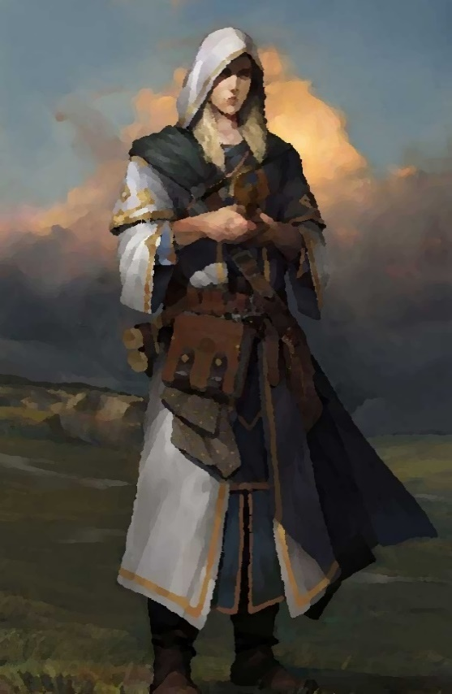 | There is a common creation myth among many of the tribes of Aedun that tells of a mystic river of primal force that entered the universe at the beginning of time. The river flooded existence with its raw energy, igniting the sun and the stars, and quickening the world with life, consciousness, and magic. The stories say the first people swam in this river and breathed it and could feel its flow all around them and through them. Its power made them both beautiful and terrible and eventually, it is said, gave them the means for their own destruction. In our times, the river has receded from its earlier flood, and for most, it flows just beyond our abilities to sense or draw upon. But there are some sensitives that can still feel the flow and may channel the river, guiding its chaotic energies to heal and to empower potent spells.

Channeling sensitive
At 1st level, you dare not draw more than a tiny fraction of the power you sense from the river. You channel to empower cantrips and a handful of minor spells. As an action, once per short rest, you may channel the energy of the river to yourself or another creature, restoring 1d6 + Constitution hit points. The undead and constructs may not benefit from this feature.

Channeling initiate
By 6th level, channeling has made your spellcasting much more powerful, and your sensitivity has grown to the point where you are able to channel the river’s dangerous ebb as well as its flow. You spend 2 sorcery points and, as an action, you select two creatures within 60 feet that you can see. One of the creatures receives the flow of the river and gains 2d6 + Constitution hit points, while the other creature feels the ebb of the river and loses an equal number of hit points. However, your control is imperfect. Each creature affected makes a DC 15 Constitution saving throw (either creature may choose to fail this save). If either creature succeeds on their save, you lose control of your channeling (or you may choose to lose control). The DM chooses 2 creatures at random within 60 feet, and each is subjected to one of the following effects at random (no saving throw):
Die roll (d10) | Effect
1 | Lose 2d6 + Constitution hit points
2 | Gain 1 level of exhaustion
3 | Blinded for 1 round
4 | Deafened for 1 round
5 | Frightened for 1 round
6 | Incapacitated for 1 round
7 | Paralyzed for 1 round
8 | Stunned for 1 round
9 | Unconscious for 1 round
10 | Gain 2d6 + Constitution hit points

Channeling adept
By 14th level, your control over your channeling has improved. When you attempt a channeling to use the ebb and flow of the river to add and remove hit points from 2 creatures, the difficulty class for the creatures to save has increased to 20. In addition, you may spend up to 2 additional sorcery points on this channeling. Each additional sorcery point adds 2d6 to the effects.

Channeling master
At 18th level, you have mastered your channeling control. When you attempt a channeling to use the ebb and flow of the river to add and remove hit points from 2 creatures, the difficulty class for the creatures to save has increased to 25. In addition, you may spend up to 4 additional sorcery points on this channeling. Each additional sorcery point adds 2d6 to the effects.

Warlock: Pact of the Ancestors
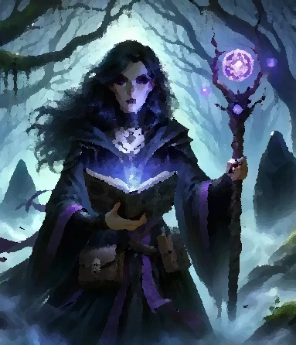 | Where other warlocks must seize eldritch power through shadowy pacts with fiend or fey, your power is a birthright. The power flows through your bloodline; each generation in your family, producing at least one gifted warlock. For the members of your line, death is often not the final parting it is for other families. For as long as you can remember, one or more of your ancestor spirits has been watching over you, sometimes as animal familiars, sometimes in spirit form, unseen by others, but present to you as a friend or sometimes a stern taskmaster. Your ancestors may assist you with mundane tasks – lifting and carrying heavy burdens, opening locked doors, and keeping watch over you while you rest. When called upon, they can be fierce protectors lashing out against your foes or even transporting you briefly into the spirit world to help you escape the reach of your enemies.

Ancestors expanded spells
Spell Level | Spells
1st | alarm, Tenser’s floating disk
2nd | knock, rope trick
3rd | Leomund’s tiny hut, spirit guardians
4th | Mordenkainen’s faithful hound, Mordenkainen’s private sanctum
5th | animate objects, wall of force

Watchful ancestors
Starting at 1st level, you may call upon your ancestor’s watchful spirits for help. As an action, all unallied creatures within 20 feet of you must make a Dexterity saving throw against your warlock spell DC. Creatures that fail their saving throws are knocked prone and grappled until the end of your next turn. This feature may be used once between short or long rests.

Spirit door
Starting at 6th level, you may call upon your ancestor spirits to move through physical obstacles by opening a temporary path through the spirit realm. Once per long rest you may cast the Passwall spell.

Passage through the spirit realm
At 10th level, your ancestor’s abilities to transport you through the spirit realm has grown more powerful. Once per long rest you may cast the Arcane Gate spell. The far end of the portal opened by use of this spell may not be further than 500 feet away, but it may open into the corresponding location in the Feywild or Shadowfell if desired.

Awaken the elder spirit
When you reach 14th level, you gain the ability to awaken a powerful elder spirit that was long ago bonded to your family. Once per long rest, you may cast the Planar Ally spell.

Wizard: School of Patterning
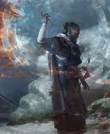 | The School of Patterning focuses not on one category of spells but rather on gaining a deeper understanding of the art of spellcasting and the nature of magic itself. Patterners make a study of other magic users and can see the arcane pattern and potential of a spell as a spectrum of variable futures. As a spell is cast by another, the patterner can effect minor changes in the mystic substrate through which the spell’s energy flows so that the spell is enhanced, dissipated, or even so that it rebounds upon the sender. Patterning is a rare skill and usually takes a lifetime of experience to acquire. Because of this and because of their typical broad range of spell interests, patterners are often mentors or teachers to other wizards. A young patterner is exceedingly rare and is often a sign of one destined for great power.

Patterner Savant
Beginning when you enter the school of Patterning at 2nd level, you gain advantage when rolling to retain your concentration on a spell.

Aegis Pattern
At 2nd level, as a reaction when you or an ally within 10 feet is hit by an attack or targeted by a magic missile spell, you choose a point within 5 feet of you and cause an invisible barrier of magical force to appear. Every ally within the aegis pattern gains a +5 bonus to AC for the triggering attack.

Arcane Resonance Pattern
At 6th level, you may take the Help action during combat to enhance another caster’s spell. When you choose to take the Help action in this way, you may choose one of the following benefits for the caster: advantage on the attack roll, disadvantage on the target’s saving throw, add 1d10 damage, double the range of the spell, or bend the effect of the spell so that it excludes a number of creatures equal to your Intelligence modifier. The additional damage increases to 2d10 at 10th level and increases to 3d10 at 14th level.

Pattern Bound Spell Trap
At 10th level, you’ve learned to cast a spell such that it is suspended in a closed arcane pattern and can be released as a reaction. Once a spell is suspended in this manner it does not require concentration. If you choose, you may specify an area of affect when you cast the spell even if that area is no longer in range or visible when the spell is released. If not released, the spell will dissipate after 24 hours.

Cheval Pattern
By 14th level, any spell cast in your presence is potentially subject to your influence. As a reaction when a spell is cast in your presence, you and the spell caster each make an opposed skill check using your spellcasting ability. The spell is affected by the result of the opposed check according to the table below.
Opposed Skill Check Result | Result
Patterner loses by 5 or more | Spell takes effect as normal
Patterner loses by less than 5 | Half damage (if applicable)
Tie or patterner wins by less than 5 | Spell has no effect
Patterner wins by 5 to 9 | Spell rebounds on the caster (half damage)
Patterner wins by 10 or more | Spell rebounds on the caster

Languages
Not including the many rare and exotic languages spoken here and there in remote locations or by secret organizations, there are nine languages that may commonly be encountered in Aedun.

Aedunaic (Common)
Aedunaic is the most widely spoken language in the lands of Aedun and is often referred to as the common tongue or simply Common.

Elvish
There are four commonly spoken dialects of elvish. These dialects are related languages which sound similar to non-speakers but are mutually incomprehensible to the speakers of these dialects.
Incanta (High Elvish)
The Incanta or High Elvish dialect is the most commonly spoken language within the Elderwood. There are many Incanta speakers in the Guarded Forest and a few of the dwarves of the High Watch mountains are known to speak Incanta. Incanta is very rarely spoken outside of these regions.
Sylvan (Wood Elvish)
Sylvan is the most commonly spoken language of the Guarded Forest. Most of the inhabitants of the Guarded Forest are bilingual at least, speaking Sylvan and Common, and many also speak a third language (Incanta or Ruic typically).
Wullah (Dawn Elvish)
Wullah is the common language of the Ambersea tribes. The Dawn Elves are the original speakers, but it is the primary language of the human tribes of this region as well. Most tribes will have a few speakers able to converse in Aedunaic, but other languages are uncommon in this region.
Drow (Dark Elvish)
The drow of the White Waste speak their own unique dialect. Amongst those groups of drow that have dealings with outsiders, many speak a second language (Aedunaic, Ruic, or Gaizhan are most common).

Ruic (Dwarven)
Ruic is the language of the dwarves. It is the primary language spoken by those who live in the High Watch mountains and is commonly spoken in the Guarded Forest, the Elderwood, and by the halflings of Greenvale. Ruic is also spoken by the dwarves of Iceland, but with a marked accent. Frost dwarves of Iceland, unused to travel outside of their home country have difficulty understanding and making themselves understood by the hill dwarves and mountain dwarves from other parts of Aedun.

Gaizhan (Tiefling)
Gaizhan is the language of the tieflings in Haven. It is an ancient language, spoken today by the noble houses and upper classes of Haven, their servants and retainers, and by the military and merchant classes that deal with the noble houses. It is also the most common language in the city of Zhendohar. Most of the commoners of Haven speak at least a little Gaizhan as well as Aedunaic.

Daymu
Daymu is the most commonly spoken language in the city of Haven. It is the primary language of the working classes and the poor and most of the elite know at least a smattering of Daymu (though they may be loath to admit to speaking the language). Daymu is also the most common language amongst the farmers and fisherfolk living in the Sea of Reeds.

Sea Bash
Sea Bash is a cant spoken by the tide orcs of Cormar. It appears to be a language derived from an older language spoken by the first generation of tide orcs but has since evolved as its own language and includes some words or phrases from Ruic, Aedunaic, Daymu, and even Draconic.

Draconic
Draconic is the language of the Dragon Isles. Other languages are very uncommon in the Dragon Isles. But, those dragonborn who travel to Haven or Zhendohar or points beyond have usually acquired Aedunaic or another language as a second tongue. Outside of a few scholars in Haven and other cities, there are few speakers of Draconic outside of the dragonborn.

Shadow Talk
Shadow Talk is the secret signing language created by the Shadow Gnomes of Durany. Very few non-gnomes are able to sign with this language.

Currency in Aedun
Durany Currency:
- Ivory Imperial (100 sp)
- Gold Piece (10 sp)
- Silver Piece (1 sp)
- Steel Common (1/10 sp)
Haven Currency:
- Platinum piece (60sp)
- Gold piece (2sp)
- Silver piece (1sp)
- Brass button (1/12 sp)
- Bronze piece (1/20 sp)
Dragon Isles Currency:
- Coral Caravel (90 sp)
- Gold Galleon (10 sp)
- Electrum Galley (5 sp)
- Silver Dromond (1sp)
- Bronze Oar (1/10 sp)
Stoneport Currency:
- Gold sun (12 sp)
- Electrum star (6 sp)
- Silver Kent (1/2 sp)
- Bronze orb (1/24 sp)
Skye and Guarded Forest Currency:
- Platinum Crown (50sp)
- Electrum Corona (5sp)
- Silver Collar (1sp)
- Iron Piece (1/20sp)
Ambersea:
Currency is not much in use in the Ambersea. Small sums may be written onto scraps of hide and marked with a sign, letters of credit in effect, and can be exchanged for food or the use of a mount. Precious stones are occasionally used for larger exchanges.

The Faiths of Aedun
Most of the people in Aedun, if they are religious, will fall into one of two belief systems that are common in Aedun.

The Old Gods
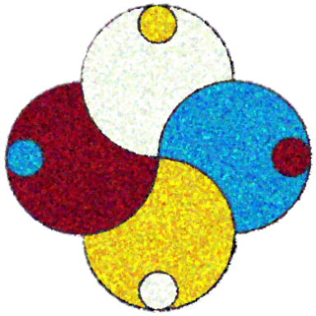 | For as long as humans, elves, dwarves, and the other races have been in Aedun, the Old Gods have been with them. The Old Gods (known in most parts of Aedun as simply “the gods”) are a pantheon of deities each of whom personify an elemental force of nature or the balance between elemental forces. Each of the old gods has an animal totem and is associated with an element and a primary mortal virtue or ideal.
The pantheon of the old gods is headed by the four elders – Raweni, Honu, Koyote, and Paya representing the four fundamental elements Air, Water, Fire, and Earth respectively. The other deities of the old gods are conceived as children of the elders and represent, in different ways, the balance of forces between two of these four elements. Each combination of elements has two deities; each of whom represent the converse influence the specific combination of elements has on the mortal realm. For example, Waro and Kawau each represent, in different ways, the union of the elemental forces of Air and Water and the balance of the virtues of Wisdom and Empathy. Waro (Crane) is inward turning and is the spirit of Contemplation while Waro’s twin, Kawau (Cormorant) is outward turning and is the spirit of Counsel and Discourse.
The dwarves, the dawn elves, the drow and other groups have different names in their languages for the old gods. For example, the name Paya (Incanta), Karkhu (Ruic), and Bear (Common) are all understood to represent the same deity. During the Long Night, the high elves were largely responsible for preserving the knowledge and worship of the old gods such that today the Incanta names for the deities are widely used across Aedun. Below is a brief description of each of the old gods listed under their Incanta and Common language names.

Raweni (Raven)
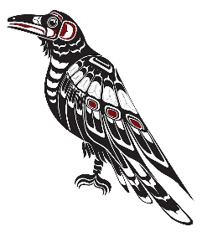 | First of the four elders, Raweni is the elemental spirit of Air. Raweni is the embodiment of the Sky and represents Wisdom.

Honu (Turtle)
 | Second of the four elders, Honu is the elemental spirit of Water. Honu is the embodiment of the Ocean and represents Empathy.

Koyote (Coyote)
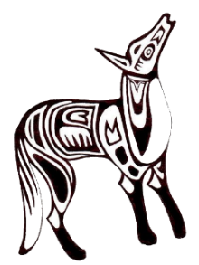 | The third of the four elders, Koyote is the elemental spirit of Fire. Koyote is the embodiment of the Sun and represents Inspiration.

Paya (Bear)
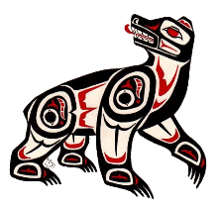 | The last of the four elders, Paya is the elemental spirit of Earth. Paya is the embodiment of the Mountain and represents Patience.

Waro (Crane)
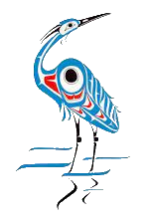 | Waro symbolizes the union and balance of the elemental forces of Air and Water. Waro is the spirit of clouds and mists and represents Contemplation and stillness of mind.

Kawau (Cormorant)
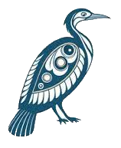 | Kawai, Waro’s twin, also symbolizes the elemental forces of Air and Water. Kawai is the rain spirit. Where Waro is inward turning, Kawai is outward turning and represents the virtues of wise Counsel and Discourse.

Ekara (Eagle)
 | Ekara is one of the two spirits representing the balance of Air and Fire. Ekara is the wind spirit and symbolizes War and conquest.

Pi (Bee)
 | Pi is Ekara’s twin and also represents the forces of Air and Fire. Pi is the spirit of the grasslands and symbolizes Harmony.

Oru (Owl)
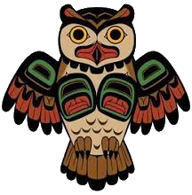 | Oru symbolizes the union of the elemental forces of Air and Earth. Oru is the moon spirit and represents Prudence.

Rapeti (Rabbit)
 | Rapeti, Oru’s twin, also represents the balance between the forces of Air and Earth. Rapeti is the patron of travelers and symbolizes Luck.

Otur (Otter)
 | Otur is one of two deities representing the intersection of the elemental forces of Water and Fire. Sailors pray to Otur for safe travel on the water. Otur symbolizes Love, fertility, and family.

Nakahi (Snake)
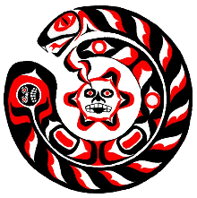 | Nakahi, Otur’s twin, is the other deity symbolizing the intersection of Water and Fire. Nakahi is thought to create the witchfire that appears in certain marshlands and represents Hatred and vengeance.

Aimok (Ox)
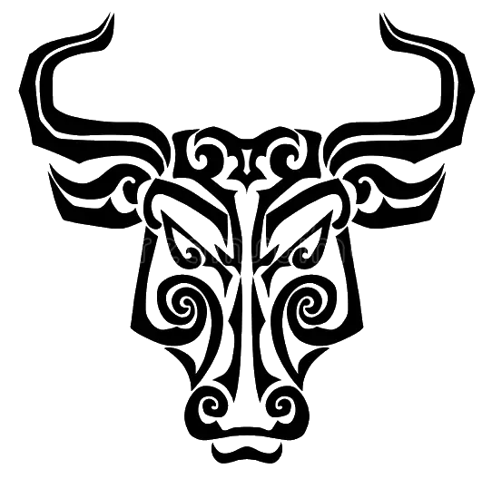 | Aimok represents the joining of the elemental forces of Water and Earth. Farmers pray to Aimok for a good harvest. Aimok symbolizes agriculture, mastery, and Dominion.

Hati (Stag)
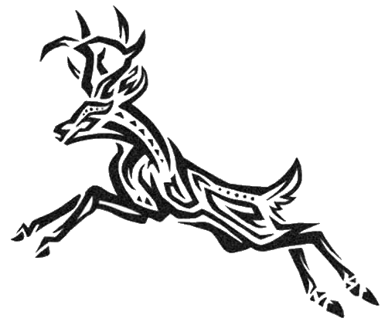 | Hati, Aimok’s twin, represents the Forces of Water and Earth in a converse aspect. Hati symbolizes wilderness and Nature. Hati is the spirit of the forest and hunters offer sacrifices to Hati in exchange for a successful hunt.

Meijok (Wolf)
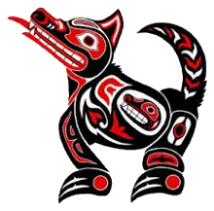 | Meijok represents the elemental forces of Fire and Earth in balance. When death comes to a mortal, Meijok’s breath turns the body to ash and Meijok guides the fiery ember of the mortal’s spirit to its next life. Meijok symbolizes Death.

Mahoi (Mouse)
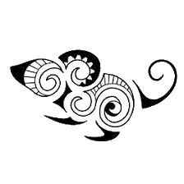 | Mahoi is Meijok’s twin. Mahoi also represents Fire and Earth in balance but where Meijok is the harbinger of death, Mahoi symbolizes rebirth. Mahoi is the patron spirit of children.

Ayat Light Bringer
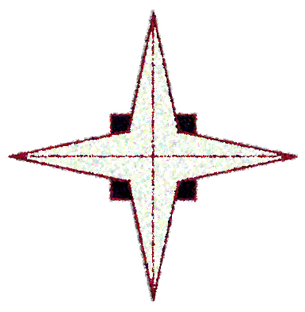 | When Ronan Aubret led the Aeduni to victory over the Ungartten, light returned, miraculously, to the lands of Aedun. Aubret, with a small coalition army assembled from the various tribes of humans, elves, and dwarves, managed to route a powerfully malevolent force that had been preying upon the Aeduni for millennia. The strength, courage, and resourcefulness of Aubret and his forces at that time is universally praised and admired.
But just how was it done? What, actually, was done to cause sunlight to return to Aedun? The events of those days are clouded in mystery, but scholars note that it was just after this time that the first accounts began to emerge of encounters with a divine being known as Ayat Light Bringer. In those days, just after the end of the Long Night, magic was still very rare. No schools of wizardry yet existed, the arts of abjuration, invocation, patterning, and channeling had yet to be developed, and those gifted with magical skill or talent labored alone without guidance.
At first the stories of Ayat's miracles were dismissed as fabrications, or exaggerations of minor feats performed by early mortal channelers. But the stories continued to accumulate of a mystical white robed figure, Ayat Light Bringer, shining with a divine radiance and performing incredible acts of beneficence: mass resurrections, floodwaters stemmed, earthquakes quieted, acts far beyond mortal capability. Some of these miracles had hundreds of witnesses and could no longer be dismissed as mere fable or rustic superstition, and many soon connected the appearance of Ayat with the mysterious return of the light.

Early History
The Temple of Ayat Light Bringer was soon founded in Denburg and, over time, became the most widely practiced religion in Durany, displacing the Old Gods in popularity. Words of moral guidance, attributed to utterances of Ayat, were set down and categorized by the early acolytes of Ayat into a set of numbered Dictums.
For most of the Temple's existence, its priests and clerics preached these Dictums with the aim of nurturing moral virtues: charity, honesty, courage, justice, wisdom, and temperance. Over the years, the Temple was instrumental in saving and improving the lives of thousands of Durany's citizens, especially its poorest and most vulnerable. The Temple was active in the ongoing struggle against the Ungartten that menaced Durany's western border, training fighters and nurturing the new art forms practiced by spellcasters in skills essential to fighting the Ungartten.
There were no further credible reports of visitations from Ayat, but the Temple continued to grow in power and to expand its influence. The Temple’s detractors criticized its priests for becoming overly rigid and dogmatic in their interpretations of Ayat's Dictums, too obsessed with the struggle against the Ungartten and more interested in exercising power than in helping the citizenry.

The Purge of Ayat
In the Year of the New Sun 1912, the high priests of Ayat surprised the Kingdom by revealing a new Dictum from Ayat: The human race is chosen to be responsible for upholding the light-bringing torch of Ayat and must exercise dominion for the betterment of all.
With this new Dictum, the Temple, where their authority was strongest in Durany, took steps to remove all non-humans from positions of influence and a short time later began what has since been called the Purge of Ayat. The Temple systematically organized efforts to remove all non-human races from Duran society. Dwarves, elves, gnomes, and halflings were actively driven out from Durany, enslaved, or killed. Among humans in Durany, the result was shock and a deep polarization. Supporters of the Temple, perhaps fewer in number, became much more suspicious, and more extreme and uncompromising in their beliefs.
At this time, those within Durany who disagree with the Temple's intentions dare not speak out. Some have sought to break with the greater Temple and return, in secret, to the earlier teachings of Ayat. Those realms adjacent to Durany, the Guarded Forest and Stoneport, keep a watchful eye on their neighbor's ambitions towards empire.

Other Belief Systems
There are other, smaller, religious sects and cults that exist among the Aeduni, aside from the Old Gods and the religion of Ayat Light Bringer. Notably, the dragonborn of the Dragon Isles, while fascinated by the Old Gods, generally worship Bahamut the Platinum Dragon. In the city of Haven there exist many smaller cults that, over the years, wax and wane in popularity amongst the citizenry: Ossa Goddess of Fertility, Maphykis God of Wealth, Khoth God of Knowledge, Kasm God of the Deep, Skerrit the Cat goddess, Ru Yuah the god of Disease, and Sathreh the Shark god to name a few.

Notable Institutions
There are several institutions that, while outside the official channels of government, nevertheless hold considerable influence in the lands of Aedun.

Citadel of the Seven Houses
As an institution of learning, the Citadel of the Seven Houses in Haven is wholly unique. Wizards, monks, bards, and fighters all aspire to enter one of the many schools of learning within the citadel, each specializing in a singular discipline. The citadel stands in one of the few areas of high ground in Haven and is visible from practically everywhere in the city (though curiously difficult to find). It is a massive citadel, with high walls, elegant towers, gilded domes, and great halls. Physically, it is an ancient and impressive structure, and as an institution, it represents the pooled resources of seven off the great houses of Haven; one of the few instances where the great houses have been known to cooperate with one another for any length of time. The Citadel of the Seven Houses is the pre-eminent school for wizards in Aedun. It is the only school that has teaching masters for all the eight schools of wizardry. Monk aspirants from all over Aedun make pilgrimage to the citadel in hopes of being taught the Way of the Open Hand by one of the school’s famous masters. The citadel trains bards in its highly regarded School of Lore, and most of the great houses send at least a few of their family’s fighters to train at the citadel’s renowned School of Battle.

Schools of Wizardry
During the Long Night, wizardry and the arcane arts were almost completely extinguished in Aedun. In the time since the Long Night ended, magic and spell casting has experienced a renaissance and there are now many casters of a novice or intermediate capability but there are still relatively few true masters of the arcane arts, and it can sometimes be difficult for the aspiring mage to find a teacher. Aside from the Citadel of the Seven Houses, there are only a few other well-known schools of wizardry in Aedun.
Gray House - Somewhere amidst the cold and misty moors of northern Durany, hidden by powerful enchantments, lies the somber and foreboding Gray House. Gray House is a secretive school for wizards with masters teaching spellcraft for the following schools of magic: Abjuration, Conjuration, Divination, Evocation, Illusion, and Necromancy.
The Tower of the Eye - The Tower of the Eye in the Elderwood is raised upon a rocky crag high in the foothills of the High Watch Mountains overlooking a deep wooded valley. The high-elven wizards of the tower practice and teach spell casting for the following schools of wizardry: Abjuration, Conjuration, Divination, Enchantment, Illusion, Transmutation.
Royal Society School of Wizardry – One of three schools of the Royal Society, the School of Wizardry is located high on a mountainside of a remote island in the archipelago of the Dragon Isles. The masters of this school are rumored to be silver dragons. The following schools of spellcraft are taught here: Evocation, Illusion, Transmutation.
Tombe College of Wizardry – Just outside the city of Skye, behind high, magically-warded hedges, lies a large, rambling estate with elegantly manicured gardens, hedges, and burbling brooks. The large, sturdily constructed, ivy-covered, stone buildings of the estate house the Tombe College of Wizardry. The masters here teach spellcraft from the following schools: Abjuration, Enchantment, Evocation.
Whiteholm School for Magicians – On a rocky islet in Lake Heron, just offshore from Stoneport, rises the bleached stone tower of Whiteholm School for Magicians. The masters of Whiteholm tower are expert practitioners and teachers of the following schools of magic: Abjuration, Divination, Transmutation.
Tower of Sorcery – West of Zhendohar, the coast rises to steep cliffs with numerous narrow inlets. Passing into one of these inlets, the traveler will find a narrow, switch-backed trail leading up from the narrow beach high into the desolate and rocky interior to a lonely tower overlooking to the north and west the endless dunes of the White Waste. This is the Tower of Sorcery. Wizards from Zhendohar, Cormar, Haven, and farther places journey here to learn from the secretive masters of this tower. The Tower of Sorcery is famous for spellcraft in the following schools of magic: Conjuration, Enchantment, Evocation.

Military Academies
Every village and town in Aedun may boast of a skilled veteran who can teach the rudiments of fighting with sword, axe, or bow. But, in addition to the Citadel of the Seven Houses, there are a few notable institutions that are renowned for their knowledge of battle and warfare and produce fighters of exceptional and deadly skill.
Royal Society School of Warfare – The second of the three Royal Society schools, the School of Warfare is located within the fortress citadel guarding the capital city of Kerakorem in the Dragon Isles. Promising fighters in the army or navy of the Dragon Isles are sent here to study.
Proving Grounds at Bleak Hill – Bleak Hill is the name of a fortress a few days ride east of Stoneport in the coastal hills overlooking the south shore of Lake Heron. The battle-hardened fighting masters of this fortress teach Battle Maneuvers to younger fighters (mostly from Stoneport) with relentless, uncompromising efficiency.
Denburg Military Academy – Outsiders know very little of the Denburg Military Academy except that the knights produced by this academy, identifiable by their feared Star-And-Skull insignia are known to be deadly and remorseless fighters.
Expeditionary Corps – The Expeditionary Corps is part of the armed forces protecting the Guarded Forest. They have no fixed headquarters but rather roam in small bands throughout the Guarded Forest and beyond, communicating intermittently with other forces to share information. Fighters seek out the Expeditionary Corps to learn invaluable wilderness fighting skills and is where many of the Guarded Forest’s Partisans are trained.

Bard Colleges
Aside from the Citadel of the Seven Houses, there are only a handful of other locations in (or near) Aedun where the enterprising bard may go to learn their craft.
Royal Society School of Art and Music – The third of the three Royal Society schools, this school is also in the capital city of Kerakorem in the Dragon Isles. The school contains a College of Lore and a College of Valor.
College of Valor – The College of Valor in Stoneport attracts skalds from Durany as well as spirit singers from the Ambersea. The teachers at this college are known to be unconventional but are highly regarded and many notable and influential bards have studied at this college.
College of Lore – The College of Lore in Skye attracts bards from across the Guarded Forest, the Elderwood, Greenvale, and even dwarven söngvari from the High Watch mountains.
College of Secrets – The College of Secrets is also thought to be located somewhere in the city of Skye, but its exact location is a mystery to outsiders. Bards, as well as actors, entertainers, and politicians are approached to join the College of Secrets to serve as intelligence agents in the clandestine struggle between the Guarded Forest and the Temple of Ayat in Durany.

Monasteries
Like the arcane arts, the knowledge and practice of harnessing ki energy almost disappeared during the Long Night. Since the end of the Long Night, the harnessing of ki through martial art forms has grown. The Citadel of the Seven Houses trains monks in the Way of the Open Hand, and the Thieves Guild in Haven and the Black Hand in Zhendohar train monks in the Way of Shadow. Aside from these institutions, there are a handful of remote monasteries where monks may train in martial art forms and mastery of ki.
Temple of the Four Dragons - In the Dragon Isles, there exists a remote temple known as the Temple of the Four Dragons where monks are trained in the Way of the Four Elements.
Tower of the Four Winds – In the Elderwood there are two schools of martial arts that teach aspirants the ability to harness ki energy. The first of these schools is the Tower of the Four Winds and is located high in the foothills of the High Watch mountains overlooking a deep and narrow valley.
Tower of the Hand – The second of the two schools of martial arts in the Elderwood is the Tower of the Hand. The Tower of the Hand is located within a walled redoubt on an island in the middle of the Gray River, just upstream from Stones Bridge.

Criminal Syndicates
There are two large criminal syndicates that operate in Aedun that are notable for wielding significant power and influence through unofficial channels.
Thieves’ Guild – The Thieves’ Guild in Haven is by far the larger of the two notable criminal organizations. It is an ancient guild that has operated in Haven for hundreds of years. The guild includes smugglers, thieves, confidence artists, and assassins. The guild contains numerous shifting factions representing different economic interests and influence from the great houses. The populace knows little of the internal power struggles within the guild, only noting a change of leadership when the bodies pile up.
The Black Hand – When House Fallon was exiled and fled Haven for Zhendohar, the faction of the Thieves’ Guild associated with Fallon also split from the guild and established a new organization known as the Black Hand. The Black Hand is a very secretive organization, infamous and feared for their deadly assassins. The Black Hand trains assassins and Shadow Monks and exerts great influence from the back ways and dark alleys of Zhendohar. They also operate in Deal and in Haven where they compete with the Thieves’ Guild.

