**1. What did you do?**

I used my tenure at Zachry to identify key opportunities for step change improvement in outcomes. As the company celebrates it’s 100th year, it finds itself carrying significant technical debt in the area of backend systems. Using the results of that exercise I used a Kepner-Tregoe analysis to identify which opportunity should provide the most benefit. While modernizing the company’s ERP system, procurement system, and work/project management system ranked as significant and valuable opportunities, and based upon Zachry’s corporate values which place the employer/employee relationship as an operational cornerstone, I identified the company’s antiquated HRIS system as the highest risk/greatest reward opportunity. In a very labor-centric business, like heavy industrial construction, any event that would cause the weekly payroll process to fail could prove catastrophic to the business and impair its ability to find and retain valuable and skilled labor in a highly competitive marketplace, like the Gulf Coast of Texas. Having identified payroll and the closely correlated HRIS system is critical to the ongoing operations of the business, I set about to identify the scope of the problem. Using resources published on the Zachry Intranet, I found that Zachry Group consists of ten discrete businesses operating across a broad range of business sectors including Consulting, Oil & Gas Exploration, Heavy Industrial Construction, Power Engineering, Turnaround and Maintenance, Nuclear Engineering & Construction, Technology, and Technology Consulting. I also discovered that not all of these business units are using the antiquated HRIS system. This allowed me to significantly pare down the scope of the problem to the Power Engineering, Turnarounds and Maintenance, and Heavy Industrial Construction business units. Across these business units I found substantial commonality among the types of employees, types of payroll activities, and requirements for managing the employee experience.

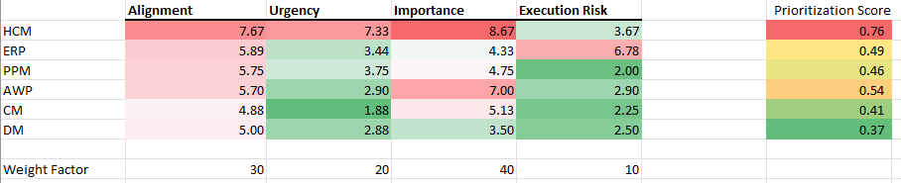

Figure Kepner-Tregoe Scoring of Enterprise Systems

**2. What were the results?**

The existing HRIS system is a 40-year-old system, written in COBOL, that requires DOS-based workstations to process payroll for the company’s nearly 25,000 employees.

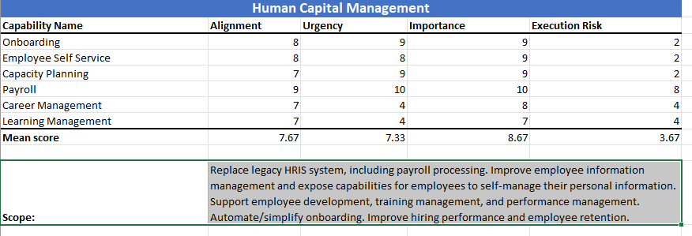

Figure Human Capital Management Scorecard

Figure ERP System Scorecard

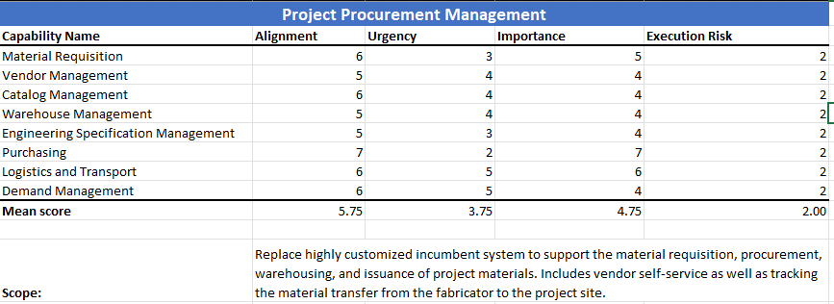

Figure Project Procurement Management Scorecard

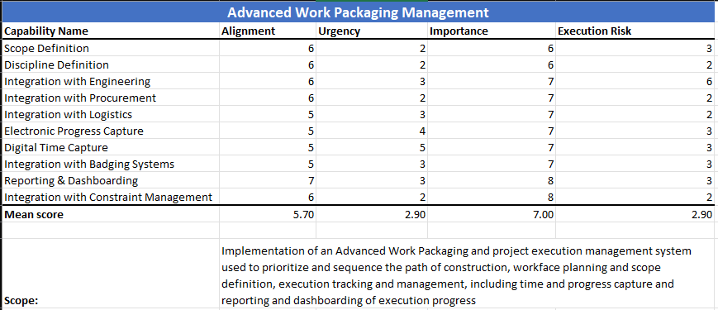

Figure Advanced Work Packaging Scorecard

Figure Constraint Management Scorecard

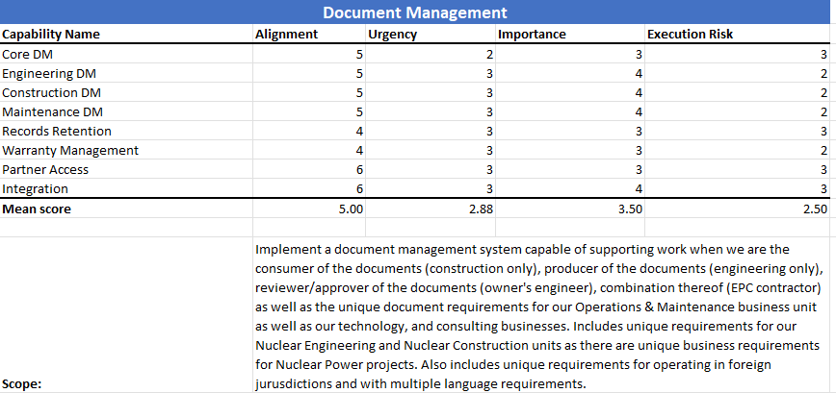

Figure Document Management Scorecard

I discovered that, because of legacy concerns around connectivity at the remote project locations, the current system is designed to function as a stand-alone system that captures employee and payroll information, processes payroll, generates paper-checks, and the synchronizes/transmits the weekly payroll data with the Home Office-based system. Effectively this means that IT/IS is supporting as many as 30 discrete payroll systems (in support of the company’s numerous concurrent projects) as well as the integrations required to capture the data centrally and fund payroll accordingly through the company’s treasury department. I also discovered that, since the original system was implemented, the field of Human Resources has undergone substantial changes. To start with the current system is a marginal solution offering fundamental capabilities as a Human Resource Information System, specifically around Employee Data Management and Payroll Processing. Most business units are using paper timesheets with clerks performing data entry. Similar processes are in play for employee data management, including the employee onboarding process. Modern systems now include a new category of features around Human Resource Management and the overarching term for Human Resource Management coupled with Human Resource Information Management is Human Capital Management.

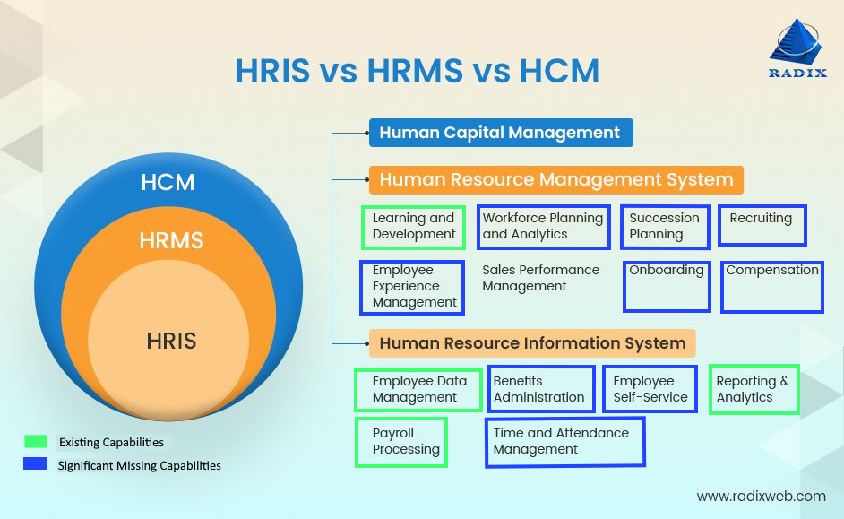

Diagram illustrating current HCM capabilities and Zachry gaps. (Maitray-Gadhavi, 2023)

The current employee experience at Zachry lacks visibility and management of information is slow and prone to human error during the data entry process. Current onboarding processes introduce significant delays, lacks visibility, and ultimately serves as a competitive disadvantage to the company.

**3. What did you learn?**

Opportunities for improvement of these long-standing processes were both abundant and obvious and enhancement of other processes that are either outsourced or serviced by other means leaves the organization at a significant competitive disadvantage. Changing the existing tools will allow for streamlining of processes and improvement of the employee experience including things like employee self-service of their personal information, banking information, tax withholding information, automation of employee time-off coordination/requests and increased visibility of the same, as well as exposing opportunities for improved employee/supervisor interactions, annual review processes, visibility of career progression, and much more (A3Logics, 2023). Organization efficiencies will be gained by introducing coordinated and consolidated access to key staffing metrics like time to hire, retention, years of service reporting, compensation analysis, optimization of benefit utilization and offerings, and much more. What I learned from the process is that Zachry is currently operating outside of it’s core values by claiming that employees sit at the center of their operational philosophy while at the same time operating in a way that is cumbersome, opaque, and wrought with risk and opportunity for failure. I learned that previous strategic initiatives including the development/enhancement of a suite of home-grown project control and execution tools, the attempted development/enhancement of the company’s home-grown ERP system, or the procurement of a new graphical work packaging tool were all poorly conceived and misplaced. I learned that the current manual or paper-based processes degrade the employee experience and introduce a 10-30 day process penalty for the hiring process as reference checks, drug screens, background checks, offer presentation and acceptance, and document collection, all pre-cursors to actually on-boarding an employee, lead to a significant number of candidates opting to accept competing offers from other companies that are quicker to pull the trigger. I also learned that IT processes of acquiring, configuring, and issuing equipment to a new hire are similarly delayed because of delays in getting the information back from payroll that’s necessary to provision user accounts and initiate the equipment build process. I learned that the current system(s) and the associated legacy processes cannot be replaced fast enough and corporate prioritization of this effort needs to be escalated.

**4. How does it relate?**

In week one we read about the Strategic Implications of Emerging Technologies by Kevin Coleman (Coleman, 2019) and, while the concept of Human Capital Management and Human Resource Management Systems are neither new nor emerging, when put in the context of a century old organization that is steeped in tradition, slow to adopt new technologies, and long-accustomed to the status-quo, these technologies do indeed represent a catalyst for business strategy and transformation. The challenge for Zachry will center upon its ability to properly message to the users the importance of the change and to effectively manage the organizational change in such a way that the employees quickly begin to see and feel the value proposition of such a change. In week three we have read about Digital Transformation and its impact as we transition to a Knowledge Society (Jennex 2021). The digital transformation associated with this implementation will make a fundamental change to the competitive positioning of the company by allowing the company to more quickly find and hire the best talent, retain the talent we have, and ultimately allow us to execute our projects more effectively by dramatically improving the employee experience.

**References**

A3Logics. (2023, July 7). *A comprehensive guide to HCM software development | A3Logics*. A3logics Blog. https://www.a3logics.com/blog/everything-you-need-to-know-about-hcm-software-development#:~:text=When%20successfully%20implemented%2C%20an%20HCM%20system%20can%20transform,software%20is%20to%20optimize%20an%20organization%E2%80%99s%20human%20resources.

Maitray-Gadhavi. (2023, July 20). *HRIS explained: Functions, features, benefits, and how to choose the right system?* Radixweb. https://radixweb.com/blog/complete-guide-to-hris

Coleman, K. (2019, July). *The Strategic Implications of Emerging Technologies*. ProjectManagement.com.

*Jennex, M.* (2021, Sept.). Digital Transformation and the Knowledge Society West Texas A&M University WTClass. https://wtclass.wtamu.edu/webapps/osc-BasicLTI-BB608c5bc47e949/tool.jsp?course_id=_61644_1&content_id=_2828080_1