**1. What did you do?**

I used Tableau to evaluate the data provided. Following the prompts of the assignment, I studied the schema of each of the data tables and then studied the data. Next I reviewed the overall database and data architecture to understand holistically what information was available. I then looked at the star schema of the data in order to understand how to evaluate the database to produce the desired outcome

**2. What were the results?**

To the first question I found that Coffee yields the highest profit in Major Markets and both Tea/Herbal Tea yields the highest profit in Small Markets. I found it interesting that both types of tea combined represent nearly the same profit in the small markets as coffee does in the major markets. I also thought it was interesting that all coffee in the smaller markets is less that either type of tea in the same market.

The second question exposes the fact that Coffee yields the most sales in the East and Central markets, Espresso yields the most sales in the south market, and Herbal Tea is the highest seller in the west market.

As you can see in the Question 3 table below Columbian Coffee in Massachusetts is far and away the highest profit generator in the company.

Question 4 raises some concerns about the amount of inventory that the company is carrying. All four regions are carrying around $300K in inventory.

Decaf’s greatest sales ins in the state of California, which is 10% higher than the second highest state (Illinois).

**Summary of all 5 questions:**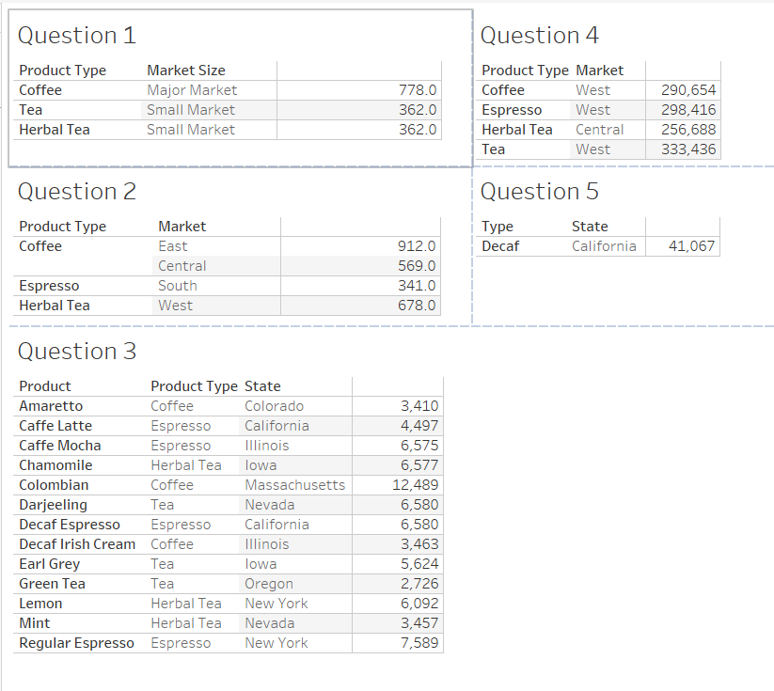

**Question 1**

**Question 2**

**Question 3**

**Question 4**

**Question 5**

**3. What did you learn?**

I learned that the coffee company is carrying too much inventory for the level of sales. Further complicating that is that it seems that the inventory being maintained in each market would be better spread or shared to other markets. I also learned that the company could likely improve their revenue and margin by focusing on Coffee product sales in the major markets in the East and West and on Tea product sales in small markets in the Central and West Regions. Particular interest should be paid to small market sales in the Central and West regions as they yield the highest margins and profits. Finally inventory realignment would improve profitability and carrying costs by pulling inventory from the major markets in the East and West regions and spread it across the Central and South regions. It would also appear that inventory in small markets is elevated across the board. The Inventory to Sales ratio for every product in every market is notably higher than expected.

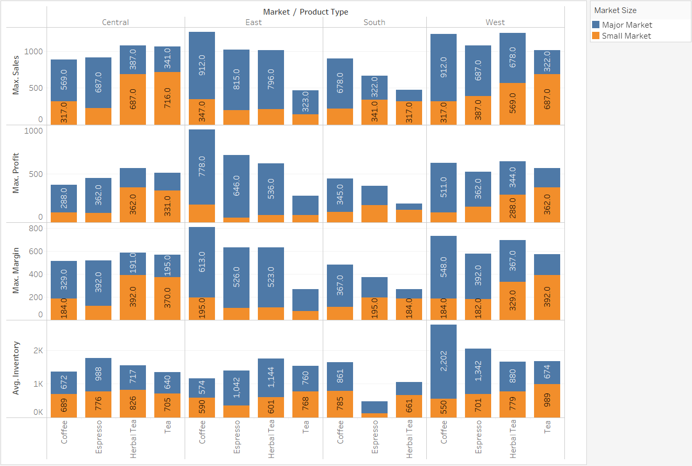

**4. How does it relate?**

The Tableau exercise was a great exercise to teach how to use sales and inventory data to make better informed decisions, decisions that are based on actual data, rather than decisions based on speculation and cold-eyes reviews, or spot-checks of a particular warehouse, or a specific store’s sales. Visualization of data and the ability to develop meaningful insights quickly and easily into sales and inventory can make or break a company. In my opinion, and as an IT leader, this, in addition to the blocking and tackling of a safe, secure, and performant technology environment, represents the single greatest value we can bring to a business.