Offline Password Manager – Operating Instructions

Jim McKeown
13 June 2023

Edit Passwords

The Offline Password Manager appears as an additional keyboard when plugged in to a PC. The device
can store up to 15 passwords of up to 63 characters each. The user initially stores passwords in each location (1 – 15) using this procedure:

1. Plug the USB cable into a PC.

2. Determine the device assigned to the password manager.

In Linux, open /dev directory. The device is likely ttyACMx. If there is more than one (ttyACM0, ttyACM1…) unplug the USB cable and see which device is removed. Then plug the USB cable back in and confirm that the device returns.

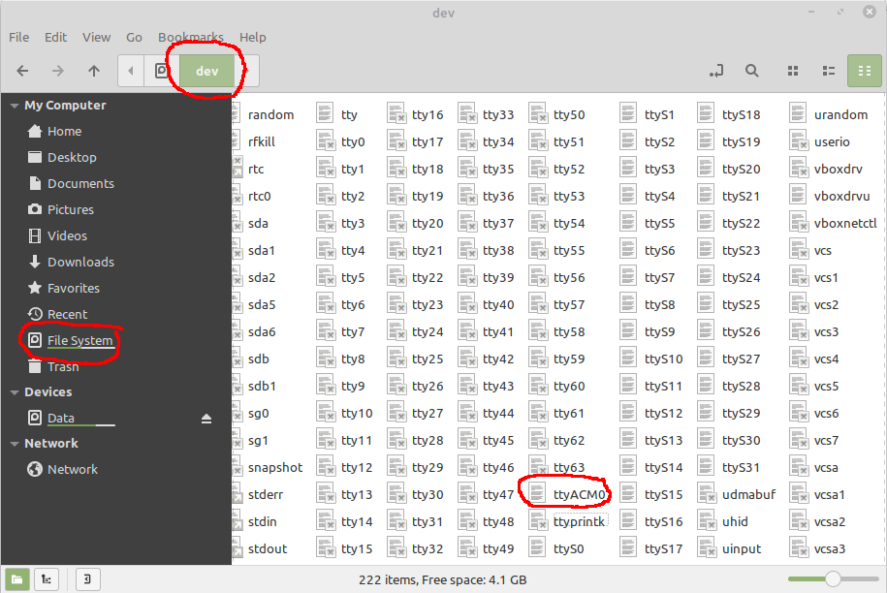

In Windows, use Device manager, Ports (COM & LPT) to configure the Password Manager as a serial port.

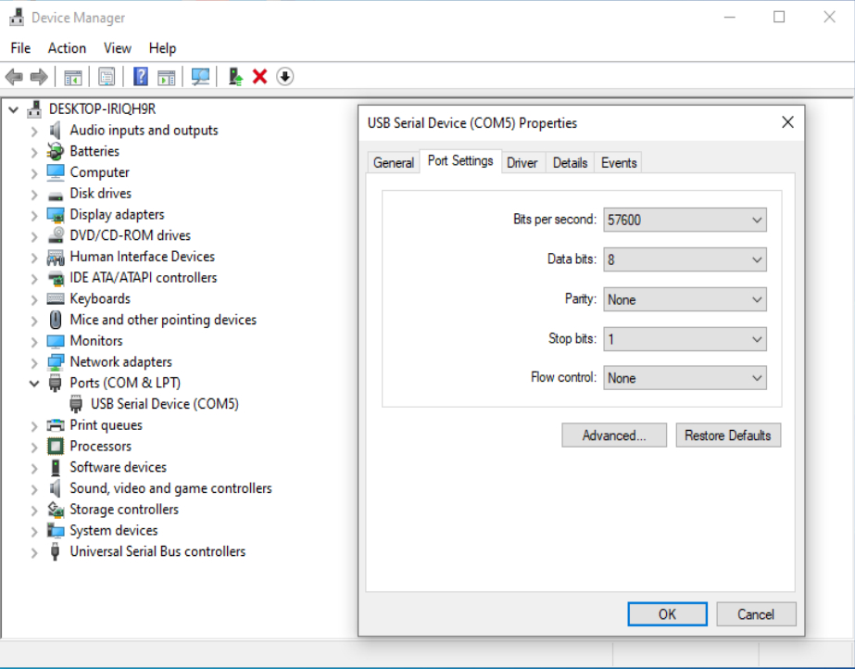
3. Open a serial communication application such as PuTTY.
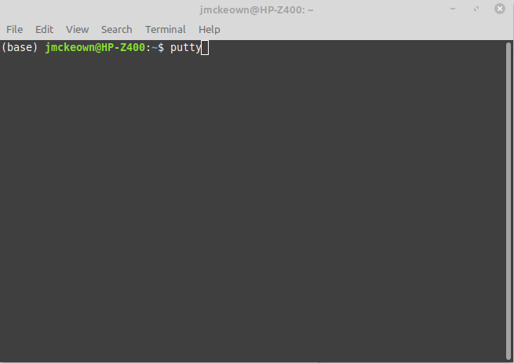

4. Change Session settings to:
Destination: dev/ttyACM0 (change to the device from step 2)
Speed 57600
Connection type: Serial

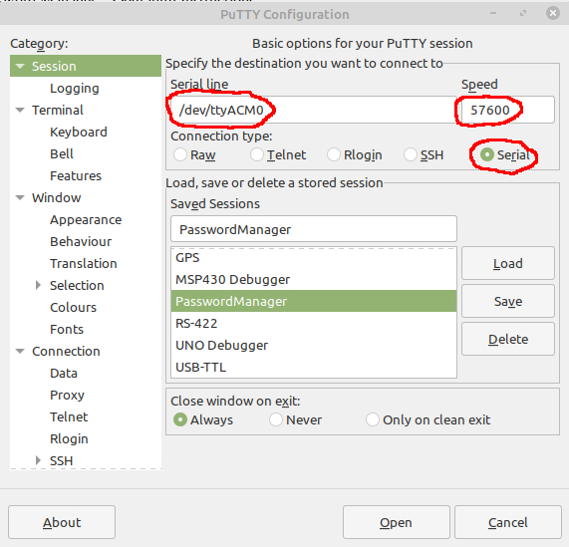

5. Change Terminal settings to:
Local echo: Force on
Local line editing: Force on

All other settings are default.

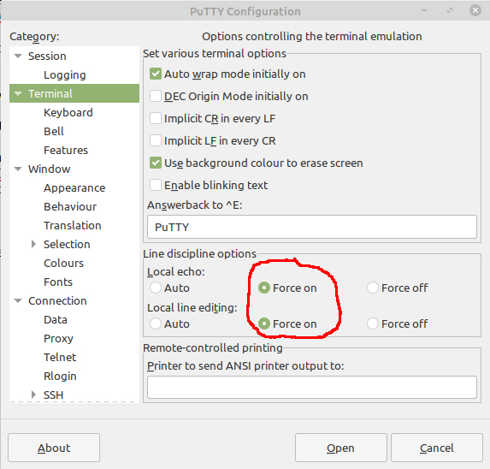

6. Save the configuration with a meaningful name so you can skip steps 2, 4, and 5 next time. Load the configuration if you have already saved it.

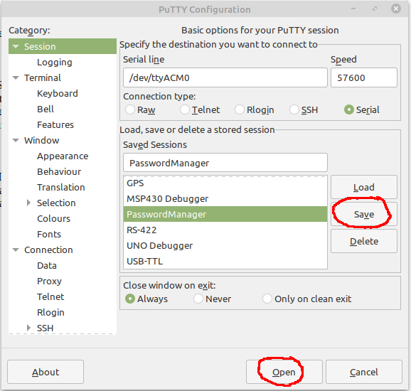
7. Select “Open”.

8. In the PuTTY terminal, type “editPW” and press the Enter key.

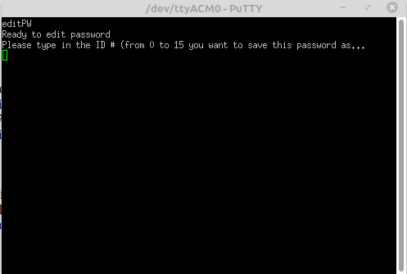

9. Follow the prompts to edit any valid password ID #.
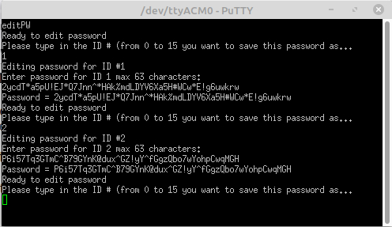

10. Repeat step 9 for all password IDs you would like to edit.

11. When finished editing, unplug the USB cable.

Note: If you have a long password that you have copied to the clipboard, use Ctrl+right-click, “Paste from CLIPBOARD” from the context menu to paste into PuTTY.

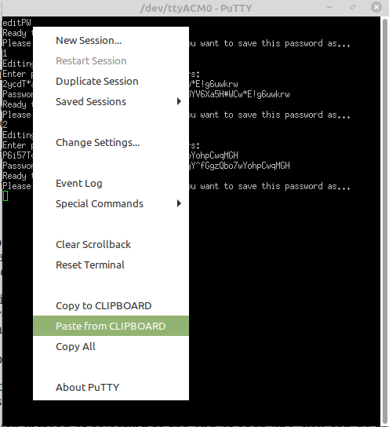

Normal Operation

1. Hold down buttons 2 and 8 while plugging in the USB cable to the PC.

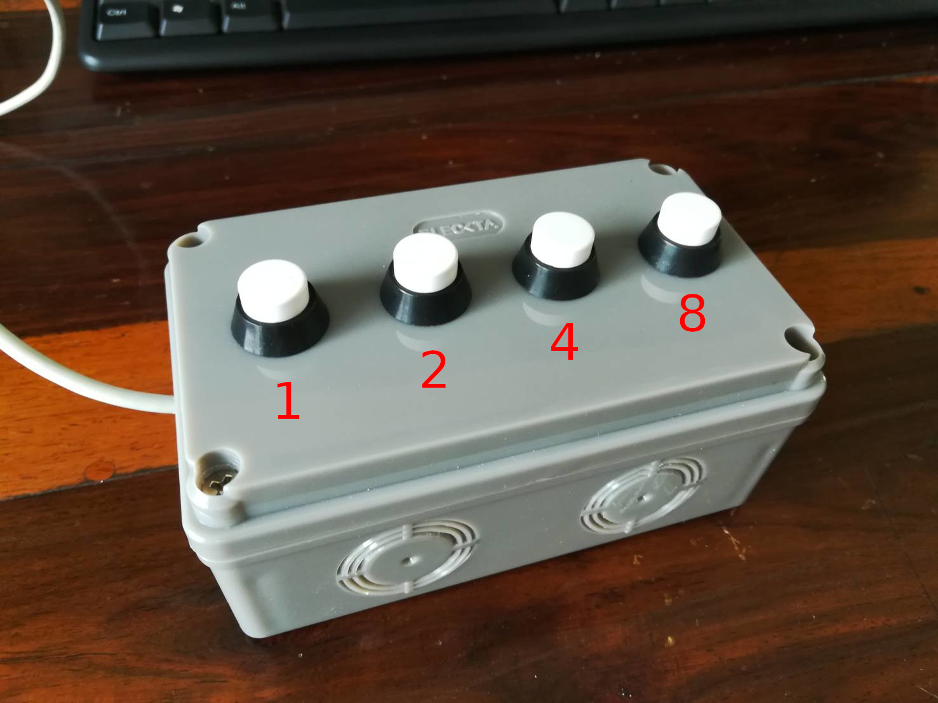

2. After about 3 seconds, release the buttons. This will unlock the device.

3. Set the PC cursor focus on an appropriate password prompt text box.

4. Press the appropriate button or combination of buttons to select a password number. Button 1 send password 1. Button 4 sends password 4. Buttons 2 and 4 together send password 6 (2+4), and so on. The password selected will be immediately sent once to the PC as a USB keyboard input. All buttons must be released to send the next password.

5. Press Enter on the keyboard to send out the password.

Repeat steps 3, 4, and 5 to send additional passwords.

Note:

The device will stay unlocked as long as it is powered. Any number of passwords can be sent until the device looses power.

If the device is in the locked state, the button number will be sent to the keyboard instead of the stored password.

