CS 4375 report notes – Jim Moore

Categorizing if a song has more than 2500 plays (4012 of 8000 songs satisfy this)

Using sklearn MLPClassifier with 20 MFCCs sampled every

**Accuracy by always guessing above average: 50.23%**

**On a small data set a network with hidden layer size (40,20) performed like this:**

training with max iter=40

true positives: 62, true negatives: 144

false positives: 3, false negatives: 15

accuracy: 0.9196

testing with max iter=40

true positives: 16, true negatives: 64

false positives: 12, false negatives: 23

**accuracy: 0.6957**

**Hidden layer size (100,20)**

maximum test accuracy: 0.562 with 110 epochs

true positives: 631, true negatives: 898

false positives: 490, false negatives: 702

accuracy: 0.5619

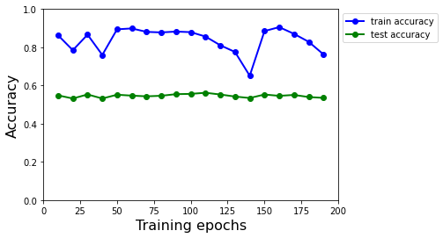

**Hidden layer size (200,100)**

maximum test accuracy: 0.573 with 190 epochs

true positives: 762, true negatives: 798

false positives: 590, false negatives: 571

accuracy: 0.5733

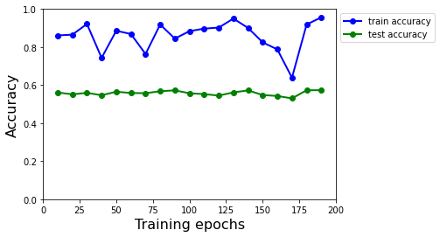

**(1000,100)**

maximum test accuracy: 0.574 with 160 epochs

true positives: 675, true negatives: 886

false positives: 502, false negatives: 658

accuracy: 0.5737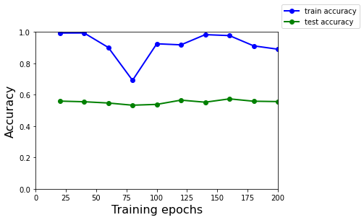

**(1000,500,100)**

maximum test accuracy: 0.587 with 340 epochs

true positives: 781, true negatives: 815

false positives: 573, false negatives: 552

accuracy: 0.5865

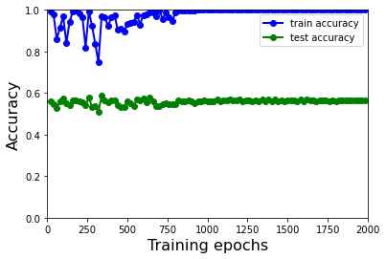

**Director (40,40) Predictor (40,20)**

20 networks

maximum test accuracy: 0.549 with 340 epochs

true positives: 816, true negatives: 678

false positives: 710, false negatives: 517

accuracy: 0.5491

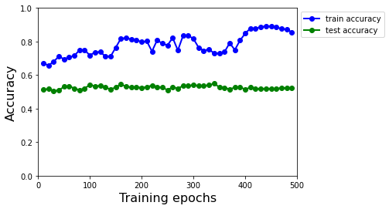

Personal data

(40,20) - 90 songs

maximum test accuracy: 0.667 with 45 epochs

true positives: 16, true negatives: 4

false positives: 9, false negatives: 1

accuracy: 0.6667

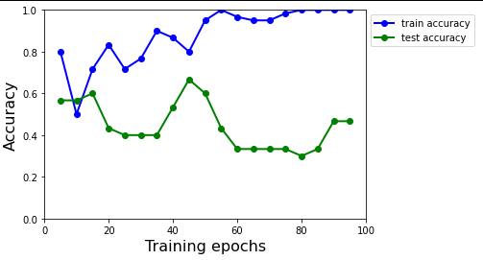

**Max confidence director with predictor (40,20)**

20 networks

maximum test accuracy: 0.552 with 130 epochs

true positives: 783, true negatives: 718

false positives: 670, false negatives: 550

accuracy: 0.5516

