MEMTYPE FLASHING GUIDE

Programmer: USBasp
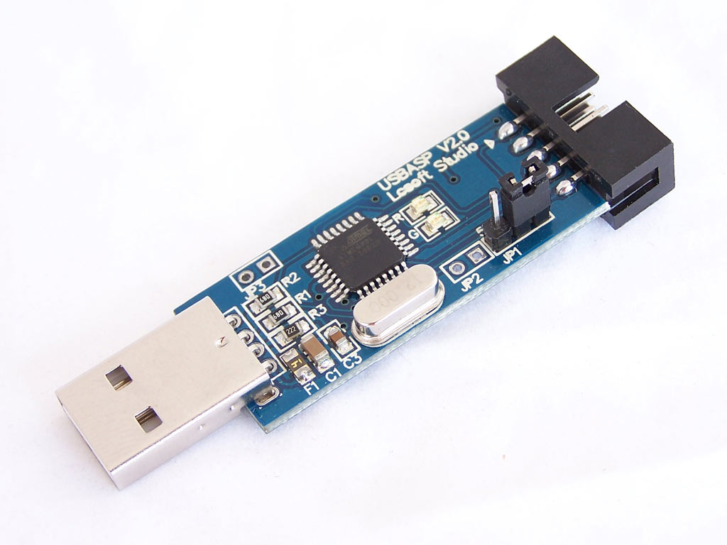

Pinout description:
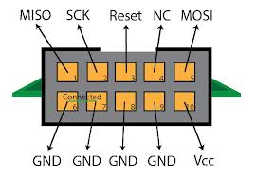
Memtype connections:
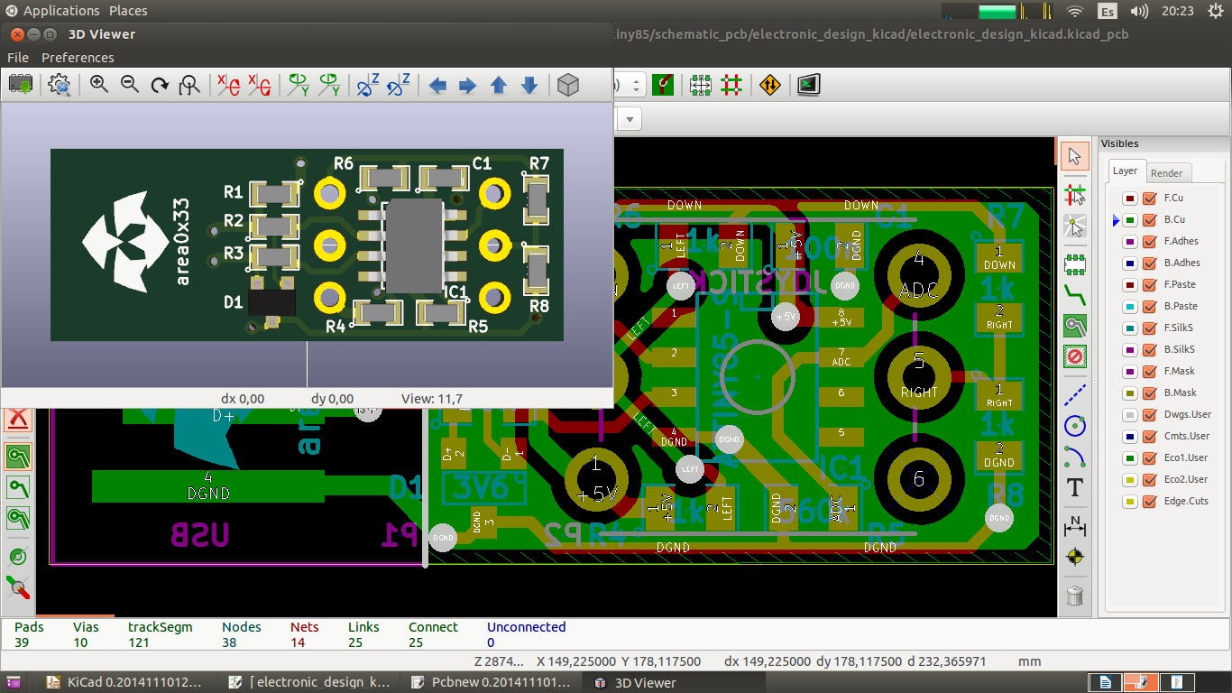
RST
GND
VCC
MISO
MOSI
SCK
FLASHING COMMANDS
1- GEN HEX: make clean && make hex
2- FUSES & FIRMWARE: avrdude -c usbasp -p attiny85 -U lfuse:w:0xe1:m -U hfuse:w:0xdd:m -U efuse:w:0xfe:m -U flash:w:main.hex:i

All should be working fine !

FUSE BYTES (explanation)

Fuse low byte

Fuse Low Byte | Bit | Description | Default Value (62h) | MemType Value (E1h)
CKDIV8 | 7 | Clock divided by 8 | 0 (programmed) | 1 (unprogrammed)
CKOUT | 6 | Clock output enabled | 1 (unprogrammed) | 1 (unprogrammed)
SUT1 | 5 | Start-up time setting | 1 (unprogrammed) | 1 (unprogrammed)
SUT0 | 4 | Start-up time setting | 0 (programmed) | 0 (unprogrammed)
CKSEL3 | 3 | Clock source setting | 0 (programmed) | 0 (programmed)
CKSEL2 | 2 | Clock source setting | 0 (programmed) | 0 (programmed)
CKSEL1 | 1 | Clock source setting | 1 (unprogrammed) | 0 (programmed)
CKSEL0 | 0 | Clock source setting | 0 (programmed) | 1 (unprogrammed)

MemType Value = E1h
CKDIV8: disabled
CKOUT: disabled
Start-up time setting: 14ck+1024ck+64ms
Clock source setting: High Frequency PLL Clock (16Mhz)

Fuse high byte

Fuse High Byte | Bit | Description | Default Value (DFh) | MemType Value (DDh)
RSTDISBL | 7 | External reset disabled | 1 (unprogrammed) | 1 (unprogrammed)
DWEN | 6 | DebugWIRE enabled | 1 (unprogrammed) | 1 (unprogrammed)
SPIEN | 5 | Serial program and data download enabled | 0 (programmed) | 0 (programmed)
WDTON | 4 | Watchdog timer always on | 1 (unprogrammed) | 1 (unprogrammed)
EESAVE | 3 | EEPROM preserves chip erase | 1 (unprogrammed) | 1 (unprogrammed)
BODLEVEL2 | 2 | Brown-out Detector trigger level | 1 (unprogrammed) | 1 (unprogrammed)
BODLEVEL1 | 1 | Brown-out Detector trigger level | 1 (unprogrammed) | 0 (unprogrammed)
BODLEVEL0 | 0 | Brown-out Detector trigger level | 1 (unprogrammed) | 1 (unprogrammed)

MemType Value = DDh
External Reset: enabled
Debug Wire: disabled
Serial Programming: enabled
Watchdog timer always on: disabled
Erase eeprom on chip erase: enabled
Brown-out Detector trigger level: 2.5V(min) 2.7V(typ) 2.9V(max)

Fuse extended byte

Fuse Extended Byte | Bit | Description | Default Value (FFh) | MemType Value (FEh)
 | 7 |  | 1 (unprogrammed) | 1 (unprogrammed)
 | 6 |  | 1 (unprogrammed) | 1 (unprogrammed)
 | 5 |  | 1 (unprogrammed) | 1 (unprogrammed)
 | 4 |  | 1 (unprogrammed) | 1 (unprogrammed)
 | 3 |  | 1 (unprogrammed) | 1 (unprogrammed)
 | 2 |  | 1 (unprogrammed) | 1 (unprogrammed)
 | 1 |  | 1 (unprogrammed) | 1 (unprogrammed)
SELFPRGEN | 0 | Self-programming enabled | 1 (unprogrammed) | 0 (unprogrammed)

MemType Value = FEh
Self-programming: enabled

