進階機器學習 Advanced Machine Learning
M113040064 李冠宏
M103040072 吳浩宇

(一) For the 20 pairs of (x,y) data provided in the attached HW1-1.csv file, use either tensorflow2.0 or pytorch to implement：

(a) Writing a multi-layer neural network model to simulate a function y=f(x) which can produce the above data. The output data y produced by the neural network for a given input data x must have a mean error (MSE) less than 0.1.
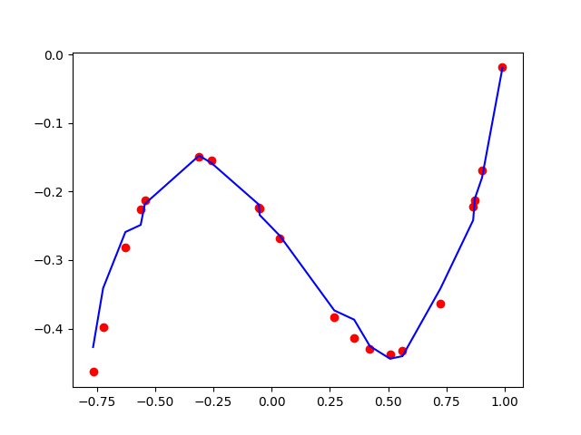
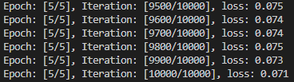
(b) Write a multi-order regression equation model y = 𝑤𝑚𝑥 𝑚 + ⋯ + 𝑤1𝑥 1 + 𝑤0 to also simulate the above function with the same MSE requirement. You should

(i) Print out the coefficients of the equation 𝑤𝑚, … , 𝑤0。

(ii) Use the tensorflow or pytorch to calculate the following
gradients: 𝑓 ′ (3.0), 𝑓 ′ (0.1), 𝑓 ′ (−0.5).
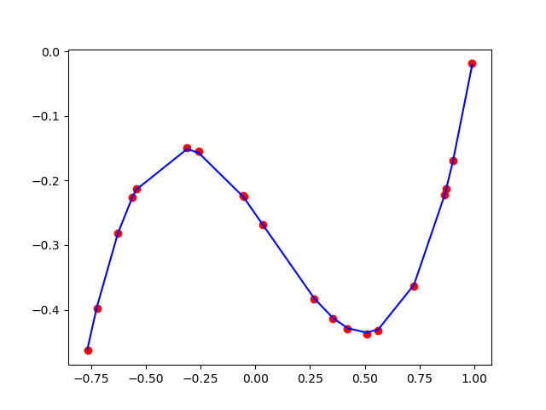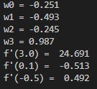
(二) Cifar-10 dataset consists of 60,000 RGB color pictures of 32*32, a total of 10 categories. It contains a total of 50,000 training data, and a total of 10,000 testing data.

Answer the following questions:
(a) Calculate the total number of parameters (including kernel and bias). List the calculation process. You compare it with the results of model.summary() in tensorflow or torchsummary(model) in pytorch.
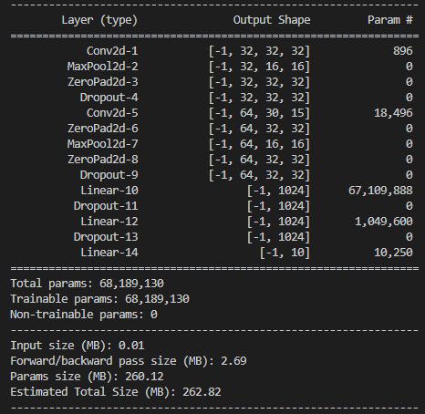
(b) Calculate the top-1 and top-5 accuracy and loss of the training & validation data.
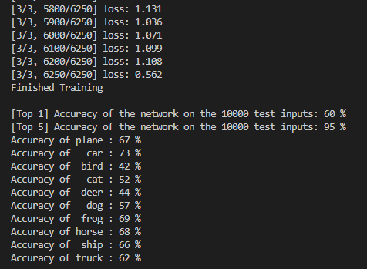
(c) Adjust the architecture by yourself (increase/decrease the number of convolution, max pooling, relu, dropout, and internal parameters), so that the top-1 accuracy result of the test data is more than 10% higher than the above architecture.

透過調整卷積層的kernel_size為(7,7)、第一層的output channel為64、第一層的output channel為128，卷積層和全連階層沒有使用dropout，並且經過卷積後沒有做padding，從原本的60%準確率提升至72%的準確率。
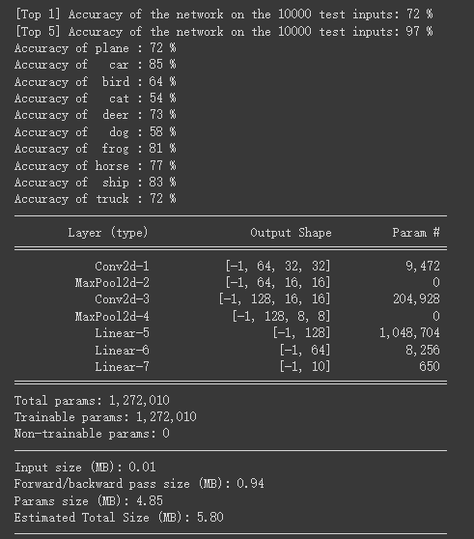

(三)Suppose we have an input feature map with a size of 4x4, and the features will pass through a convolution layer with a kernel size of 3x3. The activation function used in convolution is sigmoid. The convolution results will be flattened and multiplied by the corresponding weights. The products will be added together to produce a final regression value. Assume the correct label value is yy, and the MSE has been used as the loss function. Derive the loss gradient with respect to for the weight w10 in the following figure.
