CA Project2 M113040064 李冠宏

Problem 1

a. Please prove your design’s correctness. (result of compiling code)

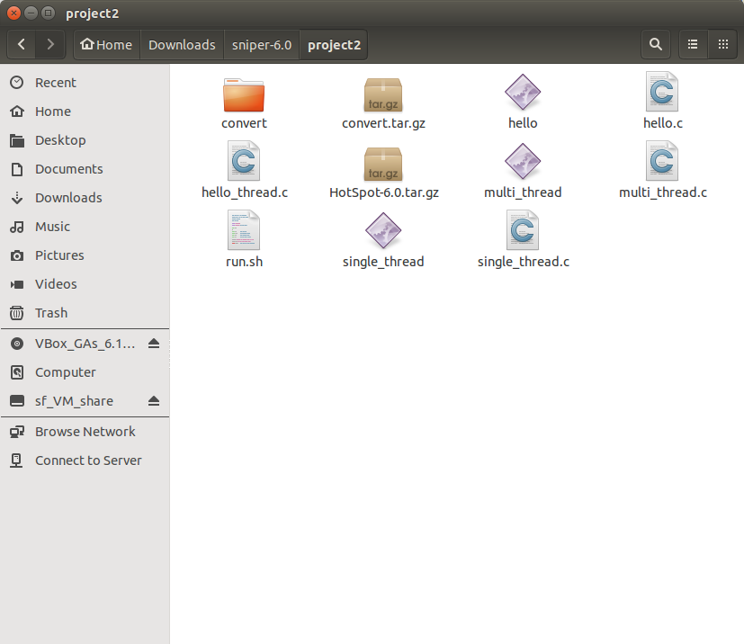

b. How many cycles are used? (submit sim.out file)

Single thread:

Core 0 uses 272712 cycles.

Multi-threads:

Core 0 uses 627155 cycles.

Core 1 uses 616830 cycles.

Core 2 uses 616771 cycles.

Core 3 uses 615869 cycles.

c. How much is your CPI?

Single thread:

|  |  |
| --- | --- |
| core | Core 0 |
| 1. Instructions | 95122 |
| 1. Cycles | 272712 |
| 1. CPI (Cycles/ Instructions) | 2.87 |

Multi thread:

|  |  |  |  |  |
| --- | --- | --- | --- | --- |
| core | Core 0 | Core 1 | Core 2 | Core 3 |
| 1. Instructions | 198427 | 45124 | 19592 | 20515 |
| 1. Cycles | 627155 | 616830 | 616771 | 615869 |
| 1. CPI   (Cycles/ Instructions) | 3.16 | 13.67 | 31.48 | 30.02 |

d. Best to submit your C code of single thread and multi thread.

Single thread:

Multi-thread:

