Homework (Storage)

1. Hash Storage Structure (refer the handout – a hashed file)
(a) If we modify the hash function to |key| mod 8, and one data block can hold 3 records, what will be the result of the new storage structure with the same database?
(b) After (a), insert a new record CHINESE.
(c) After (b), modify Compsognathus to AMERICAN.

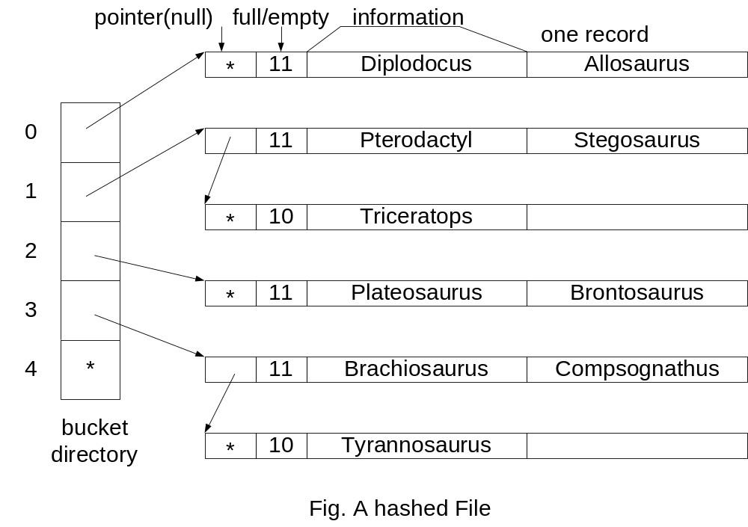
2. Index Storage Structure for Unpinned Records. (refer the handout – Sorted, indexed dinosaur file (unpinned records))
(a) If one data block can hold 3 records, what will be the result of the new storage structure with the same database?
(b) After (a), insert a new record CHINESE.
(c) After (b), modify Compsognathus to AMERICAN.

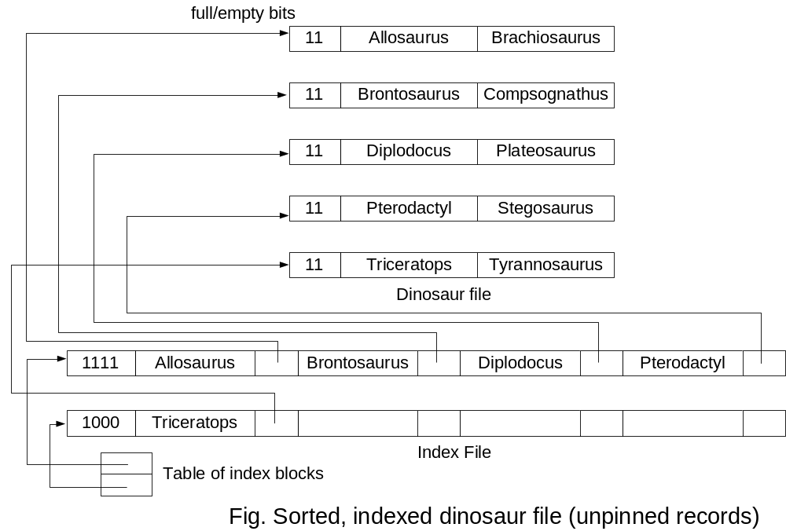
3. Index Storage Structure for Pinned Records. (refer the handout – Insertion (pinned records))
(a) Insert a new record CHINESE.
(b) After (a), modify Compsognathus to AMERICAN.

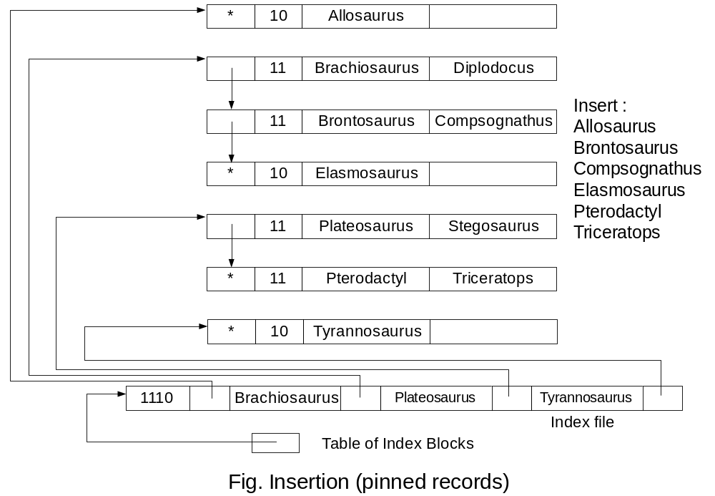

4. B-tree (refer the handout – Initial B-tree)
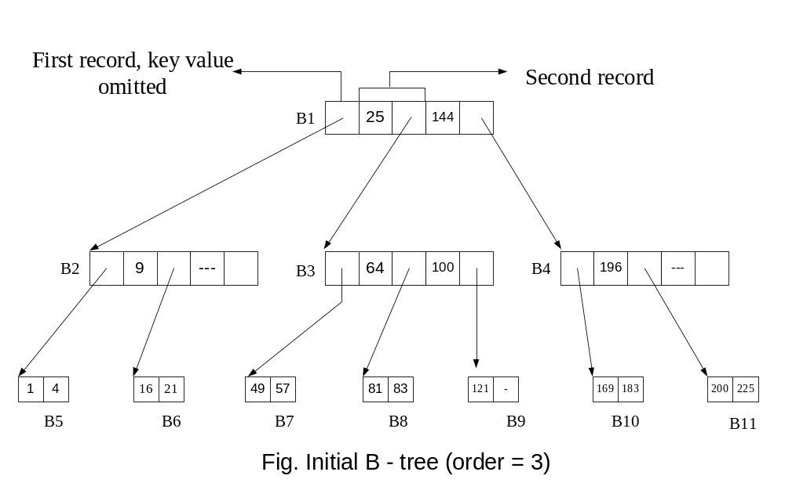(a) Insert 195.
(b) Delete 100.

